Sudan

Prompt:(Write the letter which is most likely to get a response from the dictator / national embassy, which will help put you in a position to make the country more successful. I'm looking for expert local knowledge here that could give you a political edge to make the country great again. It's your responsibility to make the world a better place, but you'll need to get somebody's attention, somebody with power.)

To be able to write a persuasive letter with the hopes of making the world a better place that is likely to get a response from a politician, one must talk about ideas that will benefit the people in charge while also providing a better future for the people leaving in the country. To achieve that one must have good diplomatic skills combined with in-depth knowledge of the country, the people leaving there and the people in charge.
Let’s see what we information we have about Sudan:
Sudan (Official name: Republic of the Sudan), is a country in Northeast Africa. It’s population is 45.7 million people as of 2022. Sudan is considered to be one of the most corrupt nations in the world.
On Transparency International's Corruption Perceptions Index ranking conducted in 2021(1), Sudan ranked 164th out of 180 countries, with a score of 20/100 (with 100 being very clean and 0 being highly corrupt).
On World Bank Worldwide Governance Indicators(2) with a scale from 0 to 100 (%), Sudan scored a single digit in almost every category for the past 11 years as of 2021 (2010 - 2021), the main ones that we are interested in being:
Rule of Law (perceptions of the extent to which agents have confidence in and abide by the rules of society, and in particular the quality of contract enforcement, property rights, the police, and the courts, as well as the likelihood of crime and violence)
Control of Corruption (perceptions of the extent to which public power is exercised for private gain, including both petty and grand forms of corruption, as well as "capture" of the state by elites and private interests)
Government Effectiveness (perceptions of the quality of public services, the quality of the civil service and the degree of its independence from political pressures, the quality of policy formulation and implementation, and the credibility of the government's commitment to such policies)
Regulatory Quality (perceptions of the ability of the government to formulate and implement sound policies and regulations that permit and promote private sector development)
Political Stability and Absence of Violence/Terrorism (perceptions of the likelihood of political instability and/or politically-motivated violence, including terrorism)
And here is the data between 2010 and 2021:
Series Name | 2010 | 2011 | 2012 | 2013 | 2014 | 2015 | 2016 | 2017 | 2018 | 2019* | 2020* | 2021
Rule of Law | 6.64 | 7.51 | 8.92 | 7.98 | 9.13 | 8.17 | 8.65 | 11.54 | 10.58 | 11.06 | 13.46 | 10.1
Control of Corruption | 8.57 | 9 | 0.47 | 0.47 | 3.37 | 3.37 | 3.37 | 2.88 | 6.25 | 5.77 | 5.77 | 7.69
Government Effectiveness | 6.22 | 5.69 | 5.21 | 4.27 | 4.81 | 5.77 | 5.77 | 6.73 | 4.81 | 4.81 | 5.77 | 5.29
Political Stability | 0.95 | 0.95 | 2.37 | 2.37 | 3.81 | 3.81 | 2.86 | 5.71 | 6.13 | 6.13 | 7.08 | 5.19
Regulatory Quality | 6.7 | 8.53 | 5.69 | 6.64 | 5.77 | 4.81 | 5.77 | 3.85 | 4.33 | 4.81 | 5.29 | 5.77

*
Here are some charts for better visualize what we are working with:

That is the above data but plotted on a graph:
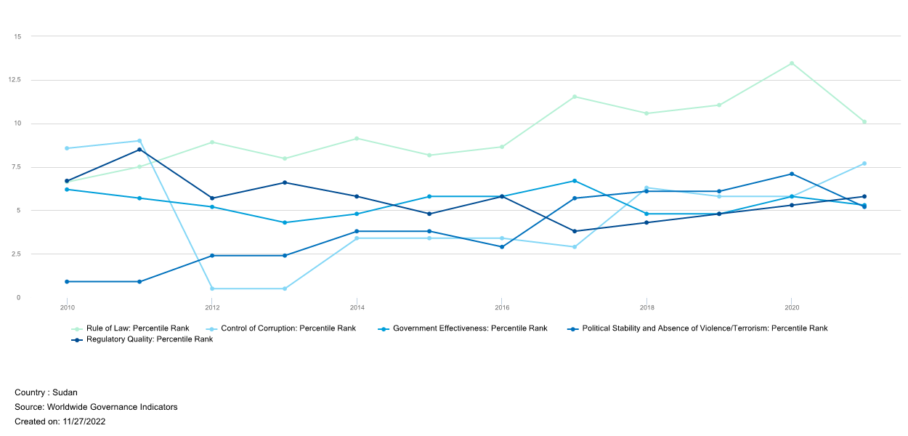
However to really see where is the problem we need to compare the data with the same data of another country. Let’s take Ireland for example:
Here is the same data but for Ireland:
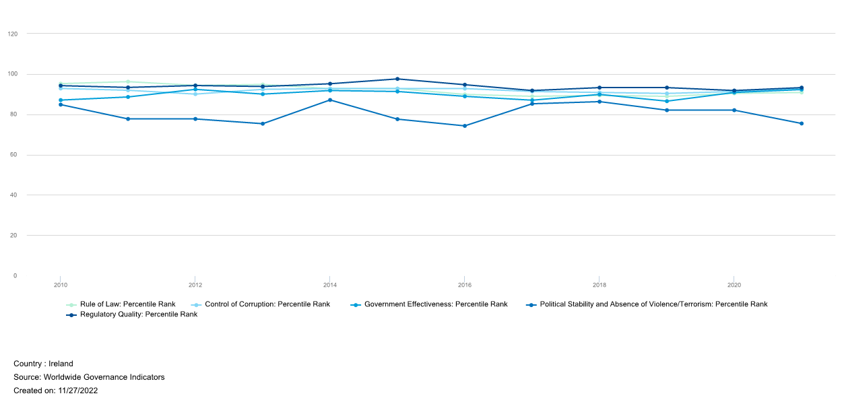
If don’t look deep into the graphs, we might wrongfully assume that Sudan is not that bad, however we are missing one key ingredient: Scale! Let me show you:
Here is the same information as the graphs above, but everything is placed on one graph:
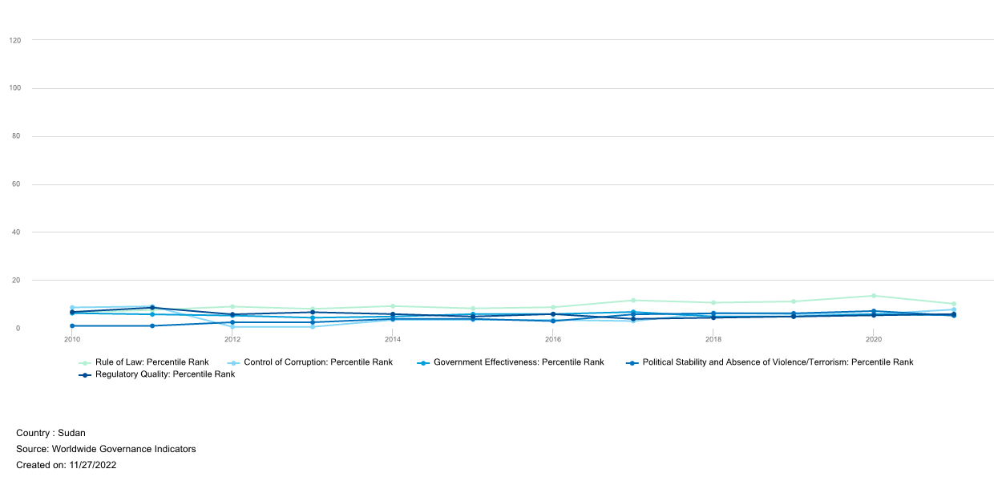

(The top 5 lines represent Ireland, the bottom 5 represent Sudan)
Needless to say we have the information to show that what is currently happening in countries like Sudan is really concerning. But many questions arise when we start compering countries like:
What lead to that kind of situation?
We have two types of information. The history of how the country was created and the data about how the corruption in Sudan. Knowing the past of the country may help us understand how the foreign interventions formed the country and correlate this to corruption and lawfulness.
So let’s see what we know:
Sudan was colonized at 1898 by the British Empire and split with Egypt. The British ruling over the north and the Egyptians ruling over the south. Britain used it’s power to encourage Islam in the northern part of the country, while in the south, they allowed the power to be shared between many tribes with Christian missionaries running the education system. That allowed Britain to divide and control Sudan, however with that brought the side effects of socioeconomic tensions that played a role in Sudan’s future conflicts.
Sudan gained independents from the British colonial rule in 1956, however because on Sudan’s strategic placement in the world, many countries competed to influence on it’s future. This lead to influx of weapons from superpowers like the United States of America, and it’s adversaries. This increased the already existing tensions between the northern and southern parts. Earning the title of “Africa’s arms dump” for the country. This continued during the cold war, with the USA sold Sudan nearly 1 billion dollars worth of arms. Nowadays Sudan become a big arms exporter reselling most of that equipment to Russia.
As we can see the situation in Sudan was not a pure coincidence. First because of the British colonial policies, it inherited many religious and ethical tensions. Also, because of Sudan’s strategic location it happened to be armed to the teeth by huge countries. As a result, Sudan suffered 2 civil wars only 11 years apart: in 1972, and 1983 – 2005. This caused hundreds of thousands of casualties, leading to the collapse of the economy, which in turn worsened the political instability, which made the country spiral down to total lawfulness.
In 200? South Sudan gained independence from the the north, and ended up controlling 95% of oil reserves the main source of income for the country.
At this point the military of Sudan took control from the former ruler in 2019, and manage to keep control of the north despite sanctions from the world powers.
The ruler for over 3 decades (3), was Field Marshal Omar al-Bashir(4), and he was in control of Sudan from June 1989 to April 2019. In 2019, 8 months after Omar al-Bashir was forced from office in April after months of anti-government protests, the former president was summoned in a court in Khartoum (capital of the north) facing charges of money laundering, possession of illicit foreign funds and corruption, after suitcases containing millions of dollars were discovered at his home.
He admitted to receiving millions of dollars from Saudi Arabia, but denied the usage of those money for private purposes. The former leader of Sudan was sentenced to 2 years in prison, while the expected time for that kind of crime is at least 10 years. He also was indirectly responsible for killings of demonstrators right before he was overthrown, but this was not accounted for in his sentencing.
During his ruling, Omar al-Bashir was charged by the International Criminal Court (ICC) with 2 counts of war crimes, 5 counts of crimes against humanity, 3 counts of genocide, inciting the killing of protesters, possession of illicit foreign currency, and corruption. He is also accused of genocide in the state of Darfur. The UN estimates that 300 000 people were killed during the conflict there. After he was overthrown, the UN wanted for the new government to extradite Omar al-Bashir, so that he can be held accountable for his actions by the ICC.
Despite all this allegations, the new government lead by General Abdel Fattah al-Burhan(5) also a military leader declined the request of the ICC.
In politics, everyone can have their own personal opinion, so here is mine based on the information above:
I don’t believe that what Omar al-Bashir did can’t be excused in any way. I also think that he should be by all means taken out of Sudan to be held accountable for the crimes he has committed. As to the economic situation in Sudan over the years, what happened can be related to the external powers influencing the politics in Sudan due to it’s the strategic location and resources, but the decisions taken by the political elite made the situation even worse.
Knowing the past and the present, what can we predict?
As of now, the government is again under the rule of the military. And so if we look back at what happened in the past, the future of Sudan is not looking bright. As we can see apart from some periods, where the ruling of the country was shared broadly, Sudan has for the past 50 years predominantly being ruled by the military regimes. Furthermore, the military is in a pretty comfortable situation since there is no real challenger to force them out of power. In addition they have no incentive to alow accountability and rule of law, since the moment the county moves to any form of democracy, many dark secrets will surface. That almost certainly will bring everyone that is now in power, or was in power to be held accountable for their actions, ether by the ICC or put in prison by independent local courts. So if I had to make an educated guess as to what will happen next, I think it is highly probable that the military is going to stay in power for a while. However no hope is lost, since in the past the people already overturned the government once. This is not a question if, but when it will happen and what can be done then.
When that happens, how can we make sure that Sudan stays resilient to corruption and have independent courts and government in the future?
Let us look at other local countries that had similar history and now are thriving economies(6). Affter some research, the history of Nigeria almost seem as a slightly modified copy of Sudan's. Perfect, we found our candidate: prosperous, and with the same history. So what did they do to achieve that? After reading about Nigeria(7), as it turns out, the sucssesor of their dictator, Sani Abacha, addopted a constitution. He then held an election and handed over power to the winner of those elections.
The problem with what happened last time in Sudan, when the military ruler Omar al-Bashir was overturned, was that the democratic changes did not hold. The people’s representatives were initially included in the government along with the military, but were thrown out by the new 60 years old military leader Abdel Fattah al-Burhan, before they even finished their first 3-year term. Which in essence didn’t change much compared to the situation under the previous ruler. Neither did his right to sweep in and take full control of power.
Knowing that I believe that the answer to that question is really straightforward. Making sure that whoever is in charge next, like in Nigeria knows better and is ready use his power to turn the country arround.
Having the information we can write a persuasive letter with one clear goal in mind: To make Sudan more successful in the future.
What we can use to provoke a dictator to allow that?
After thinking about it, the most likely angel to give results is to use the age of the dictator, now in his 60’s, and let him think about his legacy and what he will be remembered with. Instead of pledging for democracy, we can advocate for creating better economic conditions that will allow his country to get out of poverty. We can offer to educate the youth of his country in business as well in business law to ensure the businesses can progress and survive under his protection. Eventually this will create a well educated elite able to achieve our set goal.
So without further ado, here is what an example letter may look like:

Dear General Abdel Fattah al-Burhan,
I am writing to you today as a student in Maynooth University of Ireland in regards to a project I am currently working on. The idea of the project is to pick a country and try to make in more succesfull and powerfull. I decided to try and use my knowledge to propose some ideas that you might find beneficiel to incorporate in your country.
Firstly, for a country to trive, it requires exports, so that it can gain the nececery capital to expand and satisfy it’s basic needs. In my oppinion the easyest way for that to happen is to provide education to the young people of Sudan in business and economics. That will allow them to make new businesses that will generate huge amounts of capital to the country.
Secondly, not one can live forever, but their legacy can. That is why I believe that it is import to leave this earth knowing that people will remember you. To achieve that, my suggestion is to educate the next generations of leaders in politics. The best way in my opinion is by sending them to learn in Europe where the education is arguably advanced, which will allow them to then return back and continue your legacy.
I hope at least some of those ideas are useful and I would be really happy if I managed to help.
Thank you for your time. It was an honer speaking to you.
Yours Sincerely,
A student in Maynooth University of Ireland

