Lab 3 – Thunderbird Lights Prelab

**Name:**

**Documentation Statement:**

1. State Transition Diagram **(replace with screenshot from PowerPoint)**

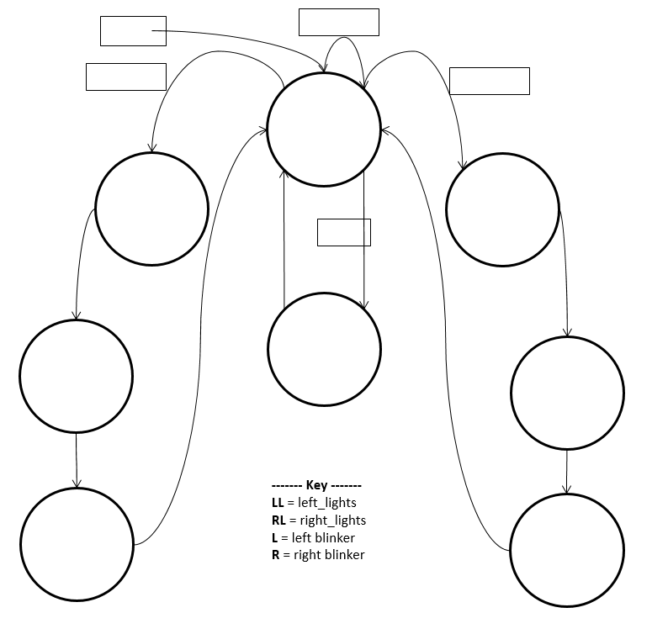

1. State Transition/Output Tables (**Binary Encoding**)

|  |  |  |  |  |
| --- | --- | --- | --- | --- |
| **Binary Encoding** | | | | |
|  | **State** | **S2** | **S1** | **S0** |
| 0 | OFF |  |  |  |
| 1 | ON |  |  |  |
| 2 | R1 |  |  |  |
| 3 | R2 |  |  |  |
| 4 | R3 |  |  |  |
| 5 | L1 |  |  |  |
| 6 | L2 |  |  |  |
| 7 | L3 |  |  |  |

|  |  |  |  |  |  |  |  |  |  |
| --- | --- | --- | --- | --- | --- | --- | --- | --- | --- |
| State Transition Table with Binary Encoding | | | | | | | | | |
| State | **S2** | **S1** | **S0** | **L** | **R** | **S\*** | **S2\*** | **S1\*** | **S0\*** |
| OFF |  |  |  | 0 | 0 |  |  |  |  |
| OFF |  |  |  | 0 | 1 |  |  |  |  |
| OFF |  |  |  | 1 | 0 |  |  |  |  |
| OFF |  |  |  | 1 | 1 |  |  |  |  |
| ON |  |  |  | X | X |  |  |  |  |
| R1 |  |  |  | X | X |  |  |  |  |
| R2 |  |  |  | X | X |  |  |  |  |
| R3 |  |  |  | X | X |  |  |  |  |
| L1 |  |  |  | X | X |  |  |  |  |
| L2 |  |  |  | X | X |  |  |  |  |
| L3 |  |  |  | X | X |  |  |  |  |

|  |  |  |  |  |  |  |  |  |  |
| --- | --- | --- | --- | --- | --- | --- | --- | --- | --- |
| Output Table with Binary Encoding | | | | | | | | | |
| State | **S2** | **S1** | **S0** | **lights_L(c)** | **lights_L(b)** | **lights_L(a)** | **lights_R(c)** | **lights_R(b)** | **lights_R(a)** |
| OFF |  |  |  |  |  |  |  |  |  |
| ON |  |  |  |  |  |  |  |  |  |
| R1 |  |  |  |  |  |  |  |  |  |
| R2 |  |  |  |  |  |  |  |  |  |
| R3 |  |  |  |  |  |  |  |  |  |
| L1 |  |  |  |  |  |  |  |  |  |
| L2 |  |  |  |  |  |  |  |  |  |
| L3 |  |  |  |  |  |  |  |  |  |

1. State Transition/Output Tables (**One-Hot Encoding**)

|  |  |  |  |  |  |  |  |  |
| --- | --- | --- | --- | --- | --- | --- | --- | --- |
| One-Hot Encoding | | | | | | | | |
| State | **S7** | **S6** | **S5** | **S4** | **S3** | **S2** | **S1** | **S0** |
| OFF |  |  |  |  |  |  |  |  |
| ON |  |  |  |  |  |  |  |  |
| R1 |  |  |  |  |  |  |  |  |
| R2 |  |  |  |  |  |  |  |  |
| R3 |  |  |  |  |  |  |  |  |
| L1 |  |  |  |  |  |  |  |  |
| L2 |  |  |  |  |  |  |  |  |
| L3 |  |  |  |  |  |  |  |  |

|  |  |  |  |  |  |  |  |  |  |  |  |  |  |  |  |  |  |  |  |
| --- | --- | --- | --- | --- | --- | --- | --- | --- | --- | --- | --- | --- | --- | --- | --- | --- | --- | --- | --- |
| State Transition Table with One-Hot Encoding | | | | | | | | | | | | | | | | | | | |
| State | **S7** | **S6** | **S5** | **S4** | **S3** | **S2** | **S1** | **S0** | **L** | **R** | **S\*** | **S7\*** | **S6\*** | **S5\*** | **S4\*** | **S3\*** | **S2\*** | **S1\*** | **S0\*** |
| OFF |  |  |  |  |  |  |  |  |  |  |  |  |  |  |  |  |  |  |  |
| OFF |  |  |  |  |  |  |  |  |  |  |  |  |  |  |  |  |  |  |  |
| OFF |  |  |  |  |  |  |  |  |  |  |  |  |  |  |  |  |  |  |  |
| OFF |  |  |  |  |  |  |  |  |  |  |  |  |  |  |  |  |  |  |  |
| ON |  |  |  |  |  |  |  |  |  |  |  |  |  |  |  |  |  |  |  |
| R1 |  |  |  |  |  |  |  |  |  |  |  |  |  |  |  |  |  |  |  |
| R2 |  |  |  |  |  |  |  |  |  |  |  |  |  |  |  |  |  |  |  |
| R3 |  |  |  |  |  |  |  |  |  |  |  |  |  |  |  |  |  |  |  |
| L1 |  |  |  |  |  |  |  |  |  |  |  |  |  |  |  |  |  |  |  |
| L2 |  |  |  |  |  |  |  |  |  |  |  |  |  |  |  |  |  |  |  |
| L3 |  |  |  |  |  |  |  |  |  |  |  |  |  |  |  |  |  |  |  |

|  |  |  |  |  |  |  |  |  |  |  |  |  |  |  |
| --- | --- | --- | --- | --- | --- | --- | --- | --- | --- | --- | --- | --- | --- | --- |
| Output Table with One-Hot Encoding | | | | | | | | | | | | | | |
| State | **S7** | **S6** | **S5** | **S4** | **S3** | **S2** | **S1** | **S0** | **lights_L(c)** | **lights_L(b)** | **lights_L(a)** | **lights_R(c)** | **lights_R(b)** | **lights_R(a)** |
| OFF |  |  |  |  |  |  |  |  |  |  |  |  |  |  |
| ON |  |  |  |  |  |  |  |  |  |  |  |  |  |  |
| R1 |  |  |  |  |  |  |  |  |  |  |  |  |  |  |
| R2 |  |  |  |  |  |  |  |  |  |  |  |  |  |  |
| R3 |  |  |  |  |  |  |  |  |  |  |  |  |  |  |
| L1 |  |  |  |  |  |  |  |  |  |  |  |  |  |  |
| L2 |  |  |  |  |  |  |  |  |  |  |  |  |  |  |
| L3 |  |  |  |  |  |  |  |  |  |  |  |  |  |  |

1. **Next State Equations:**

S7* =

S6* =

S5* =

S4* =

S3* =

S2* =

S1* =

S0* =

**Output Equations:**

lights_L(c) =

lights_L(b) =

lights_L(a) =

lights_R(c) =

lights_R(b) =

lights_R(a) =