**Issues For New Build**:- **03-06-2024**

1. In the Department Configuration, a user can register a department with a name that is already in use.  
     
   **Loginà Adminà Admin Managementà Department Configurationà New Registration with Department Name as eg. Productionà Again New Registration with same Department Name as Productionà Registering Successfully**  
     
   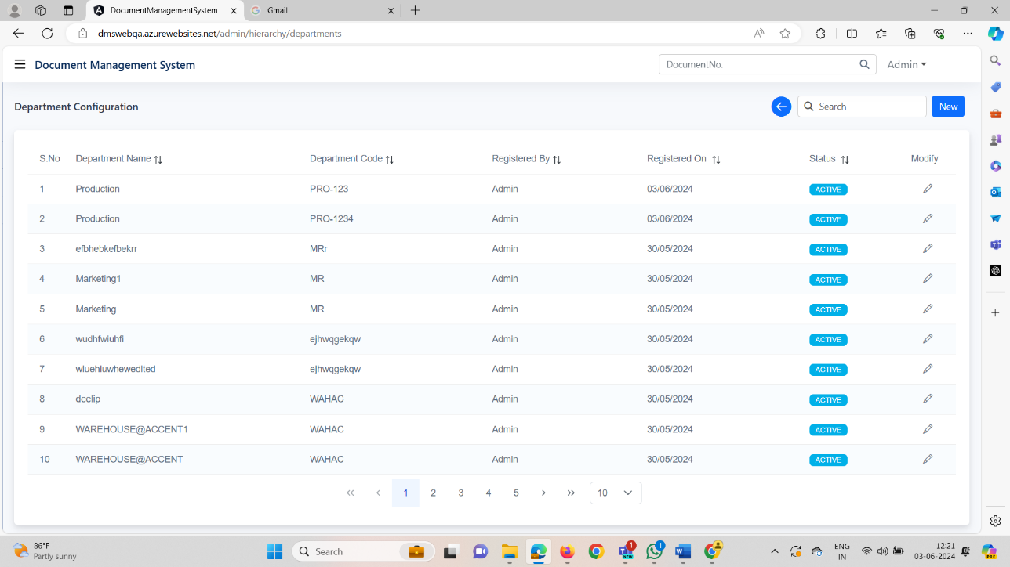
2. In the Plant Management, a user can register a Plant with a name that is already in use.(Deferred)

**Loginà Adminà Admin Managementà Plant Managementà New Registration with Plant Name as eg.Textilesà Again New Registration with same Plant Name as Textilesà Registering Successfully  
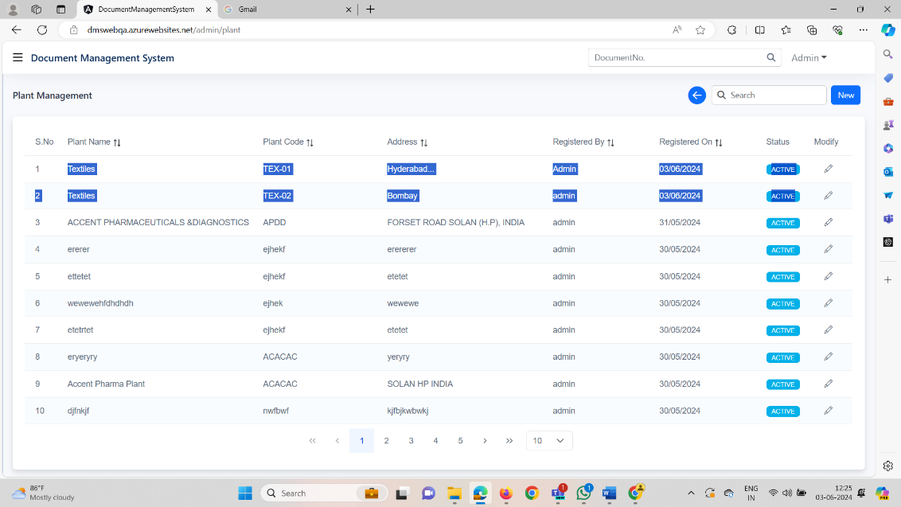**

1. In SetFunctional Profile, the word "Hierarchy" is misspelled.  
     
   **Loginà Adminà Admin Managementà Hierarchy Managementà Setfunctional Profileà Hierarchy word is wrongly Spelled**  
   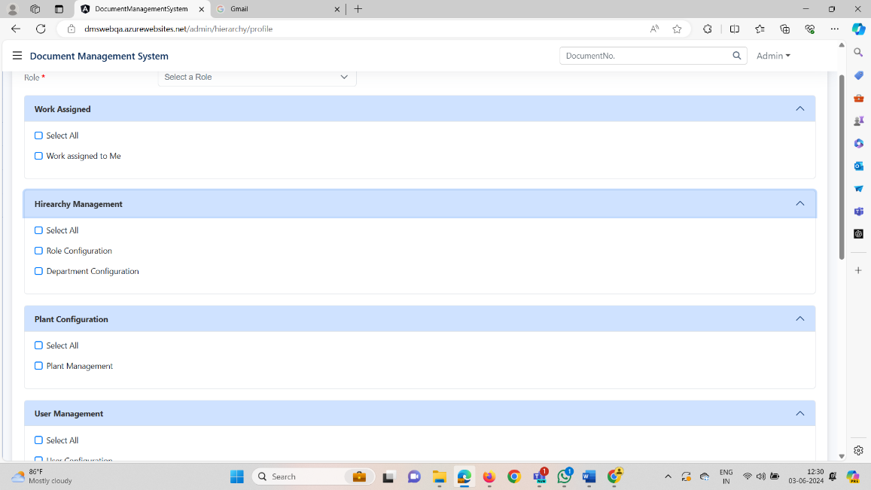
2. In the User Configuration, the Date of Joining (DOJ) field is incorrectly accepting future dates(by entering manually). Although a validation message "DOJ cannot be a future date" is displayed, clicking the update button still submits the form.  
   **Loginà Adminà Admin ManagementàUser Managementà User Configurationà Newà DOJà Enter manuallyàclick on Updateà Accepting**

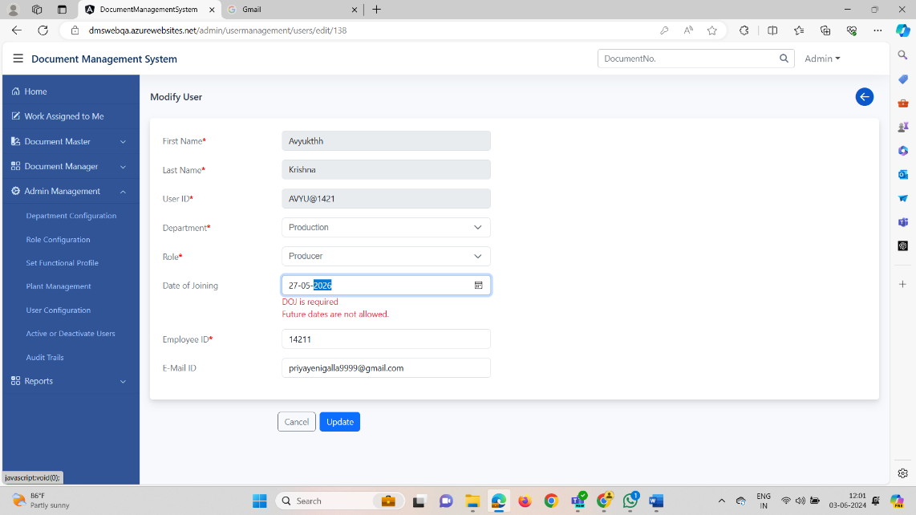

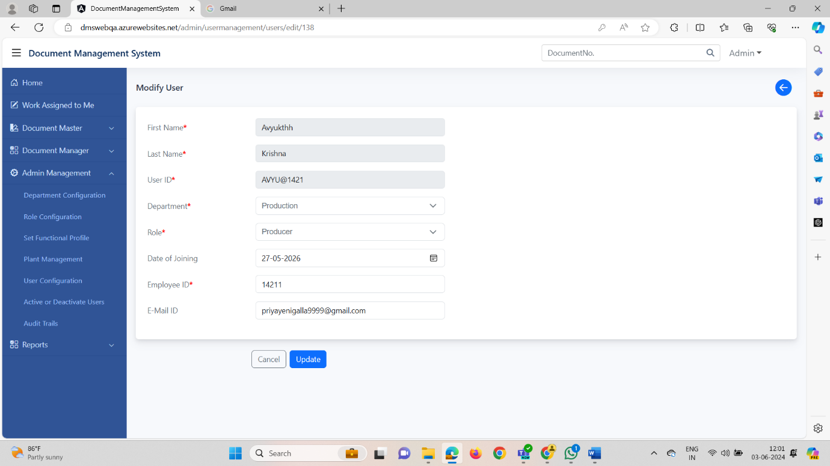

1. Sorting is not working for Registered On in Active/de-active users Module

**Loginà Adminà Admin ManagementàUser Managementà Active/Deactive Userà Click on SortingàRegistered On à Not working  
  
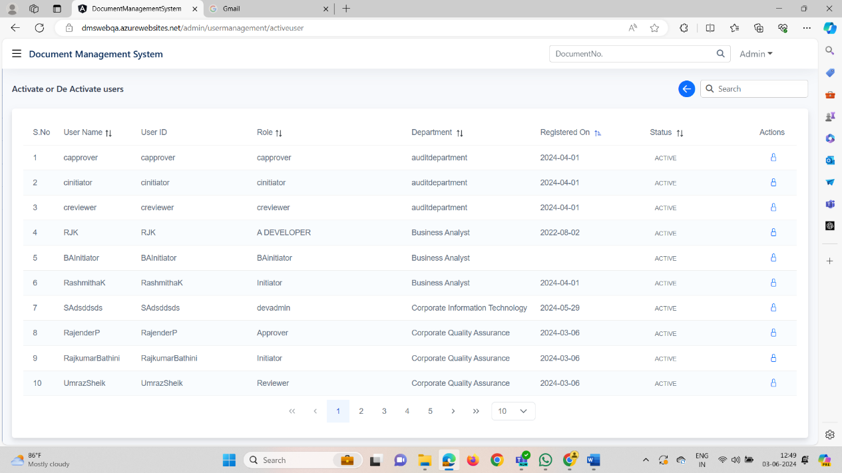**

1. The sorting functionality in "Work Assigned To Me" is not working for the "Assigned Type" category

**Loginà Reviewerà Work Assigned To MeàClick on Sort Functionalityà Assigned TypeàNo Action**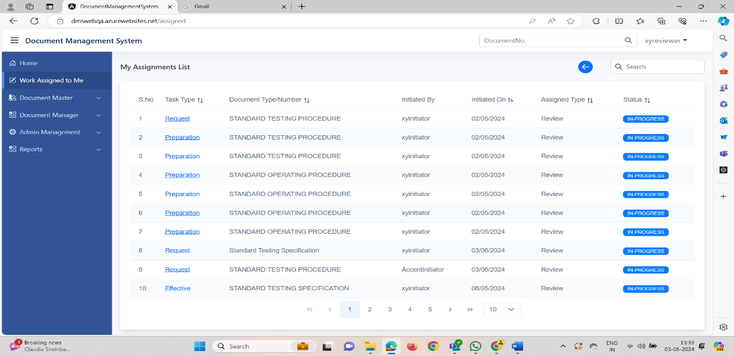

1. The name of the Company & Address is not Fetching in the Header in View Document and also in the Preview  
    **Loginà Initiator, Reviewer, ApproveràDocument ManageràDocument PreparationàModifyàView Documentà Headerà Name of the Company & Address are not fetching**  
   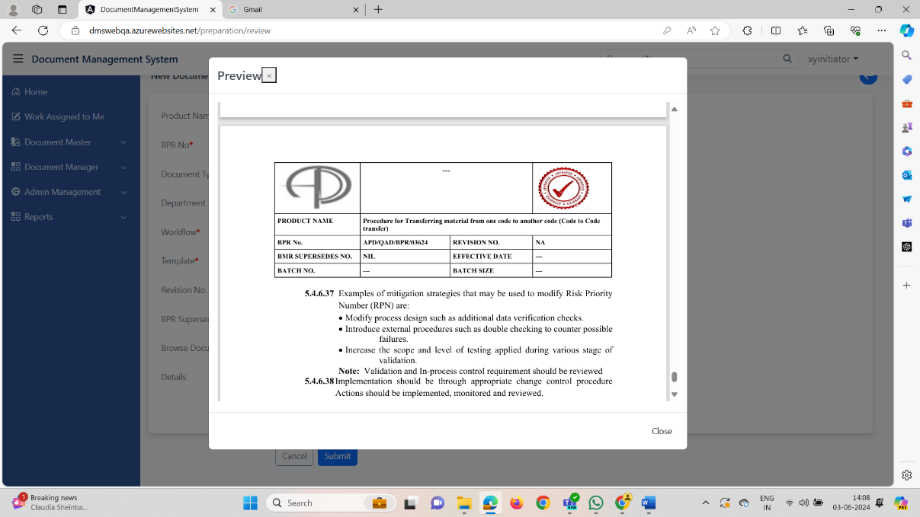
2. The Reviewer Preview for Document Print is not displaying the complete header correctly.  
    **Loginà Reviewer, ApproveràWork Assigned To meà Click on Print Linkà PreviewàComplete header radio buttonà Submità No action**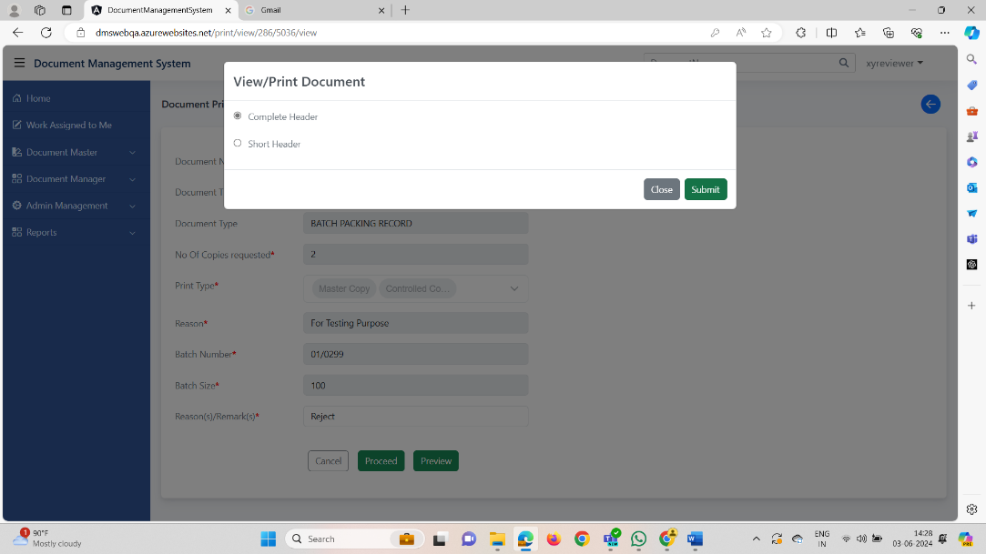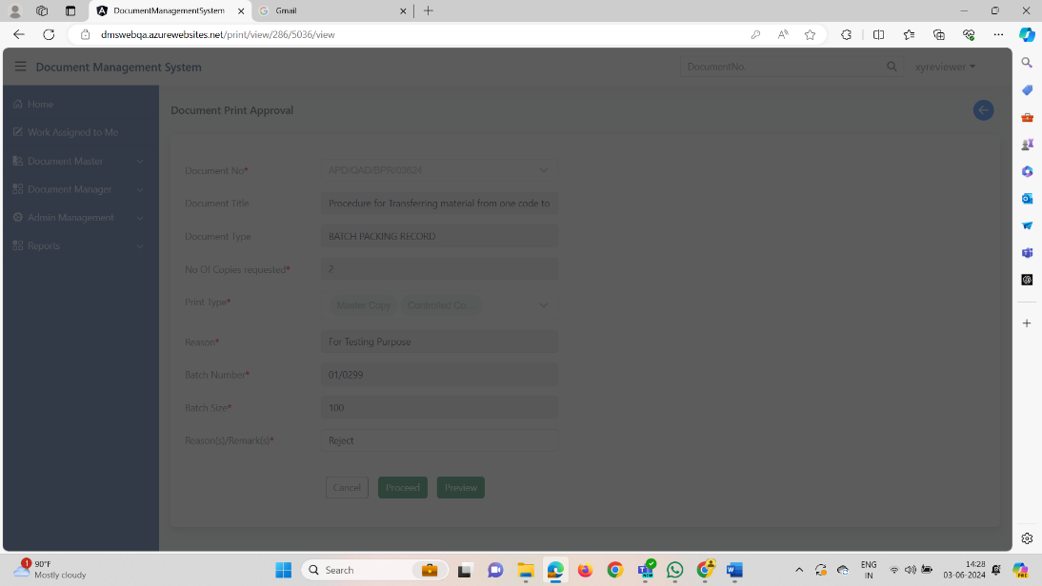
3. By Clicking on Print Symbol in Document Print Request Complete header is not working and Print count is also not updating.  
   **LoginàInitiatoràDocument Managerà Document Print Requestà click on Print symbolàComplete Headeràsubmità No Response  
     
     
   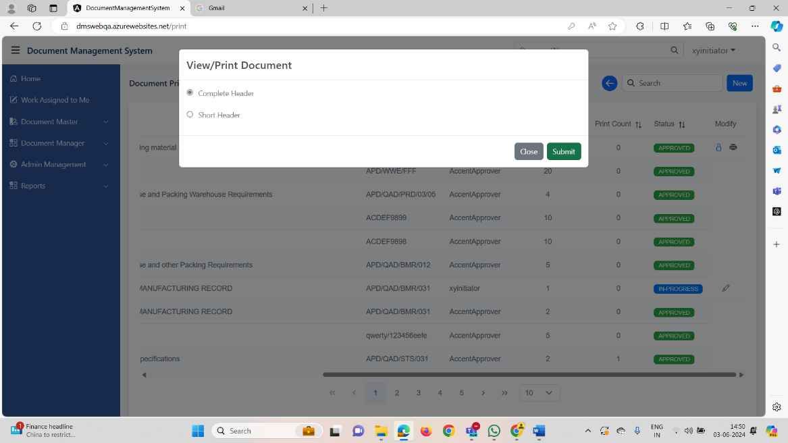  
     
   LoginàInitiatoràDocument Managerà Document Print Requestà click on Print symbolàComplete Headeràsubmità No Responseà Print Count is not Updating  
     
   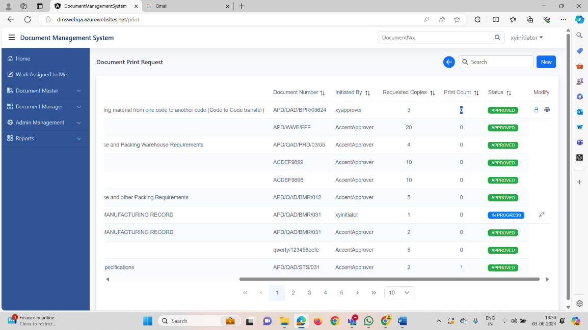**
4. By Clicking on Print Symbol in Document Print Request Short header is working but Print count is not updating.  
   **LoginàInitiatoràDocument Managerà Document Print Requestà click on Print symbolàShort Headeràsubmità Openedà Print Count is not Updating**

**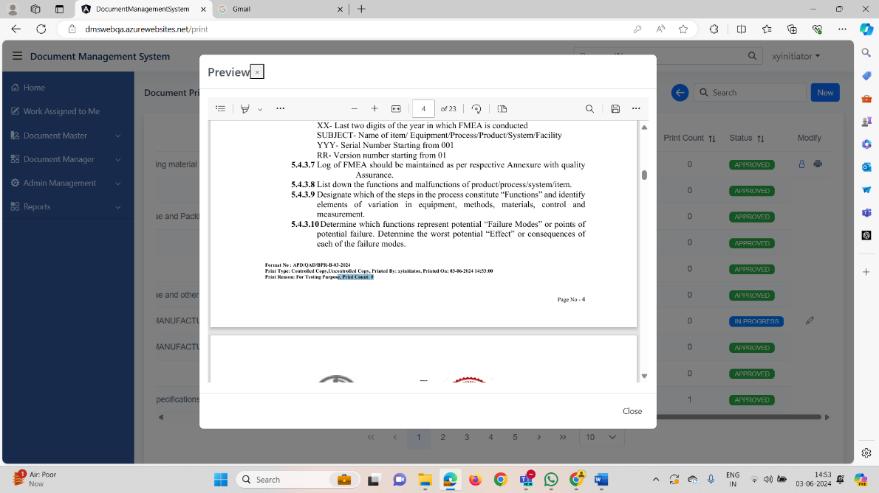  
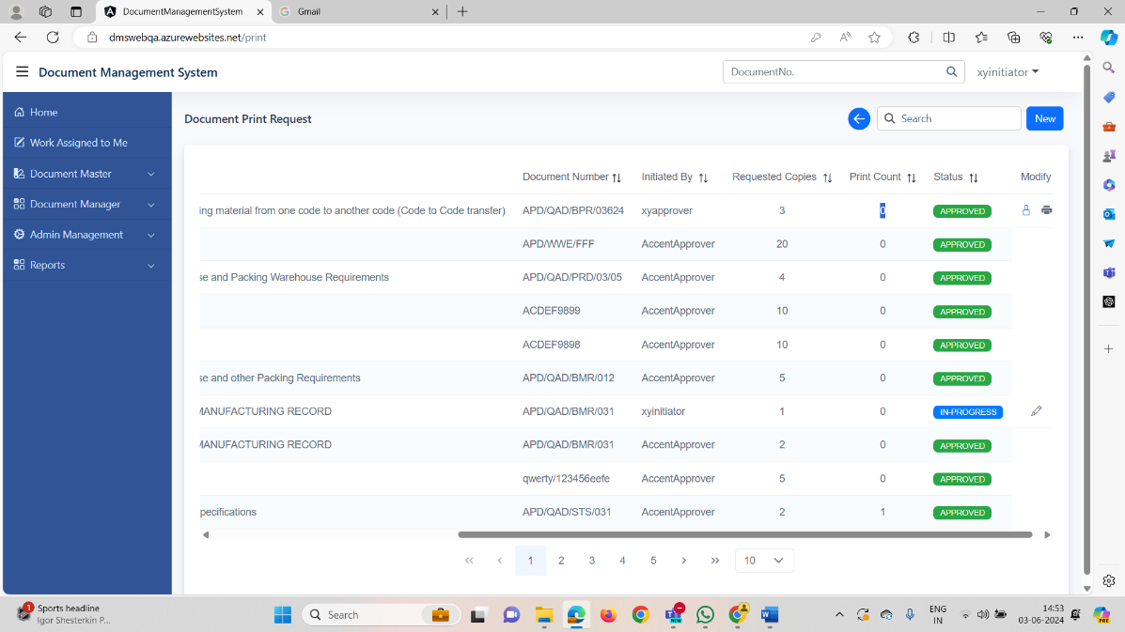**

1. In Document Repository, Complete Header is not Working in Preview  
     
   **LoginàInitiatoràDocument ManageràDocument Repositoryà Click on PreviewàComplete Headerà No response  
   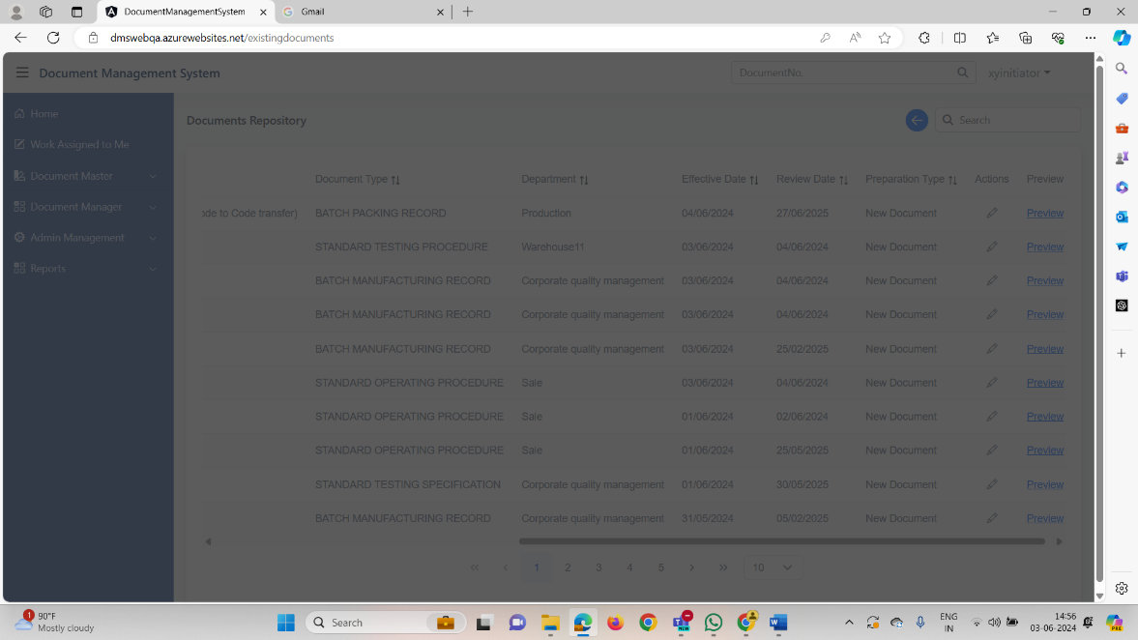**
2. In Document Effective for Reviewer & Approver, Reason(s)/Remarks(s) Filed Initially given text is displaying instead of blank field after returning the Document   
     
   **Loginà Reviewer & Approverà Effective linkà Reason(s)/Remarks(s) Fieldà initially givenà Text is diplaying (After Returning the document)  
     
   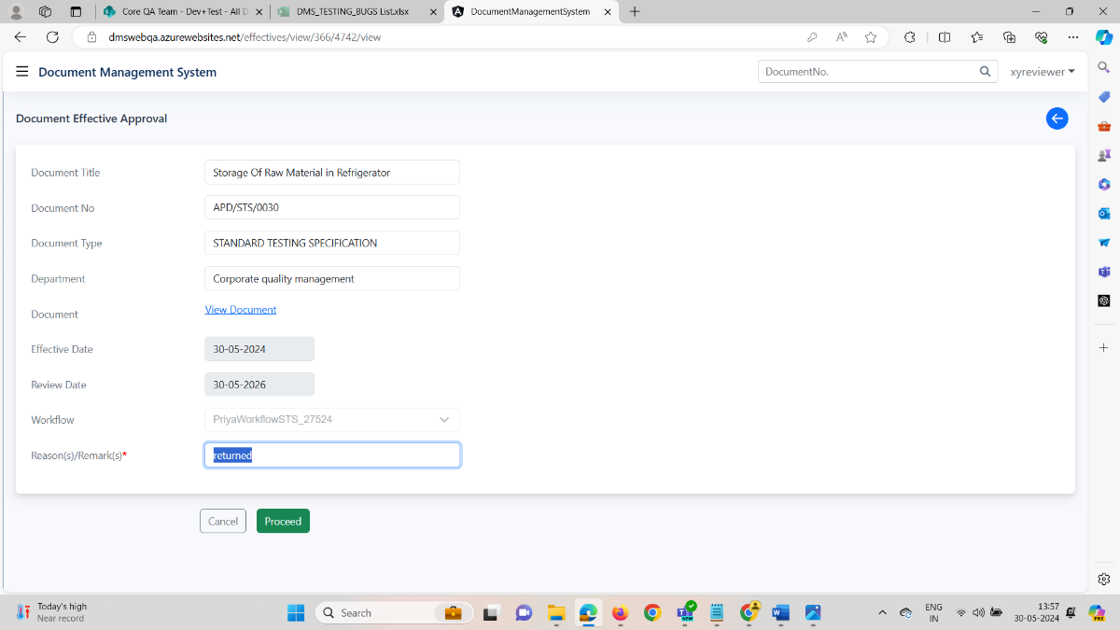**
3. In Preparation & Effective Stages in the initiator, after editing the Returned document, **In progress Status**  is not getting Highlighted  
   **Login**à**Initiator**à**Document Manager**à **Document Preparation**à **Edit the Returned Document**à**In progress**à **not Highlighted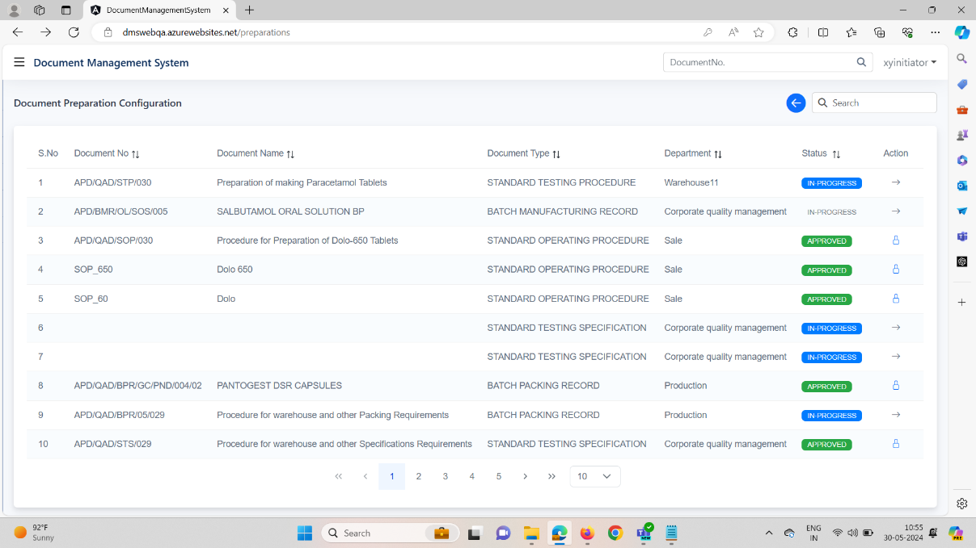 Login**à**Initiator**à**Document Manager**à **Document Effective**à **Edit the Returned Document**à**In progress**à **not Highlighted**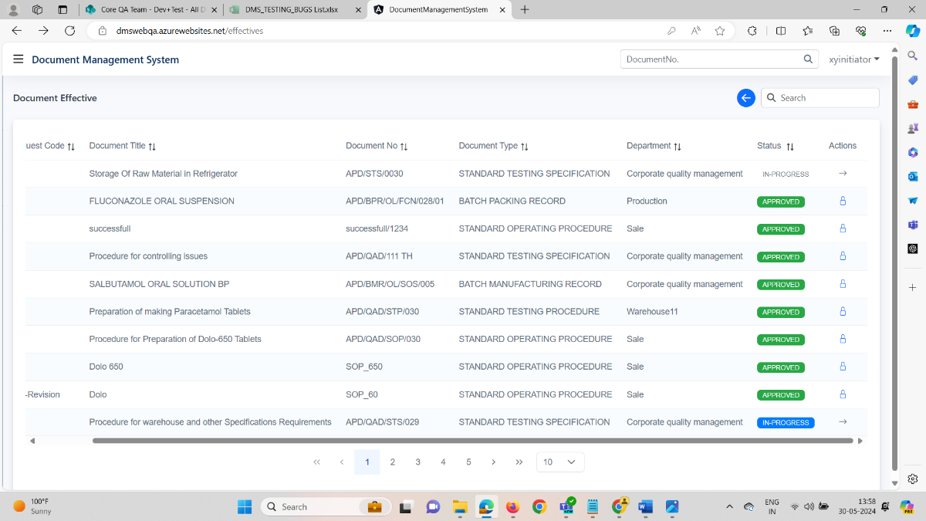  
   14. The Back button is not placed in the correct position in the application(work assigned grid page)  
   **Loginà Reviewerà Work Assigned to Meà Back Buttonà should be placed same as other screens**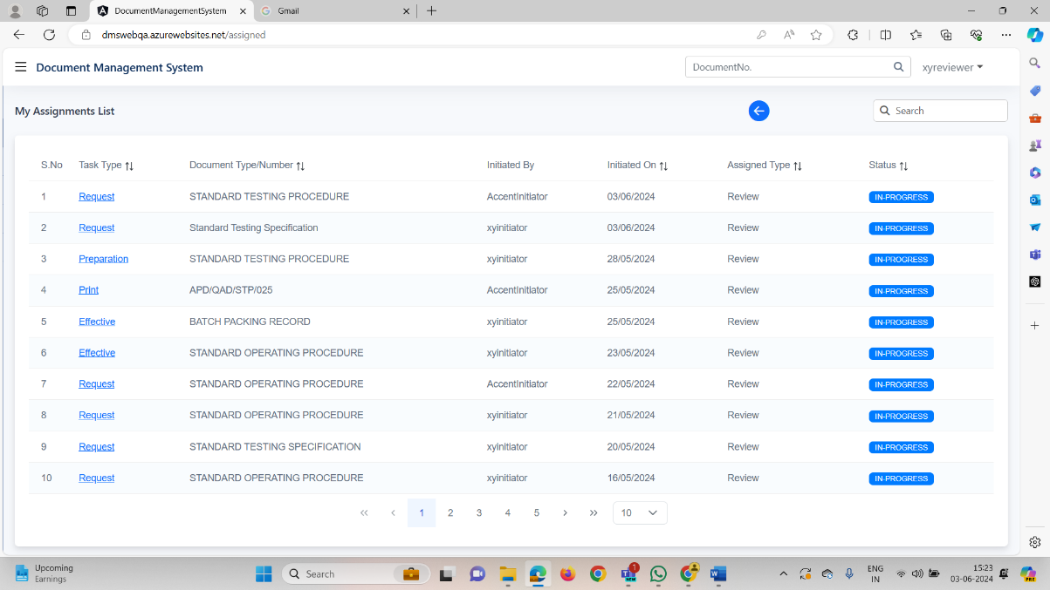  
     
   15. Password expiry notification is not coming for initiator/approver/reviewer - it is only coming for admin but it is showing wrong .  
     
   **LoginàADMINàHomepageàPassword Expiry Notificationà Days Count is not Stable**   
     
   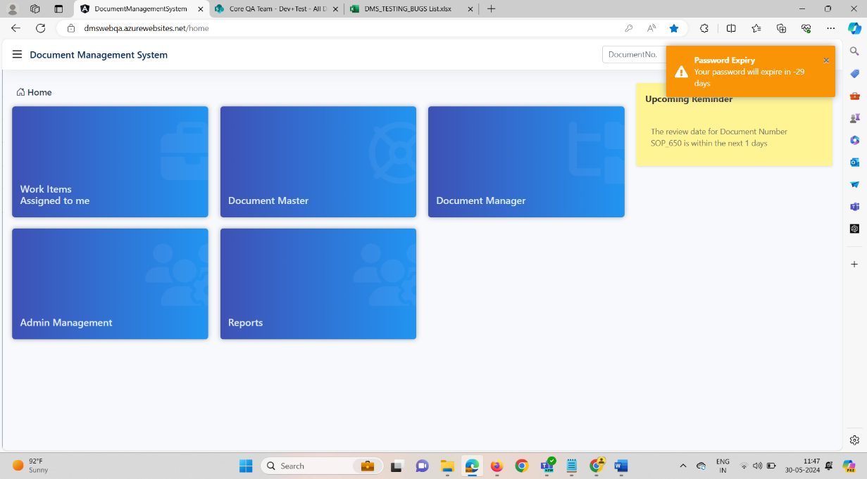

**LoginàInitiatorà Homepage àPassword Expiry Notificationà Absent (as it has to come same as admin with stability)**   
  
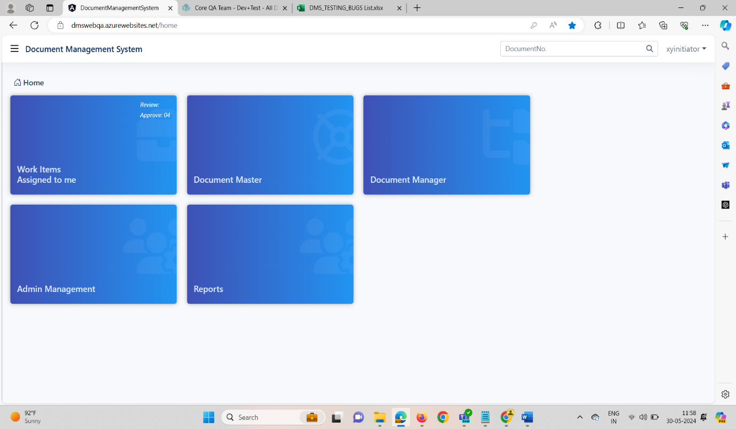

**LoginàReviewerà Homepage àPassword Expiry Notificationà Absent (as it has to come same as admin with stability)**   
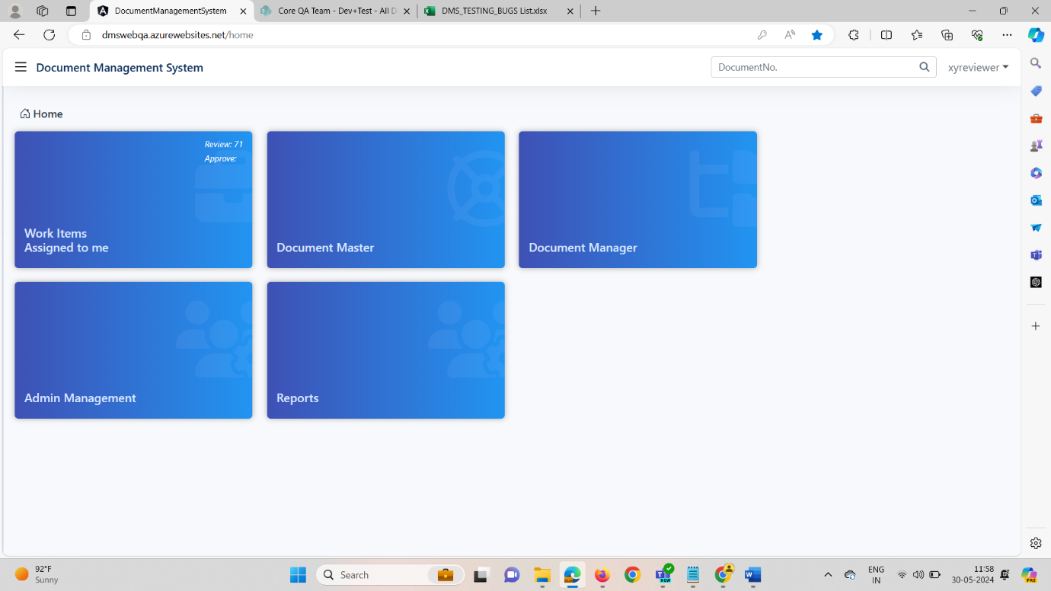

**LoginàApproverà Homepage àPassword Expiry Notificationà Absent (as it has to come same as admin with stability)**

