**Section A (1 Mark Each)**

**A1. Discuss how advancements in printing technology are shaping industries like manufacturing and healthcare.**

**Ans:** Advancements in printing, such as 3D printing, enable customized production in manufacturing and create medical models for healthcare, improving efficiency and patient treatment.

**A2. What is a plotter?**

**Ans:** A plotter is a computer output device that produces precise and large-scale line drawings by moving a pen continuously on paper, unlike printers that print dots.

**A3. Define hardware and mention two examples.**

# **Ans:** The physical components of any electronic device or system that can be seen and touched.

**Example:** CPU and monitor.

**A4. What does ULSI stand for in computer generations?**

**Ans:** ULSI stands for **“Ultra Large Scale Integration”**, a chip technology integrating millions of transistors for powerful modern computers.

**Section B (3 Marks Each)**

**B1. Write the difference between impact and non-impact printers.**

**Ans:**

|  |  |  |
| --- | --- | --- |
| **Feature** | **Impact Printer** | **Non-Impact Printer** |
| ***Printing Mechanism*** | Prints by physically striking an inked ribbon | Prints without touching the paper |
| ***Print Process*** | Uses hammers, pins, or wheels to hit the ribbon | Uses ink spray, laser, or heat to print |
| ***Speed*** | Slower printing speed | Faster printing speed |
| ***Noise Level*** | Noisy due to mechanical striking | Quiet, no mechanical impact |
| ***Print Quality*** | Lower, suitable for text and simple graphics | Higher, produces sharp text and images |
| ***Ink Usage*** | Uses inked ribbons | Uses ink cartridges or toner |
| ***Technology*** | Traditional, old technology | Modern, advanced technology |
| ***Cost*** | Generally cheaper | More expensive |
| ***Maintenance*** | More frequent due to mechanical wear | Less frequent maintenance |
| ***Paper Handling*** | Uses continuous paper sheets | Uses individual sheets of paper |
| ***Suitable For*** | Printing multipart forms and carbon copies | High-quality documents, photos, and fast printing |
| ***Examples*** | Dot matrix, Daisy wheel, Line printers | Inkjet and Laser printers |

**B2. Explain the working of a laser printer and its advantages/disadvantages.**

**Ans:** **LASER Printer:** A laser printer is a non-impact printer, meaning it prints without physically striking the paper. It uses a laser beam to create sharp, high-quality text and images on paper.

**Working**

* The printer works by using static electricity, light, and toner powder (a fine plastic powder) to form the printed image.
* First, a photosensitive drum inside the printer is given a uniform electrostatic charge.
* A laser beam scans the surface of this drum, removing the charge in specific areas to form an invisible image pattern.
* As the drum rotates, it passes by a developer roller which applies toner powder. The toner sticks to the parts of the drum left with charge, making the image visible.
* Then, paper passes under the drum, and the toner is attracted from the drum onto the paper by a stronger electrostatic charge on the paper.
* The paper moves through a fuser unit where heat and pressure melt and bond the toner permanently to the paper.
* Any leftover toner on the drum is cleaned off, and the drum is recharged for the next print cycle.

## Advantages of Laser Printers

* Laser printers print very fast, so they are good when you need to print many pages quickly.
* The print quality is sharp and clear, especially for text and graphics.
* Toner cartridges last longer than ink cartridges, so printing each page costs less in the long run.
* Laser printers are reliable and often require less maintenance.
* They can print on different types of paper, including thicker paper like cards and envelopes.

## Disadvantages of Laser Printers

* Laser printers usually cost more to buy than inkjet printers.
* They are bigger and heavier, so they need more space.
* They use more electricity than inkjet printers, which might increase energy costs.
* Some laser printers can be noisy when printing.
* They are not the best for high-quality photo printing compared to inkjet printers.

**B3. Demonstrate the role of RAM and ROM in a computing system.**

**Ans:** The roles of RAM (Random Access Memory) and ROM (Read-Only Memory) in a computing system are fundamental and distinct, essential for the proper functioning of computers.

**Role of RAM in a Computing System**

RAM acts as the computer's short-term memory. It temporarily stores data and instructions the CPU (Central Processing Unit) needs to access quickly for running applications and processes. Because RAM is very fast compared to other storage forms like SSDs or hard drives, it enables rapid data retrieval and manipulation, which is crucial for smooth operation and multitasking.

When a program or file is opened, its relevant data is moved from the slower permanent storage into RAM, allowing the CPU to fetch and process this data swiftly. RAM's volatile nature means it only holds information while the system is powered on, erasing all data once the computer is shut off. The amount and speed of RAM directly affect a system's performance, with more and faster RAM allowing for quicker execution of tasks, smooth running of resource-intensive applications, and efficient multitasking.

**Role of ROM in a Computing System**

Unlike RAM, ROM is non-volatile memory that permanently stores critical instructions needed for the system’s startup process. It holds firmware such as the BIOS (Basic Input/Output System) or UEFI, which initializes hardware components and boots the operating system when the computer is powered on. Since these instructions must not be altered or lost, ROM is read-only, ensuring these essential programs remain intact and accessible even when the system is off.

In addition to bootstrapping, some embedded systems use ROM to store software that controls device functions, making ROM essential for maintaining the system’s operational instructions and configuration.

**B4. Summarize the major characteristics and timeline of the five generations of computers, highlighting key technology.**

**Ans:**

|  |  |  |  |  |  |
| --- | --- | --- | --- | --- | --- |
| **Generation** | **Period** | **Key Hardware Technology** | **Key Software Technology** | **Key Characteristics** | **Representative Systems** |
| First | 1940–1956 | Vacuum tubes, magnetic drums, punched cards/paper tape | Machine language (binary) | Massive size, unreliable, huge power/AC needs, produced excessive heat, high cost, manual programming, slow, batch processing | ENIAC, EDVAC, UNIVAC I, IBM 701, IBM 650 |
| Second | 1956–1963 | Transistors, magnetic core memory, punched cards | Assembly, early high-level (FORTRAN, COBOL), batch and multiprogramming OS | More reliable, smaller, faster, less heat, less power, more affordable, still large, batch/multi-programmed processing, improved storage | IBM 1620, IBM 7094, UNIVAC 1108, CDC 1604 |
| Third | 1964–1971 | Integrated Circuits (ICs), magnetic tapes/disks | Operating systems, high-level languages (BASIC, ALGOL, PASCAL, COBOL) | Compact, cost reduction, improved speed, less maintenance, lower power, multitasking, time-sharing, support for remote and terminal access | IBM 360 series, Honeywell 6000, PDP-8, PDP-11 |
| Fourth | 1971–1980 | VLSI chips, microprocessors, semiconductor memory; keyboard, monitor, printer | Advanced OS, high-level languages (C, C++, dBASE, various GUIs), networking | Very small, affordable, personal computers, increased speed/power, pipeline processing, no AC requirement, internet concept, networking, reliability boost | IBM PC, Apple II, CRAY-1, STAR 1000, PDP 11 |
| Fifth | 1980–Present | ULSI (Ultra Large-Scale Integration), parallel/AI hardware, mobile & cloud devices | AI, ML, natural language, multimedia | Knowledge-based systems, AI, natural language understanding, parallel & quantum processing, cloud, portable & consumer-friendly, multimedia, robotics | Desktops, laptops, tablets, smartphones, modern AI/devices |

**B5. Can you explain how CRT technology worked in older computer screens?**

**Ans:** **CATHODE RAY TUBE (CRT)** **MONITORS**

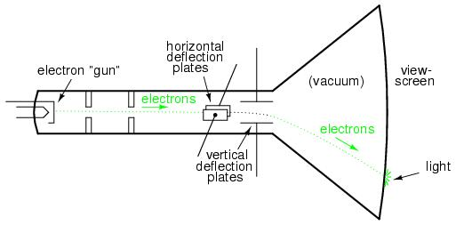

* **CRT** stands for Cathode Ray Tube.
* Most computer monitors are based on Cathode Ray Tube (CRT) technology.
* The basic operation of these tubes is similar to that in television sets.
* CRT monitor contains cathode, electron gun, focusing system, deflection plates & phosphor coated screen.
* **Electron gun**: Electron gun generates negatively charged electrons. Electron gun consists of cathode and heating filament. When heat is supplied to cathode by a heating filament its electron become loose and gets emitted from cathode surface.
* **Focusing system:** The purpose of focusing system in CRT is to force the electron beam to converge into spots and travel in straight line.
* **Deflection System:** The purpose of deflection system is to change the direction of electron beam so that electron beam can be made to strike at different locations.
* **Phosphor coated screen:** The screen is coated with phosphorus crystals called phosphors. These phosphor crystals emit small spots of light when the electron beam strikes on them.

**Advantages of CRT display**

* Produce more colors.
* Price is lower than LCD & Plasma.
* High contrast ratio.
* Can easily increase brightness of monitor by reflecting the light.

**Disadvantages of CRT display**

* High power consumed.
* Heavy to pick up and carry.
* Large space required.

**Section C (3.5 Marks Each)**

**C1. Could you explain the concept of a computer, outlining fundamental characteristics and core operational principles in detail?**

**Ans:** **Definition:**

A computer is an electronic device that can **accept data (input)**, process it according to specific instructions, store the results, and **produce output (information)**.

**The main task that a computer does are:**

* **Input:** Taking in data and instructions.
* **Process:** Working on the data according to the instructions.
* **Output:** Giving out the final results or information.

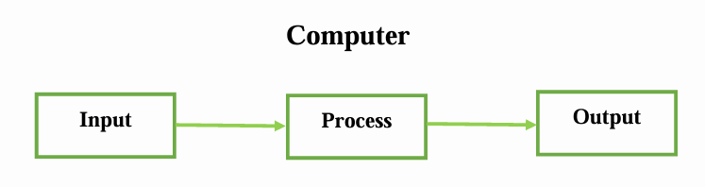

**CHARACTERISTICS OF COMPUTER**

**Some important characteristics of a computer are as follow:**

* **Automatic:**
* Computers work automatically without human intervention once started on a task.
* They carry on processing until the task is completed.
* However, computers cannot start themselves; they need to be switched on by a user.
* They follow instructions stored inside them as programs, which tell them how to perform specific jobs.
* **Accuracy:**
  + Computers provide very high accuracy in their results.
  + The level of accuracy depends on the design of the computer.
  + Any errors produced are usually due to incorrect input or human mistakes, not because of the computer itself.
* **Speed:**
  + Computers are extremely fast and can perform in seconds what might take a human year.
  + Their speed is measured in microseconds (millionths of a second).
  + Powerful computers can perform billions of simple arithmetic operations every second.
* **Diligence:**
  + Unlike humans, computers do not get tired, bored, or lose concentration.
  + They can work continuously for hours without making mistakes.
  + Even if asked to perform millions of calculations, a computer will maintain the same speed and accuracy throughout.
* **Versatility:**
  + Computers are highly versatile and can perform a wide range of tasks.
  + For example, one moment they might process exam results, next they can prepare electricity bills, and then help in managing office correspondence—all quickly and efficiently.
* **Memory Power (Storage Capacity):**
  + Computers can store and remember huge amounts of data because of their large storage capacity.
  + Information can be saved for a long time and recalled whenever needed.
  + Even after many years, the recalled data is as accurate as it was when stored.
* **No Intelligence (No IQ):**
  + Computers do not have intelligence or decision-making ability.
  + Their IQ is zero; they cannot think or act on their own.
  + They perform only the instructions given by users in the correct sequence.
  + Computers cannot make decisions by themselves.

**Core Operational Principles**

**Input:** The system accepts raw data and instructions through input devices like keyboards, mice, or sensors.

**Processing:** The Central Processing Unit (CPU) executes instructions and processes data. It includes the Arithmetic Logic Unit (ALU) for calculations and logical operations, control units to manage timing and control signals, and registers for temporary storage of data during processing.

**Memory Management:** Data and programs currently in use are temporarily stored in RAM for quick access, while permanent instructions such as boot programs are held in ROM.

**Output:** Processed data is presented to the user via output devices like monitors and printers.

**Storage:** Data that needs to be retained beyond the immediate task is saved on storage devices like hard drives or SSDs.

**Software Control:** The computer operates based on software programs, which are sequences of instructions that direct hardware how to perform specific tasks. Programs can range from simple scripts to complex operating systems.

**C2. Differentiate between hardware and software in tabular form.**

**Ans:**

|  |  |  |
| --- | --- | --- |
| **Feature** | **Hardware** | **Software** |
| Definition | Physical parts of a computer that you can touch | Programs and instructions that tell hardware what to do |
| Tangibility | Tangible (can be seen and touched) | Intangible (cannot be touched or seen physically) |
| Function | Performs data processing and supports software | Controls hardware and performs specific tasks |
| Examples | Keyboard, mouse, monitor, CPU, printer | Operating system, MS Word, web browsers |
| Dependency | Cannot work without software | Cannot work without hardware |
| Durability | Can wear out or get damaged over time | Does not wear out but can become outdated |
| Development | Manufactured physically | Developed by programming and coding |
| Repair/Replacement | Physically repaired or replaced | Reinstalled or updated |
| Effect of Viruses | Not affected by viruses | Can be infected by viruses |
| Operation Level | Works at the machine level | Works at the logical/instruction level |

**C3. Explain how cache memory improves system performance efficiency.**

**Ans:** Cache memory significantly improves system performance efficiency by acting as a small, very fast type of memory located close to the CPU that stores copies of frequently used data and instructions. Its main role is to reduce the average time the CPU takes to access data from the slower main memory (RAM), thereby speeding up processing considerably.

Cache memory works on the principle of locality of reference, which means the CPU is likely to reuse data or instructions it accessed recently or data located near that recently accessed data. By keeping such data close to the processor, cache minimizes the need for the CPU to access the slower RAM repeatedly, which reduces data access latency. When the CPU needs data, it first searches in the cache, if the data is found (a cache hit), it is accessed immediately with minimal delay. If not found (a cache miss), the CPU must fetch data from the slower main memory and then copy it to the cache for future use.

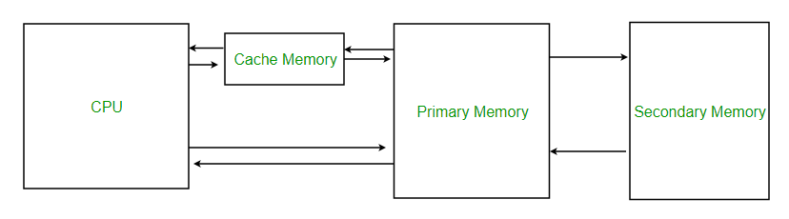

Key features of cache memory that contribute to system efficiency include its speed (much faster than RAM), its proximity to the CPU (often integrated directly into the CPU chip), and its function to temporarily hold data likely to be used soon. This temporary storage reduces the time the CPU spends waiting for data, allowing it to process instructions more quickly and efficiently.

**Cache memory is organized in levels:**

* **L1 Cache:** The smallest and fastest, located inside each CPU core, storing the most immediately needed data.
* **L2 Cache:** Larger than L1, either inside or near the core, shared between cores depending on architecture.
* **L3 Cache:** The largest, located outside the CPU cores but shared among them, supporting L1 and L2 caches.