PROJECT REPORT
Breast Cancer Diagnosis Prediction
Classifying tumours as malignant or benign using machine learning
Submitted by: YourName
September 2026

1. Abstract
Early and accurate classification of breast tumours as benign or malignant supports timely treatment decisions. This project builds a machine learning classifier on the Breast Cancer Wisconsin (Diagnostic) dataset, which contains 569 samples described by 30 numeric features computed from digitised images of fine-needle aspirates. Five classifiers (Logistic Regression, K-Nearest Neighbours, Support Vector Machine, Random Forest and Gradient Boosting) were compared with 5-fold stratified cross-validation, and three of them were tuned with grid search. The selected model, an RBF-kernel SVM, reached an accuracy of 97.4%, precision of 100.0%, recall of 92.9% and ROC-AUC of 0.993 on a held-out test set of 114 samples. The project is intended for educational purposes and is not a clinical tool.

2. Introduction

2.1 Problem Statement
Given a set of measurements describing the cell nuclei in a breast mass, predict whether the mass is malignant (cancerous) or benign. This is a binary classification problem in which the two kinds of error have very different costs: a missed cancer (false negative) can delay treatment, while a false alarm (false positive) leads to further testing.

2.2 Objectives
- Explore and understand the structure of the dataset and the relationships between its features.
- Build a leakage-free preprocessing and modelling pipeline.
- Compare several classification algorithms fairly using cross-validation.
- Tune the most promising models and evaluate the final choice once on unseen data.
- Identify which measurements contribute most to the predictions.

3. Dataset Description
The Breast Cancer Wisconsin (Diagnostic) dataset is available from the UCI Machine Learning Repository (https://archive.ics.uci.edu/dataset/17/breast+cancer+wisconsin+diagnostic) and is also bundled with scikit-learn. Features are computed from a digitised image of a fine-needle aspirate of a breast mass and describe the characteristics of the cell nuclei present in the image.
Property | Value
Number of samples | 569
Number of features | 30 (all numeric)
Target | Diagnosis: malignant or benign
Class balance | 37.3% malignant, 62.7% benign
Missing values | None
Duplicate rows | None

Ten base measurements are computed for each nucleus: radius, texture, perimeter, area, smoothness, compactness, concavity, concave points, symmetry and fractal dimension. For each one the dataset provides the mean, the standard error and the "worst" value (the mean of the three largest values), giving 30 features in total. In scikit-learn the target is encoded as 0 for malignant and 1 for benign. In this project it is flipped so that malignant is the positive class (1), which makes recall and precision refer to the cancer class directly.

4. Methodology

4.1 Tools and Environment
The project was implemented in Python using a Jupyter Notebook. The main libraries are pandas and NumPy for data handling, scikit-learn for modelling and evaluation, Matplotlib and Seaborn for visualisation, and joblib for saving the trained model. The random seed is fixed at 42 so that results are reproducible.

4.2 Data Splitting and Preprocessing
The data was divided into a training set of 455 samples (80%) and a test set of 114 samples (20%) using a stratified split, which preserves the class proportions in both parts. Features were standardised (zero mean, unit variance) with StandardScaler. The scaler is part of a scikit-learn Pipeline together with the classifier, so during cross-validation it is fitted only on each training fold. This prevents information from the validation data leaking into training.

4.3 Models
- Logistic Regression: a linear, interpretable baseline.
- K-Nearest Neighbours: classifies a sample by the majority class among its closest neighbours.
- Support Vector Machine (RBF kernel): finds a maximum-margin boundary in a non-linear feature space.
- Random Forest: an ensemble of decision trees trained on random subsets of the data and features.
- Gradient Boosting: trees built sequentially, each correcting the errors of the previous ones.

4.4 Model Selection and Tuning
All five models were first scored with 5-fold stratified cross-validation on the training data. Logistic Regression, SVM and Random Forest were then tuned with GridSearchCV, optimising the F1 score of the malignant class. The final model was chosen using cross-validated F1 only. The test set was not used for any selection decision and was evaluated once at the end.

4.5 Evaluation Metrics
- Accuracy: share of all predictions that are correct.
- Precision: of the tumours predicted malignant, the share that truly are.
- Recall (sensitivity): of the truly malignant tumours, the share that the model detects.
- F1 score: the harmonic mean of precision and recall.
- ROC-AUC: how well the predicted probabilities rank malignant above benign cases, regardless of threshold.

5. Exploratory Data Analysis
The dataset contains no missing values or duplicates. The classes are moderately imbalanced, with 37.3% of samples malignant, which is why stratified splitting and recall/F1 are used alongside accuracy.
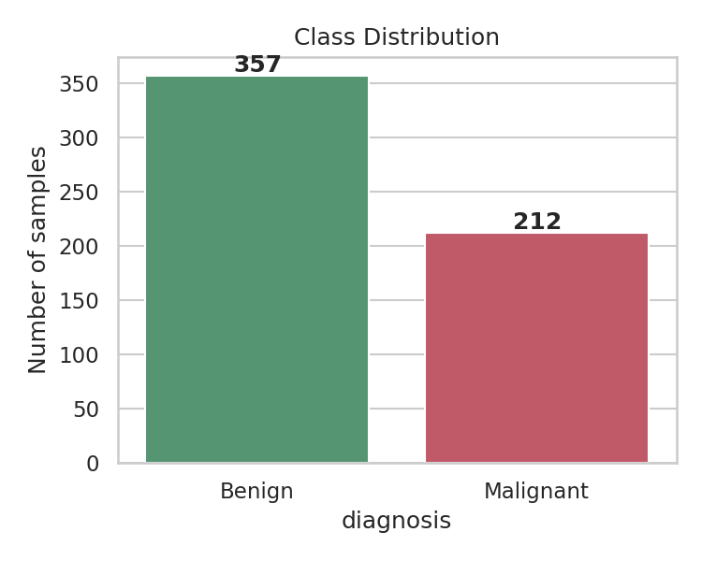
Figure 1: Class distribution of the dataset
Distributions of the main size and shape features differ visibly between the two classes. Malignant tumours tend to have larger radius, perimeter and area and higher concavity and concave-point values, with only limited overlap.
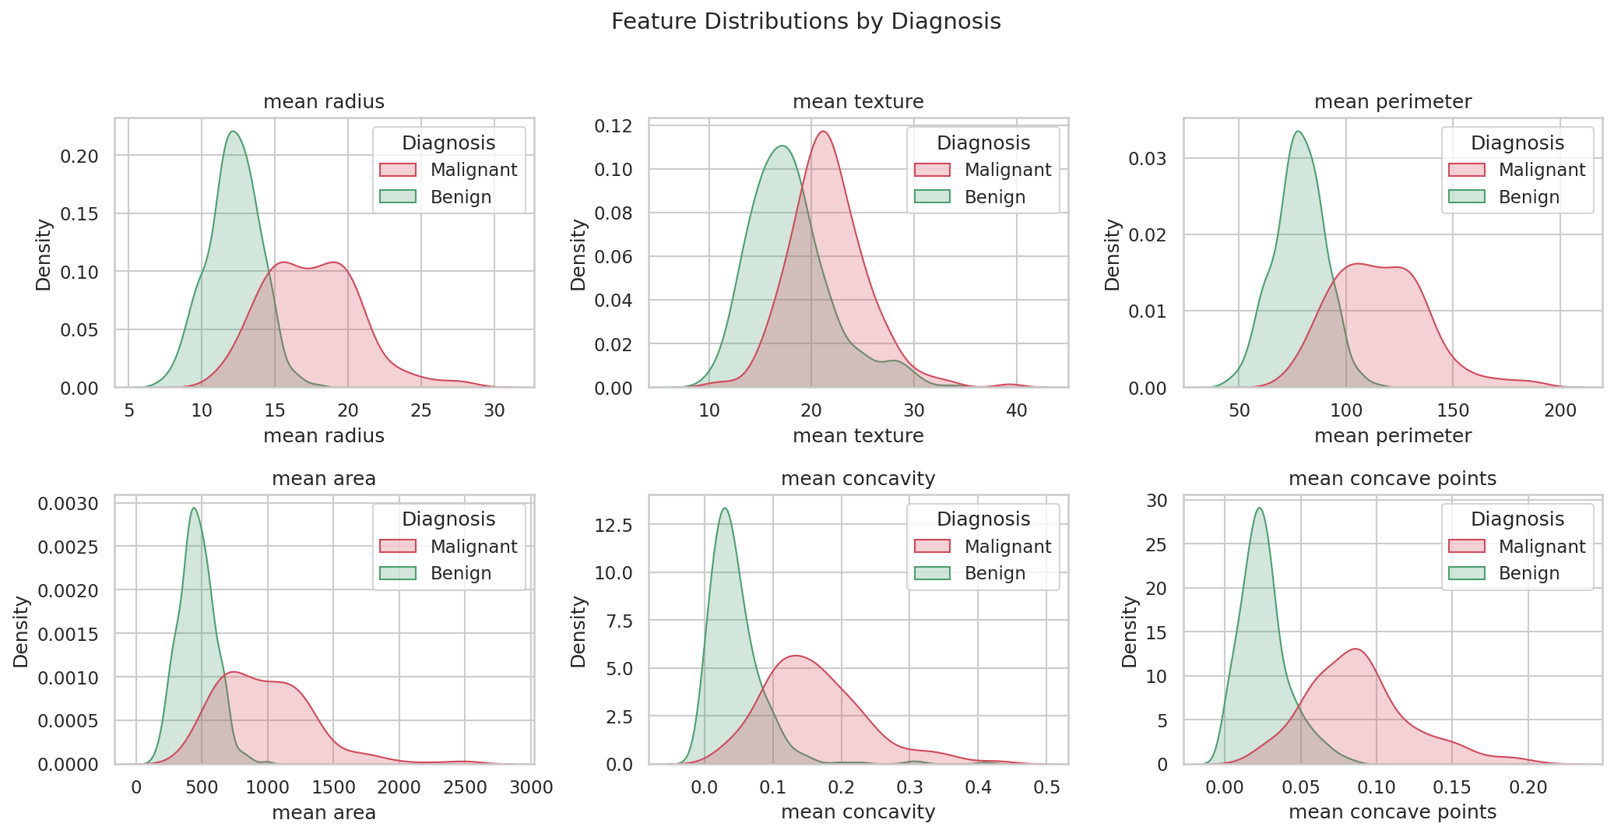
Figure 2: Distribution of selected features by diagnosis
The correlation matrix shows that many features are strongly related. Radius, perimeter and area are almost perfectly correlated, since they all measure nucleus size. This redundancy is one reason regularised models and tree ensembles work well on this dataset.
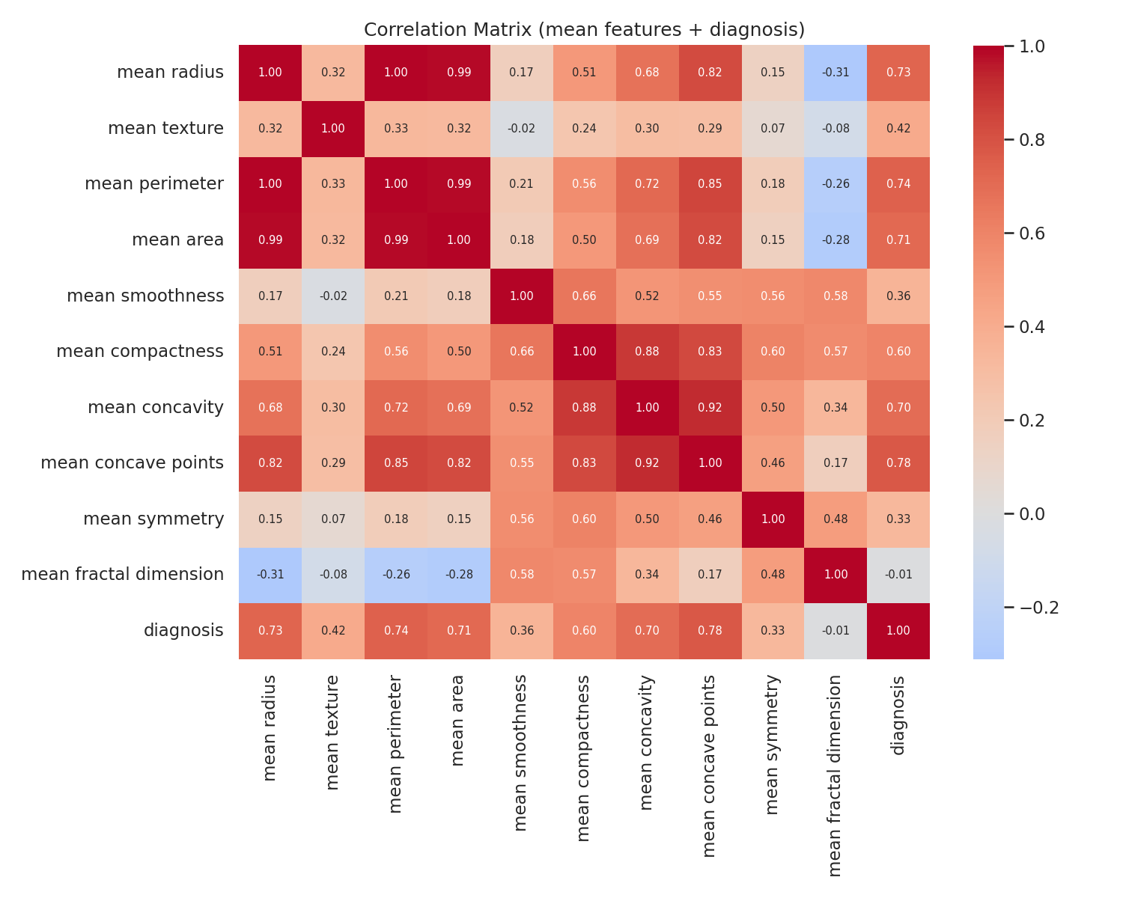
Figure 3: Correlation matrix of the mean features and the diagnosis

6. Results

6.1 Baseline Model Comparison
Table 1 shows the mean 5-fold cross-validation scores on the training set. All five models perform well, with accuracy between 96% and 97.4%. Logistic Regression and the SVM lead on F1, while Random Forest is slightly behind.
Model | Accuracy | Precision | Recall | F1 | ROC-AUC
Logistic Regression | 0.9736 | 0.9771 | 0.9529 | 0.9640 | 0.9958
SVM (RBF) | 0.9714 | 0.9769 | 0.9471 | 0.9610 | 0.9949
Gradient Boosting | 0.9670 | 0.9646 | 0.9471 | 0.9553 | 0.9908
KNN | 0.9648 | 0.9875 | 0.9176 | 0.9510 | 0.9871
Random Forest | 0.9604 | 0.9584 | 0.9353 | 0.9461 | 0.9880
Table 1: Cross-validated baseline performance (training set)
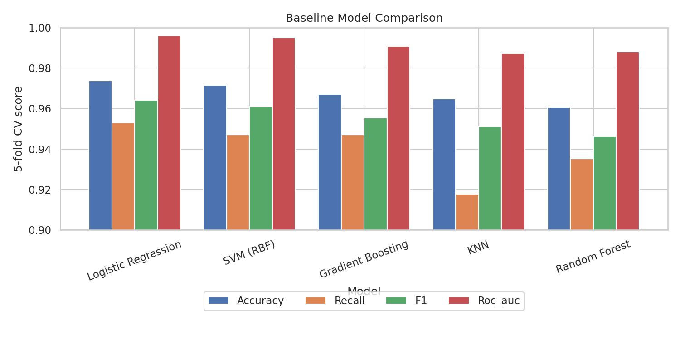
Figure 4: Baseline model comparison

6.2 Hyperparameter Tuning
Grid search improved the cross-validated F1 for the SVM and Random Forest. The SVM obtained the highest tuned score and was selected as the final model.
Model | Best parameters | CV F1
SVM (RBF) | C = 10, gamma = scale | 0.9674
Logistic Regression | C = 1 | 0.9640
Random Forest | n_estimators = 200, max_depth = 6, min_samples_leaf = 1 | 0.9516
Table 2: Best hyperparameters and cross-validated F1

6.3 Test Set Performance
The selected SVM was evaluated on the 114 held-out samples. It reached an accuracy of 97.4%, a precision of 100.0%, a recall of 92.9%, an F1 of 0.963 and a ROC-AUC of 0.993.
Model | Accuracy | Precision | Recall | F1 | ROC-AUC
SVM (RBF) | 0.9737 | 1.0000 | 0.9286 | 0.9630 | 0.9927
Logistic Regression | 0.9649 | 0.9750 | 0.9286 | 0.9512 | 0.9960
Random Forest | 0.9649 | 1.0000 | 0.9048 | 0.9500 | 0.9947
Table 3: Test set performance of the tuned models (selected model in the first row)
 | Predicted benign | Predicted malignant
Actual benign | 72 | 0
Actual malignant | 3 | 39
Table 4: Confusion matrix of the selected model on the test set
The model produced 0 false positives and 3 false negatives. All 72 benign tumours were classified correctly, and 39 of the 42 malignant tumours were detected.
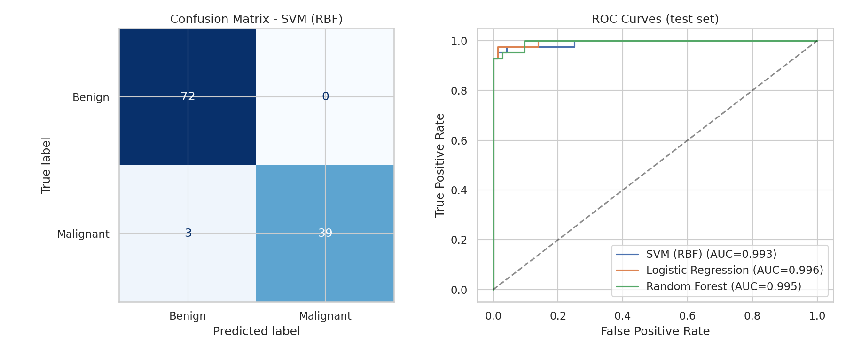
Figure 5: Confusion matrix and ROC curves on the test set

6.4 Feature Importance
Permutation importance on the test set (the drop in F1 when a feature is shuffled) ranks worst texture, worst concavity and mean concavity as the most influential features for the SVM, followed by worst concave points and worst smoothness. The individual values are small because many features are correlated: when one is shuffled, the others still carry much of the same information.
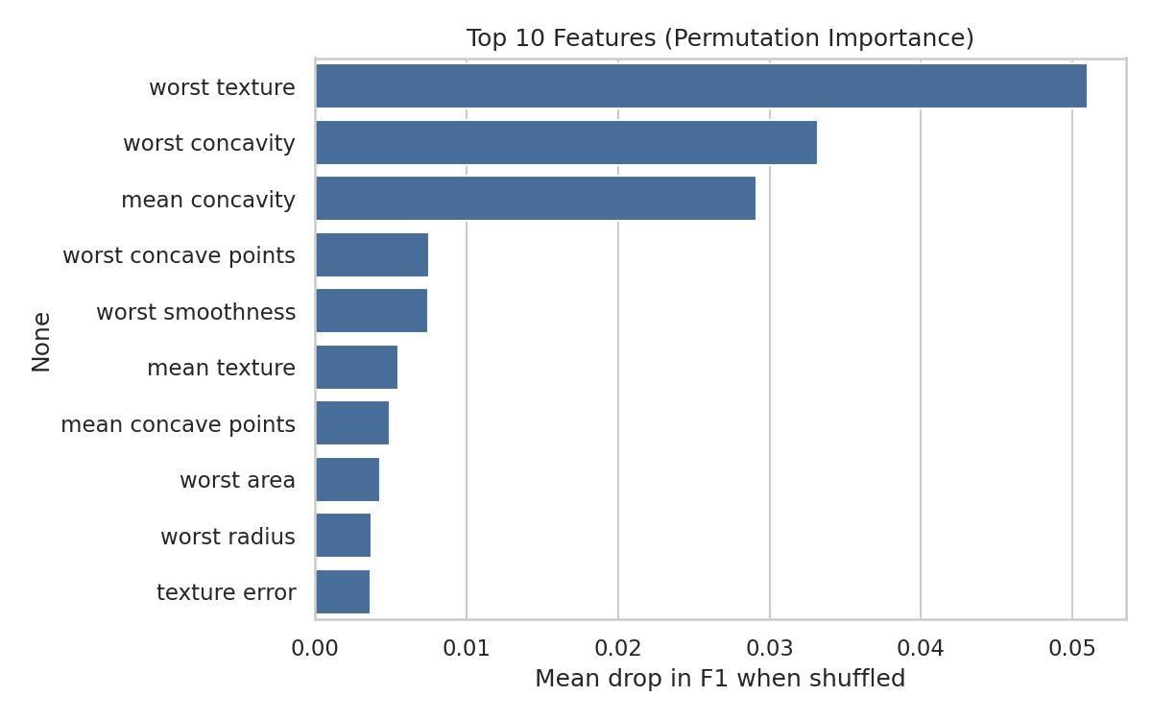
Figure 6: Top 10 features by permutation importance

7. Discussion
Every model reached at least 96% cross-validated accuracy, so on this dataset the choice of algorithm matters less than careful preprocessing. Differences between the top models are small: the SVM and Logistic Regression differ by less than one percentage point in cross-validated F1. With only 114 test samples, a single prediction changes accuracy by about 0.9 percentage points, so the ranking of the top models on the test set should not be over-interpreted. For example, Logistic Regression scored a slightly higher ROC-AUC on the test set than the SVM, but the SVM was selected in advance on cross-validation results, which is the correct procedure.
The most important weakness is the recall of 92.9%. In a screening setting, missing 3 of 42 cancers is more serious than the 0 false alarms the model produced. Because the model has no false positives, there is room to lower the decision threshold and trade some precision for higher recall.

8. Limitations and Future Work
- The dataset is small (569 samples), so all estimates have noticeable variance. Repeated or nested cross-validation would give more stable estimates.
- Only one train/test split was used. Results could differ slightly with another split.
- The data comes from one source and has not been validated externally on other hospitals, devices or populations.
- Threshold tuning, probability calibration and cost-sensitive learning could be used to favour recall.
- Feature selection or dimensionality reduction (for example PCA) could be explored to reduce redundancy among correlated features.
- Model explanations such as SHAP could support clinical interpretability.

9. Conclusion
This project built and evaluated a complete machine learning workflow for breast tumour classification. After standardising the features and comparing five algorithms with cross-validation, an RBF-kernel SVM was selected and reached 97.4% accuracy and a ROC-AUC of 0.993 on unseen data, with no false positives and 3 missed malignant cases. The results show that standard models can separate the two classes very well on this dataset, while also highlighting that recall on the malignant class needs the most attention before any real-world use. The system is a learning exercise and must not be used for medical diagnosis.

10. References
- Wolberg, W. H., Street, W. N., & Mangasarian, O. L. (1995). Breast Cancer Wisconsin (Diagnostic) [Dataset]. UCI Machine Learning Repository. https://archive.ics.uci.edu/dataset/17/breast+cancer+wisconsin+diagnostic
- Pedregosa, F. et al. (2011). Scikit-learn: Machine Learning in Python. Journal of Machine Learning Research, 12, 2825-2830.
- Hunter, J. D. (2007). Matplotlib: A 2D graphics environment. Computing in Science & Engineering, 9(3), 90-95.
- McKinney, W. (2010). Data structures for statistical computing in Python. Proceedings of the 9th Python in Science Conference.

Appendix: How to Run the Project
Install the dependencies with pip install -r requirements.txt, then open YourName_BreastCancerPrediction.ipynb in Jupyter and choose Restart & Run All. The notebook creates the figures folder, the trained model file (breast_cancer_model.joblib) and a results.json summary. Full instructions are given in README.md.

