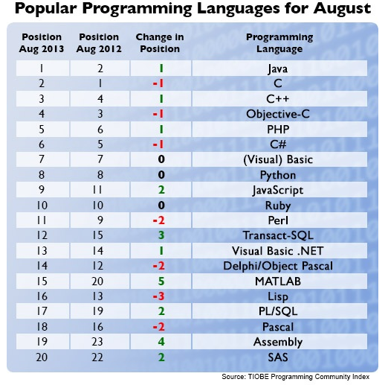

**Short information about the programming languages:**

1. **Java**

Java is a computer programming language that is concurrent, class-based, object-oriented, and specifically designed to have as few implementation dependencies as possible. It is intended to let application developers "write once, run anywhere" (WORA), meaning that code that runs on one platform does not need to be recompiled to run on another. Java applications are typically compiled to bytecode (class file) that can run on any Java virtual machine (JVM) regardless of computer architecture. Java is, as of 2012, one of the most popular programming languages in use, particularly for client-server web applications, with a reported 9 million developers.

1. **C**

C is one of the most widely used programming languages of all time, and C compilers are available for the majority of available computer architectures and operating systems.

Many later languages have borrowed directly or indirectly from C, including C#, D, Go, Rust, Java, JavaScript, Limbo, LPC, Objective-C, Perl, PHP, Python, Verilog (hardware description language) and Unix's C shell. The most pervasive influence on these languages (excluding Python) has been syntactical, and they tend to combine the recognizable expression and statement syntax of C with underlying type systems, data models, and semantics that can be radically different. C++ and Objective-C started as compilers that generated C code; C++ is currently nearly a superset of C, while Objective-C is a strict superset of C.

1. **C++**

C++ (pronounced see plus plus) is a programming language that is general purpose, statically typed, free-form, multi-paradigm and compiled. It is regarded as an intermediate-level language, as it comprises both high-level and low-level language features. Developed by Bjarne Stroustrup starting in 1979 at Bell Labs, C++ was originally named C with Classes, adding object oriented features, such as classes, and other enhancements to the C programming language. The language was renamed C++ in 1983, as a pun involving the increment operator.

1. **Objective – C**

Objective-C is a general-purpose, object-oriented programming language that adds Smalltalk-style messaging to the C programming language. It is the main programming language used by Apple for the OS X and iOS operating systems and their respective APIs, Cocoa and Cocoa Touch.

Originally developed in the early 1980s, it was selected as the main language used by NeXT for its NeXTSTEP operating system, from which OS X and iOS are derived.[1] Generic Objective-C programs that do not use the Cocoa or Cocoa Touch libraries, or using parts that is ported or reimplemented for other systems can also be compiled for any system supported by GCC or Clang.

1. **PHP**

PHP is a server-side scripting language designed for web development but also used as a general-purpose programming language. PHP is now installed on more than 244 million websites and 2.1 million web servers. Originally created by Rasmus Lerdorf in 1995, the reference implementation of PHP is now produced by The PHP Group. While PHP originally stood for Personal Home Page, it now stands for PHP: Hypertext Preprocessor, a recursive acronym.

PHP code is interpreted by a web server with a PHP processor module, which generates the resulting web page: PHP commands can be embedded directly into an HTML source document rather than calling an external file to process data. It has also evolved to include a command-line interface capability and can be used in standalone graphical applications.

1. **C#**

C# (pronounced see sharp) is a multi-paradigm programming language encompassing strong typing, imperative, declarative, functional, procedural, generic, object-oriented (class-based), and component-oriented programming disciplines. It was developed by Microsoft within its .NET initiative and later approved as a standard by Ecma (ECMA-334) and ISO (ISO/IEC 23270:2006). C# is one of the programming languages designed for the Common Language Infrastructure.

C# is intended to be a simple, modern, general-purpose, object-oriented programming language.[5] Its development team is led by Anders Hejlsberg. The most recent version is C# 5.0, which was released on August 15, 2012.