Team “Albert Camus”

**Team members:**

* **Filip Sarbinovski (student username:** [**fsrbinovski**](http://telerikacademy.com/Users/Tsigularov)**)**
* **Vasil Bonev (student username:** [**V45370**](http://telerikacademy.com/Users/V45370)**)**
* **Dzhenko Penev (student username:** [**dzhenko**](http://telerikacademy.com/Users/veke_D)**)**

**Did not participate:**

**Vladimir Yankov (student username:** [**Rimida**](http://telerikacademy.com/Users/StefanPopgeorgiev)**lv)**

**Lybomir Papazov (student username:** [**lpapazow**](http://telerikacademy.com/Users/S.Zoichkin)**)**

**Deyan Valkanov (student username:** [**valkanov**](http://telerikacademy.com/Users/Gornakov)**)**

Academy RPG

# Overview

AcademyRPG is a Role Playing Game about our experience as students in Telerik Academy. It is a general representation of what students need to do in order to successfully graduate(beat the game).

# Players

Every student is a unique player in the game. The player has different types of knowledge, time and items. The player can move around the map and can solve riddles, do homeworks or attend lectures and he is rewarded with knowledge or items. The player also has a stash where he treasure up items.

# Knowledge

There are 3 base knowledge types: Desktop and Mobile (DaM), Quality Assurance (QA), Web Developer (WD). Each knowledge type can be obtained from corresponding subjects.

For example: In order to gain DaM knowledge you need to complete subjects “C#1”,”C#2” and “OOP”.

# Subjects

One subject has a set of homeworks, lectures, presentations and an exam. In order to proceed to the next subject you must solve the exam for the previous one. In order to solve and exam you have to cover two things – solve enough homeworks, so you can attend the exam and have enough knowledge to pass the exam itself.

# Time

Every time you watch lecture or presentation you lose time. A better player will win the game (take all exams) in less amount of time.

# NPCs

There are several NPC (Non-player character) in the game. Every NPC holds different subjects. For each type of knowledge there is a unique NPC. The player’s goal is to talk to each NPC and master every subject which the NPC contains. There is a special NPC (named Nakov) who gives you riddles which you need to solve. Every riddle has a reward.

# Rewards

Rewards are different items. Once you obtain an item you choose if you want to equip it or not. The main benefit of the rewards is that they give you bonus knowledge. The items can be: paper, pen, book or a laptop. Each item has a level (Basic, Advanced, Expert). Depending on how superior one item is the more knowledge bonus you get from doing homeworks.

# Class diagram

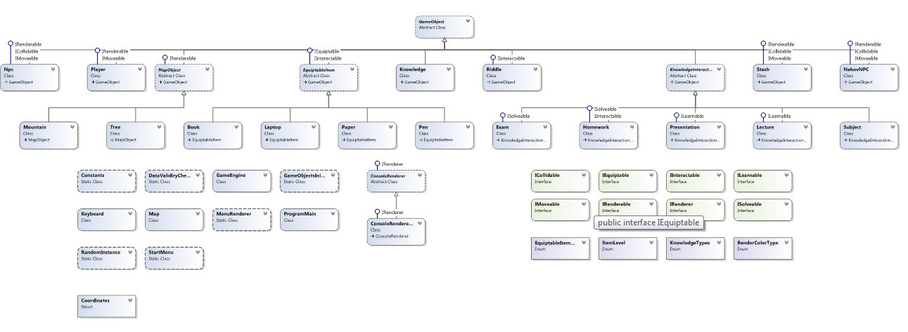

Abstract classes – 5

Static classes – 6

Classes – 23

Interfaces – 8

Enumerations- 4

# Git repository URL:

# https://albertcamus.codeplex.com/