Assignment 2

# jQuery

## Varun Gawande

## 43117

## Q9



+

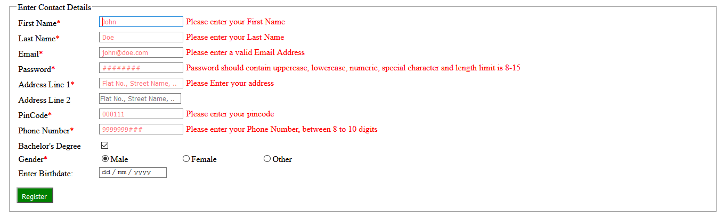

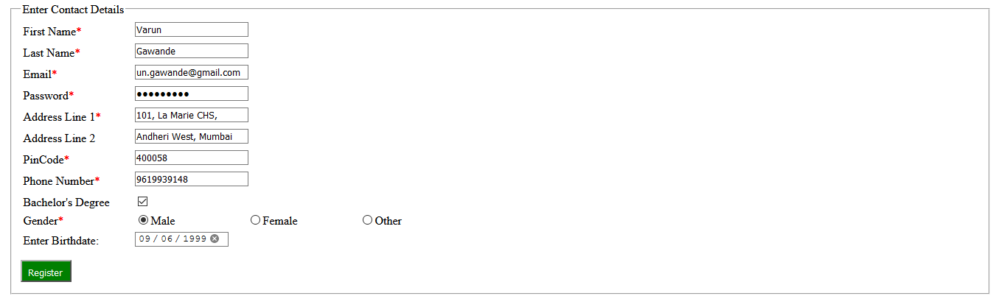

Order-portal.html

<!DOCTYPE html>

<html lang="en">

<head>

    <title>Pizza Delivery Portal</title>

    <meta charset="UTF-8" />

    <meta name="viewport" content="width=device-width, initial-scale=1" />

    <link href="../assets/css/layout.css" rel="stylesheet" />

    <link href="../assets/css/style.css" rel="stylesheet" />

    <script src="../assets/js/script.js"></script>

    <script src="https://code.jquery.com/jquery-3.5.1.slim.min.js"

        integrity="sha256-4+XzXVhsDmqanXGHaHvgh1gMQKX40OUvDEBTu8JcmNs=" crossorigin="anonymous"></script>

    <script src="https://cdn.jsdelivr.net/npm/jquery-validation@1.19.3/dist/jquery.validate.min.js"></script>

    <script src="../assets/js/validation.js"></script>

    <style>

        .dropbtn {

*background-color*: #4caf50;

*color*: white;

*padding*: 16px;

*font-size*: 16px;

*border*: none;

*width*: 250px;

        }

        .dropdown {

*position*: relative;

*display*: inline-block;

        }

        .dropdown :hover {

*background-color*: #ddd;

        }

        .dropdown:hover .dropbtn {

*background-color*: #3e8e41;

        }

    </style>

</head>

<body>

    <header>

        <span>

            <strong><a class="page-title" href="../index.html">Mama Cha Pizza</a></strong>

        </span>

        <span>

            <a href="../index.html" class="logo-img-link">

                <img src="../assets/images/pizza_logo.png" alt="Logo" height="10%" width="10%" class="logo-img" />

            </a>

        </span>

        <span>

            <p class="page-number">420-69-6969</p>

        </span>

        <br /><br />

    </header>

    <ul class="navbar">

        <li><a href="../index.html">Home </a></li>

        <li><a href="about-us.html">Our Story </a></li>

        <li><a href="privacy-policy.html">Privacy Policy </a></li>

        <li><a href="terms-conditions.html">Terms and Conditions </a></li>

        <li class="navbar-active">

            <a href="order-portal.html">Order Pizza Online</a>

        </li>

    </ul>

    <section class="text-container">

        <!-- <form name="personalDetails" action="<?php echo htmlspecialchars($_SERVER['PHP_SELF']);?>" method="POST" onsubmit="//return validate();"> -->

        <!-- <br> -->

        <form action="" name="registration">

            <fieldset class="input-personal">

                <legend>Enter Contact Details</legend>

                <table class="details">

                    <col width=150>

                    <tr>

                        <td><label for="firstname">First Name<span class="red">*</span></label></td>

                        <td><input type="text" name="firstname" id="firstname" placeholder="John" /></td>

                    </tr>

                    <tr>

                        <td><label for="lastname">Last Name<span class="red">*</span></label></td>

                        <td><input type="text" name="lastname" id="lastname" placeholder="Doe" /></td>

                    </tr>

                    <tr>

                        <td><label for="email">Email<span class="red">*</span></label></td>

                        <td><input name="email" id="email" placeholder="john@doe.com" /></td>

                    </tr>

                    <tr>

                        <td><label for="password">Password<span class="red">*</span></label></td>

                        <td><input type="password" name="password" id="password" placeholder="########"/></td>

                        <td><label id="validationMsg"></label></td>

                    </tr>

                    <tr>

                        <td><label for="address">Address Line 1<span class="red">*</span></label></td>

                        <td><input name="address" id="address" placeholder="Flat No., Street Name, ....."></td>

                    </tr>

                    <tr>

                        <td><label for="address2">Address Line 2</label></td>

                        <td><input name="address2" id="address2" placeholder="Flat No., Street Name, ....."></td>

                    </tr>

                    <tr>

                        <td><label for="pincode">PinCode<span class="red">*</span></label></td>

                        <td><input name="pincode" id="pincode" placeholder="000111"></td>

                    </tr>

                    <tr>

                        <td><label for="number">Phone Number<span class="red">*</span></label></td>

                        <td><input type="text" name="number" class="number" placeholder="9999999###" /></td>

                    </tr>

                </table>

                <table>

                    <col width=150>

                    <col width=150>

                    <col width=150>

                    <tr>

                        <td><label for="education">Bachelor's Degree</label></td>

                        <td><input type="checkbox" name="education" id="education" checked></td>

                    </tr>

                    <tr>

                        <td><label for="gender">Gender<span class="red">*</span></label></td>

                        <td><input type="radio" name="gender" class="gender" checked>Male</td>

                        <td><input type="radio" name="gender" class="gender">Female</td>

                        <td><input type="radio" name="gender" class="gender">Other</td>

                    </tr>

                    <tr>

                        <td><label for="dob">Enter Birthdate:</label></td>

                        <td><input type="date" name="dob" class="dob" /></td>

                    </tr>

                </table>

                <button type="submit">Register</button>

            </fieldset>

        </form>

    <footer>

        <ul class="navbar">

            <li><a href="../index.html">Home </a></li>

            <li><a href="../html/about-us.html">Our Story </a></li>

            <li><a href="../html/privacy-policy.html">Privacy Policy </a></li>

            <li>

                <a href="../html/terms-conditions.html">Terms and Conditions </a>

            </li>

            <li class="navbar-active">

                <a href="../html/order-portal.html">Order Pizza online</a>

            </li>

        </ul>

        <h5 style="color: white">2021 @ Mama cha Pizza. No rights reserved</h5>

    </footer>

</body>

</html>

validation.js

$(function () {

    function passwordValidation() {

        if ($("#password").val().match(/^(?=.*\d)(?=.*[a-z])(?=.*[A-Z])(?=.*[^a-zA-Z0-9])(?!.*\s).{8,15}$/)) {

            $("#validationMsg").text("Password Looks Strong");

            $("#validationMsg").css("color", "green");

            return true;

        } else {

            $("#validationMsg").text("Password should contain uppercase, lowercase, numeric, special character and length limit is 8-15");

            $("#validationMsg").css("color", "red");

            return false;

        }

    }

    $("form[name='registration']").validate({

        rules: {

            firstname: "required",

            lastname: "required",

            number: {

                required: true,

                digits: true,

                minlength: 8,

                maxlength: 10

            },

            password: {

                required: true,

            },

            email: {

                required: true,

                email: true

            },

            address: "required",

            pincode: {

                required: true,

                digits: true,

                minlength: 6,

                maxlength: 6

            }

        },

        messages: {

            firstname: "Please enter your First Name",

            lastname: "Please enter your Last Name",

            number: "Please enter your Phone Number, between 8 to 10 digits",

            password: "Password should contain uppercase, lowercase, numeric, special character and length limit is 8-15",

            email: "Please enter a valid Email Address",

            address: "Please Enter your address",

            pincode: "Please enter your pincode"

        },

        submitHandler: function (form) {

            if (passwordValidation())

                form.submit()

        }

    })

})