NetFlow UML Modelling
Task 2 - UML Modelling (Unit II)
This document models the implemented NetFlow platform using UML views. The diagrams use actual repository concepts including SessionBuilder, NetFlowModel, RulesBasedClassifier, OnlineSessionTracker, database records, Flask routes, and the React dashboard.

1. Use-Case Diagram
Actors: Security operator, Data / ML engineer, and streaming consumer. The model includes more than five use cases and shows include and extend relationships.
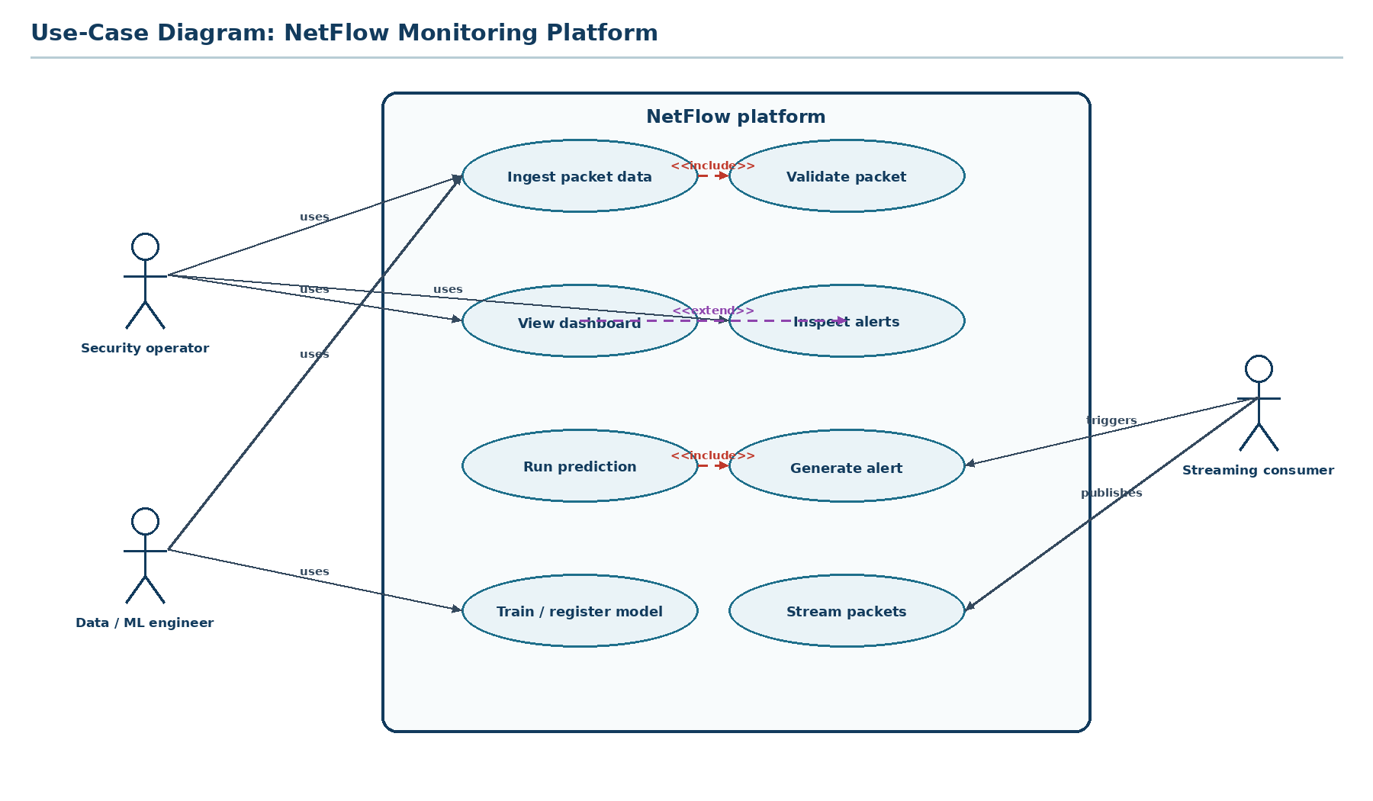
Figure 1. NetFlow platform use cases.

2. Class Diagram
The class model includes multiplicities, role names, composition between sessions and packets, and generalization from RulesBasedClassifier to the classifier abstraction.
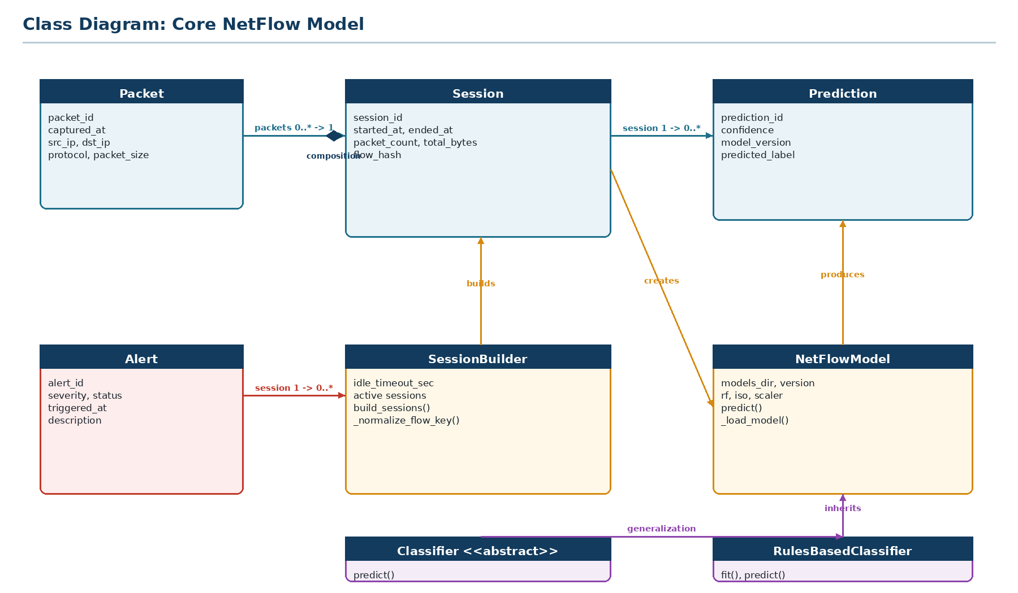
Figure 2. Core classes and relationships.

3. Object Diagram
This snapshot represents a live detection: flow_17 is active in the tracker, model_v1 has classified the session as DOS, prediction_884 has been persisted, alert_91 is open, and the dashboard has received the event over SSE.
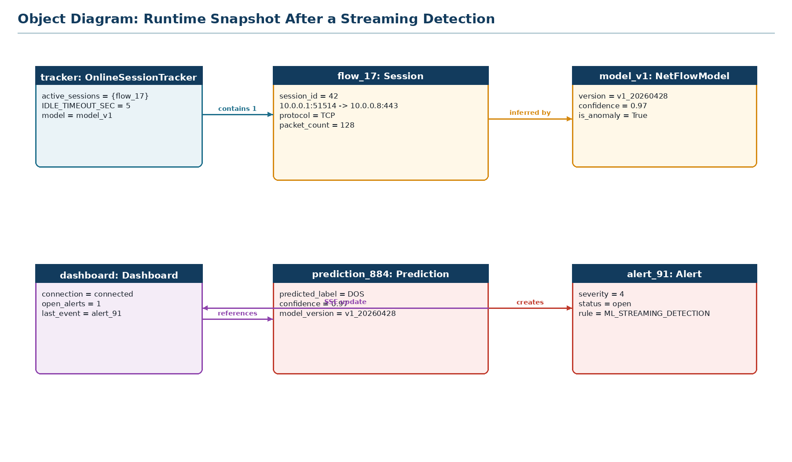
Figure 3. Runtime object snapshot.

4. Sequence Diagram 1: Batch Ingestion
This scenario shows a CSV ingestion run through validation, staging, deduplication, session construction, and feature persistence.
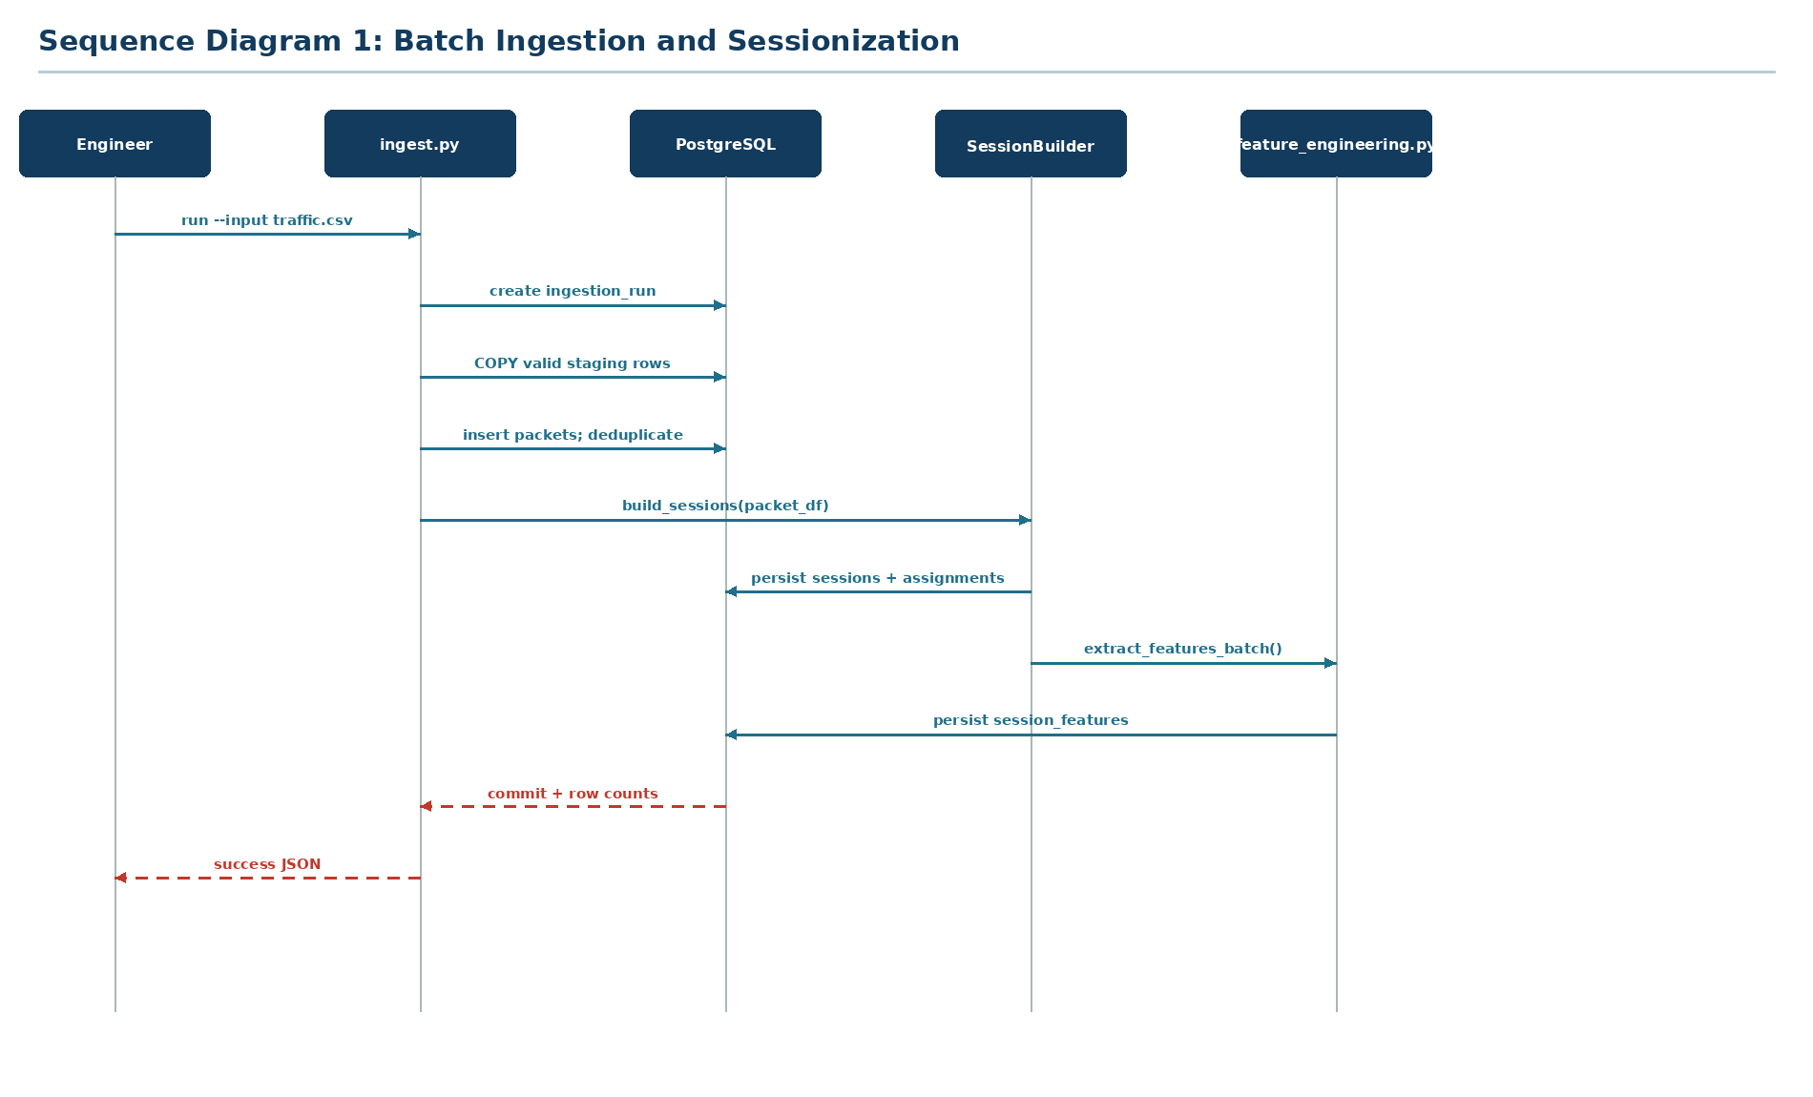
Figure 4. Batch ingestion and sessionization sequence.

5. Sequence Diagram 2: Streaming Detection
This scenario shows a PostgreSQL notification flowing through OnlineSessionTracker, model inference, prediction persistence, alert creation, and the dashboard SSE stream.
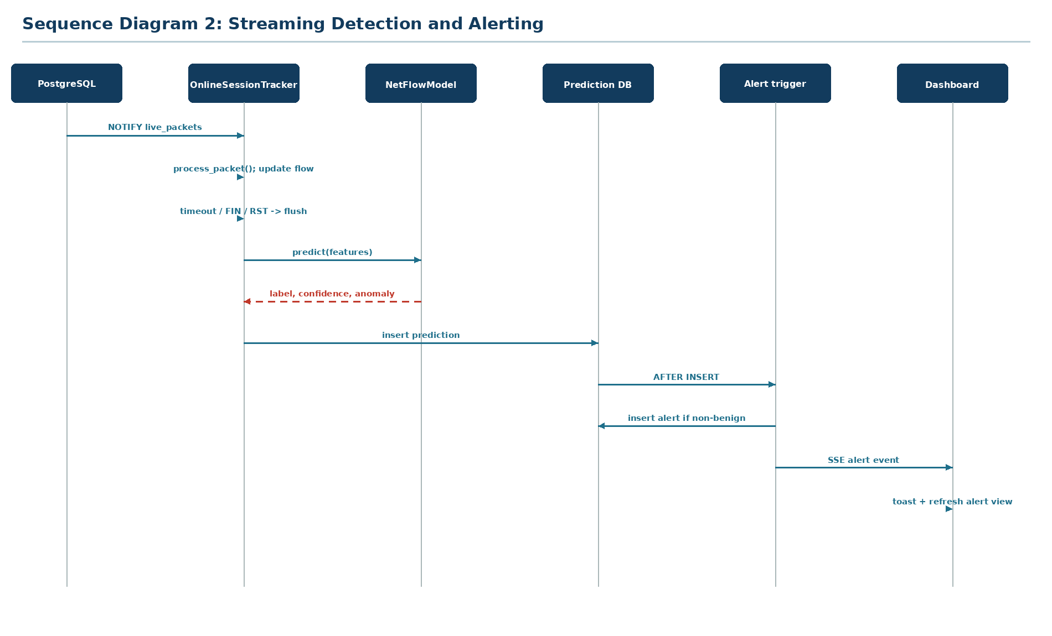
Figure 5. Streaming detection and alerting sequence.

6. State Chart Diagram
The modeled object is a network Session. Its lifecycle moves from New to Active, then to Closed when FIN/RST, timeout, or capacity pressure occurs, followed by persistence and inference.
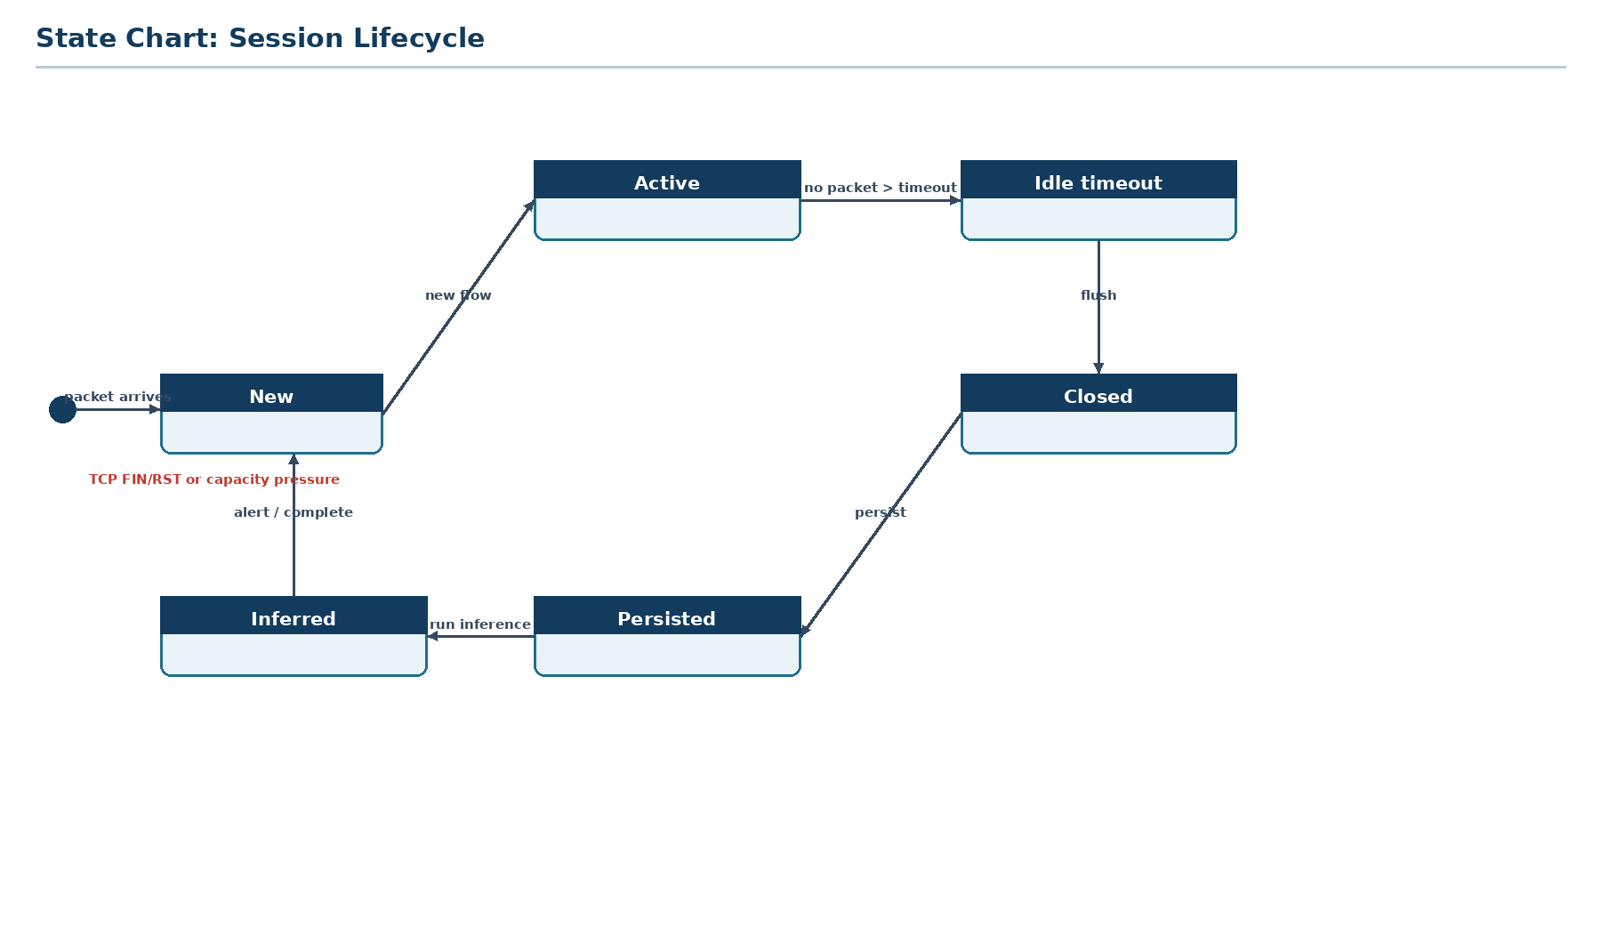
Figure 6. Session lifecycle state chart.

7. Activity Diagram
The main workflow combines batch and streaming entry points, validation, persistence, sessionization, feature engineering, inference, alerting, and dashboard notification.
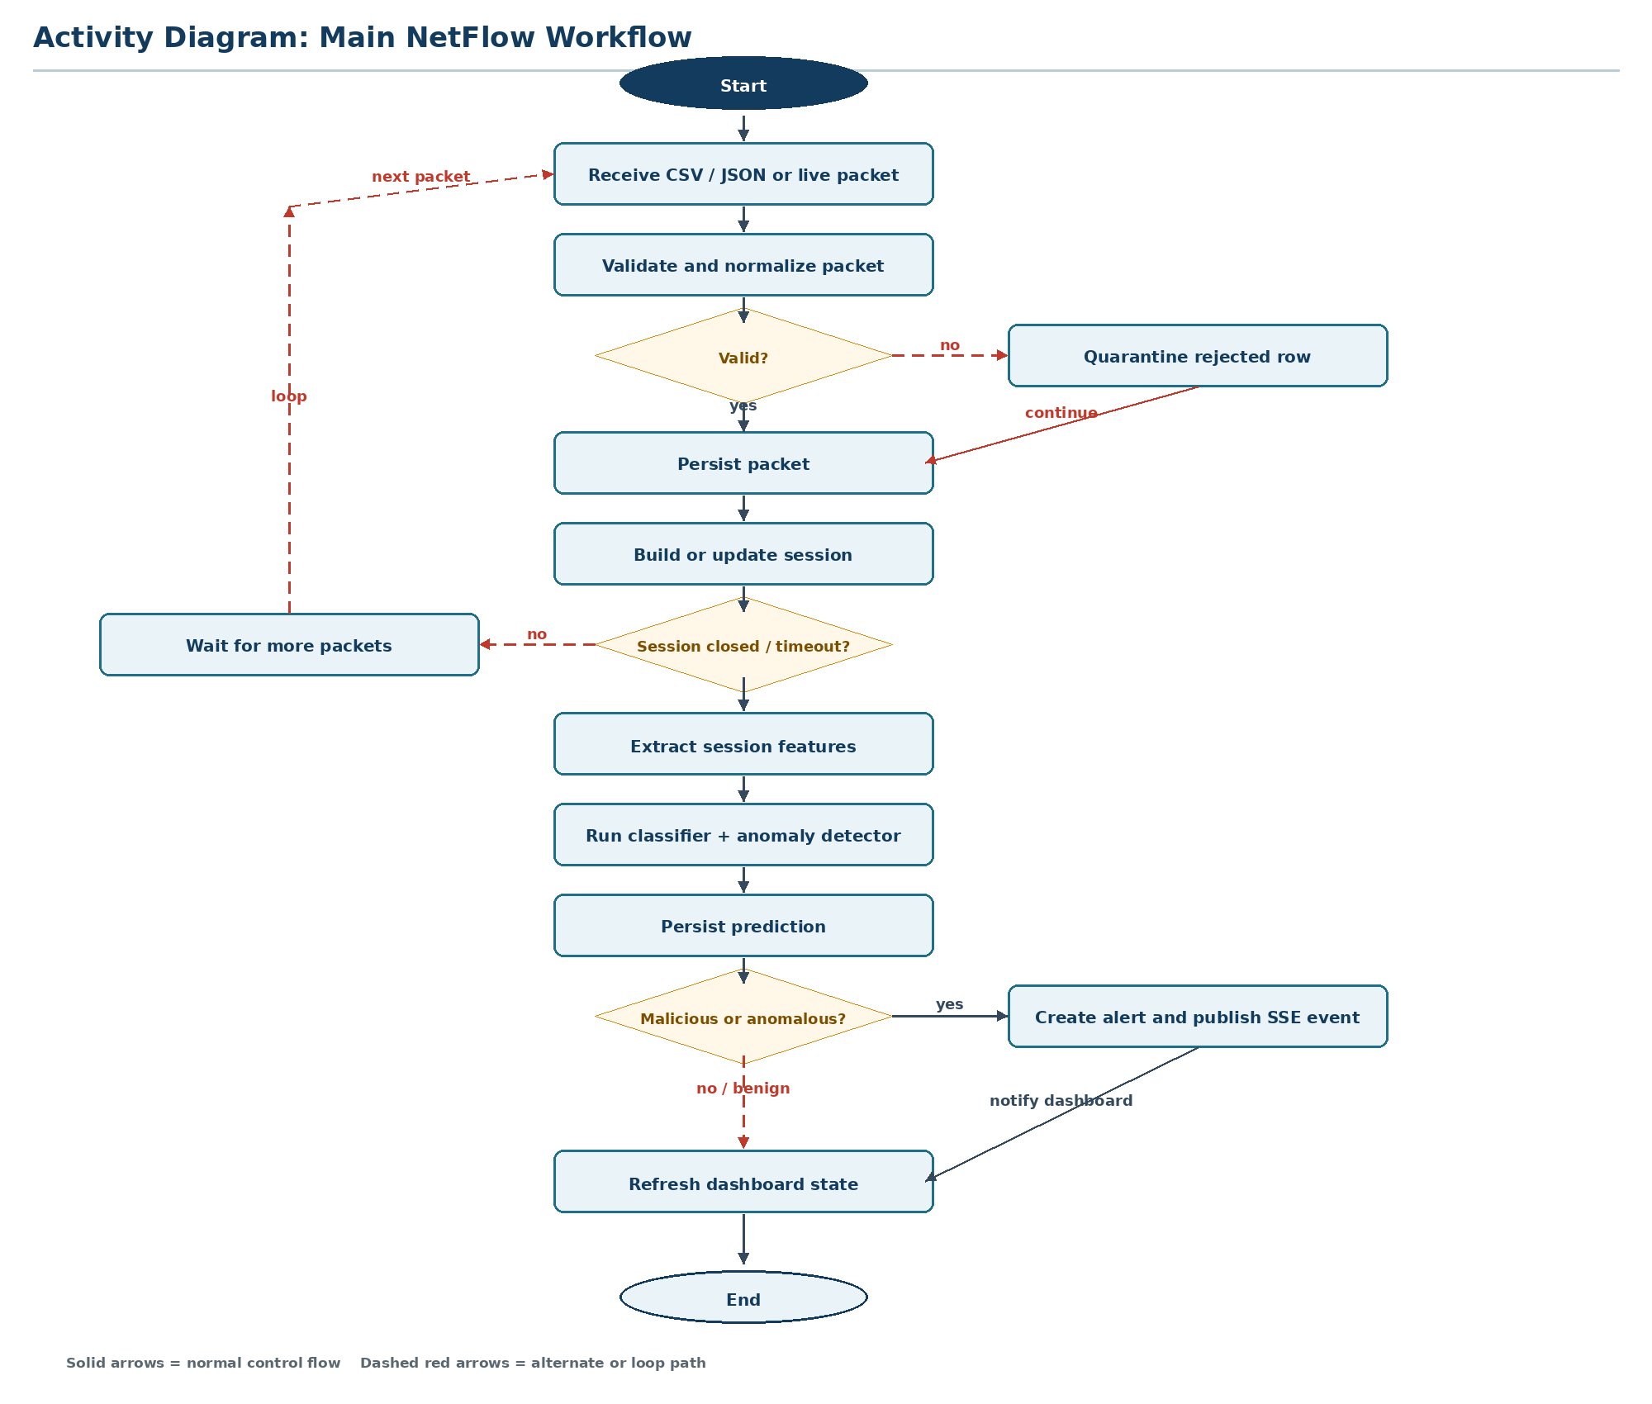
Figure 7. Main NetFlow workflow activity diagram.

Requirement Coverage
- Use-case diagram: three actors, eight use cases, include and extend relationships.
- Class diagram: eight classes, multiplicities, role labels, composition, and generalization.
- Object diagram: realistic runtime snapshot with tracker, session, model, prediction, alert, and dashboard objects.
- Sequence diagrams: batch ingestion and streaming detection scenarios.
- State chart: Session lifecycle from creation through inference.
- Activity diagram: main packet-to-alert workflow.

