Asha
Flowcharts, screenshots and results
Detecting hidden low mood in older adults · Cognitive Robotics course project
Source code (GitHub): https://github.com/V4run05/elderly-emotion-detection
Prepared by: Varun and Sandhyaa Sriram
Date: 21 October 2026

1. Flowcharts

1.1 System overview
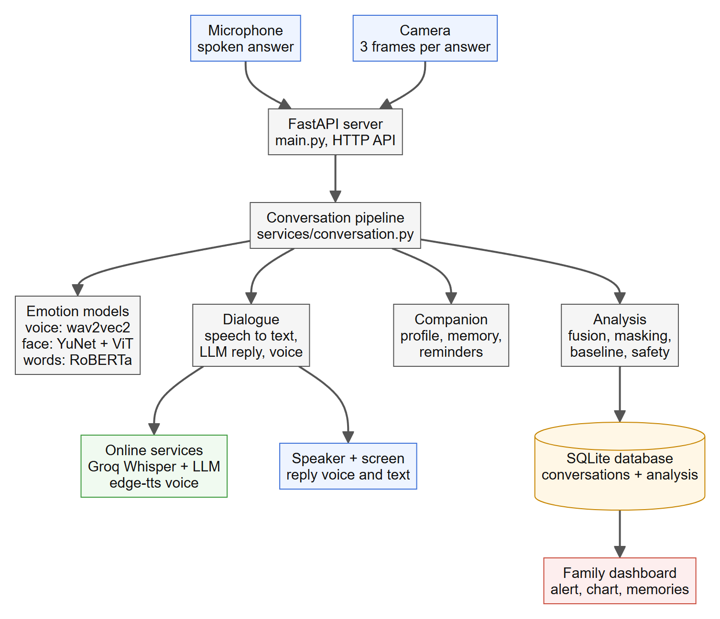
Figure 1. System overview. The device sends the spoken answer and camera frames to the server, which reads the words, voice and face, replies by voice, and stores the result for the family dashboard.

1.2 One message, part 1: reading the answer
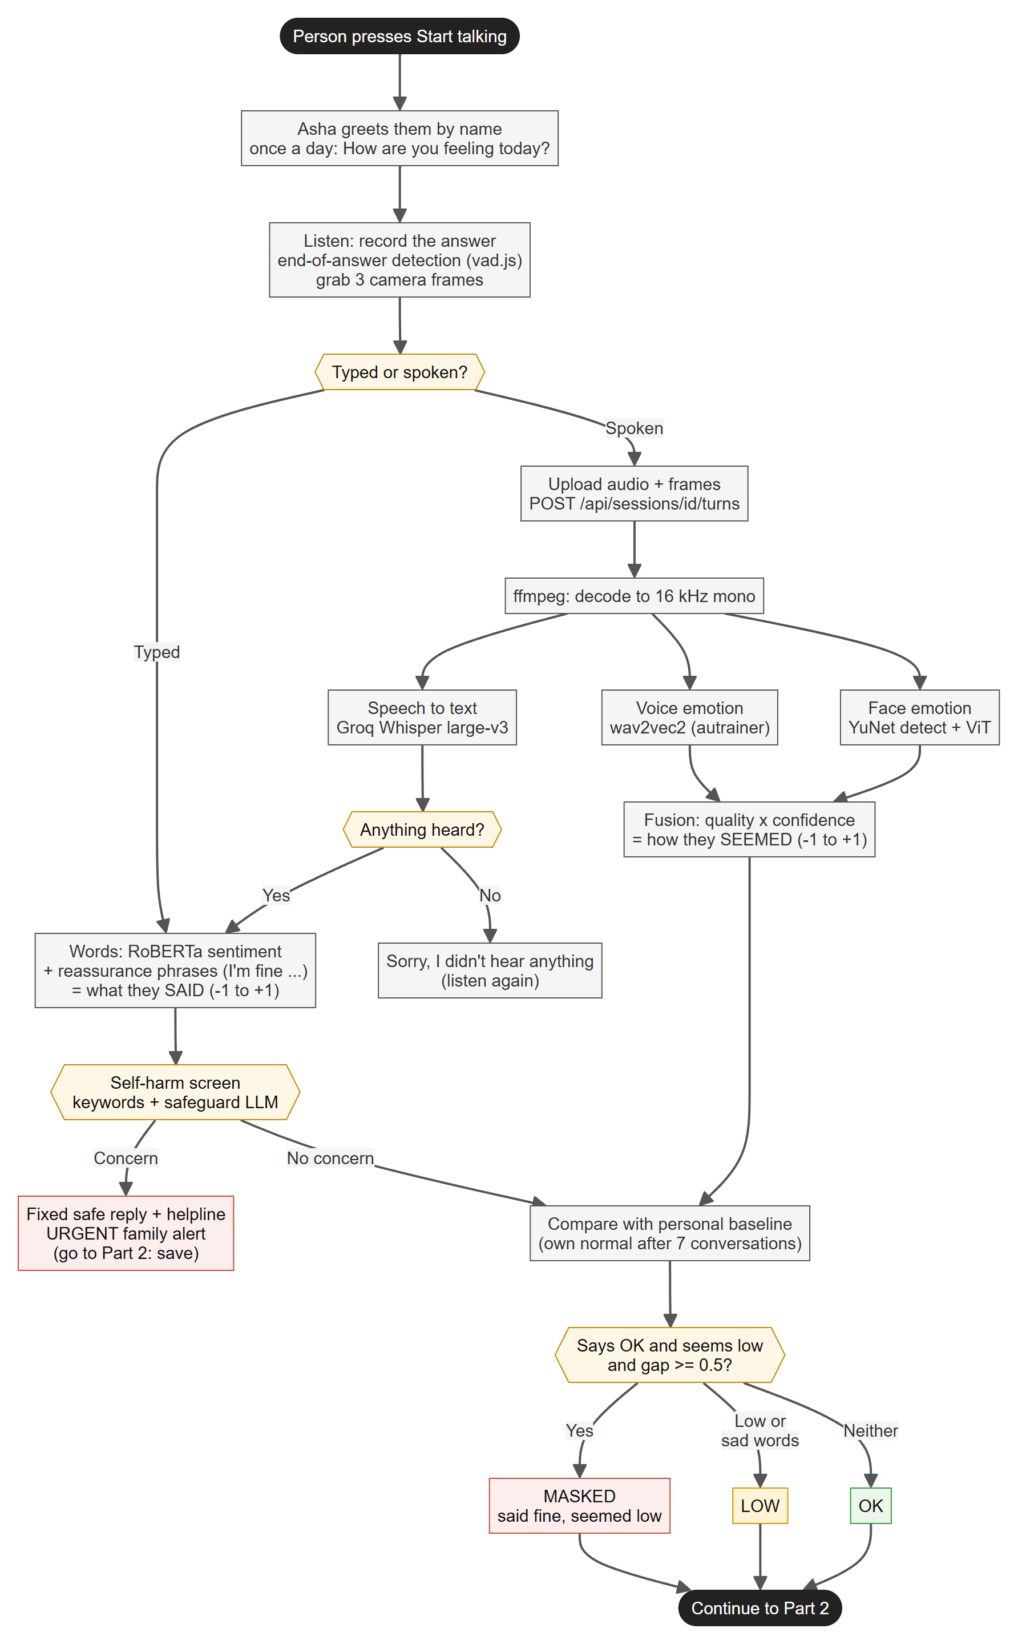
Figure 2. What they said (words) and how they seemed (voice and face) are read in parallel, screened for self-harm, compared with the person's own normal, and classified as OK, LOW or MASKED.

1.3 One message, part 2: replying and saving
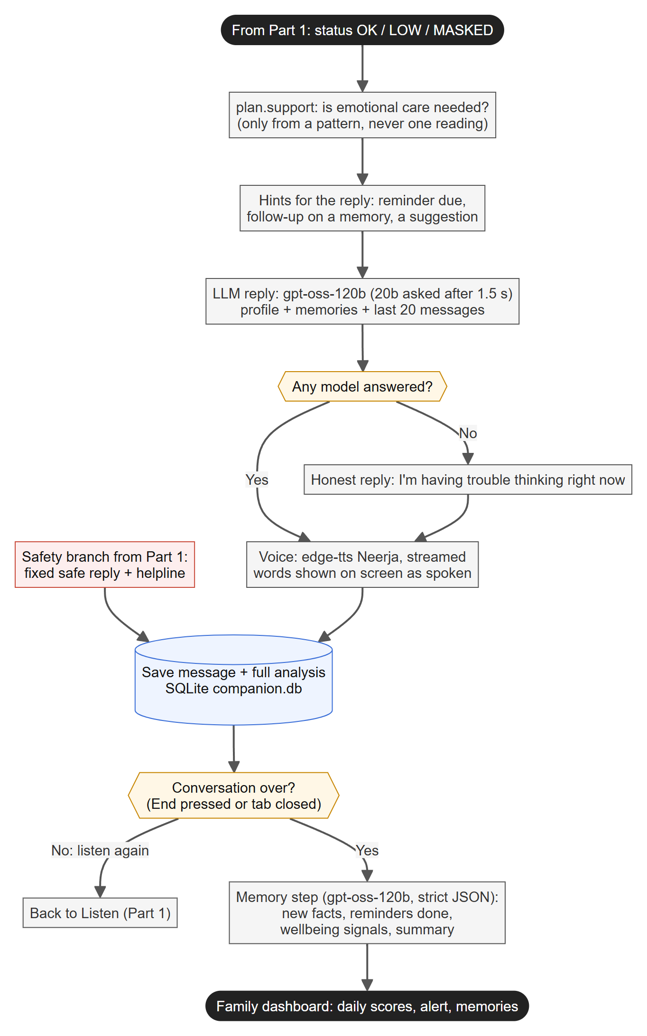
Figure 3. The companion writes a personal reply, speaks it, saves the analysis, and learns from the conversation when it ends.

1.4 From daily results to a family alert
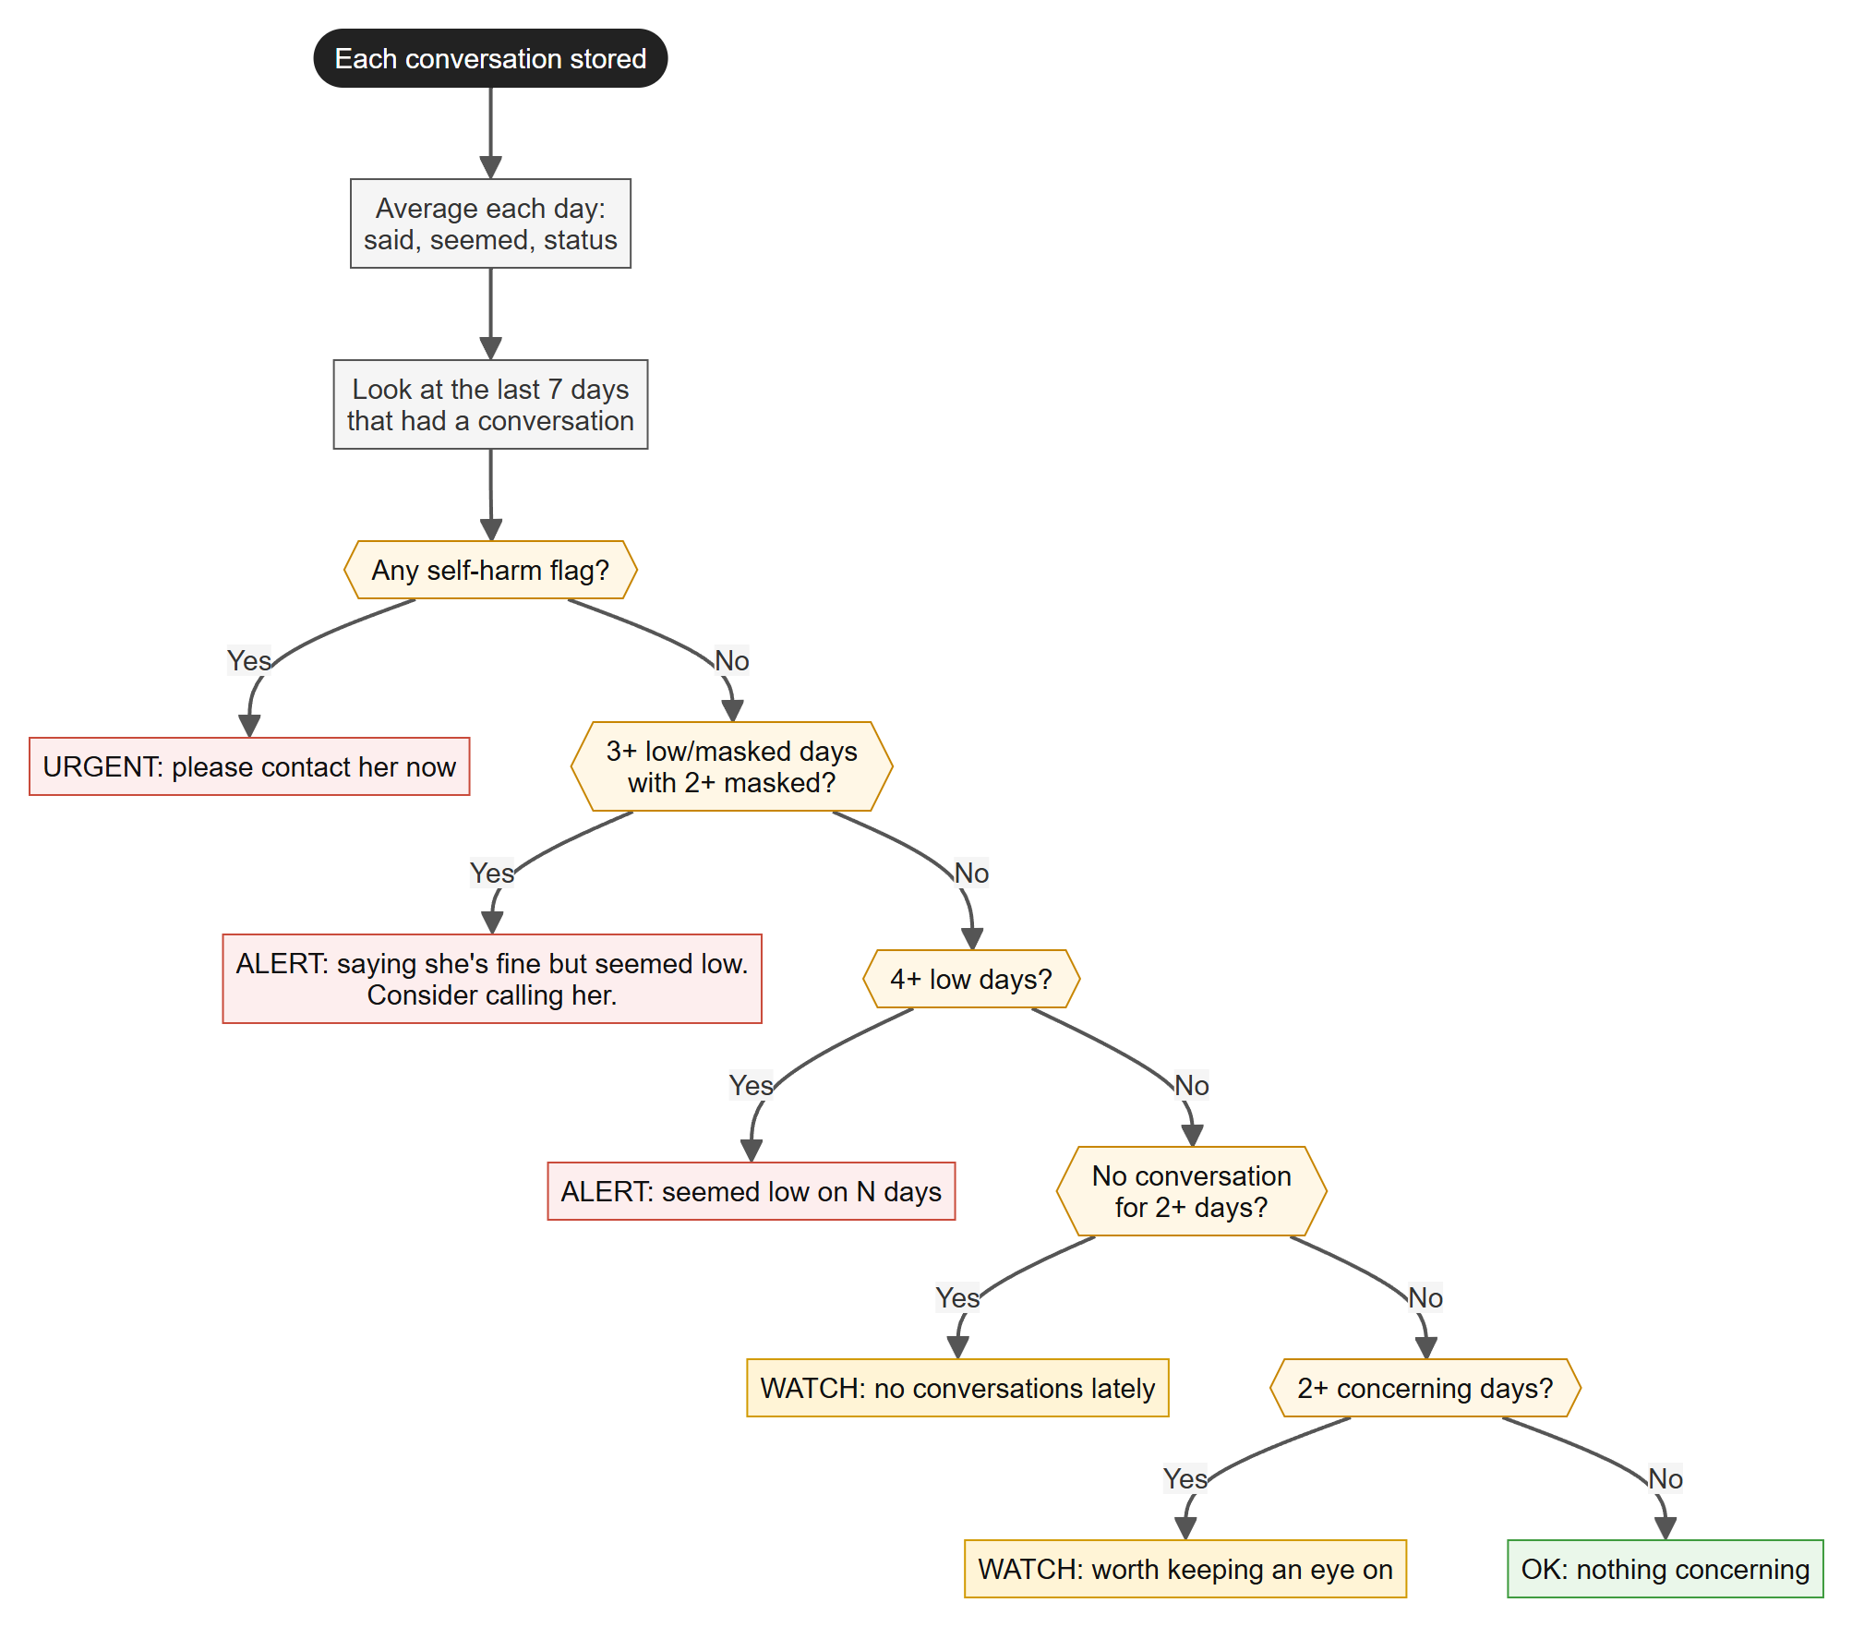
Figure 4. The dashboard looks at the last 7 days that had a conversation and shows the most serious level that applies. One bad moment never raises an alert.

2. Screenshots of the web page outputs
Taken from the running application. The history is the built-in demo data for the sample person, Lakshmi; the conversation on 21 October is a live run through the real models.

2.1 Talk page
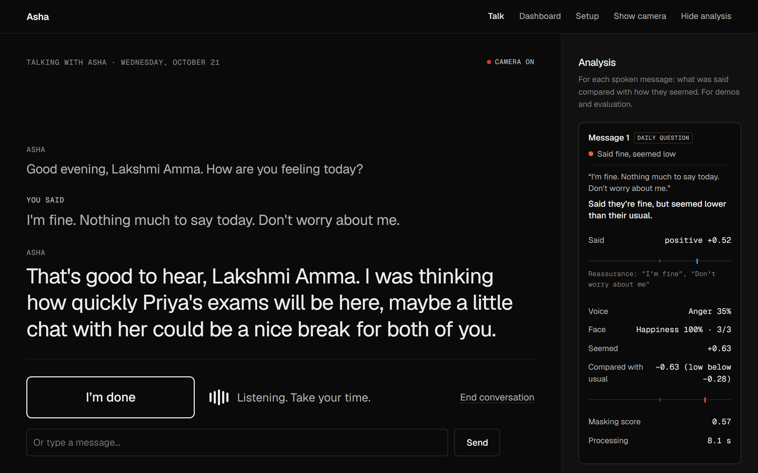
Figure 5. A spoken answer, "I'm fine. Nothing much to say today. Don't worry about me.", flagged as "Said fine, seemed low": the words are positive (+0.52) with two reassurance phrases, but the voice is well below her usual (-0.63, low below -0.28).
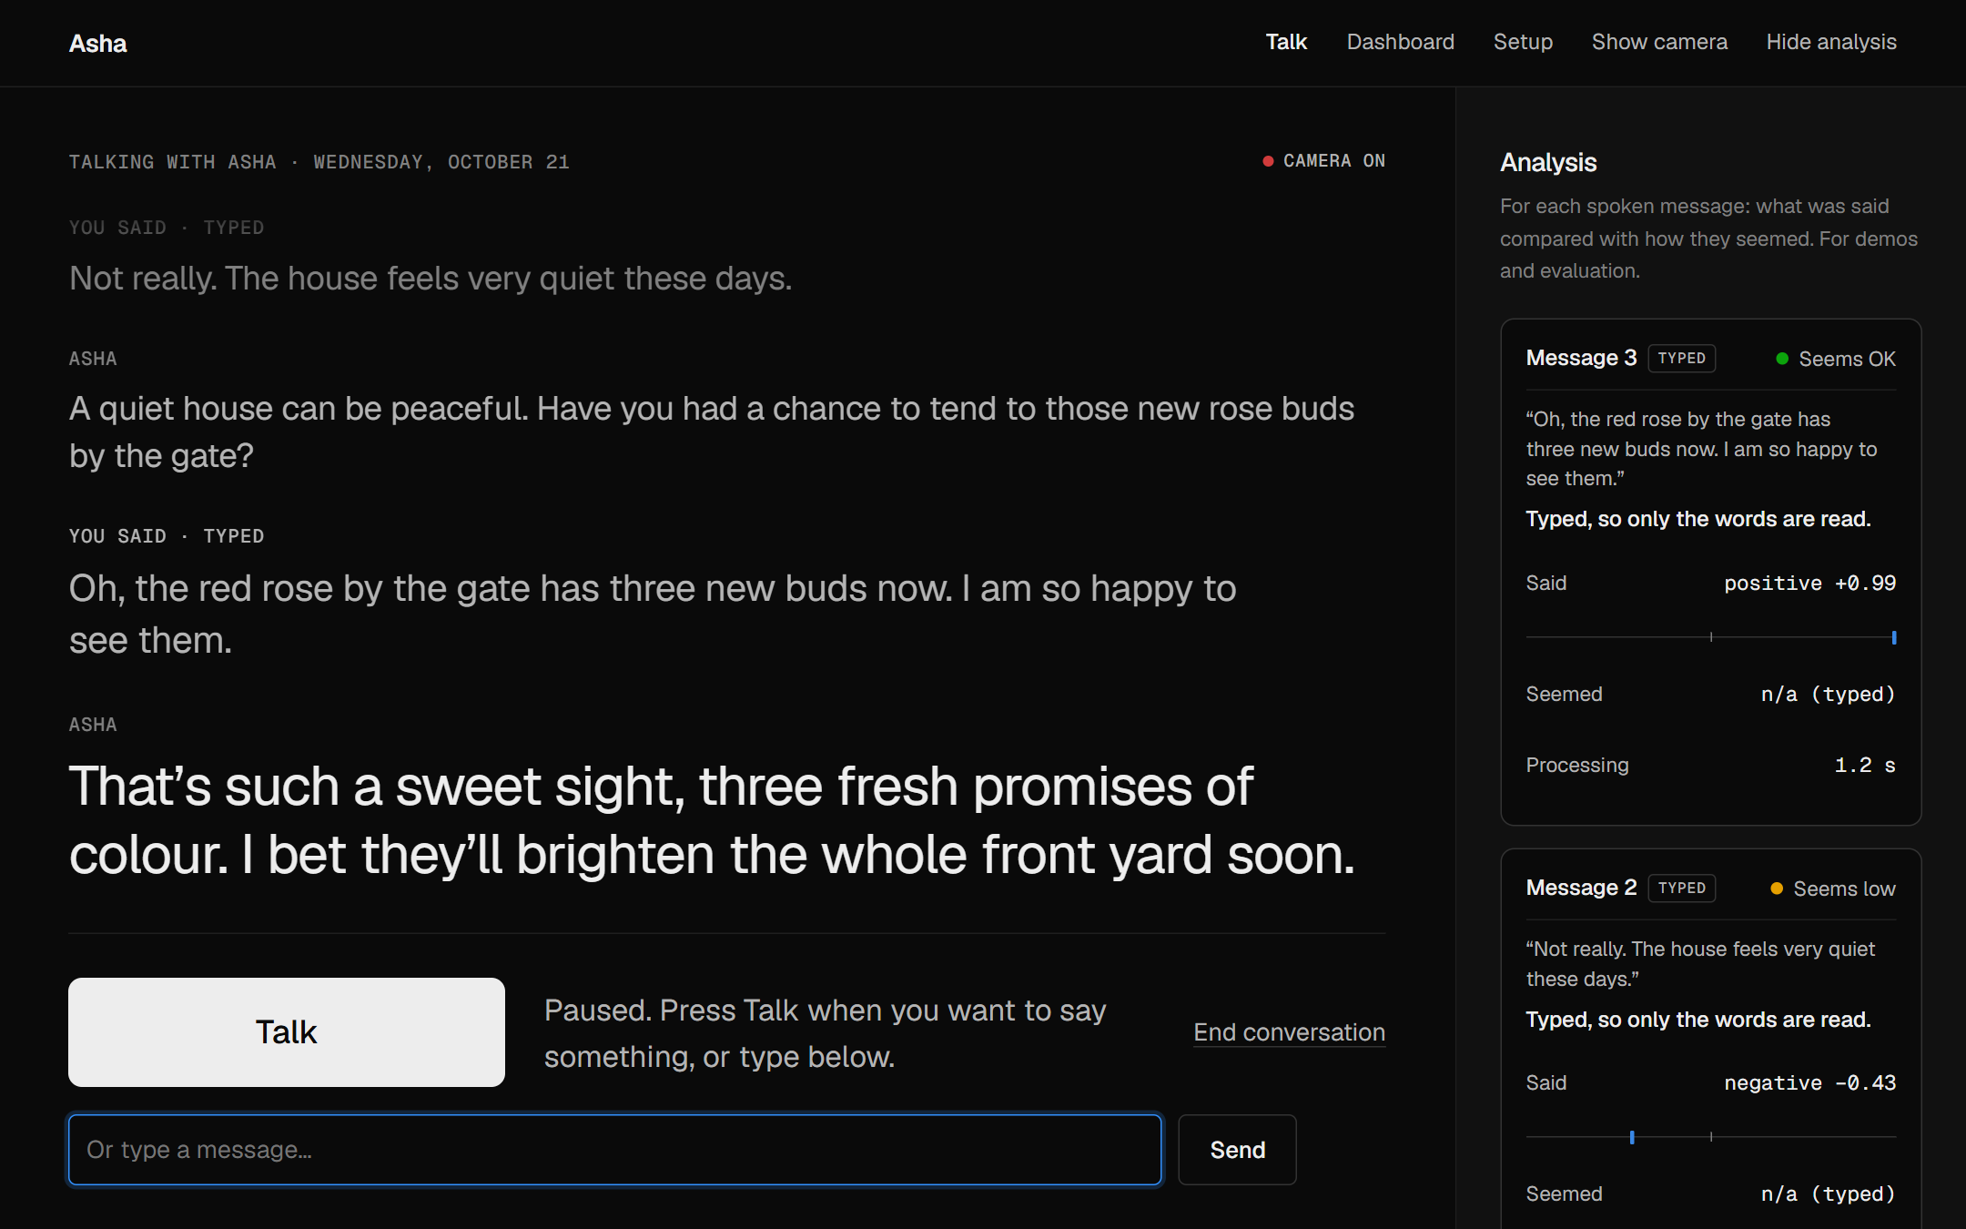
Figure 6. The conversation continues. Asha brings up her roses from memory; each message gets its own result card.

2.2 Family dashboard
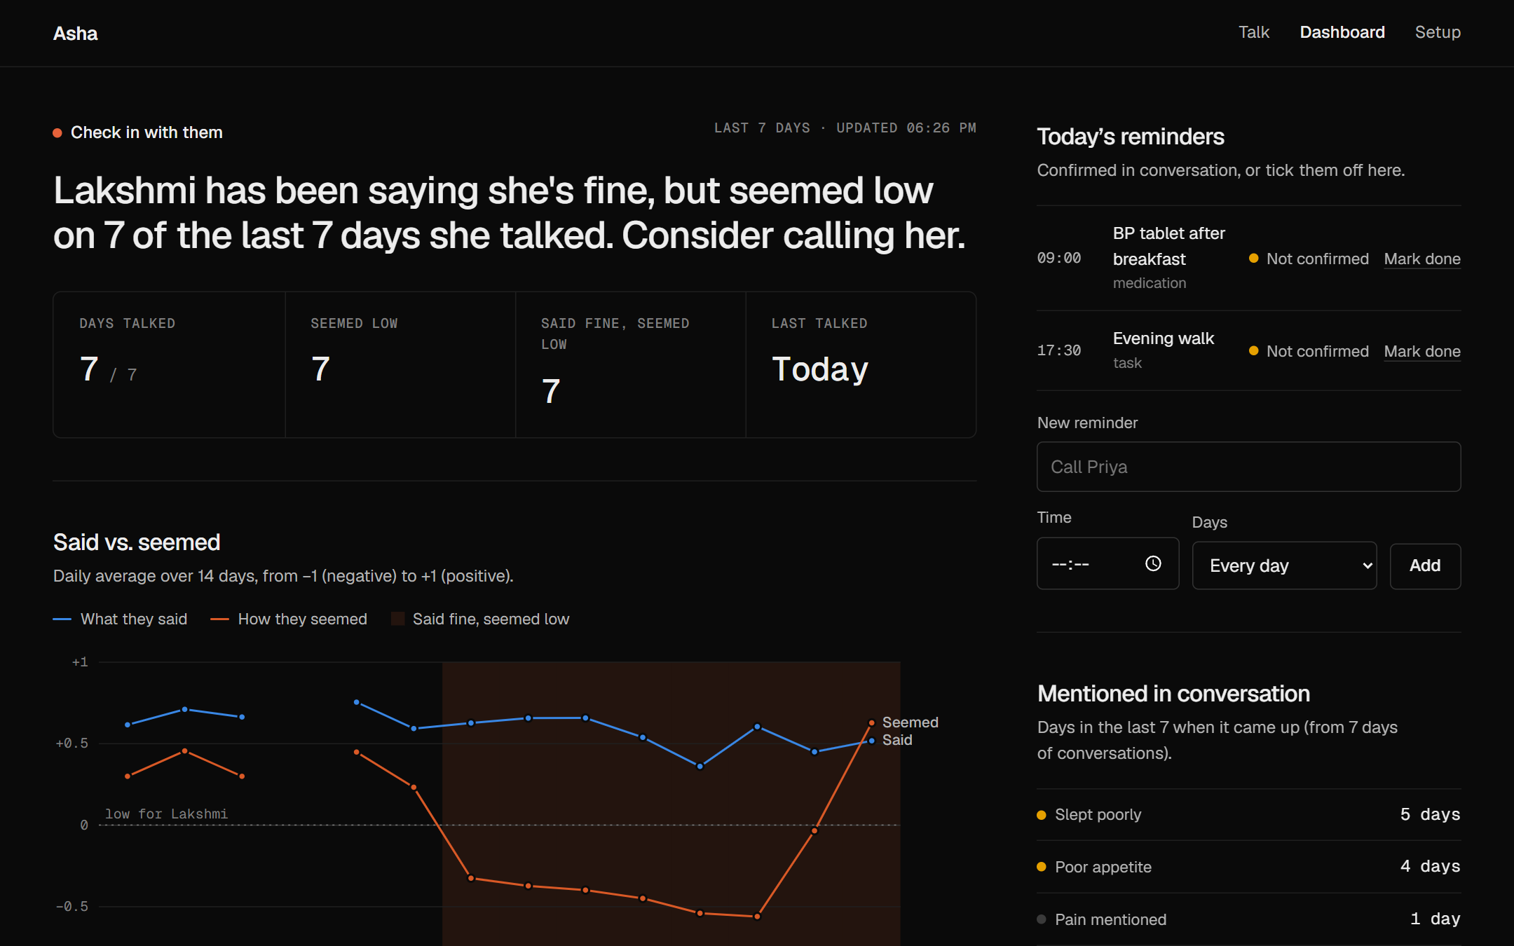
Figure 7. The family alert: "Lakshmi has been saying she's fine, but seemed low on 7 of the last 7 days she talked. Consider calling her." Beside it, today's reminders and what came up in conversation.
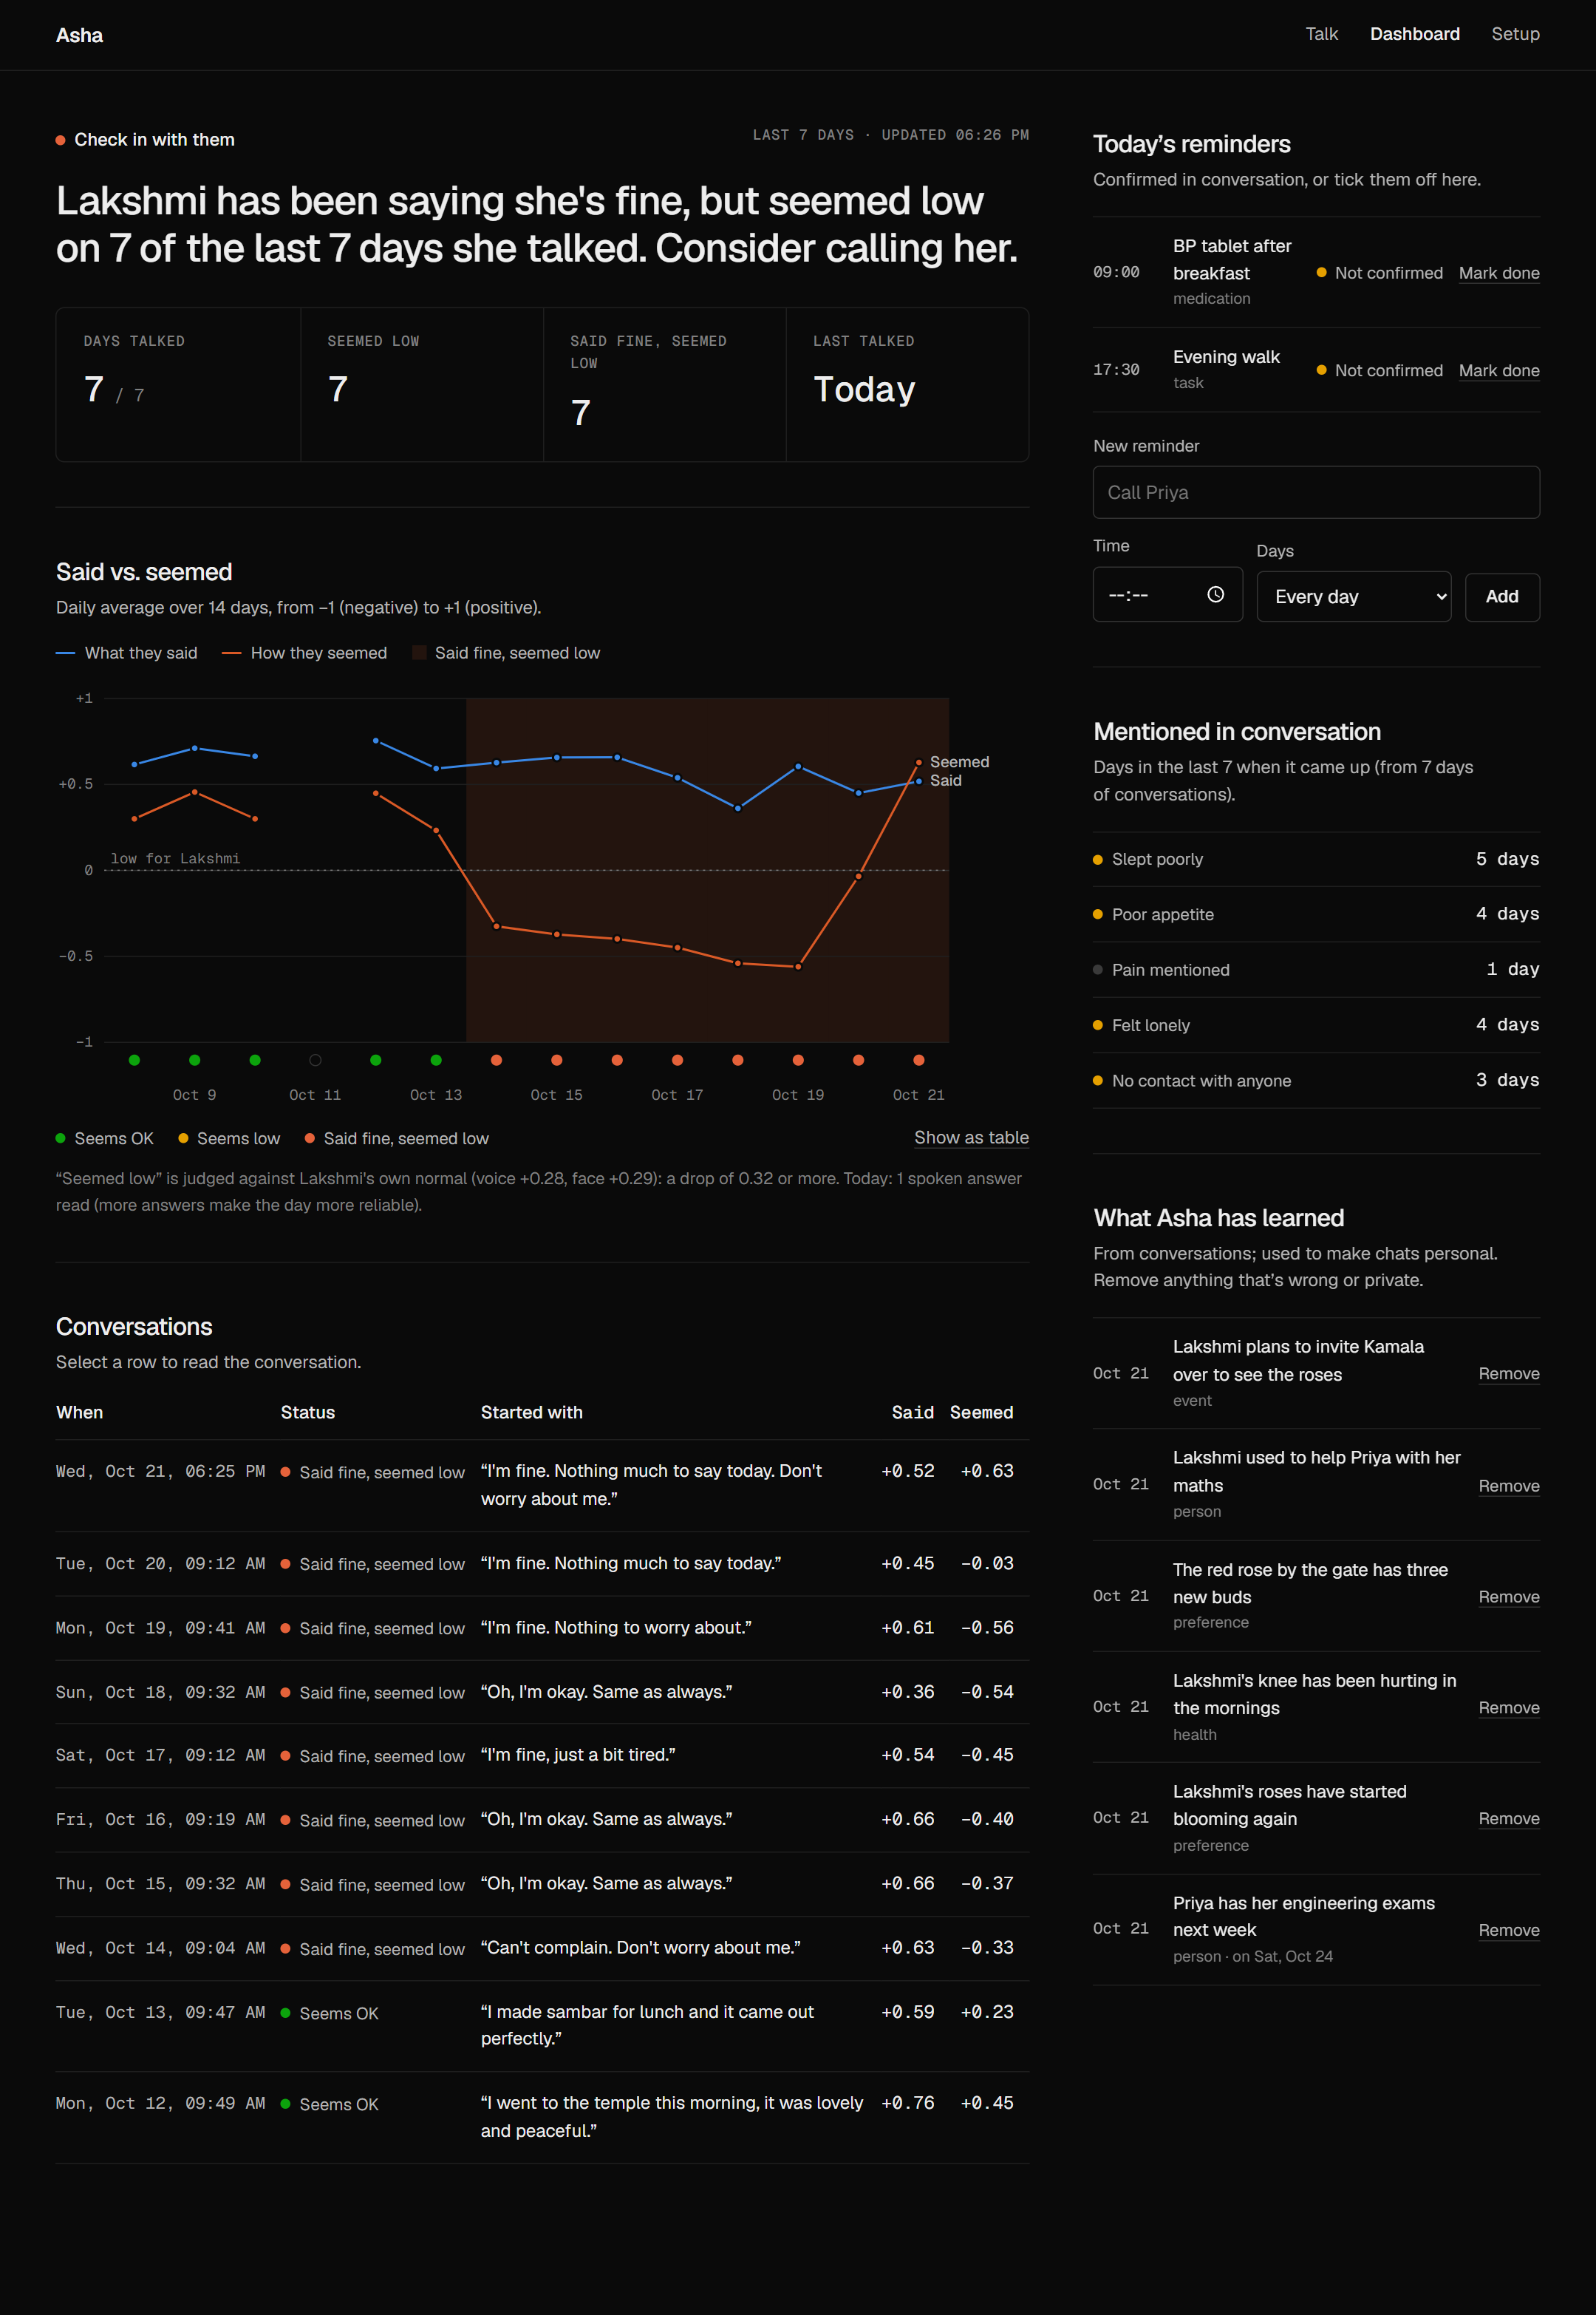
Figure 8. The full dashboard. The 14-day chart shows what she said (blue) staying positive while how she seemed (orange) drops; the shaded band marks "said fine, seemed low" days. Below: the conversations and what Asha has learned.
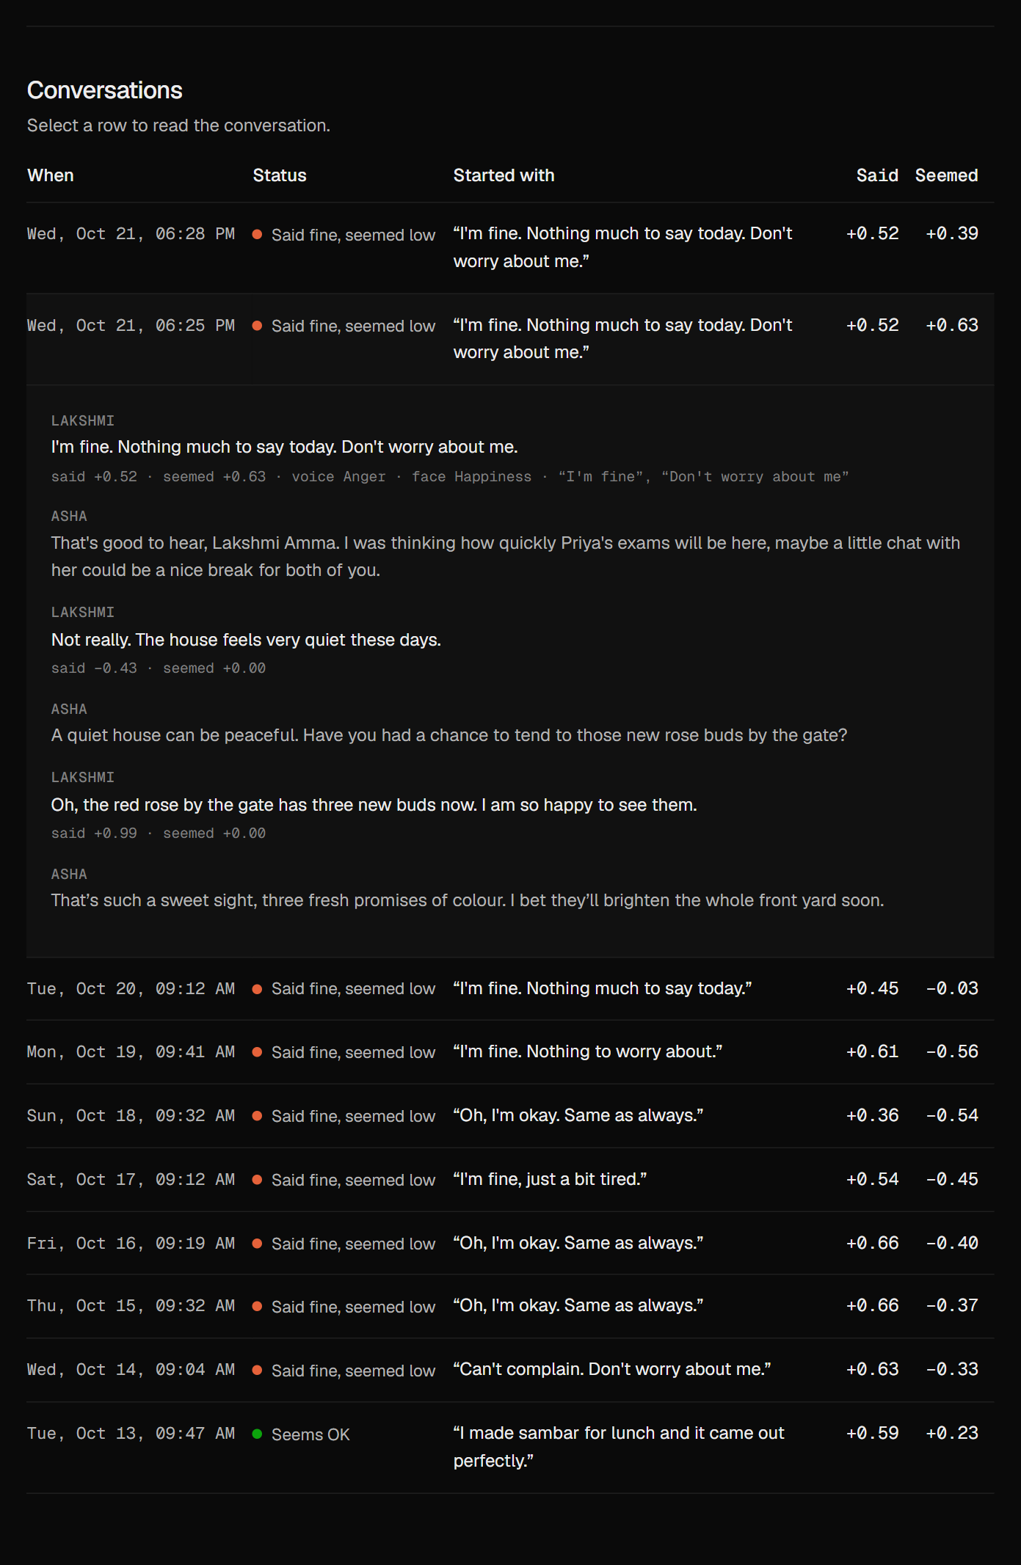
Figure 9. An opened conversation, with what was said and how she seemed for each message.

3. Results
Tested on public data (CREMA-D voice recordings, UTKFace face photos), written test sentences and simulated conversations.
What was measured | Result
"I'm fine"-type answers recognised as "says OK" | 100%
"I'm fine, but I miss him" read as opening up, not masking | 5 of 5
Calm "I'm fine" answers wrongly flagged as masked | 17%, and 9% once her normal is learned
Low weeks caught by the family alert (camera always on) | 72%, with 7% false alerts
Low weeks caught by the family alert (camera on some days) | 70%, with 9% false alerts
Self-harm statements caught (direct / indirect) | 100% / 100%, no false alarms
Crisis messages from simulated conversations flagged | 5 of 5, each with a fixed safe reply
Memory: facts stored correctly | 7 of 7, nothing wrong stored
Companion replies with invented details | 13%
Time to reply after they stop talking | About 2 to 4 seconds

No recordings of older adults were available yet, so these results show that the method works, not its clinical accuracy for people in their 80s.

