

**DC Geared Motor with Encoder**

**MO-SPG-30E-XXXK**

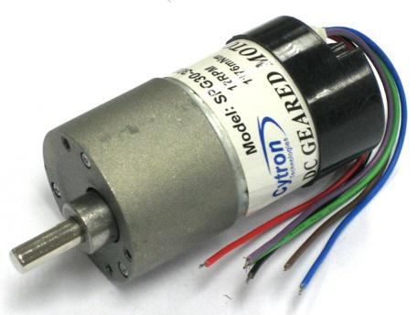

**User's Manual**

**V3.0**

**April 2018**



**Index**

1. Introduction and Overview 3

2. Pin Descriptions 5

3. Sample Schematic 7

4. Warranty 9

**1.0 INTRODUCTION AND OVERVIEW**

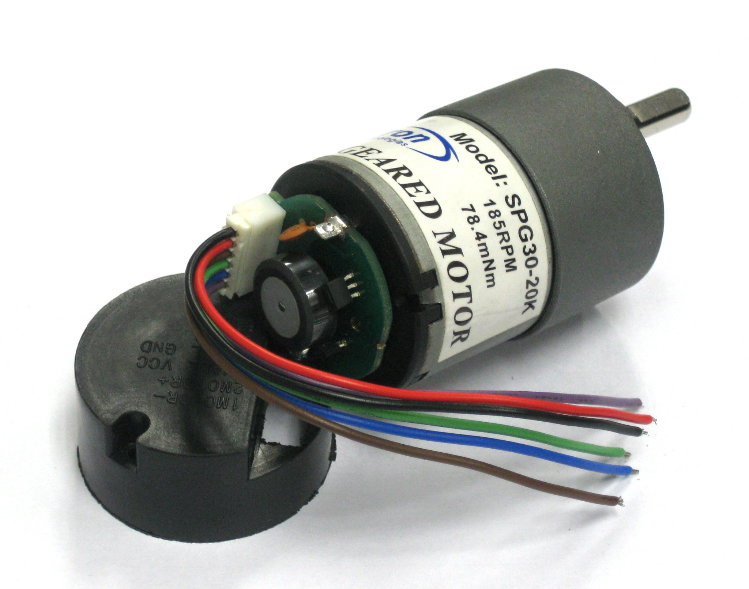

**Figure 1.0 DC geared motor with encoder and its removable cover**

This document explains the general method to use the encoder for [MO-SPG-30E-XXXK](http://cytron.com.my/c-84-dc-motor/c-91-dc-geared-motor/c-405-spg30-with-encoder-spur-gear). “XXX” is referring to the gear ratio of Cytron’s SPG-30 Geared Motor series which is either 20, 30, 60, 150*, 200 or 300*. This DC Geared Motor with Encoder is formed by a quadrature hall effect encoder board which is designed to fit on the rear shaft of Cytron’s SPG-30 Geared Motor series. Two hall effect sensor are placed 90 degree apart to sense and produce two output A and B which is 90 degree out of phase and allowing the direction of rotation to be determined. This encoder provides 3 counts per revolution of the rear shaft. Please note that the encoder is mounted at the rear shaft, the minimum resolution depends on the motor’s gear ratio.

* The actual gear ratio for SPG30E-150K is 120:1

* The actual gear ratio for SPG30E-300K is 270:1

Features of Quadrature Hall Effect Encoder:

* Operating voltage: 4.5 V to 5.5 V, * accordingly to customer feedback, some uses 24V for the Hall effect sensor’s VCC and the encoder still works. But use it at your own risk.
* Two digital outputs ( Quadrature waveform )
* Small in size and light in weight
* Resolution: 3 pulses per rear shaft revolution, single channel output.
* 60 counts per main shaft revolution for 1:20 geared motor
* 90 counts per main shaft revolution for 1:30 geared motor
* 180 counts per main shaft revolution for 1:60 geared motor
* ~~450~~ 360 counts per main shaft revolution for 1:120 geared motor (SPG30E-150K)
* 600 counts per main shaft revolution for 1:200 geared motor
* ~~900~~ 810 counts per main shaft revolution for 1:270 geared motor (SPG30E-300K)

**1.1 State Diagrams and Waveform**

**State Diagram**

**Clockwise Rotation**

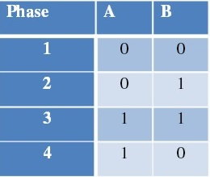

**Counter Clockwise Rotation**

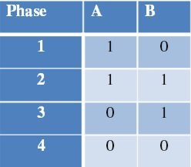

Square quadrature waveform for Channel A and B (Clockwise)

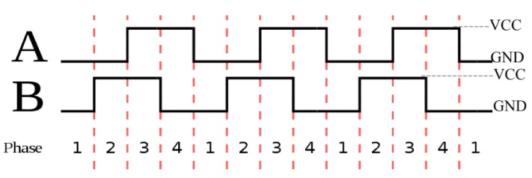

**2.0 PIN DESCRIPTIONS**

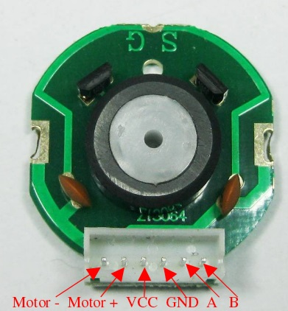

**Figure 2.0 2020-06 connector pin descriptions**

|  |  |  |
| --- | --- | --- |
| **Pin** | **Name** | **Description** |
| 1 | Motor - | Output of motor driver |
| 2 | Motor + | Output of motor driver |
| 3 | Hall effect sensor Vcc | Supply voltage for sensor circuit (4.5V-5.5V) |
| 4 | Hall effect sensor GND | Ground |
| 5 | Channel A | Output of the encoder |
| 6 | Channel B | Output of the encoder |



**Figure 2.1 Rear view of the motor with encoder and cover**

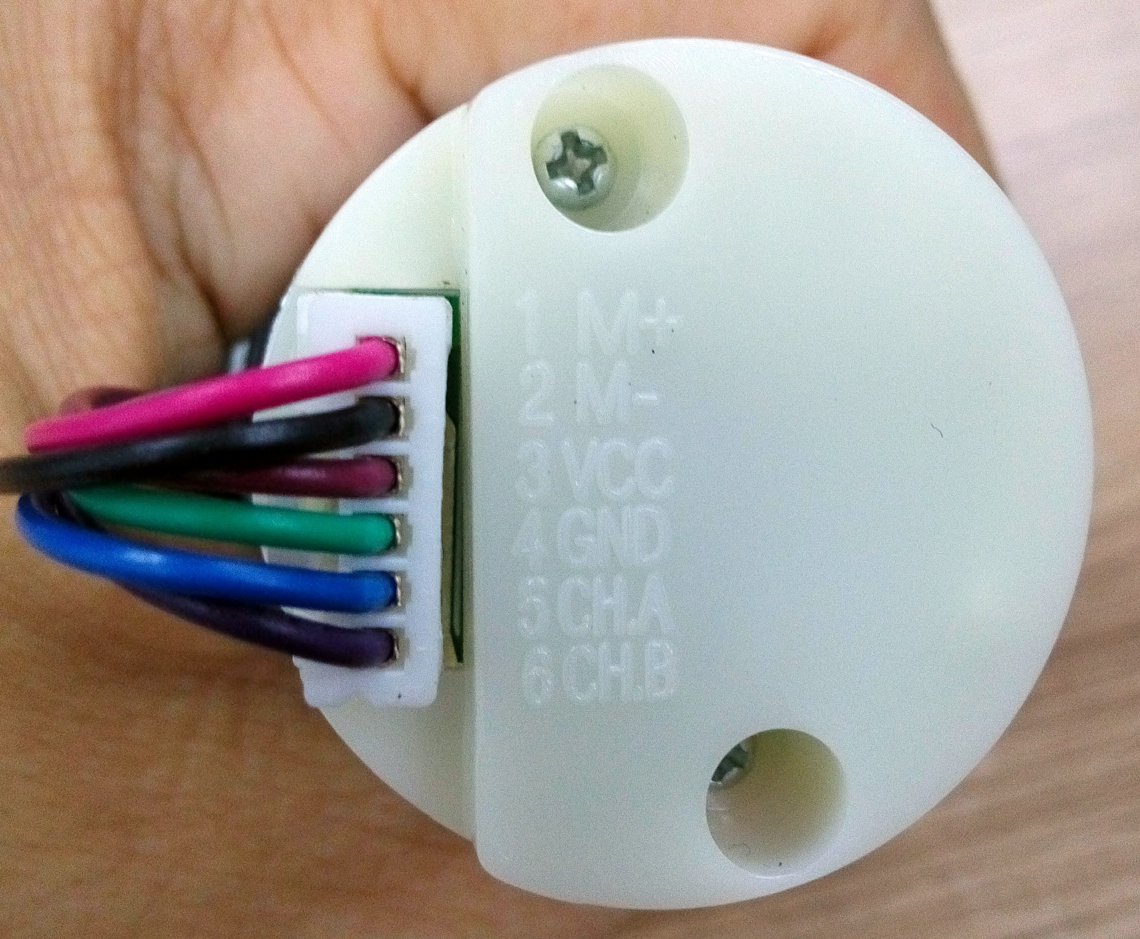

**Figure 2.2 Rear view of the motor with encoder and cover**

**3.0 SAMPLE SCHEMATIC**

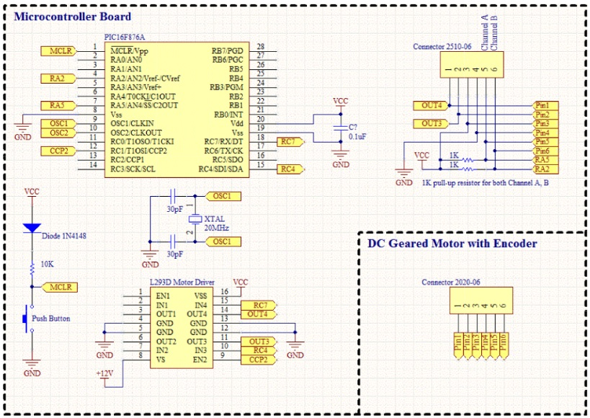**Figure 3.0 Sample schematic diagram with respect to sample source code\*\***

**Schematic above is an example with respect to the sample source code provided. RC4, RC7, RA2, and RA5 can be replaced by any other digital I/O pins. Besides, for PWM control, user can also use CCP1 instead of CCP2. For Channel A and channel B, this sample (schematic and source code) shows continuous monitoring of quadrature signals which can be done by any digital I/O pin. Users are encouraged to modify the schematic and source code to allow use of external interrupt to count the rising or falling edge of either channel to reduce the processing power used by monitoring both channel A and B. The encoder output is **open drain** or sometime called **NPN output**. Users need to pull-up resistor to any voltage user want. As an example circuit above, channel A and channel B are pull-up with 1K resistor to 5V, therefore it will output ground and 5V when the motor rotates.

Sample connection for encoder to the Arduino Board:

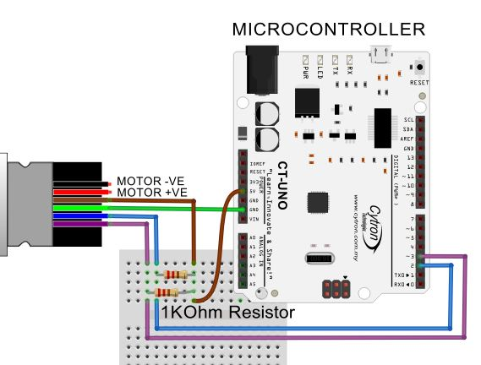

**4.0 WARRANTY**

* Product warranty is valid for 6 months.
* Warranty only applies to manufacturing defect.
* Damaged caused by misuse is not covered under warranty
* Warranty does not cover freight cost for both ways.

*Prepared by*

***Cytron Technologies Sdn. Bhd.***

No. 1, Lorong Industri Impian 1,

Taman Industri Impian,   
14000 Bukit Mertajam,  
Penang, Malaysia.

*Tel: +604-548 0668*

*Fax: +604-548 0669*

*URL:* [www.cytron.com.my](http://www.cytron.com.my/)

*Email:* [support@cytron.com.my](mailto:support@cytron.com.my)

[sales@cytron.com.my](mailto:sales@cytron.com.my)