

**Basic Linux Commands Assignments**

Assignment-1

Connect and disconnect with login Access

* What happens when you login a non-existent users or username?

Answer: We will get user does not exist message in the terminal.

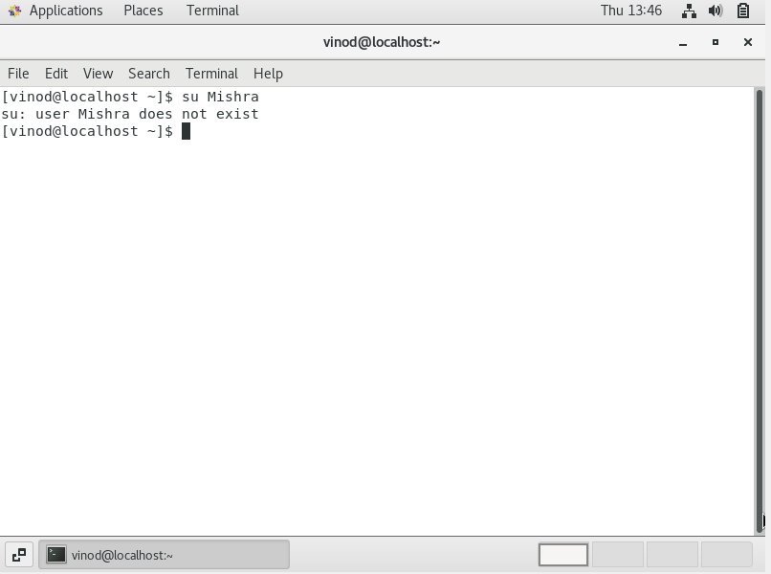

Assignment-2

Password changing

* Login into your account and then change password?
  + Change your password into ***IneuR0n#42*** and hit the **Enter** key

Answer: We will get the “Authentication token manipulation error”

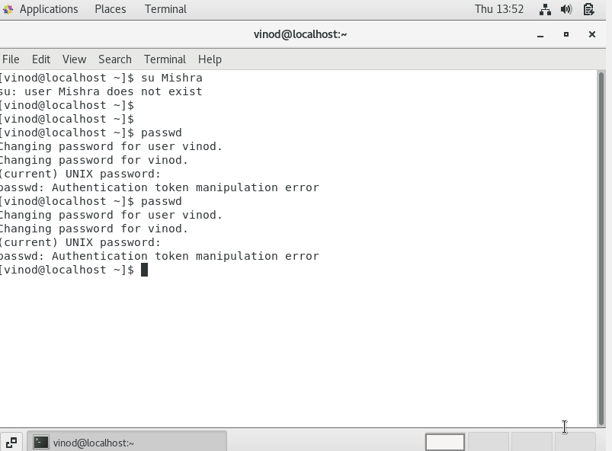

* + Try again to change password but use like password ***1234*** or ***abcd***

Answer: We will get the “Authentication token manipulation error”.

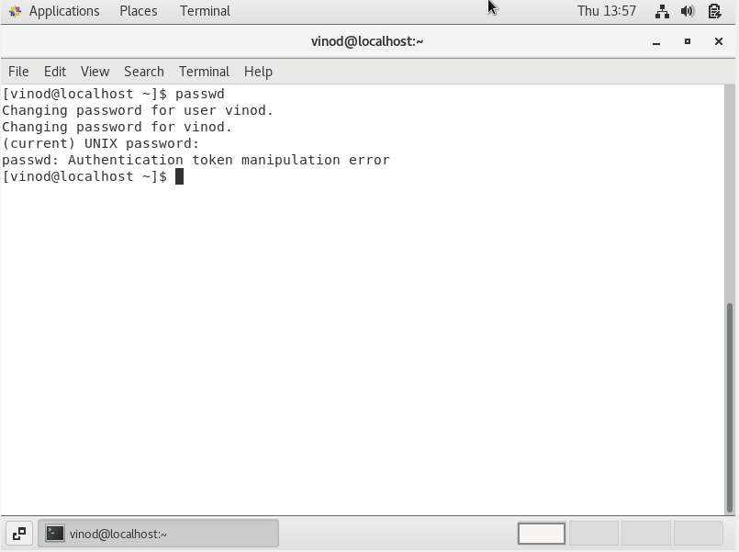

* + Try again to change password but now don’t use any password just hit **Enter** key

Answer:



Assignment-3

Working with Directories

* Enter the command **cd /** and then **ls** and then hit **Enter** key

Answer: / is the root directory of any Linux system. Everything on the our Linux system is present under this root directory.

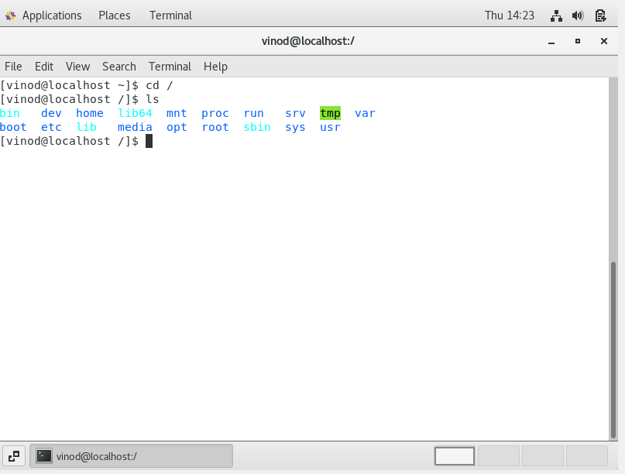

* Enter the command now **cd /home** and then hit **Enter** key

Answer: We will get the user inside the home directory. /home directory contain a home folder for each user.

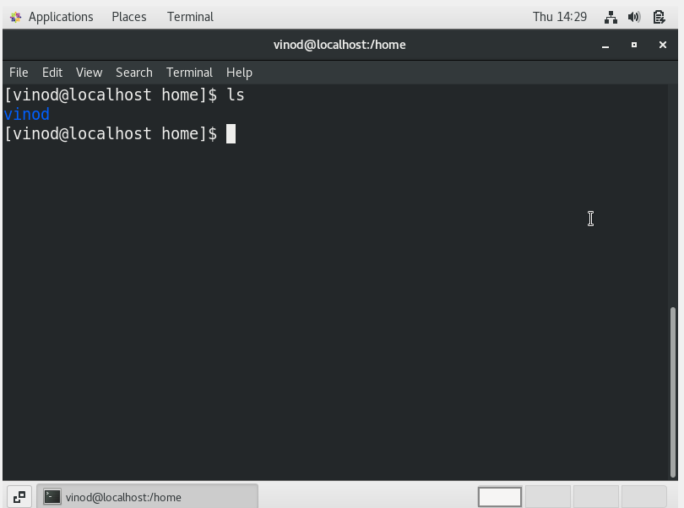

* Enter **cd ..** and hit **Enter** key [ *Note: here we have space after cd then use double dot*]

Answer: It will change the previous directory.

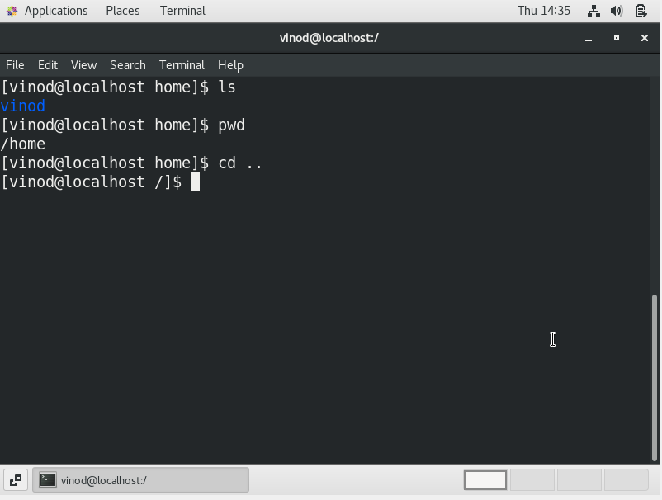

* Now enter **cd /var/www/html** and then type **cd** and hit **Enter** key

Answer:

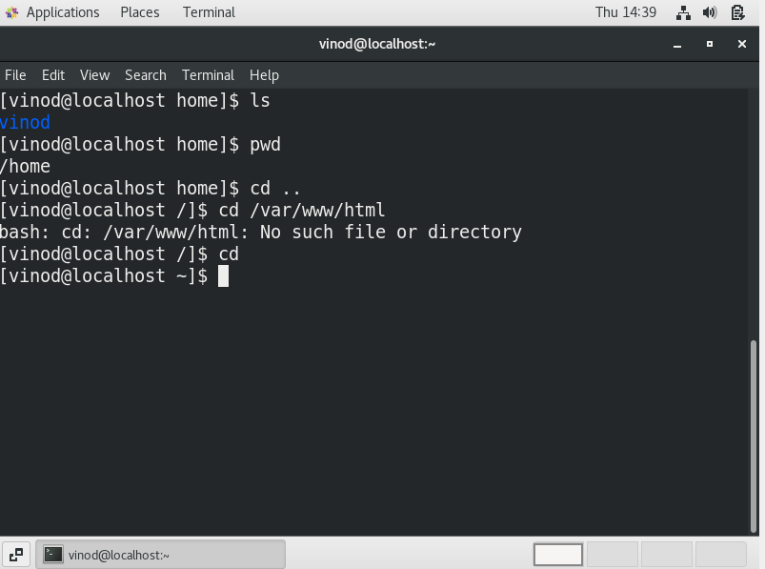

* Now type **cd /root** and then hit **Enter** key

Answer: Got the permission denied error as currently I am logged in as user.

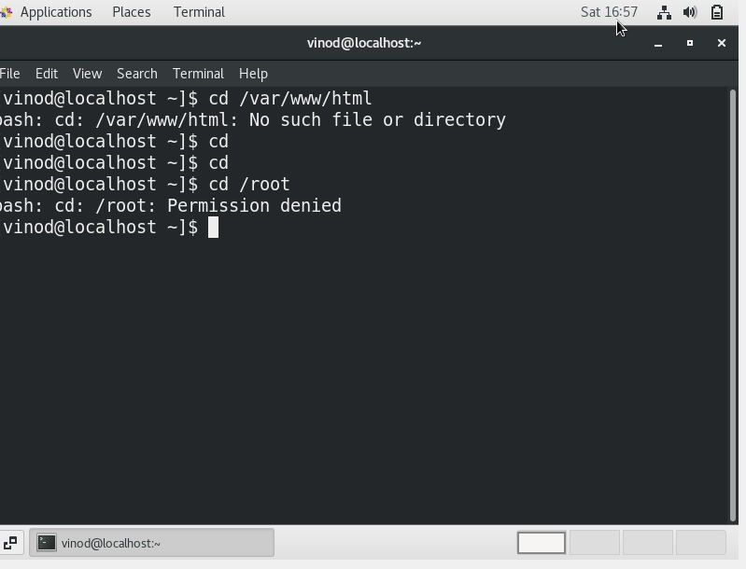

Assignment-4

Working with File Listing

* Go to **cd /etc** and type **ls**

Answer: This folder is a central location of all our configuration files.

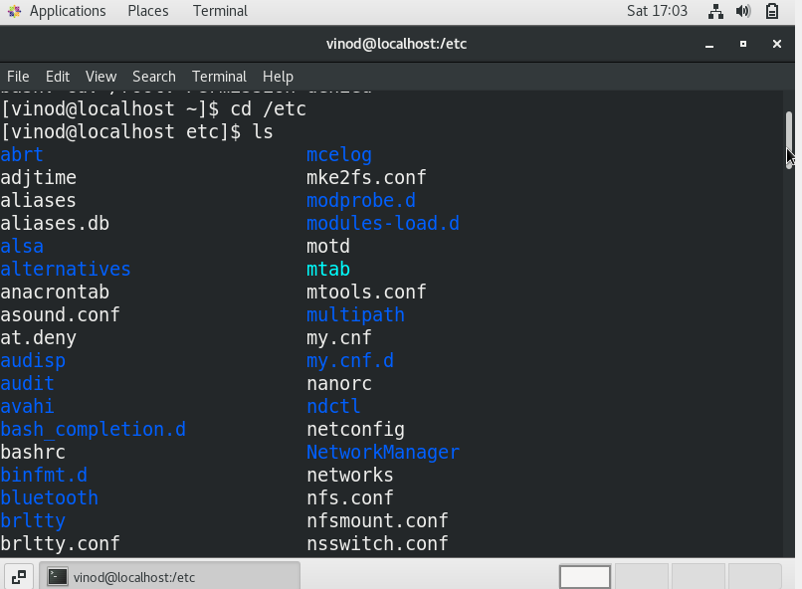

* Then type **ls -al** and hit **Enter** key

Answer: It will list all the hidden folders example .bash_profile

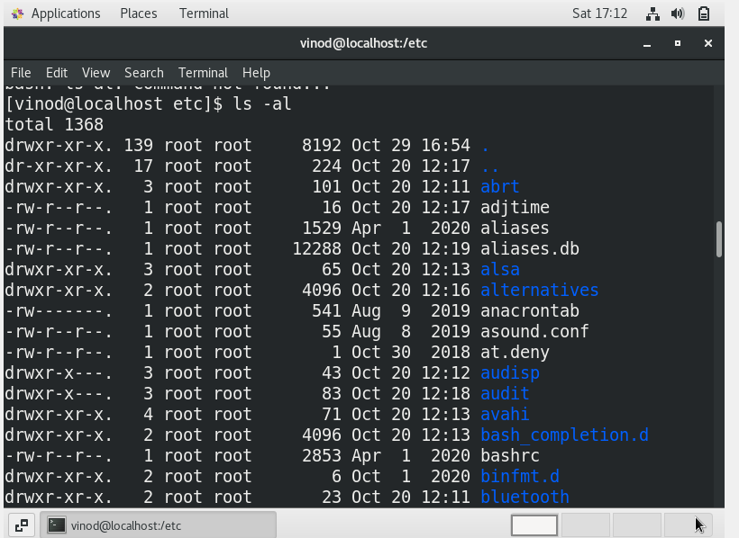

* Then use **ls -i** and hit **Enter** key

Answer: Getting the same output but including I node number.

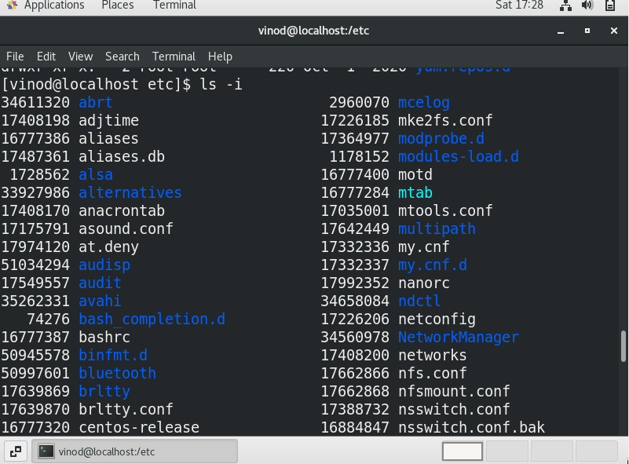

* Then use **ls –help** and see other options about **ls** command

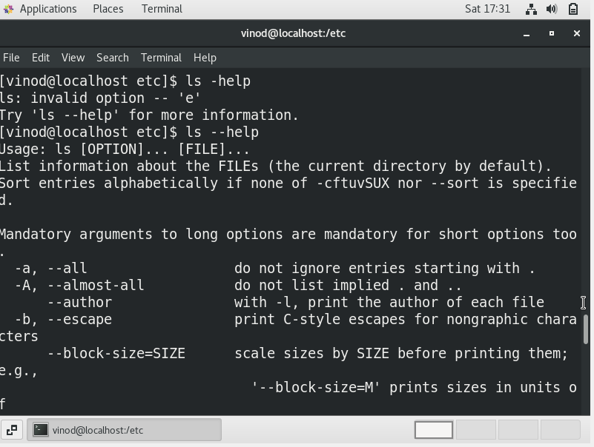

Assignment-5

Know where you are and where you working

*Here we use* ***pwd, cd and ls*** *as combine task to understand where you working on terminal and how you can switch from one directory to another one.*

* Open terminal after restart the linux

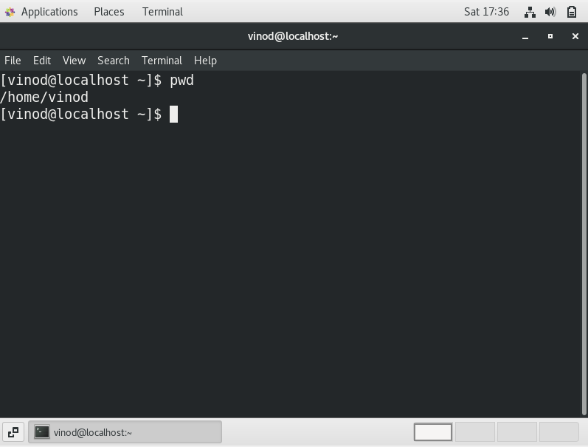

* Now use **cd /var** and hit **Enter** key

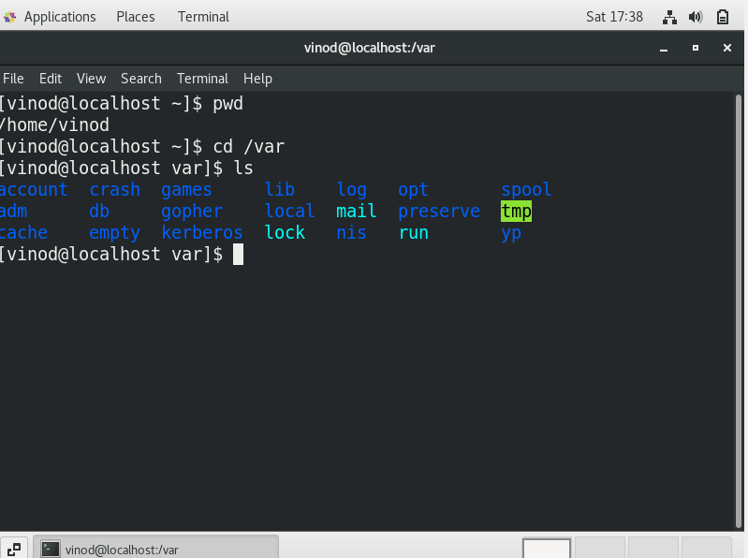

* Do explore other help options of each command to learn more other things we can do with these commands