Assignment Part-3

Playing with files

1. Create a file like nano file1.txt

* Edit some data and then save the file

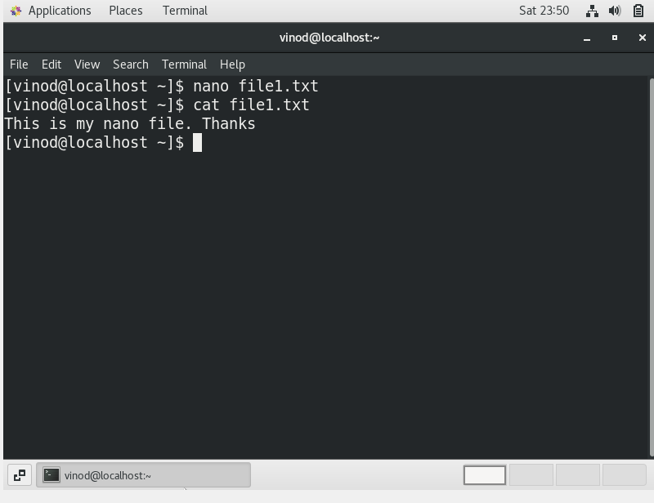

2. Now we will copy date from file1 to new file2

* cp file1.txt file2.txt
* Then see the output of file2.txt, cat file2.txt
* Give screenshot

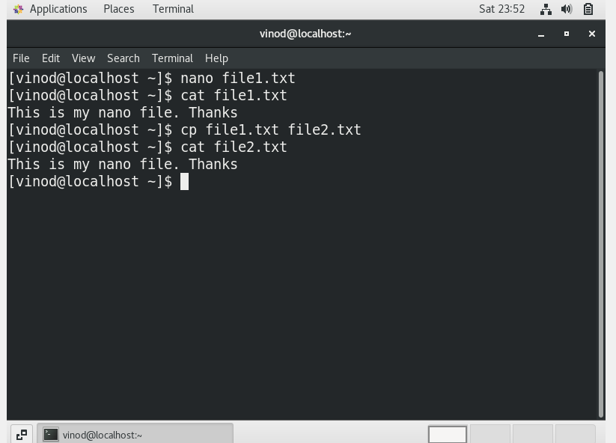

3. Now we will move the file2.txt to new folder /home

* mv file2.txt /home
* Then go to home directory and check ls, file exits or not?
* Given screenshot

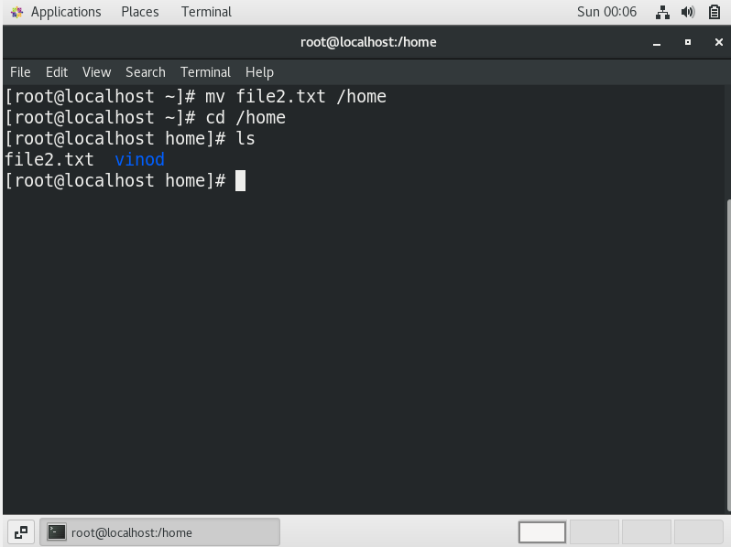

4. Then we create a new file3.txt and file4.txt in home directory and add content in it.

* Now do echo “Hello I am newline” > file3.txt and provide the output of file3.txt

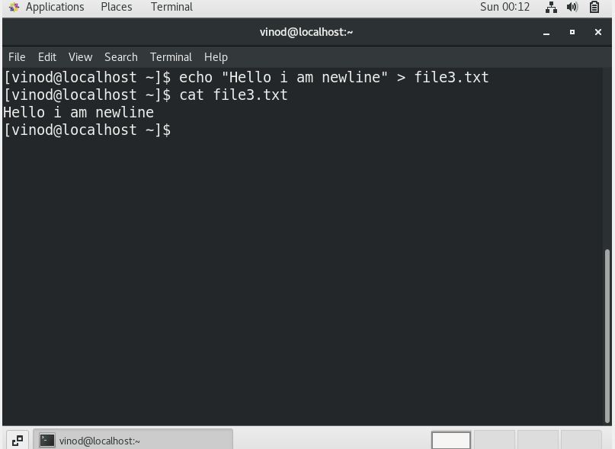

* Now do echo “Hello I am newline” >> file4.txt and provide the output of file4.txt

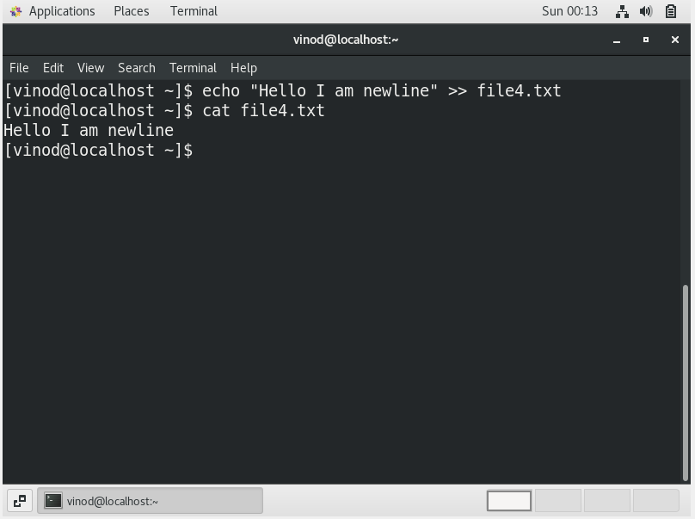

* Tell the different between both step you follow and the reason behind it.

Answer: In first step we are creating a new file and in the second step we are appending the file.

5. For remove a file or directory you can use the below two commands

* To delete a file – rm <any_filename>

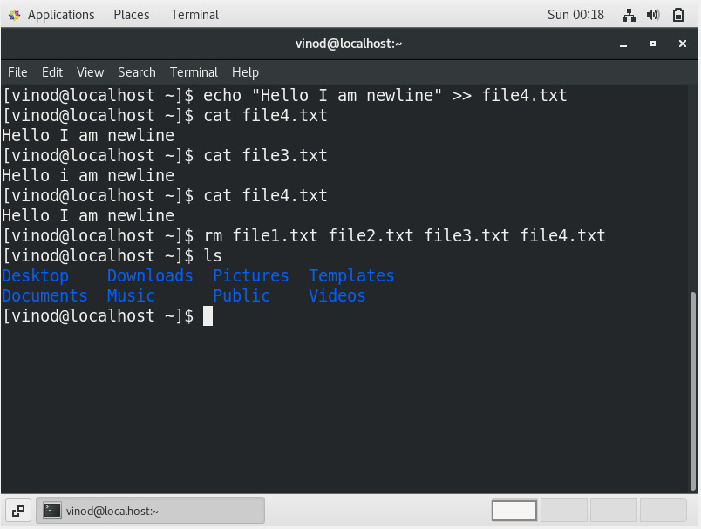

* To delete a directory – rm <any_anydirectory>

