AI Tools and Frameworks: Theoretical Understanding Report

Part of AI Tools and Applications

Prepared by: GROUP

Date: [Insert Date]

Institution: [Insert Institution Name]

# Abstract

Artificial Intelligence (AI) has revolutionized multiple sectors through its ability to learn patterns, make predictions, and automate tasks. Central to the success of AI are tools and frameworks that provide infrastructure for model development and deployment. This report explores key AI tools—including TensorFlow, PyTorch, Scikit-learn, spaCy, and Jupyter Notebooks—by examining their use cases, strengths, weaknesses, and practical applications. Through theoretical comparisons and real-world examples, the report aims to guide the selection and effective use of these frameworks in various AI workflows.

# 1. Introduction

AI tools and frameworks are critical for implementing and operationalizing AI models. They provide high-level APIs and optimized performance for model training, testing, evaluation, and deployment. With rapid advancements in hardware and cloud computing, these tools help translate theoretical models into scalable, efficient solutions across industries.

# 2. Understanding AI Tools and Frameworks

## 2.1 What Are AI Tools and Frameworks?

AI tools and frameworks are software environments that simplify the development of machine learning (ML) and AI applications. They abstract complex mathematical computations and provide modules for data processing, model design, training, and evaluation.

## 2.2 Importance in Real-World Context

These tools reduce the time, effort, and complexity required to build AI systems. They facilitate reproducibility, enable faster deployment, and integrate performance tracking tools. Fields like healthcare, agriculture, education, and finance benefit significantly from these frameworks.

# 3. Key Types of AI Tools

|  |  |
| --- | --- |
| Tool | Primary Use |
| Scikit-learn | Regression, classification, clustering |
| TensorFlow, PyTorch | Neural networks, CNNs, RNNs |
| spaCy | Tokenization, NER, POS tagging |
| Jupyter Notebooks | Exploratory data analysis, prototyping |
| TensorFlow Lite, Flask, Streamlit | Mobile/web applications |

# 4. Real-World Applications

|  |  |
| --- | --- |
| Tool | Use Case |
| TensorFlow | Diabetic retinopathy detection |
| Scikit-learn | Hospital readmission prediction |
| PyTorch | Product recommendation engine |
| spaCy | Brand extraction from user reviews |
| Scikit-learn | Fraud detection |
| TensorFlow | Stock market trend forecasting |
| TensorFlow | Plant disease classification |
| spaCy | Market/weather data text analysis |

# 5. Choosing the Right Tool

|  |  |
| --- | --- |
| Task | Recommended Tool |
| Predict customer churn | Scikit-learn |
| Recognize handwritten digits | TensorFlow or PyTorch |
| Extract brand names from reviews | spaCy |
| Rapid data exploration | Jupyter Notebooks |
| Deploy web-based prediction tool | Flask or Streamlit |

# 6. Pros and Cons of Popular Frameworks

|  |  |  |
| --- | --- | --- |
| Tool | Pros | Cons |
| Scikit-learn | Easy to use, consistent API | Limited to classical ML |
| TensorFlow | Scalable, great for deployment | Steeper learning curve |
| PyTorch | Dynamic graphs, research-friendly | Fewer deployment tools |
| spaCy | Fast NLP, pre-trained pipelines | Limited deep NLP extensions |
| Jupyter Notebook | Interactive, good for learning | Not production-ready |

# 7. Theoretical Insights

## 7.1 TensorFlow vs. PyTorch

TensorFlow uses static computation graphs and is optimized for deployment. PyTorch uses dynamic graphs and is preferred in research.

## 7.2 Jupyter Notebooks in AI

Useful for Exploratory Data Analysis and step-by-step model development with integrated markdown and code.

## 7.3 spaCy vs. Python String Operations

spaCy provides industrial-grade NLP with NER, POS tagging, and tokenization, unlike basic string methods.

## 7.4 Scikit-learn vs. TensorFlow

|  |  |  |
| --- | --- | --- |
| Aspect | Scikit-learn | TensorFlow |
| Type of Models | Classical ML | Deep Learning |
| Data Types | Structured | Unstructured |
| Usability | Simple API | Flexible via Keras |
| Community | Strong academic use | Vast industry support |

# 8. Code Results and Evaluation

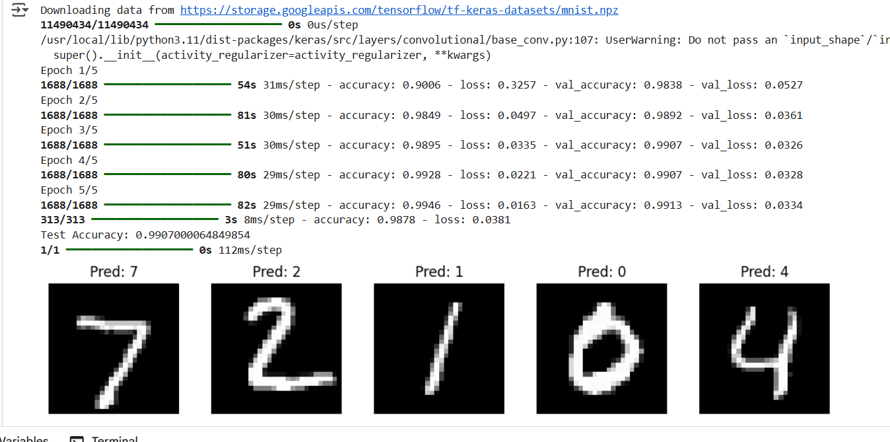

Figure 1: CNN Model Training on MNIST Dataset

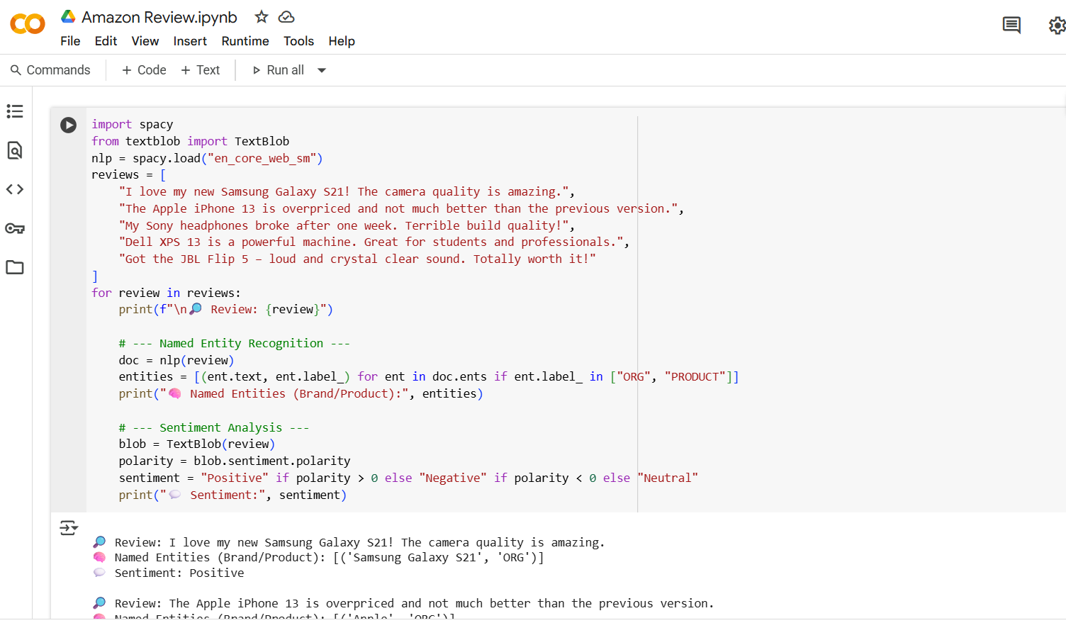

Figure 2: spaCy NER and TextBlob Sentiment Code

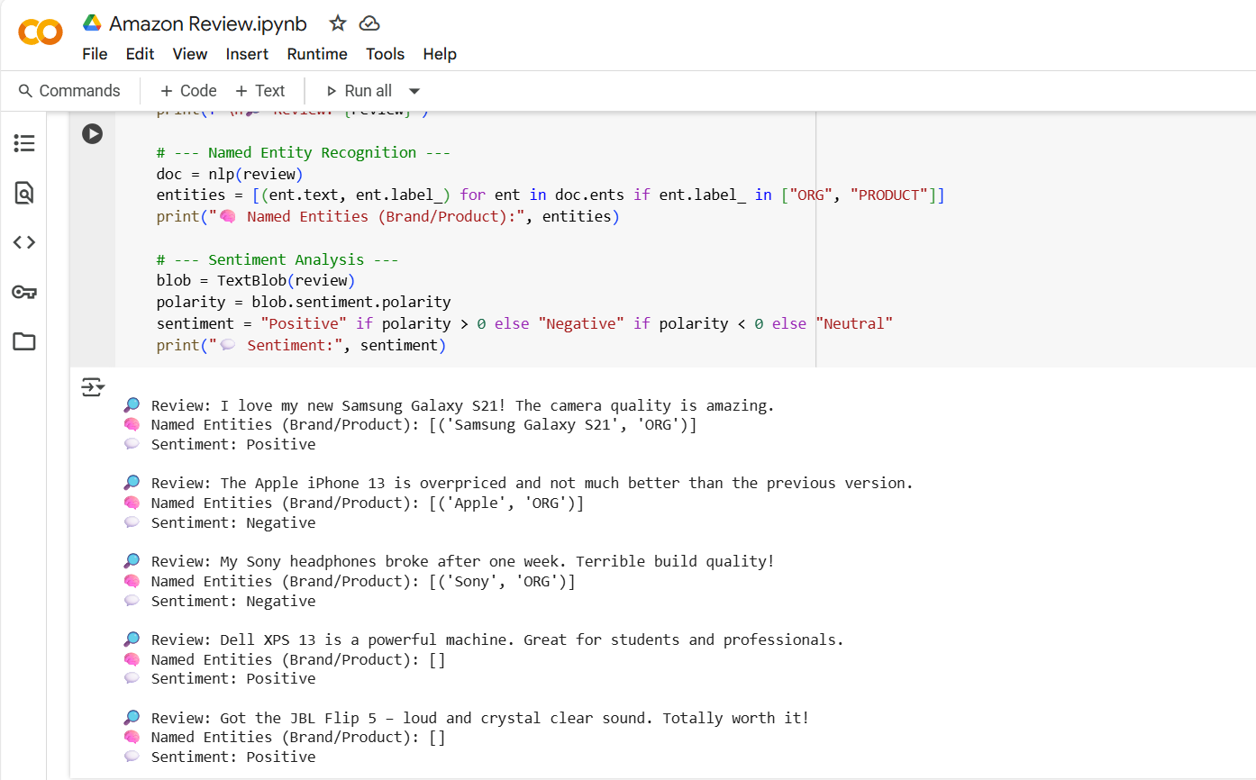

Figure 3: Output of spaCy NER and Sentiment

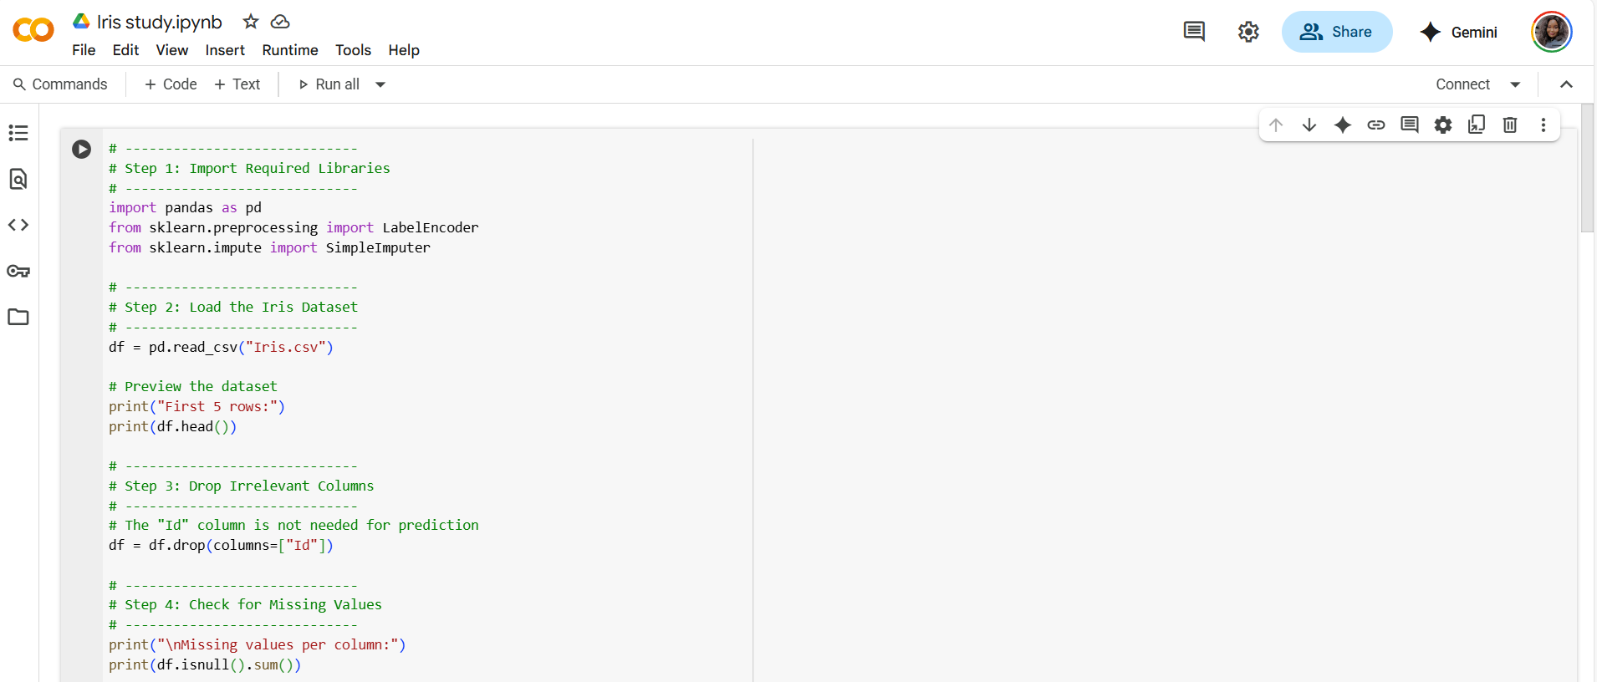

Figure 4: Iris Dataset Preprocessing Code

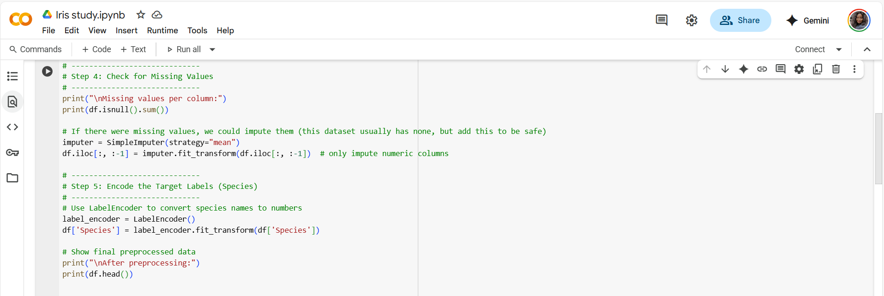

Figure 5: Label Encoding and Missing Value Handling

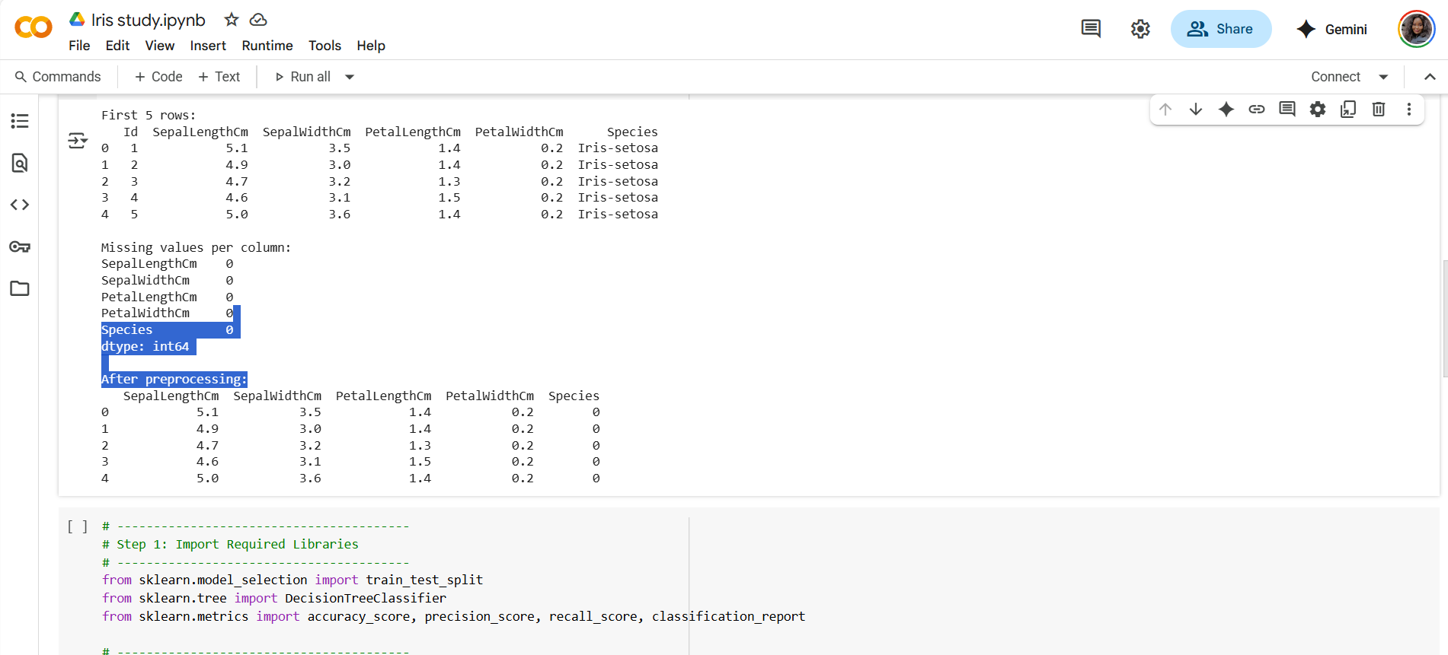

Figure 6: Missing Values and Encoded Output

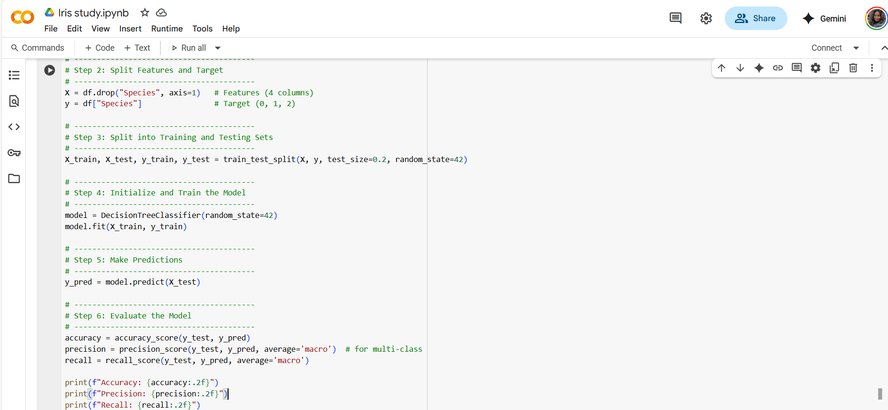

Figure 7: Model Training and Prediction

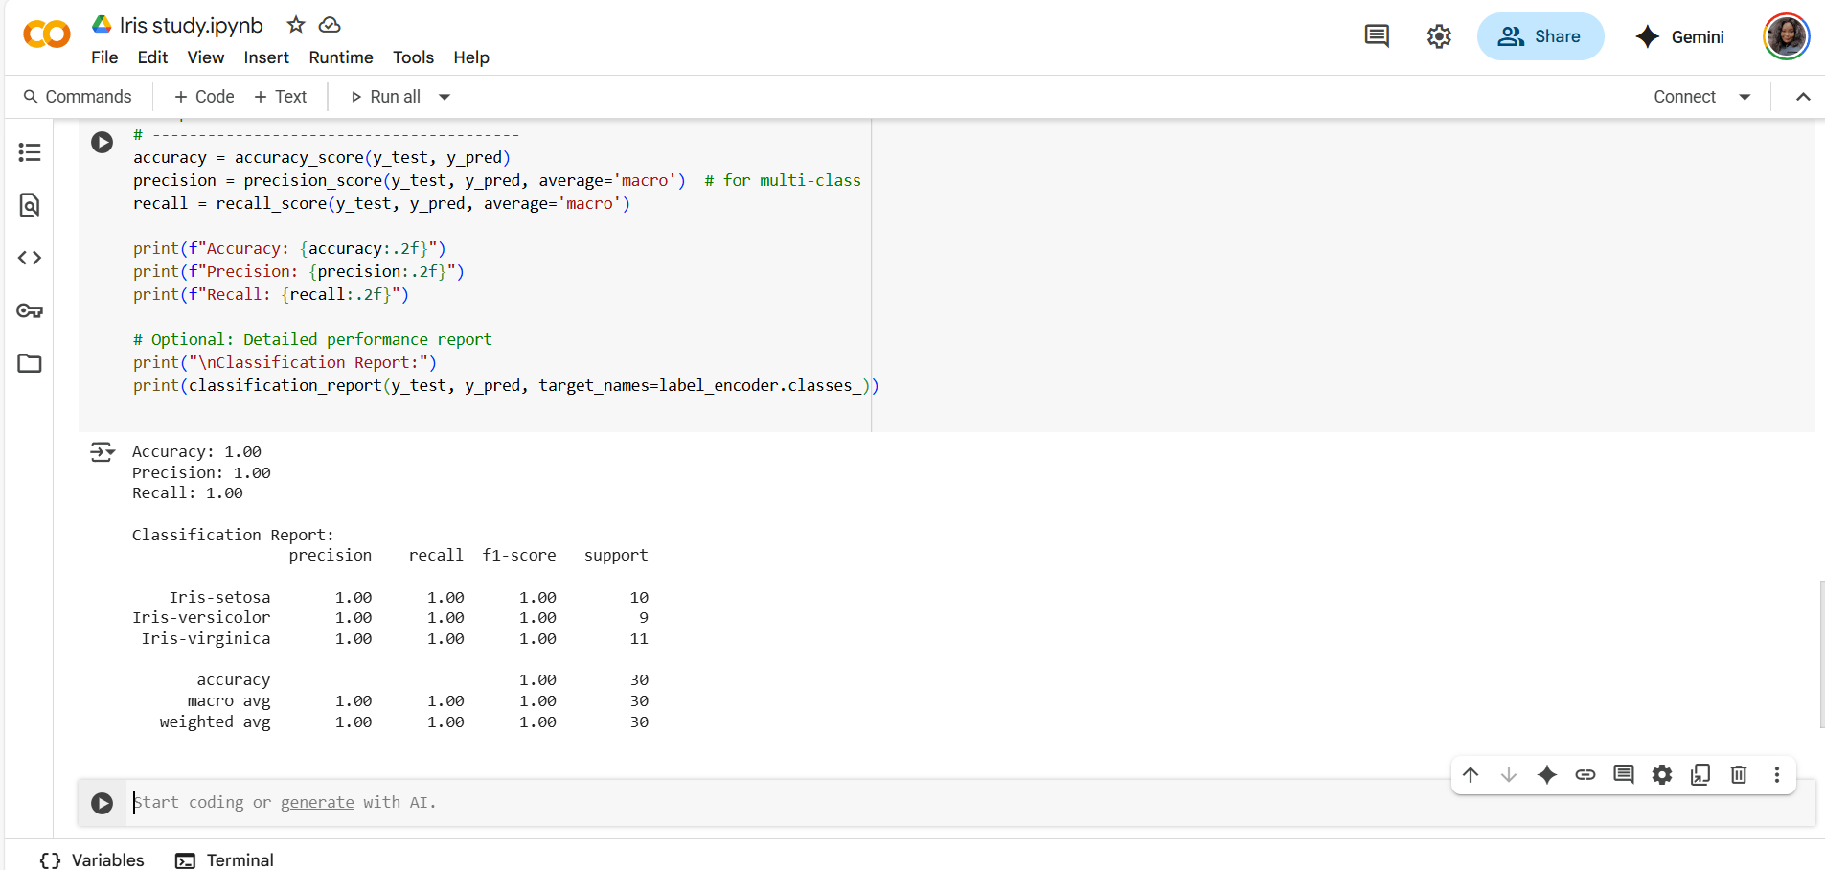

Figure 8: Final Classification Report

9. Ethics & Optimization – Self Review

# 1. Ethical Considerations

## Amazon Reviews – My Reflections

While working with the Amazon Reviews data, I used spaCy for Named Entity Recognition and created a simple rule-based sentiment classifier. However, I’ve realized there are several ethical considerations I need to address:  
  
- Bias in Sentiment Detection: My rule-based sentiment analysis may not account for sarcasm, cultural language nuances, or informal expressions. For example, phrases like “This product is sick!” might be misclassified if not handled carefully.  
- Imbalanced Representation: If my dataset has more positive reviews for certain brands, the system might wrongly assume those brands are always good. This could lead to biased recommendations.  
  
To reduce this bias, I could:  
- Incorporate custom spaCy patterns to better handle negation (e.g., 'not great').  
- Use more balanced datasets or normalize entity counts so that frequently mentioned brands don’t dominate the NER results unfairly.  
- In the future, integrating a small ML-based sentiment model with fairness constraints would improve objectivity.

## MNIST CNN Model – Ethical Perspective

While developing the CNN for digit recognition, I used the standard MNIST dataset. Reflecting critically, I noticed:  
  
- Bias from Data Composition: The MNIST dataset features clean, centered digits in a Western handwriting style. My model might struggle with culturally diverse or less “neat” handwriting, which isn’t fair if it were used in real-world settings.  
  
To address this, I would:  
- Use data augmentation to simulate writing variability (rotation, slant, size).  
- Consider using TensorFlow Fairness Indicators to analyze performance differences across digit classes.  
- Explore datasets like EMNIST, which includes more diversity in character styles.

# 2. Troubleshooting Challenge – Fixing My TensorFlow Code

In my original MNIST_CNN_Assignment.ipynb, I encountered a few issues that affected the model’s correctness and performance:

|  |  |
| --- | --- |
| Issue | Explanation |
| Input shape mismatch | I didn’t reshape the image data to 4D (needed for Conv2D) |
| Missing normalization | I forgot to divide by 255 to scale pixel values |
| Incorrect activation | I used a non-softmax activation in the final layer |
| Wrong loss function | I used a binary or categorical loss instead of sparse_categorical_crossentropy for integer labels |

# Final Reflection

This section reminded me that building models is more than just getting high accuracy. I’ve learned that:  
- Biases—whether in text or vision—can sneak in through data and design.  
- Tools like spaCy’s rule-based matchers and TensorFlow Fairness Indicators can help me build more inclusive, balanced systems.  
- Careful debugging of loss functions, input shapes, and activation choices is essential for functional and ethical ML models.