STACK_PRIORIT-QUEUE_HASHMAP

* HEAPS

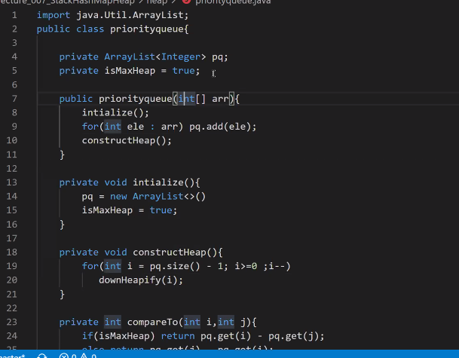

* WHY COMPLEXITY IS LINEAR WHEN WE ARE BUILDING HEAP

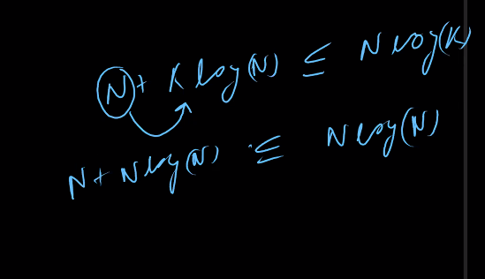

* HOW TO REDUCE COMPLEXITY OF KTH LARGEST ELEMENT ;

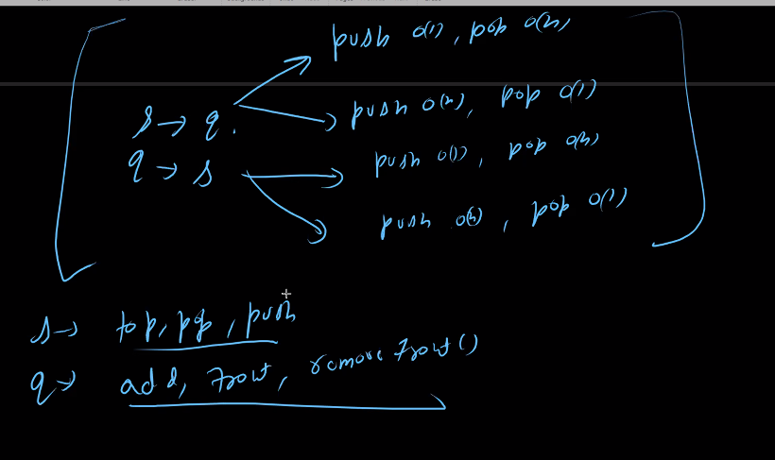

* DAY-1 HOMEWORK STACK AND STACK ADAPTER CLASSES

LINEAR TIME REASONING FOR HEAPS

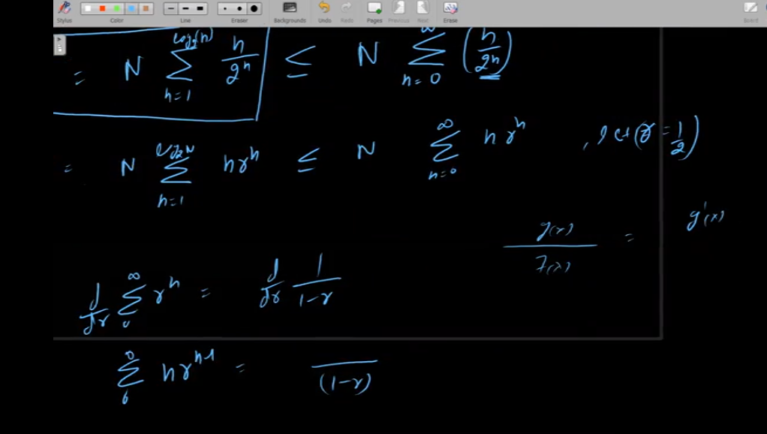

HASHMAPS

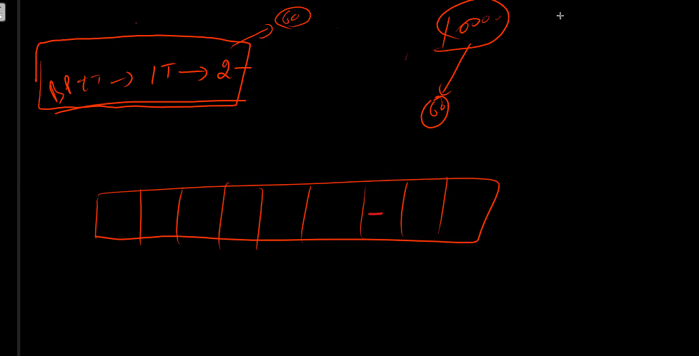

Hashmap is annotized means not fix time

Leetcode 128

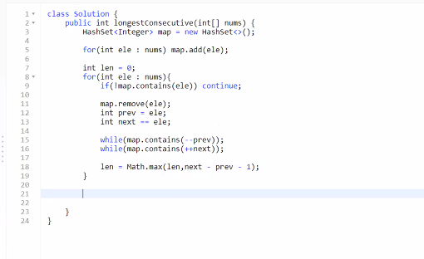

Leetcode 760 lockesr

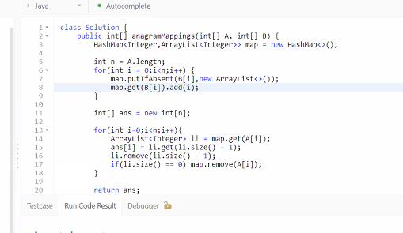

Leetcode 973

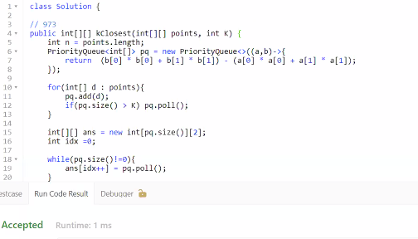

Leetcode 908

