**INDEX**

**Subject:- CA LAB-VII(A): LAB on Machine Learning**

|  |  |  |  |
| --- | --- | --- | --- |
| **Sr.No.** | **Name Of The Practical** | **Date** | **Remark** |
| **1** | **Introduction to Pycharm, Pandas Library, DataFrames, And Loading CSV File in DataFrame.** |  |  |
| **2** | **Implement the Find-S Inductive Learning algorithm.** |  |  |
| **3** | **Implement the Candidate-Elimination Inductive Learning algorithm.** |  |  |
| **4** | **Write program for linear regression and find parameters like Mean Squared Error** |  |  |
| **5.1** | **Write a program to implement Decision tree using the Python/R/Programming language of your choice** |  |  |
| **5.2** | **Write a program to calculate popular attribute selection measures (ASM) like Information Gain, Gain Ratio, and Gini Index etc. for decision tree.** |  |  |
| **6** | **Implement simple KNN using Euclidean distance in python.** |  |  |
| **7** | **Write a program to implement k-Nearest Neighbour algorithm to classify the iris dataset. Print both correct and wrong predictions. Java/Python ML library classes can be used for this problem.** |  |  |
| **8** | **Write a Program for Confusion Matrix and calculate Precision, Recall, F-Measure** |  |  |
| **9** | **Write a program for linear regression and find parameters like Sum of Squared Errors (SSE), Total Sum of Squares (SST), R2, Adjusted R2, etc.** |  |  |
| **10** | **Write a program to implement the naïve Bayesian classifier for a sample training dataset stored as a . CSV file. Compute the accuracy of the classifier, considering a few test data sets.** |  |  |
| **11.1** | **Implementing Agglomerative Clustering in Python** |  |  |
| **11.2** | **Write a Program for Fuzzy c-means clustering in Python.** |  |  |
| **12** | **Implement the non-parametric Locally Weighted Regression algorithm in order to fit data points. Select the appropriate data set for your experiment and draw graphs.** |  |  |
| **13.1** | **Build a Simple Artificial Neural Network** |  |  |
| **13.2** | **Build an Artificial Neural Network by implementing the Backpropagation algorithm and test the same using appropriate data sets.** |  |  |

**Practical – 1: Introduction to pycharm, Pandas Library, DataFrames, And Loading CSV File in DataFrame**

import pandas as pd

'''pd.__version__'''

df1 = pd.DataFrame({"A": [1, 2, 3], "B": [2, 3, 4]}, index=[0, 1, 2])

print("df1:\n", df1)

df2 = pd.DataFrame({"B": [4, 5, 7], "C": ["x", "y", "z"]}, index=[4, 5, 6])

print("\ndf2:\n", df2)

df3 = df1.combine_first(df2)

print("\n combination of df1 and df2:\n", df3)

classes = pd.Series(["mathematics", "chemistry", "physics", "history", "geography", "german"])

grades = pd.Series([90, 54, 77, 22, 25, 40])

year = pd. Series([2015, 2016, 2017, 2018, 2019, 2020])

df4 = pd. DataFrame({"Classes": classes, "Grades": grades, "Year": year})

print("\n", df4)

# upload a csv file in sample_data section

# load the .csv in data frame

data_frame = pd.read_csv("C:/Users/sejal/PycharmProjects/dataset.csv")

print("\n", data_frame)

**OUTPUT :**

C:\Users\sejal\MCA-I_ML\Scripts\python.exe C:/Users/sejal/PycharmProjects/MCA-I_ML/1_prat.py

df1:

A B

0 1 2

1 2 3

2 3 4

df2:

B C

4 4 x

5 5 y

6 7 z

combination of df1 and df2:

A B C

0 1.0 2 NaN

1 2.0 3 NaN

2 3.0 4 NaN

4 NaN 4 x

5 NaN 5 y

6 NaN 7 z

Classes Grades Year

0 mathematics 90 2015

1 chemistry 54 2016

2 physics 77 2017

3 history 22 2018

4 geography 25 2019

5 german 40 2020

sky temp humidity water wind forcast enjoy-sport

0 sunny warm high cool strong same yes

1 sunny warm high warm strong same yes

2 rainy cold low warm weak change no

3 rainy cold high warm weak change no

4 sunny warm high warm strong same yes

5 sunny cold high warm strong same no

**Practical - 2.: Implement the find-S inductive learning algorithm.**

import pandas as pd  
import numpy as np  
  
*# To read the data in csv file*data = pd.read_csv("C:/Users/comp273/Desktop/pract1ML.csv")  
print("The Data-set For Enjoy Sport Example is:- ")  
print(data)  
  
*# Making an array of all the attributes*d = np. array(data)[:, :-1]  
print("\nThe Attributes are :- ")  
print(d)  
  
*# Segragating the target that has positive and negative example*target = np.array(data)[:, -1]  
print("\nThe Target is :- ")  
print(target)  
  
*# Find S-algorithm - initial and f hypothesis*def train(c, t):  
 for i, val in enumerate(t):  
 if val == "yes":  
 sp_hp = d[i].copy()  
 break  
 print("\nInitial Hypothesis:- ")  
 print(sp_hp, "\n")  
  
  
 for i, val in enumerate(c):  
 if target[i] == "yes":  
 for x in range(len(sp_hp)):  
 if sp_hp[x] != val[x]:  
 sp_hp[x] = "?"  
 else:  
 pass  
 print("Hypothesis is:- ", i, "= ", sp_hp)  
 return sp_hp  
  
print("\nFinal Hypothesis is :- ", train(d, target))

**OUTPUT:**

C:\Users\comp273\PycharmProjects\ML_107\venv\Scripts\python.exe C:/Users/comp273/PycharmProjects/ML_107/find_s_algo.py

The Data-set For Enjoy Sport Example is:-

Sky AirTemp Humidity Wind Water Forcast EnjoySport

0 sunny warm normal strong warm same yes

1 sunny warm high strong warm same yes

2 sunny cold high strong warm change yes

3 rainy cold normal strong cool change no

4 sunny cold high weak warm change no

5 sunny cold normal weak warm same yes

6 rainy warm high weak cool change no

The Attributes are :-

[['sunny' 'warm' 'normal' 'strong' 'warm' 'same']

['sunny' 'warm' 'high' 'strong' 'warm' 'same']

['sunny' 'cold' 'high' 'strong' 'warm' 'change']

['rainy' 'cold' 'normal' 'strong' 'cool' 'change']

['sunny' 'cold' 'high' 'weak' 'warm' 'change']

['sunny' 'cold' 'normal' 'weak' 'warm' 'same']

['rainy' 'warm' 'high' 'weak' 'cool' 'change']]

The Target is :-

['yes' 'yes' 'yes' 'no' 'no' 'yes' 'no']

Initial Hypothesis:-

['sunny' 'warm' 'normal' 'strong' 'warm' 'same']

Hypothesis is:- 0 = ['sunny' 'warm' 'normal' 'strong' 'warm' 'same']

Hypothesis is:- 1 = ['sunny' 'warm' '?' 'strong' 'warm' 'same']

Hypothesis is:- 2 = ['sunny' '?' '?' 'strong' 'warm' '?']

Hypothesis is:- 3 = ['sunny' '?' '?' 'strong' 'warm' '?']

Hypothesis is:- 4 = ['sunny' '?' '?' 'strong' 'warm' '?']

Hypothesis is:- 5 = ['sunny' '?' '?' '?' 'warm' '?']

Hypothesis is:- 6 = ['sunny' '?' '?' '?' 'warm' '?']

Final Hypothesis is :- ['sunny' '?' '?' '?' 'warm' '?']

Process finished with exit code 0

**Practical - 3 .: Implement the Candidate-Elimination Inductive Learning algorithm.**

import numpy as np

import pandas as pd

data = pd.read_csv("C:/Users/sejal/OneDrive/Desktop/FyMca Sem II Notes/"

"Practical Practice/CA LAB-VII(A) ML/Enjoy-sportExample.csv")

concepts = np.array(data.iloc[:, 0:-1])

print("\nInstances are:\n", concepts)

target = np.array(data.iloc[:, -1])

print("\nTarget Values are: ", target)

def learn(concepts, target):

specific_h = concepts[0].copy()

print("\nInitialization of Specific_Hypothesis and General_Hypothesis")

print("\nSpecific Boundary: ", specific_h)

general_h = [["?" for i in range(len(specific_h))] for i in range(len(specific_h))]

print("\nGeneric Boundary: ", general_h)

for i, h in enumerate(concepts):

print("Instance", i+1, "is ", h)

if target[i] == "yes":

print("Instance is Positive ")

for x in range(len(specific_h)):

if h[x] != specific_h[x]:

specific_h[x] = '?'

general_h[x][x] = '?'

else:

print("Instance is Negative ")

for x in range(len(specific_h)):

if h[x] != specific_h[x] and specific_h[x] != '?':

general_h[x][x] = specific_h[x]

else:

general_h[x][x] = '?'

print("Specific Boundary after ", i+1, "Instance is ", specific_h)

print("Generic Boundary after ", i+1, "Instance is ", general_h)

print("\n")

indices = [i for i, val in enumerate(general_h) if val == ['?', '?', '?', '?', '?', '?']]

for i in indices:

general_h.remove(['?', '?', '?', '?', '?', '?'])

return specific_h, general_h

s_final, g_final = learn(concepts, target)

print("Final Specific_Hypothesis: ", s_final, sep="\n")

print("Final General_Hypothesis: ", g_final, sep="\n")

**OUTPUT:**

C:\Users\sejal\MCA-I_ML\Scripts\python.exe C:/Users/sejal/PycharmProjects/MCA-I_ML/candidate_elimination.py

Instances are:

[['sunny' 'warm' 'normal' 'strong' 'warm' 'same']

['sunny' 'warm' 'high' 'strong' 'warm' 'same']

['sunny' 'cold' 'high' 'strong' 'warm' 'change']

['rainy' 'cold' 'normal' 'strong' 'cool' 'change']

['sunny' 'cold' 'high' 'weak' 'warm' 'change']

['sunny' 'cold' 'normal' 'weak' 'warm' 'same']

['rainy' 'warm' 'high' 'weak' 'cool' 'change']]

Target Values are: ['yes' 'yes' 'yes' 'no' 'no' 'yes' 'no']

Initialization of Specific_Hypothesis and General_Hypothesis

Specific Boundary: ['sunny' 'warm' 'normal' 'strong' 'warm' 'same']

Generic Boundary: [['?', '?', '?', '?', '?', '?'], ['?', '?', '?', '?', '?', '?'], ['?', '?', '?', '?', '?', '?'], ['?', '?', '?', '?', '?', '?'], ['?', '?', '?', '?', '?', '?'], ['?', '?', '?', '?', '?', '?']]

Instance 1 is ['sunny' 'warm' 'normal' 'strong' 'warm' 'same']

Instance is Positive

Specific Boundary after 1 Instance is ['sunny' 'warm' 'normal' 'strong' 'warm' 'same']

Generic Boundary after 1 Instance is [['?', '?', '?', '?', '?', '?'], ['?', '?', '?', '?', '?', '?'], ['?', '?', '?', '?', '?', '?'], ['?', '?', '?', '?', '?', '?'], ['?', '?', '?', '?', '?', '?'], ['?', '?', '?', '?', '?', '?']]

Instance 2 is ['sunny' 'warm' 'high' 'strong' 'warm' 'same']

Instance is Positive

Specific Boundary after 2 Instance is ['sunny' 'warm' '?' 'strong' 'warm' 'same']

Generic Boundary after 2 Instance is [['?', '?', '?', '?', '?', '?'], ['?', '?', '?', '?', '?', '?'], ['?', '?', '?', '?', '?', '?'], ['?', '?', '?', '?', '?', '?'], ['?', '?', '?', '?', '?', '?'], ['?', '?', '?', '?', '?', '?']]

Instance 3 is ['sunny' 'cold' 'high' 'strong' 'warm' 'change']

Instance is Positive

Specific Boundary after 3 Instance is ['sunny' '?' '?' 'strong' 'warm' '?']

Generic Boundary after 3 Instance is [['?', '?', '?', '?', '?', '?'], ['?', '?', '?', '?', '?', '?'], ['?', '?', '?', '?', '?', '?'], ['?', '?', '?', '?', '?', '?'], ['?', '?', '?', '?', '?', '?'], ['?', '?', '?', '?', '?', '?']]

Instance 4 is ['rainy' 'cold' 'normal' 'strong' 'cool' 'change']

Instance is Negative

Specific Boundary after 4 Instance is ['sunny' '?' '?' 'strong' 'warm' '?']

Generic Boundary after 4 Instance is [['sunny', '?', '?', '?', '?', '?'], ['?', '?', '?', '?', '?', '?'], ['?', '?', '?', '?', '?', '?'], ['?', '?', '?', '?', '?', '?'], ['?', '?', '?', '?', 'warm', '?'], ['?', '?', '?', '?', '?', '?']]

Instance 5 is ['sunny' 'cold' 'high' 'weak' 'warm' 'change']

Instance is Negative

Specific Boundary after 5 Instance is ['sunny' '?' '?' 'strong' 'warm' '?']

Generic Boundary after 5 Instance is [['?', '?', '?', '?', '?', '?'], ['?', '?', '?', '?', '?', '?'], ['?', '?', '?', '?', '?', '?'], ['?', '?', '?', 'strong', '?', '?'], ['?', '?', '?', '?', '?', '?'], ['?', '?', '?', '?', '?', '?']]

Instance 6 is ['sunny' 'cold' 'normal' 'weak' 'warm' 'same']

Instance is Positive

Specific Boundary after 6 Instance is ['sunny' '?' '?' '?' 'warm' '?']

Generic Boundary after 6 Instance is [['?', '?', '?', '?', '?', '?'], ['?', '?', '?', '?', '?', '?'], ['?', '?', '?', '?', '?', '?'], ['?', '?', '?', '?', '?', '?'], ['?', '?', '?', '?', '?', '?'], ['?', '?', '?', '?', '?', '?']]

Instance 7 is ['rainy' 'warm' 'high' 'weak' 'cool' 'change']

Instance is Negative

Specific Boundary after 7 Instance is ['sunny' '?' '?' '?' 'warm' '?']

Generic Boundary after 7 Instance is [['sunny', '?', '?', '?', '?', '?'], ['?', '?', '?', '?', '?', '?'], ['?', '?', '?', '?', '?', '?'], ['?', '?', '?', '?', '?', '?'], ['?', '?', '?', '?', 'warm', '?'], ['?', '?', '?', '?', '?', '?']]

Final Specific_Hypothesis:

['sunny' '?' '?' '?' 'warm' '?']

Final General_Hypothesis:

[['sunny', '?', '?', '?', '?', '?'], ['?', '?', '?', '?', 'warm', '?']]

Process finished with exit code 0

**Practical - 4.: Finding the Estimated coefficient and regression coeficiant**

import numpy as np

def estimated_coef(x, y):

# number of observation\points

n = np.size(x)

# mean of x and y vector

m_x = np.mean(x)

m_y = np.mean(y)

# calculating cross deviation and deviation about x

ss_xy = np.sum(y * x) - n * m_y * m_x

ss_xx = np.sum(x * x) - n * m_x * m_x

# calculating regression coefficients

b_1 = ss_xy / ss_xx

b_0 = m_y - b_1 * m_x

return (b_0, b_1)

def main():

# observations/data

x = np.array([0, 1, 2, 3, 4, 5, 6, 7, 8, 9, 10])

y = np.array([1, 3, 2, 5, 7, 8, 8, 9, 10, 12, 15])

# estimating coefficients

b = estimated_coef(x, y)

print("Estimated coefficients :-\n b_0 = {} \n b_1 = {}".format(b[0], b[1]))

y_pred = b[0] + b[1] * x

print("x input :", x)

print("original y : ", y_pred)

e = y - y_pred

merror = np.sum(e*e)

n = np.size(x)

print("mean square error = ", merror/(2 * n))

if __name__ == "__main__":

main()

**OUTPUT:**

C:\Users\comp\mca107\venv\Scripts\python.exe C:/Users/comp/mca107/ml_pract4.py

Estimated coefficients :-

b_0 = 0.9545454545454541

b_1 = 1.2636363636363637

x input : [ 0 1 2 3 4 5 6 7 8 9 10]

original y : [ 0.95454545 2.21818182 3.48181818 4.74545455 6.00909091 7.27272727

8.53636364 9.8 11.06363636 12.32727273 13.59090909]

mean square error = 0.38801652892561994

**Practical - 5.1: Write a program to implement Decision tree using the Python/R/Programming language of your choice**

import matplotlib.pyplot as plt

import pandas as pd

from sklearn.datasets import load_iris # load_iris

data_b = load_iris() # lo

df = pd.DataFrame(data_b.data, columns=data_b.feature_names)

df['target'] = data_b.target

# df['target']

print(df)

print("Dataset Labels=", data_b.target_names)

from sklearn.tree import DecisionTreeClassifier

from sklearn import metrics

from sklearn.model_selection import train_test_split

# import numpy as np

from sklearn import tree

X_train, X_test, Y_train, y_test = train_test_split(df[data_b.feature_names], df['target'], random_state=1)

print(X_train)

print(X_test)

print(Y_train)

print(y_test)

clf = DecisionTreeClassifier(max_depth=5, random_state=1, criterion='gini') # 'gini'/'entropy'

clf.fit(X_train, Y_train)

y_pred = clf.predict(X_test)

print(y_test, y_pred)

print("Accuracy: ", metrics.accuracy_score(y_test, y_pred))

# tree.plot_tree(clf)

fn = ['sepal length (cm)', 'sepal width (cm)', 'petal length (cm)', 'petal width (cm)']

cn = ['setosa', 'versicolor', 'virginica']

fig, axes = plt.subplots(nrows=1, ncols=1, figsize=(4, 4), dpi=300)

tree.plot_tree(clf, feature_names=fn, class_names=cn, filled=True); fig.savefig('Dicision_tree.png')

**OUTPUT:**

C:\Users\sejal\MCA-I_ML\Scripts\python.exe C:/Users/sejal/PycharmProjects/MCA-I_ML/Decision_tree.py

sepal length (cm) sepal width (cm) ... petal width (cm) target

0 5.1 3.5 ... 0.2 0

1 4.9 3.0 ... 0.2 0

2 4.7 3.2 ... 0.2 0

3 4.6 3.1 ... 0.2 0

4 5.0 3.6 ... 0.2 0

.. ... ... ... ... ...

145 6.7 3.0 ... 2.3 2

146 6.3 2.5 ... 1.9 2

147 6.5 3.0 ... 2.0 2

148 6.2 3.4 ... 2.3 2

149 5.9 3.0 ... 1.8 2

[150 rows x 5 columns]

Dataset Labels= ['setosa' 'versicolor' 'virginica']

sepal length (cm) sepal width (cm) petal length (cm) petal width (cm)

54 6.5 2.8 4.6 1.5

108 6.7 2.5 5.8 1.8

112 6.8 3.0 5.5 2.1

17 5.1 3.5 1.4 0.3

119 6.0 2.2 5.0 1.5

.. ... ... ... ...

133 6.3 2.8 5.1 1.5

137 6.4 3.1 5.5 1.8

72 6.3 2.5 4.9 1.5

140 6.7 3.1 5.6 2.4

37 4.9 3.6 1.4 0.1

[112 rows x 4 columns]

sepal length (cm) sepal width (cm) petal length (cm) petal width (cm)

14 5.8 4.0 1.2 0.2

98 5.1 2.5 3.0 1.1

75 6.6 3.0 4.4 1.4

16 5.4 3.9 1.3 0.4

131 7.9 3.8 6.4 2.0

56 6.3 3.3 4.7 1.6

141 6.9 3.1 5.1 2.3

44 5.1 3.8 1.9 0.4

29 4.7 3.2 1.6 0.2

120 6.9 3.2 5.7 2.3

94 5.6 2.7 4.2 1.3

5 5.4 3.9 1.7 0.4

102 7.1 3.0 5.9 2.1

51 6.4 3.2 4.5 1.5

78 6.0 2.9 4.5 1.5

42 4.4 3.2 1.3 0.2

92 5.8 2.6 4.0 1.2

66 5.6 3.0 4.5 1.5

31 5.4 3.4 1.5 0.4

35 5.0 3.2 1.2 0.2

90 5.5 2.6 4.4 1.2

84 5.4 3.0 4.5 1.5

77 6.7 3.0 5.0 1.7

40 5.0 3.5 1.3 0.3

125 7.2 3.2 6.0 1.8

99 5.7 2.8 4.1 1.3

33 5.5 4.2 1.4 0.2

19 5.1 3.8 1.5 0.3

73 6.1 2.8 4.7 1.2

146 6.3 2.5 5.0 1.9

91 6.1 3.0 4.6 1.4

135 7.7 3.0 6.1 2.3

69 5.6 2.5 3.9 1.1

128 6.4 2.8 5.6 2.1

114 5.8 2.8 5.1 2.4

48 5.3 3.7 1.5 0.2

53 5.5 2.3 4.0 1.3

28 5.2 3.4 1.4 0.2

54 1

108 2

112 2

17 0

119 2

..

133 2

137 2

72 1

140 2

37 0

Name: target, Length: 112, dtype: int32

14 0

98 1

75 1

16 0

131 2

56 1

141 2

44 0

29 0

120 2

94 1

5 0

102 2

51 1

78 1

42 0

92 1

66 1

31 0

35 0

90 1

84 1

77 1

40 0

125 2

99 1

33 0

19 0

73 1

146 2

91 1

135 2

69 1

128 2

114 2

48 0

53 1

28 0

Name: target, dtype: int32

14 0

98 1

75 1

16 0

131 2

56 1

141 2

44 0

29 0

120 2

94 1

5 0

102 2

51 1

78 1

42 0

92 1

66 1

31 0

35 0

90 1

84 1

77 1

40 0

125 2

99 1

33 0

19 0

73 1

146 2

91 1

135 2

69 1

128 2

114 2

48 0

53 1

28 0

Name: target, dtype: int32 [0 1 1 0 2 1 2 0 0 2 1 0 2 1 1 0 1 1 0 0 1 1 2 0 2 1 0 0 1 2 1 2 1 2 2 0 1

0]

Accuracy: 0.9736842105263158

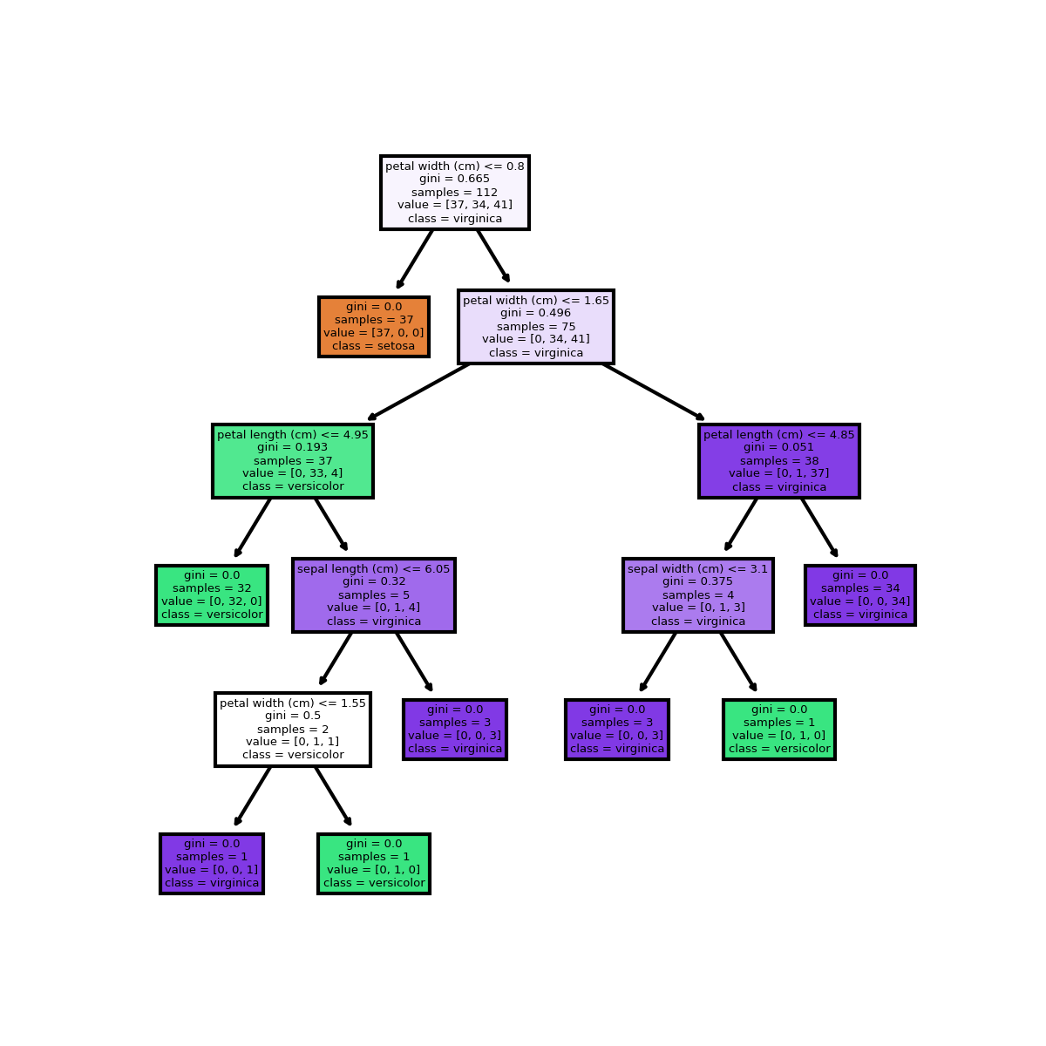

**Practical – 5.2 : Write a program to calculate popular attribute selection measures (ASM) like Information Gain, Gain Ratio, and Gini Index etc. for decision tree.**

import math

import pandas as pd

def entropy(class_labels):

counts = {}

total = len(class_labels)

entropy_value = 0.0

for label in class_labels:

if label not in counts:

counts[label] = 0

counts[label] += 1

for label in counts:

probability = counts[label] / total

entropy_value -= probability * math.log2(probability)

return entropy_value

def information_gain(data, attribute, class_labels):

total_entropy = entropy(class_labels)

attribute_values = data[attribute].unique()

weighted_entropy = 0.0

for value in attribute_values:

subset = data[data[attribute] == value]

subset_class_labels = subset['Class']

subset_entropy = entropy(subset_class_labels)

weight = len(subset_class_labels) / len(class_labels)

weighted_entropy += weight * subset_entropy

information_gain_value = total_entropy - weighted_entropy

return information_gain_value

def gain_ratio(data, attribute, class_labels):

info_gain = information_gain(data, attribute, class_labels)

attribute_values = data[attribute].unique()

split_info = 0.0

for value in attribute_values:

subset = data[data[attribute] == value]

proportion = len(subset) / len(data)

split_info -= proportion * math.log2(proportion)

if split_info == 0:

return 0

gain_ratio_value = info_gain / split_info

return gain_ratio_value

def gini_index(class_labels):

counts = {}

total = len(class_labels)

gini_index_value = 1.0

for label in class_labels:

if label not in counts:

counts[label] = 0

counts[label] += 1

for label in counts:

probability = counts[label] / total

gini_index_value -= probability ** 2

return gini_index_value

# Example usage

data = {

'Outlook': ['Sunny', 'Sunny', 'Overcast', 'Rainy', 'Rainy', 'Rainy', 'Overcast', 'Sunny', 'Sunny', 'Rainy', 'Sunny',

'Overcast', 'Overcast', 'Rainy'],

'Temperature': ['Hot', 'Hot', 'Hot', 'Mild', 'Cool', 'Cool', 'Cool', 'Mild', 'Cool', 'Mild', 'Mild', 'Mild', 'Hot',

'Mild'],

'Humidity': ['High', 'High', 'High', 'High', 'Normal', 'Normal', 'Normal', 'High', 'Normal', 'Normal', 'Normal',

'High', 'Normal', 'High'],

'Wind': ['Weak', 'Strong', 'Weak', 'Weak', 'Weak', 'Strong', 'Strong', 'Weak', 'Weak', 'Weak', 'Strong', 'Strong',

'Weak', 'Strong'],

'Class': ['No', 'No', 'Yes', 'Yes', 'Yes', 'No', 'Yes', 'No', 'Yes', 'Yes', 'Yes', 'Yes', 'Yes', 'No']

}

df = pd.DataFrame(data)

attribute = 'Outlook'

class_labels = df['Class']

print("Information Gain:", information_gain(df, attribute, class_labels))

print("Gain Ratio:", gain_ratio(df, attribute, class_labels))

print("Gini Index:", gini_index(class_labels))

**OUTPUT:**

C:\Users\sejal\MCA-I_ML\Scripts\python.exe C:/Users/sejal/PycharmProjects/MCA-I_ML/example.py

Information Gain: 0.24674981977443933

Gain Ratio: 0.15642756242117528

Gini Index: 0.4591836734693877

Process finished with exit code 0

**Practical - 6 : Implement simple KNN using Euclidean distance in Python.**

**------------------------------------------------------------------------------------------------**

**Code: KNN using Euclidean distance**

from pandas import DataFrame

from sklearn.datasets import load_iris

data_b = load_iris()

df= DataFrame(data_b.data, columns=data_b.feature_names)

df['target'] = data_b.target

#print(df)

#print(data_b.DESCR)

print("Dataset Labels=",data_b.target_names)

from sklearn.neighbors import KNeighborsClassifier

from sklearn import metrics

from sklearn.metrics import confusion_matrix

from sklearn.model_selection import train_test_split

X_train, X_test, Y_train, y_test = train_test_split(df[data_b.feature_names], df['target'], random_state=1)

print(X_train.head(6))

print(Y_train.head(6))

print(X_test.head())

clf = KNeighborsClassifier(n_neighbors=6)

clf.fit(X_train, Y_train) # model is trained

y_pred=clf.predict(X_test)

#print(y_test, y_pred)

print("Accuracy:",metrics.accuracy_score(y_test, y_pred))

cm = confusion_matrix(y_test, y_pred)

print("Confusion Matrix:")

print(cm)

**OUTPUT :**

C:\Users\sejal\MCA-I_ML\Scripts\python.exe C:/Users/sejal/PycharmProjects/MCA-I_ML/KNN.py

Dataset Labels= ['setosa' 'versicolor' 'virginica']

sepal length (cm) sepal width (cm) petal length (cm) petal width (cm)

54 6.5 2.8 4.6 1.5

108 6.7 2.5 5.8 1.8

112 6.8 3.0 5.5 2.1

17 5.1 3.5 1.4 0.3

119 6.0 2.2 5.0 1.5

103 6.3 2.9 5.6 1.8

54 1

108 2

112 2

17 0

119 2

103 2

Name: target, dtype: int32

sepal length (cm) sepal width (cm) petal length (cm) petal width (cm)

14 5.8 4.0 1.2 0.2

98 5.1 2.5 3.0 1.1

75 6.6 3.0 4.4 1.4

16 5.4 3.9 1.3 0.4

131 7.9 3.8 6.4 2.0

Accuracy: 1.0

Confusion Matrix:

[[13 0 0]

[ 0 16 0]

[ 0 0 9]]

Process finished with exit code 0

**####################################################################**

**Code: For Breast Cancer Data Set**

from pandas import DataFrame

#from sklearn.datasets import load_iris

from sklearn.datasets import load_breast_cancer

from sklearn.neighbors import KNeighborsClassifier

from sklearn import metrics

from sklearn.metrics import confusion_matrix

from sklearn.model_selection import train_test_split

#data_b = load_iris()

data_b = load_breast_cancer()

df = DataFrame(data_b.data, columns=data_b.feature_names)

df['target'] = data_b.target

# print(df)

# print(data_b.DESCR)

print("Dataset Labels=", data_b.target_names)

X_train, X_test, Y_train, y_test = train_test_split(df[data_b.feature_names], df['target'], random_state=1)

print(X_train.head(6))

print(Y_train.head(6))

print(X_test.head())

clf = KNeighborsClassifier(n_neighbors=6)

clf.fit(X_train, Y_train) # model is trained

y_pred = clf.predict(X_test)

# print(y_test, y_pred)

print("Accuracy:", metrics.accuracy_score(y_test, y_pred))

cm = confusion_matrix(y_test, y_pred)

**OUTPUT:**

C:\Users\sejal\MCA-I_ML\Scripts\python.exe C:/Users/sejal/PycharmProjects/MCA-I_ML/KNN.py

Dataset Labels= ['malignant' 'benign']

mean radius mean texture ... worst symmetry worst fractal dimension

562 15.22 30.62 ... 0.4089 0.14090

291 14.96 19.10 ... 0.2962 0.08472

16 14.68 20.13 ... 0.3029 0.08216

546 10.32 16.35 ... 0.2681 0.07399

293 11.85 17.46 ... 0.3101 0.07007

350 11.66 17.07 ... 0.2731 0.06825

[6 rows x 30 columns]

562 0

291 1

16 0

546 1

293 1

350 1

Name: target, dtype: int32

mean radius mean texture ... worst symmetry worst fractal dimension

421 14.69 13.98 ... 0.2827 0.09208

47 13.17 18.66 ... 0.3900 0.11790

292 12.95 16.02 ... 0.3380 0.09584

186 18.31 18.58 ... 0.3206 0.06938

414 15.13 29.81 ... 0.3233 0.06165

[5 rows x 30 columns]

Accuracy: 0.9370629370629371

Confusion Matrix:

[[51 4]

[ 5 83]]

Number of correct predictions= 134

Number of wrong predictions = 9

Process finished with exit code 0

**Practical No: 7**

**Practical Name: Write a program to implement the k-Nearest Neighbour algorithm to classify the iris dataset. Print both correct and wrong predictions. Java/Python ML library classes can be used for this problem**

**Code: For Iris Data Set**

from pandas import DataFrame

from sklearn.datasets import load_iris

#from sklearn.datasets import load_breast_cancer

from sklearn.neighbors import KNeighborsClassifier

from sklearn import metrics

from sklearn.metrics import confusion_matrix

from sklearn.model_selection import train_test_split

data_b = load_iris()

#data_b = load_breast_cancer()

df = DataFrame(data_b.data, columns=data_b.feature_names)

df['target'] = data_b.target

# print(df)

# print(data_b.DESCR)

print("Dataset Labels=", data_b.target_names)

X_train, X_test, Y_train, y_test = train_test_split(df[data_b.feature_names], df['target'], random_state=1)

print(X_train.head(6))

print(Y_train.head(6))

print(X_test.head())

clf = KNeighborsClassifier(n_neighbors=6)

clf.fit(X_train, Y_train) # model is trained

y_pred = clf.predict(X_test)

# print(y_test, y_pred)

print("Accuracy:", metrics.accuracy_score(y_test, y_pred))

cm = confusion_matrix(y_test, y_pred)

print("Confusion Matrix:")

print(cm)

# corr = cm[0, 0] + cm[1, 1] + cm[2, 2] # ----for iris

# corr = cm[0, 0] + cm[1, 1] #----for breast cancer

corr = 0

for i in range(len(data_b.target_names)):

corr = corr + cm[i, i]

wrg = len(y_test) - corr

print("Number of correct predictions=", corr)

print("Number of wrong predictions = ", wrg)

**OUTPUT:**

C:\Users\sejal\MCA-I_ML\Scripts\python.exe C:/Users/sejal/PycharmProjects/MCA-I_ML/KNN.py

Dataset Labels= ['setosa' 'versicolor' 'virginica']

sepal length (cm) sepal width (cm) petal length (cm) petal width (cm)

54 6.5 2.8 4.6 1.5

108 6.7 2.5 5.8 1.8

112 6.8 3.0 5.5 2.1

17 5.1 3.5 1.4 0.3

119 6.0 2.2 5.0 1.5

103 6.3 2.9 5.6 1.8

54 1

108 2

112 2

17 0

119 2

103 2

Name: target, dtype: int32

sepal length (cm) sepal width (cm) petal length (cm) petal width (cm)

14 5.8 4.0 1.2 0.2

98 5.1 2.5 3.0 1.1

75 6.6 3.0 4.4 1.4

16 5.4 3.9 1.3 0.4

131 7.9 3.8 6.4 2.0

Accuracy: 1.0

Confusion Matrix:

[[13 0 0]

[ 0 16 0]

[ 0 0 9]]

Number of correct predictions= 38

Number of wrong predictions = 0

Process finished with exit code 0

**####################################################################**

**Code: For Breast Cancer Data Set**

from pandas import DataFrame

#from sklearn.datasets import load_iris

from sklearn.datasets import load_breast_cancer

from sklearn.neighbors import KNeighborsClassifier

from sklearn import metrics

from sklearn.metrics import confusion_matrix

from sklearn.model_selection import train_test_split

#data_b = load_iris()

data_b = load_breast_cancer()

df = DataFrame(data_b.data, columns=data_b.feature_names)

df['target'] = data_b.target

# print(df)

# print(data_b.DESCR)

print("Dataset Labels=", data_b.target_names)

X_train, X_test, Y_train, y_test = train_test_split(df[data_b.feature_names], df['target'], random_state=1)

print(X_train.head(6))

print(Y_train.head(6))

print(X_test.head())

clf = KNeighborsClassifier(n_neighbors=6)

clf.fit(X_train, Y_train) # model is trained

y_pred = clf.predict(X_test)

# print(y_test, y_pred)

print("Accuracy:", metrics.accuracy_score(y_test, y_pred))

cm = confusion_matrix(y_test, y_pred)

print("Confusion Matrix:")

print(cm)

# corr = cm[0, 0] + cm[1, 1] + cm[2, 2] # ----for iris

# corr = cm[0, 0] + cm[1, 1] #----for breast cancer

corr = 0

for i in range(len(data_b.target_names)):

corr = corr + cm[i, i]

wrg = len(y_test) - corr

print("Number of correct predictions=", corr)

print("Number of wrong predictions = ", wrg)

**OUTPUT:**

C:\Users\sejal\MCA-I_ML\Scripts\python.exe C:/Users/sejal/PycharmProjects/MCA-I_ML/KNN.py

Dataset Labels= ['malignant' 'benign']

mean radius mean texture ... worst symmetry worst fractal dimension

562 15.22 30.62 ... 0.4089 0.14090

291 14.96 19.10 ... 0.2962 0.08472

16 14.68 20.13 ... 0.3029 0.08216

546 10.32 16.35 ... 0.2681 0.07399

293 11.85 17.46 ... 0.3101 0.07007

350 11.66 17.07 ... 0.2731 0.06825

[6 rows x 30 columns]

562 0

291 1

16 0

546 1

293 1

350 1

Name: target, dtype: int32

mean radius mean texture ... worst symmetry worst fractal dimension

421 14.69 13.98 ... 0.2827 0.09208

47 13.17 18.66 ... 0.3900 0.11790

292 12.95 16.02 ... 0.3380 0.09584

186 18.31 18.58 ... 0.3206 0.06938

414 15.13 29.81 ... 0.3233 0.06165

[5 rows x 30 columns]

Accuracy: 0.9370629370629371

Confusion Matrix:

[[51 4]

[ 5 83]]

Number of correct predictions= 134

Number of wrong predictions = 9

Process finished with exit code 0

**Practical No.: 8**

**Practical Name: Write a Program for Confusion Matrix and calculate Precision, Recall, F-Measure**

from sklearn.datasets import load_iris, load_breast_cancer

from sklearn.model_selection import train_test_split

from sklearn.neighbors import KNeighborsClassifier

from sklearn.metrics import confusion_matrix, precision_score, recall_score, f1_score

# Load the Irish dataset

iris = load_iris()

X_iris = iris.data

y_iris = iris.target

# Split the Irish dataset into training and testing sets

X_train_iris, X_test_iris, y_train_iris, y_test_iris = train_test_split(X_iris, y_iris, test_size=0.2, random_state=42)

# Train the KNN classifier on the Irish d3ataset

knn_iris = KNeighborsClassifier()

knn_iris.fit(X_train_iris, y_train_iris)

# Make predictions on the Irish testing set

y_pred_iris = knn_iris.predict(X_test_iris)

# Calculate the confusion matrix for Irish dataset

cm_iris = confusion_matrix(y_test_iris, y_pred_iris)

print("Confusion Matrix (Irish Dataset):")

print(cm_iris)

# Calculate precision, recall, and F-measure for Irish dataset

precision_iris = precision_score(y_test_iris, y_pred_iris, average='macro')

recall_iris = recall_score(y_test_iris, y_pred_iris, average='macro')

f1_iris = f1_score(y_test_iris, y_pred_iris, average='macro')

print("Precision (Irish Dataset):", precision_iris)

print("Recall (Irish Dataset):", recall_iris)

print("F-measure (Irish Dataset):", f1_iris)

# Load the Breast Cancer dataset

cancer = load_breast_cancer()

X_cancer = cancer.data

y_cancer = cancer.target

# Split the Breast Cancer dataset into training and testing sets

X_train_cancer, X_test_cancer, y_train_cancer, y_test_cancer = train_test_split(X_cancer, y_cancer,

test_size=0.2, random_state=42)

# Train the KNN classifier on the Breast Cancer dataset

knn_cancer = KNeighborsClassifier()

knn_cancer.fit(X_train_cancer, y_train_cancer)

# Make predictions on the Breast Cancer testing set

y_pred_cancer = knn_cancer.predict(X_test_cancer)

# Calculate the confusion matrix for Breast Cancer dataset

cm_cancer = confusion_matrix(y_test_cancer, y_pred_cancer)

print("\nConfusion Matrix (Breast Cancer Dataset):")

print(cm_cancer)

# Calculate precision, recall, and F-measure for Breast Cancer dataset

precision_cancer = precision_score(y_test_cancer, y_pred_cancer)

recall_cancer = recall_score(y_test_cancer, y_pred_cancer)

f1_cancer = f1_score(y_test_cancer, y_pred_cancer)

print("Precision (Breast Cancer Dataset):", precision_cancer)

print("Recall (Irish Dataset):", recall_cancer)

print("F-measure (Irish Dataset):", f1_cancer)

**OUTPUT:**

Confusion Matrix (Irish Dataset):

[[10 0 0]

[ 0 9 0]

[ 0 0 11]]

Precision (Irish Dataset): 1.0

Recall (Irish Dataset): 1.0

F-measure (Irish Dataset): 1.0

Confusion Matrix (Breast Cancer Dataset):

[[38 5]

[ 0 71]]

Precision (Breast Cancer Dataset): 0.9342105263157895

Recall (Irish Dataset): 1.0

F-measure (Irish Dataset): 0.9659863945578232

**Practical No.: 9**

**Practical Name: Write a program for linear regression and find parameters like Sum of Squared Errors (SSE), Total Sum of Squares (SST), R2, Adjusted R2, etc.**

import numpy as np

from sklearn.linear_model import LinearRegression

from sklearn.metrics import r2_score

# Input data

X = np.array([[1, 1], [1, 2], [2, 2], [2, 3]])

y = np.array([3, 4, 5, 6])

model = LinearRegression() # Create a linear regression model

model.fit(X, y) # Fit the model to the data

y_pred = model.predict(X) # Predict the output

sse = np.sum((y_pred - y) ** 2) # Calculate SSE (Sum of Squared Errors)

sst = np.sum((y - np.mean(y)) ** 2) # Calculate SST (Total Sum of Squares)

r2 = r2_score(y, y_pred) # Calculate R2 score

# Calculate adjusted R2

n = X.shape[0] # Number of samples

p = X.shape[1] # Number of predictors

adjusted_r2 = 1 - (1 - r2) * (n - 1) / (n - p - 1)

# Print the results

print("Sum of Squared Errors(SSE):- ", sse)

print("Total Sum of Squares(SST):- ", sst)

print("R Square(R2):- ", r2)

print("Adjusted Square(R2):- ", adjusted_r2 )

**OUTPUT:**

Sum of Squared Errors(SSE):- 0.0

Total Sum of Squares(SST):- 5.0

R Square(R2):- 1.0

Adjusted Square(R2):- 1.0

**Practical – 10: Write a program to implement the naïve Bayesian classifier for a sample training dataset stored as a . CSV file. Compute the accuracy of the classifier, considering a few test data sets.**

import numpy as np

import pandas as pd

import matplotlib.pyplot as plt

from sklearn import datasets

iris = datasets.load_iris() # loading dataset

x = iris.data[:, ] # input

y = iris.target # target

print("Features : ", iris['feature_names'])

iris_dataframe = pd.DataFrame(data=np.c_[iris['data'], iris['target']], columns=iris['feature_names']+['target'])

grr = pd.plotting.scatter_matrix(iris_dataframe, c=iris['target'], figsize=(1, 5), s=30, alpha=1)

plt.show()

# OUTPUT SHOULD BE:

# Features : ['sepal length (cm)', 'sepal width (cm)', 'petal length (cm)', 'petal width (cm)']

import seaborn as sns

dataplot = sns.heatmap(iris_dataframe.corr(), annot=True)

plt.show()

from sklearn.model_selection import train_test_split

x_train, x_test, y_train, y_test = train_test_split(x, y, test_size=0.25, random_state=0)

from sklearn.naive_bayes import GaussianNB

NB = GaussianNB()

NB.fit(x_train, y_train)

Y_pred = NB.predict(x_test)

from sklearn.metrics import confusion_matrix

cm = confusion_matrix(y_test, Y_pred)

df_cm = pd.DataFrame(cm, columns=np.unique(y_test), index=np.unique(y_test))

df_cm.index.name = 'Actual'

df_cm.columns.name = 'Predicted'

sns.heatmap(df_cm, annot=True) # font size

plt.show()

**OUTPUT:**

Features:- ['sepal length (cm)', 'sepal width (cm)', 'petal length (cm)', 'petal width (cm)']

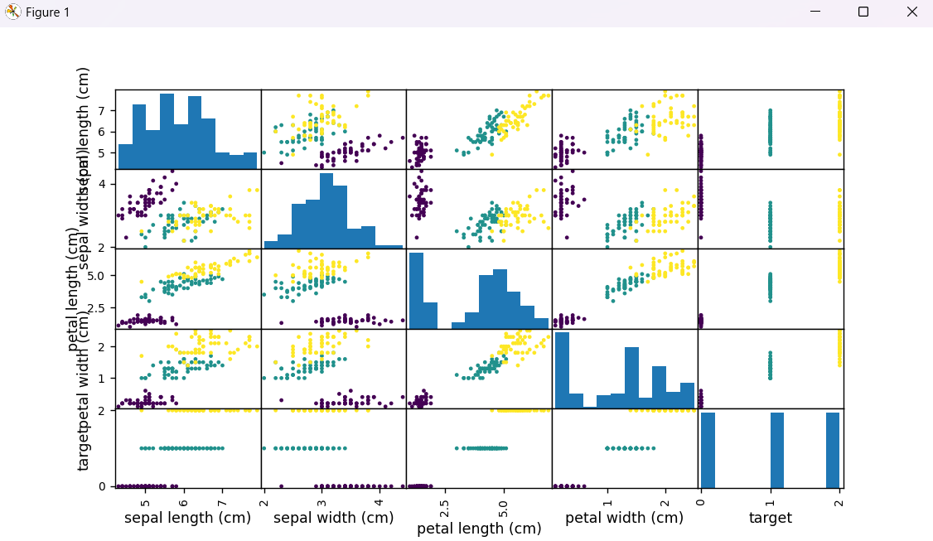

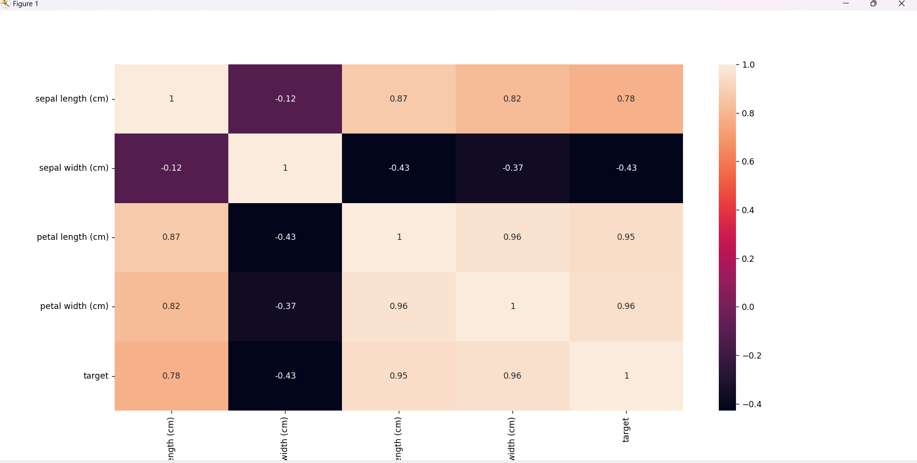

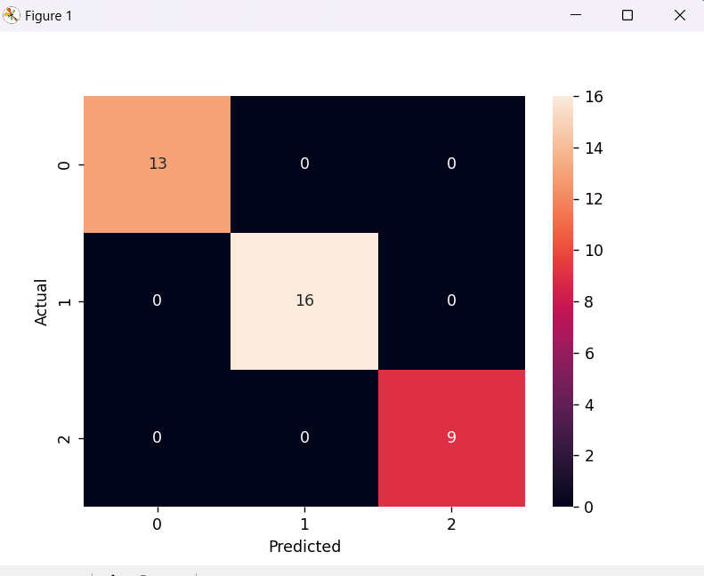

**Practical – 11.1: Implementing Agglomerative Clustering in Python.**

import pandas as pd

import matplotlib.pyplot as plt

import seaborn as sns

data = pd.read_csv("https://raw.githubusercontent.com/amankharwal/Website-data/master/customers.csv")

print(data.head())

data["Income"] = data["Annual Income (k$)"]

data["Spending"] = data["Spending Score (1-100)"]

data = data[["Income", "Spending"]]

print(data.head())

from sklearn.cluster import AgglomerativeClustering

model = AgglomerativeClustering()

model.fit(data)

pred = model.fit_predict(data)

plt.figure(figsize=(12, 10))

sns.scatterplot(data=data, x="Income", y="Spending", hue=pred, palette='rainbow', alpha=0.9)

plt.grid(True)

plt.show()

**OUTPUT:**

C:\Users\sejal\MCA-I_ML\Scripts\python.exe C:/Users/sejal/PycharmProjects/MCA-I_ML/example.py

CustomerID Gender Age Annual Income (k$) Spending Score (1-100)

0 1 Male 19 15 39

1 2 Male 21 15 81

2 3 Female 20 16 6

3 4 Female 23 16 77

4 5 Female 31 17 40

Income Spending

0 15 39

1 15 81

2 16 6

3 16 77

4 17 40

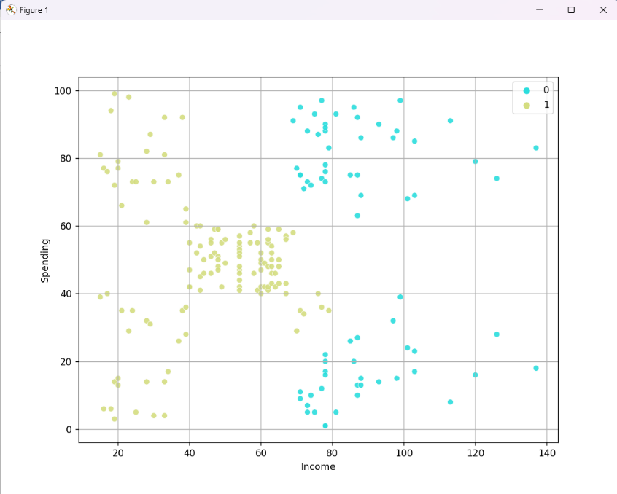**Practical – 11.2: Write a Program for Fuzzy c-means clustering in Python.**

import numpy as np

from sklearn import datasets

# Load the iris dataset

iris = datasets.load_iris()

data = iris.data

k = 3 # Number of clusters

max_iter = 100 # Maximum number of iterations

m = 2 # Fuzzy parameter

# Randomly initialize the membership matrix

n_samples = len(data)

membership_mat = np.random.rand(n_samples, k)

membership_mat /= np.sum(membership_mat, axis=1)[:, np.newaxis]

# Fuzzy C-means algorithm

for _ in range(max_iter):

# Calculate cluster centers

centroids = np.dot(data.T, membership_mat ** m) / np.sum(membership_mat ** m, axis=0)

# Update membership values

distances = np.zeros((n_samples, k))

for j in range(k):

distances[:, j] = np.linalg.norm(data - centroids[:, j], axis=1)

membership_mat = 1 / (distances ** (2 / (m - 1)))

membership_mat /= np.sum(membership_mat, axis=1)[:, np.newaxis]

# Get the cluster assignments

labels = np.argmax(membership_mat, axis=1)

# Print the cluster assignments

print("Cluster assignments:")

for i in range(k):

print(f"Cluster {i+1}:")

for j, label in enumerate(labels):

if label == i:

print(iris.target[j])

print()

**OUTPUT:**

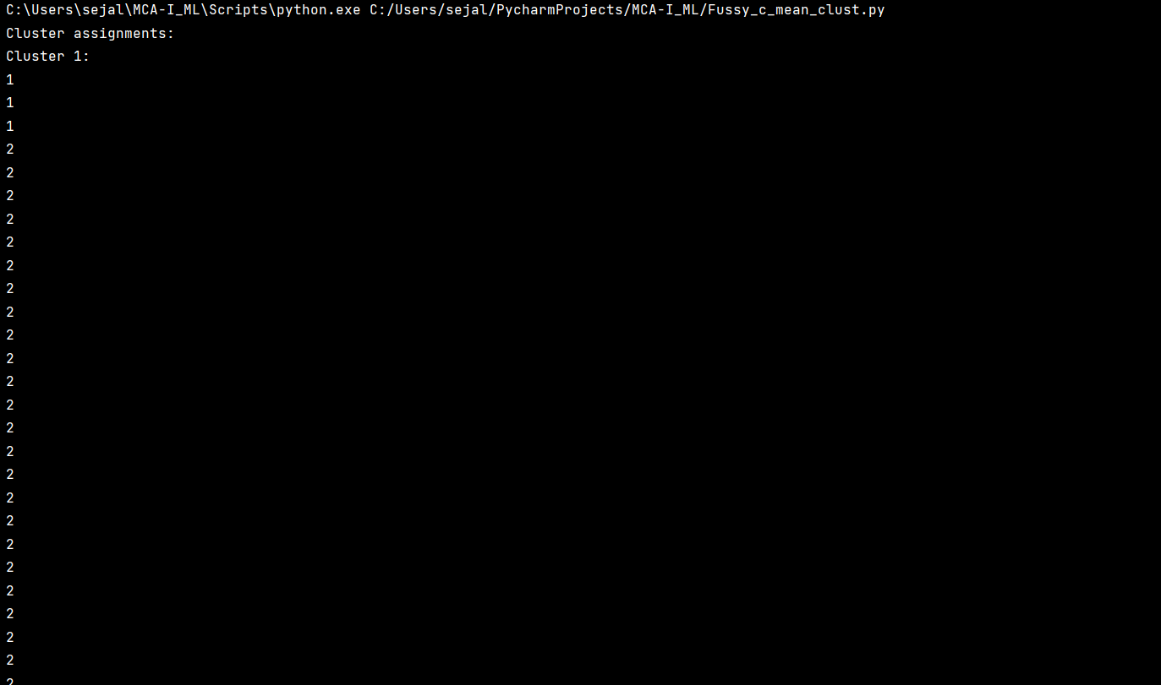

**Practical – 12: Implement the non-parametric Locally Weighted Regression algorithm in order to fit data points. Select the appropriate data set for your experiment and draw graphs.**

import numpy as np

import matplotlib.pyplot as plt

from sklearn.datasets import load_iris

def locally_weighted_regression(X, y, query_point, tau):

m = X.shape[0]

weights = np.exp(-np.sum((X - query_point) ** 2, axis=1) / (2 * tau * tau))

X = np.hstack((np.ones((m, 1)), X)) # Add a column of ones for the bias term

W = np.diag(weights)

theta = np.linalg.inv(X.T @ W @ X) @ (X.T @ W @ y)

query_point = np.hstack((1, query_point)) # Add a one for the bias term in the query point

predicted_value = query_point @ theta

return predicted_value

# Load the Iris dataset

iris = load_iris()

X = iris.data[:, :3] # Using the first three features for simplicity

y = iris.data[:, 3] # Petal width as the target variable

# Reshape X to have two dimensions

X = X[:, 2].reshape(-1, 1)

# Generate query points for prediction

query_points = np.linspace(np.min(X), np.max(X), num=100)

# Fit the Locally Weighted Regression model and make predictions

tau = 0.5 # Bandwidth parameter

predicted_values = []

for query_point in query_points:

predicted_value = locally_weighted_regression(X, y, query_point, tau)

predicted_values.append(predicted_value)

# Plotting the original data and the regression curve

plt.scatter(X, y, c='b', label='Data points')

plt.plot(query_points, predicted_values, c='r', label='Locally Weighted Regression')

plt.xlabel('Petal Length (cm)')

plt.ylabel('Petal Width (cm)')

plt.title('Locally Weighted Regression on Iris Dataset')

plt.legend()

plt.show()

**OUTPUT:**

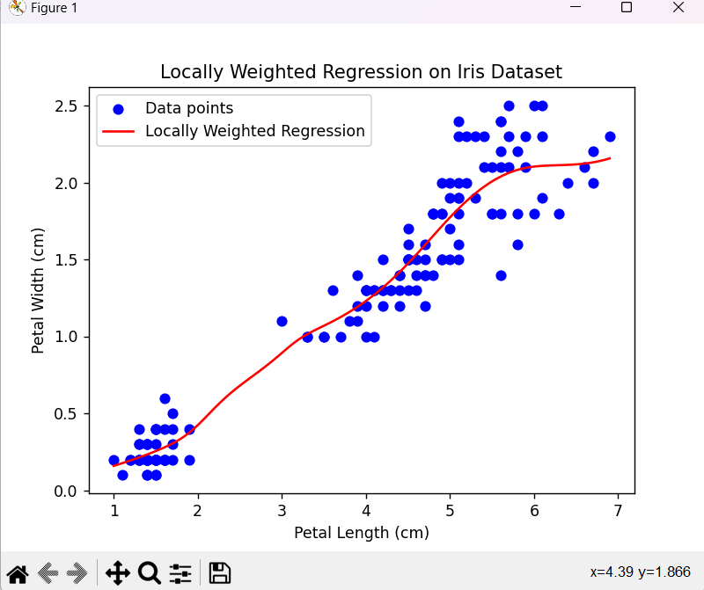

**Practical - 13.1: Construction Of simple Neural Network using Python**

**Code:**

import numpy as np

from scipy.special import expit as activation_function

from scipy.stats import truncnorm

# define the network

# generate numbers within a truncated (bounded)

# normal Distribution

def truncated_normal(mean=0, sd=1, low=0, upp=10):

return truncnorm((low - mean) / sd, (upp - mean) / sd, loc=mean, scale=sd)

# creat the Network class and define the arguments:

# set the no. of neurons/nodes for each layer

# and initialize the weight matrices

class Nnetwork:

def __init__(self, no_of_in_nodes, no_of_out_nodes, no_of_hidden_nodes, learning_rate):

self.no_of_in_nodes = no_of_in_nodes

self.no_of_out_nodes = no_of_out_nodes

self.no_of_hidden_nodes = no_of_hidden_nodes

self.learning_rate = learning_rate

self.create_weight_matrices()

def create_weight_matrices(self):

"""A method to initialize the weight matrices of the neural network"""

rad = 1 / np.sqrt(self.no_of_in_nodes) # rad = 0.2707

x = truncated_normal(mean=0, sd=1, low=-rad, upp=rad)

self.weight_in_hidden = x.rvs((self.no_of_hidden_nodes, self.no_of_in_nodes))

print("weights_in_hidden = ", self.weight_in_hidden)

rad = 1/np.sqrt(self.no_of_hidden_nodes)

x = truncated_normal(mean=0, sd=1, low=-rad, upp=rad)

self.weight_in_hidden_out = x.rvs((self.no_of_out_nodes, self.no_of_hidden_nodes))

print("weights_in_hidden_out = ", self.weight_in_hidden_out)

def train(self, input_vector, target_vector):

pass

def run(self, input_vector):

input_vector = np.array(input_vector, ndmin=2).T

print("Input = ", input_vector)

input_hidden = activation_function(self.weight_in_hidden @ input_vector)

print("Hidden = ", input_hidden)

output_vector = activation_function(self.weight_in_hidden_out @ input_hidden)

print("Output = ", output_vector)

return output_vector

simple_network = Nnetwork(no_of_in_nodes=2, no_of_out_nodes=2, no_of_hidden_nodes=4, learning_rate=0.6)

#run simple network for arrays, lists and tuples with shape (2):

y = simple_network.run([2,3])

print("Y = ", y)

**OUTPUT”:**

weights_in_hidden = [[-0.68798443 0.29428266]

[ 0.57363879 -0.64646032]

[-0.38809421 0.07104818]

[-0.23288421 0.26427463]]

weights_in_hidden_out = [[ 0.12718945 -0.15067287 -0.36574728 0.3725497 ]

[-0.09102931 -0.22077172 0.40025881 -0.32163589]]

Input = [[2]

[3]]

Hidden = [[0.37915865]

[0.31171721]

[0.36284346]

[0.58104275]]

Output = [[0.52124119]

[0.46381691]]

Y = [[0.52124119]

[0.46381691]]

**Practical No - 13.2: Classification Of Iris Dataset By Applying Artificial Neural Network With Back-Propagation Algorithm**

# Classification of iris data set by applying artificial neural network using Back-propagation algorithm  
**import** numpy **as** np  
**import** pandas **as** pd  
**from** sklearn.datasets **import** load_iris  
**from** sklearn.model_selection **import** train_test_split  
**import** matplotlib.pyplot **as** plt  
  
# load dataset  
data = load_iris()  
  
# Get features and target  
x = data.data  
y = data.target  
print(**"Y="**, y)  
  
y = pd.get_dummies(y).values  
print(y[:3])  
  
# split data into train and test data  
x_train, x_test, y_train, y_test = train_test_split(x, y, test_size=20, random_state=4)  
  
# initialize variable  
learning_rate = 0.1  
iteration = 6000  
N = y_train.size  
  
# number of input features  
input_size = 4  
  
# number of hidden layers neurons  
hidden_size = 2  
  
# mo. of neurons at output layers  
output_size = 3  
results = pd.DataFrame(columns=[**"mse"**, **"accuracy"**])  
  
# initialize weights  
np.random.seed(10)  
# initialiizing weight for the hidden layers  
W1 = np.random.normal(scale=0.5, size=(input_size, hidden_size))  
print(**"weight 1"**, W1)  
  
# initializing weight for the output layers  
W2 = np.random.normal(scale=0.5, size=(hidden_size, output_size))  
print(**"weight 2"**, W2)  
  
  
**def** sigmoid(x):  
 **return** 1/(1 + np.exp(-x))  
  
  
**def** mean_squared_error(y_pred, y_true):  
 **return** (((y_pred - y_true) ** 2).sum()) / (2 * y_pred.size)  
  
  
**def** accuracy(y_pred, y_true):  
 acc = y_pred.argmax(axis=1) == y_true.argmax(axis=1)  
 **return** acc.mean()  
  
  
**for** itr **in** range(iteration):  
  
 # feedforward propagation  
 # on hidden layer  
 Z1 = np.dot(x_train, W1)  
 A1 = sigmoid(Z1)  
  
# on output layer  
 Z2 = np.dot(A1, W2)  
 A2 = sigmoid(Z2)  
  
# calculating error  
 mse = mean_squared_error(A2, y_train)  
 acc = accuracy(A2, y_train)  
 results = results._append({**"mse"**: mse, **"accuracy"**: acc}, ignore_index=**True**)  
  
# backpropagation  
 E1 = A2 - y_train  
 dw1 = E1 * A2 * (1 - A2)  
  
 E2 = np.dot(dw1, W2.T)  
 dw2 = E2 * A1 * (1 - A1)  
  
# weight updates  
 W2_update = np.dot(A1.T, dw1) / N  
 W1_update = np.dot(x_train.T, dw2) / N  
  
 W2 = W2 - learning_rate * W2_update  
 W1 = W1 - learning_rate * W1_update  
  
results.mse.plot(title=**"Mean squared Error"**)  
  
results.accuracy.plot(title=**"Accuracy"**)  
  
# feedforward  
Z1 = np.dot(x_test, W1)  
A1 = sigmoid(Z1)  
  
Z2 = np.dot(A1, W2)  
A2 = sigmoid(Z2)  
  
acc = accuracy(A2, y_test)  
print(**"Accuracy: {}"**.format(acc))

**OUTPUT:**

C:\Users\sejal\MCA-I_ML\Scripts\python.exe C:/Users/sejal/PycharmProjects/MCA-I_ML/nural_network_Backpropa_algo.py

Y= [0 0 0 0 0 0 0 0 0 0 0 0 0 0 0 0 0 0 0 0 0 0 0 0 0 0 0 0 0 0 0 0 0 0 0 0 0

0 0 0 0 0 0 0 0 0 0 0 0 0 1 1 1 1 1 1 1 1 1 1 1 1 1 1 1 1 1 1 1 1 1 1 1 1

1 1 1 1 1 1 1 1 1 1 1 1 1 1 1 1 1 1 1 1 1 1 1 1 1 1 2 2 2 2 2 2 2 2 2 2 2

2 2 2 2 2 2 2 2 2 2 2 2 2 2 2 2 2 2 2 2 2 2 2 2 2 2 2 2 2 2 2 2 2 2 2 2 2

2 2]

[[ True False False]

[ True False False]

[ True False False]]

weight 1 [[ 0.66579325 0.35763949]

[-0.77270015 -0.00419192]

[ 0.31066799 -0.36004278]

[ 0.13275579 0.05427426]]

weight 2 [[ 0.00214572 -0.08730011 0.21651309]

[ 0.60151869 -0.48253284 0.51413704]]

**-----------------------------------------------------XXX-----------------------------------------------------**