WEEK 3: ADVANCED DATA ANALYSIS AND VISUALIZATION IN LOGISTICS
Project Title: Exploratory Data Analysis of Logistics Operations Using Python
1. Introduction
Logistics management involves transporting goods efficiently while controlling costs and ensuring timely deliveries. Data analysis helps organizations understand delivery performance, identify cost-related patterns, and improve operational decisions.
This project uses a hypothetical logistics dataset containing 120 shipment records. Python libraries such as Pandas, NumPy, Matplotlib, and Seaborn are used to analyze the data and create visualizations.
2. Objectives
The main objectives are:
- To analyze a hypothetical logistics dataset.
- To calculate descriptive statistics.
- To examine relationships between logistics variables.
- To create graphs using Python.
- To interpret delivery times and transportation costs.
- To suggest improvements in logistics operations.
3. Dataset Description
The dataset contains hypothetical shipment records with the following variables:
Variable | Description
Shipment_ID | Unique shipment number
Distance_km | Shipment distance in kilometres
Shipment_Weight_kg | Shipment weight in kilograms
Traffic_Level | Traffic category
Transport_Mode | Road, Rail, or Air
Delivery_Time_hr | Delivery time in hours
Transport_Cost_INR | Transportation cost in rupees
The dataset is simulated for educational purposes and does not represent actual company operations.
4. Tools and Technologies
- Python
- Pandas
- NumPy
- Matplotlib
- Seaborn
- Google Colab
5. Methodology
The analysis follows these steps:
- Create and load the hypothetical logistics dataset.
- Inspect the dataset using Pandas.
- Calculate statistical summaries.
- Check for missing values.
- Calculate correlations between numerical variables.
- Create five visualizations.
- Interpret the results.
- Develop recommendations based on the findings.
6. Exploratory Data Analysis
Exploratory Data Analysis (EDA) is used to understand the characteristics of a dataset before drawing conclusions.
The describe() function summarizes numerical variables, including their mean, standard deviation, minimum, maximum, and quartiles.
The mean() function calculates the average, while median() identifies the middle value.
The isnull().sum() function checks for missing values in each column.
The corr() function measures linear relationships between numerical variables.
These methods help identify patterns and understand the structure of the logistics dataset.
7. Data Visualization and Interpretation
7.1 Distribution of Delivery Times
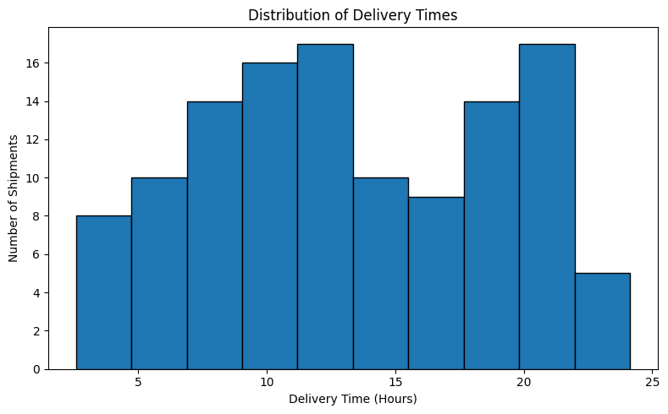
The histogram displays the distribution of delivery times across the simulated shipments. The delivery times vary considerably, with shipments appearing across a broad range of durations.
This visualization helps identify common delivery-time ranges and understand variation in delivery performance.
7.2 Distance vs Transportation Cost
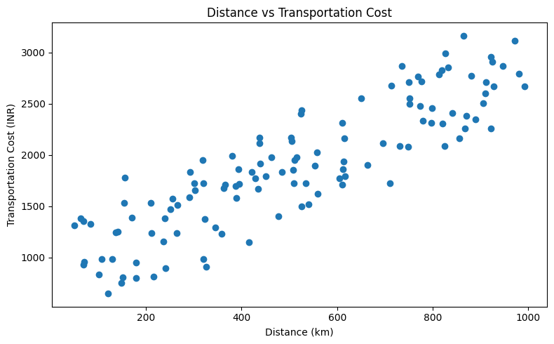The scatter plot shows a clear positive relationship between shipment distance and transportation cost. In general, shipments travelling longer distances have higher transportation costs in this simulated dataset.
This relationship suggests that distance is an important factor to consider when analyzing transportation expenses.
7.3 Average Delivery Time by Transport Mode
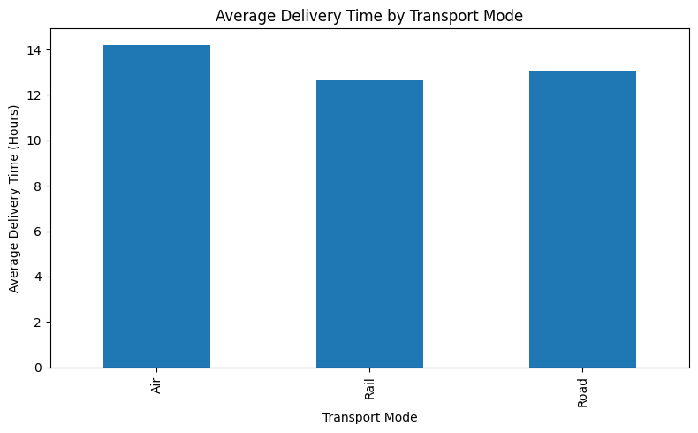
The bar chart compares average delivery times for Air, Rail, and Road transportation in the simulated dataset.
The graph shows that Air has the highest average delivery time in this particular sample, while Rail has the lowest.
These results describe only the generated dataset. They should not be interpreted as proof that rail is generally faster than air because actual delivery performance depends on distance, handling time, schedules, and other factors.
7.4 Delivery Time by Traffic Level
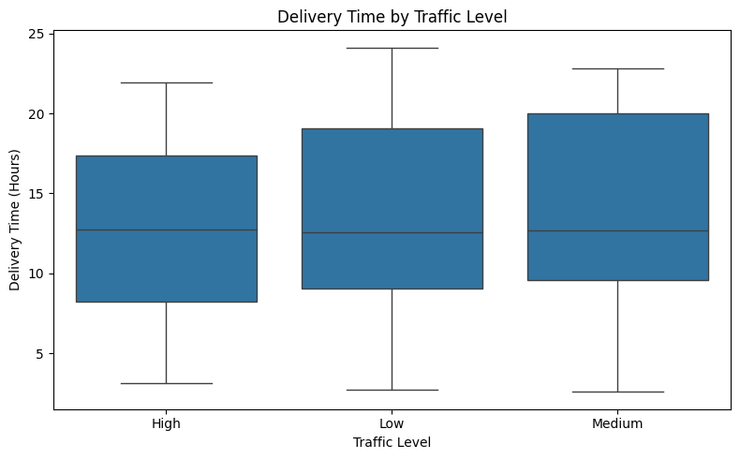
The box plot compares delivery-time distributions across High, Low, and Medium traffic categories.
The median delivery times appear relatively similar across the three groups, although the distributions show considerable variation.
This visualization helps compare the spread of delivery times. However, the graph alone cannot establish whether traffic causes delivery delays.
7.5 Correlation Heatmap
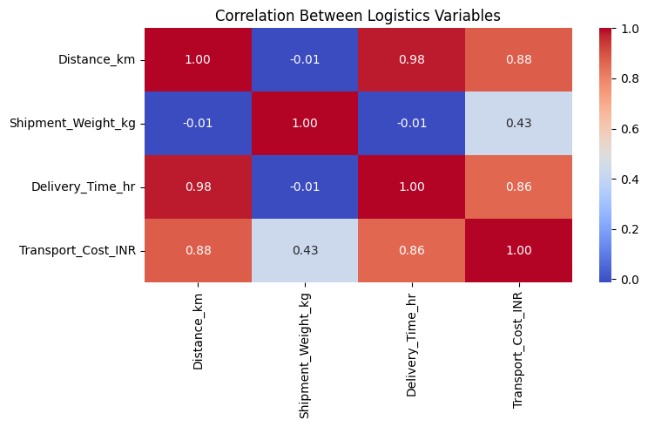The correlation heatmap displays relationships between numerical variables.
The graph shows the following correlations:
- Distance and delivery time: approximately 0.98.
- Distance and transportation cost: approximately 0.88.
- Delivery time and transportation cost: approximately 0.86.
- Shipment weight and transportation cost: approximately 0.43.
These results indicate strong positive relationships between distance and delivery time, distance and cost, and delivery time and cost within the simulated dataset.
Shipment weight and transportation cost show a moderate positive relationship.
Correlation does not prove causation.
8. Key Findings
The analysis provides several observations:
- Delivery times vary across the simulated shipments.
- Transportation costs generally increase with shipment distance.
- Average delivery times differ across transportation modes.
- Delivery-time distributions overlap across traffic categories.
- Distance has a strong positive correlation with delivery time and transportation cost.
- Shipment weight has a moderate positive correlation with transportation cost.
These findings demonstrate how statistical analysis and visualization can help explore logistics performance.
9. Recommendations
The following recommendations can be considered:
- Monitor delivery-time performance regularly.
- Analyze transportation costs alongside shipment distance and weight.
- Compare transportation modes using cost, delivery time, and service requirements.
- Investigate unusually long delivery times.
- Maintain accurate shipment records for future analysis.
- Use clearly defined performance indicators to measure logistics efficiency.
- Validate findings using real operational data before making business decisions.
10. Limitations
The dataset is hypothetical and was generated for educational purposes. It does not represent actual deliveries or transportation expenses.
The patterns observed depend on how the simulated data were generated. Consequently, the results should not be generalized to real logistics companies without further analysis.
11. Conclusion
This project demonstrates the use of Python for exploratory data analysis and visualization in logistics.
Descriptive statistics help summarize shipment information, while histograms, scatter plots, bar charts, box plots, and correlation heatmaps help reveal distributions and relationships.
The analysis demonstrates how data visualization can support the investigation of delivery performance and transportation costs. Reliable logistics decisions require accurate data, appropriate analytical methods, and validation using real-world information.
12. References
- Pandas Documentation — https://pandas.pydata.org/docs/
- NumPy Documentation — https://numpy.org/doc/
- Matplotlib Documentation — https://matplotlib.org/stable/
- Seaborn Documentation — https://seaborn.pydata.org/

