**Student Assessment Submission and Declaration**

When submitting evidence for assessment, each student must sign a declaration confirming that the work is their own.

|  |  |  |  |
| --- | --- | --- | --- |
| Student name: Vajresh Patkar | | Assessor name: Aniket | |
| Issue date: 3 Jul 2019 | Submission date: 24 Jul 19 | | Submitted on: |
| Programme: Pearson BTEC Level 5 HND in Application Development | | | |
| Unit: 4 Web Design and Development | | | |
| Assignment number and title: 1 of 2: Development of website for a Training Organization – Part 1 | | | |

**Plagiarism**

Plagiarism is a particular form of cheating. Plagiarism must be avoided at all costs and students who break the rules, however innocently, may be penalised. It is your responsibility to ensure that you understand correct referencing practices. As a university level student, you are expected to use appropriate references throughout and keep carefully detailed notes of all your sources of materials for material you have used in your work, including any material downloaded from the Internet. Please consult the relevant unit lecturer or your course tutor if you need any further advice.

**Student Declaration**

|  |
| --- |
| **Student declaration**  I certify that the assignment submission is entirely my own work and I fully understand the consequences of plagiarism. I understand that making a false declaration is a form of malpractice.  Student signature: nhwksh Date: |

Table of Contents

1. DNS Configuration 3

2. Port Numbers 3

3. SEO Strategy 3

# Website Requirements

## Intro

The first step when making a website is to analyse its purpose and its requirements. This helps to give it a reason for its development and makes all the next steps easy. It can be features, pages, content and functionality that should be available to the user. This helps to prioritize the steps and make a **minimum viable product(MVP)**.

There are several ways to distinguish the requirements documents. Most general are **business requirements, user requirements, implementation requirements, functional requirements, quality of service requirements,** etc.

Since ABC Learning Center asked me to develop website to showcase their courses and want the users to enroll in the courses, it is user driven website. So I can start by gathering the user requirements

## User Requirements

User requirements is the description of how the user interacts with the website, what will be their expectations, how they can use the features, functions and content. Reasons why user comes to your site, what will they receive comes in user requirements.

Some of the questions that needs to answered in this requirements are

1. **Who is the user?**

The user ABC Learning Center is looking are **passionate learners** from any age group. But most preferred are between the age 15 to 30 since they will benefit the most from the site.

1. **Why does user comes to the site?**

The main goal of the website is to offer courses to the user from which they can **enhance their skills**. Once they enroll in specific courses, they must have access to 24/7 ask questions from anywhere.

1. **What goals does they have?**

Users will be looking for the courses which are **unique** and which will help them to **gain the skills** they desire in **short amount** of time and money.

1. **How can we serve and make the site easy to consume?**

User should have nice experience when surfing through the website. **Navigation** and **accessibility** should be easy. **Multiple courses** should be available to choose from, **rating** to the courses to shortlist the best one and lastly **testimonies** of other learners to validate the courses. This will all result is great experience to the user and will make it more likely to come back to the website again.

## List all the Pages

Lets finalize all the pages that will be required for the website. This helps to divide the website into pages and develop it one by one. All the pages that are required are

1. Home Page
2. Registration Page
3. Thank You page
4. About Us
5. Contact Us
6. Course Listing Page
7. Site Map
8. Privacy Policy
9. Individual course details page
10. Individual course schedule page

## Information Architecture

It is the outline of the information in any app or website. It is the structure of your app’s content. It has 2 components in IA

* + The site’s content
  + Functionality and structure that defines relationship between site’s content/functionality.

Even though IA itself isn’t visible in UI but is a foundation of a great user experience.That’s why the best time to start creating IA is before the website is even build. Some of the tools are DYNO mapper, online whiteboard, OmniGraffle, Smart-Draw, etc.

Here is the information architecture of our website which describe all the pages and its relational and navigation visually.

## Wireframes

Wire-frames are page **schematics** or screen **blueprints** that are visual guide which represents **skeletal framework** of the website. It focus on functions available, relative priorities of information and functions, rules for displaying certain information.

Software available in the market are sketch, adobe illustrator, adobe photo-shop, figma, etc. I am going to use **balsamiq,** which is online tool as well as available as desktop app. I will use the browser version.

This is the home page of the website where we have fixed **navigation bar**, **hero image** and **featured courses** and link to course listing page. It also have what ABC will provide and its **benefits**

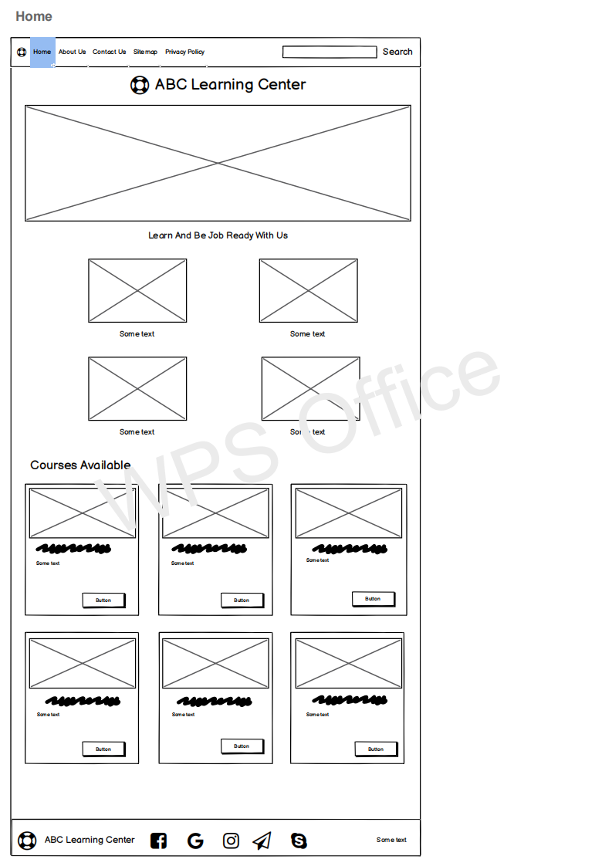

About us page displays what ABC stands for and their **mission and vision** 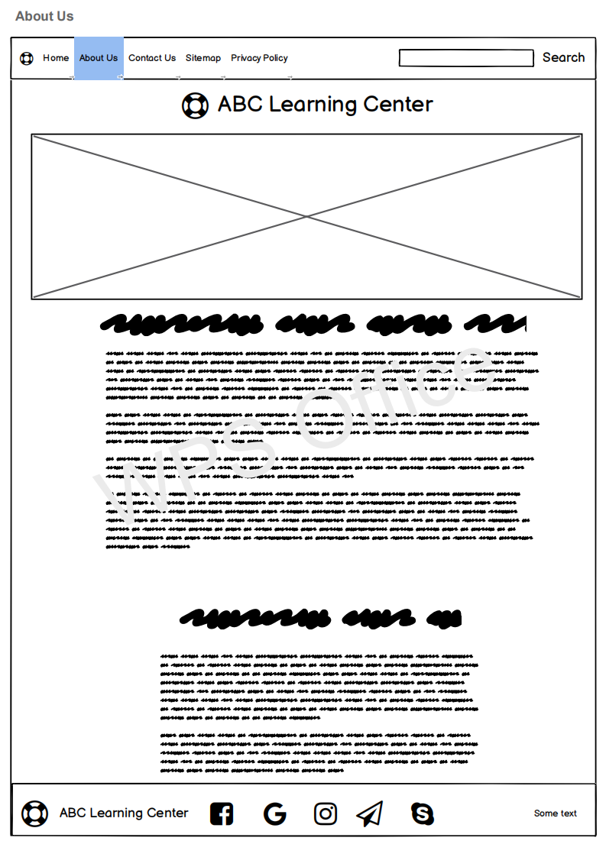

Contact Us page will have info about ABC office and contact information. It also has in-window form where user can directly message.

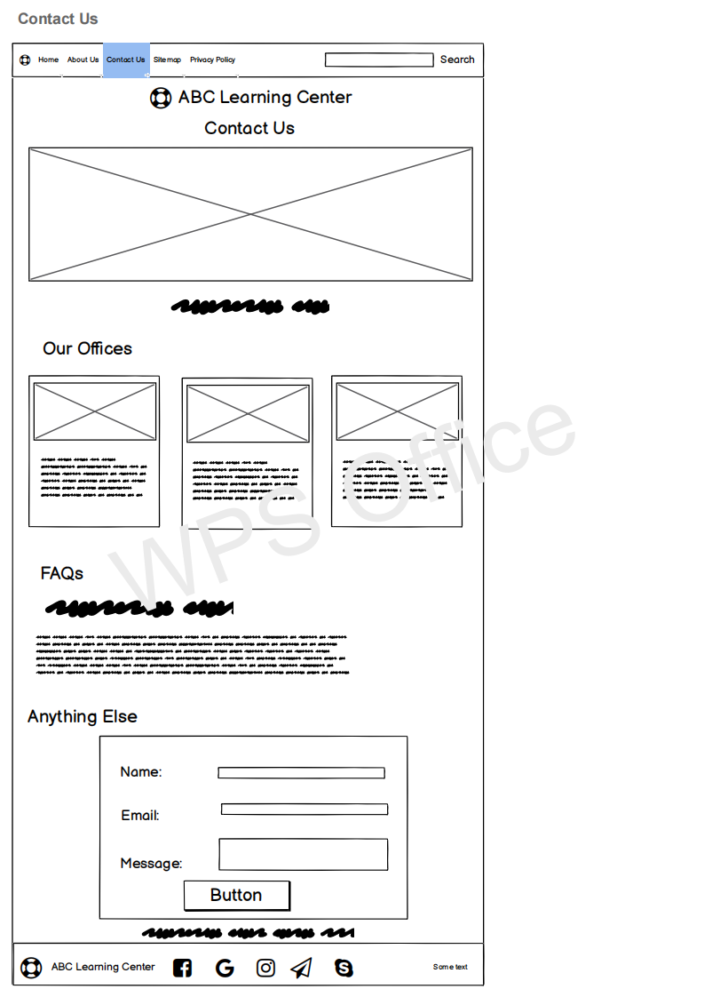

Sitemap will all the links for better SEO 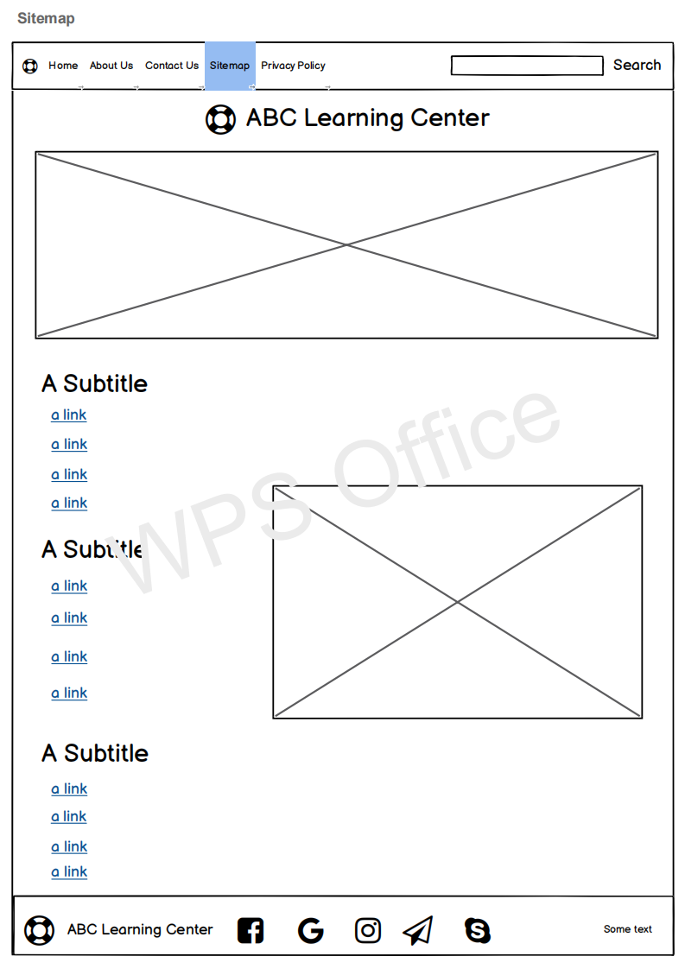

Privacy policy page will contain the term and conditions and guideline for usage.

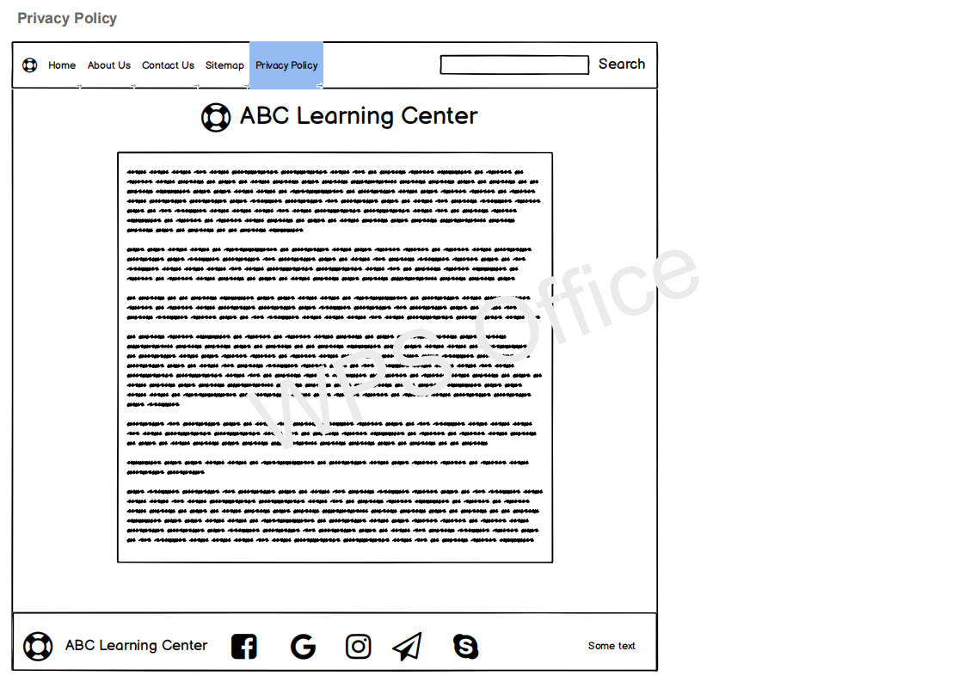

## Storyboard

It is the **blue print** for a website or app. It is a graphic organizer that plans narrative for the website. It is simple and flexible. It serves as outline of design approach. It defines elements that needs to go on each page. It shows **navigational architecture** and information flow and demonstrate how pages work together. Adobe After Effects is most commonly used software.

# Website Design Guidelines and Standards

## Intro

Planning for website design and development will save time and gives you direction to move forward. Planning for a website includes setting a goal, set the number of pages and its content, technology that suites you. Design documents like wire-frames and storyboards for visual representation. Setting the guidelines and design patterns for the project which make it maintainable and readable.

## Plan

In my case, I have been assigned to develop website by ABC Learning Center. So first thing I will do is to **understand** what are the **requirements** and **expectations** of the ABC Learning Center. What they they think are the user’s expectation. What is their **target audience**.

After understanding the requirements I shall do my own **research** about the **user** and **resources requirements** and **market** research. This will help me to understand their position in the market and their **competitors**.

Now I need to finalize the **number of pages** and their **content**. Select the **technology stack** that I will be working for developing the website. Since this is a website **HTML** and **CSS** are must and to make interactive I will use **JavaScript** and **Jquery**. Other resources which will be need are **font awesome** for icons, **AJAX** for communication, **Apache HTTP server** for hosting, etc.

Since I have the pages its content, I will need some visual representation of it to show it to ABC. I will develop **Information Architecture**, **wire-frames** and **storyboard** and will finalize the design with clients.

After the design phase is complete, development will start in the order of priority to the pages. Coding **guidelines** and **best practices** along with **responsive design** will be followed. Website will also be **SEO friendly**. The development will be followed along with **tests** to ensure that nothing is broken.

Once all the tests are passed and website is ready, it will be **deployed** to the server and will be **released** to public for consumption.

To sum it up, this are the steps that needs to be followed

1. Understand goals and expectations of ABC Learning Center
2. User requirements and market research
3. Decision of pages and tech stack
4. Design Documents
5. Development
6. Testing
7. Deployment

## Strategy and feature and tech

## Hosted Website SS

# Website Testing

## Intro

## Different kinds of testing and libraries

## Write about Test cases

## Tabular Format

# Design and Output

## Intro

# Quality Assurance

## Intro

# Technical Challenges

## Intro

# Test Reviews

## Intro

# Bibliography

<https://www.usability.gov/how-to-and-tools/methods/requirements.html#:~:text=Website%20requirements%20are%20a%20list,and%20prioritize%20the%20project%20plan.>

<https://storyboardartists.com/what-are-storyboards-used-for/>

<https://dynomapper.com/blog/487-website-development-planning-process>