**RUSHABH KADAM 180001045**

**JEMIN VAGADIA 180001023**

Indian Institute of Technology, Indore

CS 257

DBIS Project

**DBMS PROJECT:**

**RTO DATABASE MANAGEMENT SYSTEM:**

**INTRODUCTION:**

* **RTO needs a database to manage information regarding vehicles, vehicle owner details also the people who break traffic rules. RTO will have to store its department and employee details too.**
* **RTO management will be having a lot of work regarding registration of vehicles and issue of driver’s license. RTO related problems will be solved by storing all the information related to vehicle and driver at database by RTO administrator.**
* **RTO DBMS will be keeping a view to make the existing registration and issues of information and about license easier and faster.**
* **The system provides information regarding the RTO application.**
* **RTO DATABASE will contain information about license applicant, license holder, vehicle registration, rules offended.**

**PROBLEM FACED:**

1. **DIFFICULTY IN REGISTRATION:** In many villages, there is only one day camp of RTO and the people who want driving license they should remain present on that day if they missed that day then they have to go to the district RTO office. So it is a disadvantage because that may not be able to go or he having worked on that day. so that here we are developing one web application which provides easiest and efficient way for RTO works like making driving license, the registration number of the vehicle.
2. **REMOVING THIRD PARTY INTERVENTION:**In many cases, we found that RTO office work gets completed through the third party called agent. When a person goes to the RTO office for a driving license, vehicle passing, and registration number of the vehicle then a person go through the agent and agent will complete person work by taking a lot of money and that person is unaware of all these systems. According to the TOI new on dated 3 September 2015 RTO office is the more corrupted area. So using our web application we are somewhere to help to reduce corruption

* **PROPOSED SOLUTION:**Here, we are developing a web application for RTO so here we give a brief description of our project overview. First, we provide familiar environment means the needy user can access this site for their work purpose related to RTO. First user needs to fill the registration form so that we provide authentication to him and then user can choose option he wants means if he select to making a driving license then we provide driving license requirement details and give available date to him so that he come on that date direct give the test so that he can save his time as well as money. If user wants to pass his vehicle number then also it takes time in old system but here we provide facility that user he buy new vehicle he should have to first register on our site and fill all the required and importance details of vehicle and we gives this details to RTO office directly so that this work will get complete within less time and the user get his number template easily. The administrator is providing for authentication purpose as well as it handles all the database of RTO and manages all the process. He has authority to approved learning license number, permanent license number; pass the vehicle registration number, etc. Facilities are provided by the administrator.
* **ER Analysis**: Identifying Entity Sets and Relationship Sets

1. APPLICANT (ENTITY)
2. DEPARTMENT (ENTITY)
3. E_D (RELATION B/W EMPLOYEE AND DEPARTMENT)
4. EMAIL (ENTITY)
5. EMPLOYEE(ENTITY)
6. EMPLOYEE_DETAILS (RELATION B/W EMPLOYEE AND PERSONAL)
7. LICENSE (ENTITY)
8. LICENSE HOLDER (RELATION B/W LICENSE AND PERSONAL)
9. LICENSE_TEST (ENTITY)
10. PERSONAL (ENTITY)
11. REGISTRATION (RELATION BETWEEN VEHICLES AND PERSONAL)
12. RULES (ENTITY)
13. RULES_CONTRAVENED (RELATION B/W VEHICLE, LICENSE, PERSONAL AND RULES)
14. VEHICLES (ENTITY)

* **ENTITY DEFINITIONS**:

1. APPLICANT: This entity set will contain information about license applicant. it will contain ID, A, B, C, D, E attributes where a, b, c, d, e are types of license class these attributes will store value APPLIED, N.A., PASS, FAIL values only.
2. DEPARTMENT: This entity set will contain department number, department name, department location.
3. E_D: This is a relationship between employee and department. This will contain EID, DEPARTMENT_ID AS attributes.
4. EMAIL: This table will store the ID of the person whom the mail is sent by RTO for any reason
5. EMPLOYEE:This entity set contains information regarding employees like ID, employee ID, salary, job and hire date.
6. EMPLOYEE_DETAILS : This table will relate EID AND ID of the employee so that personal information of the employee need not be filled again somewhere else.
7. LICENSE: This entity set contains personal details about license holder such as license holder name, birth date, age, blood group, address, mobile number, sex.
8. LICENSE DETAILS: This entity will contain details of License details such as LID, expiry date, license class (A, B, C, D, E which denotes

MC 50 CC / MCWOG OR FOR / LMV-NT /MGV /…), DATE OF ISSUE.

1. LICENSE_TEST: This will define license class, test to be passed for that license and type of vehicle for license_class.
2. PERSONAL: This is a table which will contain all personal details about any person. In real case this could be aadhar card.
3. Registration: This shows relationship between vehicle and it’s owner it will have ID, VID, and purpose to buy vehicle.
4. RULES: This entity will show rule number and it’s description.
5. RULES_CONTRAVENED: This entity will tell about traffic rules offended for e.g. ID of the person who broke the law, VID of the vehicle, LID (if any) of the driver, date, time of that, rule number offended, fine paid or not.
6. VEHICLES : This will contain information of vehicles.

.

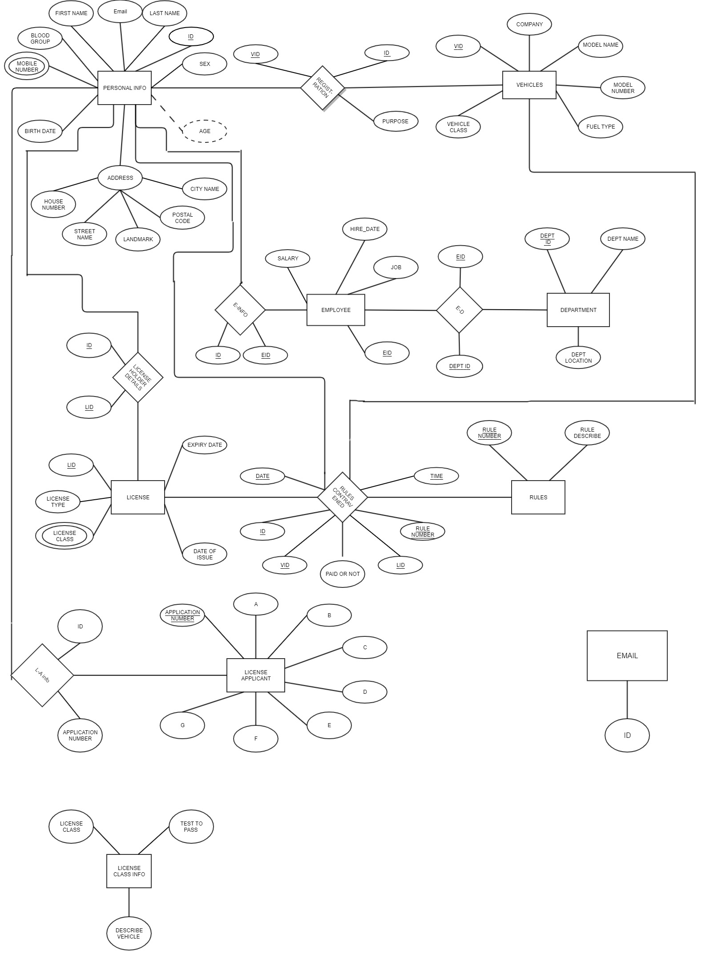

TABLES:

CREATE TABLE PERSONAL(

ID INT PRIMARY KEY NOT NULL AUTO_INCREMENT,

FIRST_NAME VARCHAR(255) NOT NULL,

LAST_NAME VARCHAR(255) NOT NULL,

EMAIL VARCHAR(255) NOT NULL,

SEX CHAR(1) NOT NULL,

MOBILE_NUMBER INT(20) NOT NULL,

BLOOD_GROUP VARCHAR(255) NOT NULL,

BIRTH_DATE DATE NOT NULL,

AGE INT AS (YEAR(CURRENT_TIMESTAMP) - YEAR(BIRTH_DATE)),

HOUSE_NUMBER INT,

STREET_NAME VARCHAR(255),

LANDMARK VARCHAR(255),

POSTAL_CODE INT,

CITY_NAME VARCHAR(255)

);

CREATE TABLE VEHICLES(

VID INT PRIMARY KEY NOT NULL,

COMPANY VARCHAR(255),

MODEL_NAME VARCHAR(255),

MODEL_NUMBER INT,

VEHICLE_CLASS VARCHAR(255),

FUEL_TYPE VARCHAR(255)

);

CREATE TABLE REGISTRATION(

VID INT NOT NULL,

ID INT NOT NULL,

PURPOSE VARCHAR(255)

);

CREATE TABLE EMAIL(

ID INT NOT NULL

);

CREATE TABLE EMPLOYEE(

EID INT PRIMARY KEY NOT NULL,

JOB VARCHAR(255),

SALARY VARCHAR(255),

HIREDATE DATE

);

CREATE TABLE DEPARTMENT(

DEPT_ID INT PRIMARY KEY NOT NULL,

DEPT_NAME VARCHAR(255),

DEPT_LOCATION VARCHAR(255)

);

CREATE TABLE LICENSE(

LID INT PRIMARY KEY NOT NULL,

DATE_OF_ISSUE DATE NOT NULL,

A VARCHAR(255),

B VARCHAR(255),

C VARCHAR(255),

D VARCHAR(255),

E VARCHAR(255)

);

CREATE TABLE LICENSE_HOLDER(

ID INT PRIMARY KEY NOT NULL,

LID INT NOT NULL

);

CREATE TABLE EMPLOYEE_DETAILS(

ID INT PRIMARY KEY NOT NULL,

EID INT NOT NULL

);

CREATE TABLE RULES(

RULE_NUMBER INT PRIMARY KEY NOT NULL,

DECRIPTION VARCHAR(255) NOT NULL,

FINE INT

);

CREATE TABLE RULES_CONTRAVENED(

ID INT NOT NULL,

VID INT NOT NULL,

LID INT,

RULE_NUMBER INT NOT NULL,

RDATE DATETIME,

PAID_OR_NOT VARCHAR(20) DEFAULT 'NOT PAID'

);

CREATE TABLE LICENSE_TEST(

LICENSE_CLASS VARCHAR(255) PRIMARY KEY NOT NULL,

TEST VARCHAR(255) ,

VEHICLE VARCHAR(255)

);

CREATE TABLE L_A(

ID INT NOT NULL,

APPLICATION_NUMBER INT PRIMARY KEY NOT NULL AUTO_INCREMENT

);

CREATE TABLE APPLICANT(

APPLICATION_NUMBER INT PRIMARY KEY NOT NULL AUTO_INCREMENT,

A VARCHAR(255),

B VARCHAR(255),

C VARCHAR(255),

D VARCHAR(255),

E VARCHAR(255)

);

CREATE TABLE DEPARTMENT(

DEPT_ID INT PRIMARY KEY,

DEPT_NAME VARCHAR(255),

DEPT_LOCATION VARCHAR(255)

);

CREATE TABLE E_D(

EID INT PRIMARY KEY,

DEPT_ID INT

);

TRIGGERS:-

//for expired license

CREATE OR REPLACE TRIGGER expired_license

BEFORE INSERT

ON license

FOR EACH ROW

DELETE FROM license WHERE LID = NEW.LID AND DATEDIFF(CURDATE(), DATE_OF_ISSUE) > 3650;

//If already registered vehicle is to be registered email will be sent to previous owner

CREATE OR REPLACE TRIGGER registration_verify

BEFORE INSERT

ON registration

FOR EACH ROW

INSERT INTO EMAIL(ID) select registration.ID FROM registration WHERE registration.ID = NEW.ID;

//email will be sent to rule_offender

CREATE OR REPLACE TRIGGER rule_offender

AFTER INSERT

ON rules_contravened

FOR EACH ROW

INSERT INTO EMAIL(ID) SELECT rules_contravened.ID FROM rules_contravened WHERE rules_contravened = NEW.ID;

//After applying for license email will be sent to applicant for further information

CREATE OR REPLACE TRIGGER license_notification

AFTER INSERT

ON applicant

FOR EACH ROW

INSERT INTO EMAIL(ID) SELECT applicant.ID FROM applicant WHERE applicant.ID = NEW.ID;

//Those who have given test of license are either passed or failed data of those //will be removed

DELIMITER //

CREATE OR REPLACE TRIGGER license_pass_fail

AFTER UPDATE

ON applicant

FOR EACH ROW

DELETE FROM applicant WHERE (ID = NEW.ID);

END//

DELIMITER ;

EVENTS:

//To remove details of those whose license is expired

DELIMITER $$

CREATE

EVENT expired_license

ON SCHEDULE AT CURRENT_TIMESTAMP

DO BEGIN

DELETE FROM license where DATEDIFF(CURDATE(), DATE_OF_ISSUE) > 3650;

END $$

DELIMITER ;

//To remove details of employees who are retired

DELIMITER $$

CREATE

EVENT employee_age

ON SCHEDULE AT CURRENT_TIMESTAMP

DO BEGIN

DELETE FROM employee where EID = (SELECT EID FROM employee_details INNER JOIN personal where employee_details.ID = personal.ID AND personal.AGE > 60);

END $$

DELIMITER ;

//delete data of those who have given license’s test

DELIMITER $$

CREATE

EVENT license_pass

ON SCHEDULE AT CURRENT_TIMESTAMP

DO BEGIN

DELETE FROM applicant where A = "PASS" or A = "FAIL";

END $$

DELIMITER ;

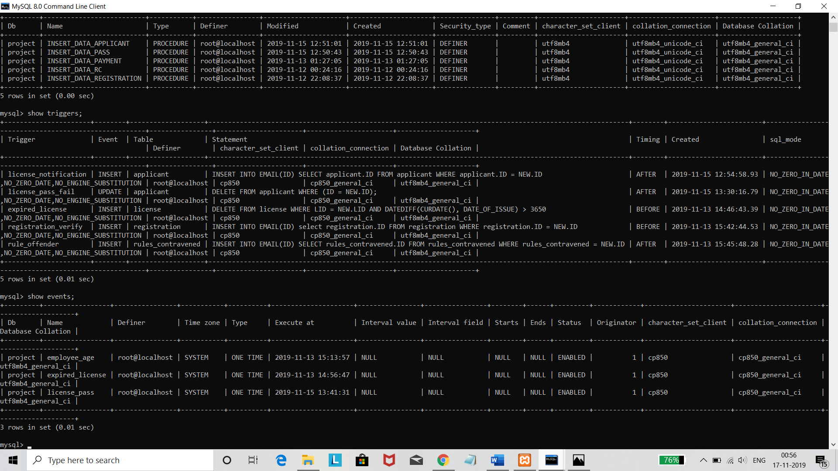

PROCEDURES:

+---------+--------------------------+-----------+----------------+---------------------+---------------------+---------------+---------+----------------------+----------------------+--------------------+

| Db | Name | Type | Definer | Modified | Created | Security_type | Comment | character_set_client | collation_connection | Database Collation |

+---------+--------------------------+-----------+----------------+---------------------+---------------------+---------------+---------+----------------------+----------------------+--------------------+

| project | INSERT_DATA_APPLICANT | PROCEDURE | root@localhost | 2019-11-15 12:51:01 | 2019-11-15 12:51:01 | DEFINER | | utf8mb4 | utf8mb4_unicode_ci | utf8mb4_general_ci |

| project | INSERT_DATA_PASS | PROCEDURE | root@localhost | 2019-11-15 12:50:43 | 2019-11-15 12:50:43 | DEFINER | | utf8mb4 | utf8mb4_unicode_ci | utf8mb4_general_ci |

| project | INSERT_DATA_PAYMENT | PROCEDURE | root@localhost | 2019-11-13 01:27:05 | 2019-11-13 01:27:05 | DEFINER | | utf8mb4 | utf8mb4_unicode_ci | utf8mb4_general_ci |

| project | INSERT_DATA_RC | PROCEDURE | root@localhost | 2019-11-12 00:24:16 | 2019-11-12 00:24:16 | DEFINER | | utf8mb4 | utf8mb4_unicode_ci | utf8mb4_general_ci |

| project | INSERT_DATA_REGISTRATION | PROCEDURE | root@localhost | 2019-11-12 22:08:37 | 2019-11-12 22:08:37 | DEFINER | | utf8mb4 | utf8mb4_unicode_ci | utf8mb4_general_ci |

+---------+--------------------------+-----------+----------------+---------------------+---------------------+---------------+---------+----------------------+----------------------+--------------------+

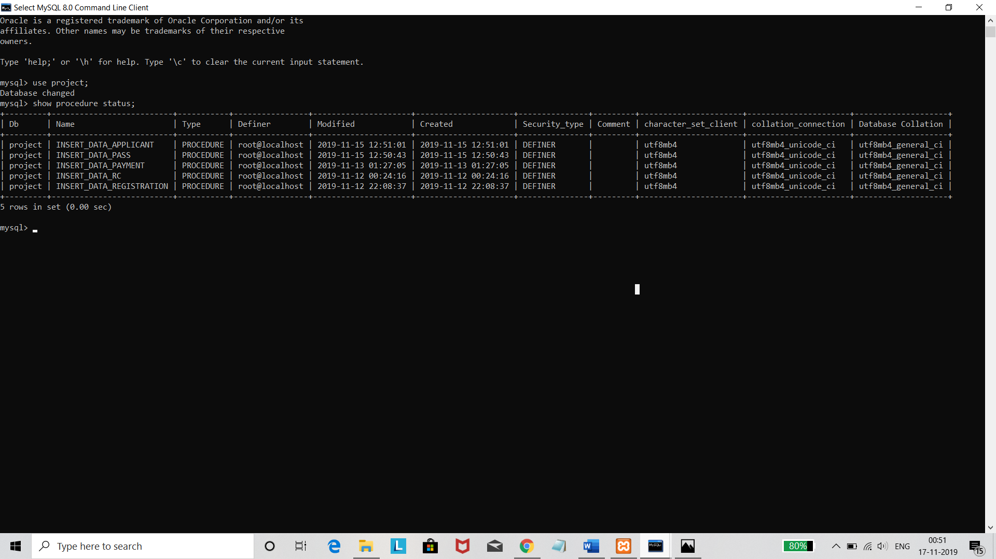

1. INSERT_DATA_APPLICANT: INSERT INTO applicant(ID, A, B, C, D, E) VALUES(id, a, b, c, d, e)
2. INSERT_DATA_PASS: REPLACE INTO applicant (ID, A, B, C, D, E) VALUES (id, a, b, c, d, e)
3. INSERT_DATA_PAYMENT: UPDATE rules_contravened SET PAID_OR_NOT = paid_or_not where ID = id AND VID = vid
4. INSERT_DATA_RC: INSERT INTO rules_contravened(ID, VID, LID, RULE_NUMBER, RDATE) VALUES(id, vid, lid, rule_number, rdate)
5. INSERT_DATA_REGISTRATION: INSERT INTO registration(VID, ID, PURPOSE) VALUES (id, vid, purpose)

TECHNOLOGY USED:

1. Front End: Web pages, Simple user friendly COMPLETELY RESPONSIVE UI created using HTML, CSS, JAVASCRIPT, BOOTSTRAP, AJAX.
2. Back End: Using mysql database, phpmyadmin, xampp localhost server.

