

SMART MUSIC PLAYER

Requirement Specification

**Team Member:**

Hien Tran

Minh Nguyen

Duc Nguyen

Hoang Nguyen

Linh Nguyen

Huy Nguyen

**Returned: _____________________**

**Checked: _____________________**

**Approved: _____________________**

**Table of Contents**

1 Product Concept 6

1.1 Purpose and Use 6

1.2 Intended Audience 6

2 Introduction, Scope and Requirements Defintion 7

2.1 Introduction 7

2.2 Scope 7

2.3 Requirements Definition 7

3 Product Description and Functional Overview 9

4 Customer Requirements 10

4.1 Acquire location 10

4.2 Cloud Server 11

4.3 Secure Cloud Communication 11

4.4 Play Music 12

4.5 Mobile Android App 12

4.6 Secure Bluetooth Communication 13

4.7 Control Audio Playback 13

5 Packaging Requirements 15

5.1 User manual 15

5.2 Cloud Software 15

5.3 App Store Submissions 15

6 Performance Requirements 17

6.1 Connecting time 17

6.2 Power up time 17

6.3 Reliable Bluetooth Data Transfer 18

6.4 Android Version Compatibility 18

6.5 Multi-threading 18

7 Acceptance Criteria 19

8 Feasibility Assessment 20

8.1 Cost Analysis 20

8.2 Size Estimate - Lines of Code (KLOC) 20

9 Reference Documents 22

9.1 Internal Documents 22

9.2 Industry Standards 22

**VERSION HISTORY**

|  |  |  |  |
| --- | --- | --- | --- |
| **Version** | **Change description** | **Person** | **Date** |
| 1.0.0 | Initial draft | Duc Nguyen | 07.10.2019 |
| 1.1.0 | Instructor suggested changes | Minh Nguyen | 08.10.2019 |
| 1.2.0 | Add Accpetance Criteria | Duc Nguyen | 08.10.2019 |
| 1.2.1 | Fill in missing data at 6.4.3, 7.1.2 and 7.4.2; grammar check | Minh Nguyen | 08.10.2019 |
| 1.3.0 | Add Feasibility Assessment, Reference Documents | Duc Nguyen | 09.10.2019 |
| 1.3.1 | Add AES reference; grammar check | Minh Nguyen | 11.10.2019 |
| 1.3.2 | Add SFTP as file transfer protocol. Small change in scope. | Minh Nguyen | 25.10.2019 |
| 1.3.3 | Minor wording changes, remove device mockup | Hien Tran | 25.10.2019 |
| 1.4.0 | Instructor suggested changes   * Add power up time constraint * Add Bluetooth range and delay * Add file size constraint * Add support for MP3 format | Minh Nguyen | 14.11.2019 |
| 1.4.1 | Remove inactive member | Minh Nguyen | 28.01.2020 |

**LIST OF FIGURES**

|  |  |  |
| --- | --- | --- |
| **Figure Number** | **Title** | **Page** |
| 1 | System Overview | 9 |
| 2 | Android App Mockup | 10 |

**LIST OF TABLES**

|  |  |  |
| --- | --- | --- |
| **Table Number** | **Title** | **Page** |
| 1 | Cost Estimates | 20 |
| 2 | Size Estimation- KLOC | 21 |

# Product Concept

This section describes the overall concept of the Smart Music Player by giving a brief and concise description of the purpose and audience.

## Purpose and Use

Smart Music Player is a portable device so that can be embedded on any moving system. The main function is to play music based on weather. The users can setup the device and control the music player manually via built-in buttons and via an Android Application.

## Intended Audience

Smart Music Player will be widely targeted towards those who travelling to different locations and wants to enjoy different types of music without having to search and choose existing playlists. The playlist will be chosen and tagged with weather label by the project team

# Introduction, Scope and Requirements Defintion

## Introduction

The purpose of this System Requirements Specification (SRS) document is to establish the functional requirements of the Smart Music Player Project.

## Scope

This document will cover hardware and software requirements for the portable device, Android application and cloud application. It does not concern the deployment of the system.

## Requirements Definition

The purpose of this section is to outline what the project team defines to be a good requirement.

### Characteristics of a requirement

All requirements should share the following characteristics:

* Unitary - The requirement should address one and only one thing.
* Complete - The requirement is fully stated in one place with no missing information.
* Consistent - The requirement does not contradict any other requirements.
* Non-Conjugated - The requirement should not be conjugated. Example: “The postal code field must validate American and Canadian postal codes” should be written in two requirement statements.
* Traceable - The requirement meets all or part of a business need as stated by the stakeholders and authoritatively documented.
* Current - The requirement has not been made obscure by the passage of time.
* Feasible - The requirement can be implemented within the constraints of the project
* Unambiguous - The requirement is concisely stated without recourse to technical jargon, acronyms, or other esoteric verbiage.

### Requirements Terminology

The purpose of this section is to define the wording that will be used in our requirements document.

* Shall - The statement is a hard requirement. It is absolutely not negotiable, and the requirement statement must be met by the team. This corresponds to critical and high, levels 1 and 2, priorities.
* Will - There is intent by our team to meet this statement. This corresponds to medium, level 3, priority.
* Should - This word, or the adjective “Recommended”, means that there may be valid reasons in particular circumstances to ignore a particular item, but the full implications must be understood and carefully weighed before choosing a different course. This corresponds to low and future, levels 4 and 5, priorities

# Product Description and Functional Overview

Smart Music Player is a portable music player with build-in GPS module detecting the location of the user. Based on detected location’s weather, music tracks will be chosen by the server and sent to the music player.

An Android application will be provided to control the music. The Android mobile device connects to the music player over a Bluetooth connection. This interface will be used to configure the Wi-Fi connection of the music player, and control the music player.

The music player communicates with the server via Wi-Fi connection.

Figure 1 describes the overview on the whole system.

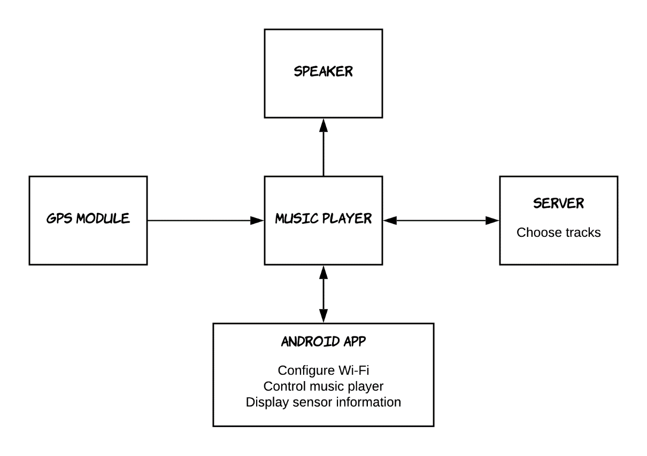

**Figure 1.** System Overview

The music player will have physical buttons to switch on/off and to control the music. There are also micro USB to recharge the device’s battery and one 3.5 audio output to external speaker.

Figure 2 provides a mockup of the user interface on Android phone. The mobile will connect to the music player via Bluetooth Link.

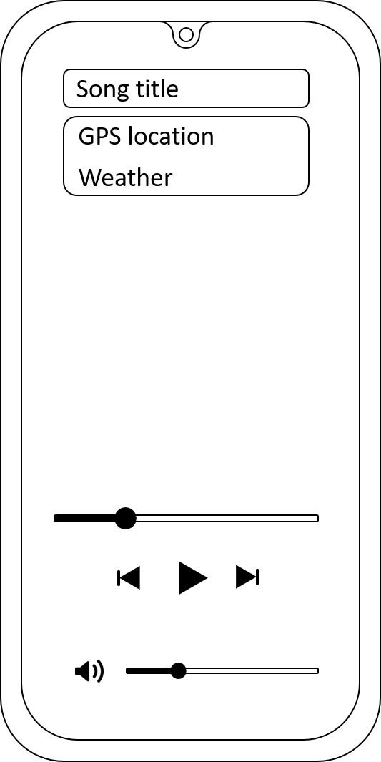

**Figure 2.** Android App Mockup

# Customer Requirements

This following section will detail the existing customer requirements. They should clearly define the restrictions and expectations set forward by the customer and give a clear definition of what the end product will be capable of performing. Some of these requirements are, but not limited to acquire GPS data, detect current location weather, send data to server to make music decision, and audio playback.

## Acquire location

### Description

The product shall have a hardware module that will return the current GPS location.

### Source

None

### Constraints

None

### Standards

None

### Priority

1 – Critical

## Cloud Server

### Description

A server shall be available for the product to communicate to over Wi-Fi connection, receiving the GPS location, getting the weather at the location, choosing the music tracks and sending back metadata of the chosen music tracks.

The server will also host all the music tracks for the device to download. The file transfer which will ensure the transfer of the file and the security of the communication

### Source

None

### Constraints

None

### Standards

None

### Priority

1 – Critical

## Secure Cloud Communication

### Description

The communication from the device to the server shall be secured using HTTPS and SFTP.

### Source

None

### Constraints

File size of maximum 5 megabytes

### Standards

### TLS 1.2 for HTTPS

SSH 2.0 for SFTP

### Priority

1 – Critical

## Play Music

### Description

The product shall be able to play music through an external speaker.

### Source

None

### Constraints

Support waveform audio file format (WAV) and MP3 at 320kps bitrate, 16-bit bit depth and 44100 Hz sample rate

### Standards

None

### Priority

1 – Critical

## Mobile Android App

### Description

We shall write an application that reads the transmitted data from the Bluetooth module, processes the data, and displays the information to the user in a visually stimulating fashion.

The mobile application is also used to configure the Wi-Fi connection of the product and control the audio playback.

### Source

None

### Constraints

Only writing application for devices running Jellybean OS up to Pie OS

### Standards

None

### Priority

2 – High

## Secure Bluetooth Communication

### Description

The communication from the product to the Android device shall be secured using Advanced Encryption Standard (AES) with a 16-byte pre-shared key.

### Source

None

### Constraints

None

### Standards

AES, Bluetooth V4.0

### Priority

2 – High

## Control Audio Playback

### Description

There shall be build-in buttons on the device to control the audio playback.

### Source

None

### Constraints

Control for play/pause, volume up/down, skip audio.

### Standards

None

### Priority

2 – High

# Packaging Requirements

This section describes the packaging requirements for the product. Packaging requirements include a user manual, server software, and application store submissions

## User manual

### Description

The system shall be packaged with a user manual explaining how to use the music player.

### Constraints

English language only

### Standards

None

### Priority

1 – Critical

## Cloud Software

### Description

The cloud software will be available to host music tracks, metadata and process GPS data with the help of a third-party API.

### Constraints

None

### Standards

None

### Priority

1 - Critical

## App Store Submissions

### Description

The Android application should be made available to Android market.

### Constraints

Time and licensing requirements

### Standards

None

### Priority

3 - Medium

# Performance Requirements

This section describes the performance requirements for the product. Performance requirements include connecting time, reliable data transfer, Android version compatibility, and multi-threading.

## Connecting time

### Description

The system should be connected to the mobile device via Bluetooth in a short amount of time. The ideal connecting time should be no more than one minute.

### Constraints

None

### Standards

None

### Priority

3 – Medium

## Power up time

### Description

The system should be fully functional after at most 1 minute after powering up, provided that the Wi-Fi connection is already configured.

### Constraints

None

### Standards

None

### Priority

3 – Medium

## Reliable Bluetooth Data Transfer

### Description

The system shall have a high success rate on bluetooth connection. System should implement error detection, receiver feedback, and retransmission to the receiver.

### Constraints

The delay should be no more than 5 seconds and the minimum range for line-of-sight connection should be 5 meters.

### Standards

None

### Priority

1 – Critical

## Android Version Compatibility

### Description

The system shall be compatible with Jellybean OS up to Pie OS.

### Constraints

None

### Standards

None

### Priority

2 – Critical

## Multi-threading

### Description

The system should be multithreaded to insure high speed data conveyance.

### Constraints

Processing power of the system in used

### Standards

None

### Priority

3 – Medium

# Acceptance Criteria

Requirements that have priority 1 and 2 will be the acceptance criteria. These acceptance criteria will be verified in the verification stage of Smart Music Player project. These items are critical to the success to the Smart Music Player project.

# Feasibility Assessment

## Cost Analysis

The main cost associated with this project will have to deal with the hardware. The current plan is to actually design and develop a printed circuit board to integrate into an existing system. If budget does not allow for a full printed circuit board, a bread boarded prototype will be produced. All other costs should be considered to be time related instead of monetary-based. The following table gives a bare bones initial estimate of the potential costs associated with the project. This estimate is broken down into a both a low- and high-end cost estimate.

**Cost Estimates**

|  |  |  |
| --- | --- | --- |
| Component | Low End Cost | High End Cost |
| Central Unit/ Udoo Neo | €40 | €60 |
| GPS Module | €20 | €120 |
| Sound card | €10 | €40 |
| Hardware Enclosure | €20 | €50 |
| Wiring and Connections | €10 | €20 |
| Circuit Board | €15 | €50 |
| Rechargeable Power Supply | €10 | €30 |
|  |  |  |
| Total | €125 | €370 |

**Table 1.** Cost Estimates

## Size Estimate - Lines of Code (KLOC)

To estimate the size of the project based on lines of code (KLOC), we first broke down and estimated the size of each individual aspect of the project. The following table gives a rundown of the size estimation for each component.

**Size Estimation - KLOC**

|  |  |  |
| --- | --- | --- |
| Component | Low Estimate | High Estimate |
| Central Unit/ Udoo Neo | 4500 | 9000 |
| Android Application | 1000 | 2000 |
| Server Software | 1000 | 2000 |
| Total | 6500 | 13000 |

**Table 2.** Size Estimation - KLOC

# Reference Documents

## Internal Documents

## Industry Standards

In the event of a conflict between a referenced document and this document, the requirements in this document shall take precedent.

### Global Positioning System

<https://en.wikipedia.org/wiki/Global_Positioning_System>

### WAV Audio format

<https://en.wikipedia.org/wiki/WAV>

### Udoo Neo Development Board

https://www.udoo.org/udoo-neo/

### Bluetooth V4.0

https://en.wikipedia.org/wiki/Bluetooth#Bluetooth_4.0

### Wi-Fi Connection

https://en.wikipedia.org/wiki/Wi-Fi

### Advanced Encryption Standard

https://en.wikipedia.org/wiki/Advanced_Encryption_Standard

**APPENDIX**

**List of Acronyms**

GPS - Global Positioning System

SRS - Systems Requirement Specification

TLS - Transport Layer Security

AES - Advanced Encryption Standard

WAV - Waveform Audio File Format

SFTP – SSH File Transfer

SSH – Secure Shell