

SMART MUSIC PLAYER

Technical Specification

**Team Member:**

Hien Tran

Minh Nguyen

Duc Nguyen

Hoang Nguyen

Linh Nguyen

Huy Nguyen

Vy Do

**Returned: _____________________**

**Checked: _____________________**

**Approved: _____________________**

**Table of Contents**

1 Introduction 4

1.1 Purpose and scale 4

1.2 Definition, notation and abbreviations 4

1.3 References 4

2 General description of the system 5

2.1 Description of application area 5

2.2 System interfacing to its environment 5

2.3 Software environment description 6

2.4 Hardware environment description 7

2.5 Essential conditions 7

2.6 Agreements and standards 7

3 Description of architecture 8

3.1 Hardware architecture 8

3.2 Software architecture 8

**Table of Figures**

Figure 1. Draft of the system and its environment 5

Figure 2. Project server package diagram 8

Figure 3. Music player application package diagram 9

Figure 4. Android application package diagram 10

**Table of TABLES**

Table 1. Special terms and abbreviations 4

**VERSION HISTORY**

|  |  |  |  |
| --- | --- | --- | --- |
| **Version** | **Change description** | **Person** | **Date** |
| 1.0.0 | Initial draft | Minh Nguyen | 24.11.2019 |
|  |  |  |  |

# Introduction

## Purpose and scale

This document describes the system, architecture and modules of the project.

The scope includes:

* Software and hardware environment
* Software and hardware architecture, modules and processes

## Definition, notation and abbreviations

The table below contains the description of the special terms and abbreviations used in this document.

|  |  |
| --- | --- |
| **Terms / Abbreviations** | **Description** |
| API | Application programming interface |
| GPS | Global positioning system |

Table 1. Special terms and abbreviations

## References

Microstack GPS  
<http://www.microstack.org.uk/assets/gps/FormattedGPSgettingstarted.pdf>

Technical specification format  
<https://git.vamk.fi/juma/VAMK_Handbook/src/branch/master/projectname_Technical_specification_0_1.doc>

# General description of the system

## Description of application area

This project is developed targeting people’s need of entertainment, specifically listening to music. The product aims to eliminate the paradox of choice - the inconvenience of browsing and choosing a suitable track among too many music tracks.

## System interfacing to its environment

The following figure shows a draft of the system interacting with its environment.

Figure 1. Draft of the system and its environment

The interfaces of the system are:

* End users
  + Input: Control from the Android application or push buttons
  + Output: Audio from the 3.5 mm output jack
* 3rd party location server
  + Input: GPS data
  + Output: Weather of the location

## Software environment description

### Project server environment

The following list contains the environment used developing the project server:

* Toolchain
  + NodeJs 10.16.2
  + npm 6.12.0
  + parcel-bundler 1.12.4
  + typescript 3.6.4
* Dependencies
  + axios 0.19.0
  + express 4.17.1
  + https 1.0.0
  + mongoose 5.7.6
  + openssh-sftp-server 1:7.9

### Music player software environment

The following list contains the environment used developing the music player software:

* Operating system: UDOObuntu 2.3.0 (Ubuntu 14.04 LTS)
* Compiler: g++ 4.84
* Libraries:
  + libssl 1.0.0
  + libcurl 7.35.0
  + libcrypto 1.0.0
  + libjsoncpp 0.6.0

### Android application environment

The following list contains the environment used developing the Android application:

* Toolchain
  + Android studio 3.5.1
  + Kotlin 1.3.50, jdk7
  + Gradle 3.5.1
* Dependencies
  + appcompat 1.1.0
  + core-ktx 1.1.0
  + constraintlayout 1.1.3

## Hardware environment description

The following list contains the environment used developing the music player hardware:

* Development board: UDOO Neo Full
* GPS module: Microstack GPS
* Sound card: Deltaco USB Soundcard 7.1

## Essential conditions

The music player requires internet connection to get new soundtracks from the server.

## Agreements and standards

This technical specification is made based on the requirement specification that has been agreed upon by the customer and the project team.

# Description of architecture

## Hardware architecture

## Software architecture

### Project server

The following figure contains the packages of the project server and their relationships:

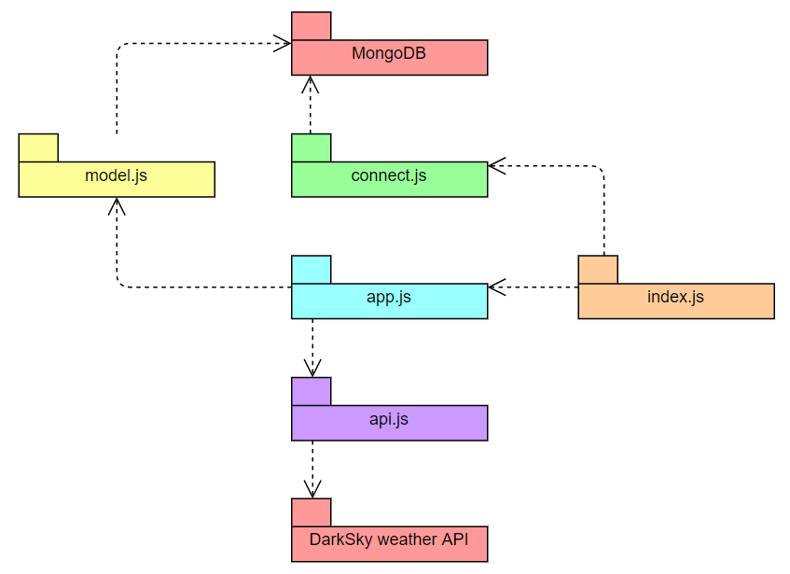

Figure 2. Project server package diagram

### Music player application

The following figure contains the packages of the music player application and their relationships:

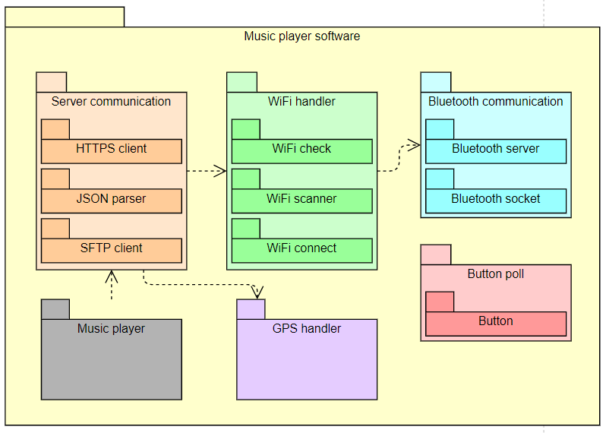

Figure 3. Music player application package diagram

### Android application

The following figure contains the packages of the Android application and their relationships:

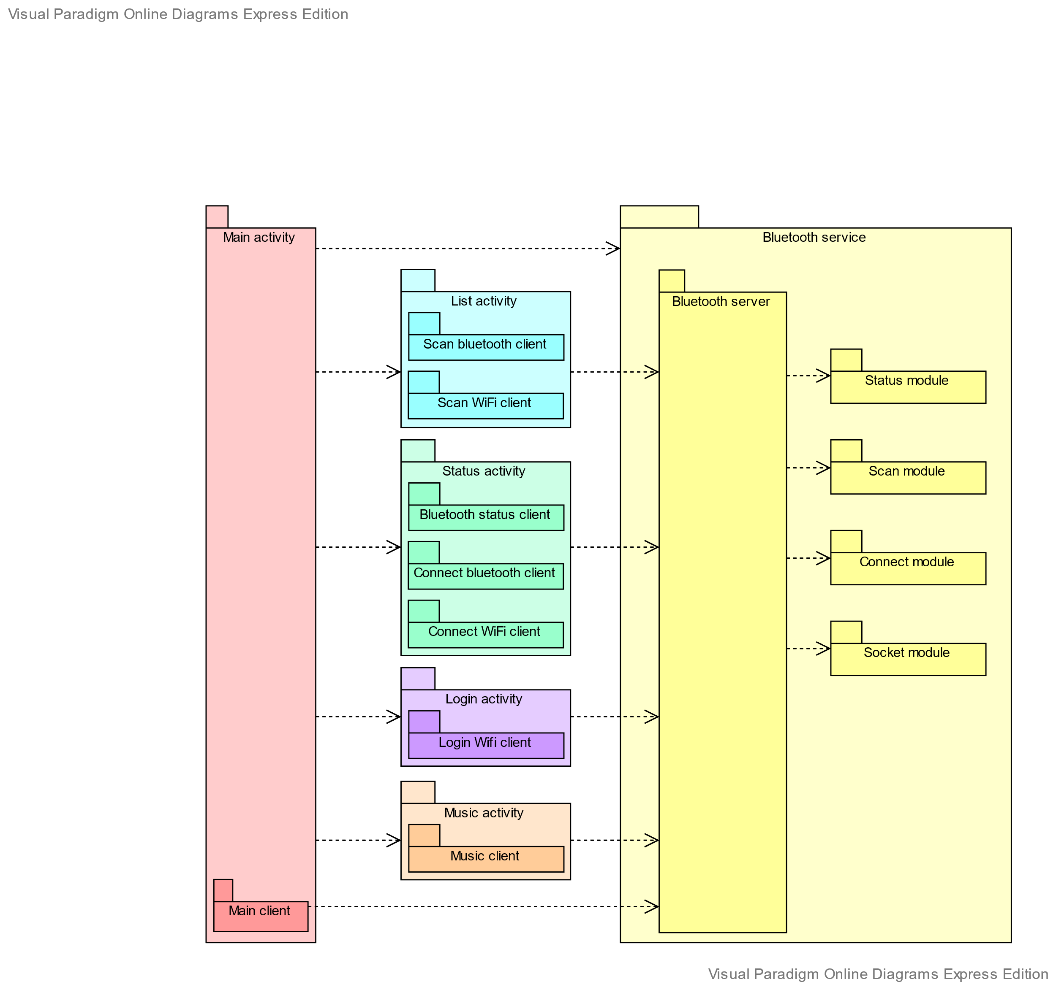

Figure 4. Android application package diagram