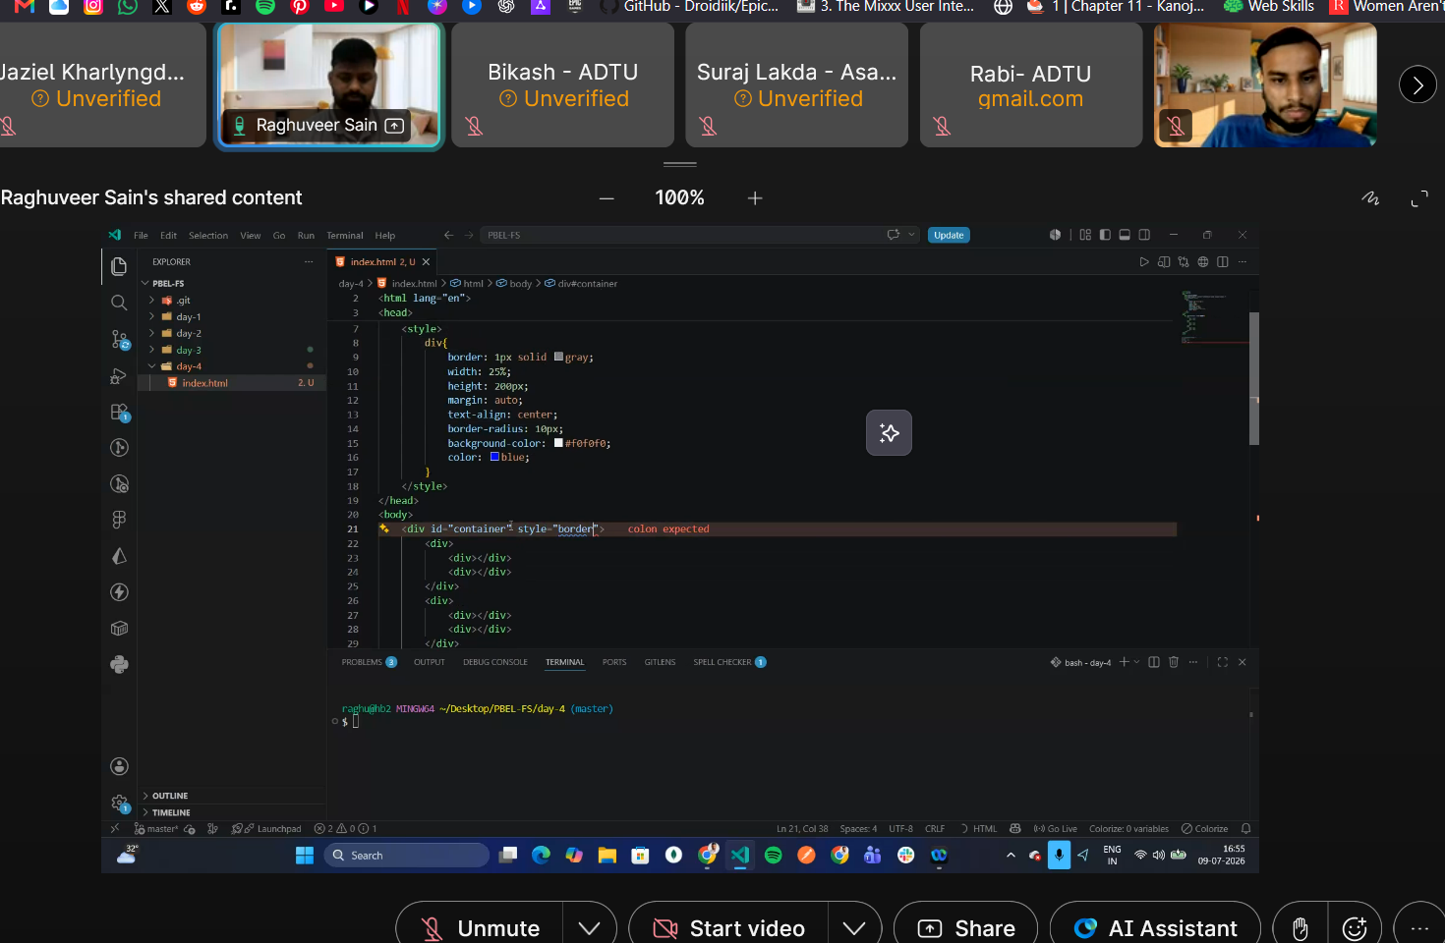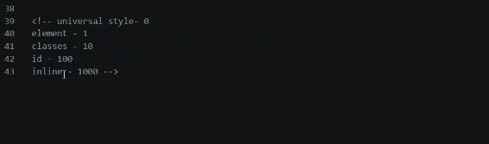
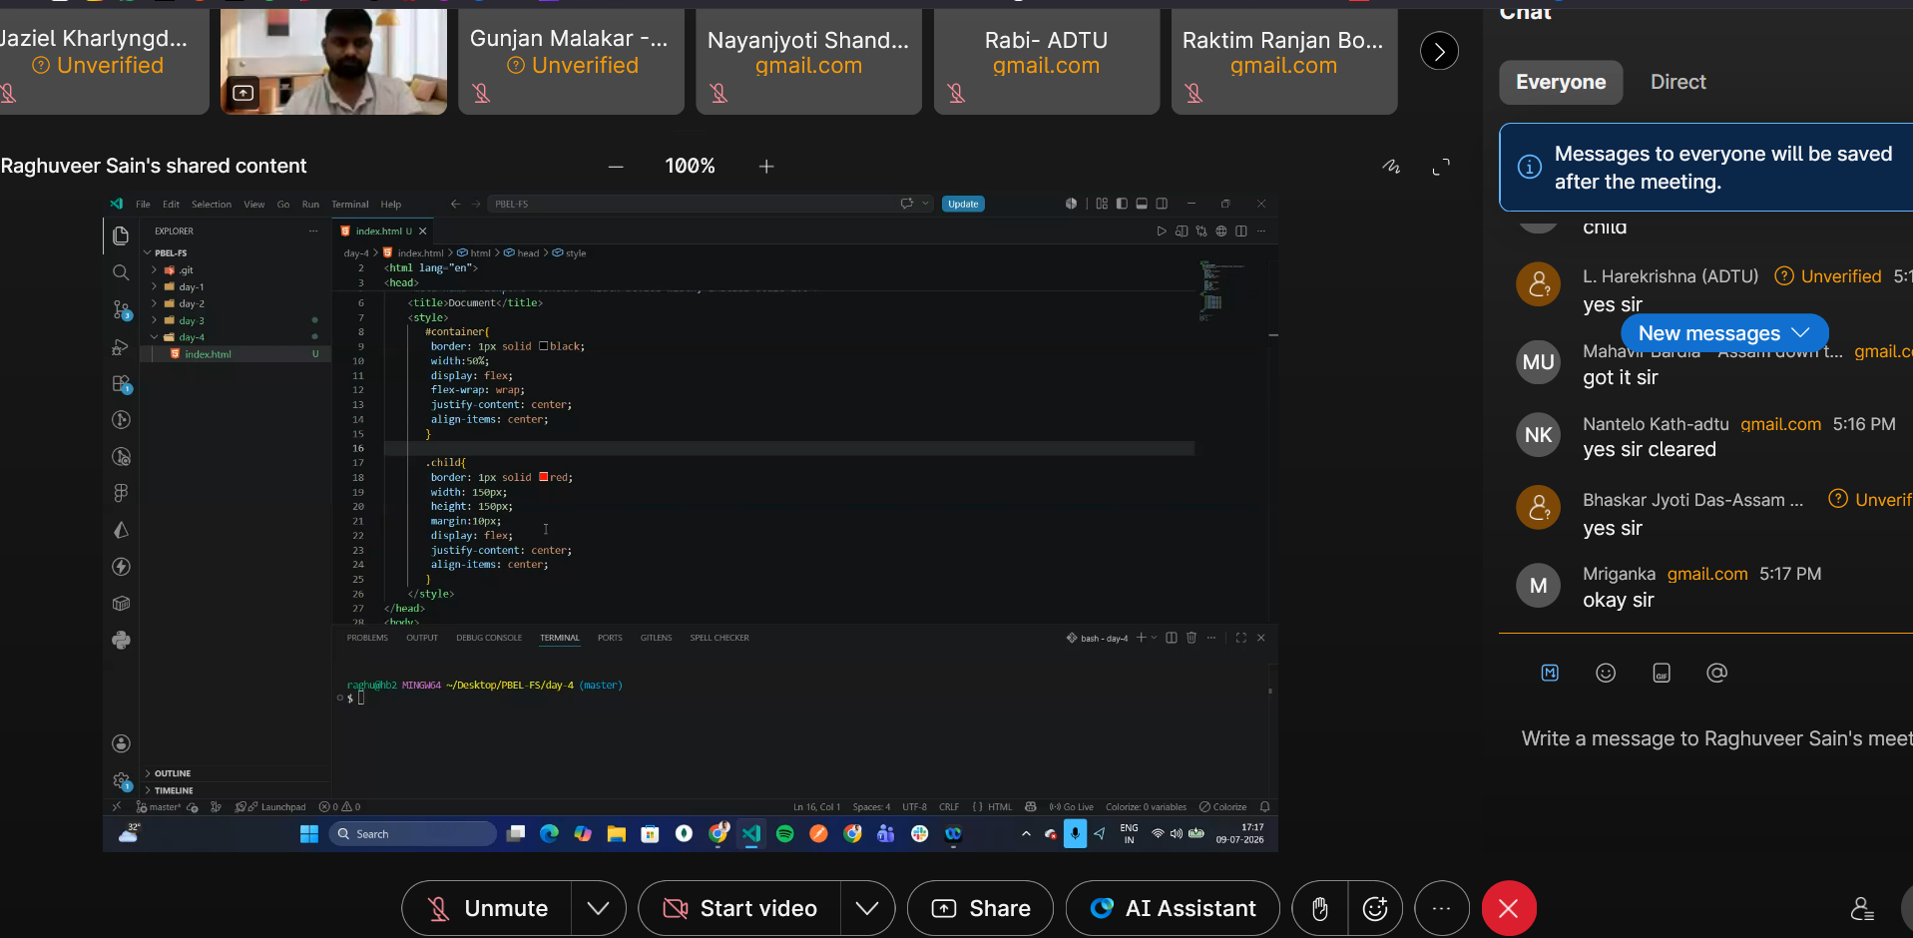
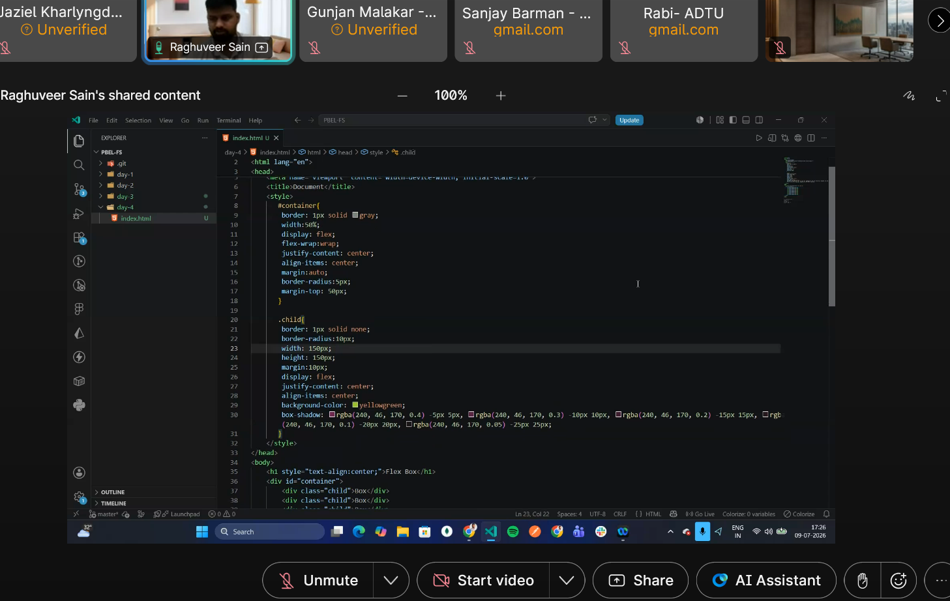
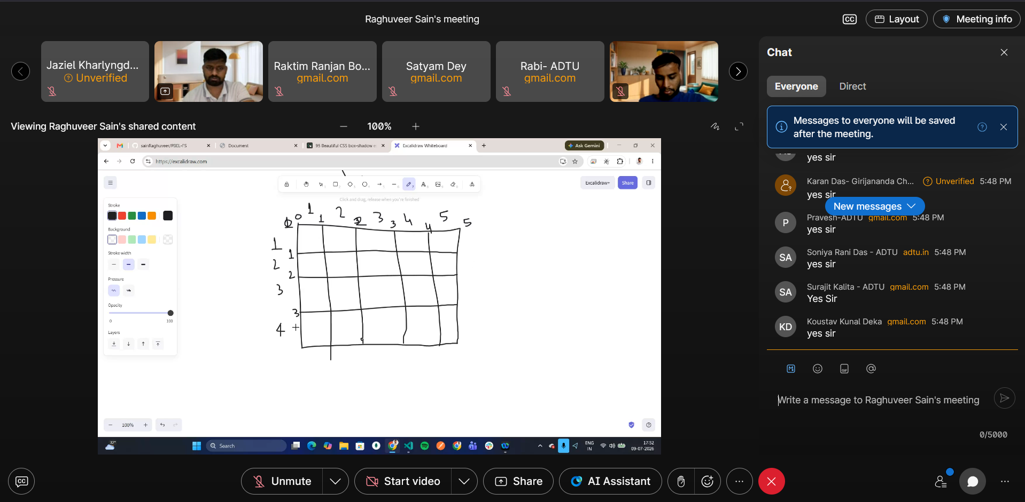
https://user-images.githubusercontent.com/107298963/204560038-ed1a0367-3b8a-4634-a457-533040800ce2.png
Assignment to recreate

