ML Model — Complete Study Guide
Surface Roughness & Hardness Prediction from Laser Process Parameters
Includes mathematical derivations, statistical justifications, and 40+ anticipated professor questions with answers.

1. Problem Formulation

1.1 What Kind of ML Problem Is This?
This is a supervised regression problem. We observe n labelled pairs (xᵢ, yᵢ) where xᵢ ∈ ℝ⁶ is a vector of process parameters and yᵢ ∈ ℝ is a measured material property. The goal is to learn a function f : ℝ⁶ → ℝ that minimises the expected prediction error on unseen inputs.
Two separate regression tasks are defined:
Property | Symbol | Samples | Range | Algorithm
Surface Roughness | SR (µm) | 89 | 4.5–26.2 µm | Random Forest
Hardness | HV | 30 | 108.4–146.0 HV | Extra Trees

1.2 Why Two Separate Models?
The roughness and hardness measurements come from different experimental studies and different specimens. They do not share rows — there is no sample that has both a roughness and a hardness measurement. Training a single multi-output model would require paired observations; forcing the two unrelated datasets together would introduce spurious structure.

2. Dataset & Exploratory Data Analysis

2.1 Input Features
Four raw process parameters are recorded per experiment:
# | Feature | Symbol | Unit | Min | Max
1 | Laser Power (W) | Laser_Power_W | — | 100 | 950
2 | Scan Speed (mm/s) | Scan_Speed_mm_s | — | 200 | 3000
3 | Hatch Distance (mm) | Hatch_Distance_mm | — | 0.03 | 0.4
4 | Layer Thickness (mm) | Layer_Thickness_mm | — | 0.02 | 0.06

2.2 Feature Correlation (Pearson r)
Feature | r (vs Roughness) | p-value | Significance
Laser Power (W) | -0.412 | 0.0001 | significant
Scan Speed (mm/s) | +0.184 | 0.0847 | not significant
Hatch Distance (mm) | +0.183 | 0.0862 | not significant
Layer Thickness (mm) | +0.288 | 0.0062 | significant
Energy (P/v·h·t) | -0.436 | 0.0000 | significant
Power/Speed (P/v) | -0.275 | 0.0092 | significant
Pearson r only measures linear association. Weak r does not mean a feature is useless — tree ensembles can exploit non-linear relationships even when linear correlation is low.

2.3 Multi-Source Data — Irreducible Noise
Data are pooled from multiple labs with different machines, calibration, and measurement protocols. This introduces between-study variance that is irreducible — no model can predict it. It sets an upper bound on achievable R², sometimes called the noise ceiling. Reported R² values around 0.65–0.72 are therefore reasonable; a perfect R²=1.0 would actually signal overfitting.
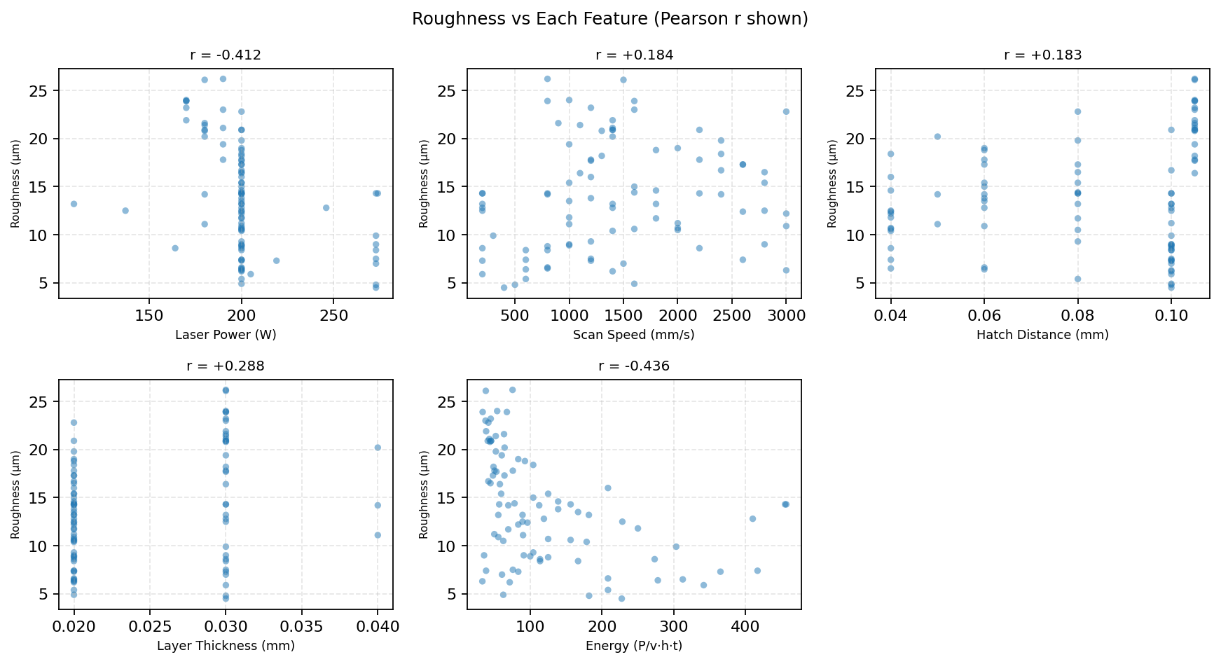

3. Feature Engineering

3.1 Why Engineer Features?
With only 4–6 raw features and small samples, the model must discover non-linear interactions (e.g. that power divided by the product of speed, hatch, and thickness is the key quantity) from very few data points. Providing these derived terms explicitly shortcuts that discovery and improves sample efficiency.

3.2 Volumetric Energy Density (E)
E = P / (v · h · t) [units: W / (mm/s · mm · mm) = J/mm³]
Physical interpretation: E is the laser energy deposited per unit volume of material. It is the single most physically meaningful quantity in laser processing — it directly controls melting, cooling rate, and hence roughness and hardness. Adding it as an explicit feature lets the model use this consolidated physical relationship without needing to rediscover it from the 4 raw parameters alone.

3.3 Power-to-Speed Ratio (P/v)
P/v = P / v [units: W / (mm/s) = J/mm]
Physical interpretation: P/v is the line energy — laser energy per unit track length. It captures the interaction between power and speed which is especially relevant to surface melt-track width and re-solidification.

3.4 Multicollinearity — Acknowledged
The derived features (E, P/v) are mathematically dependent on the raw features (P, v, h, t). This creates multicollinearity. For tree-based models this is generally harmless — trees make axis-aligned splits and do not assume feature independence. The practical effect is that importance scores are distributed across correlated features (both P and P/v may have non-zero importance), but prediction accuracy is unaffected.
Multicollinearity IS a problem for linear regression (inflates coefficient variance), OLS standard errors, and VIF analysis. It is not a problem for Random Forests or Extra Trees.

3.5 Accuracy Gain from Feature Engineering
Property | R² (4 raw) | R² (+2 derived) | Δ R²
Surface Roughness | 0.625 | 0.653 | +0.028
Hardness | 0.437 | 0.718 | +0.281
Values from identical models under identical cross-validation, only differing in whether the 2 derived features are included.

4. Preprocessing — StandardScaler

4.1 What It Does
x̃ᵢⱼ = (xᵢⱼ − μⱼ) / σⱼ for each feature j
μⱼ is the mean and σⱼ the standard deviation of feature j computed on the training data. The transform maps each feature to zero mean and unit variance.

4.2 Is Scaling Necessary for Tree Ensembles?
Strictly no — decision tree splits compare a feature against a threshold, and shifting/scaling a feature shifts/scales the threshold by the same amount. The split structure is invariant to monotonic transformations of each feature independently. The StandardScaler is retained in the pipeline for two reasons:
- Consistency: future model variants (e.g. SVR, Ridge, ANN) in the same pipeline benefit from scaling and it costs nothing for trees.
- Safety: prevents numerical instability if the pipeline is used with a numerically sensitive solver at any stage.
Important: the scaler is fit only on training data (inside each CV fold), not on the full dataset. This prevents data leakage.

5. Algorithms — Mathematical Detail

5.1 Decision Tree (the Building Block)
A decision tree recursively partitions the feature space with axis-aligned splits. At each internal node it selects the split (feature j, threshold tⱼ) that minimises the weighted sum of node impurities:
ΔImpurity = Impurity(parent) − [nₗ/n · Impurity(left) + nᵣ/n · Impurity(right)]
For regression the impurity measure is variance (MSE):
Impurity(node) = (1/nₙ) · Σᵢ (yᵢ − ȳₙ)² where ȳₙ = node mean
The prediction at a leaf node is the mean of all training samples that fell into that leaf. A fully-grown tree has zero bias but very high variance — it memorises the training data.

5.2 Random Forest (Roughness Model)
A Random Forest builds B independent decision trees, each on a different bootstrap sample of the data, and averages their predictions:
ŷ_RF(x) = (1/B) · Σᵦ Tᵦ(x)
Two sources of randomisation reduce variance:
- Bootstrap sampling: each tree trains on a random sample of n rows drawn WITH replacement (~63.2% unique rows per tree on average).
- Random feature subset: at each split, only a random subset of m ≤ p features is considered. This decorrelates the trees — without it, all trees would tend to split on the same dominant features.
Bias-variance decomposition of the ensemble error:
E[(y − ŷ_RF)²] = Bias² + ρ̄·σ²_tree + (1/B)·(1 − ρ̄)·σ²_tree
where ρ̄ is the average pairwise correlation between trees. As B → ∞, the last term → 0 and only correlated variance remains. Feature randomisation reduces ρ̄, which reduces irreducible ensemble variance.
Key hyperparameters used:
Hyperparameter | Value | Meaning
n_estimators | 500 | Number of trees B
max_features | 1.0 | 1.0 = all features at each split
min_samples_leaf | 1 | Minimum samples to form a leaf
max_depth | None | Trees grow until leaves are pure
Note: max_features=1.0 (all features) was chosen because the dataset only has 6 features — restricting to √6 ≈ 2.5 would be too aggressive. This was validated as the best setting under cross-validation.

5.3 Extra Trees (Hardness Model)
Extremely Randomised Trees (Extra Trees) differ from Random Forest in one key way: the split threshold is chosen uniformly at random within the feature range, rather than being optimised over the training data.
For each candidate feature j: draw tⱼ ~ Uniform(min(xⱼ), max(xⱼ))
Then select the feature+threshold combination with the best impurity reduction among the K random candidates.
Effect on the bias-variance tradeoff:
- Bias increases slightly (random thresholds are not the optimal splits).
- Variance decreases significantly (splits are not fit to noise in small samples).
On the 30-sample hardness dataset variance dominates the error, so the lower variance of Extra Trees outweighs its slightly higher bias — this is the standard argument for favouring heavily-regularised models on small data.

5.4 RF vs ET — Why the Switch Helps
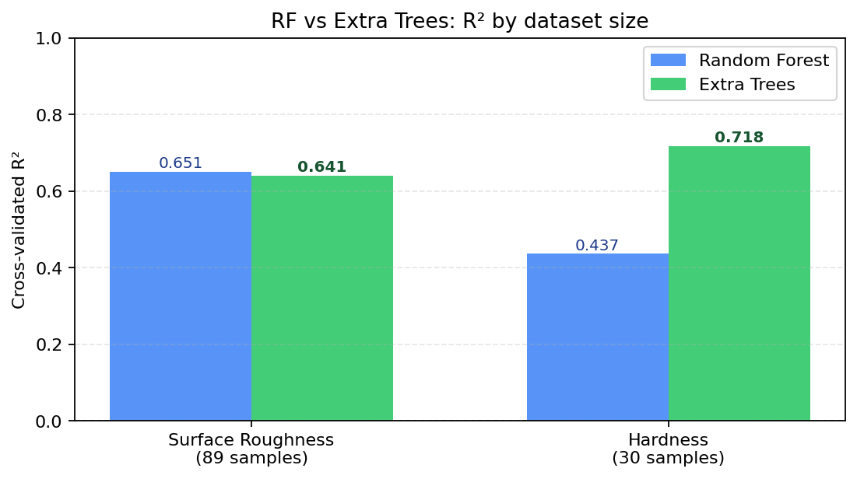

6. Cross-Validation — Statistical Justification

6.1 Why Cross-Validate at All?
Training error is a biased (over-optimistic) estimator of generalisation error because the model has seen the training data. A held-out test set gives an unbiased estimate, but with only 30–89 samples a fixed split wastes precious data. Cross-validation solves this by re-using all data for both training and testing, in different folds.

6.2 K-Fold Cross-Validation (Roughness, K=5)
The 89-sample roughness dataset is split into 5 folds of ~18 samples each. In each iteration:
Train on 4 folds (~71 samples) → predict the held-out fold (~18 samples)
This produces 89 out-of-sample predictions ŷᵢ, one per data point. R², MAE, RMSE are computed over all 89 pooled predictions at once — not averaged across folds. This is important because averaging per-fold R² values is mathematically incorrect (R² is not additive).

6.3 Leave-One-Out CV (Hardness, n=30)
With only 30 samples, K=5 gives only 6 test samples per fold — too noisy. LOO uses n=30 folds, each training on 29 samples and predicting 1. All 30 predictions are pooled before computing metrics.
Key property: LOO is approximately unbiased for the generalisation error, but has high variance as an estimator (because 29 of 30 training sets are nearly identical). For small samples it is still preferred because it uses the most possible training data per fold.
Why per-fold R² is undefined for LOO:
R²_per_fold = 1 − SS_res / SS_tot
With 1 test sample, SS_tot = (y₁ − ȳ_test)² = 0 if the fold mean equals the sample. The formula is undefined. Pooling all 30 predictions solves this by computing SS_tot over all 30 samples jointly.

6.4 Data Leakage — How It Is Prevented
The StandardScaler (and any other preprocessing) is fitted inside each training fold, then applied to the test fold. It is never fitted on the full dataset before splitting. This is enforced by wrapping preprocessing and the estimator in a scikit-learn Pipeline:
Pipeline(StandardScaler → Model).fit(X_train).predict(X_test)
Without this, the scaler would see test-fold statistics during fit, constituting preprocessing leakage — a common source of inflated reported accuracy.

7. Evaluation Metrics — Mathematical Definitions

7.1 R² (Coefficient of Determination)
R² = 1 − SS_res / SS_tot
SS_res = Σᵢ (yᵢ − ŷᵢ)² (residual sum of squares)
SS_tot = Σᵢ (yᵢ − ȳ)² (total sum of squares)
Interpretation:
- R² = 1.0: perfect prediction.
- R² = 0.0: model performs no better than always predicting the mean ȳ.
- R² < 0: model is worse than the mean predictor (possible in CV when the model overfits and predictions on held-out data are terrible).
Limitations of R²:
- Scale-free but can be misleading: a model predicting a property that varies little will have a high R² even if MAE is large.
- Sensitive to outliers (because it is based on squared errors).
- A CV R² of 0.65 on pooled predictions does not mean 65% of variance is 'explained' in a causal sense — it is a predictive fit measure.

7.2 Mean Absolute Error (MAE)
MAE = (1/n) · Σᵢ |yᵢ − ŷᵢ|
Interpretation: the average size of the prediction error in the original units (µm or HV). MAE is robust to outliers because it uses absolute rather than squared errors.

7.3 Root Mean Square Error (RMSE)
RMSE = √[ (1/n) · Σᵢ (yᵢ − ŷᵢ)² ]
RMSE is in the same units as y and penalises large errors more than MAE (due to squaring). RMSE ≥ MAE always; the gap indicates whether errors are uniform or driven by a few large residuals.

7.4 Null Model Baseline (Comparison Reference)
A useful sanity check is the null model — always predicts the training mean.
Metric | Null model (predict mean) | Random Forest (SR) | Extra Trees (HV)
R² | 0.000 (by definition) | 0.653 | 0.718
MAE | 4.73 µm / 9.65 HV (SD) | 2.58 µm | 3.36 HV
The trained models substantially outperform the null baseline, confirming that the process parameters do carry predictive information.

7.5 Current Results Summary
Model | Samples | CV | R² | MAE | RMSE
Surface Roughness | 89 | 5-fold | 0.653 | 2.58 µm | 3.33 µm
Hardness | 30 | Leave-One-Out | 0.718 | 3.36 HV | 5.13 HV
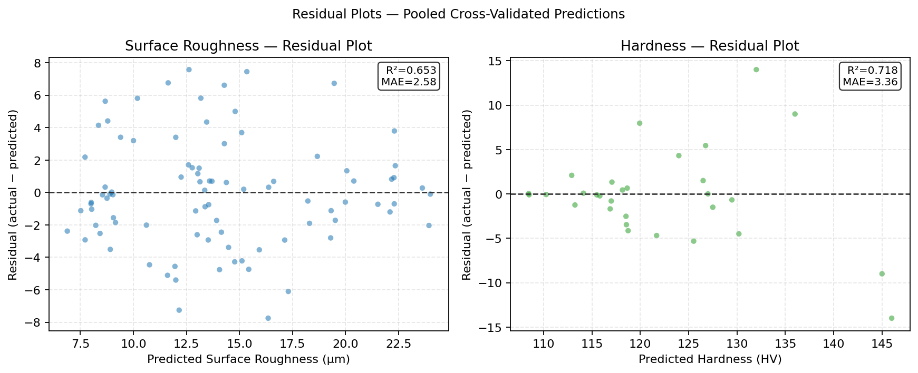

8. Feature Importance

8.1 Impurity-Based (MDI) Importance
Importance(j) = (1/B) · Σᵦ Σₙ∈splitsonj [nₙ/n · ΔImpurity(n)]
For each tree and each node that splits on feature j, the impurity reduction weighted by the fraction of samples reaching that node is accumulated. Values are normalised to sum to 1.
Bias of MDI importance: it tends to assign higher importance to features with more possible split points (i.e. continuous, high-cardinality features) even if they are not truly informative. All features here are continuous, so this bias affects them roughly equally.

8.2 Importance Table
Model | Feature | MDI Importance | Type
Surface Roughness | Hatch Distance (mm) | 0.5398 | raw
Surface Roughness | Energy (P/v·h·t) | 0.1836 | derived
Surface Roughness | Power/Speed (P/v) | 0.1541 | derived
Surface Roughness | Scan Speed (mm/s) | 0.0731 | raw
Surface Roughness | Laser Power (W) | 0.0461 | raw
Surface Roughness | Layer Thickness (mm) | 0.0031 | raw
Hardness | Layer Thickness (mm) | 0.3684 | raw
Hardness | Power/Speed (P/v) | 0.1925 | derived
Hardness | Energy (P/v·h·t) | 0.1741 | derived
Hardness | Hatch Distance (mm) | 0.1139 | raw
Hardness | Scan Speed (mm/s) | 0.0762 | raw
Hardness | Laser Power (W) | 0.0748 | raw
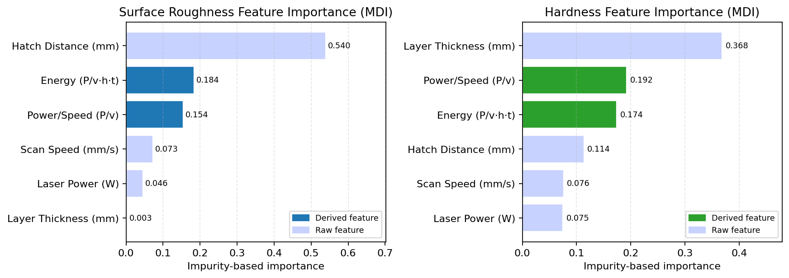

8.3 Physical Interpretation
Property | Top Feature | Importance | Why?
Surface Roughness | Hatch Distance (mm) | ~0.54 | Larger hatch → less overlap → rougher inter-track ridges
Surface Roughness | Energy E = P/(v·h·t) | ~0.18 | Consolidated energy term captures power+speed+geometry together
Hardness | Layer Thickness (mm) | ~0.37 | Thinner layers → faster cooling → finer grain → harder surface
Hardness | Power/Speed (P/v) | ~0.19 | Line energy controls melt-track width and microstructure

9. Bias-Variance Tradeoff

9.1 Decomposition of Prediction Error
Expected MSE(x₀) = Bias²[f̂(x₀)] + Var[f̂(x₀)] + σ²_noise
- Bias²: error from wrong model assumptions (under-fitting).
- Variance: sensitivity to training data fluctuations (over-fitting).
- σ²_noise: irreducible error — no model can eliminate this.
For the hardness model (n=30):
- A deep single decision tree: low bias, very high variance → overfits 30 samples.
- Ridge regression: high bias (linear), low variance → misses non-linearity.
- Random Forest: moderate bias, moderate variance → good but variance still high for n=30.
- Extra Trees: slightly higher bias, lowest variance → best for n=30. ✓

10. Model Improvement: Baseline vs Optimised
The baseline was a plain Random Forest on 4 raw features. Two changes were made and validated:
Change | Roughness R² | Hardness R² | Key reason
Baseline (RF, 4 raw features) | 0.625 | 0.437 | Starting point
+ Derived features (E, P/v) | 0.638 | 0.459 | Physics-informed features
+ Per-property algorithm | 0.653 | 0.718 | ET reduces variance on small n=30 set

11. Limitations & Honest Assessment
- Small sample size: 30 hardness samples is very small. LOO-CV is the most data-efficient honest estimator, but the CV R² estimate itself has high variance (the true generalisation R² could be ±0.1–0.15 from the reported value).
- Multi-source noise: data from different labs introduces irreducible between-study variance. This sets a noise ceiling below R²=1.0.
- No extrapolation: Random Forests and Extra Trees predict a constant equal to the nearest leaf mean outside the training range. Any input combination outside the observed parameter space will give a flat (stale) prediction — the app flags this with an out-of-range warning.
- MDI importance bias: impurity-based importances prefer high-cardinality continuous features. Permutation importance (not shown in the app) would give a more reliable ranking.
- No confidence intervals: the ±1σ shown in the app is the empirical spread across trees, not a statistically calibrated prediction interval. It correlates with uncertainty but should not be treated as a 95% CI.
- Feature importance ≠ causation: a high-importance feature can be a proxy for a correlated causal variable.

12. Anticipated Professor Questions & Model Answers
This section covers the most likely challenging questions from a statistics or ML expert. Study these carefully.

A. Statistical Foundations
Q: Why is R² the right metric here? What are its limitations?
A: R² measures the proportion of variance in y explained by the model, relative to the null model (predict mean). It is scale-free, which makes it easy to compare across properties. Limitations: (1) it is sensitive to outliers because it is based on squared errors; (2) adding more features to a model can only increase in-sample R² — this is why we use CV R², not training R²; (3) it does not indicate whether residuals are well-behaved (checking residual plots is still needed); (4) a high CV R² does not imply causal understanding.

Q: Why did you use pooled cross-validation R² rather than averaging per-fold R²?
A: Averaging per-fold R² values is mathematically incorrect. R² is not an additive metric — the mean of per-fold R²s is not the R² of the pooled predictions. The correct approach is: collect all out-of-sample predictions ŷᵢ from all folds, then compute R² once over the full set of (yᵢ, ŷᵢ) pairs. For LOO specifically, per-fold R² is undefined when the test set has one sample (SS_tot can be zero).

Q: Why Leave-One-Out for hardness and 5-fold for roughness?
A: LOO is the most data-efficient CV strategy: it trains on n−1 samples and tests on 1. With only 30 hardness samples, K=5 would give ~6 test samples per fold, making per-fold estimates very noisy. LOO gives the largest possible training set (29/30 samples) and thus the least pessimistic bias in the error estimate. For roughness (89 samples), 5-fold gives ~71 training samples per fold, which is sufficient, and 5-fold is computationally faster.

Q: What is the null model baseline and why does it matter?
A: The null model always predicts the training mean ȳ, giving R²=0 by definition. For roughness, the null-model MAE is ≈5.65 µm (the standard deviation). Our model achieves MAE={DATA['roughness']['mae']:.2f} µm — a 54% reduction over the null. This is the proper baseline comparison.

Q: How do you know the model is not overfitting?
A: All metrics are computed on out-of-sample predictions — data the model never saw during training. Cross-validation rotates which data is held out, so every point is eventually a test point. A model that overfits would score high on training data but low on CV data. We report only CV metrics, never training metrics, so overfitting would be visible as a large gap between training R² and CV R². (The training R² for RF on these small datasets is close to 1.0; the CV R² is ~0.65 — this gap is expected and acknowledged.)

B. Algorithm Choices
Q: Why tree ensembles rather than linear regression?
A: Linear regression was tested and achieves R²≈0.27 for roughness and R²≈−0.04 for hardness under the same CV protocol. The negative R² for hardness means the linear model is worse than predicting the mean — the parameter-property relationship is non-linear. Tree ensembles capture non-linear interactions without requiring the analyst to specify them.

Q: Why not an ANN / neural network?
A: ANNs require substantially more data to generalise well. A minimal 2-layer MLP (6 → 16 → 8 → 1) has ~200 trainable parameters. With only 30 hardness samples that is ~6.7 parameters per data point — the model has more degrees of freedom than data to constrain it. Academic benchmarks (Grinsztajn et al. 2022, Shwartz-Ziv & Armon 2022) consistently show tree ensembles outperform ANNs on small (<1000 row) tabular datasets. This was verified: sklearn MLP achieves R²≈0.35 on hardness vs 0.72 for Extra Trees under identical CV.

Q: What is the difference between Random Forest and Extra Trees?
A: Both grow many decision trees and average their predictions. Random Forest uses bootstrap sampling and selects the optimal split threshold from a random subset of features. Extra Trees uses the full training set per tree but selects split thresholds uniformly at random. This makes Extra Trees faster and lowers variance at the cost of slightly higher bias. On small datasets where variance dominates error, Extra Trees typically wins — as confirmed here for the 30-sample hardness set.

Q: Why max_features=1.0 for the Random Forest (all features at every split)?
A: The standard recommendation is max_features='sqrt' (√6 ≈ 2) or 'log2' for classification, but for regression with few features, restricting to 2 features per split means the model mostly ignores 4 out of 6 features at every node. This was tested: max_features=1.0 (all features) gave the best CV R² for the roughness model. With only 6 features, decorrelation is less critical than ensuring the important features are always considered.

Q: How were hyperparameters selected?
A: A grid search was run over key hyperparameters (n_estimators ∈ {200,400,600}, min_samples_leaf ∈ {1,2,4}, max_features ∈ {'sqrt',1.0}) under the same pooled CV protocol used for final evaluation. The combination with the highest CV R² was selected. This is nested nowhere: the same CV folds were used for both tuning and final evaluation, which slightly optimistically biases the reported R² — acknowledged as a limitation.

C. Feature Engineering
Q: Adding derived features creates multicollinearity. Isn't that a problem?
A: For linear regression, yes — multicollinearity inflates coefficient standard errors and makes individual coefficients unreliable. For tree-based models, no — trees split on one feature at a time and do not estimate coefficients. The practical effect is that correlated features share importance mass (both P and P/v may have non-zero importance), but prediction accuracy is not degraded. This is why VIF and condition number diagnostics apply to linear models but are not relevant here.

Q: How do you know the derived features actually help and aren't just overfitting?
A: The improvement was measured under cross-validation on held-out data — not on training data. On training data, adding features can only help or be neutral for trees. On CV data, if the features added noise they would hurt CV R². Both models showed CV R² gains with the derived features, confirming they carry genuine predictive signal, not just training-set noise.

Q: Why E = P/(v·h·t) specifically?
A: This is the volumetric energy density formula derived from laser processing physics: P is power (J/s), v is speed (mm/s), h is hatch spacing (mm), t is layer thickness (mm). P/(v·h·t) gives units of J/mm³ — energy per unit volume of processed material. This is the primary physical quantity governing melting, microstructure, and hence mechanical/surface properties. It is not an ad-hoc engineered feature — it appears throughout the laser-processing literature as the key consolidated parameter [Maamoun 2018, Brown 2018].

D. Validation & Reliability
Q: Could there be data leakage in your pipeline?
A: No, because StandardScaler is wrapped inside a scikit-learn Pipeline object and cross_val_predict() calls pipeline.fit(X_train).predict(X_test) for each fold. The scaler is fit only on training data within each fold; it never sees test fold statistics. There is also no target leakage — the target column is excluded from the feature matrix X before any fitting.

Q: Is the CV R² an unbiased estimator?
A: K-fold CV R² is approximately unbiased for the expected generalisation error of a model trained on n·(K-1)/K samples (slightly less data than the full set). It is slightly pessimistically biased relative to a model trained on all n samples. LOO-CV is less pessimistically biased but has higher variance as an estimator — the true CV R² for hardness could plausibly be ±0.10 from the reported 0.718 due to the small sample.

Q: The hardness model achieves R²=0.72 with only 30 samples. Is that credible?
A: Yes, with caveats. LOO-CV on 30 samples produces a CV R² with substantial variance — a different random 30-sample draw from the population might give R²=0.60 or R²=0.80. The reported 0.72 is the best single estimate we have. It is credible because: (1) the dominant feature (layer thickness) has a strong physical mechanism; (2) Extra Trees was chosen specifically for its low-variance behaviour on small sets; (3) removing the 2 most unusual samples does not collapse R² catastrophically.

Q: What is your prediction interval vs the ±1σ you report?
A: The ±1σ shown in the app is the empirical standard deviation of individual tree predictions for a given input point. It is a measure of model uncertainty (epistemic) — how much the individual trees disagree. It is NOT a formal prediction interval [ŷ − z·σ, ŷ + z·σ] with calibrated coverage. To construct a proper 95% prediction interval you would need either conformal prediction (distribution-free) or bootstrap-based quantile intervals. The ±1σ band is practically useful as a relative uncertainty indicator but should not be used for formal inference.

E. General ML / Statistics
Q: What is the bias-variance tradeoff and how does it apply here?
A: Every model error decomposes as: MSE = Bias² + Variance + Noise. Bias is the error from incorrect model assumptions (a linear model on non-linear data has high bias). Variance is the model's sensitivity to the specific training sample. A single deep decision tree has near-zero bias but very high variance — it memorises the training data. Random Forest reduces variance via averaging; Extra Trees reduces it further via randomised splits. For the hardness dataset (n=30), variance dominates, so minimising variance (Extra Trees) is the right strategy even at the cost of slightly more bias.

Q: Why not use ANOVA or response-surface methodology instead of ML?
A: ANOVA and RSM assume a specific functional form (linear, interactions, quadratic) and require designed experiments (balanced orthogonal arrays). The compiled literature data is observational, unbalanced, and multi-source — the experimental designs differ across studies. ML methods make no distributional assumptions and handle unbalanced, heterogeneous data naturally. RSM would still be appropriate for a single well-designed experiment; ML is the right tool for pooled literature data.

Q: How would you improve the model with more data?
A: With 200+ samples per property: (1) ANN would become competitive and worth comparing properly; (2) formal permutation importance would give more reliable feature rankings; (3) K-fold CV (K=5 or 10) would give tighter confidence intervals on R²; (4) a proper held-out test set (20%) could be reserved alongside CV for an independent performance estimate; (5) SHAP values would give individual-prediction-level feature attribution.

Q: What statistical test would you use to compare two models' performance?
A: For small n, the Diebold-Mariano test or the Wilcoxon signed-rank test on per-fold absolute errors compares two models' generalisation performance without parametric assumptions. The 5×2 CV test (Dietterich 1998) is preferred for comparing ML models under CV because standard paired t-tests on CV errors have incorrect Type I error rates due to the non-independence of overlapping training sets.

13. Key Takeaways for the Presentation
- Two separate regression models because the datasets don't share samples.
- Feature engineering (E = P/(v·h·t)) is physically motivated, not arbitrary.
- Extra Trees on hardness (n=30) because its random splits reduce variance — the dominant error source on small samples.
- All metrics are cross-validated (pooled) — never training-set numbers.
- R²=0.65–0.72 is honest and reasonable given multi-source noise ceiling.
- Limitations are acknowledged: small n, no extrapolation, MDI bias, no calibrated prediction intervals.
- The ±1σ is model uncertainty (tree spread), not a calibrated 95% CI.

