Prediction of Surface Roughness and Hardness Using Machine Learning
A Detailed Machine-Learning Project Report

Abstract
This project develops machine-learning models that predict two key part properties — surface roughness and hardness — directly from four laser process parameters: laser power, scan speed, hatch distance, and layer thickness. Experimental data were compiled from the published literature [1]–[16] and used to train two independent regression models. Two engineered features (an energy term and a power-to-speed ratio) were added, and the best-performing algorithm was selected separately for each property. Through feature engineering and model selection, the cross-validated accuracy of the hardness model improved markedly from R² = 0.44 to R² = 0.72, while surface roughness improved from R² = 0.62 to R² = 0.65. The trained models are deployed in an interactive application that returns predictions with an uncertainty estimate.
Keywords: surface roughness, hardness, Random Forest, Extra Trees, feature engineering, regression, machine learning.

List of Symbols and Abbreviations
Symbols and abbreviations used in this report.
Symbol / Abbreviation | Meaning | Unit
P | Laser power | W
v | Scan speed | mm/s
h | Hatch distance | mm
t | Layer thickness | mm
E | Energy term, P / (v · h · t) | —
P/v | Power-to-speed ratio (derived feature) | —
SR | Surface roughness | µm
HV | Hardness (Vickers) | HV
ML | Machine learning | —
RF | Random Forest | —
ET | Extra Trees (Extremely Randomised Trees) | —
CV | Cross-validation | —
R² | Coefficient of determination (variance explained) | —
MAE | Mean absolute error | (target unit)
RMSE | Root-mean-square error | (target unit)
LOO | Leave-One-Out cross-validation | —
σ | Standard deviation (used for the ±1σ uncertainty band) | —

Contents
- List of Symbols and Abbreviations
- 1. Introduction
- 2. Objectives
- 3. Literature Review
- 4. Dataset
- 5. Methodology
- 6. The Machine-Learning Model (Detailed)
- 7. Improving the Model: Before vs After
- 8. Results and Discussion
- 9. Conclusion
- Appendix A: Complete Dataset
- Appendix B: Source Code
- References

1. Introduction

1.1 Background
Surface engineering plays a decisive role in the functional performance and service life of engineering components, because properties such as roughness and hardness strongly influence wear, fatigue, fluid interaction, and durability. Laser-based processing has become an important, non-contact way to tailor these surface and near-surface properties with high precision and repeatability, and is widely used on metallic materials in the aerospace, automotive, and biomedical sectors [1], [5].

1.2 Process Parameters
During laser processing, focused laser energy is delivered to the material while the beam is scanned across the surface. The outcome is controlled mainly by four process parameters:
- Laser power (P) — the energy delivery rate; higher power deposits more energy into the material.
- Scan speed (v) — how fast the beam moves; higher speed reduces the energy received per unit length.
- Hatch distance (h) — the spacing between adjacent scan tracks, which sets how much neighbouring tracks overlap.
- Layer thickness (t) — the depth of material processed per layer.
These four parameters jointly determine the energy delivered per unit volume of material. Too little energy leaves material poorly consolidated and rough; too much causes excessive melting and defects [6], [7]. Because the parameters interact, their combined effect — rather than any single one — governs the final roughness and hardness.

1.3 Why Machine Learning
The relationship between these parameters and the resulting properties is non-linear and involves interacting factors, which makes it difficult to optimise by trial and error [6], [13]. Earlier studies have used statistical designs such as the Taguchi method and response-surface methodology to study these effects [21], [23]; more recently, machine learning has been applied to predict properties such as roughness, hardness, and density directly from process parameters [17], [18]. Machine learning learns the mapping directly from data and predicts properties for new parameter combinations, reducing the number of physical trials required.

1.4 Present Work
This project builds two predictive models — one for surface roughness and one for hardness — from compiled experimental data, improves their accuracy through feature engineering and model selection, and deploys them in an interactive tool that reports each prediction with an uncertainty estimate.

2. Objectives
- Compile and structure experimental data relating process parameters to surface roughness and hardness [1]–[16].
- Train baseline regression models for both properties.
- Improve accuracy through feature engineering and per-property model selection.
- Validate the models honestly using cross-validation (R², MAE, RMSE).
- Quantify which process parameters most influence each property.
- Deploy the models in an interactive prediction interface with uncertainty.

3. Literature Review

3.1 Process Parameters and Part Properties
A large body of experimental work has characterised how laser process parameters affect part quality. Relative density and hardness generally improve with sufficient energy input but degrade when energy is excessive, while surface roughness depends strongly on layer thickness, hatch distance, and scan speed [1], [2], [5], [6]. A recurring finding is that no single parameter explains the response on its own — the parameters interact, and the combined energy input is often the more meaningful descriptor [11], [19].

3.2 Statistical and Optimisation Approaches
To reduce experimental effort, researchers have applied statistical designs such as the Taguchi method and response-surface methodology to identify influential parameters and near-optimal settings [21], [23]. These methods are effective for screening and for modest, well-structured experiments, but they can struggle to capture strongly non-linear interactions across a wide parameter space.

3.3 Machine-Learning Approaches
More recently, machine-learning regressors — including tree ensembles such as Random Forests and related methods — have been used to predict properties like roughness, hardness, and density from process parameters [17], [18]. Such models capture non-linear interactions automatically and provide interpretable feature-importance scores, making them well suited to the modest, multi-source datasets typical of compiled literature data.

3.4 Research Gap
While individual studies report parameter–property trends, the data are scattered across many papers with differing setups, and there is limited integration of these results into a single, validated predictive tool. This project addresses that gap by compiling the data, engineering physically motivated features, and building cross-validated models for both surface roughness and hardness.

4. Dataset
Data were compiled from published experimental studies [1]–[16]. Because the roughness and hardness measurements come from different experiments, each property has its own dataset and its own model.
Table 4.1 — Datasets and target ranges.
Property | Samples | Range | Cross-validation
Surface Roughness | 89 | 4.5–26.2 µm | 5-fold
Hardness | 30 | 108.4–146.0 HV | Leave-One-Out

Table 4.2 — Input process parameters and their ranges.
Parameter | Min | Max
Laser Power (W) | 100 | 950
Scan Speed (mm/s) | 200 | 3000
Hatch Distance (mm) | 0.03 | 0.4
Layer Thickness (mm) | 0.02 | 0.06

5. Methodology

5.1 Overview
The end-to-end workflow runs from raw data through feature engineering, model training, cross-validation, and finally deployment.
Figure 5.1 — Machine-learning workflow.
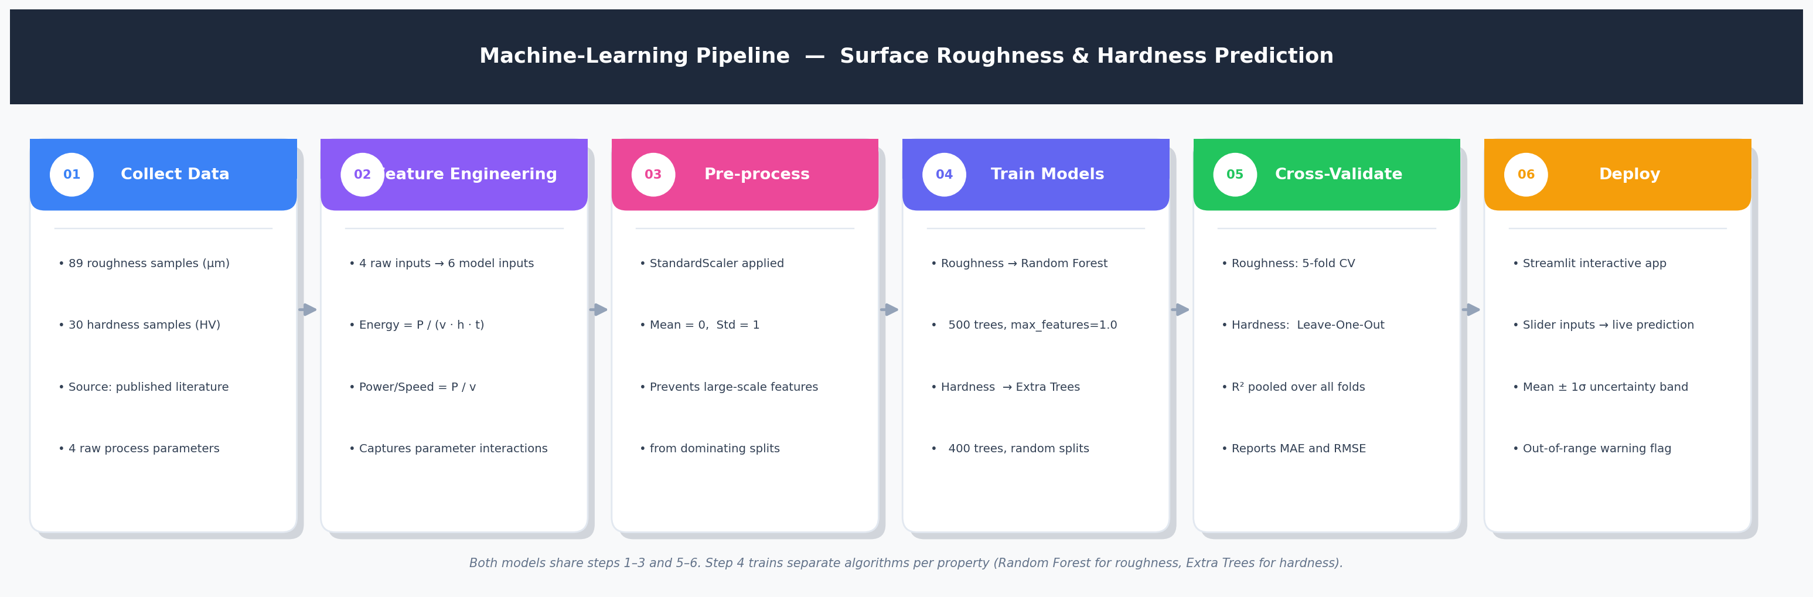

5.2 Feature Engineering
In addition to the four raw parameters, two derived features are computed for every sample:
- Energy = P / (v · h · t) — laser energy delivered per unit volume.
- Power/Speed = P / v — energy delivered per unit track length.
These consolidate the interactions between parameters into single quantities that the model can use directly, rather than having to reconstruct them from the raw inputs on a small dataset. As shown in Section 6, adding them improves accuracy. The implementation is shown below.
Code — feature engineering (config.py).
def add_derived_features(df):
"""Append the two engineered features. Operates on a copy; guards against a
zero denominator (none occur in the data, but cheap insurance)."""
df = df.copy()
denom = (df["Scan_Speed_mm_s"] * df["Hatch_Distance_mm"]
* df["Layer_Thickness_mm"]).replace(0, float("nan"))
df["Energy"] = df["Laser_Power_W"] / denom
df["Power_Speed_Ratio"] = df["Laser_Power_W"] / df["Scan_Speed_mm_s"].replace(0, float("nan"))
return df

5.3 Validation Approach
Each model is assessed with cross-validation, where the data are repeatedly split so every sample is predicted by a model that did not train on it. For the small hardness set (<40 samples) Leave-One-Out cross-validation is used; otherwise 5-fold. Predictions from all held-out folds are pooled and the metrics — R² (variance explained), MAE (mean absolute error), and RMSE — computed once over the pooled set. This gives an honest estimate of generalisation rather than the optimistic numbers a single train/test split can produce.

6. The Machine-Learning Model (Detailed)

6.1 Why a Tree-Ensemble Model
The parameter-to-property relationship is non-linear, has interacting factors, and carries appreciable measurement scatter. Tree-ensemble regressors are well suited to this setting:
- They capture non-linear interactions automatically, without manually specified cross terms [18].
- As ensembles of many decorrelated trees, they resist over-fitting on small, noisy datasets [17], [18].
- They provide interpretable feature-importance scores.
- The spread across trees gives a built-in uncertainty estimate (±1σ).
Two such algorithms are used. A Random Forest builds each tree on a bootstrap resample of the data. Extra Trees (Extremely Randomised Trees) additionally randomises the split thresholds, which further reduces variance and proved more accurate for the small hardness dataset (Section 6).

6.2 How the Model Works
Each tree makes its own prediction by following a series of yes/no splits on the input features. The ensemble's prediction is the average of all the trees' outputs, which cancels much of the individual trees' error. The standard deviation across the trees provides the ±1σ uncertainty band reported by the application.
Figure 6.1 — A tree ensemble averages many decision trees into one prediction with an uncertainty band.
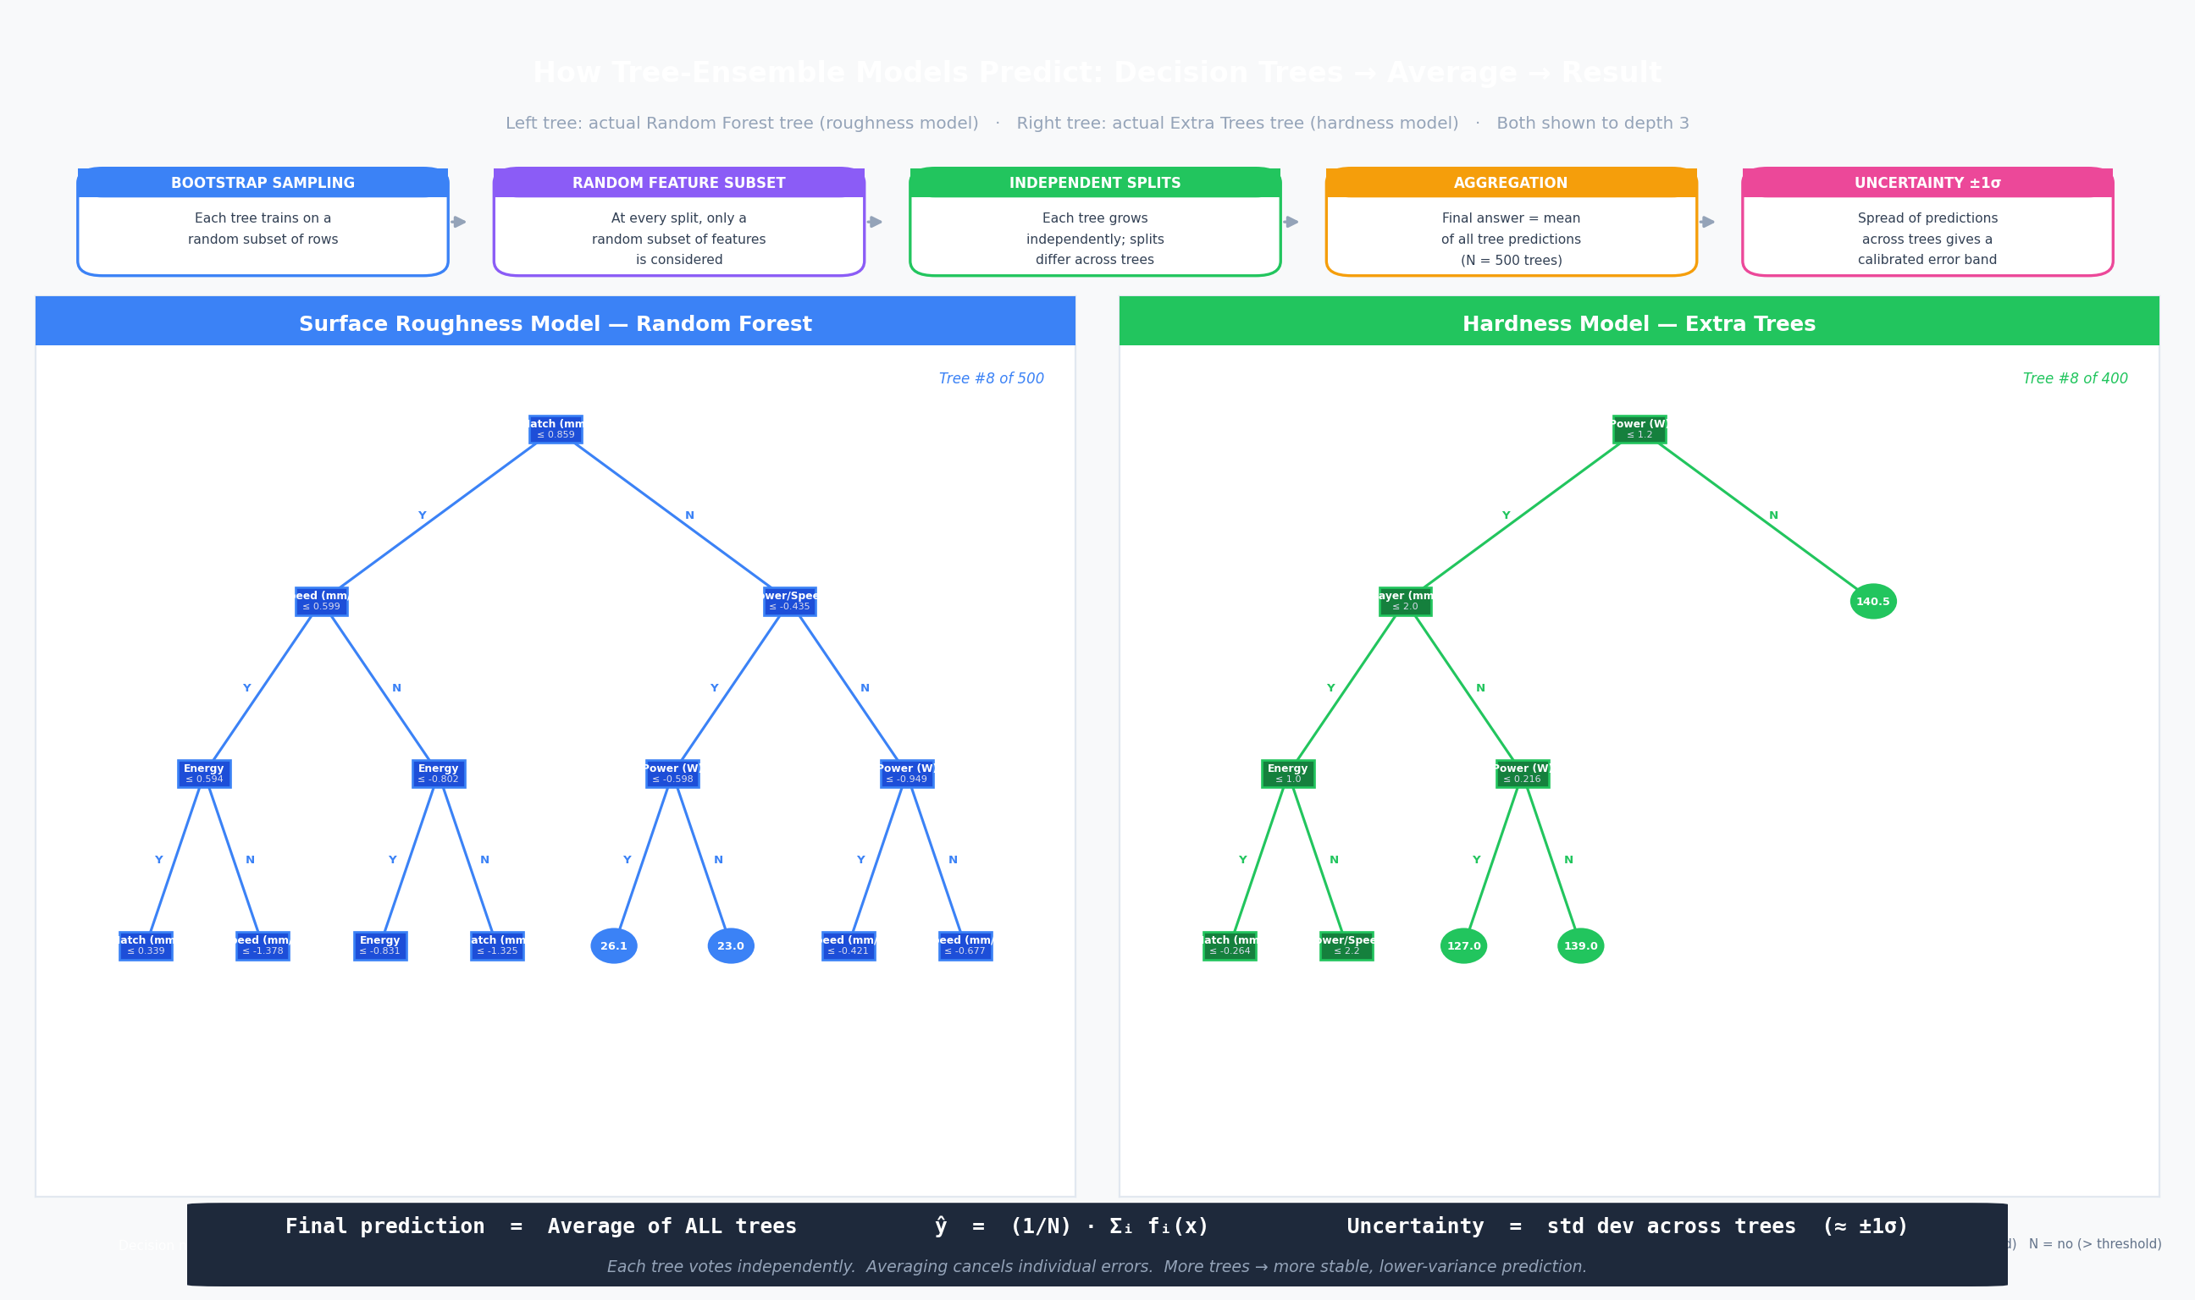

6.3 Input Features
Table 6.1 — Model input features.
# | Feature | Type
1 | Laser Power (W) | raw parameter
2 | Scan Speed (mm/s) | raw parameter
3 | Hatch Distance (mm) | raw parameter
4 | Layer Thickness (mm) | raw parameter
5 | Energy (P/v·h·t) | derived
6 | Power/Speed (P/v) | derived

6.4 Model Configuration
Each property uses the algorithm that cross-validated best for it: a tuned Random Forest for surface roughness and Extra Trees for hardness. Both wrap the estimator in a pipeline that first standardises the features.
Table 6.2 — Model configuration per property.
Property | Algorithm | Key settings
Surface Roughness | Random Forest | 500 trees, min_samples_leaf=1, max_features=1.0
Hardness | Extra Trees | 400 trees, min_samples_leaf=1
Code — model definition (config.py).
def build_model(kind="rf"):
"""Standardised regressor for the given target. `kind` selects the algorithm
that validated best for that property."""
if kind == "extratrees":
estimator = ExtraTreesRegressor(**EXTRATREES_PARAMS)
else:
estimator = RandomForestRegressor(**RF_PARAMS)
return Pipeline([
("scaler", StandardScaler()),
("model", estimator),
])

6.5 Training and Prediction Code
The training routine cross-validates, fits on all data, and saves each model:
Code — training one property (train.py).
def train_one(key, spec):
df = add_derived_features(pd.read_csv(DATA_DIR / spec["csv"]))
X, y = df[FEATURES], df[spec["column"]].values
label, unit, kind = spec["label"], spec["unit"], spec["model"]
print("\n" + "=" * 55)
print(f" {label} ({unit}) — {len(df)} samples [{kind}]")
print("=" * 55)
# Cross-validated accuracy on pooled held-out predictions.
cv, cvname = cv_for(len(df))
y_pred = cross_val_predict(build_model(kind), X, y, cv=cv)
r2 = r2_score(y, y_pred)
mae = mean_absolute_error(y, y_pred)
rmse = np.sqrt(mean_squared_error(y, y_pred))
print(f" {cvname} CV R² = {r2:+.4f}")
print(f" {cvname} CV MAE = {mae:.3f} {unit}")
print(f" {cvname} CV RMSE = {rmse:.3f} {unit}")
# Fit on all data and save.
model = build_model(kind)
model.fit(X, y)
MODEL_DIR.mkdir(parents=True, exist_ok=True)
joblib.dump(model, MODEL_DIR / f"model_{key}.pkl")
print(f" Saved → model_{key}.pkl")
_plot_actual_vs_pred(y, y_pred, spec, r2, mae)
_plot_importance(model, spec)
return {"rows": len(df), "cv": cvname, "r2": r2, "mae": mae, "rmse": rmse}
At prediction time the app averages the trees and reports the spread as ±1σ:
Code — prediction with uncertainty (app.py).
def predict_one(model, input_df):
"""Mean ±1σ across the ensemble's trees."""
ens = model.named_steps["model"]
Xt = model.named_steps["scaler"].transform(input_df[FEATURES])
preds = np.array([t.predict(Xt) for t in ens.estimators_])
return float(preds.mean()), float(preds.std())

6.6 Per-Model Workflows
Although both models share the same pipeline, they differ in the dataset they learn from, the algorithm chosen, the cross-validation scheme, and the parameters that drive each property. The two diagrams below trace each model end-to-end — from input data, through feature engineering and standardisation, to the specific ensemble algorithm, validation scheme, and final cross-validated metrics. The side panel lists the top driving features for each.

6.6.1 Surface Roughness Model (Random Forest)
The surface-roughness model is trained on the 89-sample roughness dataset using a tuned Random Forest, in which each tree is grown on a bootstrap resample and the best split is chosen at each node. It is validated with 5-fold cross-validation. Hatch distance dominates the prediction, followed by the engineered energy and power/speed terms.
Figure 6.2 — Detailed workflow of the Surface Roughness model.
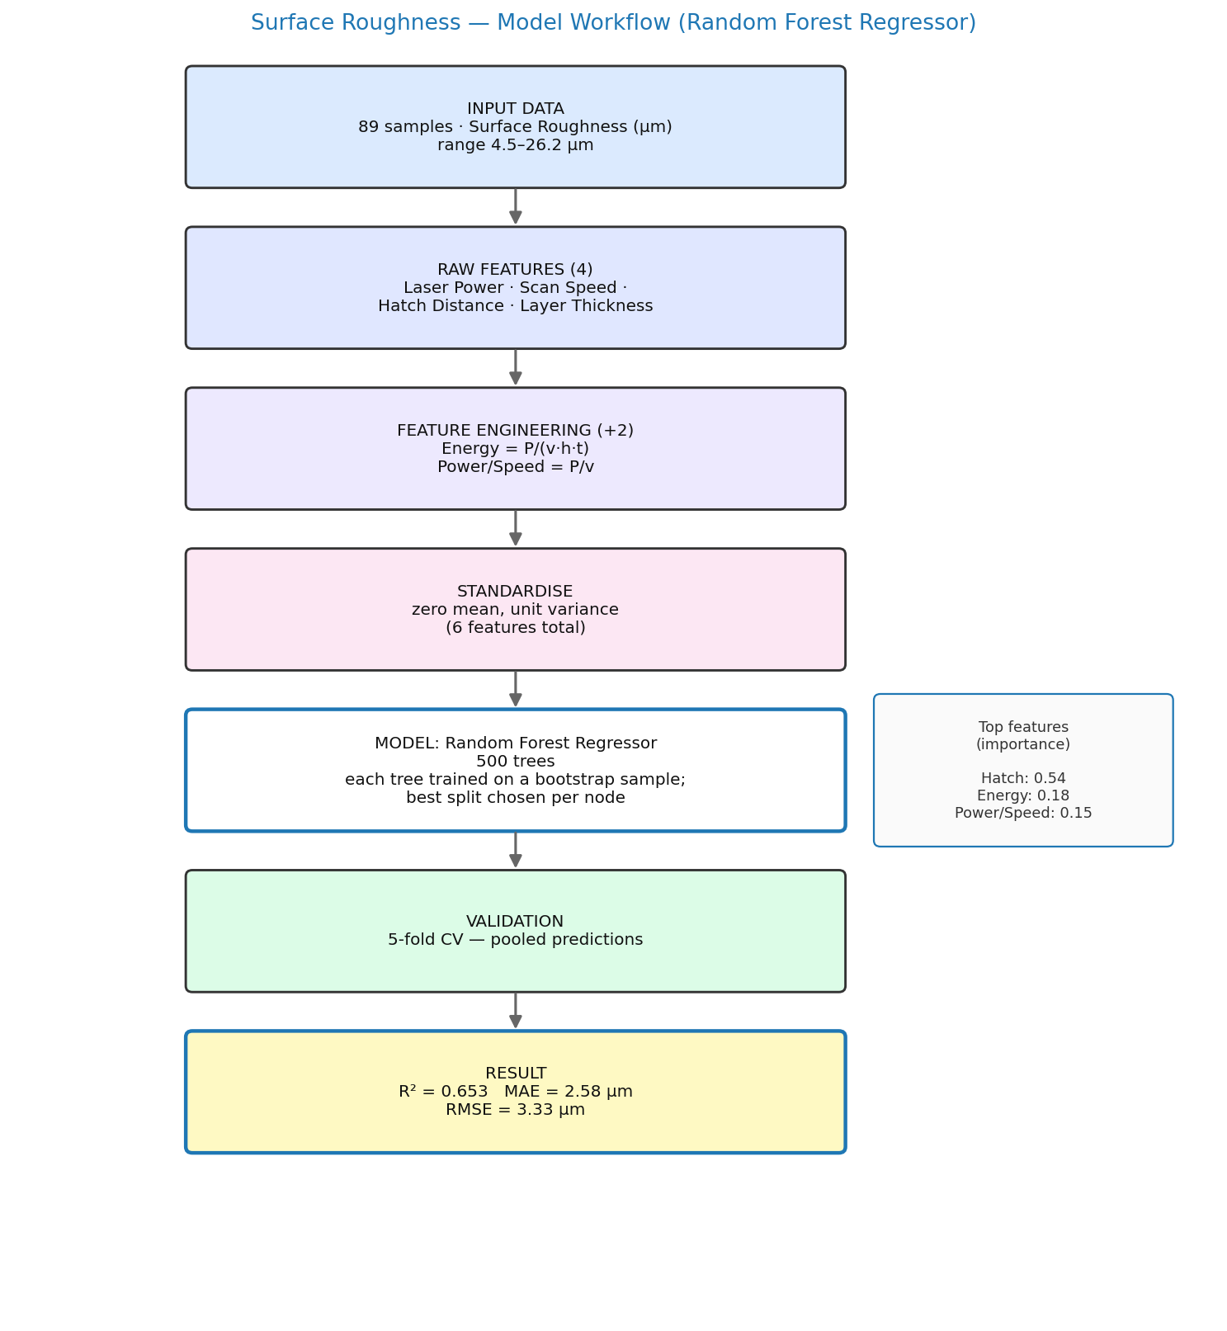

6.6.2 Hardness Model (Extra Trees)
The hardness model is trained on the smaller 30-sample hardness dataset using Extra Trees, which randomises the split thresholds to reduce variance — the key reason it generalises better than a Random Forest on this small set. Because of the limited sample count it is validated with Leave-One-Out cross-validation. Layer thickness is the strongest driver, with the power/speed and energy terms next.
Figure 6.3 — Detailed workflow of the Hardness model.
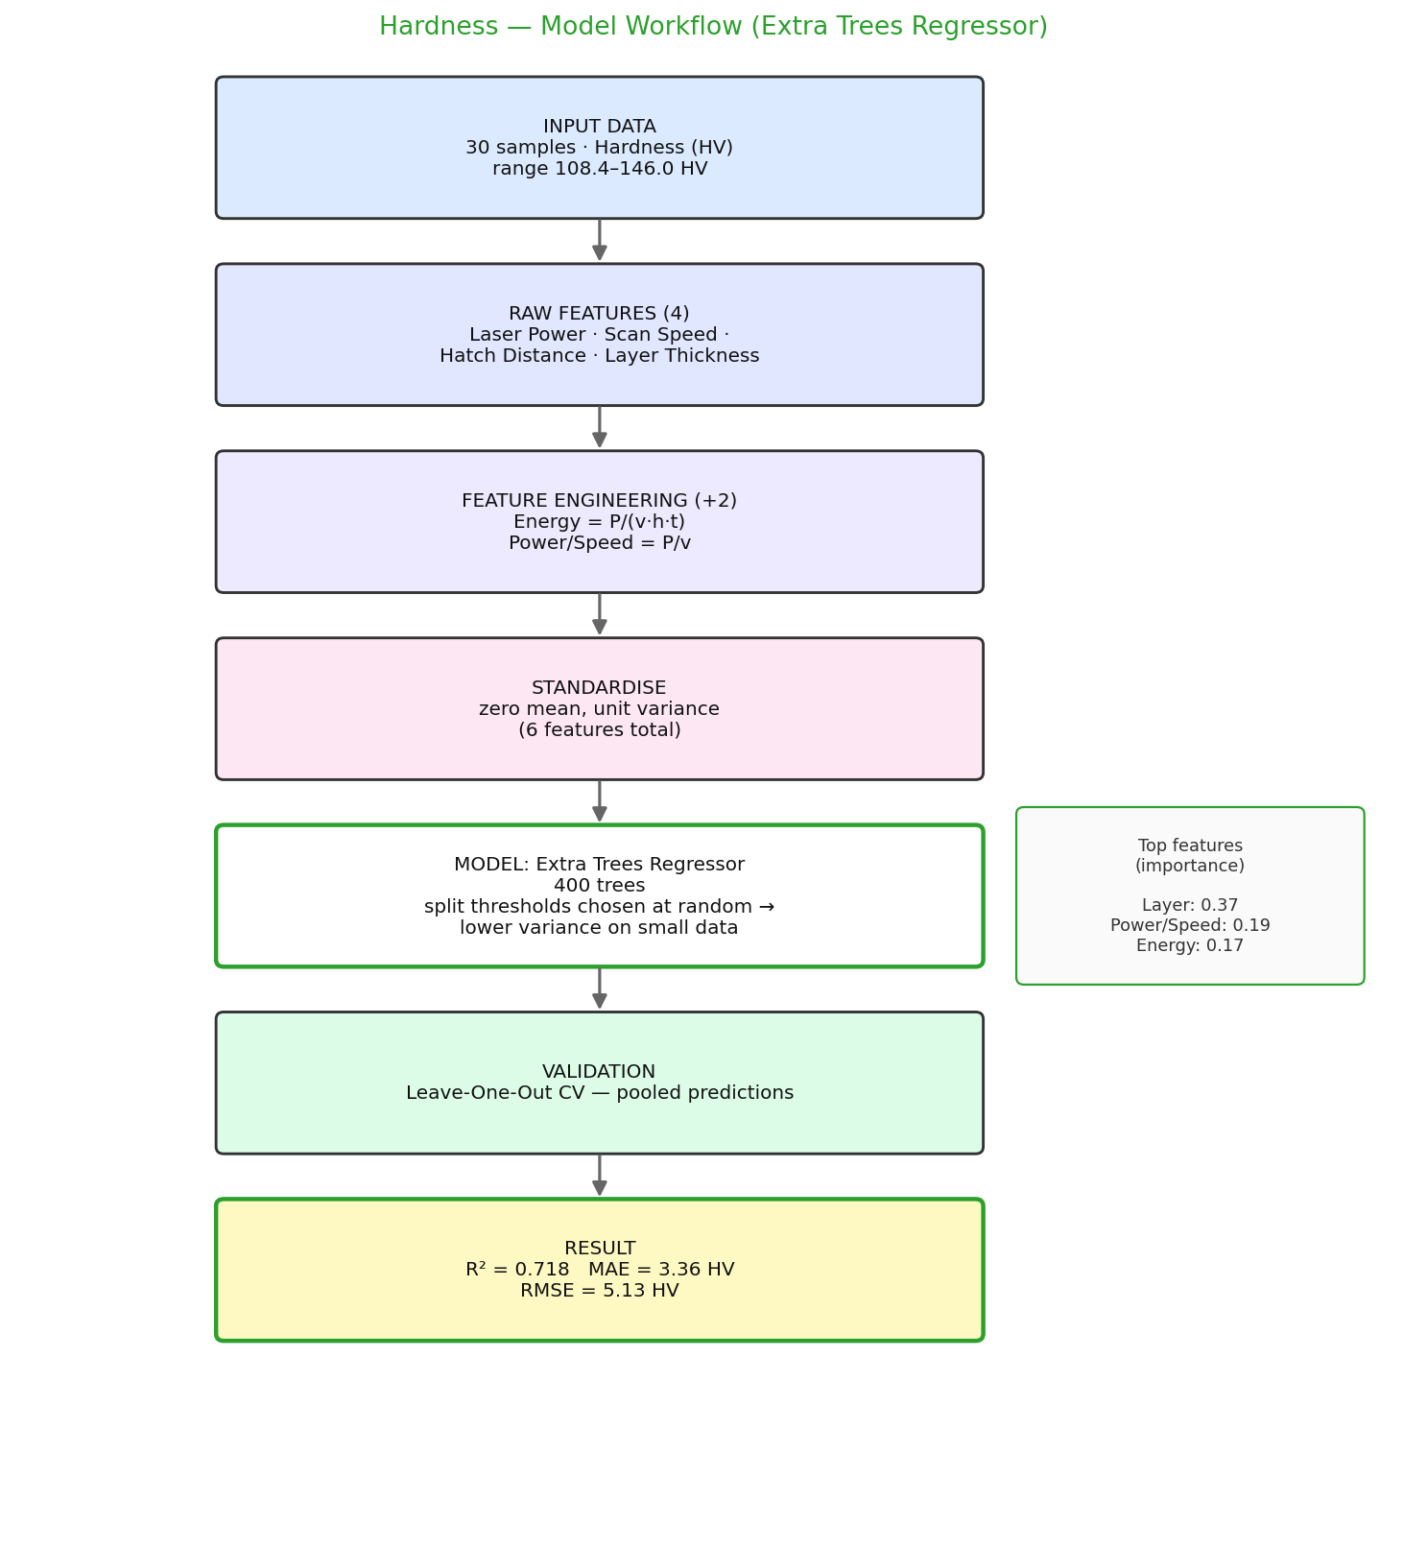

7. Improving the Model: Before vs After
The project began with a basic configuration — a single Random Forest using only the four raw parameters. Two changes were then made and validated:
- Feature engineering: added the Energy and Power/Speed derived features.
- Model selection: chose the best algorithm per property — keeping a tuned Random Forest for roughness, but switching hardness to Extra Trees.
The figure and table below compare the basic and improved configurations under identical cross-validation.
Figure 7.1 — Accuracy (R²) and error (MAE): before vs after.
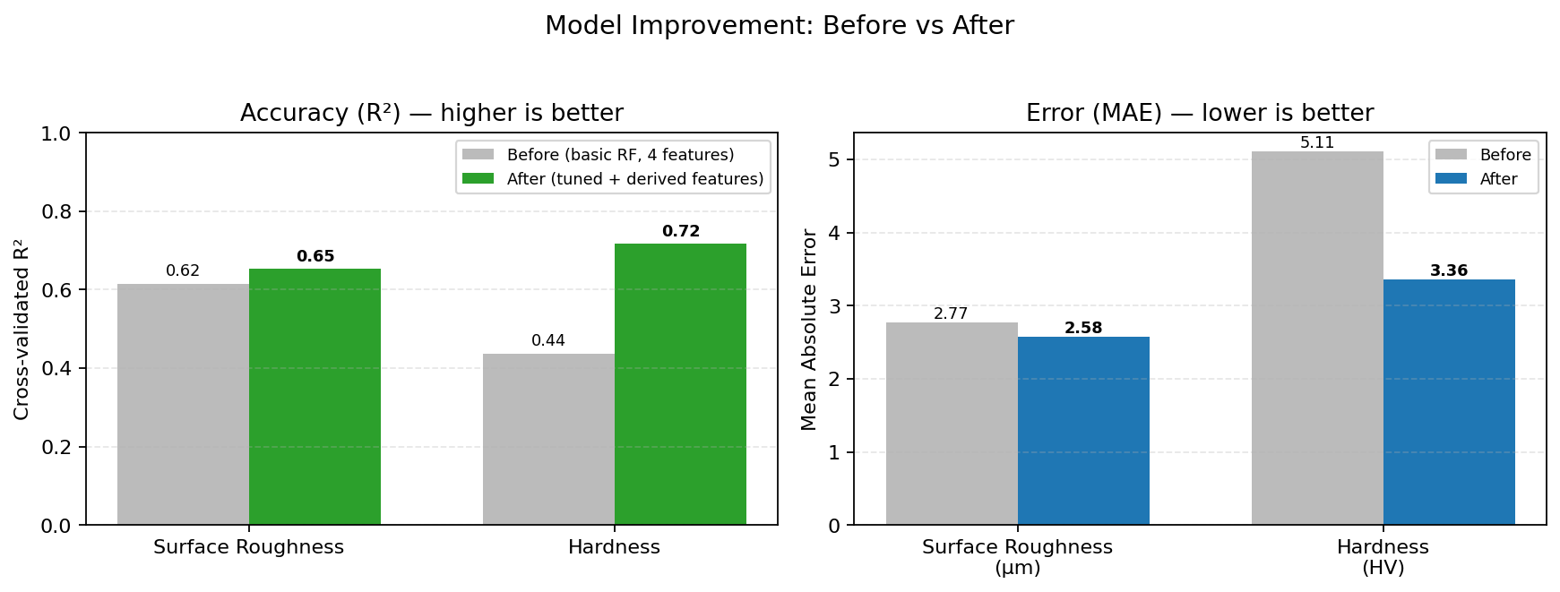
Table 7.1 — Before vs after (cross-validated).
Property | R² before | R² after | Δ R² | MAE before | MAE after
Surface Roughness | 0.616 | 0.653 | +0.037 | 2.77 µm | 2.58 µm
Hardness | 0.438 | 0.718 | +0.280 | 5.11 HV | 3.36 HV
The hardness model shows the largest gain: R² rose from 0.44 to 0.72 and mean absolute error fell from 5.11 to 3.36 HV. Two factors drove this. First, the derived features gave the model the energy interaction directly. Second, and most importantly, switching from a Random Forest to Extra Trees helped: with only 30 hardness samples, the extra randomisation of Extra Trees reduces variance and generalises better than a standard Random Forest. Surface roughness also improved, more modestly, from feature engineering and hyperparameter tuning.

8. Results and Discussion

8.1 Final Model Performance
Table 8.1 — Final cross-validated performance.
Property | Samples | CV | R² | MAE | RMSE
Surface Roughness | 89 | 5-fold | 0.653 | 2.58 µm | 3.33 µm
Hardness | 30 | Leave-One-Out | 0.718 | 3.36 HV | 5.13 HV

8.2 Feature Importance
Table 8.2 — Feature importance per property.
Feature | Surface Roughness | Hardness
Laser Power (W) | 0.046 | 0.075
Scan Speed (mm/s) | 0.073 | 0.076
Hatch Distance (mm) | 0.540 | 0.114
Layer Thickness (mm) | 0.003 | 0.368
Energy (P/v·h·t) | 0.184 | 0.174
Power/Speed (P/v) | 0.154 | 0.192
For surface roughness, the most influential feature is Hatch Distance (mm) (importance 0.54).
For hardness, the most influential feature is Layer Thickness (mm) (importance 0.37).

8.3 Property vs Parameters
Figure 8.1 — Surface Roughness vs each process parameter.
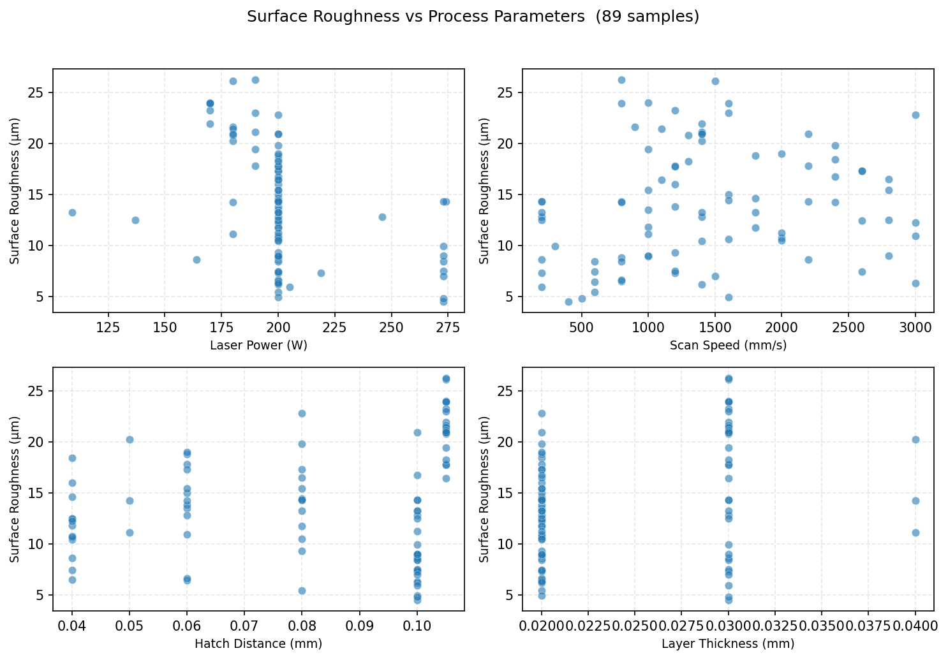
Figure 8.2 — Hardness vs each process parameter.
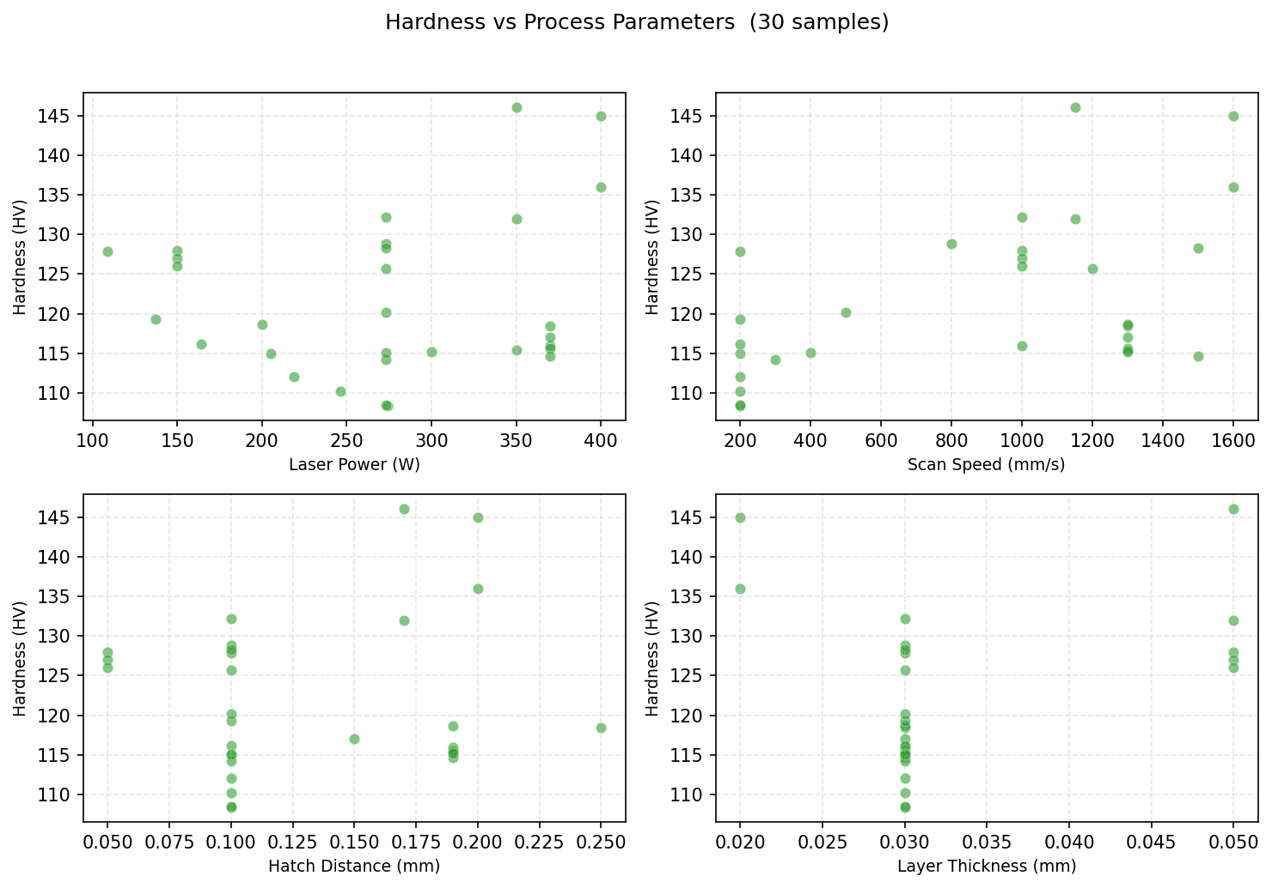

8.4 Model Validation Plots
Figure — Surface Roughness: actual vs predicted (cross-validated).
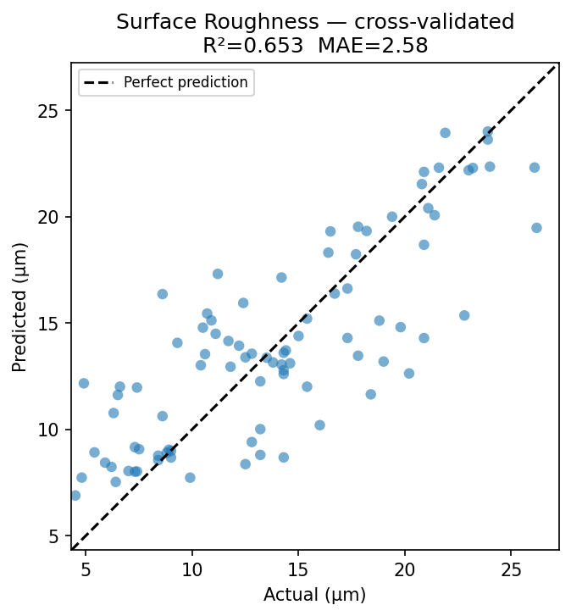
Figure — Hardness: actual vs predicted (cross-validated).
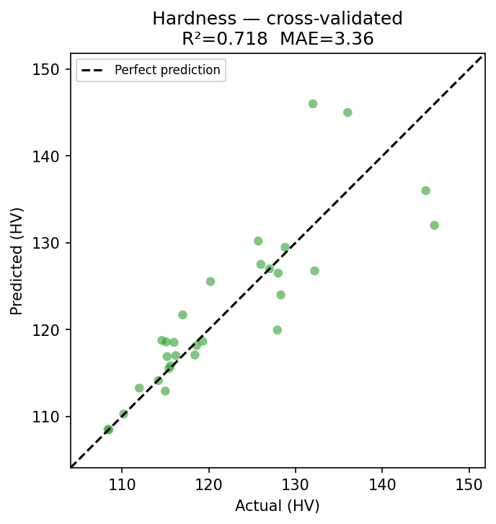

9. Conclusion
- Two models were built and validated: surface roughness (R² = 0.65) and hardness (R² = 0.72).
- Feature engineering (energy and power/speed terms) and per-property model selection measurably improved accuracy.
- The hardness model improved most, from R² = 0.44 to 0.72, mainly by switching to Extra Trees on the small dataset.
- The hardness dataset is small (30 samples); collecting more data is the clearest route to further improvement.
- The trained models are deployed in an interactive app that reports predictions with uncertainty.

Appendix A: Complete Dataset

A.1 Surface Roughness data (89 samples)
All 89 samples used to train the surface roughness model.
# | Power (W) | Speed (mm/s) | Hatch (mm) | Layer (mm) | Surface Roughness (µm)
1 | 200 | 600 | 0.04 | 0.02 | 7.4
2 | 200 | 800 | 0.04 | 0.02 | 6.5
3 | 200 | 1000 | 0.04 | 0.02 | 11.8
4 | 200 | 1200 | 0.04 | 0.02 | 16
5 | 200 | 1400 | 0.04 | 0.02 | 10.4
6 | 200 | 1600 | 0.04 | 0.02 | 10.6
7 | 200 | 1800 | 0.04 | 0.02 | 14.6
8 | 200 | 2000 | 0.04 | 0.02 | 10.7
9 | 200 | 2200 | 0.04 | 0.02 | 8.6
10 | 200 | 2400 | 0.04 | 0.02 | 18.4
11 | 200 | 2600 | 0.04 | 0.02 | 12.4
12 | 200 | 2800 | 0.04 | 0.02 | 12.5
13 | 200 | 3000 | 0.04 | 0.02 | 12.2
14 | 200 | 600 | 0.06 | 0.02 | 6.4
15 | 200 | 800 | 0.06 | 0.02 | 6.6
16 | 200 | 1000 | 0.06 | 0.02 | 13.5
17 | 200 | 1200 | 0.06 | 0.02 | 13.8
18 | 200 | 1400 | 0.06 | 0.02 | 12.8
19 | 200 | 1600 | 0.06 | 0.02 | 15
20 | 200 | 1800 | 0.06 | 0.02 | 18.8
21 | 200 | 2000 | 0.06 | 0.02 | 19
22 | 200 | 2200 | 0.06 | 0.02 | 17.8
23 | 200 | 2400 | 0.06 | 0.02 | 14.2
24 | 200 | 2600 | 0.06 | 0.02 | 17.3
25 | 200 | 2800 | 0.06 | 0.02 | 15.4
26 | 200 | 3000 | 0.06 | 0.02 | 10.9
27 | 200 | 600 | 0.08 | 0.02 | 5.4
28 | 200 | 800 | 0.08 | 0.02 | 14.3
29 | 200 | 1000 | 0.08 | 0.02 | 15.4
30 | 200 | 1200 | 0.08 | 0.02 | 9.3
31 | 200 | 1400 | 0.08 | 0.02 | 13.2
32 | 200 | 1600 | 0.08 | 0.02 | 14.4
33 | 200 | 1800 | 0.08 | 0.02 | 11.7
34 | 200 | 2000 | 0.08 | 0.02 | 10.5
35 | 200 | 2200 | 0.08 | 0.02 | 14.3
36 | 200 | 2400 | 0.08 | 0.02 | 19.8
37 | 200 | 2600 | 0.08 | 0.02 | 17.3
38 | 200 | 2800 | 0.08 | 0.02 | 16.5
39 | 200 | 3000 | 0.08 | 0.02 | 22.8
40 | 200 | 600 | 0.1 | 0.02 | 8.4
41 | 200 | 800 | 0.1 | 0.02 | 8.8
42 | 200 | 1000 | 0.1 | 0.02 | 8.9
43 | 200 | 1200 | 0.1 | 0.02 | 7.3
44 | 200 | 1400 | 0.1 | 0.02 | 6.2
45 | 200 | 1600 | 0.1 | 0.02 | 4.9
46 | 200 | 1800 | 0.1 | 0.02 | 13.2
47 | 200 | 2000 | 0.1 | 0.02 | 11.2
48 | 200 | 2200 | 0.1 | 0.02 | 20.9
49 | 200 | 2400 | 0.1 | 0.02 | 16.7
50 | 200 | 2600 | 0.1 | 0.02 | 7.4
51 | 200 | 2800 | 0.1 | 0.02 | 9
52 | 200 | 3000 | 0.1 | 0.02 | 6.3
53 | 180 | 800 | 0.05 | 0.04 | 14.2
54 | 180 | 1000 | 0.05 | 0.04 | 11.1
55 | 180 | 1400 | 0.05 | 0.04 | 20.2
56 | 170 | 800 | 0.105 | 0.03 | 23.9
57 | 170 | 1000 | 0.105 | 0.03 | 24
58 | 170 | 1200 | 0.105 | 0.03 | 23.2
59 | 170 | 1400 | 0.105 | 0.03 | 21.9
60 | 170 | 1600 | 0.105 | 0.03 | 23.9
61 | 180 | 900 | 0.105 | 0.03 | 21.6
62 | 180 | 1100 | 0.105 | 0.03 | 21.4
63 | 180 | 1300 | 0.105 | 0.03 | 20.8
64 | 180 | 1400 | 0.105 | 0.03 | 20.9
65 | 180 | 1500 | 0.105 | 0.03 | 26.1
66 | 190 | 800 | 0.105 | 0.03 | 26.2
67 | 190 | 1000 | 0.105 | 0.03 | 19.4
68 | 190 | 1200 | 0.105 | 0.03 | 17.8
69 | 190 | 1400 | 0.105 | 0.03 | 21.1
70 | 190 | 1600 | 0.105 | 0.03 | 23
71 | 200 | 1100 | 0.105 | 0.03 | 16.4
72 | 200 | 1200 | 0.105 | 0.03 | 17.7
73 | 200 | 1300 | 0.105 | 0.03 | 18.2
74 | 200 | 1400 | 0.105 | 0.03 | 20.9
75 | 274 | 200 | 0.1 | 0.03 | 14.3
76 | 246 | 200 | 0.1 | 0.03 | 12.8
77 | 219 | 200 | 0.1 | 0.03 | 7.3
78 | 205 | 200 | 0.1 | 0.03 | 5.9
79 | 164 | 200 | 0.1 | 0.03 | 8.6
80 | 137 | 200 | 0.1 | 0.03 | 12.5
81 | 109 | 200 | 0.1 | 0.03 | 13.2
82 | 273 | 200 | 0.1 | 0.03 | 14.3
83 | 273 | 300 | 0.1 | 0.03 | 9.9
84 | 273 | 400 | 0.1 | 0.03 | 4.5
85 | 273 | 500 | 0.1 | 0.03 | 4.8
86 | 273 | 800 | 0.1 | 0.03 | 8.4
87 | 273 | 1000 | 0.1 | 0.03 | 9
88 | 273 | 1200 | 0.1 | 0.03 | 7.5
89 | 273 | 1500 | 0.1 | 0.03 | 7

A.2 Hardness data (30 samples)
All 30 samples used to train the hardness model.
# | Power (W) | Speed (mm/s) | Hatch (mm) | Layer (mm) | Hardness (HV)
1 | 370 | 1000 | 0.19 | 0.03 | 116
2 | 370 | 1300 | 0.15 | 0.03 | 117
3 | 370 | 1300 | 0.19 | 0.03 | 115.6
4 | 350 | 1300 | 0.19 | 0.03 | 115.4
5 | 370 | 1500 | 0.19 | 0.03 | 114.6
6 | 300 | 1300 | 0.19 | 0.03 | 115.2
7 | 370 | 1300 | 0.25 | 0.03 | 118.4
8 | 200 | 1300 | 0.19 | 0.03 | 118.6
9 | 274 | 200 | 0.1 | 0.03 | 108.4
10 | 246 | 200 | 0.1 | 0.03 | 110.2
11 | 219 | 200 | 0.1 | 0.03 | 112
12 | 205 | 200 | 0.1 | 0.03 | 115
13 | 164 | 200 | 0.1 | 0.03 | 116.2
14 | 137 | 200 | 0.1 | 0.03 | 119.3
15 | 109 | 200 | 0.1 | 0.03 | 127.9
16 | 273 | 200 | 0.1 | 0.03 | 108.5
17 | 273 | 300 | 0.1 | 0.03 | 114.2
18 | 273 | 400 | 0.1 | 0.03 | 115.1
19 | 273 | 500 | 0.1 | 0.03 | 120.2
20 | 273 | 800 | 0.1 | 0.03 | 128.8
21 | 273 | 1000 | 0.1 | 0.03 | 132.2
22 | 273 | 1200 | 0.1 | 0.03 | 125.7
23 | 273 | 1500 | 0.1 | 0.03 | 128.3
24 | 400 | 1600 | 0.2 | 0.02 | 145
25 | 400 | 1600 | 0.2 | 0.02 | 136
26 | 350 | 1150 | 0.17 | 0.05 | 132
27 | 350 | 1150 | 0.17 | 0.05 | 146
28 | 150 | 1000 | 0.05 | 0.05 | 128
29 | 150 | 1000 | 0.05 | 0.05 | 127
30 | 150 | 1000 | 0.05 | 0.05 | 126

Appendix B: Source Code

B — config.py
"""
config.py — Configuration for the Surface Roughness & Hardness predictor.
Two independent regression models predict surface roughness and hardness from
four process parameters. The two datasets come from different experiments, so
each property has its own CSV and its own model.
"""
from pathlib import Path
from sklearn.ensemble import RandomForestRegressor, ExtraTreesRegressor
from sklearn.pipeline import Pipeline
from sklearn.preprocessing import StandardScaler
# ── Paths ────────────────────────────────────────────────────────────────────
BASE_DIR = Path(__file__).parent
DATA_DIR = BASE_DIR / "data"
MODEL_DIR = BASE_DIR / "models"
# ── General ──────────────────────────────────────────────────────────────────
SEED = 42
CV_FOLDS = 5
# ── Input features ───────────────────────────────────────────────────────────
# Four raw process parameters the user enters.
BASE_FEATURES = [
"Laser_Power_W",
"Scan_Speed_mm_s",
"Hatch_Distance_mm",
"Layer_Thickness_mm",
]
# Two derived features that consolidate the parameter interactions and measurably
# improve accuracy (see add_derived_features):
# Energy = P / (v * h * t) — energy delivered per unit volume
# Power_Speed_Ratio = P / v — energy delivered per unit track length
DERIVED_FEATURES = ["Energy", "Power_Speed_Ratio"]
# Full feature set the models actually train on.
FEATURES = BASE_FEATURES + DERIVED_FEATURES
FEATURE_LABELS = {
"Laser_Power_W": "Laser Power (W)",
"Scan_Speed_mm_s": "Scan Speed (mm/s)",
"Hatch_Distance_mm": "Hatch Distance (mm)",
"Layer_Thickness_mm": "Layer Thickness (mm)",
"Energy": "Energy (P/v·h·t)",
"Power_Speed_Ratio": "Power/Speed (P/v)",
}
# Input ranges (min, max, default) for the app sliders.
PARAM_RANGES = {
"Laser_Power_W": (100.0, 950.0, 350.0),
"Scan_Speed_mm_s": (200.0, 3000.0, 1300.0),
"Hatch_Distance_mm": (0.03, 0.40, 0.13),
"Layer_Thickness_mm": (0.02, 0.06, 0.03),
}
# ── Targets: one model per property ──────────────────────────────────────────
# Each target uses the algorithm that cross-validated best for it:
# • roughness → tuned Random Forest
# • hardness → Extra Trees (clearly higher CV R² on this dataset)
TARGETS = {
"roughness": {
"csv": "surface_roughness_data.csv",
"column": "Surface_Roughness_um",
"label": "Surface Roughness",
"unit": "µm",
"color": "#1f77b4",
"model": "rf",
},
"hardness": {
"csv": "hardness_data.csv",
"column": "Hardness_HV",
"label": "Hardness",
"unit": "HV",
"color": "#2ca02c",
"model": "extratrees",
},
}
# ── Model hyperparameters (per algorithm) ────────────────────────────────────
N_ESTIMATORS = 500
RF_PARAMS = dict(
n_estimators=N_ESTIMATORS, max_depth=None, min_samples_leaf=1,
max_features=1.0, random_state=SEED, n_jobs=-1,
)
EXTRATREES_PARAMS = dict(
n_estimators=400, min_samples_leaf=1, random_state=SEED, n_jobs=-1,
)
def add_derived_features(df):
"""Append the two engineered features. Operates on a copy; guards against a
zero denominator (none occur in the data, but cheap insurance)."""
df = df.copy()
denom = (df["Scan_Speed_mm_s"] * df["Hatch_Distance_mm"]
* df["Layer_Thickness_mm"]).replace(0, float("nan"))
df["Energy"] = df["Laser_Power_W"] / denom
df["Power_Speed_Ratio"] = df["Laser_Power_W"] / df["Scan_Speed_mm_s"].replace(0, float("nan"))
return df
def build_model(kind="rf"):
"""Standardised regressor for the given target. `kind` selects the algorithm
that validated best for that property."""
if kind == "extratrees":
estimator = ExtraTreesRegressor(**EXTRATREES_PARAMS)
else:
estimator = RandomForestRegressor(**RF_PARAMS)
return Pipeline([
("scaler", StandardScaler()),
("model", estimator),
])

B — train.py
"""
train.py — Train the surface roughness and hardness models
==========================================================
Trains one Random Forest per property from the four process parameters, reports
cross-validated accuracy, and saves the models + diagnostic plots.
Usage: python train.py
"""
import warnings
warnings.filterwarnings("ignore")
import sys
import numpy as np
import pandas as pd
from sklearn.model_selection import KFold, LeaveOneOut, cross_val_predict
from sklearn.metrics import r2_score, mean_absolute_error, mean_squared_error
import joblib
import matplotlib
matplotlib.use("Agg")
import matplotlib.pyplot as plt
from config import (DATA_DIR, MODEL_DIR, FEATURES, FEATURE_LABELS, TARGETS,
SEED, CV_FOLDS, add_derived_features, build_model)
for _s in (sys.stdout, sys.stderr):
try:
_s.reconfigure(encoding="utf-8")
except (AttributeError, ValueError):
pass
def cv_for(n):
"""Leave-One-Out for small datasets, otherwise K-fold."""
if n < 40:
return LeaveOneOut(), "Leave-One-Out"
return KFold(n_splits=CV_FOLDS, shuffle=True, random_state=SEED), f"{CV_FOLDS}-fold"
def train_one(key, spec):
df = add_derived_features(pd.read_csv(DATA_DIR / spec["csv"]))
X, y = df[FEATURES], df[spec["column"]].values
label, unit, kind = spec["label"], spec["unit"], spec["model"]
print("\n" + "=" * 55)
print(f" {label} ({unit}) — {len(df)} samples [{kind}]")
print("=" * 55)
# Cross-validated accuracy on pooled held-out predictions.
cv, cvname = cv_for(len(df))
y_pred = cross_val_predict(build_model(kind), X, y, cv=cv)
r2 = r2_score(y, y_pred)
mae = mean_absolute_error(y, y_pred)
rmse = np.sqrt(mean_squared_error(y, y_pred))
print(f" {cvname} CV R² = {r2:+.4f}")
print(f" {cvname} CV MAE = {mae:.3f} {unit}")
print(f" {cvname} CV RMSE = {rmse:.3f} {unit}")
# Fit on all data and save.
model = build_model(kind)
model.fit(X, y)
MODEL_DIR.mkdir(parents=True, exist_ok=True)
joblib.dump(model, MODEL_DIR / f"model_{key}.pkl")
print(f" Saved → model_{key}.pkl")
_plot_actual_vs_pred(y, y_pred, spec, r2, mae)
_plot_importance(model, spec)
return {"rows": len(df), "cv": cvname, "r2": r2, "mae": mae, "rmse": rmse}
def _plot_actual_vs_pred(y, y_pred, spec, r2, mae):
lo = min(y.min(), y_pred.min()) * 0.96
hi = max(y.max(), y_pred.max()) * 1.04
fig, ax = plt.subplots(figsize=(5, 5))
ax.scatter(y, y_pred, alpha=0.6, color=spec["color"], edgecolors="none")
ax.plot([lo, hi], [lo, hi], "k--", lw=1.5, label="Perfect prediction")
ax.set_xlim(lo, hi); ax.set_ylim(lo, hi); ax.set_aspect("equal")
ax.set_xlabel(f"Actual ({spec['unit']})"); ax.set_ylabel(f"Predicted ({spec['unit']})")
ax.set_title(f"{spec['label']} — cross-validated\nR²={r2:.3f} MAE={mae:.2f}")
ax.legend(fontsize=8); plt.tight_layout()
plt.savefig(MODEL_DIR / f"actual_vs_predicted_{key_safe(spec)}.png", dpi=150,
bbox_inches="tight"); plt.close(fig)
def _plot_importance(model, spec):
imp = model.named_steps["model"].feature_importances_
order = np.argsort(imp)
fig, ax = plt.subplots(figsize=(7, 4))
ax.barh([FEATURE_LABELS[FEATURES[i]] for i in order], imp[order],
color=spec["color"], alpha=0.8)
ax.set_title(f"Feature Importance — {spec['label']}")
ax.set_xlabel("Relative importance")
for i, v in enumerate(imp[order]):
ax.text(v + 0.005, i, f"{v:.3f}", va="center", fontsize=8)
plt.tight_layout()
plt.savefig(MODEL_DIR / f"feature_importance_{key_safe(spec)}.png", dpi=150,
bbox_inches="tight"); plt.close(fig)
def key_safe(spec):
return spec["column"]
def main():
results = {k: train_one(k, s) for k, s in TARGETS.items()}
print("\n" + "=" * 55)
print(" Summary")
print("=" * 55)
for k, r in results.items():
print(f" {TARGETS[k]['label']:18s}: R²={r['r2']:+.3f} "
f"MAE={r['mae']:.2f} {TARGETS[k]['unit']} ({r['rows']} samples)")
print("\n Run the app: python -m streamlit run app.py\n")
if __name__ == "__main__":
main()

B — app.py
"""
app.py — Surface Roughness & Hardness Predictor
Run with: python -m streamlit run app.py
Predicts surface roughness and hardness from four process parameters using two
independent Random Forest models.
"""
import warnings
warnings.filterwarnings("ignore")
import numpy as np
import pandas as pd
import matplotlib
matplotlib.use("Agg")
import matplotlib.pyplot as plt
import joblib
import streamlit as st
from sklearn.model_selection import KFold, LeaveOneOut, cross_val_predict
from sklearn.metrics import r2_score, mean_absolute_error, mean_squared_error
from config import (DATA_DIR, MODEL_DIR, SEED, N_ESTIMATORS, CV_FOLDS,
FEATURES, BASE_FEATURES, FEATURE_LABELS, PARAM_RANGES,
TARGETS, add_derived_features, build_model)
# ─────────────────────────────────────────────────────────────────────────────
# BACKEND
# ─────────────────────────────────────────────────────────────────────────────
@st.cache_resource(show_spinner=False)
def load_and_train():
"""Load each dataset, train or reload its model, compute CV metrics."""
MODEL_DIR.mkdir(parents=True, exist_ok=True)
bundle = {}
for key, spec in TARGETS.items():
df = add_derived_features(pd.read_csv(DATA_DIR / spec["csv"]))
X, y = df[FEATURES], df[spec["column"]].values
kind = spec["model"]
path = MODEL_DIR / f"model_{key}.pkl"
if path.exists():
model = joblib.load(path)
else:
model = build_model(kind); model.fit(X, y); joblib.dump(model, path)
cv = LeaveOneOut() if len(df) < 40 else KFold(CV_FOLDS, shuffle=True, random_state=SEED)
cvname = "LOO" if len(df) < 40 else f"{CV_FOLDS}-fold"
yp = cross_val_predict(build_model(kind), X, y, cv=cv)
bundle[key] = {
"model": model, "df": df, "rows": len(df), "cv": cvname,
"y_true": y, "y_pred": yp,
"r2": r2_score(y, yp), "mae": mean_absolute_error(y, yp),
"rmse": np.sqrt(mean_squared_error(y, yp)),
}
return bundle
def predict_one(model, input_df):
"""Mean ±1σ across the ensemble's trees."""
ens = model.named_steps["model"]
Xt = model.named_steps["scaler"].transform(input_df[FEATURES])
preds = np.array([t.predict(Xt) for t in ens.estimators_])
return float(preds.mean()), float(preds.std())
# ─────────────────────────────────────────────────────────────────────────────
# PAGE
# ─────────────────────────────────────────────────────────────────────────────
st.set_page_config(page_title="Roughness & Hardness Predictor", layout="wide", page_icon="📈")
st.markdown("""
<style>
div[data-testid="metric-container"] {
background: var(--background-color, #f9f9f9);
border-radius: 8px; padding: 10px 16px; border-left: 4px solid #1f77b4;
}
</style>
""", unsafe_allow_html=True)
with st.spinner("Loading models … (first run trains them)"):
B = load_and_train()
# ── Sidebar inputs ───────────────────────────────────────────────────────────
with st.sidebar:
st.header("🎛️ Process Parameters")
p_min, p_max, p_def = PARAM_RANGES["Laser_Power_W"]
s_min, s_max, s_def = PARAM_RANGES["Scan_Speed_mm_s"]
h_min, h_max, h_def = PARAM_RANGES["Hatch_Distance_mm"]
t_min, t_max, t_def = PARAM_RANGES["Layer_Thickness_mm"]
power = st.number_input("Laser Power (W)", p_min, p_max, p_def, step=10.0)
speed = st.number_input("Scan Speed (mm/s)", s_min, s_max, s_def, step=50.0)
hatch = st.number_input("Hatch Distance (mm)", h_min, h_max, h_def, step=0.01, format="%.3f")
layer = st.number_input("Layer Thickness (mm)", t_min, t_max, t_def, step=0.005, format="%.3f")
st.markdown("---")
st.caption(f"🌲 {N_ESTIMATORS} trees · seed {SEED}")
input_df = add_derived_features(pd.DataFrame([{
"Laser_Power_W": power, "Scan_Speed_mm_s": speed,
"Hatch_Distance_mm": hatch, "Layer_Thickness_mm": layer,
}]))
# ── Header + predictions ─────────────────────────────────────────────────────
st.title("📈 Surface Roughness & Hardness Predictor")
st.markdown("Predicting **surface roughness** and **hardness** from process "
"parameters · predictions shown with ±1σ")
st.markdown("---")
preds = {}
cols = st.columns(len(TARGETS))
for col, (key, spec) in zip(cols, TARGETS.items()):
mean, std = predict_one(B[key]["model"], input_df)
preds[key] = (mean, std)
with col:
st.metric(spec["label"], f"{mean:.2f} {spec['unit']}",
delta=f"± {std:.2f} {spec['unit']}", delta_color="off")
st.caption(f"CV R² = {B[key]['r2']:.3f} · {B[key]['rows']} samples")
# Out-of-range warning
warns = []
for f in BASE_FEATURES:
lo, hi, _ = PARAM_RANGES[f]
v = input_df[f].iloc[0]
if v < lo or v > hi:
warns.append(f"{FEATURE_LABELS[f]} = {v:g} outside [{lo:g}, {hi:g}]")
if warns:
st.warning("⚠️ Input outside the training range — " + "; ".join(warns)
+ ". Predictions outside the data range are unreliable.")
st.markdown("---")
# ── Tabs ─────────────────────────────────────────────────────────────────────
tab1, tab2, tab3, tab4 = st.tabs([
"🗺️ Process Map", "📊 Model Performance", "📈 Feature Importance", "🔎 Data Explorer",
])
TARGET_LABELS = [s["label"] for s in TARGETS.values()]
KEY_BY_LABEL = {s["label"]: k for k, s in TARGETS.items()}
# Process map
with tab1:
st.subheader("Predicted Property — Power × Scan Speed")
st.caption("Sweep Power × Speed with hatch and layer fixed. ★ = current setting.")
c0, c1 = st.columns([1, 3])
with c0:
map_label = st.selectbox("Property to map", TARGET_LABELS, index=0)
fixed_h = st.slider("Hatch Distance (mm)", float(h_min), float(h_max),
float(hatch), step=0.01, key="map_h")
fixed_t = st.slider("Layer Thickness (mm)", float(t_min), float(t_max),
float(layer), step=0.005, key="map_t")
with c1:
mkey = KEY_BY_LABEL[map_label]; spec = TARGETS[mkey]
xx, yy = np.meshgrid(np.linspace(p_min, p_max, 60), np.linspace(s_min, s_max, 60))
grid = add_derived_features(pd.DataFrame({
"Laser_Power_W": xx.ravel(), "Scan_Speed_mm_s": yy.ravel(),
"Hatch_Distance_mm": fixed_h, "Layer_Thickness_mm": fixed_t,
}))
Z = B[mkey]["model"].predict(grid[FEATURES]).reshape(xx.shape)
fig, ax = plt.subplots(figsize=(9, 5))
cf = ax.contourf(xx, yy, Z, levels=25, cmap="viridis")
fig.colorbar(cf, ax=ax).set_label(f"{spec['label']} ({spec['unit']})")
ax.scatter(power, speed, color="red", s=400, marker="*",
edgecolors="white", linewidth=1.2, label="Current", zorder=5)
ax.set_xlabel("Laser Power (W)"); ax.set_ylabel("Scan Speed (mm/s)")
ax.set_title(f"{spec['label']} Map (hatch={fixed_h:.3f} mm, layer={fixed_t:.3f} mm)")
ax.legend(); plt.tight_layout(); st.pyplot(fig); plt.close(fig)
# Performance
with tab2:
st.subheader("Model Validation — Actual vs Predicted (cross-validated)")
mcols = st.columns(len(TARGETS))
for col, (key, spec) in zip(mcols, TARGETS.items()):
b = B[key]
col.metric(spec["label"], f"R² = {b['r2']:.3f}",
delta=f"MAE {b['mae']:.2f} {spec['unit']} · {b['rows']} samples · {b['cv']}",
delta_color="off")
st.markdown("---")
fig, axes = plt.subplots(1, len(TARGETS), figsize=(6 * len(TARGETS), 5), squeeze=False)
for ax, (key, spec) in zip(axes[0], TARGETS.items()):
b = B[key]; y_t, y_p = b["y_true"], b["y_pred"]
lo = min(y_t.min(), y_p.min()) * 0.96; hi = max(y_t.max(), y_p.max()) * 1.04
ax.scatter(y_t, y_p, alpha=0.55, s=26, color=spec["color"], edgecolors="none")
ax.plot([lo, hi], [lo, hi], "k--", lw=1.5)
ax.set_xlim(lo, hi); ax.set_ylim(lo, hi); ax.set_aspect("equal")
ax.set_xlabel(f"Actual ({spec['unit']})"); ax.set_ylabel(f"Predicted ({spec['unit']})")
ax.set_title(f"{spec['label']}\nR²={b['r2']:.3f} MAE={b['mae']:.2f}", fontsize=10)
plt.tight_layout(); st.pyplot(fig); plt.close(fig)
st.table(pd.DataFrame([
{"Property": s["label"], "Samples": B[k]["rows"], "CV": B[k]["cv"],
"R²": f"{B[k]['r2']:.3f}", "MAE": f"{B[k]['mae']:.2f} {s['unit']}",
"RMSE": f"{B[k]['rmse']:.2f} {s['unit']}"}
for k, s in TARGETS.items()]).set_index("Property"))
# Feature importance
with tab3:
st.subheader("Parameter Importance per Property")
fig, axes = plt.subplots(1, len(TARGETS), figsize=(6 * len(TARGETS), 4), squeeze=False)
for ax, (key, spec) in zip(axes[0], TARGETS.items()):
imp = B[key]["model"].named_steps["model"].feature_importances_
order = np.argsort(imp)
ax.barh([FEATURE_LABELS[FEATURES[i]] for i in order], imp[order],
color=spec["color"], alpha=0.8)
ax.set_title(spec["label"], fontsize=11); ax.set_xlabel("Importance")
plt.tight_layout(); st.pyplot(fig); plt.close(fig)
# Data explorer
with tab4:
st.subheader("Dataset Explorer")
which = st.selectbox("Dataset", TARGET_LABELS, index=0)
key = KEY_BY_LABEL[which]; spec = TARGETS[key]; df = B[key]["df"]; col = spec["column"]
d1, d2, d3 = st.columns(3)
d1.metric("Samples", len(df))
d2.metric(f"{spec['label']} range", f"{df[col].min():.1f}–{df[col].max():.1f} {spec['unit']}")
d3.metric("Power range", f"{df['Laser_Power_W'].min():.0f}–{df['Laser_Power_W'].max():.0f} W")
with st.expander("Full dataset"):
st.dataframe(df, use_container_width=True)

References
In-text citations use bracketed numbers [n] in IEEE style. References [1]–[16] are the experimental data sources; [17]–[24] support the modelling methodology.
- A. Maamoun, Y. Xue, M. Elbestawi, and S. Veldhuis, “The Effect of Selective Laser Melting Process Parameters on the Microstructure and Mechanical Properties of Al6061 and AlSi10Mg Alloys,” Materials, vol. 12, no. 1, p. 12, 2018, doi: 10.3390/ma12010012.
- X. Han, H. Zhu, X. Nie, G. Wang, and X. Zeng, “Investigation on selective laser melting AlSi10Mg cellular lattice strut: Molten pool morphology, surface roughness and dimensional accuracy,” Materials, vol. 11, no. 3, 2018, doi: 10.3390/ma11030392.
- P. Wei et al., “The AlSi10Mg samples produced by selective laser melting: single track, densification, microstructure and mechanical behavior,” Appl Surf Sci, vol. 408, pp. 38–50, 2017, doi: 10.1016/j.apsusc.2017.02.215.
- S. L. Sing, L. P. Lam, D. Q. Zhang, Z. H. Liu, and C. K. Chua, “Interfacial characterization of SLM parts in multi-material processing: Intermetallic phase formation between AlSi10Mg and C18400 copper alloy,” Mater Charact, vol. 107, pp. 220–227, 2015, doi: 10.1016/j.matchar.2015.07.007.
- N. Read, W. Wang, K. Essa, and M. M. Attallah, “Selective laser melting of AlSi10Mg alloy: Process optimisation and mechanical properties development,” Mater Des, vol. 65, pp. 417–424, 2015, doi: 10.1016/j.matdes.2014.09.044.
- K. Kempen, L. Thijs, E. Yasa, M. Badrossamay, W. Verheecke, and J.-P. Kruth, “Process Optimization and Microstructural Analysis for Selective Laser Melting of AlSi10Mg,” in 22nd Annual International Solid Freeform Fabrication Symposium, 2011.
- N. T. Aboulkhair, N. M. Everitt, I. Ashcroft, and C. Tuck, “Reducing porosity in AlSi10Mg parts processed by selective laser melting,” Addit Manuf, vol. 1, pp. 77–86, 2014, doi: 10.1016/j.addma.2014.08.001.
- C. Y. Yap, C. K. Chua, and Z. L. Dong, “An effective analytical model of selective laser melting,” Virtual Phys Prototyp, vol. 11, no. 1, pp. 21–26, 2016, doi: 10.1080/17452759.2015.1133217.
- A. A. Raus, M. S. Wahab, M. Ibrahim, K. Kamarudin, A. Ahmed, and S. Shamsudin, “Mechanical and physical properties of AlSi10Mg processed through selective laser melting,” in AIP Conference Proceedings, 2017, doi: 10.1063/1.4981168.
- W. H. Kan, Y. Nadot, M. Foley, L. Ridosz, G. Proust, and J. M. Cairney, “Factors that affect the properties of additively-manufactured AlSi10Mg: Porosity versus microstructure,” Addit Manuf, vol. 29, 2019, doi: 10.1016/j.addma.2019.100805.
- S. Bai, N. Perevoshchikova, Y. Sha, and X. Wu, “The effects of selective laser melting process parameters on relative density of the AlSi10Mg parts and suitable procedures of the archimedes method,” Applied Sciences, vol. 9, no. 3, 2019, doi: 10.3390/app9030583.
- L. Wang, S. Wang, and J. Wu, “Experimental investigation on densification behavior and surface roughness of AlSi10Mg powders produced by selective laser melting,” Opt Laser Technol, vol. 96, pp. 88–96, 2017, doi: 10.1016/j.optlastec.2017.05.006.
- O. Poncelet et al., “Critical assessment of the impact of process parameters on vertical roughness and hardness of thin walls of AlSi10Mg processed by laser powder bed fusion,” Addit Manuf, vol. 38, p. 101801, 2021, doi: 10.1016/j.addma.2020.101801.
- S. M. Yusuf, M. Hoegden, and N. Gao, “Effect of sample orientation on the microstructure and microhardness of additively manufactured AlSi10Mg processed by high-pressure torsion,” Int. J. Adv. Manuf. Technol., vol. 106, no. 9–10, pp. 4321–4337, 2020, doi: 10.1007/s00170-019-04817-5.
- A. Tridello et al., “Effect of microstructure, residual stresses and building orientation on the fatigue response up to 10^9 cycles of an SLM AlSi10Mg alloy,” Int J Fatigue, vol. 137, p. 105659, 2020, doi: 10.1016/j.ijfatigue.2020.105659.
- B. J. Mfusi, L. C. Tshabalala, A. P. I. Popoola, and N. R. Mathe, “The effect of selective laser melting build orientation on the mechanical properties of AlSi10Mg parts,” IOP Conf Ser Mater Sci Eng, vol. 430, p. 012028, 2018, doi: 10.1088/1757-899X/430/1/012028.
- H. Abdulla, M. Maalouf, I. Barsoum, and H. An, “Truncated Newton Kernel Ridge Regression for Prediction of Porosity in Additive Manufactured SS316L,” Applied Sciences, vol. 12, no. 9, 2022, doi: 10.3390/app12094252.
- G. O. Barrionuevo, J. A. Ramos-Grez, M. Walczak, and C. A. Betancourt, “Comparative evaluation of supervised machine learning algorithms in the prediction of the relative density of 316L stainless steel fabricated by selective laser melting,” Int. J. Adv. Manuf. Technol., vol. 113, no. 1–2, pp. 419–433, 2021, doi: 10.1007/s00170-021-06596-4.
- C. U. Brown et al., “The effects of laser powder bed fusion process parameters on material hardness and density for nickel alloy 625,” Gaithersburg, MD, 2018, doi: 10.6028/NIST.AMS.100-19.
- D. Wang, J. Lv, X. Wei, D. Lu, and C. Chen, “Study on Surface Roughness Improvement of Selective Laser Melted Ti6Al4V Alloy,” Crystals, vol. 13, no. 2, 2023, doi: 10.3390/cryst13020306.
- S. Dingal, T. R. Pradhan, J. K. S. Sundar, A. R. Choudhury, and S. K. Roy, “The application of Taguchi’s method in the experimental investigation of the laser sintering process,” Int. J. Adv. Manuf. Technol., vol. 38, no. 9–10, pp. 904–914, 2008, doi: 10.1007/s00170-007-1154-1.
- E. Abele, H. A. Stoffregen, M. Kniepkamp, S. Lang, and M. Hampe, “Selective laser melting for manufacturing of thin-walled porous elements,” J Mater Process Technol, vol. 215, pp. 114–122, 2015, doi: 10.1016/j.jmatprotec.2014.07.017.
- J. Sun, Y. Yang, and D. Wang, “Parametric optimization of selective laser melting for forming Ti6Al4V samples by Taguchi method,” Opt Laser Technol, vol. 49, pp. 118–124, 2013, doi: 10.1016/j.optlastec.2012.12.002.
- B. Vandenbroucke and J. Kruth, “Selective laser melting of biocompatible metals for rapid manufacturing of medical parts,” Rapid Prototyp J, vol. 13, no. 4, pp. 196–203, 2007, doi: 10.1108/13552540710776142.

