Assignment-1

COL819

Sahil Jain(2016BSY7510)

Vamsi Yalavarthi(2015MCS2358)

1. **Introduction**

Pastry is a scalable, distributed, peer-to-peer, overlay network of nodes for sharing files and data. Each node in a pastry has a unique nodeId, a leaf set, a neighbourhood set and a routing table.

1. **Leaf Set**

Every node has a leaf set where the neighbours of a node are present, two nodes smaller than the current node’s nodeId and two nodes with nodeId’s greater than current node’s nodeId.

1. **Neighbour Set**

Every node has a set of 4 closest neighbour nodes which are in proximity with the current node.

1. **Design**

The core design is we use MD5 hashing algorithm to generate the key for every new node to be added in the network. Each key is unique and all the nodes run on a separate thread. The resources of the node are to be accessed by requesting the node using messages. The message is placed in the queue of the destination node using the object of that node. All communication between the peers is happens through messages.

We can store <key,values> in the network at any node and is stored at appropriate node and can be requested from any node. A node can quit the network by informing others regarding its departure.

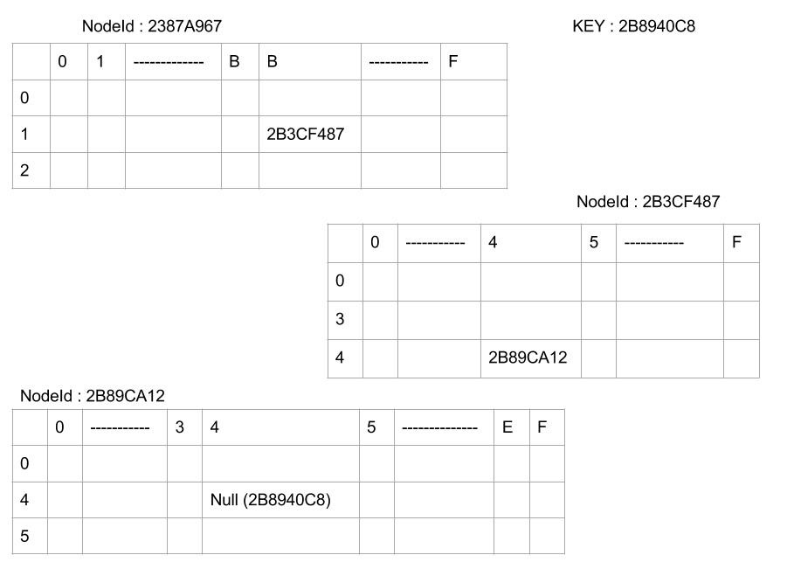

1. **Code**

**Pastry.java -** This is the main process that accepts users commands to execute in the DHT.

**PastryNode.java -** In this part all the functions that a node performs are written. It contains a Routing Table, a LeafSet and a neighbourhood set. Each node runs on a separate thread. Any command from the user is communicated to the thread my message passing.

**MessageQueue.java -** In this part we design the message queue for each node.

**Message.java -** This contains the structure of a message including its type, message and the sender.

**Graphs**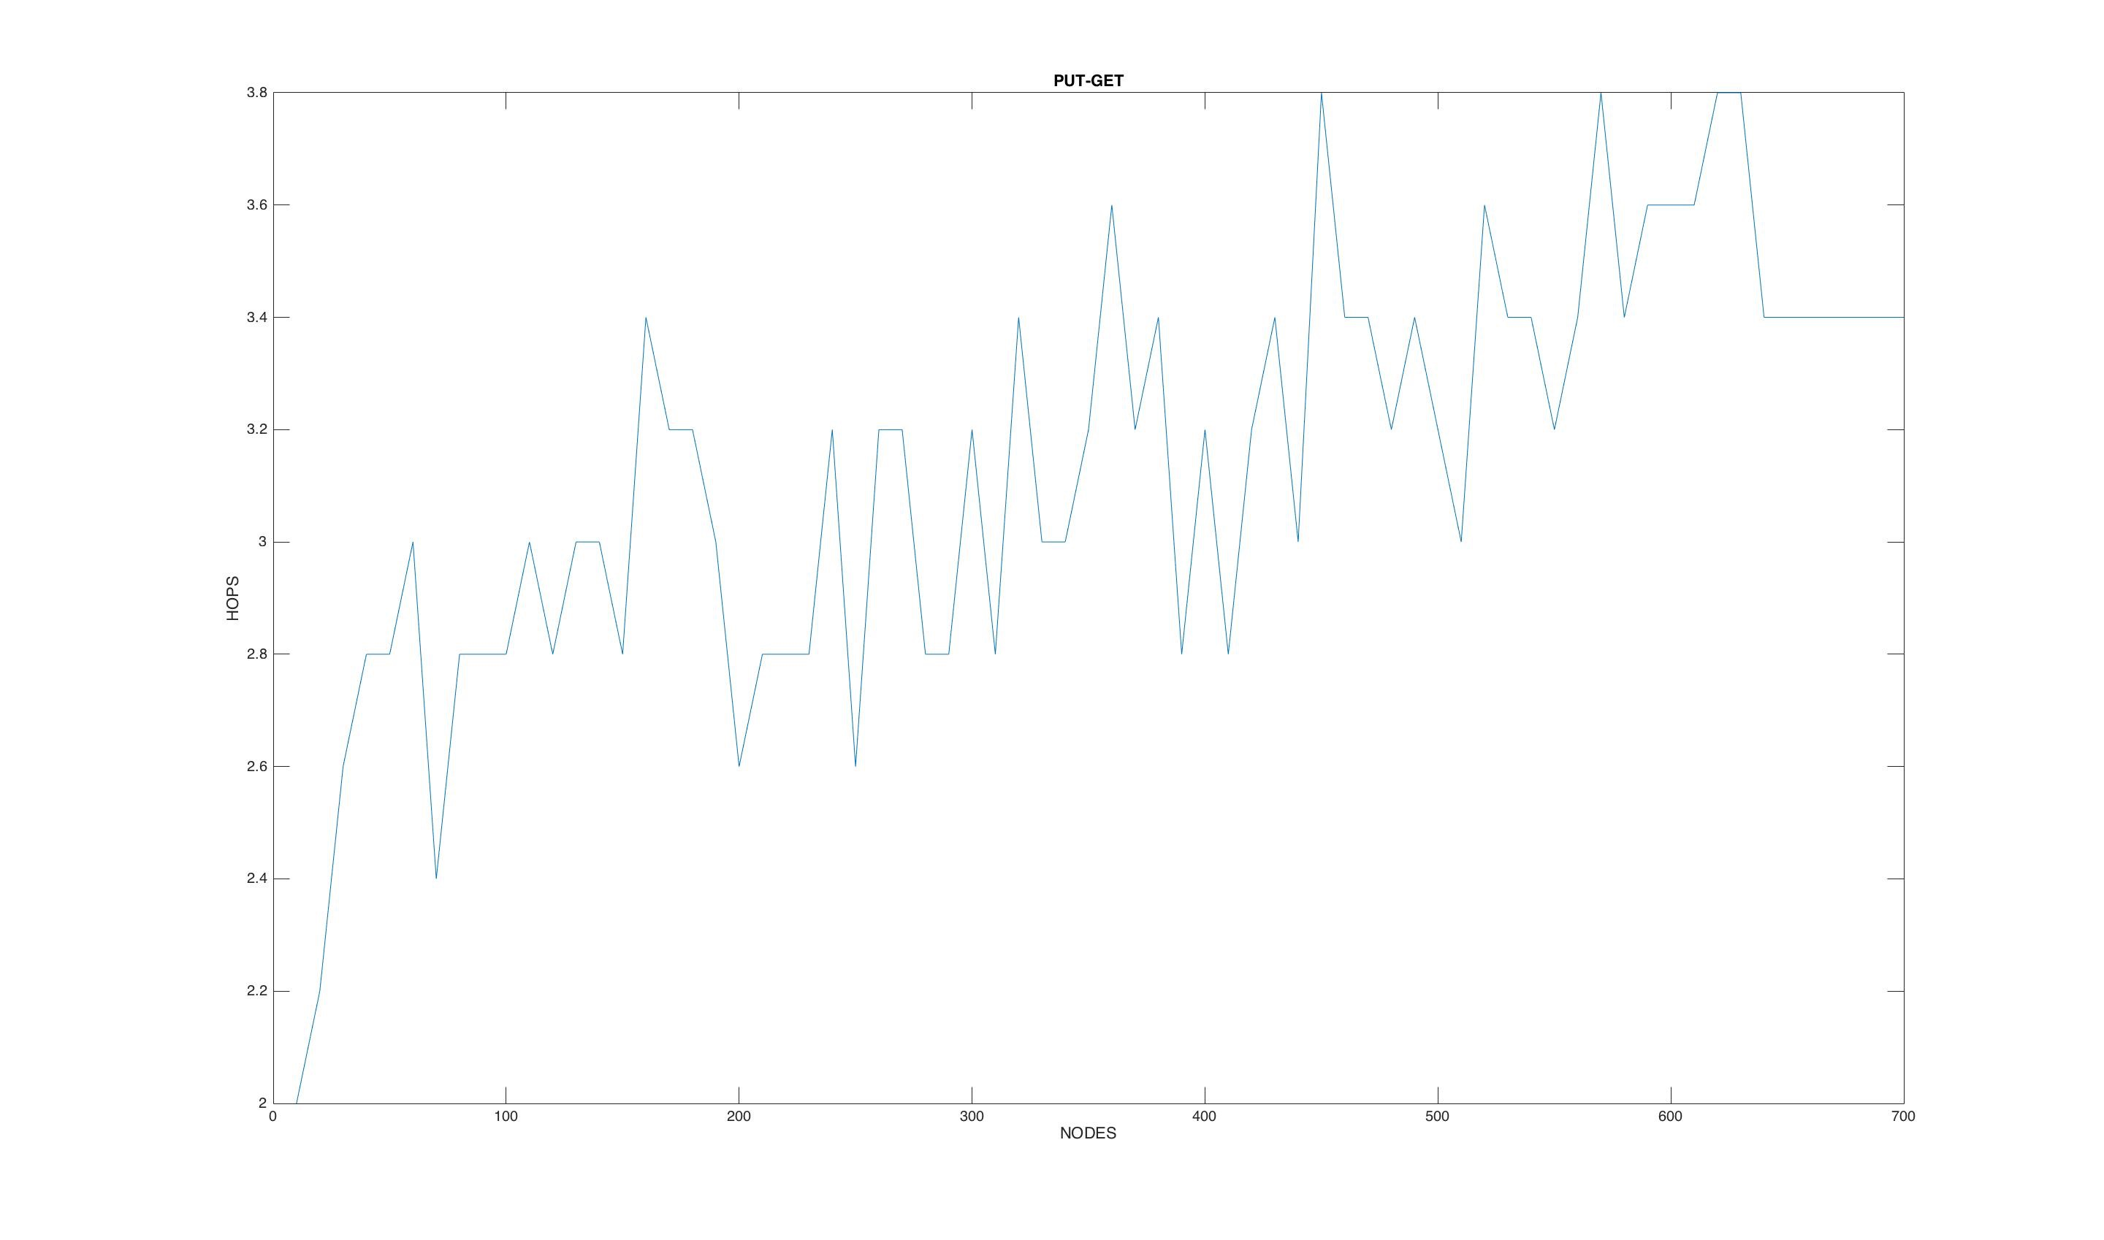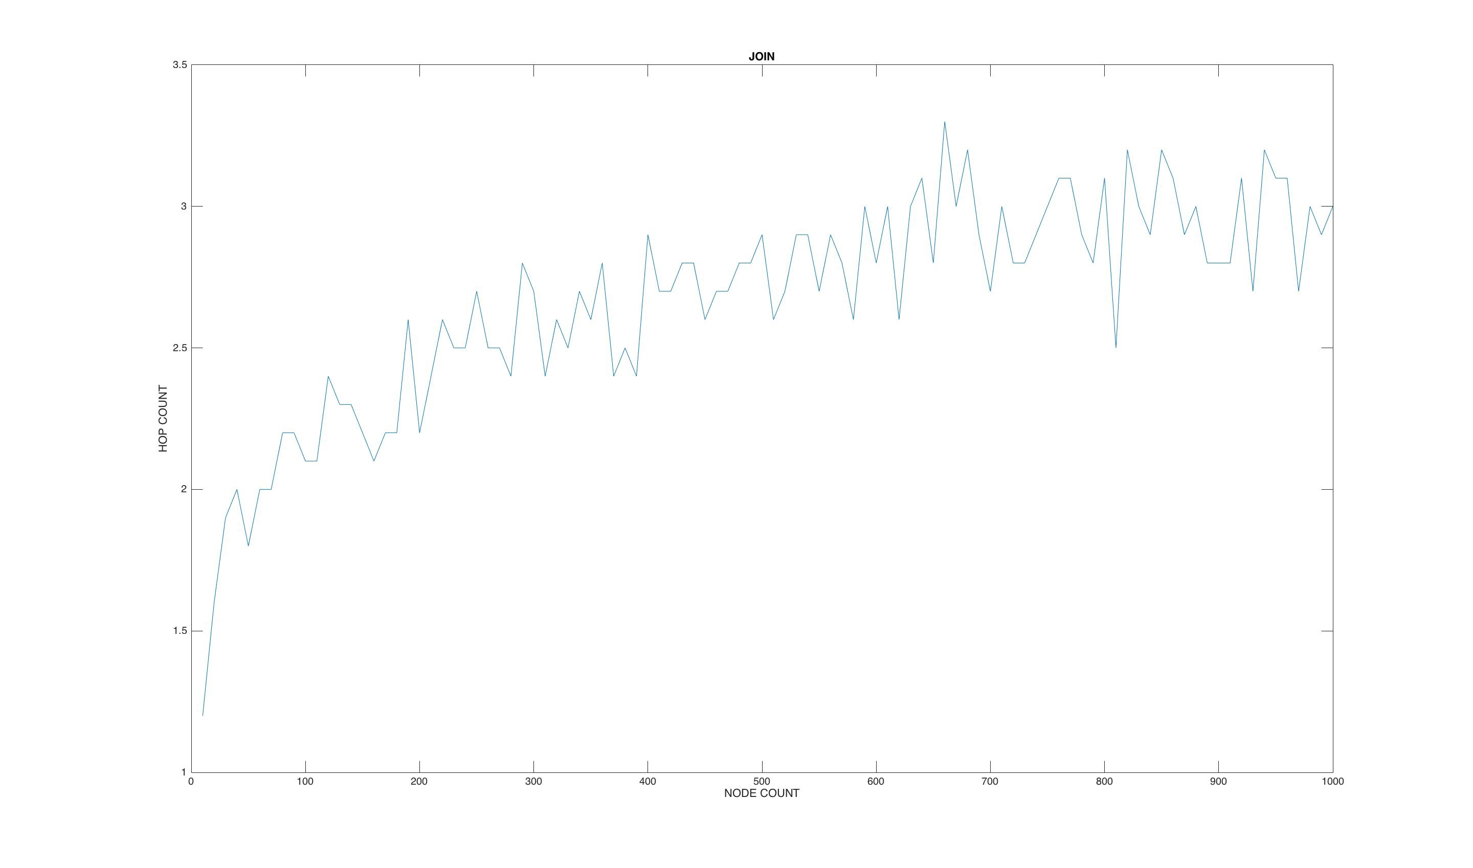

**Probability Distribution**