c program implementation:
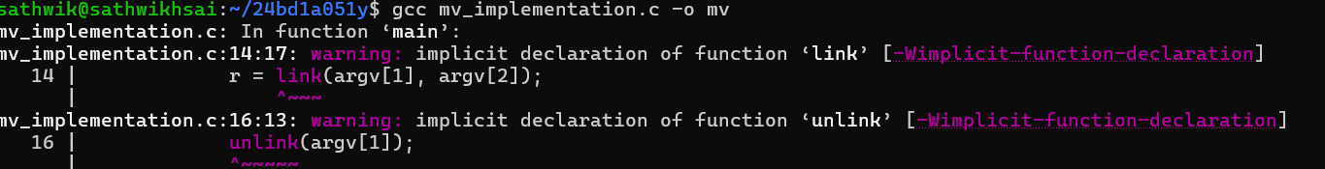
compiling the program:

Creating a new file:
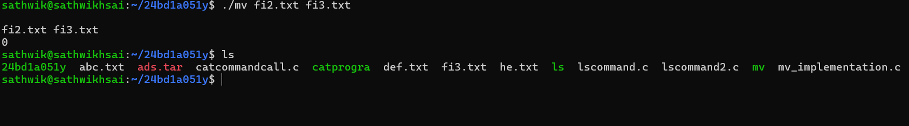
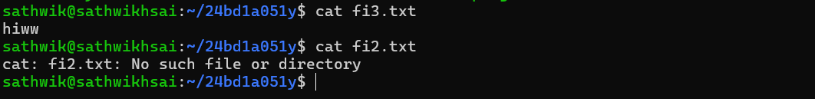
C program to implement the preemptive SJF
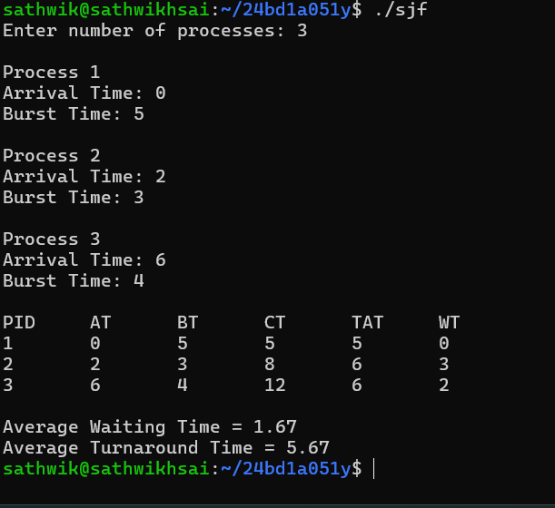
Content in the sjf.c:
