1.Find all sid’s of sailors who have a rating of 10 or reserved boat 104.
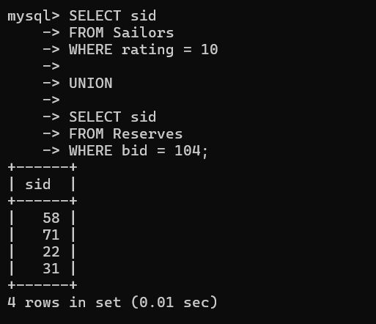

2. Find the names of sailors who have reserved boat 103 using nested queries

mysql> SELECT sname
-> FROM Sailors
-> WHERE sid IN (
-> SELECT sid
-> FROM Reserves
-> WHERE bid = 103
-> );
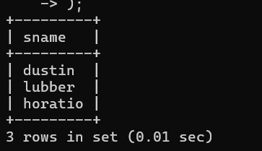
3. Find the names of sailors 'who have reserved a red boat using nested queries
mysql> SELECT sname
-> FROM Sailors
-> WHERE sid IN (
-> SELECT sid
-> FROM Reserves
-> WHERE bid IN (
-> SELECT bid
-> FROM Boats
-> WHERE color = 'red'
-> )
-> );

4. Find sailors id whose rating is better than some sailor called Horatio.
mysql> SELECT sid
-> FROM Sailors
-> WHERE rating > ANY (
-> SELECT rating
-> FROM Sailors
-> WHERE sname = 'horatio'
-> );
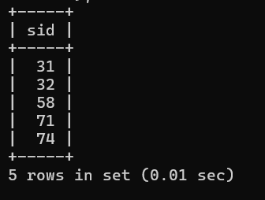
5 rows in set (0.01 sec)
5. Find the sailor'sid with the highest rating using all.
mysql> SELECT sid
-> FROM Sailors
-> WHERE rating >= ALL (
-> SELECT rating
-> FROM Sailors
-> );
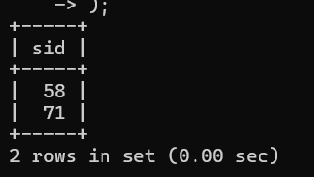
6. Find the average age of all sailors
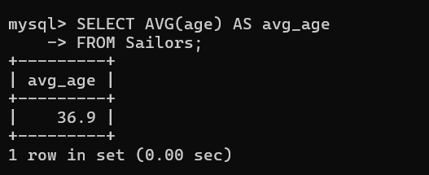
7. Find the average age of sailors with a rating of 10.
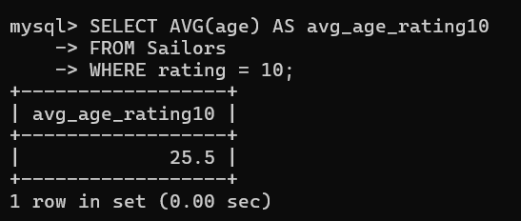
8. Find the name and age of the oldest sailor.
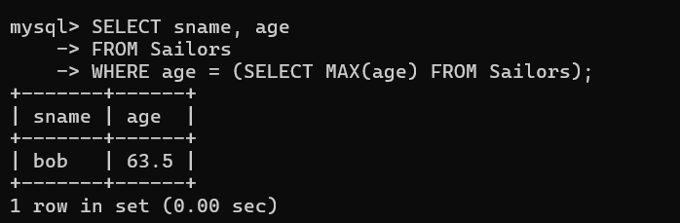
9. Count the number of sailors
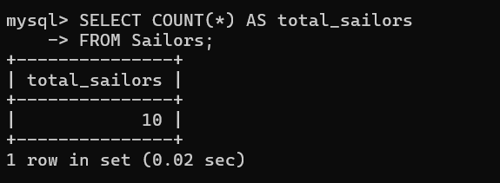
10. Find the names of sailors who are older than the oldest sailor with a rating of 10.
mysql> SELECT sname
-> FROM Sailors
-> WHERE age > (
-> SELECT MAX(age)
-> FROM Sailors
-> WHERE rating = 10
-> );
