**Power BI Driven Exhaustive Analysis of the Indian Agriculture Sector**

**Problem Statement**

Develop an interactive Power BI dashboard to provide a comprehensive analysis of the Indian agriculture sector, leveraging 19 years of historical data from 33 states, 646 districts, and across five seasons for 122 unique crops.

**Aim**

The aim of this project is to create a comprehensive and interactive Power BI dashboard that enables users to explore, analyze, and understand the Indian agriculture sector in depth. By leveraging 19 years of historical data, the dashboard will provide valuable insights into crop production trends, regional variations, key performance indicators, and the factors influencing minimum support prices.

**Learning Objectives**

The objectives of this project are to:

1. **Explore and visualize trends** in crop production, yields, and prices over time across different states, districts, and seasons.
2. **Identify key crops, seasons, states, and districts** that contribute significantly to agricultural production and economic value.
3. **Analyze regional variations** in crop patterns, production levels, and economic factors to understand the diversity of the Indian agriculture sector.
4. **Develop and interpret key performance indicators (KPIs)** to assess the health and efficiency of the agriculture sector, such as yield per hectare, production costs, and market prices.
5. **Utilize data mining techniques** to discover hidden patterns, correlations, and relationships within the agricultural data.
6. **Build predictive models** to estimate minimum support prices (MSPs) for various crops based on historical data and current market conditions.
7. **Develop interactive visualizations** using Power BI to effectively communicate insights and findings to stakeholders.
8. **Gain a deep understanding of the Indian agriculture sector** and its challenges, opportunities, and potential for growth.

**About Project**

This project presents a comprehensive analysis of the Indian agriculture sector using Power BI. By leveraging 19 years of historical data from 33 states, 646 districts, and across five seasons for 122 unique crops, the project aims to uncover valuable insights and trends. Key findings include the dominance of coconut as the most produced crop, Kerala's leadership in total production, and the seasonal variations in crop yields. The analysis also highlights regional disparities and the potential for growth through diversification and improved agricultural practices.

**Data Source Link**

The data for this project is based on the Indian Agriculture dataset, which can be accessed from various government sources and agricultural research organizations. Please note that the specific link may vary depending on the availability and accessibility of the dataset at the time of your access.

Link: [apy_1.csv](https://edunetfoundationorg-my.sharepoint.com/:x:/g/personal/namra_edunetfoundation_org/EXdRfdWRWp1JvV7bmov1hM0BEI_i8BHRSpGsVfU5BCBffQ?e=ffFTaP)

**Tools Used**

* Power BI refers to a business intelligence (BI) platform developed by Microsoft. It allows users to connect to various data sources, analyze it, create interactive visualizations, and share their findings with others. Power BI offers both a desktop application for detailed analysis and a cloud-based service for sharing and collaboration.
* In this Project Space Mission data source is of CSV type. After Importing the data into Power BI, we will write DAX which is useful for the analysis of the data, and sorting of various columns will be done. Visualization will be implemented and formatted. Finally, the functionality of the project will be tested and submitted.

**Findings and Insights**

**Overall Crop Production**

**Total Production:** India produced a staggering 45 billion tons of agricultural products over the 19-year period.

**Average Production:** The average annual production across all states, districts, and crops was 612,000 tons.

**Top Crops and Regions**

**Coconut:** This was the most produced crop, accounting for 42 billion tons of the total.

**Kerala:** Kerala emerged as the top state in terms of total production, contributing 33.14 billion tons.

**Kozhikode:** The district of Kozhikode led in terms of total production among districts, with 4.38 billion tons.

**Seasonal Trends**

**Kharif Season:** The Kharif season was the most productive, contributing significantly to the overall production.

**Winter Season:** Wheat production was highest during the Winter season.

**Production Trends Over Time**

**Year-on-Year Fluctuations:** Production levels varied across years, indicating the influence of factors like climate, government policies, and market conditions.

**Growth Potential:** While production has been substantial, there's potential for further growth through improved agricultural practices, technological advancements, and policy support.

**Key Insights**

**Regional Disparity:** Production is concentrated in certain states and districts, highlighting the need for balanced regional development.

**Crop Diversification:** The dominance of a few crops suggests the potential benefits of diversifying agricultural production to reduce risks.

**Climate Impact:** The influence of seasons on crop production underscores the importance of climate-resilient agricultural practices.

**Policy Implications:** The findings can inform policy decisions related to agricultural subsidies, research and development, and market regulations.

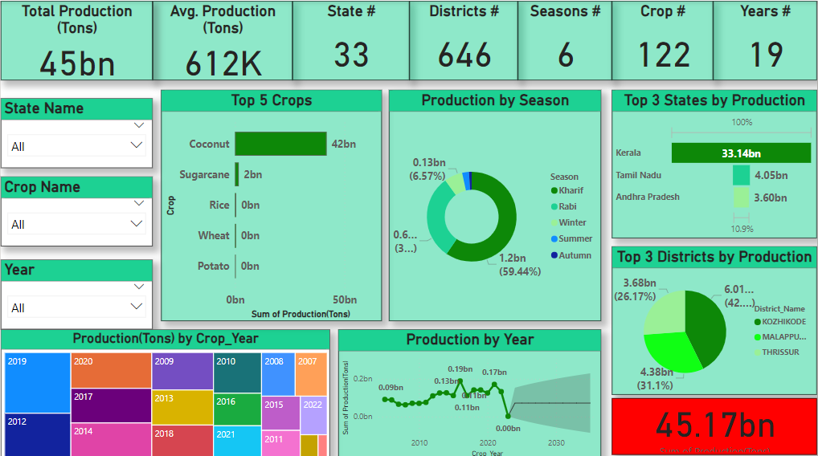

**Conclusion**

The Power BI-driven analysis of the Indian agriculture sector provides valuable insights into the trends, patterns, and challenges faced by the industry. By leveraging 19 years of historical data, the project has successfully identified key crops, regions, and seasons that contribute significantly to the overall production. The analysis has also revealed regional disparities, the impact of climate factors, and the potential for growth through diversification and improved agricultural practices.

The interactive dashboard developed in Power BI empowers users to explore and visualize the data in a user-friendly manner, enabling informed decision-making and policy development. The findings from this analysis can be utilized by policymakers, researchers, and agricultural stakeholders to address the challenges faced by the sector and promote sustainable and equitable agricultural development in India.