## Task 1

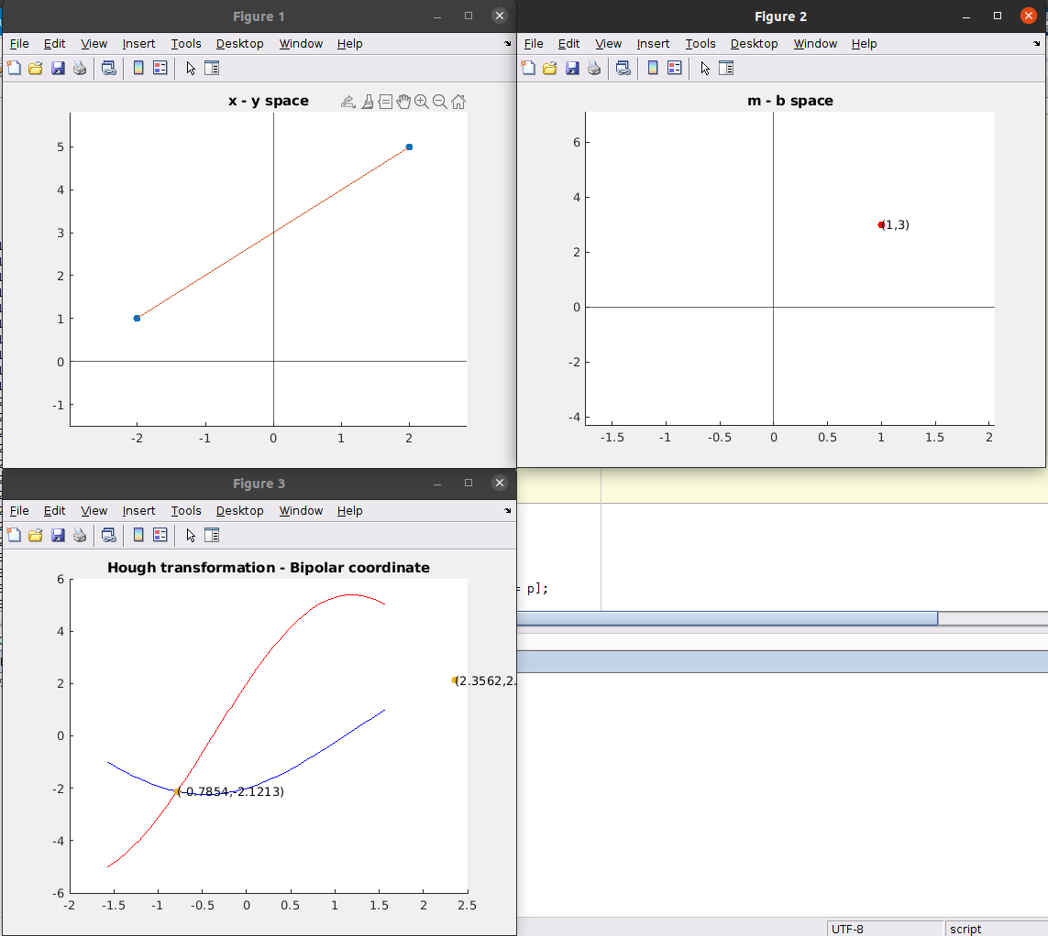

The matlab code is in Task1.m file

## Task 2

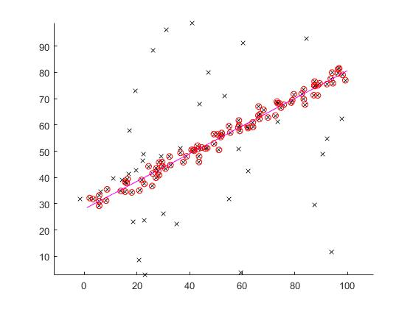

## Task 3

The NCC with the normalization has better measured distance than the SSD in case of scaling pixel

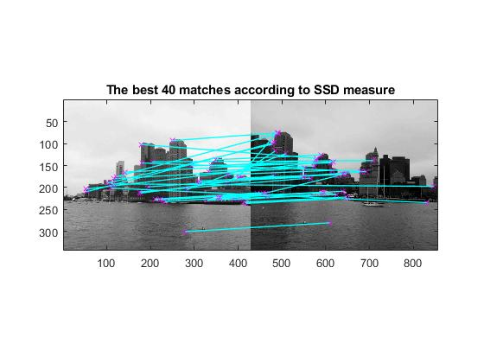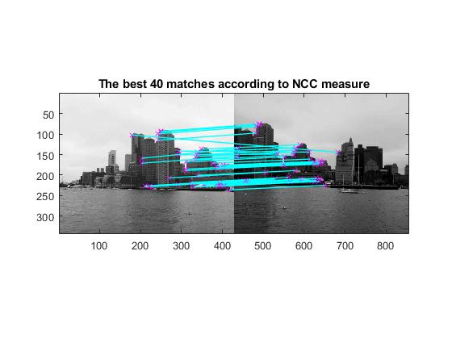

## Task 4

SURF has better accuracy than Harris but Harris has better computational speed because of the simple algorithm implied.

