Airport Lounge Staffing Estimation Report

1. Introduction
This report explains how to convert customer arrival demand into staffing requirements for an airport lounge operation. The model estimates employee requirements for six staff roles: Reception Staff (RS), Dining Area Staff (DAS), Buffet Line Operator (BLO), Food Safety & Temperature Checker (FSTC), Dishwashing Staff (DS), and Supply & Logistics Staff (SLS).
The staffing method does not allocate employees by fixed percentages. Instead, each role is estimated from its own operational workload driver. For example, RS is driven by customer arrivals, DAS by table clear/reset tasks, DS by dirty dish batches, and SLS by refill events.
Role | Full Name | Main Responsibility
RS | Reception Staff | Check-in / access control
DAS | Dining Area Staff | Clear and reset tables
BLO | Buffet Line Operator | Buffet service and line interaction
FSTC | Food Safety / Temperature Checker | Temperature and food safety checks
DS | Dishwashing Staff | Dishwashing by batch
SLS | Supply / Logistics Staff | Buffet stock refill and logistics

2. Overall Methodology
The model starts from customer demand by time slice, creates customer arrival events, estimates dwell time and departures, then translates these events into role-specific workload drivers. Workload minutes are then converted into required staff and validated in SimPy against waiting time and utilization targets.

Figure 1. Logic for converting customer demand into staff requirements.
Customer Demand -> Arrival Events -> Operational Drivers -> Workload Minutes -> Required Staff -> Simulation Validation

3. General Staffing Formula
Where:
$$W_{r,s}$$
is the total workload in minutes for role $r$during shift $s$,
$$Q_{r,s}$$
is the workload driver quantity for role $r$during shift $s$,
$$T_{r}$$
is the average processing time per task for role $r$.
For each role r and shift s, workload is calculated as:
$$W_{r,s}=Q_{r,s}×T_{r}$$
where W is total workload in minutes, Q is the workload driver quantity, and T is the average service time per task.
The workload-based staff requirement is:
$$Staff_{r,s}^{workload}=\left\lceil \frac{W_{r,s}}{E}\right\rceil$$
The effective working time per employee per shift can be defined in two ways:
E = 8 × 60 × 0.8 = 408 minutes
E = 8 × 60 × 0.75 = 360 minutes
The first option uses the target utilization of 0.8. The second option uses the target utilization of 0.75.
The final staffing level should also include mandatory minimum staffing and KPI validation:
The final staffing level should include the mandatory minimum and KPI validation:
$$Staff_{r,s}^{final}=max⁡\left(Staff_{min} , Staff_{r,s}^{workload} , Staff_{r,s}^{KPI}\right)$$
Given:
$$Staff_{min}=1$$
for each role.

4. Role-Based Workload Driver Formulas

4.1 Reception Staff (RS)
The RS workload driver is customer arrivals in each shift.
he main workload driver for RS is the number of customer arrivals.
$$W_{RS,s}=A_{s}×T_{RS}$$
Where:
$$A_{s}=\text{number of customer arrivals in shift }s$$
Reception service time:
$$T_{RS}=E[TRIA(0.15,0.25,0.40)] \\ T_{RS}=\frac{0.15+0.25+0.40}{3} \\ T_{RS}=0.267\text{ minutes/customer}$$
Therefore:
$$W_{RS,s}=A_{s}×0.267$$
Staff requirement:
$$Staff_{RS,s}=max⁡\left(1 , \left\lceil \frac{W_{RS,s}}{E}\right\rceil \right)$$

4.2 Dining Area Staff (DAS)
The DAS workload driver is the number of table clear/reset tasks. These are estimated from customer departures and, when available, party size.
First, customer departure time is calculated as:
$$DepartureTime_{i}=ArrivalTime_{i}+DwellTime_{i}$$
Customer dwell time is:
$$DwellTime_{i}=min⁡(180,TRIA(45,90,180))$$
The mean dwell time is:
$$E[DwellTime]=\frac{45+90+180}{3}=105\text{ minutes}$$
Then, the number of table turns in shift $s$can be estimated as:
Mixed individual and shared seating Base DAS TableResetRate = 0.65
$$TableTurns_{s}≈D_{s}×TableResetRate$$
DAS workload is:
$$W_{DAS,s}=TableTurns_{s}×T_{DAS}$$
If using the effective mean:
$$T_{DAS}=7.1\text{ minutes/task}$$
$$W_{DAS,s}=TableTurns_{s}×7.1$$
Staff requirement:
$$Staff_{DAS,s}=max⁡\left(1 , \left\lceil \frac{W_{DAS,s}}{E}\right\rceil \right)$$

4.3 Buffet Line Operator (BLO)
The BLO workload driver is the number of buffet service visits. A simple assumption is one buffet visit per arriving customer. A more realistic assumption multiplies arrivals by a visit rate.
This assumes each customer has one main buffet service interaction.
More realistic version:
VisitRate = 1.5 buffet trips/customer
InterventionRate = 0.20
$$BuffetVisits_{s}=A_{s}×VisitRate$$
Where:
$$VisitRate=\text{average buffet visits per customer}$$
This is different because a buffet is usually self-service. Not every buffet trip requires BLO staff to serve the customer.
$$BLOServiceEvents_{s}=A_{s}×VisitRate×InterventionRate$$
BLO workload is:
$$W_{BLO,s}={BLOServiceEvents}_{s}×T_{BLO}$$
Buffet service time:
$$T_{BLO}=E[TRIA(0.50,0.75,1.20)] \\ T_{BLO}=\frac{0.50+0.75+1.20}{3} \\ T_{BLO}=0.817\text{ minutes/visit}$$
Therefore:
$$W_{BLO,s}=A_{s}×VisitRate×InterventionRate×0.817$$
Staff requirement:
$$Staff_{BLO,s}=max⁡\left(1 , \left\lceil \frac{W_{BLO,s}}{E}\right\rceil \right)$$

4.4 Food Safety / Temperature Checker (FSTC)
The FSTC workload driver is the number of scheduled temperature checks during a shift..
$$Checks_{s}=\frac{ShiftLength}{CheckInterval}$$
For one 8-hour shift:
$$ShiftLength=480\text{ minutes}$$
If the check interval is between 30-60 minutes:
$$Checks_{s}=\frac{480}{30}=16$$
FSTC workload is:
$$W_{FSTC,s}=Checks_{s}×T_{FSTC}$$
Temperature check service time:
$$T_{FSTC}=E[TRIA(2,3,5)] \\ T_{FSTC}=\frac{2+3+5}{3} \\ T_{FSTC}=3.333\text{ minutes/check}$$
Therefore:
$$W_{FSTC,s}=Checks_{s}×3.333$$
Staff requirement:
$$Staff_{FSTC,s}=max⁡\left(1 , \left\lceil \frac{W_{FSTC,s}}{E}\right\rceil \right)$$

4.5 Dishwashing Staff (DS)
The DS workload driver is dishwashing batches generated from dirty dishes after customer consumption.
$$DirtyDishes_{s}=D_{s}×DishPerCustomer$$
Where:
$$D_{s}=\text{number of customer departures in shift }s$$
Dirty dishes per customer:
$$DishPerCustomer∼Poisson(3.0),\text{ at least }1$$
For simplified calculation:
$$DishPerCustomer≈3$$
Dishwashing batches:
$$Batches_{s}=\left\lceil \frac{DirtyDishes_{s}}{BatchSize}\right\rceil$$
Given:
$$BatchSize=80$$
Dishwashing time per batch:
$$T_{DS}=T_{prewash}+T_{machine}+T_{postwash} \\ T_{DS}=4.99+6.00+2.47 \\ T_{DS}=13.46\text{ minutes/batch}$$
Therefore:
$$W_{DS,s}=Batches_{s}×13.46$$
Staff requirement:
$$Staff_{DS,s}=max⁡\left(1 , \left\lceil \frac{W_{DS,s}}{E}\right\rceil \right)$$

4.6 Supply / Logistics Staff (SLS)
The SLS workload driver is buffet stock refill events. Refill events can be estimated from buffet consumption or simulated dynamically with stock level, reorder point, and refill quantity.
Buffet stock consumption:
$$Consumption_{s}=BuffetVisits_{s}×UnitPerVisit$$
If no detailed consumption data exists:
$$UnitPerVisit=1$$
Refill events can be estimated as:
$$RefillEvents_{s}=\left\lceil \frac{Consumption_{s}}{RefillQuantity}\right\rceil$$
Given:
$$RefillQuantity=220$$
SLS refill task time:
$$T_{SLS}=E[TRIA(3.0,4.5,6.0)] \\ T_{SLS}=\frac{3.0+4.5+6.0}{3} \\ T_{SLS}=4.5\text{ minutes/refill}$$
Therefore:
$$W_{SLS,s}=RefillEvents_{s}×4.5$$
For a more realistic model, inventory should be updated dynamically:
$$Stock_{t}=Stock_{t-1}-Consumption_{t}$$
If:
$$Stock_{t}≤ReorderPoint$$
then one refill task is triggered:
$$RefillEvents_{t}=1$$
and stock is updated as:
$$Stock_{t}=min⁡(StockMax,Stock_{t}+RefillQuantity)$$
Staff requirement:
$$Staff_{SLS,s}=max⁡\left(1 , \left\lceil \frac{W_{SLS,s}}{E}\right\rceil \right)$$

5. Summary of Role-Based Workload Formulas
Role | Workload Driver | Workload Formula | Staff Formula
RS | Customer arrivals | W_RS,s = A_s x 0.267 | max(1, ceil(W_RS,s / E))
DAS | Table clear/reset tasks | W_DAS,s = TableTurns_s x T_DAS | max(1, ceil(W_DAS,s / E))
BLO | Buffet visits | W_BLO,s = BuffetVisits_s x 0.817 | max(1, ceil(W_BLO,s / E))
FSTC | Temperature checks | W_FSTC,s = Checks_s x 3.333 | max(1, ceil(W_FSTC,s / E))
DS | Dish batches | W_DS,s = Batches_s x 13.46 | max(1, ceil(W_DS,s / E))
SLS | Refill tasks | W_SLS,s = RefillEvents_s x 4.5 | max(1, ceil(W_SLS,s / E))

6. Data Input

6.1 Customer Arrival and Shift Inputs
Input | Value | Purpose / Source Type
Operating hours | 24 hours | Defines one full lounge operating day
Time slice | 30 minutes | Demand interval for arrival model
Number of slices per day | 48 | 24 / 0.5 = 48
Shift length | 8 hours | Staff planning period
Slices per shift | 16 | 8 / 0.5 = 16
Number of shifts per day | 3 | 00:00-08:00, 08:00-16:00, 16:00-24:00
Total expected daily customers | 900 | Baseline scenario demand
Base random seed | 42 | Simulation reproducibility
Candidate replications | 30 | Simulation replication count

6.2 Staffing Policy Inputs
Input | Value
Default staff - RS | 2
Default staff - DAS | 10
Default staff - BLO | 6
Default staff - FSTC | 2
Default staff - DS | 2
Default staff - SLS | 2
Mandatory minimum staff | 1 for each role
Target utilization | 0.75-0.8

6.3 Wait KPI Inputs
Role | Wait KPI
RS | 5 minutes
DAS | 4 minutes
BLO | 6 minutes
FSTC | 5 minutes
DS | 10 minutes
SLS | 5 minutes

6.4 Lounge Capacity Inputs
Input | Value
Lounge capacity | 200 concurrent customers
Max admission wait | 30 minutes

6.5 Service Time Inputs
Process | Distribution / Value | Mean Used
Reception service time | TRIA(0.15, 0.25, 0.40) minutes | 0.267 minutes/customer
Buffet service time | TRIA(0.50, 0.75, 1.20) minutes | 0.817 minutes/visit
Customer dwell time | min(180, TRIA(45, 90, 180)) minutes | about 105 minutes
DAS table clear/reset | effective mean 7.1 minutes | 7.1 minutes/task
SLS refill task time | TRIA(3.0, 4.5, 6.0) minutes | 4.5 minutes/refill
FSTC service time | TRIA(2.0, 3.0, 5.0) minutes | 3.333 minutes/check

6.6 Dishwashing Inputs
Input | Value
Dirty dishes initial | 0
Dirty dishes per customer | Poisson(3.0), at least 1
Dish batch size | 80
DS prewash time | Positive Normal, mean 4.99, sd 1.14
DS machine cycle | 6.0 minutes
DS post-wash counting | Positive Normal, mean 2.47, sd 1.08
Mean DS batch processing time | 13.46 minutes

6.7 Stock and Refill Inputs
Input | Value
Buffet stock max | 200
Stock reorder point | 80
Stock refill quantity | 220
SLS refill task time | TRIA(3.0, 4.5, 6.0) minutes

7. Simulation Validation Logic
The workload formula gives an initial estimate of required staff. Final staffing should be validated using SimPy because waiting time, queueing, capacity limits, and stochastic arrivals may cause service quality failures even when average workload appears acceptable.
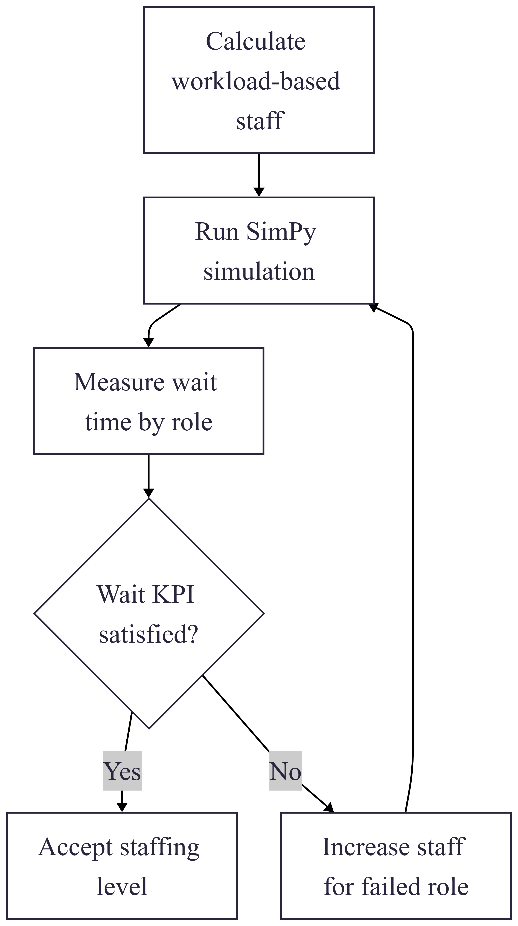
Figure 2. Validation loop for workload-based staffing.
The final staffing level should satisfy the following conditions:
$$Staff_{r,s}^{final}≥Staff_{min} \\ Utilization_{r,s}≤TargetUtilization \\ WaitTime_{r,s}≤WaitKPI_{r}$$
Therefore, the model should not only minimize the number of staff. It should also ensure that service quality remains acceptable.

