STANDARD OPERATING PROCEDURE
Acronis Backup Auditing and Verification

Document type | Standard Operating Procedure (SOP)
Applies to | Daily backup audit of all in-scope servers – India and Singapore regions
Tool used | Acronis Cloud Dashboard
Performed by | Backup audit team member
Reports to | Senior team member
Frequency | Daily

1. Purpose
This SOP defines the standard process for verifying the daily backup status of all required servers through the Acronis Cloud Dashboard. It ensures that backup failures are identified quickly, that manual backups are run where necessary, and that a clear, accurate report reaches the senior team member for review and action.

Objectives
- Confirm that every in-scope server has a successful, up-to-date backup.
- Detect failed or missed backups early and recover them through approved manual backups.
- Escalate unresolved issues with clear evidence and error details.
- Maintain a consistent daily audit record.

2. Process Overview
The audit follows eight steps. Each step is described in detail in the sections that follow.
Step | Activity | Outcome
1 | Log in to the correct regional dashboard | Access to the India or Singapore Acronis console
2 | Verify total server count | Audit scope confirmed (base server excluded)
3 | Check each server’s backup history | Latest backup date, time and status recorded
4 | Classify backup status | Every server labelled Successful, Failed, Missed, Pending or Needs Verification
5 | Perform manual backups where required | Missed or failed backups re-run and verified
6 | Prepare the audit report | Complete summary of results and remarks
7 | Submit the report | Senior team member informed for review and action
8 | Complete the final checklist | Audit confirmed as complete and accurate

3. Acronis Dashboard Login
Open the Acronis Cloud Dashboard that matches the region being audited:
- India: https://in01-cloud.acronis.com/login
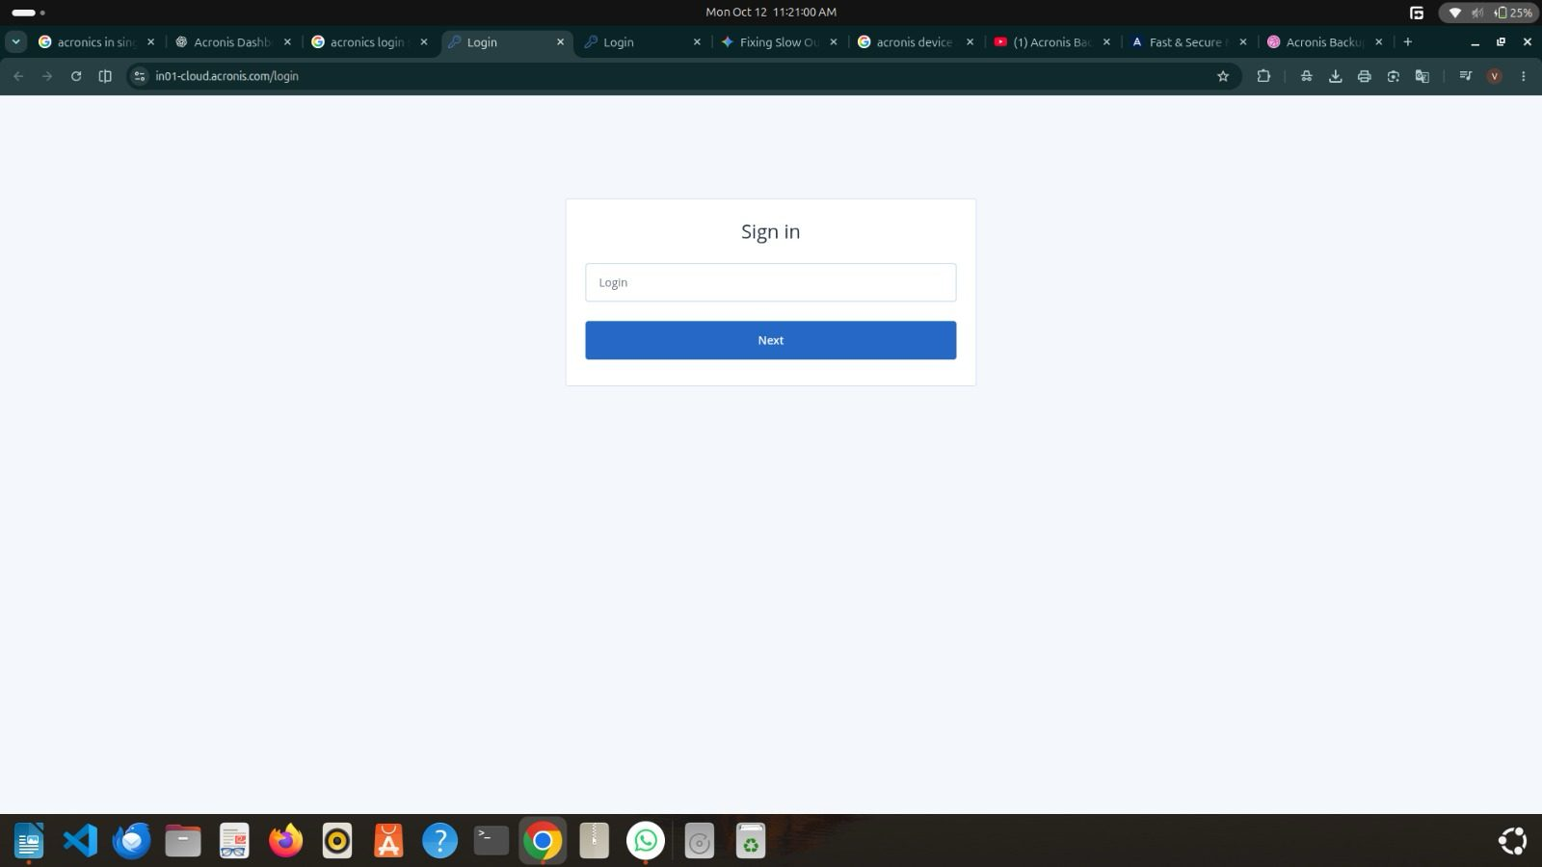
Figure 1 – Acronis Cloud Dashboard login page (India region)
- Singapore: https://sg-cloud.acronis.com/
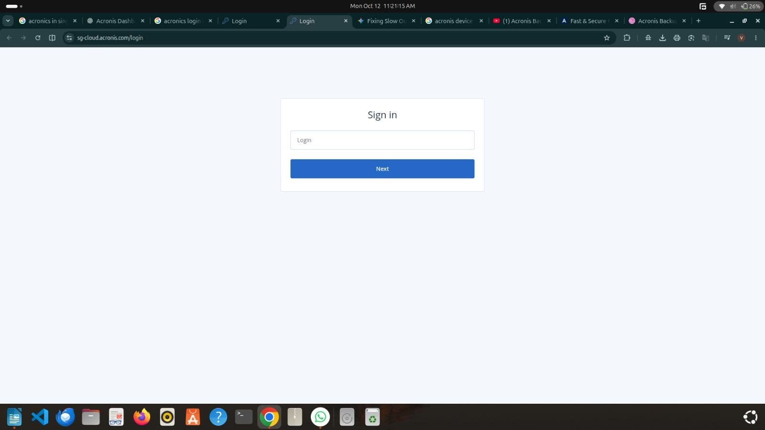
Figure 2 – Acronis Cloud Dashboard login page (Singapore region)
Log in using the authorised account username and password.
Security note
Never share credentials in the audit report, e-mails or chat messages.

4. Verify the Total Number of Servers
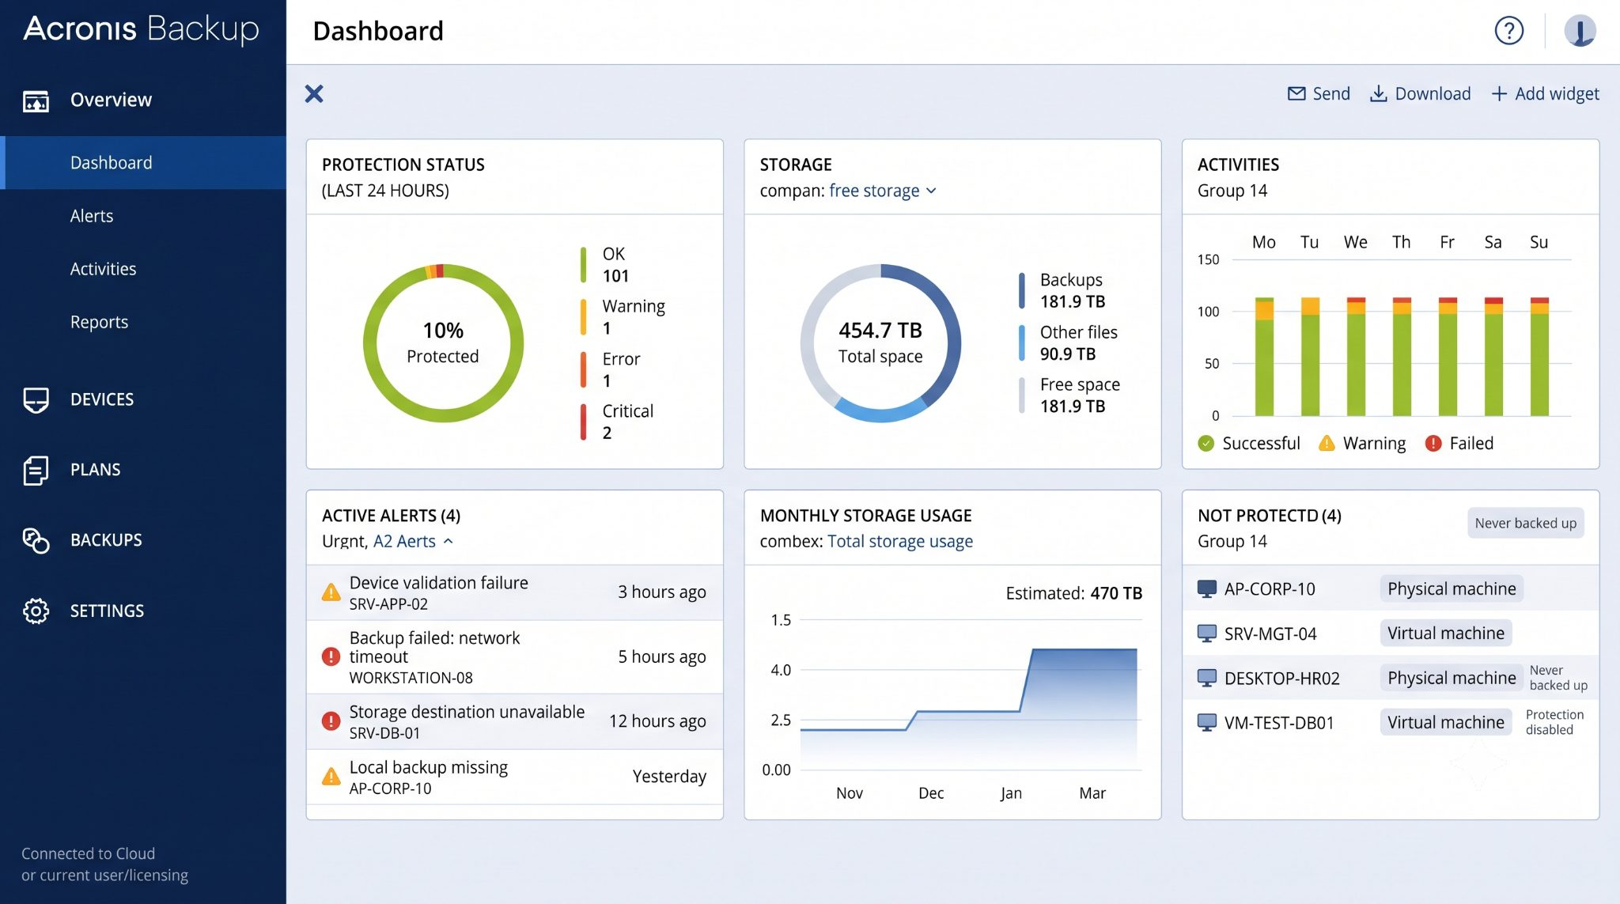
Figure 3 – Acronis Backup dashboard overview
- Open the Acronis Dashboard.
- Check the total number of servers listed.
- Identify the base server, which contains or represents the other servers in the environment.
- Exclude the base server from the backup audit if it is not configured for backup.

Example
Item | Count
Total servers listed | 40
Base server excluded from verification | 1
Servers to be audited | 39

Always confirm the actual server count for each environment before beginning the audit.

5. Check Individual Server Backups
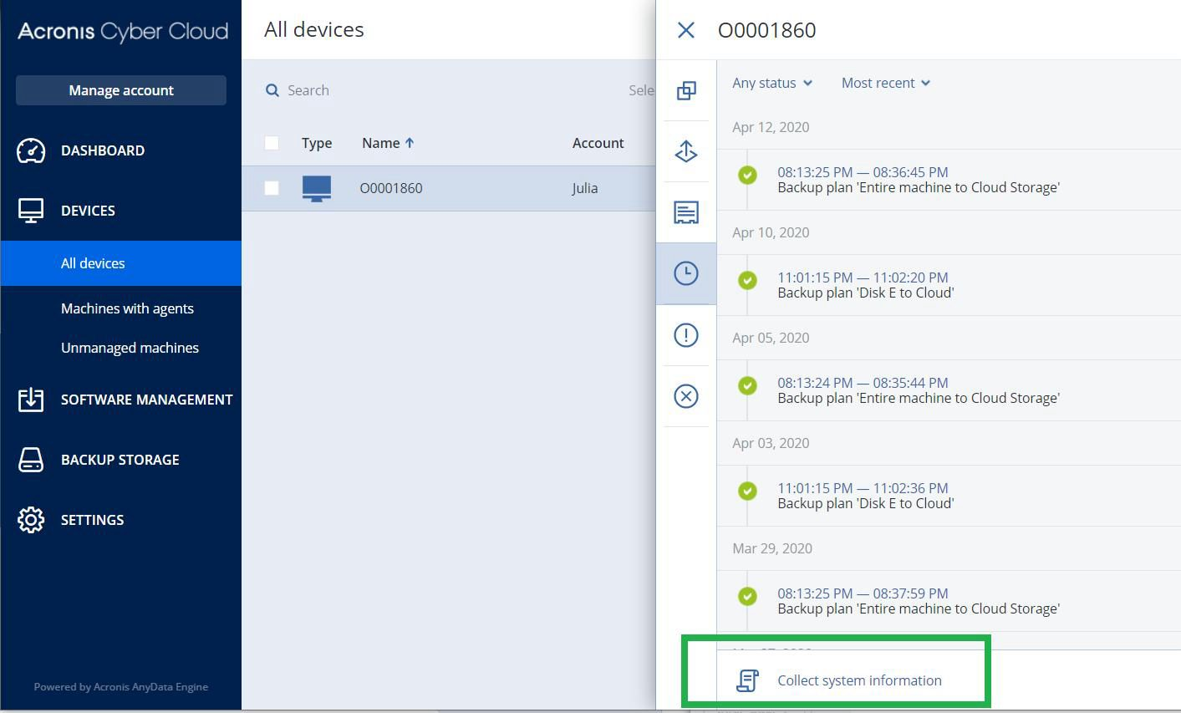
Figure 4 – Server details panel showing backup activity history
- Navigate to Devices → All Devices.
- Locate the first server to be audited.
- Double-click the server to open its details panel.
- Open the Details / Activities section.
- Review the backup status and verify whether the backup completed successfully for the previous day and the current day, as applicable to the backup schedule.
- Record the latest backup date, time and status.
- Repeat the same process for every server included in the audit.

6. Identify Backup Failures
After checking all required servers, classify each server according to its backup status:
Status | Meaning
Successful | The expected backup completed successfully.
Failed | The backup job failed.
Missed / Not Run | No expected backup is recorded.
Pending / In Progress | The backup job has not yet completed.
Needs Verification | The status or backup timestamp is unclear.

Important
Do not mark a backup as failed solely because it is still running or because no backup was scheduled for that day. Verify the configured backup schedule and job history first.

7. Perform Manual Backups When Required
If a required backup has failed or has not run as scheduled:
- Open the relevant server in Acronis.
- Review the backup activity and failure details.
- Confirm that the backup is required and that no job is already running.
- Initiate a manual backup using the approved procedure and permissions.
- Monitor the job until it completes.
- Verify the final result and update the audit report.

Escalation
If the manual backup fails again, record the error details and escalate the issue to the senior team member. Do not repeatedly restart failed jobs without investigating the cause.

8. Prepare the Backup Audit Report
After checking all servers, prepare a report containing the items below.
Report item | Details to include
Audit date and region | Date of audit and region (e.g. India, Singapore)
Total servers listed | Count shown in the dashboard
Servers excluded | Number excluded (e.g. base server)
Total servers audited | Servers actually verified
Successful backups | Count of servers with a successful backup
Failed or missed backups | Server names and count
Manual backups initiated | Servers re-run and their final status
Servers requiring investigation | Servers with unresolved or unclear status
Remarks / error messages | Relevant error text and observations

9. Submit the Report
Review the report for accuracy and completeness, then submit it to the senior team member for review and further action.

10. Final Verification Checklist
- Correct regional Acronis dashboard accessed
- Total server count verified
- Base server correctly excluded, where applicable
- All required servers checked individually
- Previous-day and current-day backup records reviewed as applicable
- Failed or missed backups identified
- Required manual backups completed and verified
- Unresolved issues documented
- Final audit report shared with the senior team member

11. Conclusion
A daily Acronis backup audit is a simple but critical control: it is the point at which a silent backup failure is caught before it becomes a data-loss incident. By following this SOP, the audit team works from the correct regional dashboard, defines the audit scope accurately, checks every server individually, classifies results consistently and escalates problems with the evidence the senior team member needs to act.
The process is complete only when every in-scope server has been verified, every failure or missed backup has been re-run or documented, and the final report has been submitted for review.

Summary of What We Learned
Topic | Key learning
Regional dashboards | India and Singapore use separate Acronis consoles – always confirm the region before starting.
Audit scope | Verify the total server count and exclude the base server if it is not configured for backup (e.g. 40 listed − 1 = 39 audited).
Server-level checks | Open each server under Devices → All Devices and review its details and activity history; record the latest date, time and status.
Status classification | Use five clear categories: Successful, Failed, Missed / Not Run, Pending / In Progress and Needs Verification.
Avoiding false alarms | A running job or an unscheduled day is not a failure – check the backup schedule and job history first.
Manual backups | Re-run a missed or failed backup only after reviewing the error and confirming no job is running; monitor it to completion.
Escalation | If a manual backup fails again, record the error and escalate. Do not keep restarting the job.
Reporting | Produce a complete report (counts, failures, manual backups, remarks) and submit it to the senior team member.
Security | Use authorised credentials only and never include them in the report.

Best Practices
- Complete the audit at a consistent time each day so results are comparable.
- Record errors exactly as shown in Acronis, including timestamps.
- When in doubt, mark a server “Needs Verification” rather than guessing.
- Keep the report factual, concise and free of credentials.

