ZABBIX
IT Infrastructure Monitoring & Alerting
A Complete Beginner's Reference Guide
Fundamentals | Architecture | Core Concepts | Terminology | Worked Examples
Prepared: September 2026

Table of Contents

1. What Is Zabbix?
Zabbix is an open-source monitoring and alerting platform used to monitor the health, performance, availability, and behavior of IT infrastructure.
In simple terms: Zabbix continuously watches servers, computers, network devices, applications, websites, databases, virtual machines, and other IT systems — and tells administrators when something is wrong.

1.1 The Problem Zabbix Solves
Consider a company operating 100 servers. Without a monitoring system, an administrator would have to manually and repeatedly check questions such as:
- Is the server running?
- Is CPU usage too high?
- Is RAM almost full?
- Is disk space running out?
- Is the website responding?
- Is the network device reachable?
- Is a database running?
- Is network traffic unusually high?
- Did a server suddenly stop responding?
Doing this manually across many systems is impractical. Zabbix automates this monitoring.
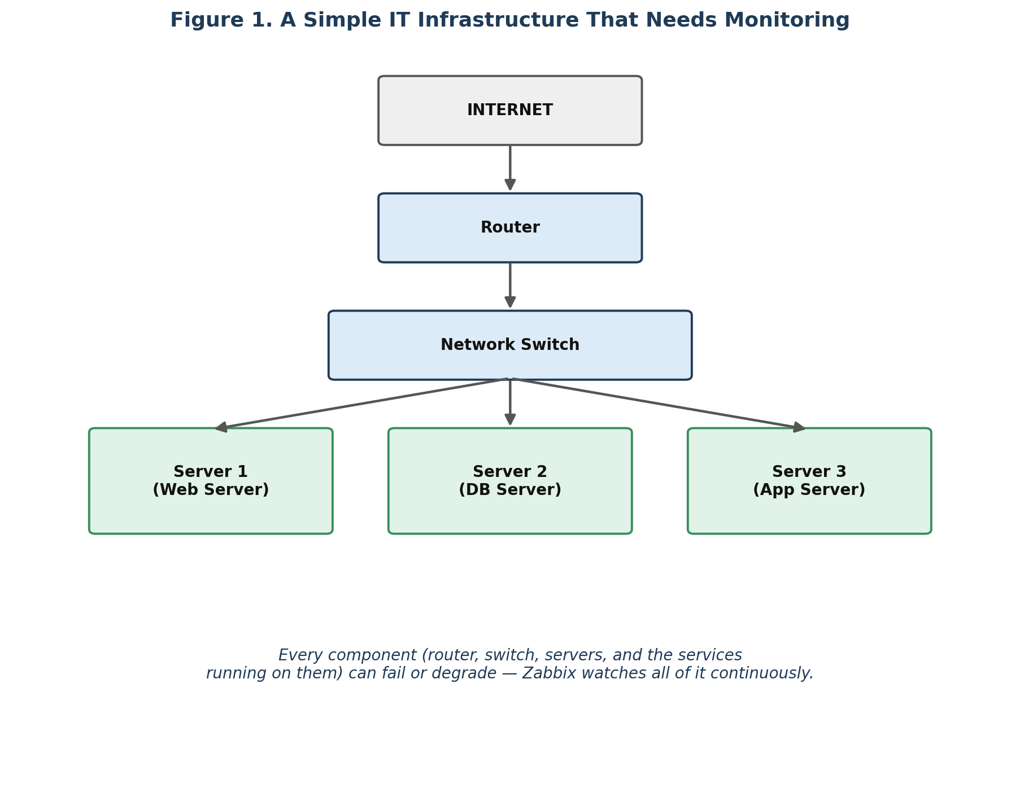
Figure 1. A simple IT infrastructure — every component (router, switch, servers, services) can develop problems that need to be watched.
Instead of an administrator discovering a problem after users complain, Zabbix can immediately raise an alert, for example:
- CRITICAL — Server3 website is unavailable.
- WARNING — Server2 disk usage is 92%.
This — continuous, automated observation with alerting — is the fundamental purpose of Zabbix.

2. Why Is Zabbix Used?
There are five core reasons organizations deploy Zabbix.

2.1 Availability Monitoring
Zabbix checks whether a component is up or down.
Component | Status
Server | UP
Router | UP
Database | UP
Website | DOWN
If a server stops responding, Zabbix detects it.

2.2 Performance Monitoring
A system can be technically "up" but still performing badly. For example:
Metric | Value
CPU | 95%
RAM | 98%
Disk I/O | Very high
Network | Very high
The server is running, but may be overloaded — Zabbix helps administrators identify this condition.

2.3 Early Warning
This is one of the most valuable functions of Zabbix: catching a slow-developing problem before it becomes an outage.
Day | Disk Usage
Monday | 70%
Tuesday | 78%
Wednesday | 85%
Thursday | 91%
Zabbix can alert the administrator before the disk becomes completely full, e.g. “Disk space on Server01 is above 90%.” The administrator can then clean up disk space or add storage before the application crashes.

2.4 Troubleshooting via Historical Data
Zabbix stores monitoring data over time. Instead of asking “Why was the server slow yesterday?” without evidence, an administrator can examine the historical record:
Time | CPU Usage
10:00 | 30%
11:00 | 35%
12:00 | 40%
13:00 | 95%
14:00 | 30%
This shows something unusual happened around 13:00, giving the administrator a specific point in time to investigate.

2.5 Centralized Monitoring
Instead of checking hundreds of servers individually, an administrator can monitor all of them from a single Zabbix interface.
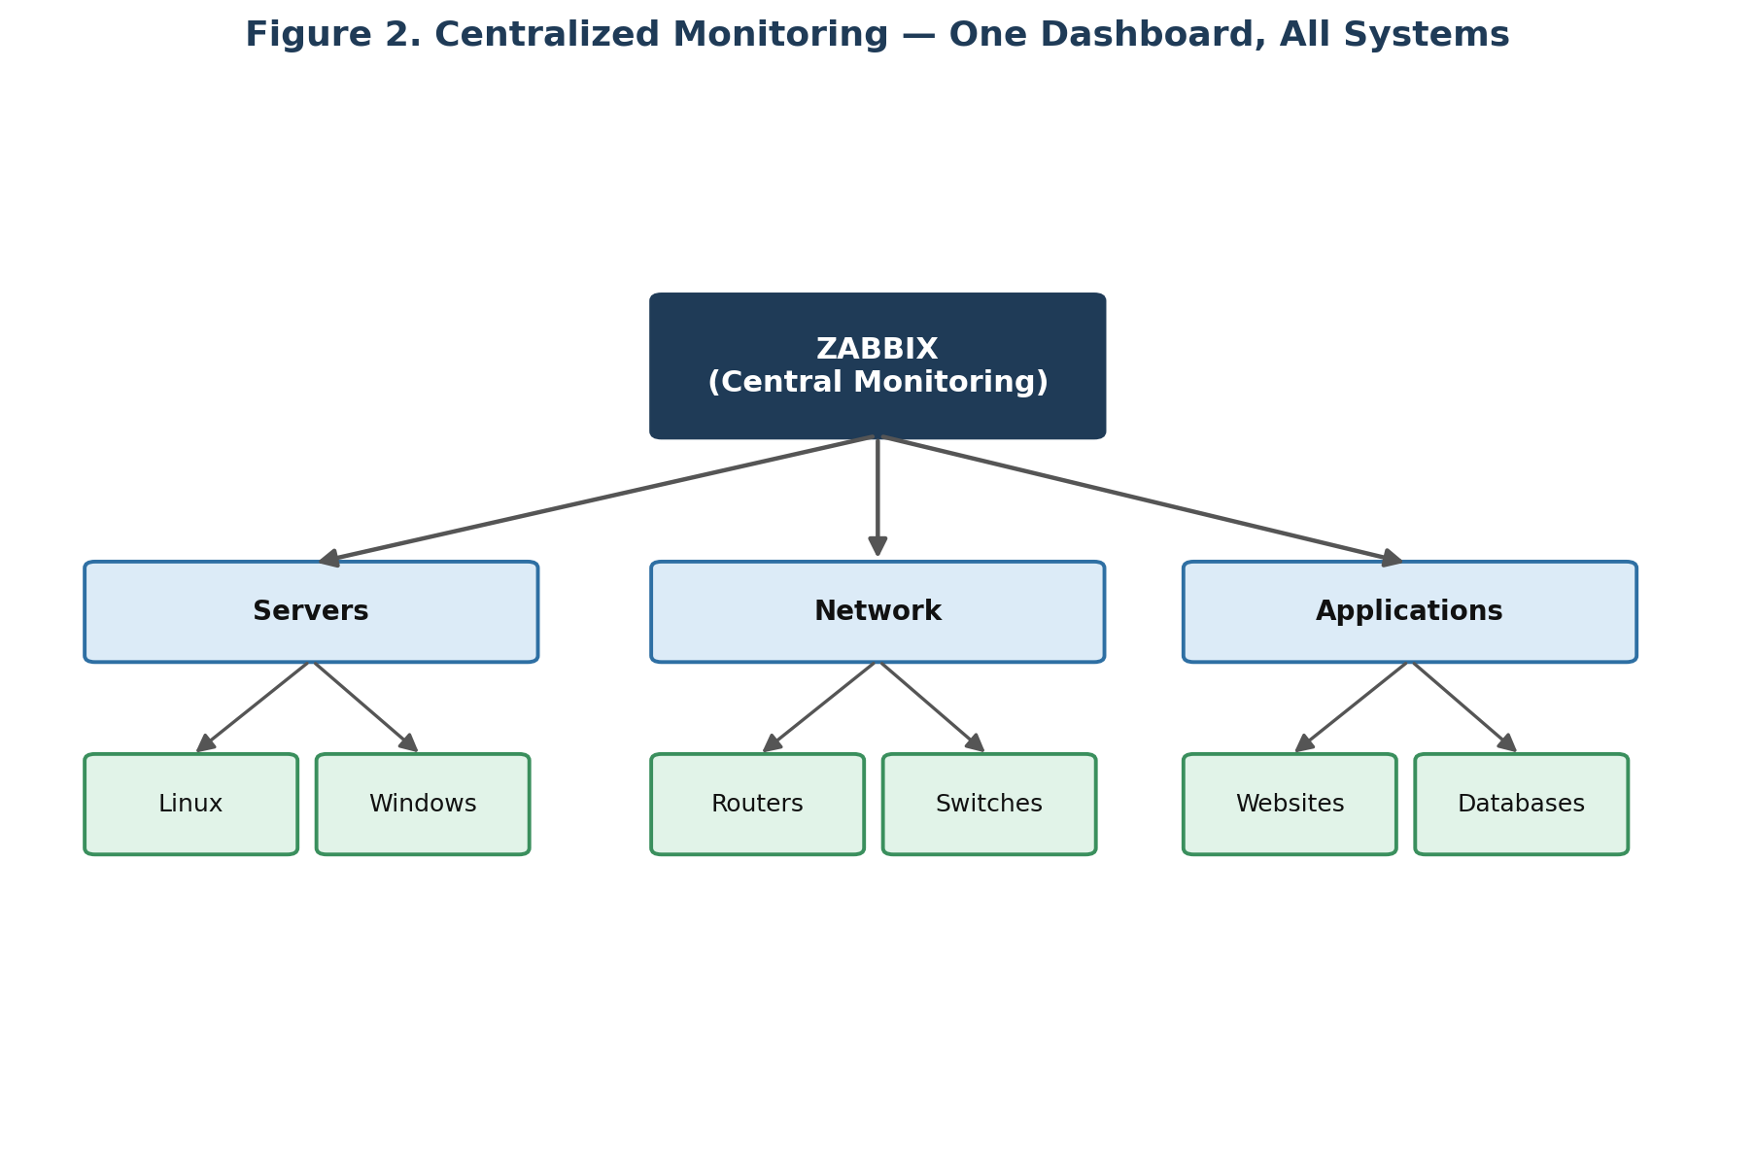
Figure 2. Centralized monitoring — a single Zabbix instance overseeing servers, network devices, and applications.

3. Where Is Zabbix Used?
Zabbix is used broadly across IT infrastructure and operations. The table below summarizes common deployment contexts.
Environment | Typical Use
Data centers | Physical servers, storage, network devices, applications, databases, UPS systems, environmental equipment
Cloud environments | Virtual machines, cloud services, applications, APIs, network resources
Enterprise networks | Centralized monitoring across head office and multiple branch locations
Web hosting companies | Server availability, CPU, RAM, disk, network, websites, and databases across large server fleets
Banks & financial organizations | Servers, databases, network infrastructure, application availability, and critical services (subject to security/compliance requirements)
Universities | Web servers, database servers, Wi-Fi infrastructure, routers, switches, authentication and application servers
Software companies | Frontend, backend, database, API, cache, message queue, load balancer, and cloud servers

4. What Exactly Can Zabbix Monitor?

4.1 Servers
On a Linux or Windows server, Zabbix can monitor:
- CPU usage
- RAM usage
- Disk usage
- Disk I/O
- Network traffic
- Running processes
- System uptime
- Load average
- File systems

4.2 Network Devices
Zabbix can monitor devices such as routers, switches, firewalls, access points, VPN devices, and other network appliances — commonly via SNMP (Simple Network Management Protocol).
Interface | Traffic
Gi0/1 (incoming) | 500 Mbps
Gi0/1 (outgoing) | 300 Mbps
Gi0/2 (incoming) | 20 Mbps
Gi0/2 (outgoing) | 15 Mbps
Beyond bandwidth, Zabbix can also track interface status, packet counts, errors, CPU, memory, and overall device availability.

4.3 Websites
Zabbix can check whether a website is reachable and responding correctly.
Check | Example Result
Website reachable? | YES
HTTP response code | 200
Response time | 250 ms
If a site starts returning errors (e.g. HTTP 500 Internal Server Error), Zabbix can detect and alert on it.

4.4 Applications
For a typical application stack — Mobile App → API Server → Database — Zabbix can monitor API response time, database availability, server CPU and memory, network conditions, and application processes.

4.5 Databases
Zabbix can be used to monitor database-related metrics such as availability, connections, query performance, storage, and replication-related metrics. Exact metrics depend on the database engine and monitoring method used.

4.6 Virtual Machines
For virtualized environments (Physical Server → Hypervisor → multiple VMs), Zabbix can monitor both the hypervisor and the individual virtual machines running on it.

4.7 Cloud Infrastructure
Zabbix can be integrated into cloud monitoring environments covering virtual machines, applications, databases, APIs, and network resources hosted in the cloud.

5. The Core Concept: Monitoring
Monitoring means: repeatedly collecting information about a system and determining whether that system is behaving normally.
For example, every 60 seconds Zabbix might ask:
- CPU usage?
- RAM usage?
- Disk usage?
- Server reachable?
- Website working?
Zabbix continuously performs checks like these across every monitored system.

6. How Zabbix Works — Architecture
At a basic level, monitoring data flows from a device, through the Zabbix Server, into a database, and out to administrators via the web interface.
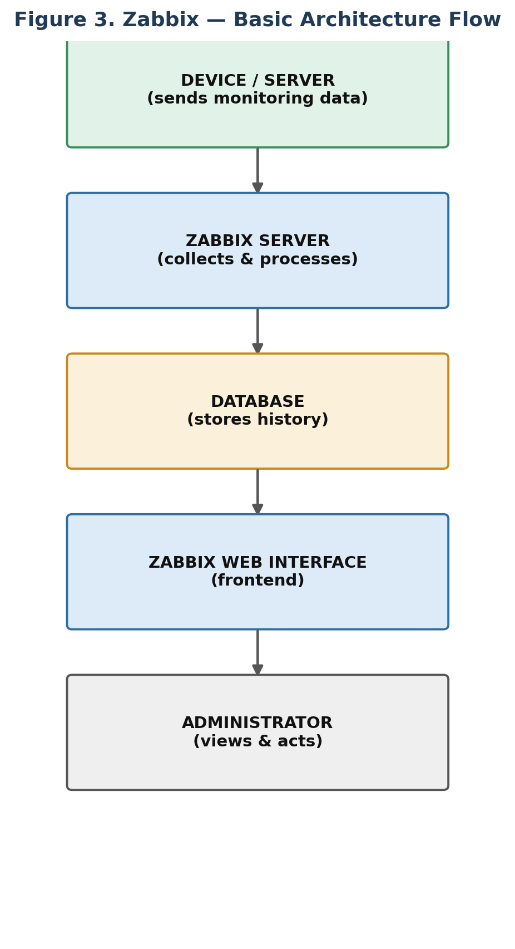
Figure 3. Basic Zabbix architecture flow.

6.1 Zabbix Server
The Zabbix Server is the central component — the “brain” of the monitoring system. It receives and processes monitoring information and determines whether values represent normal operation or a problem.
Server | CPU Usage | Status
Server01 | 30% | Normal
Server02 | 75% | Normal
Server03 | 96% | Problem

6.2 Zabbix Database
Zabbix requires a database to store monitoring information — effectively its memory. Historical values are retained so they can later be displayed and analyzed, for example:
Time | CPU
10:00 | 30%
10:01 | 32%
10:02 | 35%
10:03 | 41%
10:04 | 38%

6.3 Zabbix Frontend (Web Interface)
The frontend is the web interface administrators use in a browser to view monitored hosts, problems, graphs, dashboards, monitoring data, configuration, alerts, and reports.

6.4 Zabbix Agent
A Zabbix Agent is software installed on a machine to be monitored. It collects information such as CPU, RAM, disk, network, processes, files, and general system information, which the Zabbix Server then retrieves.

Example — Agent Monitoring an Ubuntu Server
Suppose an Ubuntu server (IP 192.168.1.10) has the Zabbix Agent installed. The agent might report:
Metric | Value
CPU utilization | 45%
Memory utilization | 62%
Disk utilization | 73%
The data flows from the server, through the agent, to the Zabbix Server, into the database, and finally to the web dashboard.

7. Core Concepts and Terminology

7.1 Host
A host is anything Zabbix monitors — not necessarily a physical computer. A host could represent a Linux server, Windows server, router, switch, firewall, virtual machine, application, or website. For example, a host might simply be named WEB-SERVER-01.

7.2 Item
An item is a specific piece of monitoring data that Zabbix collects for a host — it answers the question: “What specific value do I want to monitor?”
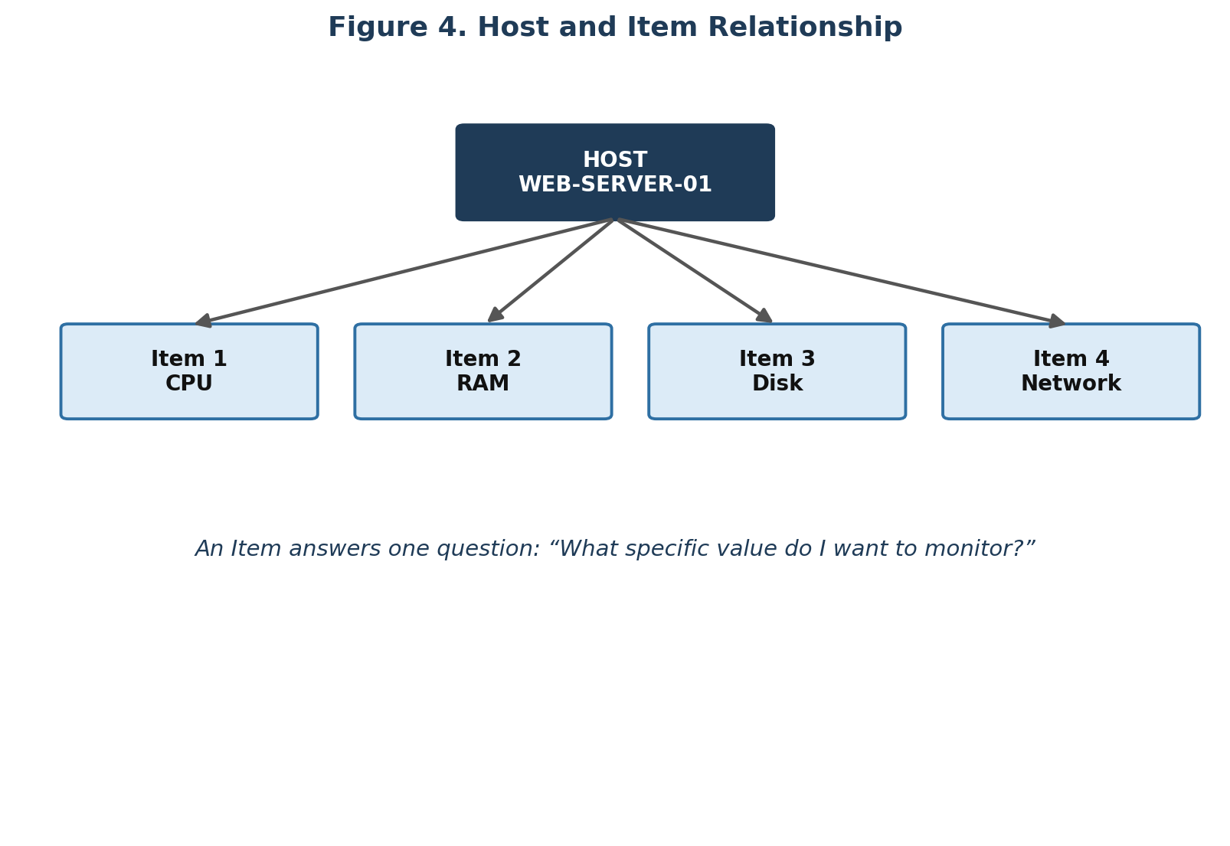
Figure 4. A host can have multiple items — CPU, RAM, disk, and network are each separate items.

7.3 Trigger
A trigger determines whether a monitored value represents a problem, by evaluating a condition against an item's value.
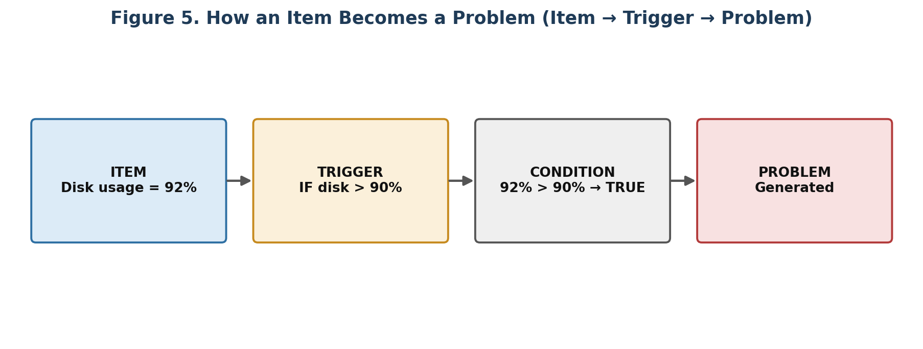
Figure 5. An item's value is evaluated by a trigger, which produces a problem when the condition is true.

Item vs. Trigger
This distinction is one of the most important in Zabbix:
Concept | Role
Item | Collects data — “What is the CPU usage?” (e.g. CPU = 95%)
Trigger | Interprets data — “Is 95% CPU usage a problem?” (e.g. CPU > 90% → Problem)
In short: Item = data. Trigger = logic/condition.

7.4 Problem
When a trigger's condition becomes true, Zabbix generates a problem event. For example, if CPU usage = 97% and the trigger condition is CPU > 90%, the result is a problem, which the dashboard might display as:
Note: PROBLEM — WEB-SERVER-01 — High CPU utilization — Severity: High

7.5 Recovery and the Alert Lifecycle
If the underlying value returns to a normal range (e.g. CPU falls from 97% to 60%), the trigger condition may no longer hold true, and Zabbix marks the problem as recovered.
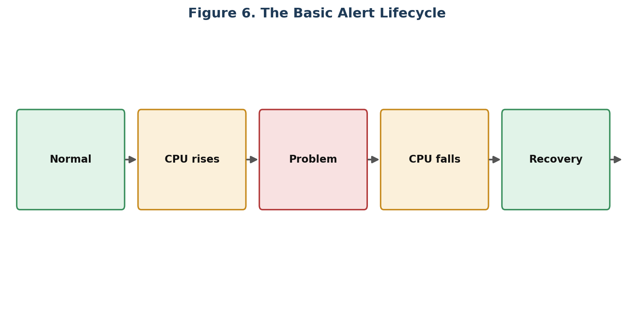
Figure 6. The basic alert lifecycle: normal → rising value → problem → falling value → recovery.

7.6 Alert
Once Zabbix identifies a problem, it can notify people through configured media such as email or other supported integrations, for example: “Zabbix Alert: Disk usage on WEB-SERVER-01 is 94%.”

7.7 Action
An action tells Zabbix what to do when a certain event occurs. For example:
- IF disk usage > 90% THEN send notification to administrator
- IF server becomes unavailable THEN notify IT team
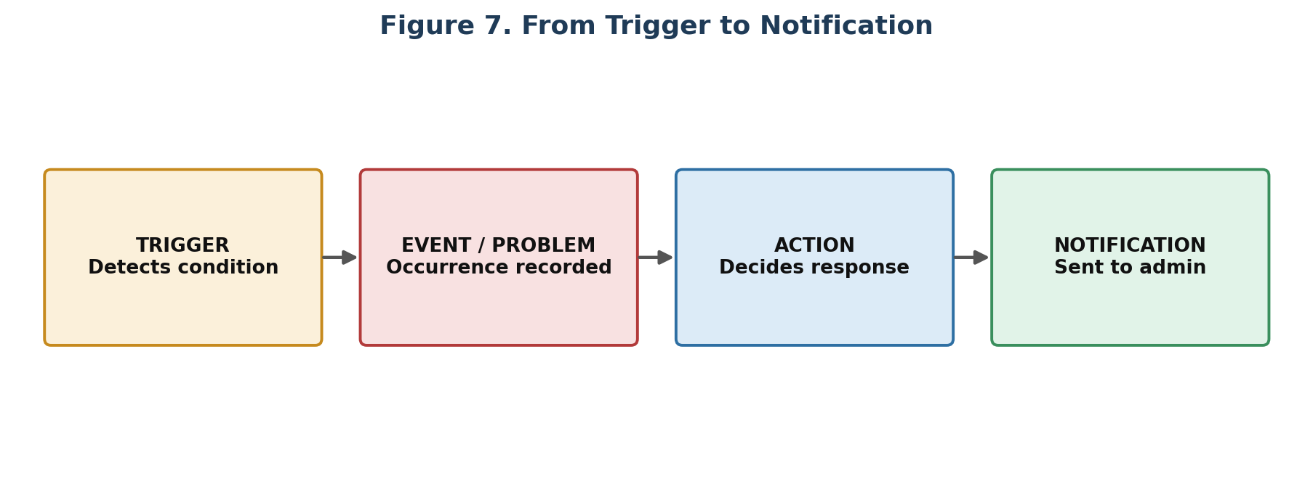
Figure 7. Trigger detects a condition, an event/problem is recorded, and an action decides the response.
Summary: Trigger detects a condition → Event/Problem represents its occurrence → Action decides what response to perform.

7.8 Template
Rather than manually configuring CPU, RAM, disk, and network items individually across 100 Linux servers, a template packages a reusable monitoring configuration (items, triggers, and graphs) that can be applied to many hosts at once.
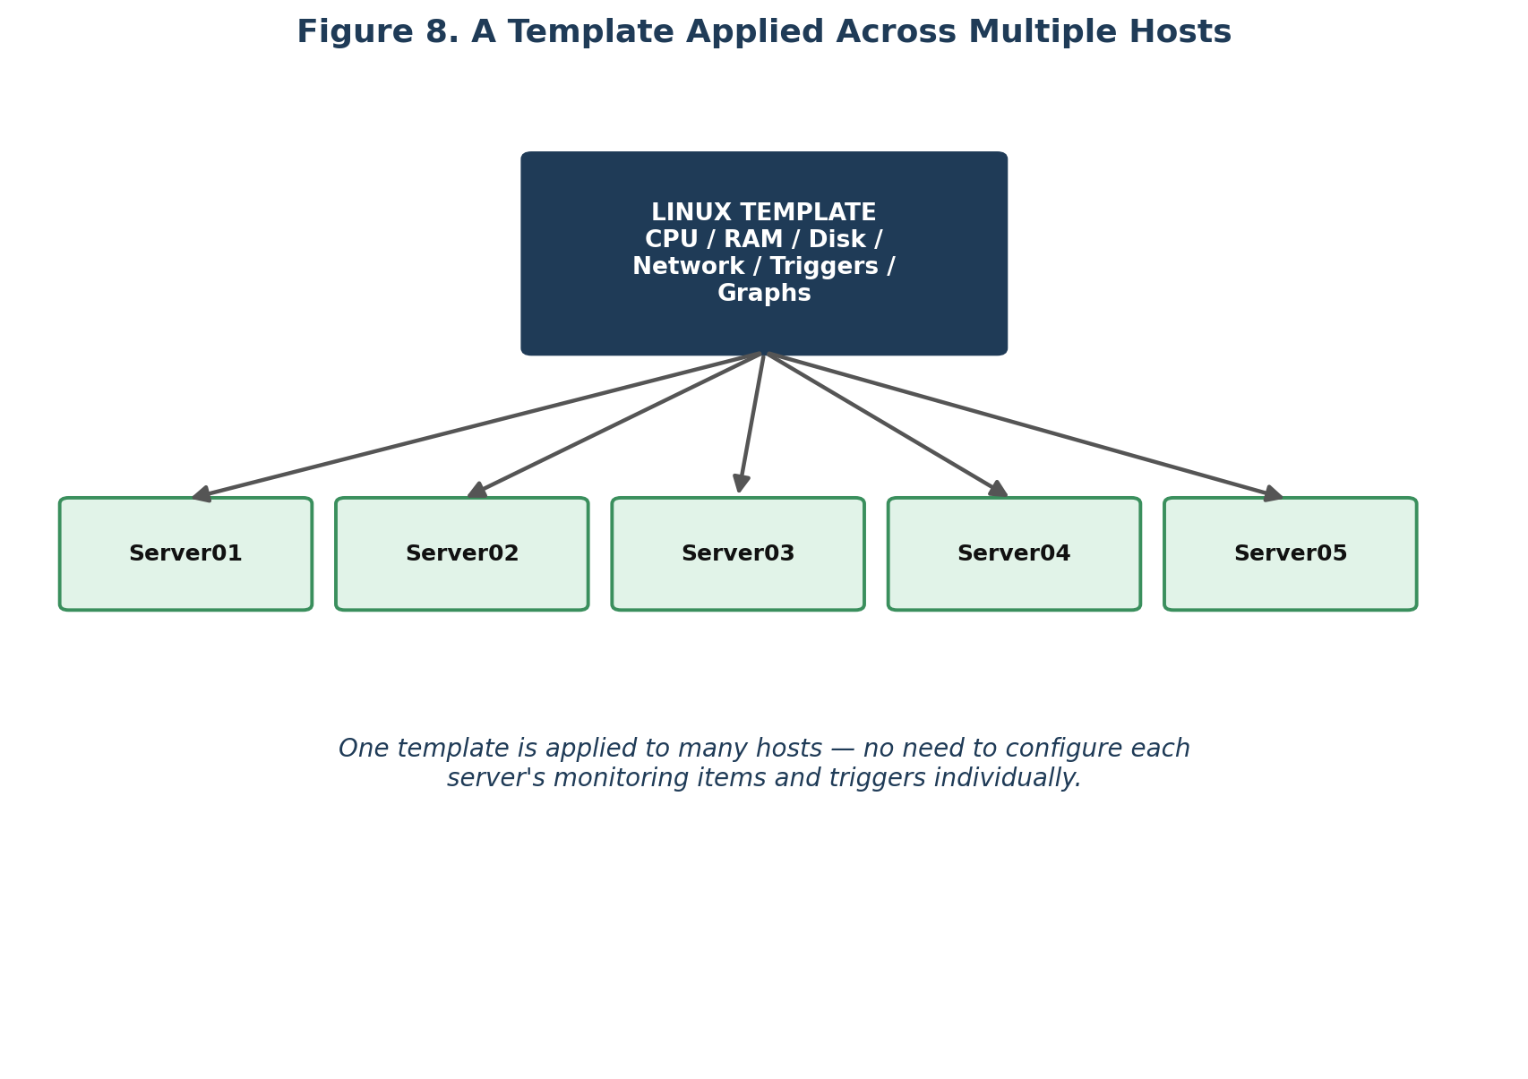
Figure 8. A single Linux template applied across multiple servers.

7.9 Host Group
A host group organizes related hosts together, making administration easier — for example, grouping all Linux servers, all Windows servers, or all network devices.
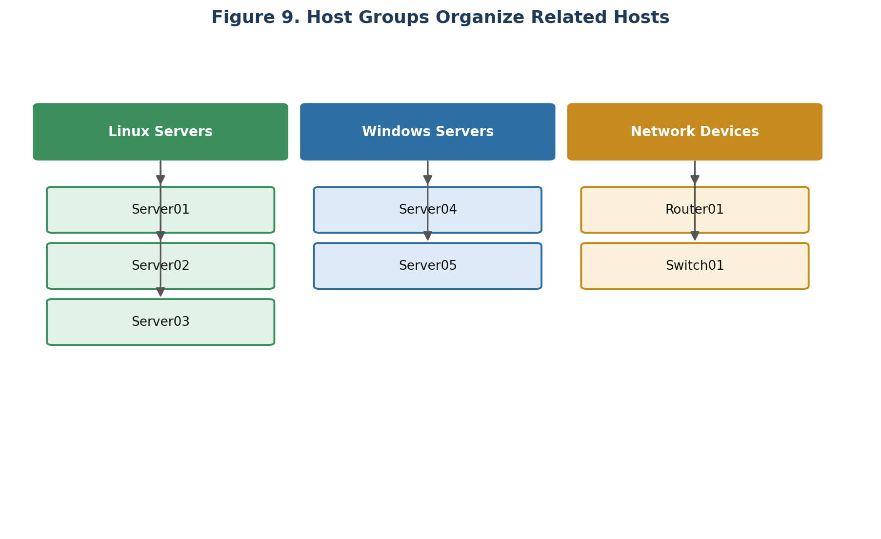
Figure 9. Host groups organize hosts by type or role.

8. Complete Worked Example — Monitoring CPU on a Server
The following walks through the entire process end to end, using CPU monitoring on an Ubuntu web server as an example.
Step | Action
1 | Install the Zabbix Agent on the Ubuntu server.
2 | Add the server to Zabbix as a host, e.g. WEB-SERVER-01.
3 | Create a CPU utilization item with a 1-minute update interval.
4 | Zabbix collects data over time, e.g. 30% → 35% → 40% → 45% → 93%.
5 | A trigger is defined: CPU > 90%.
6 | At 93% CPU, the condition 93 > 90 is true, so the trigger becomes active and Zabbix generates a problem.
7 | Zabbix sends a notification to the responsible team.
8 | CPU later falls to 50%; the problem is marked as recovered.

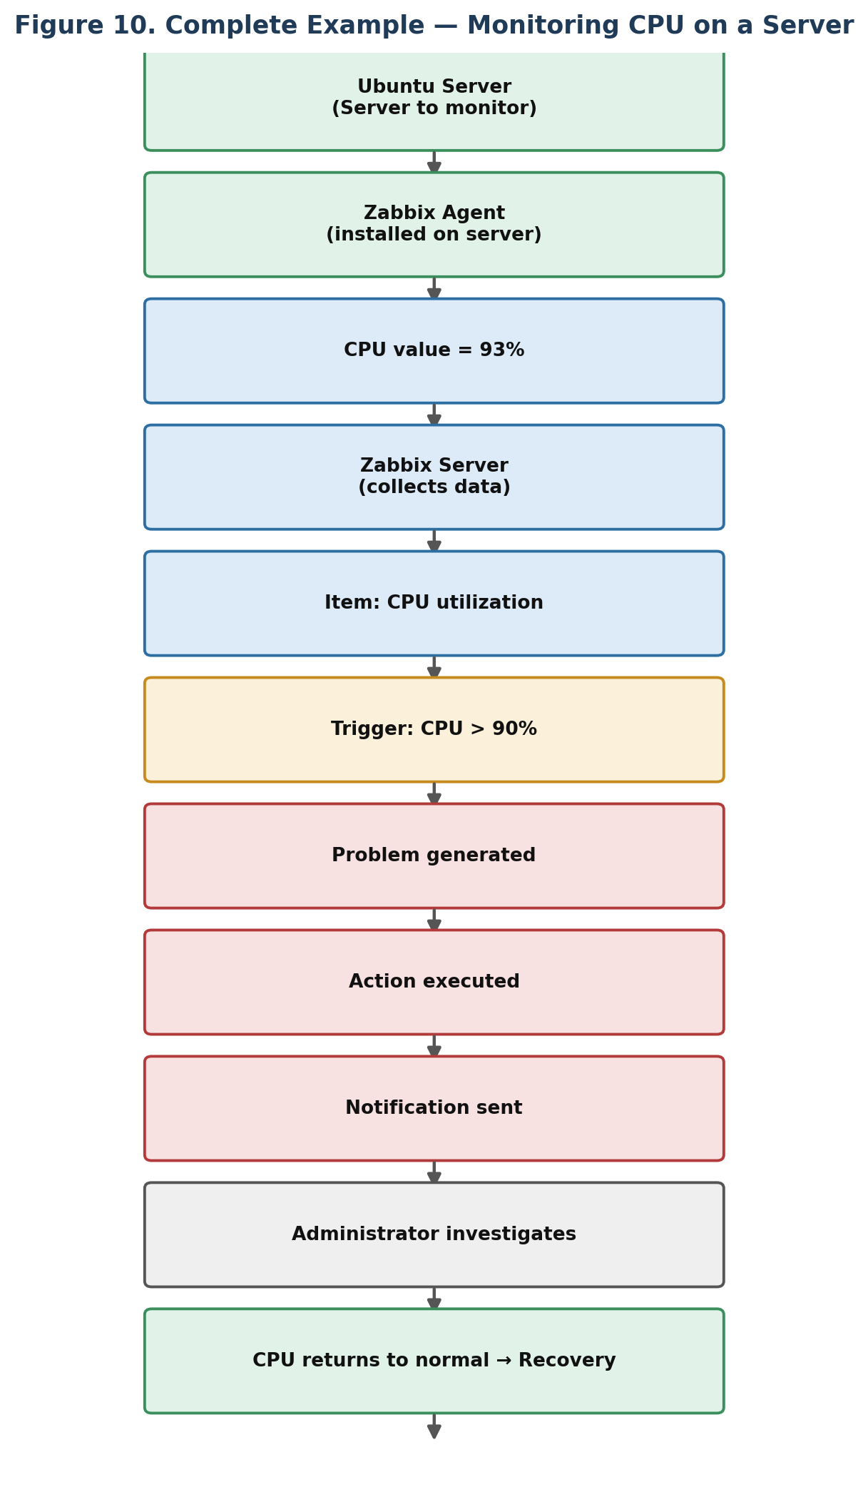
Figure 10. The complete monitoring flow, from server to recovery.

9. Monitoring Network Devices with SNMP
For network devices, SNMP (Simple Network Management Protocol) is commonly used. Zabbix queries the device (e.g. a router) for monitoring information such as CPU, memory, interface status, traffic, errors, and packet counts, and the device responds with current values, which Zabbix then stores.

10. Active vs. Passive Monitoring
There are two ways an agent can communicate with the Zabbix Server.
Mode | Description
Passive | The Zabbix Server initiates the request, asking the agent for a value (e.g. “Give me CPU usage”), and the agent responds.
Active | The Zabbix Agent initiates communication and sends its monitoring data to the server on its own. This is useful when servers are behind firewalls or when inbound connections to the monitored machine are undesirable.
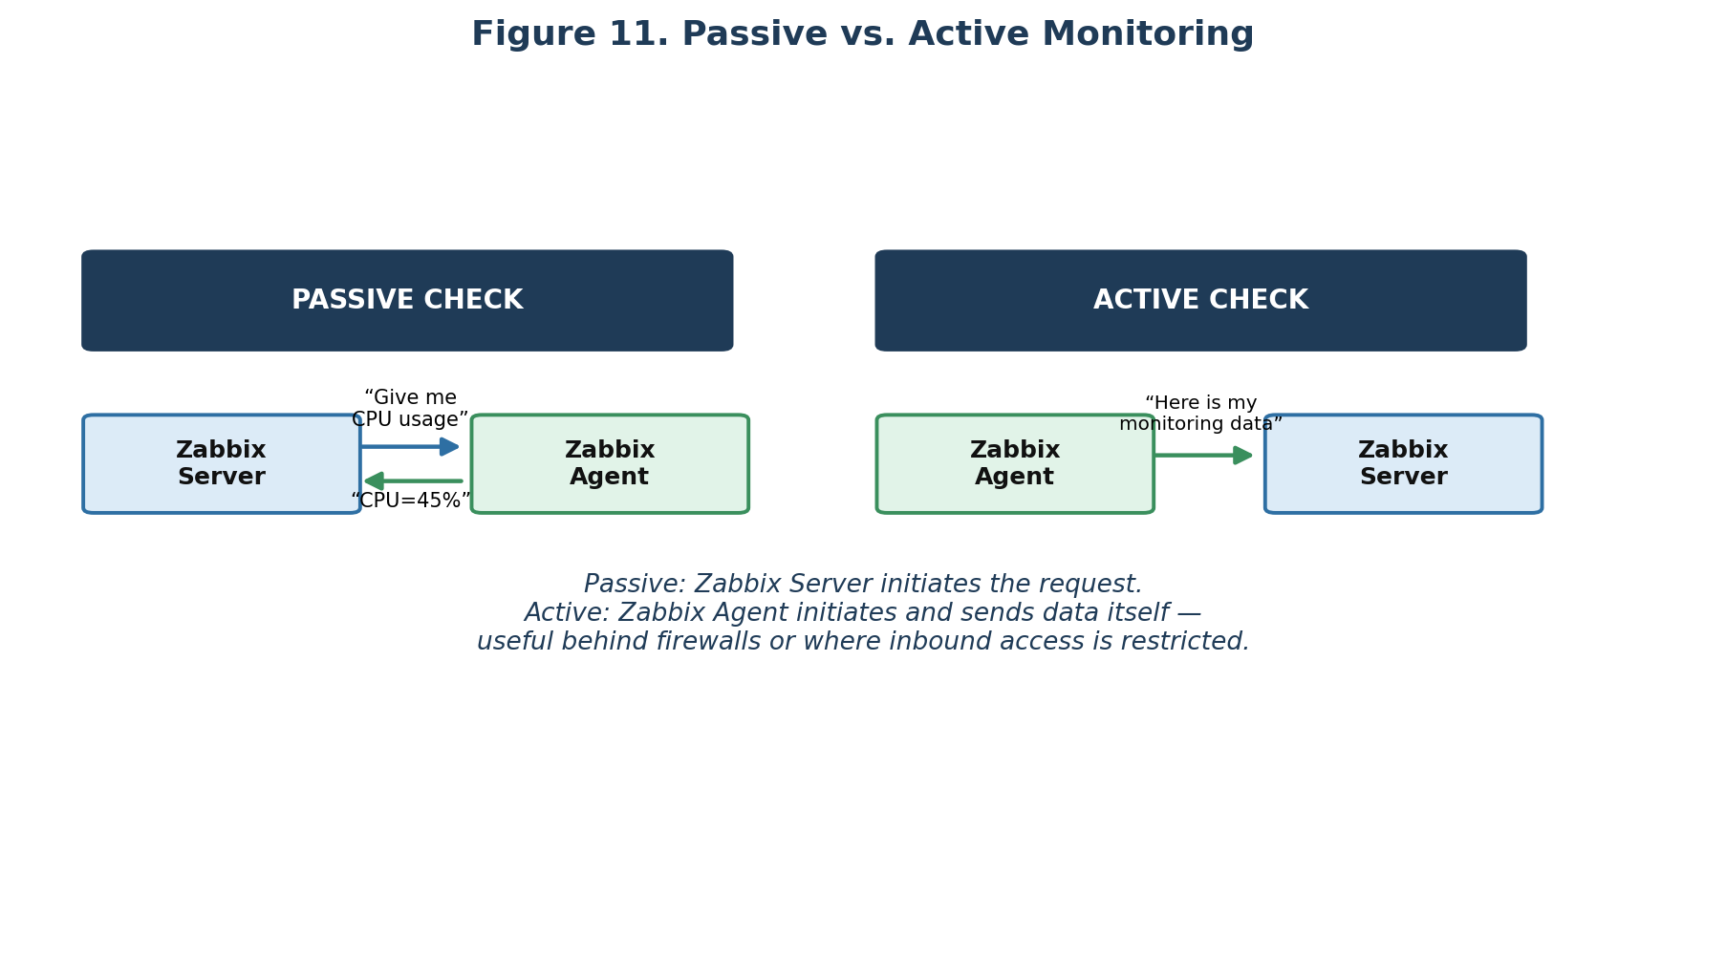
Figure 11. Passive monitoring (server asks) vs. active monitoring (agent reports).

11. Zabbix Proxy
A Zabbix Proxy is an intermediary component that collects monitoring information locally and forwards it to the central Zabbix Server, rather than having the central server monitor every remote device directly.
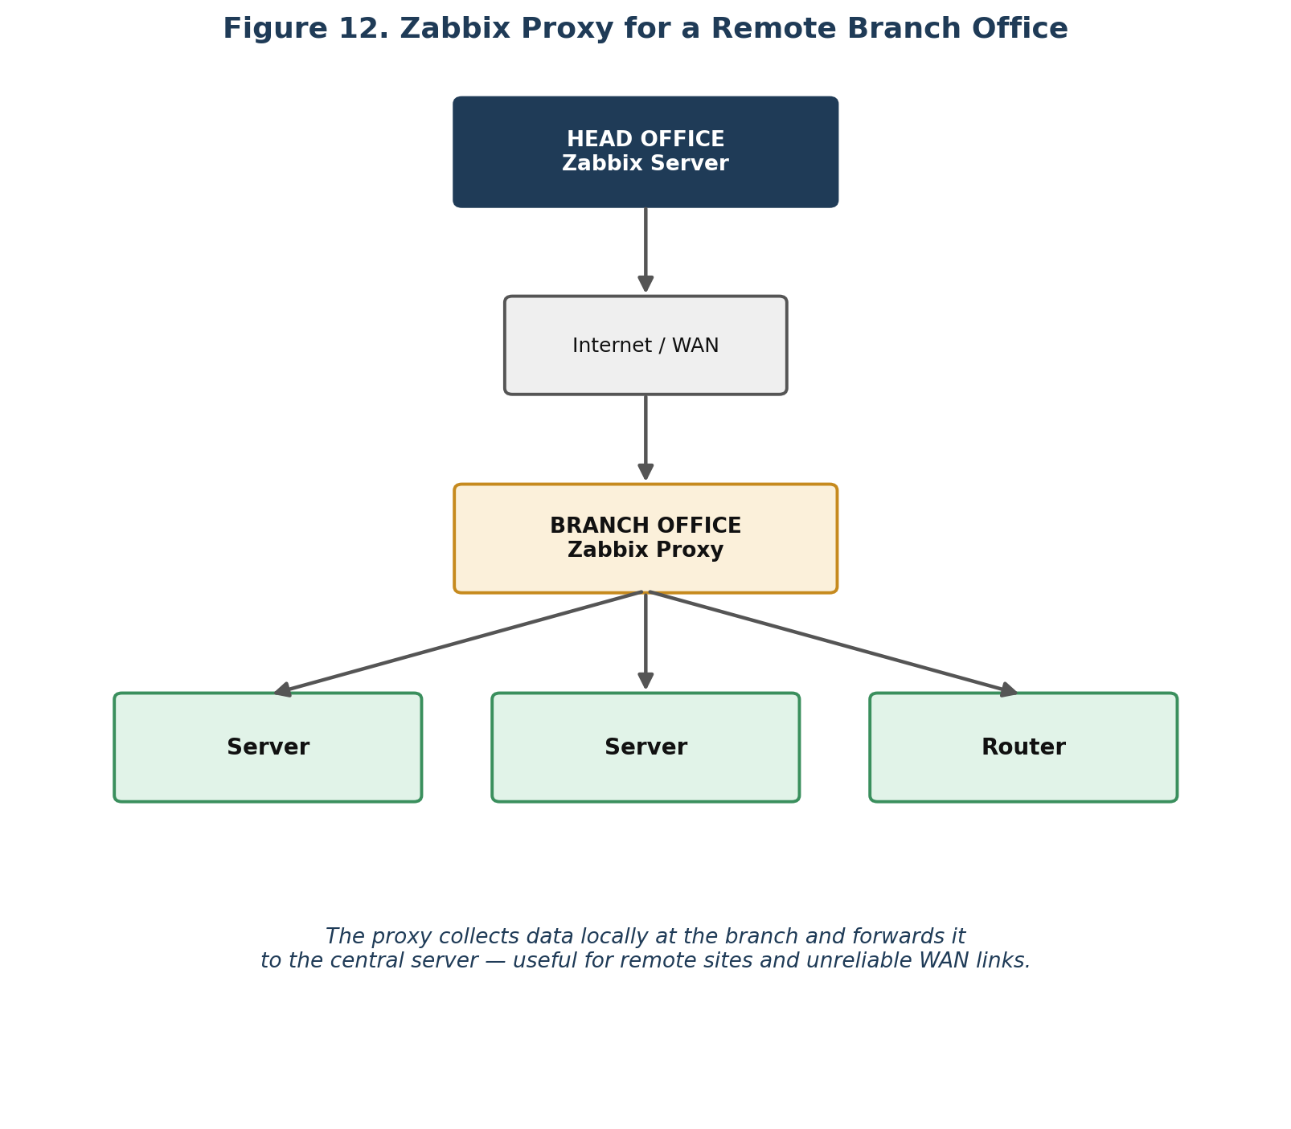
Figure 12. A Zabbix Proxy at a branch office collects data locally and forwards it to the head-office Zabbix Server.
Proxies are especially useful for:
- Remote offices
- Geographically distributed infrastructure
- Large environments
- Unreliable WAN connections
- Reducing direct monitoring traffic to the central server

12. Why Not Just Check Manually?
Manual checking might be feasible for a single server, but becomes impossible at scale — 10, 100, 1,000, or 10,000 servers cannot realistically have their CPU, RAM, disk, network, applications, databases, and websites checked manually every few minutes. Zabbix provides the necessary automation.

13. Zabbix Is More Than an Alert System
Zabbix combines several functions together, rather than being a simple alerting tool:
- Monitoring
- Data collection
- Historical data
- Visualization
- Problem detection
- Alerting
- Automation
- Infrastructure discovery
This combination supports both real-time monitoring and longer-term historical analysis.

14. What Does a Zabbix Dashboard Show?
A dashboard gives an at-a-glance overview of infrastructure health. A simplified example:
Category | Status Summary
Problems | 3 active
Servers | 47 UP / 1 DOWN
CPU | 42 Normal / 5 High / 1 Critical
Disk | 40 Normal / 7 Warning / 1 Critical
Network | 25 Healthy / 2 Problems

An administrator can immediately understand overall infrastructure status from a view like this.

15. Why Historical Data Matters
Suppose a website became slow at 2 PM but returned to normal by 3 PM. Without historical monitoring data, there may be no evidence of what happened. With Zabbix's stored history, an administrator could see that CPU usage suddenly spiked at 2 PM and investigate the cause from that specific point in time.

16. Zabbix in a Real Company Environment
A simplified production environment might include a load balancer, web servers, application servers, and a database, sitting behind the public internet. Zabbix can monitor every layer: load balancer, web servers, application servers, database, network, and storage.

16.1 Example — Website Failure
Suppose WEB-SERVER-01, WEB-SERVER-02, and the database are all working normally, and then WEB-SERVER-01 suddenly goes down. The sequence is:
- Server stops responding
- Zabbix detects the failure
- A problem is generated
- A configured action executes
- The IT administrator is notified
- The administrator investigates
Note: Zabbix does not necessarily fix the problem itself. Its primary role is to monitor, detect, record, visualize, and alert. It can also perform configured actions and automation, but monitoring and alerting remain its core purposes.

16.2 Example — E-Commerce Infrastructure
Consider an e-commerce platform: Customers → Website → Application → Database. Zabbix would typically monitor:
Layer | What Zabbix Checks
Website | Is it reachable? What is the response time?
Application | Is the service running? CPU and memory usage?
Database | Is it available? Connection count? Storage usage?
Servers | CPU, RAM, disk usage
Network | Router and switch status, traffic levels
If database storage reaches 90%, the item value triggers the storage > 90% condition, producing a problem and an action, which alerts the administrator. The administrator increases storage, usage returns to normal, and the problem recovers — a typical operational scenario Zabbix is designed to help with.

17. How Zabbix Differs From Other Tools
Tool | Primary Focus
Antivirus | Looks for malware, viruses, and suspicious software — an entirely different concern from infrastructure health.
Backup software | Saves copies of data (“Save a copy of my data”), whereas Zabbix monitors whether infrastructure is healthy (“Monitor whether my infrastructure is healthy”). Organizations typically use both together.
Logging | Records what happened inside a system (e.g. “Database connection failed”) as discrete events, whereas monitoring measures system state and performance (e.g. CPU = 90%) continuously. The two are commonly used together.

18. Why Do Companies Use Zabbix?

Without Zabbix
Infrastructure → Problems happen → Users complain → IT team discovers the problem → Investigation → Fix.

With Zabbix
Infrastructure → Zabbix continuously monitors → Abnormal condition detected → Alert → IT team investigates → Fix.
The core benefit Zabbix provides is visibility and early detection — catching problems before users are significantly affected, rather than after.

19. The Entire Zabbix Concept in One Diagram
If only one diagram is remembered, this is the one to keep in mind — it ties together data sources, the Zabbix Server, the Item → Trigger → Event → Action → Notification chain, and the historical data path through the database into dashboards.
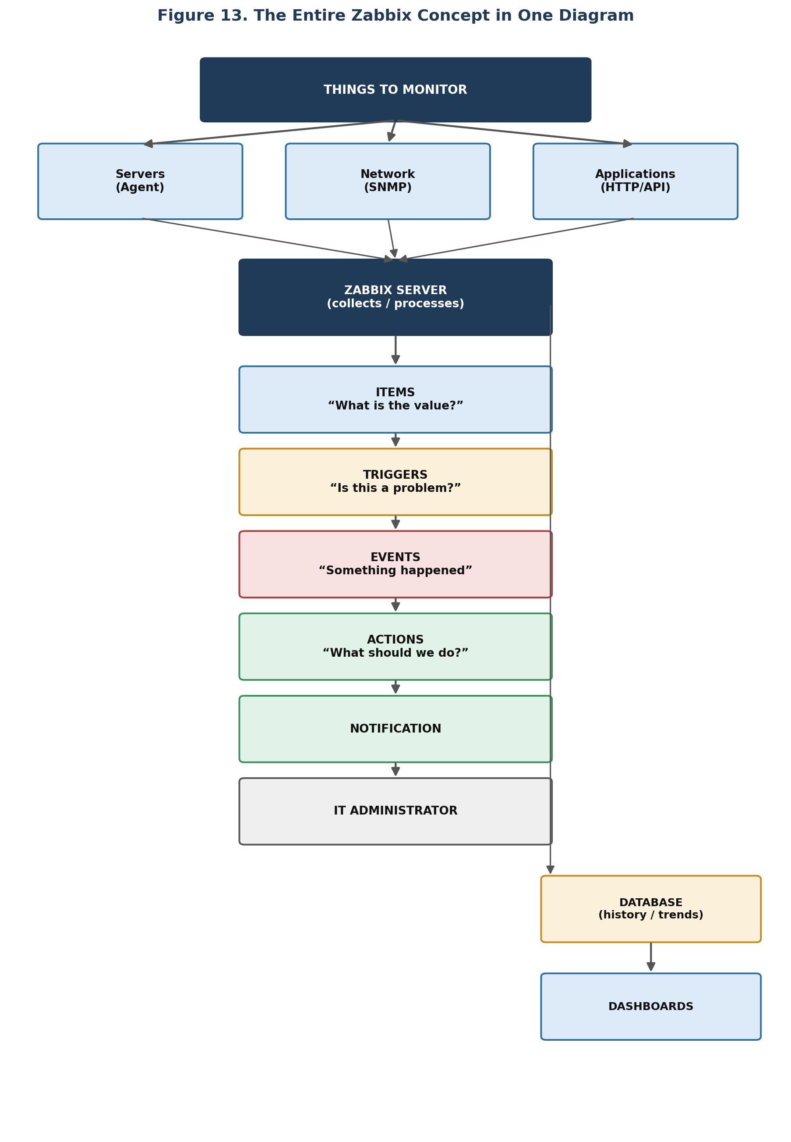
Figure 13. The complete Zabbix concept, from monitored systems through to notification and historical dashboards.

20. Key Terminology Reference
The following terms are the essential vocabulary for working with Zabbix, whether for hands-on configuration or for an interview.
Term | Meaning
Zabbix Server | Central monitoring component
Frontend | Web interface
Database | Stores monitoring and configuration data
Agent | Software that monitors a machine
Agent 2 | Newer / extensible agent implementation
Proxy | Collects monitoring data remotely and forwards it
Host | System or device being monitored
Host Group | Group of hosts
Item | Specific metric being collected
Trigger | Condition that identifies a problem
Problem | Detected abnormal condition
Event | Occurrence processed by Zabbix
Action | Response to an event
Template | Reusable monitoring configuration
Macro | Variable used in configuration
LLD | Low-level discovery
SNMP | Common protocol for monitoring network devices
Dashboard | Visual monitoring overview
History | Detailed historical monitoring values
Trends | Longer-term summarized historical data
Maintenance | Temporarily suppresses expected problems and alerts

21. Quick-Reference Summary

Q: What is Zabbix?
Zabbix is an open-source enterprise monitoring and alerting platform used to monitor the availability, performance, and health of IT infrastructure such as servers, network devices, virtual machines, applications, databases, websites, and cloud resources. It collects monitoring data, stores historical information, evaluates conditions using triggers, and generates alerts when problems are detected.

Q: Why is Zabbix used?
It is used to continuously monitor infrastructure, detect failures and performance problems early, maintain historical monitoring data, visualize system health through dashboards and graphs, and notify administrators when defined problems occur.

Q: How does it work?
Monitor → Collect data → Store data → Evaluate conditions → Detect problem → Generate event → Send alert → Recover when the condition returns to normal.

21.1 Suggested Learning Path
Once these foundational concepts are clear, the next layer of learning typically follows this order:
- Items and Item Keys
- Triggers
- Events
- Actions
- Templates
- Agents
- SNMP
- Proxies
These are the concepts most directly used when actually configuring and operating a Zabbix deployment.

