ZABBIX
Practical Monitoring Lab Guide
Server · CPU & Temperature · Storage · UPS · Website
What it is — Why you run each command — How it becomes Zabbix monitoring
Prepared: September 2026

Table of Contents

1. What Is Zabbix?
Zabbix is an open-source enterprise monitoring platform used to continuously monitor IT infrastructure such as servers, applications, databases, networks, services, and websites. It collects measurements, stores historical data, displays that data through dashboards and graphs, detects abnormal conditions, and can send alerts when problems occur.
For this practical, the whole idea reduces to one repeating loop:
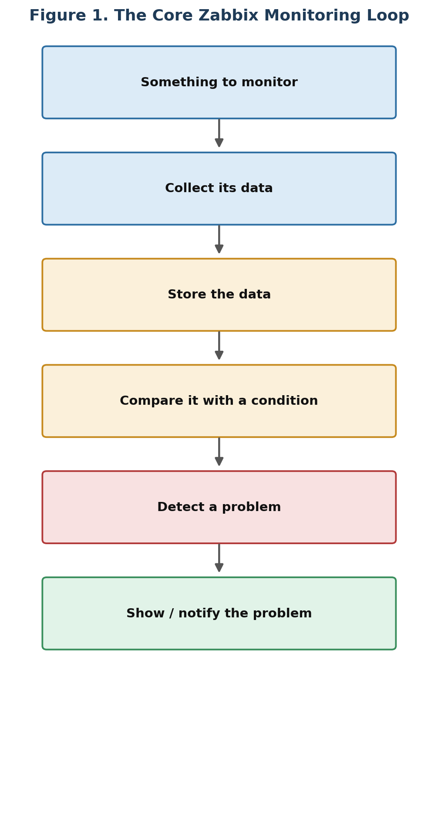
Figure 1. The core Zabbix monitoring loop.
Applied to a concrete example — CPU monitoring — the same loop looks like this:
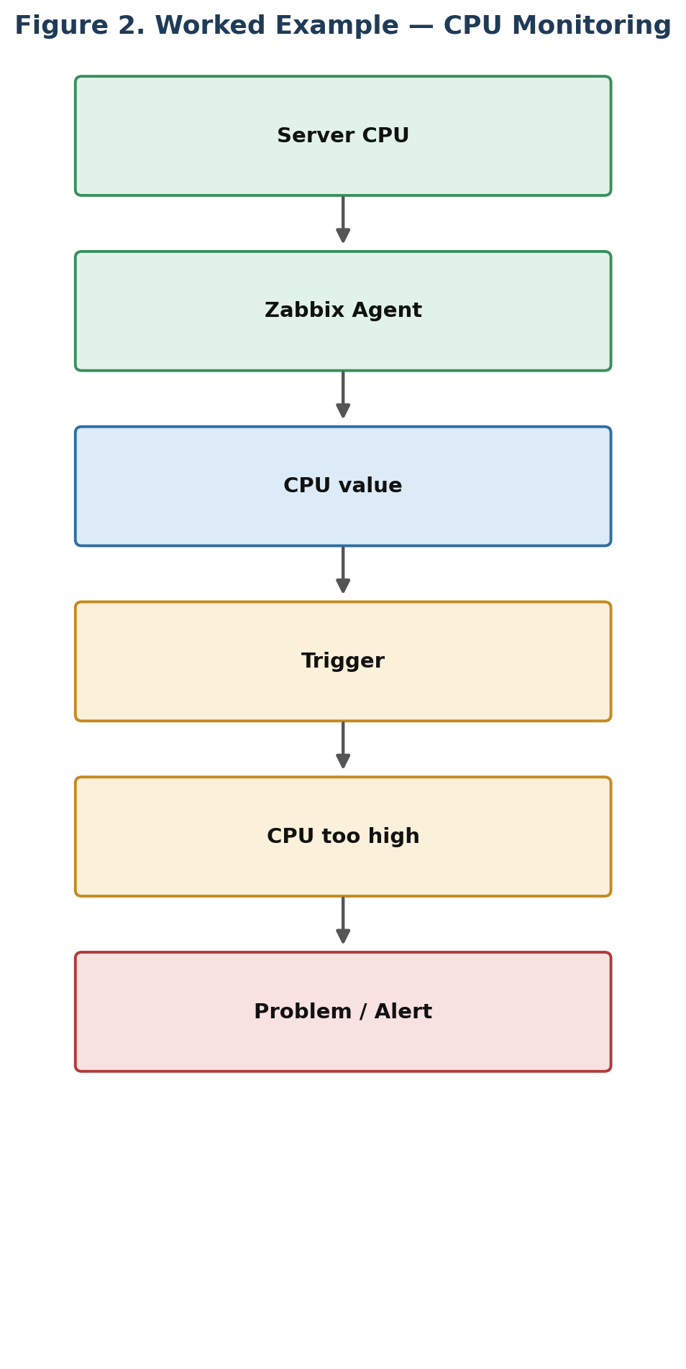
Figure 2. The monitoring loop applied to CPU usage.

2. What You Are Actually Doing in the Practical
You will be given a console or machine and asked to monitor several things. The assignment breaks down into five monitoring jobs, each using a slightly different method.
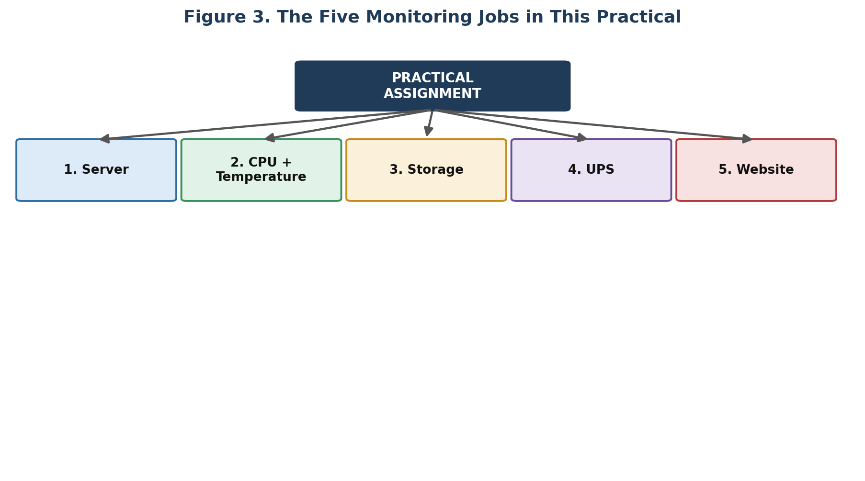
Figure 3. The five monitoring jobs covered in this practical.
Requirement | How Zabbix Monitors It
Server availability | Zabbix Agent / checks
CPU utilization | Zabbix Agent
CPU temperature | Agent / sensor information, where hardware exposes it
RAM | Zabbix Agent
Storage | Zabbix Agent + filesystem discovery
Network | Zabbix Agent
Services | Zabbix Agent
UPS | SNMP
Website | Web monitoring
Alerts | Triggers + Actions
Visualization | Latest data, Problems, Graphs, Dashboard
Zabbix's own Linux monitoring guide uses the Zabbix Agent for basic Linux monitoring, while SNMP is intended for devices such as UPS units where installing an operating-system agent is not practical.

3. The Most Important Zabbix Terms
Before touching the console, understand these six terms.

3.1 Host
A host is the machine or device being monitored — for example a Linux server, Windows server, UPS, router, or website/application host.

3.2 Item
An item is a particular piece of information Zabbix collects, such as CPU utilization, memory available, disk usage, CPU temperature, UPS battery, or website response time. Every item has a name, a type, and a key — the key identifies the exact metric being collected.

3.3 Trigger
A trigger decides whether a condition should be treated as a problem, e.g. CPU > 90%.
CPU Value | Trigger Result
40% | OK
95% | Trigger becomes true → PROBLEM

3.4 Event / Problem
A trigger changing state generates an event. An active event representing an issue appears as a problem in the monitoring interface — for example, disk usage exceeding a threshold produces a problem.

3.5 Action
An action tells Zabbix what to do when a problem occurs — send an email, send a webhook, notify a team, or execute approved automation.

3.6 Template
A template is a reusable package of monitoring configuration. Instead of manually creating CPU, RAM, disk, and network items for every Linux server individually, a template is created once and attached to as many hosts as needed. Zabbix ships templates for common systems and technologies.

4. The Complete Zabbix Workflow
This sequence is the central idea behind the entire practical — memorize it:
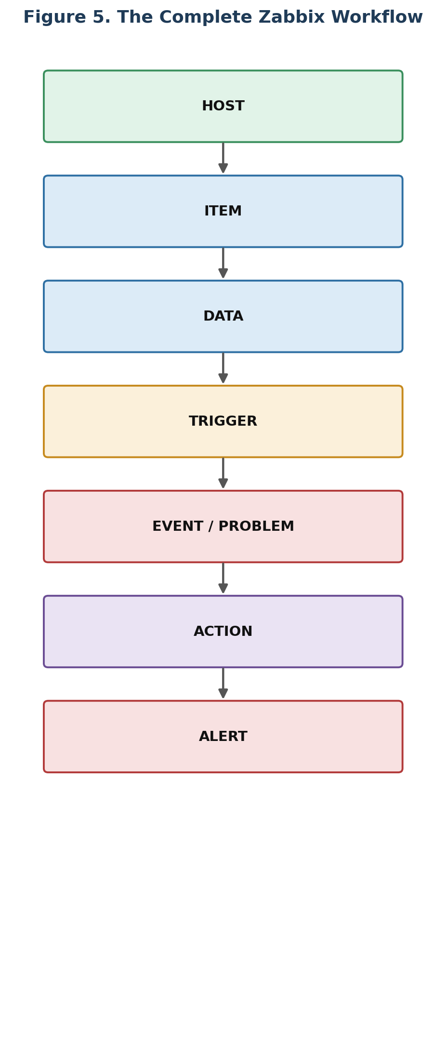
Figure 4. The complete Zabbix workflow, from host to alert.
Applied to CPU monitoring specifically:
- Linux Server → CPU utilization item → CPU = 94%
- Trigger: CPU > 90% → Problem → Action → Notification

5. What Is the Console For?
The console is primarily where you discover the machine, test connectivity, check installed software and services, check sensors, test UPS SNMP, test the website, and troubleshoot failures.
Caution: The console is not the same thing as permanent Zabbix monitoring. It tells you whether something can be seen or tested once — Zabbix is what watches it continuously over time and raises alerts.
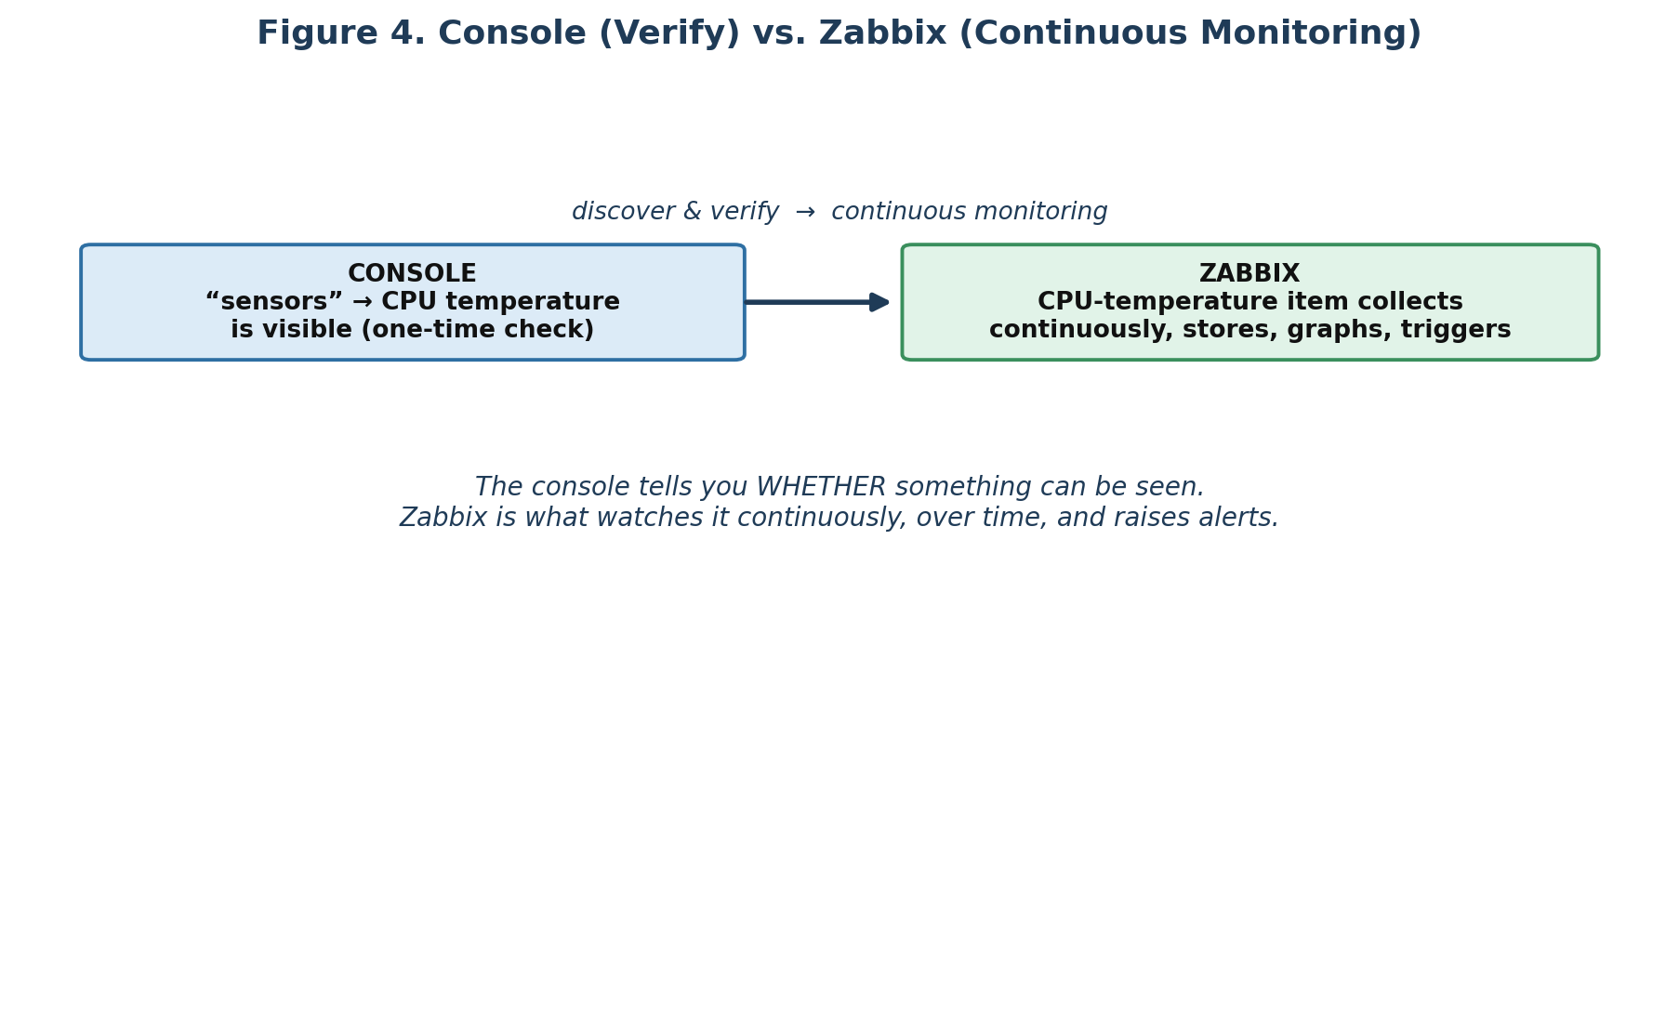
Figure 5. The console verifies; Zabbix continuously monitors.

6. First Steps When You Receive the Console
Do not immediately modify configuration. First identify the machine.

hostname
hostname
Function: Shows the machine's hostname.

hostnamectl
hostnamectl
Function: Shows hostname, operating system, kernel, and hardware information.

cat /etc/os-release
cat /etc/os-release
Function: Shows the Linux distribution and version.

ip -br addr
ip -br addr
Function: Shows network interfaces and IP addresses in a compact format.

ip route
ip route
Function: Shows routing information, usually including the default gateway.

7. What Information Should the Client / Instructor Provide?
Ask for information that cannot reliably be discovered locally. Many local facts — hostname, IP, OS, disks, sensors — you can discover yourself; the items below generally cannot.

7.1 Zabbix
- Zabbix Server IP / hostname
- Zabbix Server version
- Zabbix frontend URL
- Whether a Zabbix Proxy is being used

7.2 UPS
- UPS manufacturer and model
- UPS IP address
- SNMP version
- SNMP credentials
- Required UPS parameters

7.3 Website
- Website URL
- HTTP or HTTPS
- Expected status code
- Required page/content check
- Whether login is required

7.4 Monitoring Requirements
- Which CPU metrics?
- Which temperature?
- Which storage partitions?
- Which UPS values?
- Which website conditions?
- What alert thresholds are required?

8. How to Check Whether Zabbix Agent Is Installed
There are two common agent versions in use.

8.1 Zabbix Agent 2

zabbix_agent2 -V
zabbix_agent2 -V
Function: Shows the Agent 2 version if it is installed.

systemctl status zabbix-agent2
systemctl status zabbix-agent2
Function: Checks whether Agent 2 is installed as a service and whether it is running.
Note: A result of “Active: active (running)” means the service is currently running.

8.2 Traditional Zabbix Agent
zabbix_agentd -V
systemctl status zabbix-agent
Function: Checks the older / traditional Zabbix Agent.
Zabbix supports agent monitoring on Linux and other supported platforms, with both active and passive checking modes (see Section 11).

9. Check Installed Zabbix Packages

Ubuntu / Debian
dpkg -l | grep zabbix

RHEL / Rocky / Alma / CentOS
rpm -qa | grep zabbix
Function: Shows installed Zabbix packages.

10. Check Zabbix Agent Configuration

Agent 2
grep -E '^(Server|ServerActive|Hostname)=' /etc/zabbix/zabbix_agent2.conf
Function: Shows three critical settings: Server, ServerActive, and Hostname.
Note: For active checks, the configured Hostname needs to correspond to the host name configured in Zabbix so the agent retrieves the correct configuration.

11. Understand Passive and Active Agent Monitoring
This distinction matters throughout the rest of the practical.
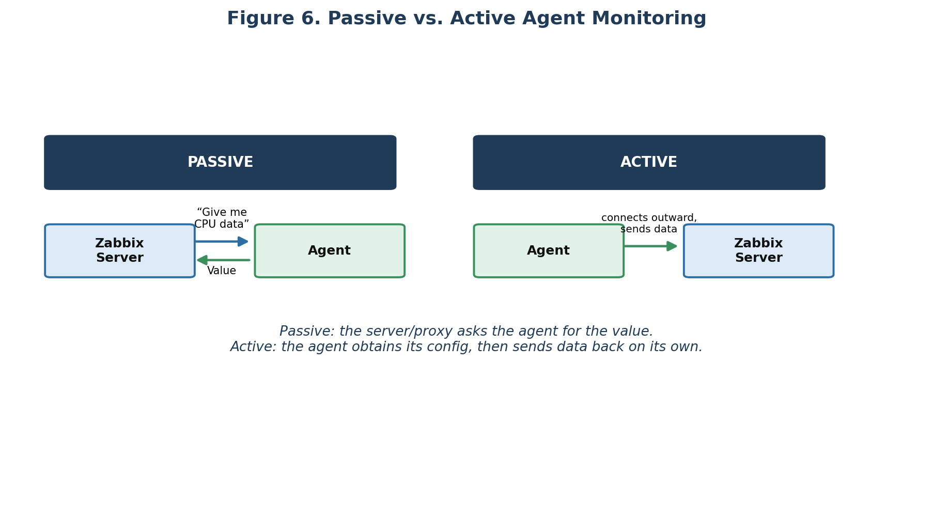
Figure 6. Passive monitoring (server asks) vs. active monitoring (agent reports).
Mode | Description
Passive | The server/proxy asks the agent for the value directly.
Active | The agent first obtains its configuration, then sends data back to the server on its own.
Zabbix supports both modes, and either can be used depending on the network design.

12. Check the Zabbix Agent Port
ss -lntp | grep 10050
Function: Checks whether the standard Zabbix Agent TCP port is listening.
Port | Component
10050/TCP | Zabbix Agent
10051/TCP | Zabbix Server / Proxy
Zabbix documents these default component ports in its requirements.

13. Test Communication From the Zabbix Server

agent.ping
zabbix_get -s <CLIENT_IP> -p 10050 -k agent.ping
Function: Asks the client's Zabbix Agent for a test value.
Note: Expected result: 1

system.hostname
zabbix_get -s <CLIENT_IP> -p 10050 -k system.hostname
Function: Tests communication and retrieves hostname information.
This is one of the best commands available for determining, in a single step, whether the network is working, the agent is running, and the agent is responding. Zabbix documents zabbix_get as a troubleshooting utility for querying agents.

14. Server Monitoring
Once the agent is confirmed working, create or add the host in Zabbix:
- Zabbix Frontend → Data collection → Hosts → Create host
Typical configuration fields:
- Host name
- Host group
- Agent interface
- Client IP / DNS
- Template
For a Linux server, link the appropriate Linux monitoring template. Zabbix's official Linux guide follows this exact model: install the agent, configure its communication, create the host, assign the Linux template, then view the collected metrics.

15. CPU Monitoring
There are two different CPU concepts you should not confuse.

15.1 CPU Utilization
Example: CPU = 75% — this tells you how busy the CPU is. The Zabbix Agent 2 CPU plugin supports keys such as system.cpu.util, system.cpu.num, and system.cpu.discovery for CPU information and utilization.

15.2 CPU Load
Load average is a different concept from CPU percentage. Check it from the console with:
uptime
Note: Example output: load average: 0.30, 0.25, 0.20 — representing load over different time periods.

16. Testing CPU Monitoring
The official Zabbix Linux guide gives a way to generate CPU load for testing:
cat /dev/urandom | md5sum
For a stronger load, multiple processes may be needed. When the Zabbix trigger detects the threshold, the problem appears under Monitoring → Problems.
In a lab, this demonstrates the full chain:
- Normal CPU → Generate load → CPU increases → Trigger fires → Problem appears
Caution: Only generate load on the lab machine when you are specifically permitted to do so.

17. CPU Temperature
CPU temperature is not the same as CPU utilization. First check whether the machine exposes temperature sensors.

sensors
sensors
Note: Possible output:
Package id 0: +48.0°C
Core 0: +45.0°C
Core 1: +46.0°C
If sensors does not exist, inspect the sysfs interfaces directly:
ls /sys/class/hwmon/
ls /sys/class/thermal/
You can also loop through the thermal zones directly:
for x in /sys/class/thermal/thermal_zone*/temp; do echo "$x: $(cat "$x")"; done

Why do this?
Because you first need to prove that the operating system can actually see the temperature. Only then can you determine how that value should be exposed to Zabbix.
Caution: The exact sensor method depends on the hardware and operating system. CPU temperature is not guaranteed to be available simply because the Zabbix Agent is installed.

18. CPU Temperature Monitoring Flow
Physical CPU
↓ Hardware sensor
↓ Linux sensor interface
↓ Agent / appropriate item
↓ Zabbix
↓ Temperature value
↓ Trigger

Example requirement:
Note: IF CPU temperature > defined safe threshold THEN Problem. Use the threshold given by the client/hardware requirements rather than inventing a universal value.

19. RAM Monitoring
free -h
Function: Shows memory usage.
Important values include Total, Used, Available, and Swap. Zabbix can then continuously monitor memory through agent/template items.

20. Storage Monitoring

df -h
df -h
Function: Shows filesystem capacity and usage.
Note: Example:
Filesystem Size Used Avail Use%
/dev/sda2 100G 75G 25G 75%

df -i
df -i
Function: Shows inode usage — a filesystem can have free storage but still run out of inodes.

lsblk
lsblk
Function: Shows disks and partitions.

lsblk -f
lsblk -f
Function: Shows filesystem type, UUID, and mount information.

21. Filesystem Discovery in Zabbix
Instead of manually creating an item for /, /home, /var, /data, and so on, Zabbix can use low-level discovery (LLD) to discover filesystems automatically:
- Filesystem discovery → Find mounted filesystems → Create monitoring items → Create triggers
This is particularly useful when servers have different or changing filesystem layouts. Zabbix's LLD supports automatic discovery of filesystems and other dynamic resources.

22. Storage Alert Example
Note: Disk utilization exceeds required threshold → Trigger → Problem.
For example, the client may specify 80% as Warning and 90% as Critical. Use the actual thresholds provided for your assignment rather than a generic default.

23. Disk Health
For physical disks, first check whether SMART tools are available:
which smartctl
Then find candidate disks and check health:
sudo smartctl --scan
Function: Finds disks that may support SMART.
sudo smartctl -H /dev/sda
Function: Requests the drive health result.
sudo smartctl -a /dev/sda
Function: Displays detailed SMART information.
Note: Use lsblk first to determine the actual device name before running smartctl.

24. Network Monitoring
ip -br addr
Function: Shows interface addresses.
ip -s link
Function: Shows packets, errors, and dropped packets.
ping -c 4 <IP>
Function: Basic reachability test.
ss -lntup
Function: Shows listening ports and network processes.
Zabbix can also automatically discover network interfaces through low-level discovery.

25. Service Monitoring
systemctl --type=service --state=running
Function: Lists running services.
Then inspect a specific service:
systemctl status nginx
systemctl status apache2
systemctl status mysql
systemctl status postgresql
Function: Determines whether a critical service is running.
This supports monitoring logic such as:
Condition | Result
nginx running? | YES → OK
nginx stopped | PROBLEM

26. UPS Monitoring
UPS monitoring is different from server monitoring — Zabbix reaches the UPS over SNMP rather than through an OS agent:
Note: Zabbix → SNMP → UPS
The UPS must expose SNMP, usually through a management interface/card or an equivalent SNMP-capable device. Zabbix specifically documents SNMP monitoring for UPS devices and other network-capable appliances.

27. Information You Need for the UPS
Ask for:
- UPS manufacturer and model
- UPS IP address
- SNMP version
- SNMP credentials
- MIB files, if available
- Required monitoring values
Depending on the model and its SNMP implementation, possible values include:
- UPS status
- Battery percentage
- Battery voltage
- Input voltage
- Output voltage
- UPS load
- Remaining runtime
- Battery condition

28. Test UPS Connectivity
ping -c 4 <UPS_IP>
Function: Tests basic IP connectivity.
Then test SNMP directly. For SNMPv2c:
snmpwalk -v2c -c <COMMUNITY> <UPS_IP> .
Function: Walks the available SNMP tree and shows OIDs/values.
Zabbix's SNMP documentation explicitly recommends snmpwalk for discovering the SNMP strings/OIDs you need to monitor.

29. Search SNMP Results
After running the walk, search for useful terms:
snmpwalk -v2c -c <COMMUNITY> <UPS_IP> . | grep -i battery
snmpwalk -v2c -c <COMMUNITY> <UPS_IP> . | grep -i voltage
snmpwalk -v2c -c <COMMUNITY> <UPS_IP> . | grep -i load
snmpwalk -v2c -c <COMMUNITY> <UPS_IP> . | grep -i runtime
snmpwalk -v2c -c <COMMUNITY> <UPS_IP> . | grep -i status
Function: Searches the SNMP output for relevant UPS information.

30. Get One UPS Value
Once an OID is known:
snmpget -v2c -c <COMMUNITY> <UPS_IP> <OID>
Function: Retrieves one particular SNMP value.
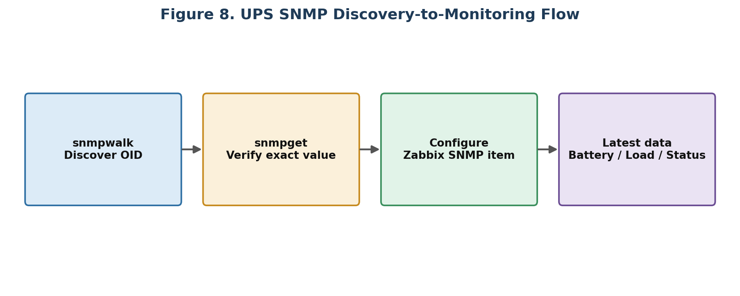
Figure 7. From SNMP discovery to a working Zabbix item.

31. UPS Monitoring Inside Zabbix
Once SNMP is confirmed working:
- Zabbix Frontend → Create UPS host → SNMP interface → IP address
- SNMP version/credentials → Template/items → Latest data
Then inspect Battery, Load, Voltage, Status, and Runtime. Zabbix may already have a suitable template for your UPS model/vendor; otherwise, SNMP items can be created directly using the discovered OIDs.

32. UPS Alerts
Possible conditions include:
- UPS unavailable
- UPS running on battery
- Battery low
- Battery runtime low
- UPS load high
- Input/output abnormal
Note: Example: Battery = 15% → Trigger → Problem. The actual thresholds should come from the assignment or UPS requirements.

33. Website Monitoring
Website monitoring does not require installing an agent on the website just to perform a basic web check.
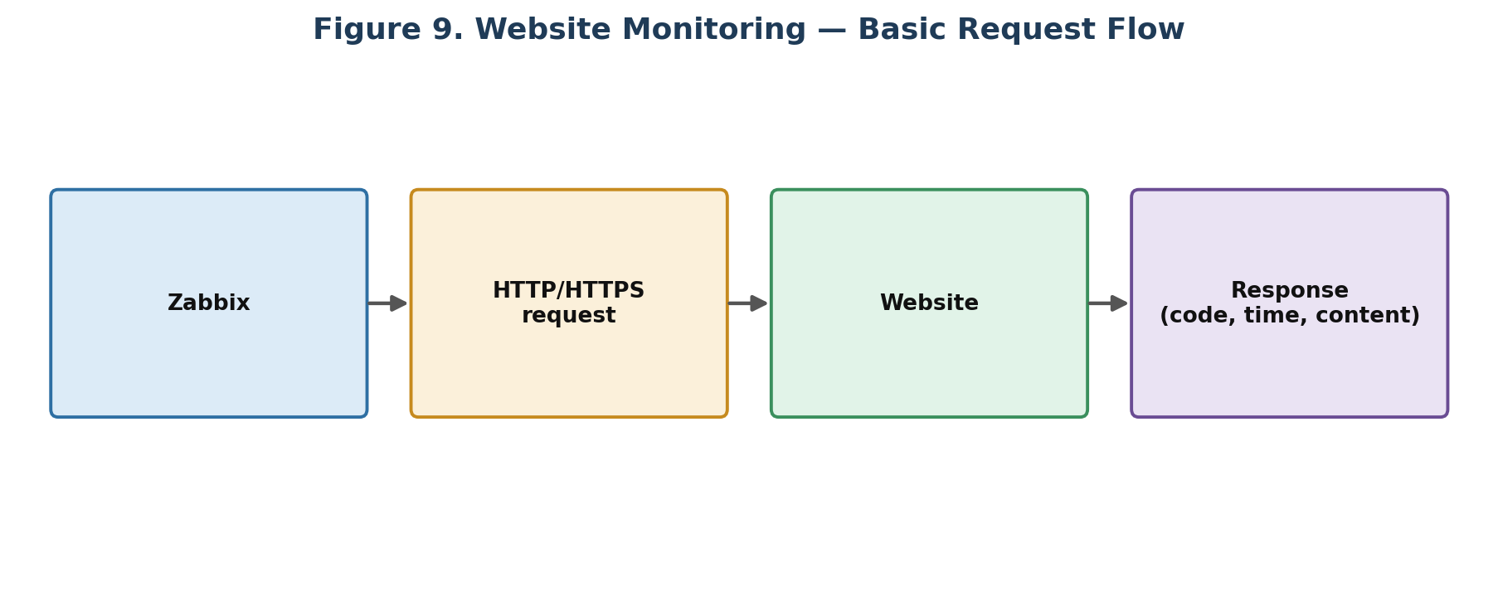
Figure 8. Basic website monitoring request flow.
Zabbix web monitoring uses web scenarios consisting of one or more HTTP steps. It can verify the HTTP status code, response time, and expected content.

34. First Test the Website From the Console

DNS resolution
getent hosts <WEBSITE>
Function: Checks whether the domain resolves.

HTTP headers
curl -I https://<WEBSITE>
Function: Shows HTTP response headers/status.
Note: Example: HTTP/2 200

Response time
curl -o /dev/null -s -w '%{http_code} %{time_total}\n' https://<WEBSITE>
Function: Shows the HTTP status code and total response time.
Note: Example output: 200 0.245

35. Website Content Testing
Suppose the page should contain the text “Company Portal”. Test it directly:
curl -fsSL https://<WEBSITE> | grep -i "Company Portal"
Function: Downloads the page and searches for the required text.
This matters because an HTTP 200 response does not always mean the application is healthy — the server could return a valid page while the application itself is malfunctioning. Zabbix web monitoring supports a Required string condition so the retrieved content must match the configured pattern.

36. Website Monitoring in Zabbix
Create a web scenario:
Note: Web scenario: Website Availability
Then define a step:
Field | Value
Step name | Homepage
URL | https://<WEBSITE>
Required status codes | 200
Required string (optional) | Company Portal

Redirects, retrieval mode, and timeout can also be configured for the scenario.

37. Website Monitoring Results
Once configured, you can monitor:
- Availability
- Response time
- HTTP status
- Downloaded content
- Required content
Zabbix makes recent web-scenario results available under Monitoring → Latest data, and provides a dedicated web-monitoring dashboard widget.

38. HTTPS Certificate Checking
openssl s_client -connect <WEBSITE>:443 -servername <WEBSITE>
Function: Tests the TLS connection and shows certificate information.
To display certificate validity dates specifically:
echo | openssl s_client -connect <WEBSITE>:443 -servername <WEBSITE> 2>/dev/null | openssl x509 -noout -dates
Function: Shows certificate validity dates — useful for investigating HTTPS problems.

39. Website Failure Scenarios
Three scenarios are worth understanding clearly:
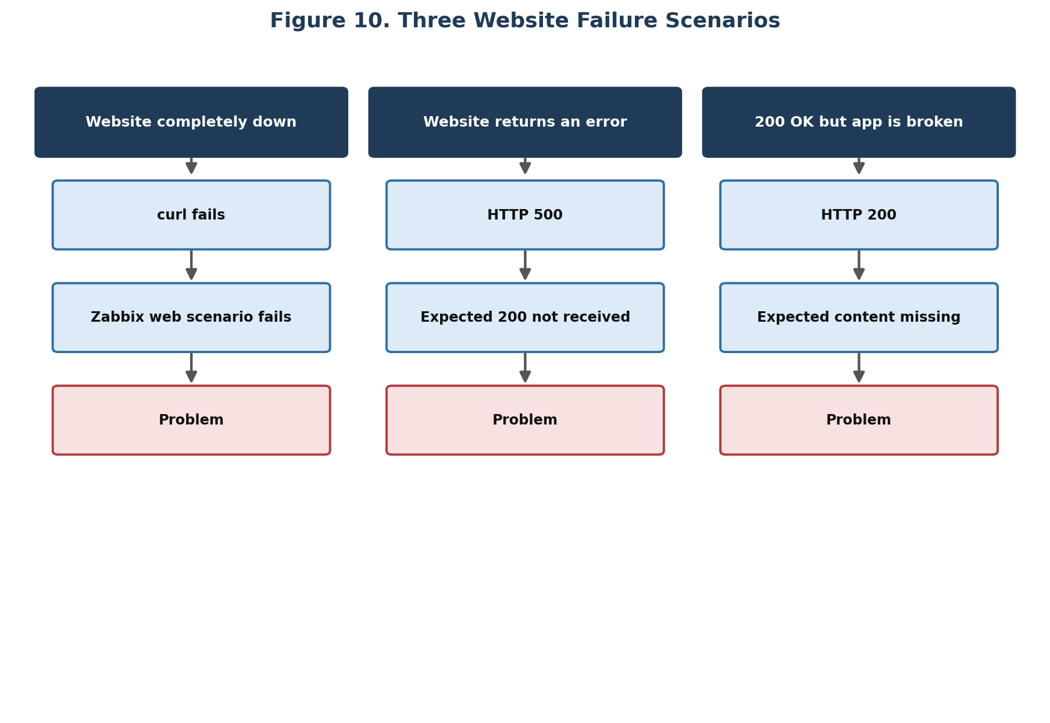
Figure 9. Three distinct ways a website check can fail.
The third scenario — HTTP 200 with missing expected content — is exactly why content checking is useful: a healthy-looking response code does not guarantee a healthy application.

40. Zabbix Item Testing
In the Zabbix frontend, items can be tested using the Test facility when supported. The item test form can use the host's configured interface and, for SNMP items, the relevant SNMP parameters — giving another troubleshooting layer:
- Console test → Zabbix item test → Latest data → Trigger

41. Problems and Alerts
Suppose a trigger CPU > required threshold is created. The workflow becomes:
- CPU value → Item → Trigger evaluates → Condition TRUE → Problem
- Problem → Action → Notification
The notification mechanism can be email, webhook, or another configured media type. Zabbix also supports APIs for managing configuration, actions, alerts, web scenarios, and other components.

42. How to Test the Whole Lab
Your practical may ask you to demonstrate that monitoring actually works end to end.

42.1 CPU
- Check current CPU → Generate temporary load if permitted → Watch Latest data
- Trigger becomes PROBLEM → Remove load → Problem resolves
Zabbix documents this kind of CPU-load simulation in its Linux monitoring guide.

42.2 Storage
Caution: Use the existing test environment only. Do not fill a production disk just to demonstrate an alert.
Instead, verify: current disk usage → item receives value → trigger threshold is configured. If the instructor provides a safe test filesystem, follow their specific procedure.

42.3 UPS
You may be asked to check UPS availability, battery value, load, and status.
Caution: If the lab has a controlled UPS test mode, use the instructor's procedure. Do not deliberately disconnect or power-cycle equipment without authorization.

42.4 Website
Verify: website accessible → HTTP code correct → response time available → required content found. If the lab provides a test website, they may give you a controlled way to make it fail.

43. Troubleshooting — Server / Agent
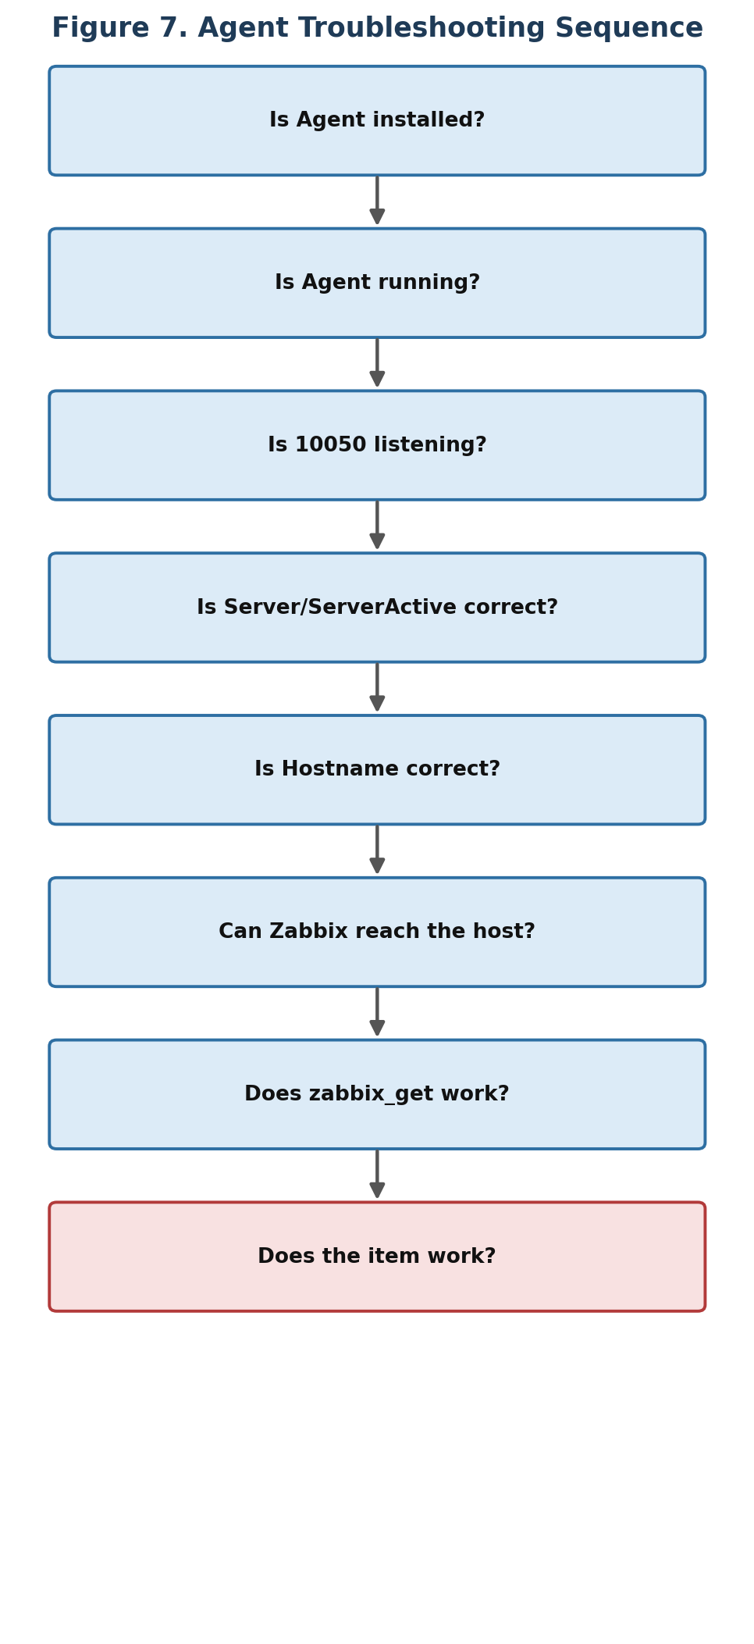
Figure 10. Agent troubleshooting sequence.
Useful commands for this sequence:
zabbix_agent2 -V
systemctl status zabbix-agent2
ss -lntp | grep 10050
zabbix_agent2 -t agent.ping
zabbix_get -s <CLIENT_IP> -k agent.ping

44. Troubleshooting — UPS
- Ping UPS → SNMP enabled? → SNMP credentials correct?
- snmpwalk works? → Correct OID? → Zabbix SNMP interface correct? → Item receiving data?
Most importantly, confirm SNMP works at all before building triggers:
snmpwalk -v2c -c <COMMUNITY> <UPS_IP> .
Note: If snmpwalk doesn't work, fix the UPS/network/SNMP issue before trying to build complicated Zabbix triggers. Zabbix itself recommends discovering SNMP OIDs/strings first.

45. Troubleshooting — Website
- DNS → Network → Port 80/443 → curl → HTTP status → Response time → Content → Zabbix web scenario
getent hosts <WEBSITE>
curl -I https://<WEBSITE>
curl -o /dev/null -s -w '%{http_code} %{time_total}\n' https://<WEBSITE>

46. Zabbix Logs

Agent 2 — recent logs
journalctl -u zabbix-agent2 -n 100
Function: Shows recent Agent 2 logs.

Agent 2 — live tail
journalctl -u zabbix-agent2 -f
Function: Shows new log messages as they arrive.

Server — recent logs
journalctl -u zabbix-server -n 100
Function: Shows recent Zabbix server logs when the server is managed as a systemd service.

47. Command Cheat Sheet

System
hostname
hostnamectl
cat /etc/os-release
ip -br addr
ip route

CPU
lscpu
nproc
top
uptime

Temperature
sensors
ls /sys/class/hwmon/
ls /sys/class/thermal/

Memory
free -h
cat /proc/meminfo

Storage
df -h
df -i
lsblk
lsblk -f
findmnt

Disk Health
which smartctl
sudo smartctl --scan
sudo smartctl -H /dev/sda
sudo smartctl -a /dev/sda

Network
ping -c 4 <IP>
ip -s link
ss -lntup
nc -zv <IP> <PORT>

Services
systemctl --type=service --state=running
systemctl status <service>
systemctl is-active <service>

Zabbix Agent
zabbix_agent2 -V
systemctl status zabbix-agent2
zabbix_agent2 -t agent.ping
ss -lntp | grep 10050
zabbix_get -s <CLIENT_IP> -k agent.ping

UPS
snmpwalk -v2c -c <COMMUNITY> <UPS_IP> .
snmpget -v2c -c <COMMUNITY> <UPS_IP> <OID>

Website
getent hosts <WEBSITE>
curl -I https://<WEBSITE>
curl -o /dev/null -s -w '%{http_code} %{time_total}\n' https://<WEBSITE>
openssl s_client -connect <WEBSITE>:443 -servername <WEBSITE>

Logs
journalctl -u zabbix-agent2 -n 100
journalctl -u zabbix-agent2 -f
journalctl -u zabbix-server -n 100

48. The Exact Practical Sequence
When you sit down at the console, use this mental checklist from start to finish.
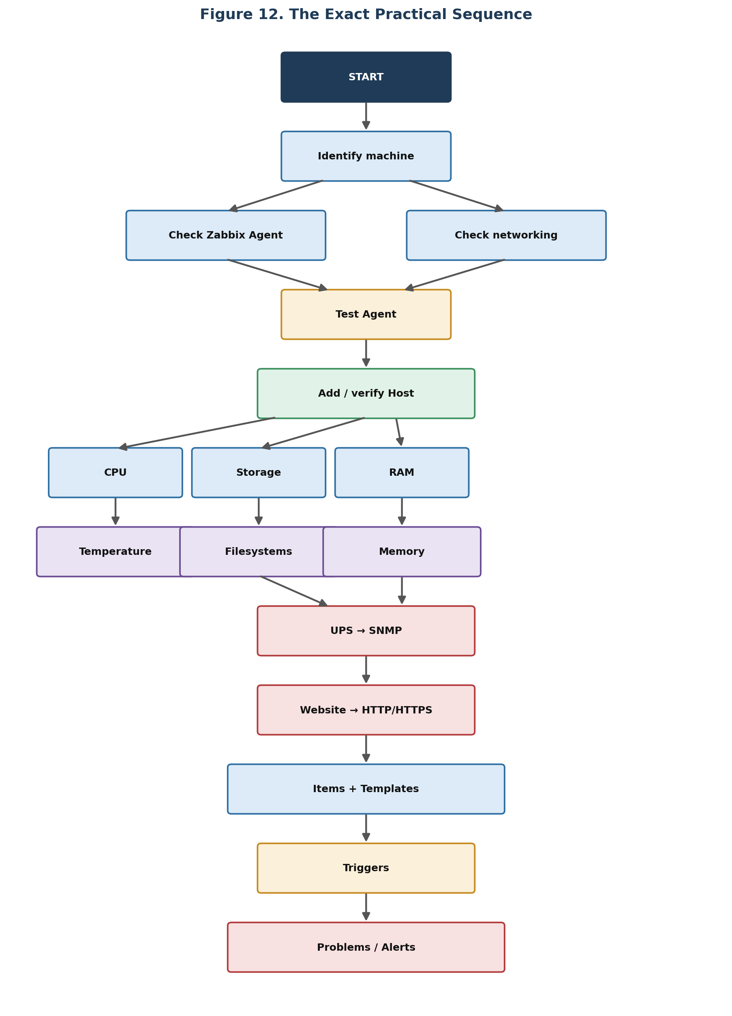
Figure 11. The complete practical sequence, from identifying the machine to raised alerts.

49. What “Successful Monitoring” Means
At the end, you should be able to open Zabbix and confirm the following checklist:
Area | Success Criteria
Server | Available
CPU | Utilization being collected; temperature being collected, if supported
RAM | Data being collected
Storage | Filesystems discovered; usage visible
UPS | SNMP reachable; battery visible; load/status/voltage available as required
Website | HTTP/HTTPS reachable; correct response code; response time visible; required content verified
Alerting | Trigger exists; problem appears when condition is true; problem resolves when condition clears

50. The Most Important Distinction for Your Practical
Keep these three layers separate in your head throughout the exercise:
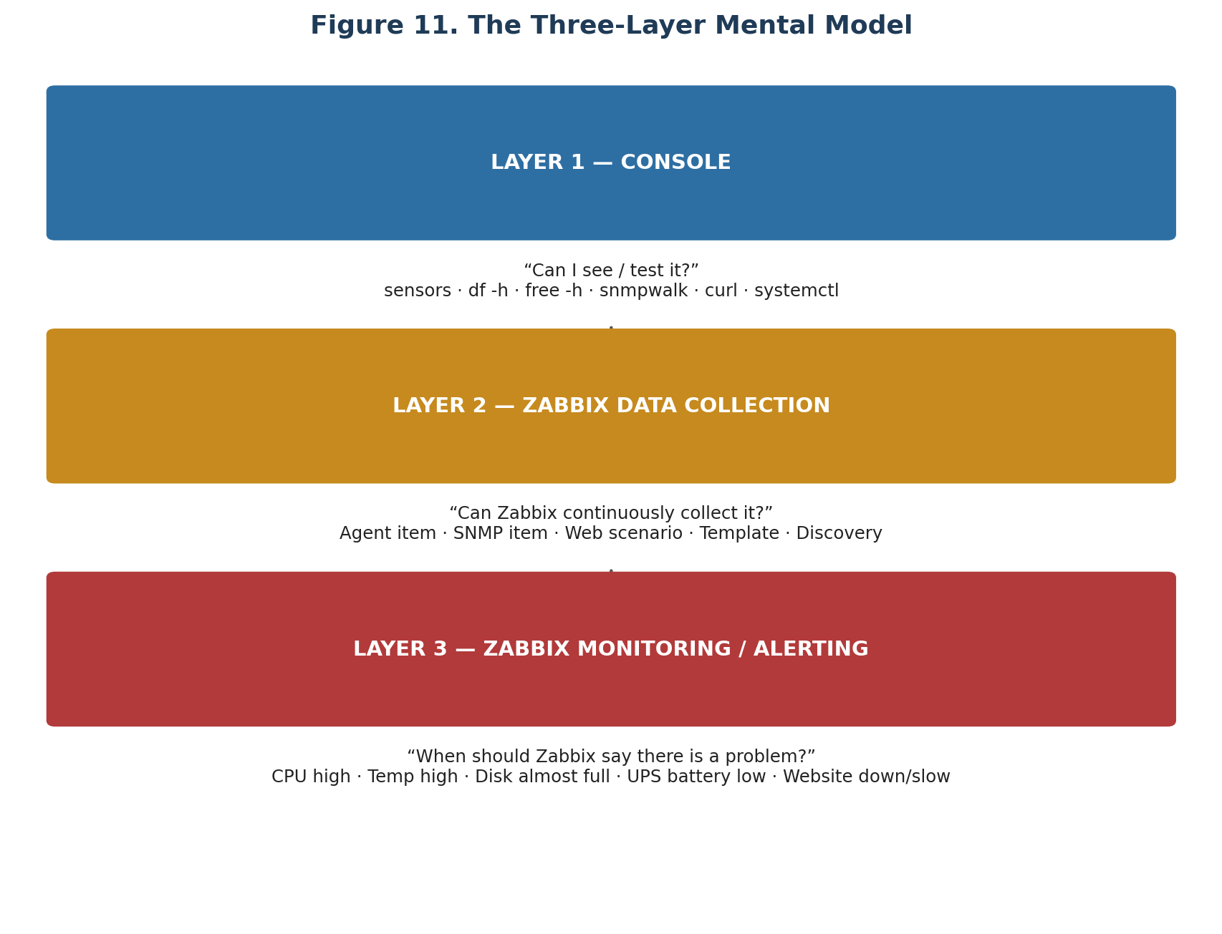
Figure 12. The three-layer mental model — console, data collection, and alerting.
In short:
- CONSOLE → VERIFY
- ZABBIX → COLLECT
- TRIGGER → DETECT
- ACTION → NOTIFY

51. Final Mental Model
For the assignment, remember these five sentences:
Area | Approach
Server | Use the Zabbix Agent to collect operating-system metrics.
CPU / Temperature | Use agent-supported CPU metrics and available hardware sensors to collect utilization and temperature.
Storage | Use agent/filesystem monitoring and discovery to monitor capacity and filesystem health.
UPS | Use SNMP to collect UPS information because the UPS is normally a network device rather than a normal operating-system host.
Website | Use a Zabbix web scenario to test HTTP/HTTPS availability, response codes, response time, and, when required, page content.

And the complete formula that ties everything together:
Note: DISCOVER → TEST → CONFIGURE ITEM → COLLECT DATA → TRIGGER → PROBLEM → ACTION → ALERT
This is the workflow you should be able to explain and perform when you are handed the console.

52. References
This guide draws on Zabbix's official documentation, including the Introduction, the Linux monitoring guide, item configuration reference, agent concepts, installation requirements, plugin reference, SNMP agent documentation, web monitoring reference, and API method reference (Zabbix documentation, versions current and 7.4).

