hotel_reservation.sql
NAME – VANSHIKA DIXIT, ROLL NO. - 2401010010
The Hotel Reservation System is a database project that manages guest details, room information, bookings, and payments. It stores and organizes data efficiently using tables and relationships. The system performs operations like booking rooms, checking availability, tracking reservations, and calculating charges, ensuring smooth and accurate hotel management operations.

CREATE DATABASE hotel_db;
USE hotel_db;

CREATE TABLE Guests (
guest_id INT PRIMARY KEY AUTO_INCREMENT,
name VARCHAR(100) NOT NULL,
email VARCHAR(100) UNIQUE,
phone VARCHAR(15)
);

CREATE TABLE Rooms (
room_id INT PRIMARY KEY AUTO_INCREMENT,
room_type VARCHAR(50),
price_per_night DECIMAL(10,2),
status VARCHAR(20)
);

CREATE TABLE Reservations (
reservation_id INT PRIMARY KEY AUTO_INCREMENT,
guest_id INT,
room_id INT,
check_in DATE,
check_out DATE,
status VARCHAR(20),
FOREIGN KEY (guest_id) REFERENCES Guests(guest_id),
FOREIGN KEY (room_id) REFERENCES Rooms(room_id)
);

CREATE TABLE Payments (
payment_id INT PRIMARY KEY AUTO_INCREMENT,
reservation_id INT,
amount DECIMAL(10,2),
payment_date DATE,
FOREIGN KEY (reservation_id) REFERENCES Reservations(reservation_id)
);

INSERT INTO Guests (name, email, phone) VALUES
('Vanshika Dixit', 'vanshika@gmail.com', '9876543210'),
('Roshani Singh', 'roshani@gmail.com', '9123456780'),
('Any friend', 'amit@gmail.com', '9988776655');

INSERT INTO Rooms (room_type, price_per_night, status) VALUES
('Deluxe', 3000, 'Available'),
('Standard', 2000, 'Available'),
('Suite', 5000, 'Available');

INSERT INTO Reservations (guest_id, room_id, check_in, check_out, status) VALUES
(1, 1, '2026-04-01', '2026-04-05', 'Booked'),
(2, 2, '2026-04-02', '2026-04-04', 'Booked');

INSERT INTO Payments (reservation_id, amount, payment_date) VALUES
(1, 12000, '2026-04-01'),
(2, 4000, '2026-04-02');

SELECT * FROM Rooms
WHERE room_id NOT IN (
SELECT room_id FROM Reservations
WHERE status = 'Booked'
);

SELECT g.name, r.room_id, r.check_in, r.check_out, r.status
FROM Reservations r
JOIN Guests g ON r.guest_id = g.guest_id;

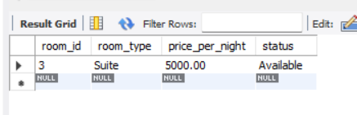

SELECT rm.room_id, g.name
FROM Reservations r
JOIN Rooms rm ON r.room_id = rm.room_id
JOIN Guests g ON r.guest_id = g.guest_id
WHERE r.status = 'Booked';

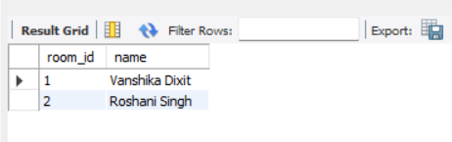

UPDATE Reservations
SET status = 'Cancelled'
WHERE reservation_id = 1;

SELECT * FROM Guests;
SELECT * FROM Rooms;
SELECT * FROM Reservations;

