User Guide



VA Solid Start Report Power BI User Guide

Prepared for

VA Solid Start

1/15/2020

Version 1.0 Draft

Prepared by

**Eloisabell Barkalow**

Consultant

[eloisabell.barkalow@microsoft.com](mailto:eloisabell.barkalow@microsoft.com)

Contributors

**Daniel Chang** [dacha@microsoft.com](mailto:dacha@microsoft.com)

Revision and Signoff Sheet

Change Record

| Date | Author | Version | Change Reference |
| --- | --- | --- | --- |
| 13-Nov-2019 | Daniel Chang | 1 | Initial draft for review/discussion |
|  |  |  |  |
|  |  |  |  |

Reviewers

| Name | Version Approved | Position | Date |
| --- | --- | --- | --- |
|  |  |  |  |
|  |  |  |  |
|  |  |  |  |

Table of Contents

1 What is a workspace ? 4

1.1 Accessing the Workspace 4

1.2 Accessing the Report 6

2 Sharing the Report 7

2.1 Granting Access to the Workspace 7

2.2 Granting Access to the Report 8

3 Report on Attempts Completed Success / Non-Success Totals 10

4 Report on Number of Calls Attempted (No Filter for Successful/Unsuccessful) 11

5 Report on Number of Interactions Assigned but are still pending (not closed) 12

6 Report on Total Number of Closed Successful interactions in each cohort 14

7 Export to Excel 15

1. What is a workspace ?

A workspace is a collaboration area within Power BI Service. A workspace is a distinct area that is dedicated to a specific team, subject area, or project. Reports are published to a workspace, so that users can view content and contribute appropriately. Accessing a workspace is different than accessing a report directly.

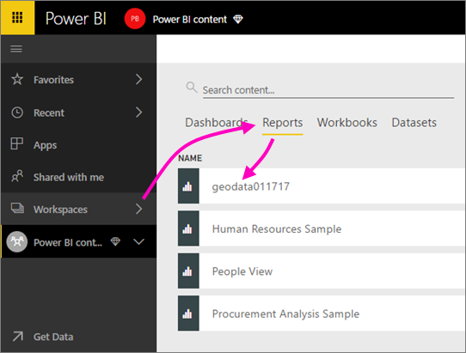

* 1. Accessing the Workspace

**Note:** *Accessing a workspace requires a pro license*

1. Navigate to [app.powerbigov.us](https://microsoft-my.sharepoint.com/personal/dacha_microsoft_com/Documents/Microsoft%20Teams%20Chat%20Files/app.powerbigov.us)
2. Log in using your VA credentials
3. Once on the Power BI Home page, expand the workspaces on the left-hand side, and select “VASS”

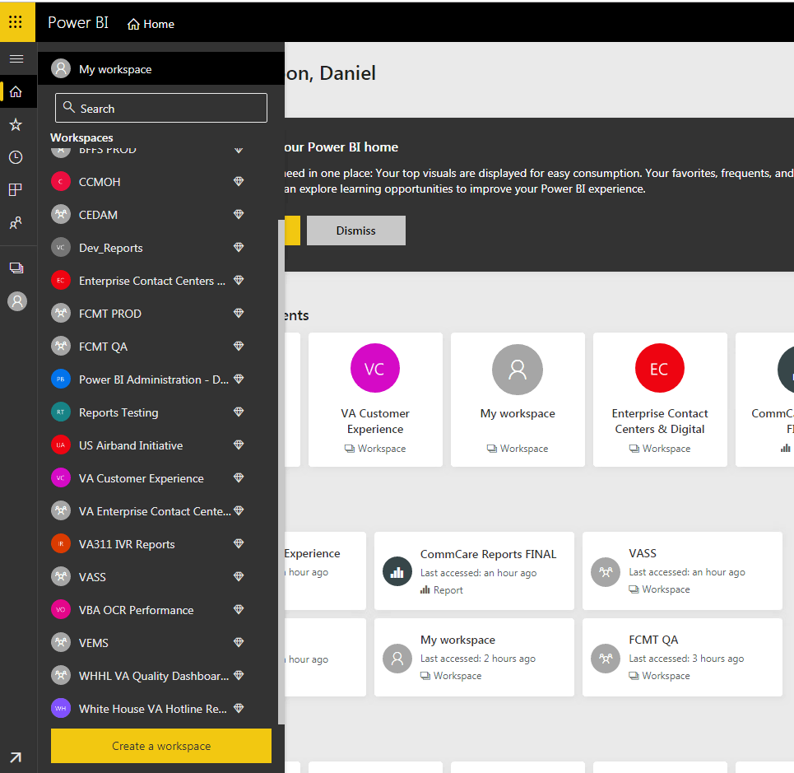

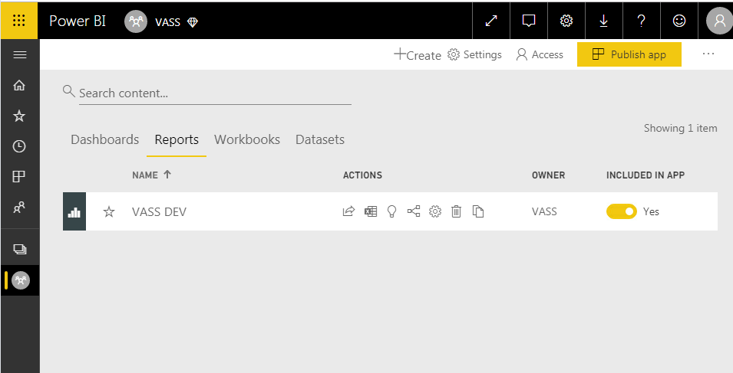

* 1. Accessing the Report

1. Now that you’ve accessed the workspace, you can then access the report by navigating to “Reports” and selecting “VASS”



1. You may also access the report via a link.
2. Sharing the Report

You may grant access to the report in one of two ways:

1. Granting access to the workspace
2. Granting access to the report.
   1. Granting Access to the Workspace

To grant access to the workspace, you must click the “Access” button at the top of the workspace. Granting access to the workspace will inherently give access to the report. It will also give others the right to share out the report as well.

**Note:**

* This feature is only available for those with “Admin” or “Contributor” rights. For more information on roles visit: <https://docs.microsoft.com/en-us/power-bi/service-new-workspaces#roles-in-the-new-workspaces>
* You must have a pro license in order to access a workspace

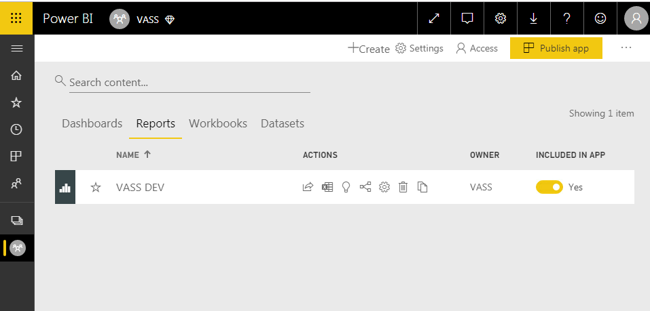

* 1. Granting Access to the Report

1. To grant access to the report you can select “Share” on the front page of the report.

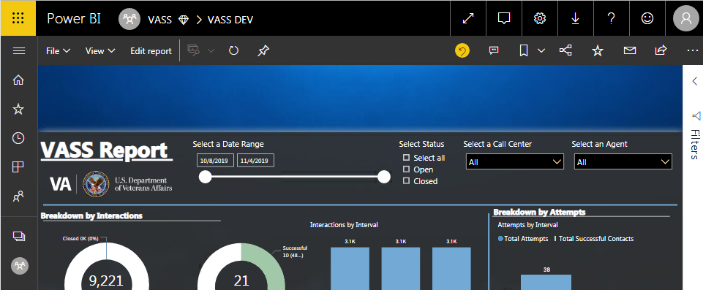

**OR** click the share icon inside the workspace.



1. Add the desired users whom you would like to share the report with. You may also add security groups or distribution lists. You are also given the option to send an email notification with the link to the report.

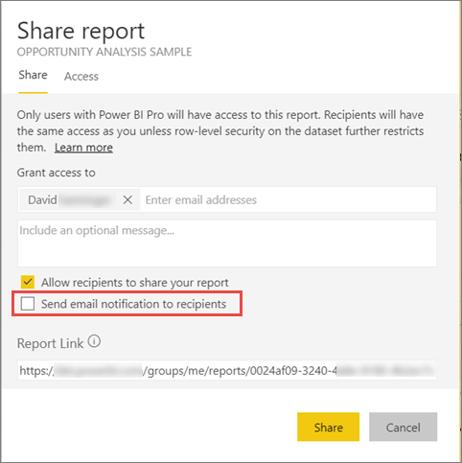

**Note:** Sharing a Report does NOT require a pro license because the report resides in a premium capacity. It is best you share a report and not the workspace to the end user.

1. Report on Attempts Completed Success / Non-Success Totals

Display: User Story: 1164288

1. Total Number of Attempts broken-down Successful vs unsuccessful
2. Percentage of Success/Non-Success Attempts

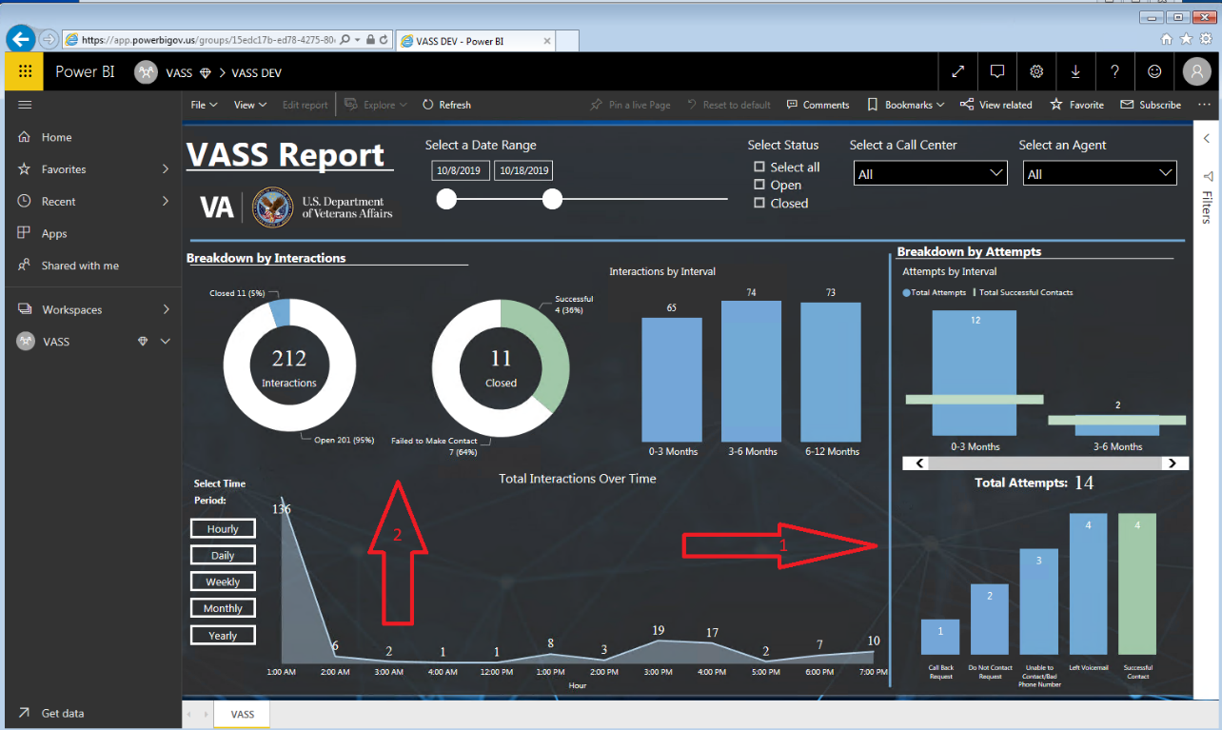

Filtering Capability by

1) National, Call Center and Agent.

2) Date Range filtering

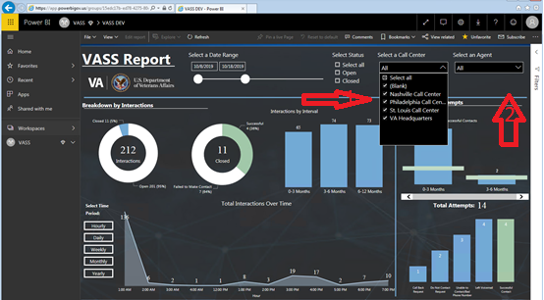

1. Report on Number of Calls Attempted (No Filter for Successful/Unsuccessful)

Display: User Story: 1164347

1.Total Number of attempts regardless of Interval

2.Total number of attempts within each Interval

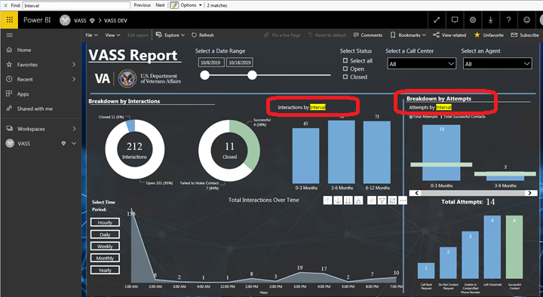

1. Report on Number of Interactions Assigned but are still pending (not closed)

Display: User Story 1164367

1.Total number of Interactions not closed (open Status) – Only Interactions where the Interval Start is today or in the Past.

All Report

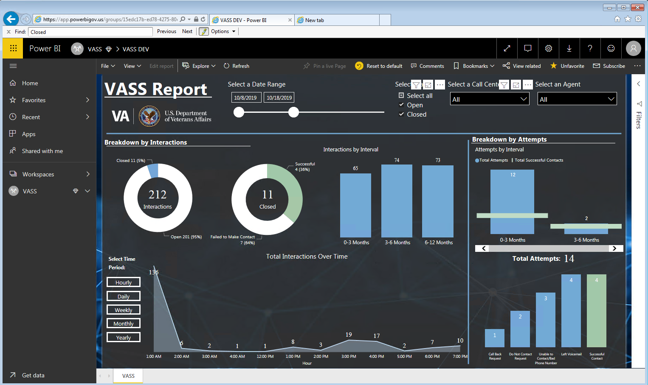

1. Filtered with Close

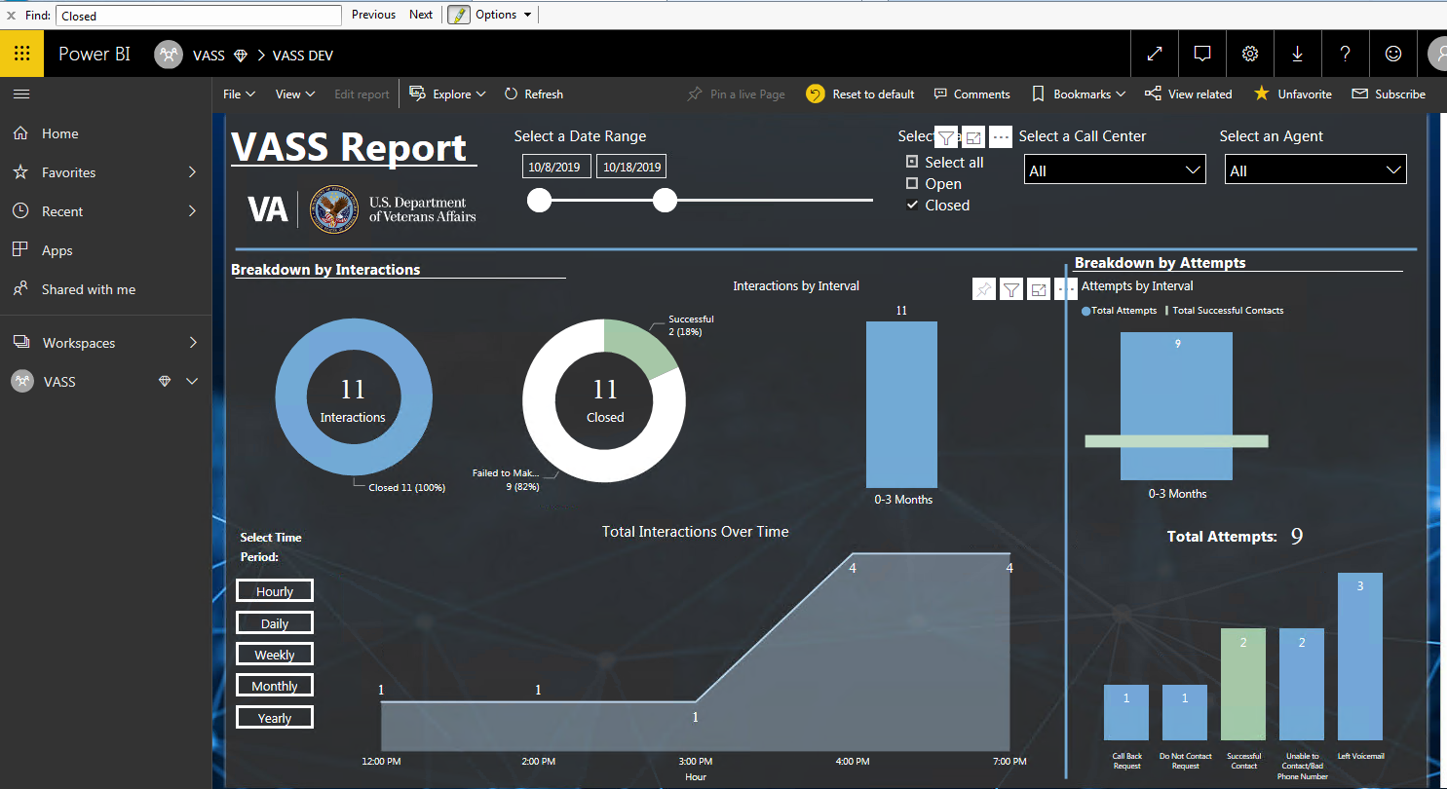

1. Filtered with Open

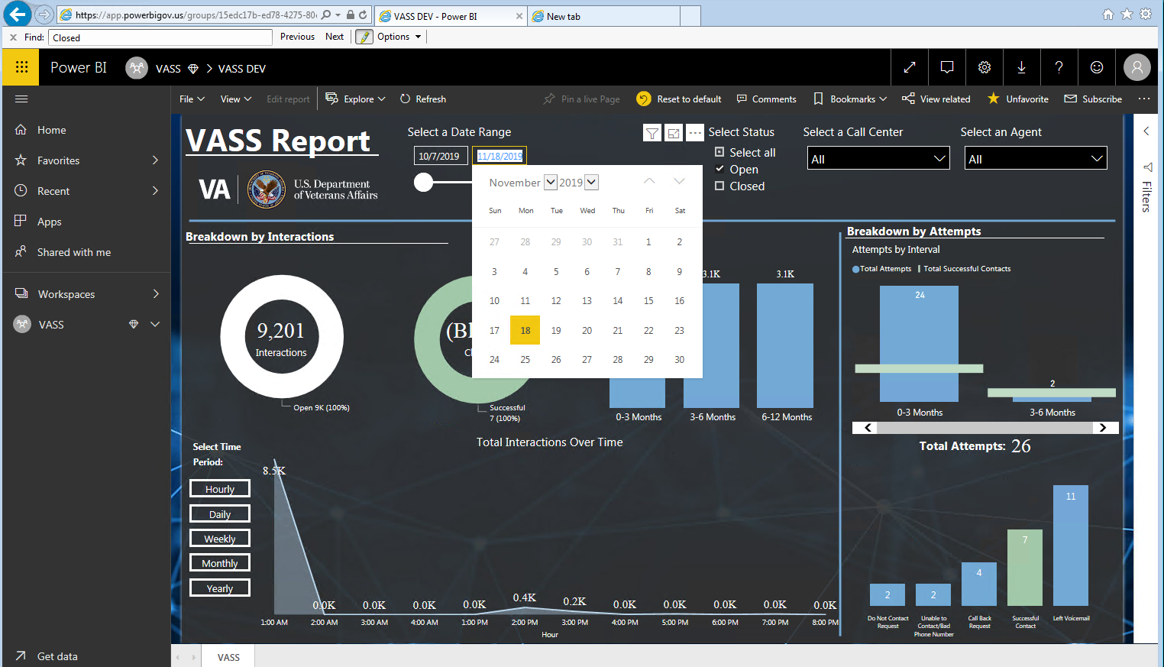

1. Report on Total Number of Closed Successful interactions in each cohort

Display: User Story1164407

1.Display Total Number of Interactions for each Interval

2.Display over time Trend line for post-MVP

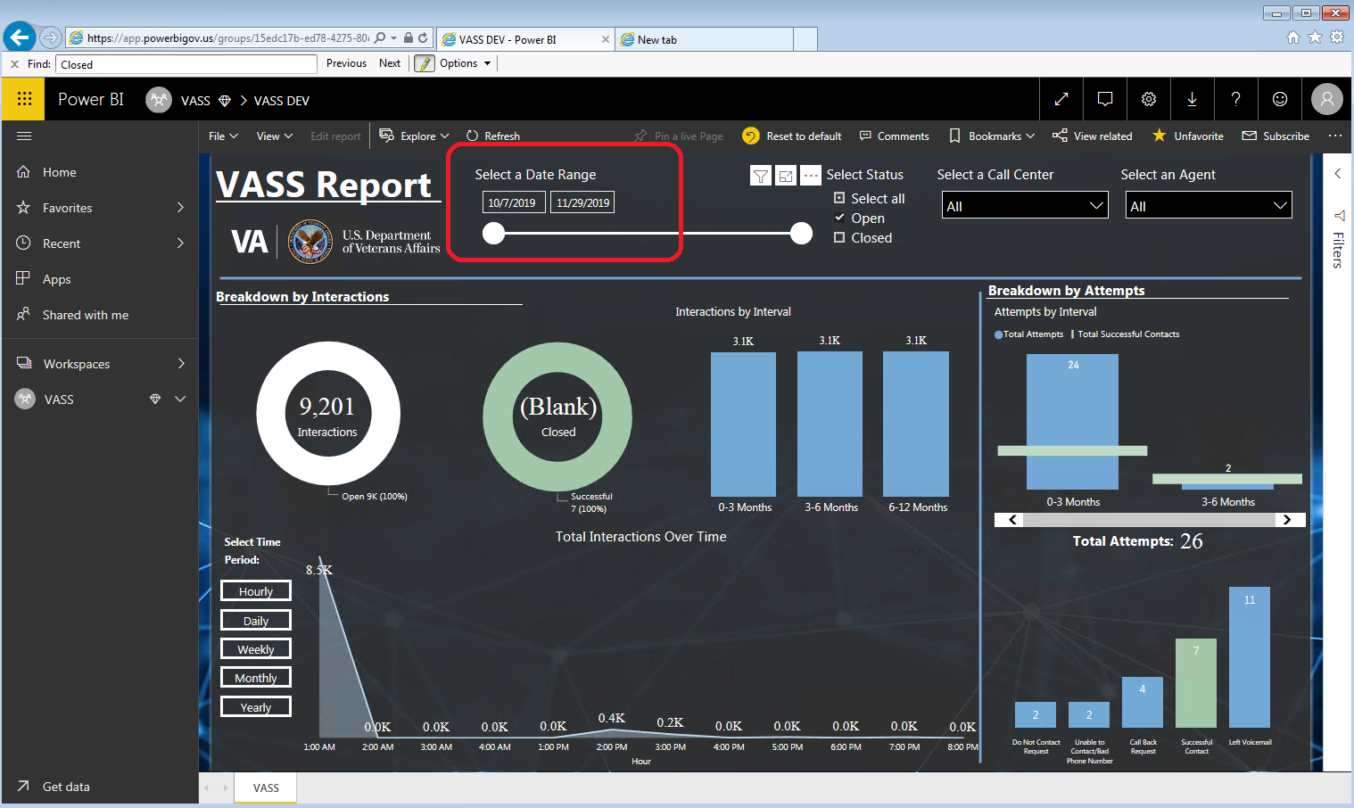

1. Export to Excel

1. In order to export the underlying data, click on a visual, then click on the ellipses in the top right corner and select “Export Data”

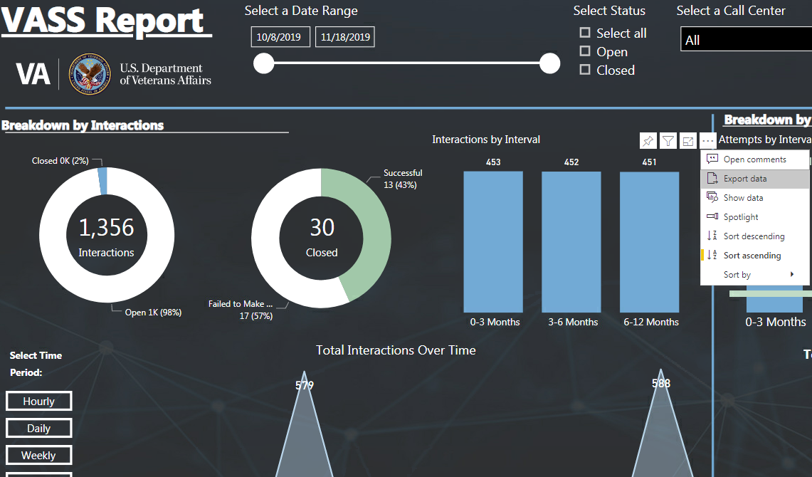

2. Select “Underlying data” to get the entire data set. Select “Export.”

