**CLOUD WAN CONFIGURATION**

A COURSE PROJECT REPORT

By

**Guru Charan Varanasi[RA2111030010075]**

**Sasi Kiran Gutha[RA2111030010088]**

**Keerthi Gurugubelli[RA2111030010093]**

**Senjuti Ghosal[RA211100010096]**

**Saranya Ghosh[RA2111030010097]**

Under the guidance of   
**Mrs. D Saveetha***In partial fulfilment for the Course*

of

18CSC302J - COMPUTER NETWORKS

in NWC

**FACULTY OF ENGINEERING AND TECHNOLOGY**

**SRM INSTITUTE OF SCIENCE AND TECHNOLOGY**

**(Under Section 3 of UGC Act, 1956)**

**Kattankulathur, Chenpalpattu District**

NOVEMBER 2023

SRM INSTITUTE OF SCIENCE AND TECHNOLOGY

(Under Section 3 of UGC Act, 1956)

**BONAFIDE CERTIFICATE**

Certified that this course project of Computer Networks (18CSC302J) report titled "**CLOUD WAN CONFIGURATION**" is the Bonafide work of **SENJUTI GHOSAL(RA2111030010096),KEERTHI G(RA2111030010093),SASI KIRAN GUTHA(RA2111030010088),VARANASI GURUCHARAN(RA2111030010075),**

**SARANYA GHOSH(RA2111030010097)** who carried out the project work under my supervision.

Certified further, that to the best of my knowledge the work reported here in does not form part of any other course project report on the basis of which a degree was conferred on an earlier occasion for this or any other candidate.

|  |  |
| --- | --- |
| **Ms.D.Saveetha** | **Dr. Annapurani Panaiyappan K** |
| Assistant Professor | Professor and Head of the Department |
| Department of Networking and Communications | Department of Networking and Communications |
| SRM Institute of Science and Technology, Kattankulathur | SRM Institute of Science and Technology, Kattankulathur |

### **ACKNOWLEDGEMENT**

We express our humble gratitude to **Dr C. Muthamizhchelvan**, Vice-Chancellor, SRM Institute of Science and Technology, for the facilities extended for the mini project work and his continued support. We extend our sincere thanks to Dean-CET, SRM Institute of Science and Technology, **Dr T.V.Gopal**, for his valuable support.

We wish to thank **Dr Revathi Venkataraman**, Professor & Chairperson, School of Computing, SRM Institute of Science and Technology, for her support throughout the project work. We are incredibly grateful to our Head of the department**, Dr. Annapurani Panaiyappan.K** Professor, Department of Networking and Communications, SRM Institute of Science and Technology, for her suggestions and encouragement at all the stages of the project work.

Our inexpressible respect and thanks to our guide, **Mrs. D. Saveetha,** Assistant professor, Department of Networking and Communications, SRM Institute of Science and Technology, for providing us with an opportunity to pursue my project under her mentorship. She provided us with the freedom and support to explore the research topics of our interest. Her passion for solving problems and making a difference in the world has always been inspiring.

We sincerely thank the Networking and Communications Department staff and students, SRM Institute of Science and Technology, for their help during our project. Finally, we would like to thank parents, family members, and friends for their unconditional love, constant support, and encouragement.

**Senjuti Ghosal[RA2111030010096]**

**Sasi kiran Gutha[RA2111030010088]**

**Guru Charan Varanasi[RA2111030010075]**

**Keerthi Gurugubelli[RA2111030010093]**

**Saranya Ghosh[RA2111030010097]**

**TABLE OF CONTENTS:**

|  |  |  |
| --- | --- | --- |
| **S.No** | **TITLE** | **Page.No** |
| **1.** | **ABSTRACT** |  |
| **2.** | **CHAPTER 1:INTRODUCTION** | **1** |
| **3.** | **CHAPTER 2:OBJECTIVE** | **11** |
| **4.** | **CHAPTER 3**:  **COMPONENTS REQUIRED** | **15** |
| **5** | **CHAPTER 4:PROCEDURE** | **19** |
| **6.** | **CHAPTER 5:USAGE OF CLOUD WAN IN REAL LIFE** | **21** |
| **7.** | **CHAPTER 6:OUTPUT** | **24** |
| **8.** | **CHAPTER 7:CONCLUSION** | **27** |
| **8.** | **REFERENCES** | **28** |

|  |  |  |
| --- | --- | --- |
| **FIG.NO.** | **Figures in Chapter** | **PAGE No.** |
| **1.1** | **DATA TRANSFER USING CLOUD COMPUTING** | **10** |
| **2.1** | **EVOLUTION IN CLOUD COMPUTING** | **14** |
| **3.1** | **COMPONENTS REQUIRED:**  **ROUTER**  **SWITCH AND PCs**  **TYPES OF WIRES**  **COMMAND PROMPT** | **15**  **16**  **17**  **18** |
| **4.1** | **PROCEDURE** | **-** |
| **5.1** | **USAGE OF CLOUD WAN** | **-** |
| **6.1** | **OUTPUT** | **24-25** |

**ABSTRACT**

In today's rapidly evolving business landscape, the seamless and secure transfer of data between a head office and its branch offices is paramount for efficient operations and decision-making. Cloud-based solutions have emerged as a robust and flexible means to facilitate this data transfer, offering scalability, accessibility, and data security. This abstract provides an overview of the key considerations and benefits associated with the transfer of data via the cloud from a head office to branch offices.The success of such data transfers relies on several critical factors:

• **Data Security**: Cloud service providers implement robust security measures to protect data from unauthorized access, ensuring that sensitive information remains confidential and compliant with data protection regulations.

• **Scalability**: Cloud solutions allow organizations to scale their data transfer requirements up or down as needed, reducing the need for extensive on-premises infrastructure investments.

• **Cost Efficiency**: Cloud-based data transfer can be more cost-effective than traditional methods, reducing the capital expenditure associated with physical servers and maintenance.

• **Reliability and Redundancy**: Leading cloud providers offer high levels of uptime and data redundancy, ensuring data is consistently available even in the event of hardware failures or disasters.

As organizations continue to expand and become more distributed, cloud-based data transfer solutions offer a valuable means to maintain the flow of information between head and branch offices.

**CHAPTER 1:**

**INTRODUCTION:**

The transfer of data via the cloud from a head office to branch offices represents a transformative approach to managing and sharing information in today's business landscape. It has become a strategic imperative for organizations seeking to streamline their operations, enhance collaboration, and harness the benefits of cloud technology. This introduction provides an overview of the concept and its significance.

In a globalized and interconnected world, businesses are often distributed across various locations, with branch offices and remote teams playing a pivotal role in their operations. Effective data sharing and communication between these geographically dispersed entities are essential for maintaining competitiveness, making informed decisions, and ensuring seamless workflows. Traditional methods of data transfer, such as physical storage devices or dedicated private networks, are often cumbersome, costly, and lack the agility required to meet the dynamic needs of modern enterprises.

The transfer of data via the cloud represents a para digm shift in how organizations exchange and manage information. Cloud-based solutions offer a versatile and scalable platform that empowers organizations to store, synchronize, and share data securely over the internet. This approach leverages the infrastructure and services provided by cloud service providers, offering several key advantages:

1. **Accessibility**: Cloud-based data is accessible from anywhere with an internet connection, enabling branch office employees to access information in real-time, irrespective of their physical location.
2. **Scalability**: Cloud solutions can scale seamlessly to accommodate the growing volume of data and users, eliminating the need for costly infrastructure upgrades.
3. **Cost-Efficiency**: Cloud-based data transfer can be more cost-effective than maintaining extensive on-premises infrastructure, as it often operates on a pay-as-you-go model, reducing capital expenditure.
4. **Data Security**: Leading cloud providers implement stringent security measures to protect data from unauthorized access and ensure compliance with data protection regulations.
5. **Collaboration**: Cloud solutions facilitate collaboration by enabling teams at the head office and branch offices to work on shared data, fostering productivity and innovation.
6. **Disaster Recovery**: Cloud-based data transfer services typically include robust backup and disaster recovery capabilities, reducing the risk of data loss.
7. **Data Consistency**: Cloud technology ensures that all branches have access to the same version of data, reducing the risk of inconsistencies and errors.
8. **Global Reach**: The cloud allows for global accessibility, enabling businesses to expand and reach new markets without major IT infrastructure investments.

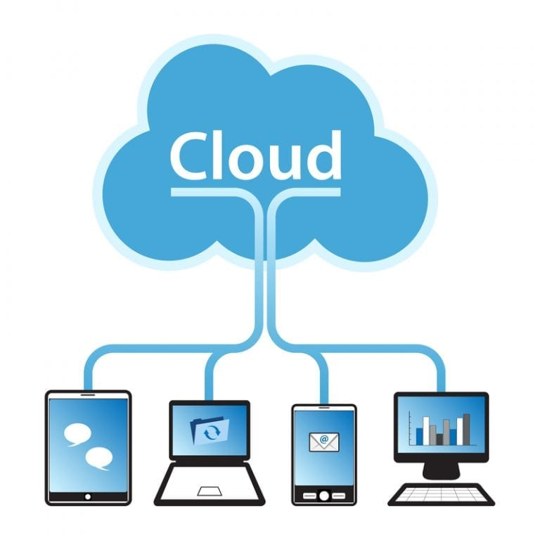Top of Form

Bottom of Form

Figure 1.1

**CHAPTER 2:**

**OBJECTIVE:**

• **Data Accessibility**: Ensure that employees at branch offices have immediate and secure access to essential data and resources stored at the head office, enabling them to perform their tasks without delays or interruptions.

• **Real-time Collaboration**: Foster seamless collaboration between teams across various locations by providing access to shared documents, applications, and communication tools that allow for real-time interaction and decision-making.

• **Scalability**: Accommodate the growth and changing needs of the organization by leveraging cloud services that can easily scale to support the increasing volume of data and users, without the need for significant infrastructure investments.

• **Cost Efficiency**: Reduce the cost of maintaining on-premises data centers and IT infrastructure by utilizing cloud-based solutions, which often offer a more cost-effective and predictable pricing model.

• **Data Security and Compliance**: Ensure that sensitive data is stored and transferred securely while maintaining compliance with industry-specific regulations, data protection laws, and internal security policies.

• **Disaster Recovery and Redundancy**: Implement robust data backup, disaster recovery, and redundancy measures to protect against data loss due to hardware failures, natural disasters, or other unforeseen events.

• **Improved Productivity**: Enhance the productivity of branch office employees by minimizing downtime and reducing the time spent waiting for data or resources to be transmitted from the head office.

• **Streamlined Management**: Simplify IT management and reduce the burden on IT staff by centralizing data storage and management in the cloud, allowing for easier updates, maintenance, and monitoring.

• **Global Accessibility**: Enable employees to access data from anywhere with an internet connection, allowing for remote work and more flexible work arrangements.

By pursuing these objectives, organizations can optimize their operations, improve collaboration, and leverage the benefits of cloud technology.

**Evolution:**

The evolution of cloud computing is one of the major advances in the computing area as well as in economics of computing technology. As an evolving technology it faces challenges like transferring data securely from the data center to the cloud considering the criticality and sensitivity of the data, performance unpredictability, and cost of data transfer. In this paper we provide a cloud computing model with its convergence with 4G technology as a solution for these challenges. This model is primarily for large companies having branches in geographically proximate regions. The model is intermediate between the cloud computing concept and the private datacenter model. Using 4G the data is transferred from the data center to the cloud and back, 4G offers a wide bandwidth of 2-8 GHz and data rate tariffs promise to be cheaper than 3G having data rates of up to 200Mbps for fixed devices. The proposed IP based network of 4G and the design of the model helps to increase the level of data confidentiality in the network. We also prove mathematically that with convergence of Cloud Computing and 4G, the cost of data transfer to and from data center to cloud reduce and also the data criticality and sensitivity issue is ameliorated.

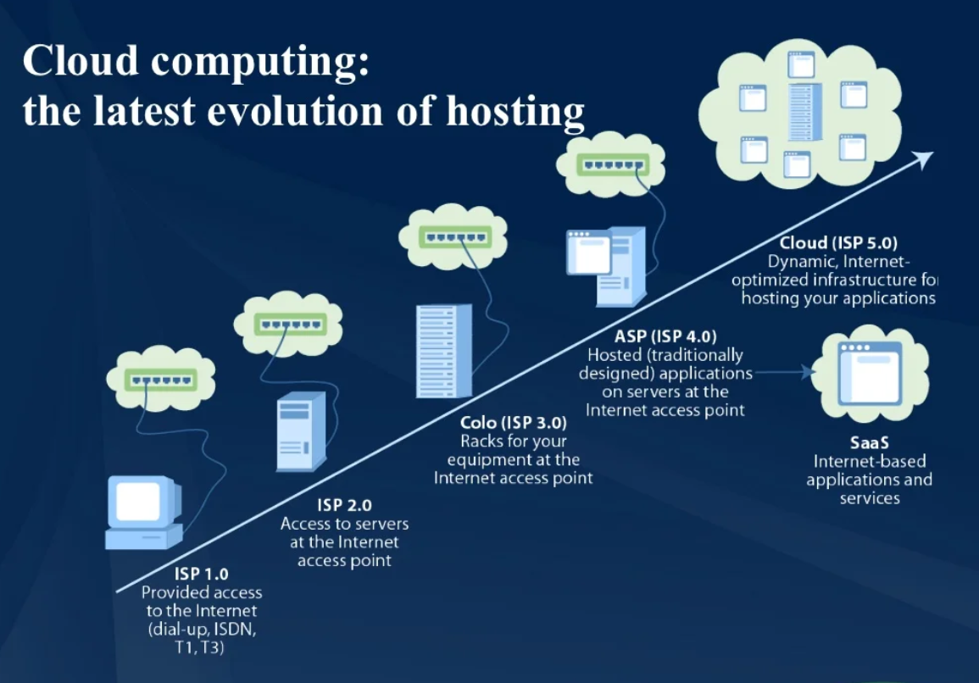

Figure 2.1

**CHAPTER 3**:

**COMPONENTS REQUIRED:**

1.Cisco Packet Tracer Software:

- You will need access to Cisco Packet Tracer, which is a network simulation tool. Ensure you have the software installed on your computer.

2.Routers:

- You'll need at least two Cisco routers to represent the head office and branch office network gateways. These routers will facilitate the routing of data between the two locations.

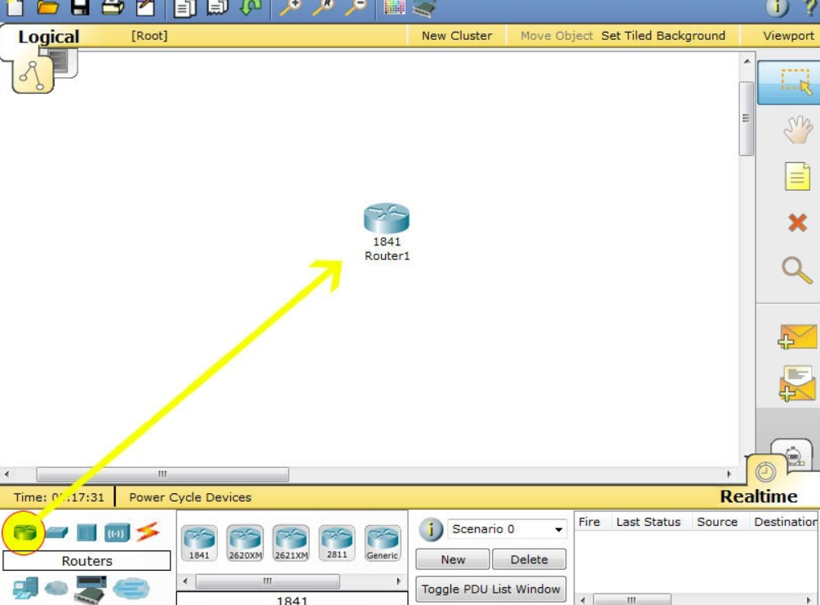

Figure 3.1

3.Switches:

- Use Cisco switches to connect devices within each office. Switches are essential for local area network (LAN) connectivity.

4.Computers or End Devices:

- Place computers or end devices (such as PCs or laptops) in both the head office and branch

office locations. These devices will be used to initiate and receive data transfers.

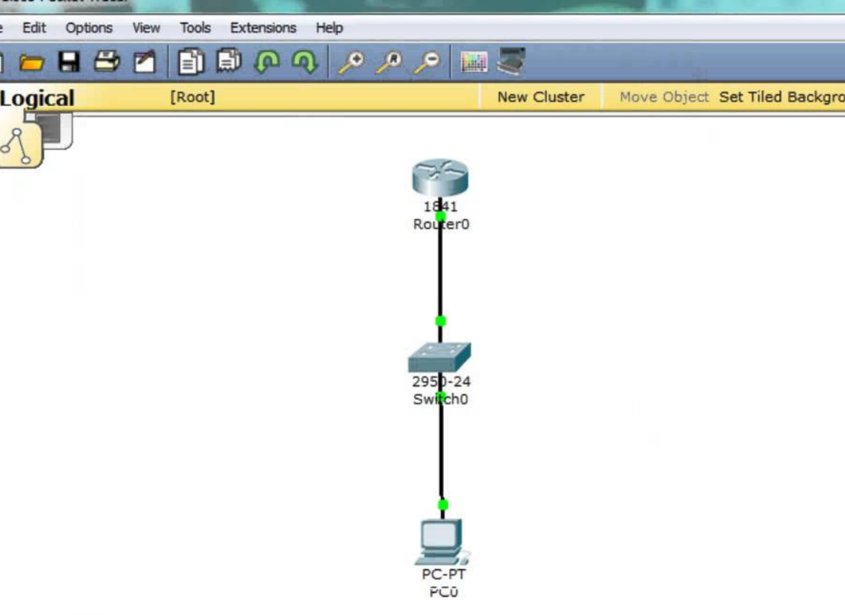

Figure 3.2

5.Cloud Services:

- Utilize the "Cloud" object in Cisco Packet Tracer to simulate internet or cloud connectivity. Connect the cloud to the routers to represent the wide area network (WAN) link between the head office and branch office. The cloud serves as a bridge to the external network.

6.Cables and Connections:

- Use appropriate cables (Ethernet or serial) to connect the routers, switches, and end devices in your network topology.

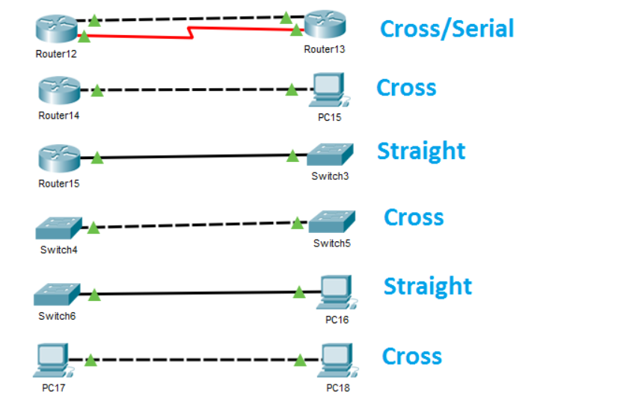

Figure 3.3

7.IP Addressing Scheme:

- Plan and configure IP addresses, subnet masks, and default gateways for all devices in the network. Define IP addressing for the WAN and LAN connections.

8.Data Transfer Tools:

- In your simulation, you can use basic data transfer tools like file transfer protocols (FTP, SCP), HTTP for web-based transfers, or built-in file sharing applications on the computers to simulate data transfer.

9.Configuration and Documentation:

- Be prepared to configure the routers with appropriate routing protocols (e.g., OSPF, EIGRP) or static routes to enable data transfer.

- Document your network configuration, including IP addresses, router configurations, and any other settings used in the simulation.

10.Monitoring and Troubleshooting Tools:

- Cisco Packet Tracer provides built-in simulation and monitoring tools to observe network traffic, monitor router interfaces, and troubleshoot any connectivity issues that may arise during the simulation.

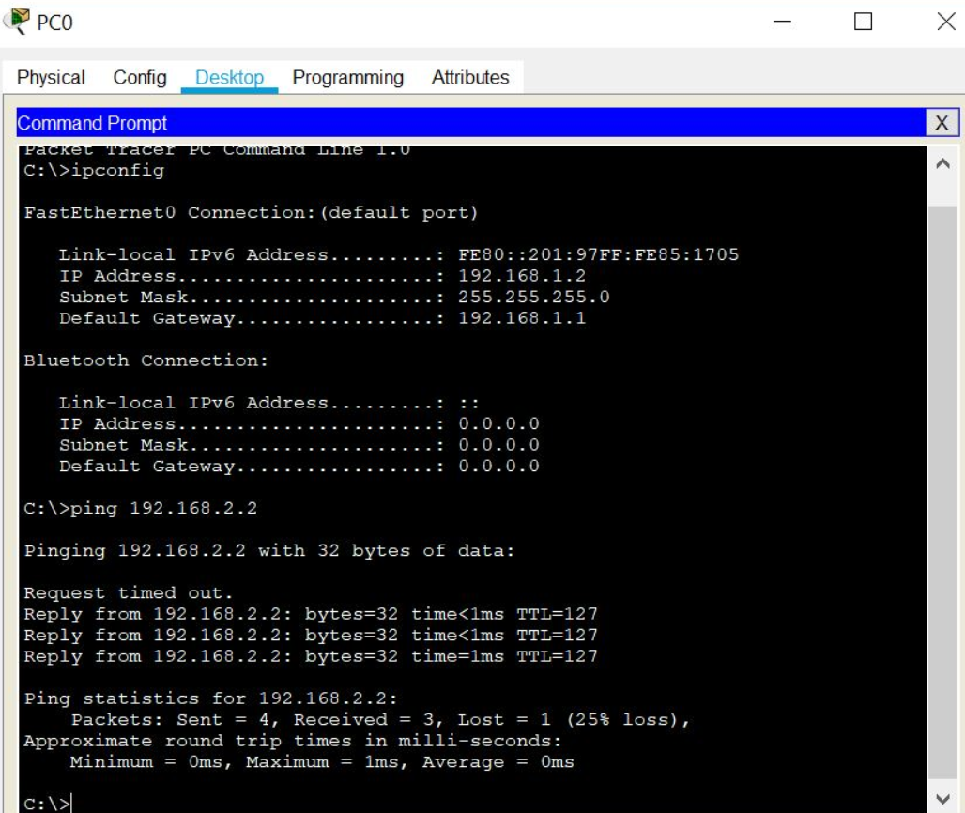

Figure 3.4

**CHAPTER 4:**

**Procedure:**

Assumptions:

- You have access to Cisco Packet Tracer software.

- You have basic networking knowledge and know how to create a network topology.

1. Create the Network Topology:

- Open Cisco Packet Tracer and create a new network file.

- Build a network topology that represents the head office and branch office. You can use routers and switches to connect various devices.

- Connect the routers using serial or Ethernet connections to simulate the wide area network (WAN) connection between the head office and branch office.

2. Configure Router Interfaces:

- Configure the router interfaces with IP addresses and subnet masks to establish connectivity between the head office and branch office.

3. Set Up Cloud Services

- Use the "Cloud" object in Cisco Packet Tracer to represent the cloud services or the internet.

- Connect the "Cloud" to the head office and branch office routers to simulate internet connectivity.

4. Configure End Devices:

- Place computers or end devices in both the head office and branch office locations.

- Configure the network settings on these devices, including IP addresses, subnet masks, and default gateways.

5. Data Transfer Simulation:

- Use a file transfer application or protocol (e.g., FTP, SCP, HTTP, or a simple file sharing tool) on the computers to transfer data.

- Initiate a file transfer from the head office computer to the branch office computer or vice versa.

6. Monitor and Troubleshoot:

- Observe the data transfer process and monitor network traffic using Packet Tracer's simulation and monitoring features.

- Troubleshoot any connectivity issues, such as routing problems, misconfigurations, or firewall settings.

7. Verify Data Transfer:

- Ensure that data is successfully transferred from the head office to the branch office and vice versa.

8. Document and Review:

- Document the network configuration and settings you used for the simulation.

- Review the simulation to identify any areas of improvement or optimization.

**CHAPTER 5:**

**USAGE OF CLOUD WAN IN REAL LIFE:**

Typically, large enterprises have resources running in different on-premises data centers, branch offices, and in the cloud. To connect these resources, network teams build and manage their own global networks using multiple networking, security, and internet services from multiple providers. They most probably use several technologies and providers to manage cloud-based networks, to connect their data centers to the AWS cloud, and for the connectivity between on-premises data centers and branch offices. All of these networks take different approaches to connectivity, security, and monitoring, resulting in an intricate patchwork of individual networks that are complicated to configure, secure, and manage.

For example, to prevent unauthorized access to resources running across locations that are connected with different network technologies, network operation teams must piece together different firewall solutions from different vendors and then manually configure and manage the policies between them. Every new location, network appliance, and security requirement exponentially increases complexity.

With Cloud WAN, networking teams connect to AWS through their choice of local network providers, then use a central dashboard and network policies to create a unified network that connects their locations and network types. This eliminates the need to configure and manage different networks individually, even when they are based on different technologies. Cloud WAN generates a complete view of your on-premises and AWS networks to help you visualize the health, security, and performance of your entire network.

Cloud WAN provides advanced security and network isolation, and I am excited by the possibilities offered by this network segmentation. You can use policies in Cloud WAN to easily segment your network traffic regardless of how many AWS Regions or on-premises locations you add to your network. For example, you can easily isolate network traffic from retail payment processing from other traffic on your corporate network while still giving both segments access to shared corporate resources. Another example would be the isolation of your development and production environment by creating logical network segments for each environment. This makes it easier to ensure consistent security policies when connecting large numbers of locations with your VPCs especially when your policies need to apply to large groups with unique security and routing requirements. Cloud WAN maintains a consistent configuration across Regions on your behalf. In a traditional network, a segment is like a globally consistent virtual routing and forwarding (VRF) table or a layer 3 IP VPN over an MPLS network. Segments are optional; smaller organizations may use Cloud WAN with one single network segment, encompassing all your traffic.

In addition to network segmentation and the simplicity it brings to your network management tasks, I see four principal benefits of using Cloud WAN:

Centralized management and network monitoring dashboard – Network Manager provides a central dashboard for connecting and managing your branch offices, data centers, VPN connections, and Software-Defined WAN (SD-WAN), as well as your Amazon VPC and AWS Transit Gateway. This dashboard helps you monitor and view the health of your network in one place, simplifying day-to-day operations.

Centralized policy management – You define access controls and traffic routing rules in a central network policy document, expressed in JSON. When you update a policy, Cloud WAN uses a two-step process to ensure accidental errors do not affect your global network. First, you review and validate that your changes will work as expected in production. Once you approve the changes, Cloud WAN handles the configuration details for the entire network. You can change your policy document using the AWS Management Console or Cloud WAN APIs.

Multi-Region VPC connectivity – Cloud WAN connects your VPCs across AWS Regions. Using a simple network policy document, you can create global networks that connect all of your EC2 resources, or you can choose to segment them across Regions.

Built-in automation. Cloud WAN can automatically attach new VPCs and network connections to your network, so you do not need to approve each change manually. It reduces the operational overhead involved in managing a growing network. You do this by tagging attachments and defining network policies that automatically map attachments with a certain tag to a specific network segment. With this tagging structure in place, you can choose which attachments can join a segment automatically, which segments require manual approval, and if attachments on the same segment can talk to each other, all based on the tags you choose.

.

**CHAPTER 6:**

**OUTPUT**

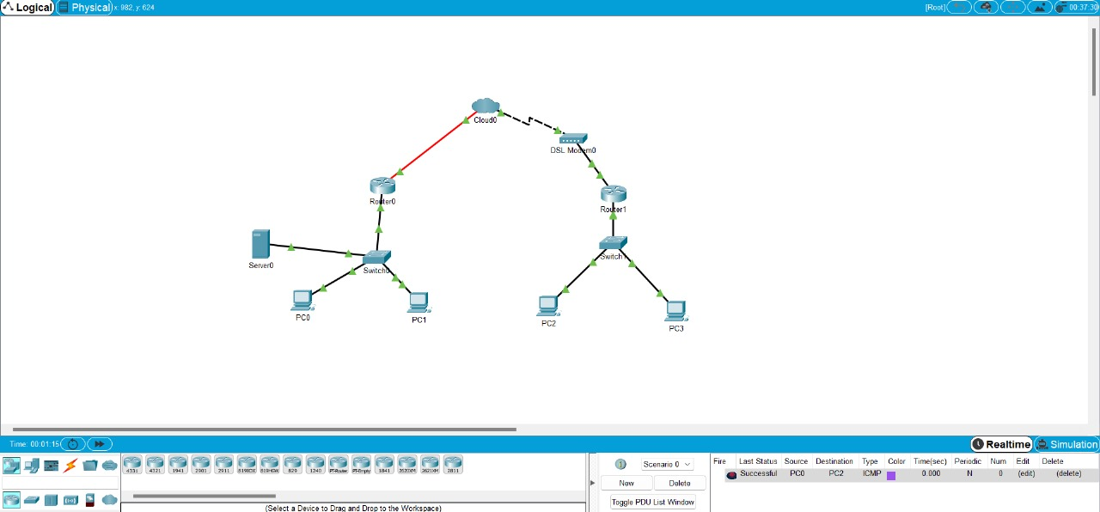

Figure 6.2

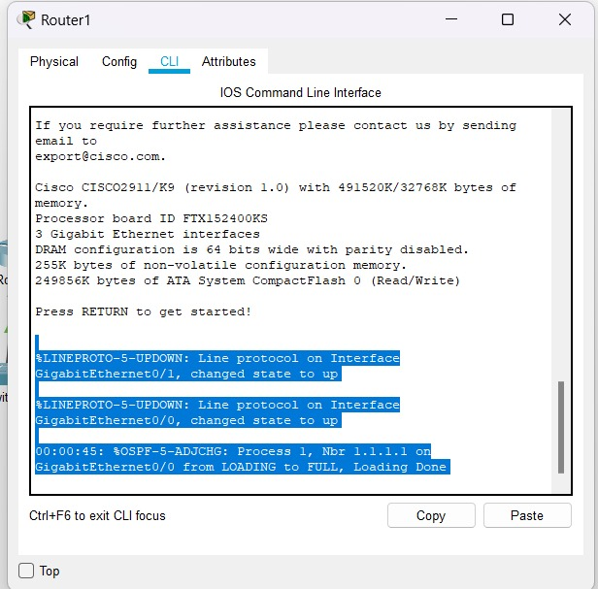

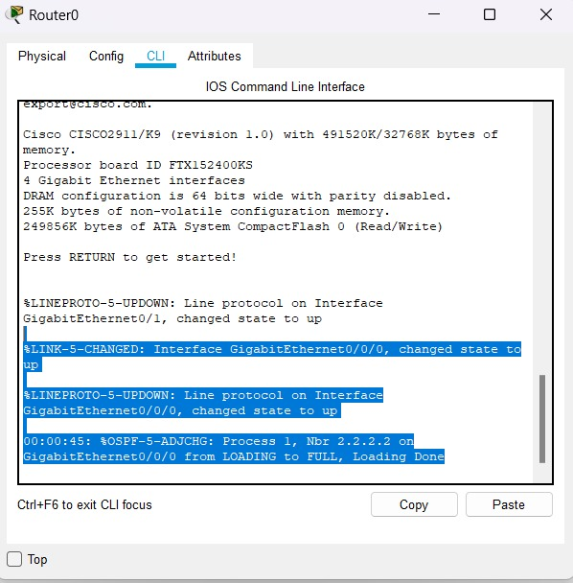

**CHAPTER 7:**

**CONCLUSION:**

In conclusion, cloud route data transfer provides a streamlined and cost-effective means of sharing information across locations. It fosters efficiency, collaboration, and accessibility while offering scalability and robust security measures. Cloud-based solutions can also play a vital role in disaster recovery planning, ensuring business continuity. However, it's essential to consider factors such as compliance, bandwidth, and adequate training to optimize the process. Overall, cloud-based data transfer is a fundamental component of modern business operations, promoting productivity and data security across the organization.

**REFERENCES**

1)Journal homepage: http://www.innovativejournal.in/index.php/ajcsit

2)Cloud Security and Privacy by Tim Mather, Subra Kumaraswamy, and Shahed Latif

3)Cloud Computing: Concepts, Technology & Architecture" by Thomas Erl, Ricardo Puttini, and Zaigham Mahmood

4) https://aws.amazon.com/cloud-data-migration/

5)https://www.cisco.com/c/en/us/td/docs/solutions/CVD/SDWAN/cisco-sdwan-design-guide.html

6)https://www.paloaltonetworks.com/cyberpedia/what-is-cloud-delivered-branch