
Earth and Space Science
Supporting Information for
An Update to the Horizontal Wind Model (HWM): The Quiet-Time Thermosphere
Douglas P. Drob¹, John T. Emmert¹, John W. Meriwether², Jonathan J.
Makela³, Eelco Doornbos⁴, Mark Conde⁵, Gonzalo Hernandez⁶*, John Noto⁷,
Katherine A. Zawdie¹, Sarah M. McDonald¹, Joe D. Huba⁸, and Jeff H.
Klenzing⁹
¹Space Science Division, Naval Research Laboratory, Washington, District of Columbia, USA
²Department of Physics and Astronomy, Clemson University, Clemson, South Carolina, USA
³Department of Electrical and Computer Engineering, University of Illinois at Urbana-Campaign, Urbana, Illinois, USA
⁴Department of Earth Observation and Space Systems, Technical University Delft, Delft, Netherlands
⁵Geophysical Institute, University of Alaska Fairbanks, Fairbanks, Alaska, USA
⁶Department of Earth and Space Sciences, University of Washington, Seattle, Washington, USA
⁷Scientific Solutions Inc., Chelmsford, Massachusetts, USA
⁸Plasma Physics Division, Naval Research Laboratory, Washington, District of Columbia, USA
⁹Space Weather Laboratory, Goddard Spaceflight Center, Greenbelt, Maryland, USA.
*Deceased 2014

Contents of this file

Figures S1 to S3

Additional Supporting Information

Software S1 (sfts01.tar.gz)

Introduction
The supporting information consists of additional plots of HWM14 output and the HWM14 software package. Figures S1-S3 are the same as Figure 3 in the main text, but for lower altitudes in the thermosphere. Software S1 is a zip file containing the HWM14 Fortran software and data files.
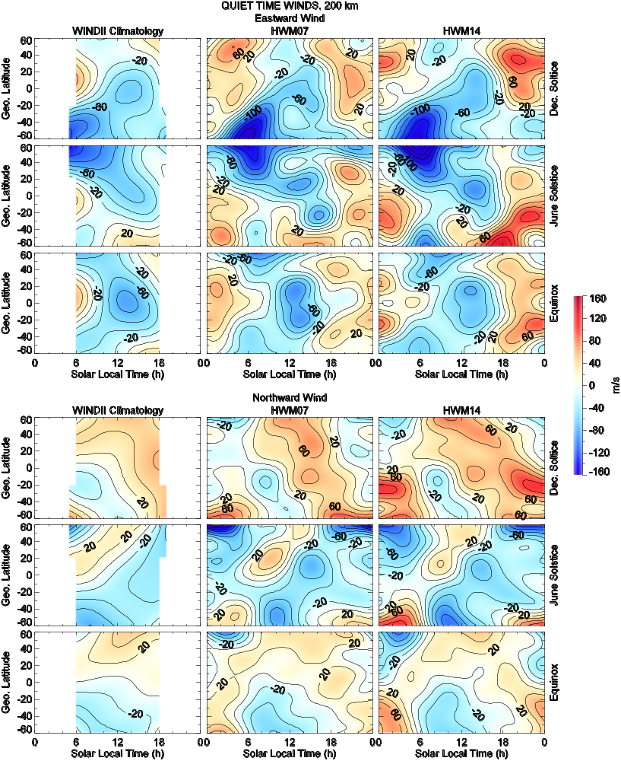
Figure S1. Zonal (top) and meridional (bottom) average quiet-time (Kp < 3) winds at 200 km altitude, as a function of solar local time and geographic latitude. Shown are results from the quiet-time WINDII climatology of Emmert et al. [2002] (left), HWM07 (middle), and HWM14(right). The models were evaluated under December solstice (day of year 0), June solstice (day 180) and combined equinox (average of days 90 and 270) conditions, as indicated by the annotation at the right of each row. The contour interval is 20 m/s.

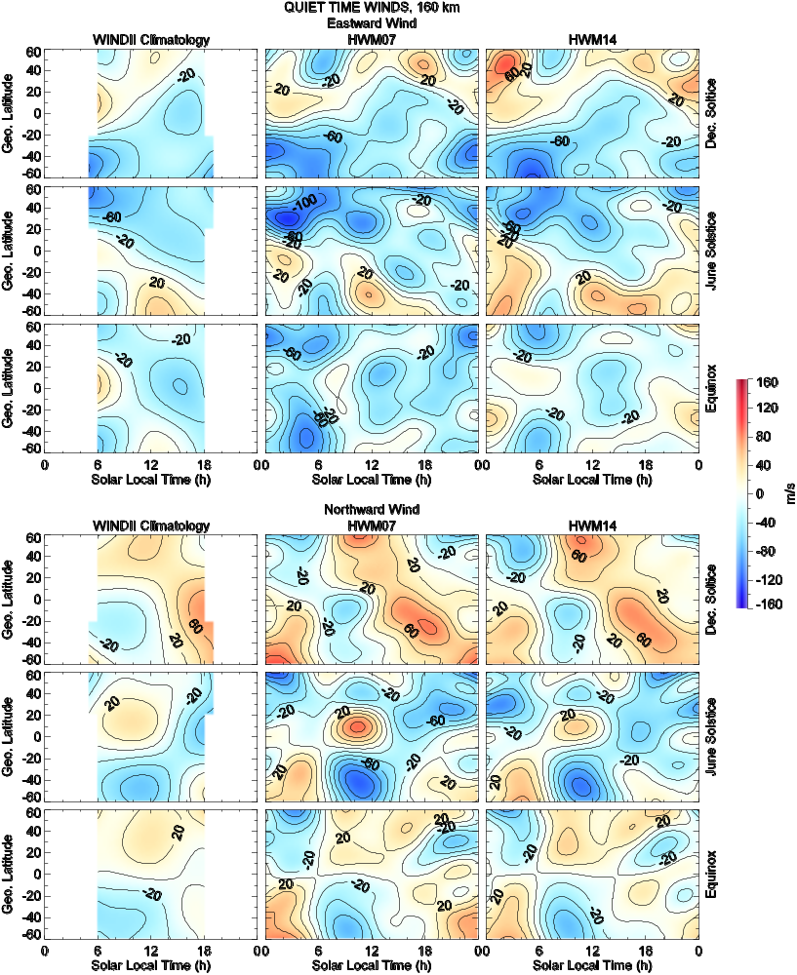
Figure S2. Same as Figure S1, but for 160 km.

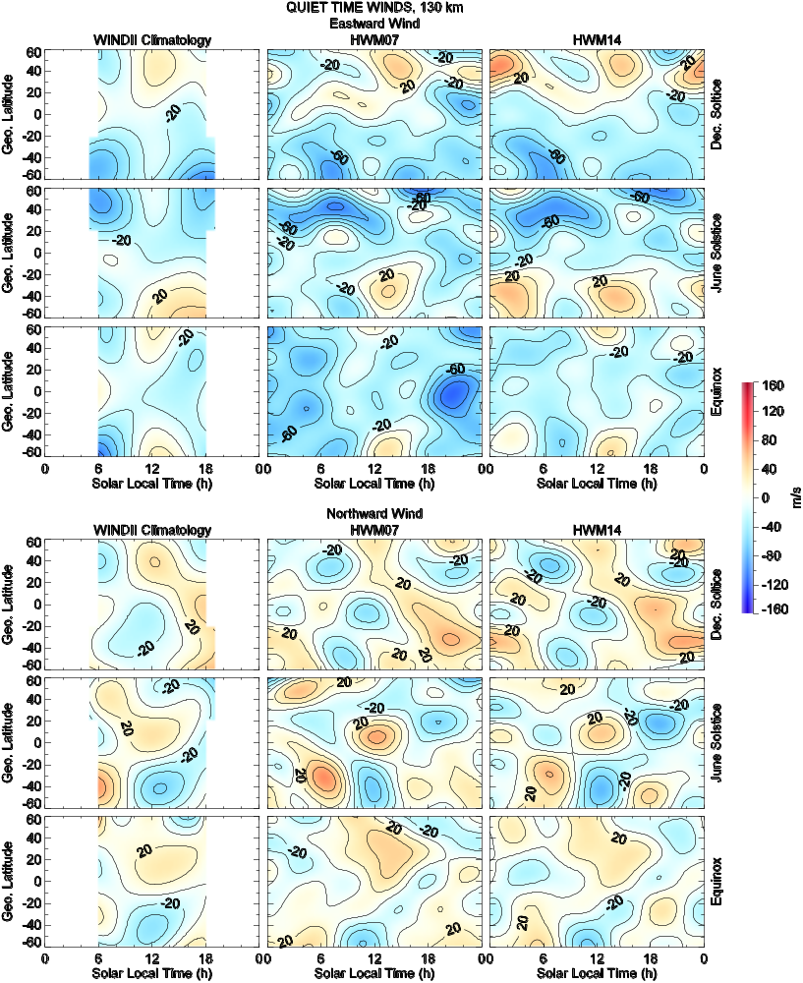
Figure S3. Same as Figure S1, but for 130 km.

Software S1. The Horizontal Wind Model, 2014 (HWM14) software distribution package (sfts01.tar.gz).

