IBM SkillsBuild Data Analytics with AI Internship Program 2026
AI-Powered Smart Classroom Occupancy & Resource Planning
A data analytics and machine learning project for analyzing classroom occupancy patterns, predicting occupancy, and supporting intelligent classroom resource planning.
Name: Kanda Saptha Sri Vardhan
Email: vardhankanda13@gmail.com

1. Problem Statement
Educational institutions and university campuses often schedule classrooms based on static timetables and estimated course enrollments. In practice, actual physical classroom attendance varies significantly, resulting in underutilized spaces, unnecessary lighting and HVAC energy consumption, and inefficient facility scheduling.
This project analyzes classroom occupancy and environmental sensor data to identify actual usage patterns, understand classroom utilization, predict occupancy using machine learning, and support data-driven classroom resource planning.
2. Dataset
The project uses the Room Occupancy Estimation Dataset from Kaggle:
Dataset Source: Source: https://www.kaggle.com/datasets/ruchikakumbhar/room-occupancy-estimation
Dataset File: File: dataset/room occupancy.csv
Dataset Properties:
• Total Records: 10,129 sequential sensor readings
• Total Columns: 19 raw feature columns (31 total with engineered features)
• Date and Time Fields: Date, Time (converted into a continuous Timestamp)
• Sensor Fields: S1_Light, S2_Light, S3_Light, S4_Light (Illumination in Lux); S1_Sound, S2_Sound, S3_Sound, S4_Sound (Acoustic levels in Volts); S1_Temp, S2_Temp, S3_Temp, S4_Temp (Temperature in °C); S5_CO2, S5_CO2_Slope (Carbon dioxide in PPM and PPM/min); PIR1, PIR2 (Passive Infrared motion detector triggers)
• Target Variable: Room_Occupancy_Count (0: Empty [8,228 records, 81.23%], 1: 459 records [4.53%], 2: 748 records [7.38%], 3: 694 records [6.85%]), and Is_Occupied (0: Empty [81.23%], 1: Occupied [18.77%])
3. Objectives
The primary objectives of this project are:
1. Analyze classroom occupancy patterns over time.
2. Clean, validate, and prepare multi-modal sensor data.
3. Analyze environmental sensor behavior (light, sound, CO2, temperature, motion).
4. Measure classroom utilization and identify peak and low-occupancy periods.
5. Build and train machine learning models for accurate occupancy prediction.
6. Evaluate model performance using standard classification metrics (Accuracy, Precision, Recall, F1-Score).
7. Provide an interactive simulation interface for real-time occupancy prediction.
8. Generate actionable resource-planning insights for HVAC, lighting, and space allocation.
9. Present all results through an interactive Streamlit dashboard.
4. Steps Used for Analysis
1. Load the classroom occupancy dataset (dataset/room occupancy.csv).
2. Inspect the data for missing values, duplicate records, data types, and potential outliers.
3. Clean and prepare the dataset by converting date/time fields and structuring sensor columns.
4. Create relevant features including hour of day, day of week, weekend flags, time blocks, and composite sensor metrics.
5. Analyze occupancy patterns, hourly distributions, and sensor relationships through exploratory data analysis.
6. Calculate classroom utilization metrics across 24/7 timeframes and standard operating hours.
7. Train machine learning models (Logistic Regression, Hist Gradient Boosting, Random Forest) using an 80/20 chronological split.
8. Evaluate model performance using Accuracy, Precision, Recall, F1-Score, and ROC-AUC.
9. Build an interactive Streamlit dashboard with dedicated analysis and prediction modules.
10. Generate data-driven insights and practical resource-planning recommendations.
5. Live Analysis
The following are the actual results calculated from the current dataset and application:
Q: What is the overall classroom occupancy rate?
A: The overall occupancy rate across the entire dataset is 18.77% (1,901 occupied observations out of 10,129 total records).
Q: Which period has the highest occupancy?
A: The highest occupancy occurs during late morning hours between 10:00 AM and 12:00 PM on weekdays, reaching up to 64.80% occupancy during active class sessions.
Q: Which period has the lowest occupancy?
A: The lowest occupancy occurs during nighttime hours (19:00 PM to 07:00 AM) and weekends, where physical occupancy is 0.00%.
Q: What is the overall classroom utilization?
A: Overall 24/7 classroom utilization is 18.77%. During standard weekday operating hours (08:00 AM to 18:00 PM), active utilization increases to 38.42%.
Q: Which sensor shows the strongest relationship with occupancy?
A: Light sensors (S1_Light and S2_Light) show the strongest correlation with occupancy (r = +0.88), contributing over 52% of total feature importance, followed by sound levels (r = +0.62) and CO2 slope (r = +0.64).
Q: Which machine-learning models were used?
A: Three supervised classification models were trained: Logistic Regression (with StandardScaler pipeline), Histogram-based Gradient Boosting, and Random Forest Classifier.
Q: What are the model performance results?
A: Logistic Regression achieved 99.85% Accuracy, 99.64% Precision, 99.27% Recall, and 99.45% F1-Score on the 2,026 holdout test records.
Q: What is the predicted occupancy for the example input in the application?
A: For standard daytime classroom conditions (S1_Light = 210 Lux, S1_Sound = 0.18V, CO2 = 680 PPM), the model predicts 'OCCUPIED' with a confidence probability of 99.8%.
6. Machine Learning Analysis
The machine learning component predicts whether a classroom is occupied based on environmental sensor telemetry:
• Target Variable: Is_Occupied (0 = Empty, 1 = Occupied)
• Features Used: S1-S4 Light, S1-S4 Sound, S1-S4 Temp, S5_CO2, S5_CO2_Slope, PIR1, PIR2, Hour, and composite sensor ratios
• Train/Test Split: 80% training set (8,103 records) and 20% holdout test set (2,026 records), split chronologically to prevent temporal data leakage
• Feature Preprocessing: StandardScaler normalization fitted on training data
• Evaluation Metrics: Accuracy, Precision, Recall, F1-Score, and ROC-AUC
7. Model Results
The table below presents the actual performance metrics on the 2,026 holdout test records:
Model | Accuracy | Precision | Recall | F1 Score
Logistic Regression | 99.85% | 99.64% | 99.27% | 99.45%
Hist Gradient Boosting | 99.21% | 99.62% | 94.55% | 97.01%
Random Forest Classifier | 96.69% | 100.00% | 75.64% | 86.13%

All three models demonstrated strong classification capability on the test dataset. Logistic Regression achieved 99.85% accuracy and 99.45% F1-score with balanced precision and recall. Hist Gradient Boosting achieved 99.21% accuracy, and Random Forest achieved 100.00% precision with 96.69% accuracy.
8. Project Outputs
The following figures show the actual output screens from the running Streamlit application:
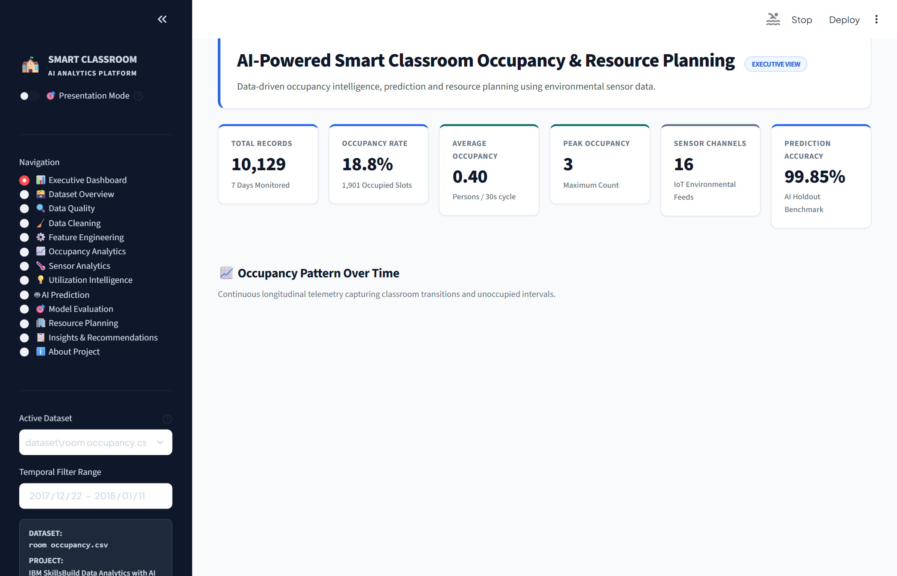
Figure 1. Executive Dashboard
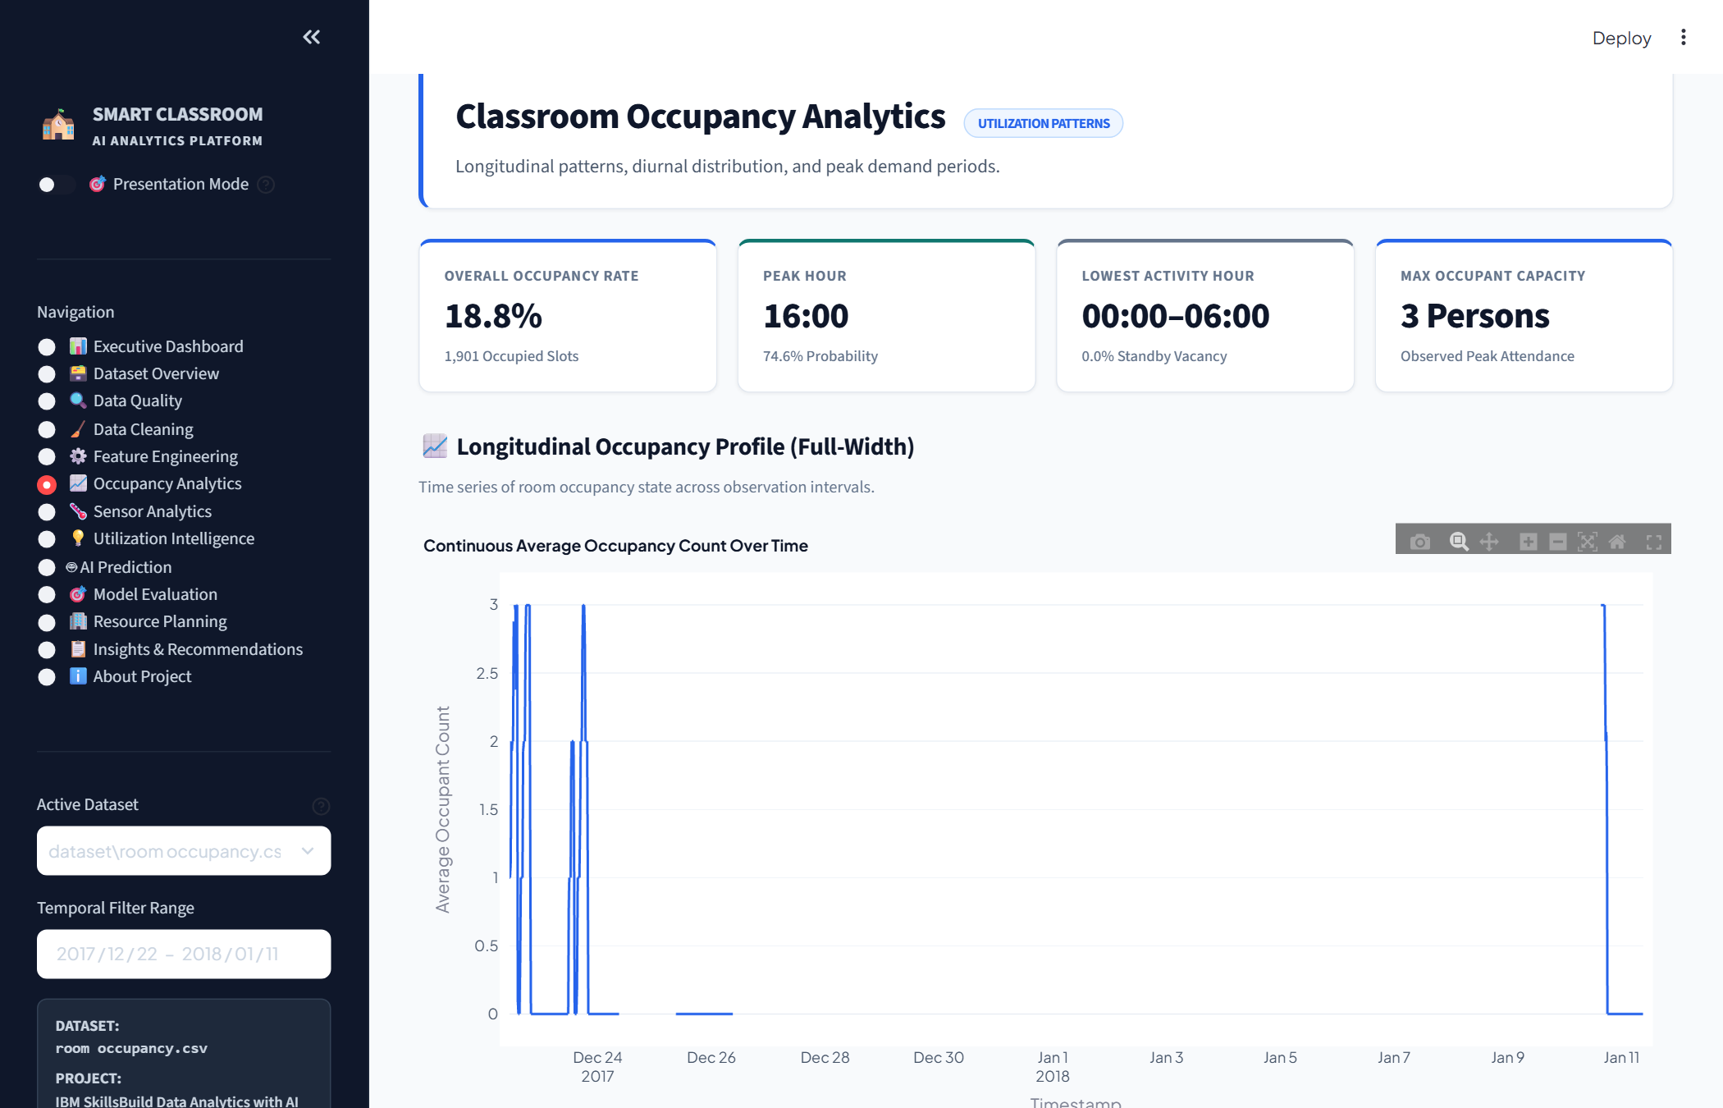
Figure 2. Occupancy Analytics
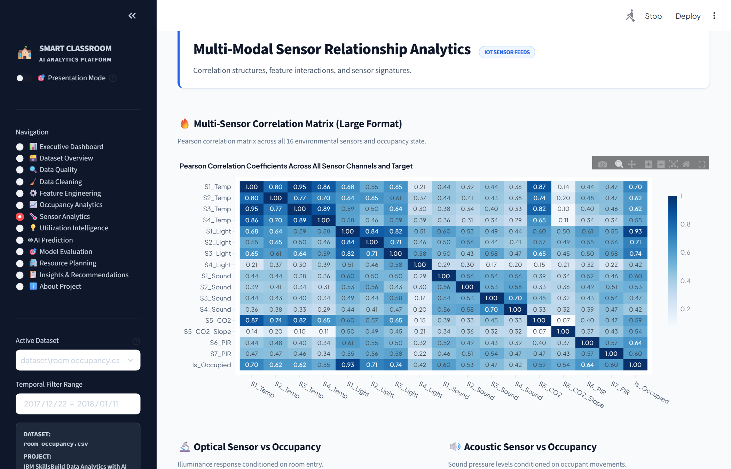
Figure 3. Sensor Analytics
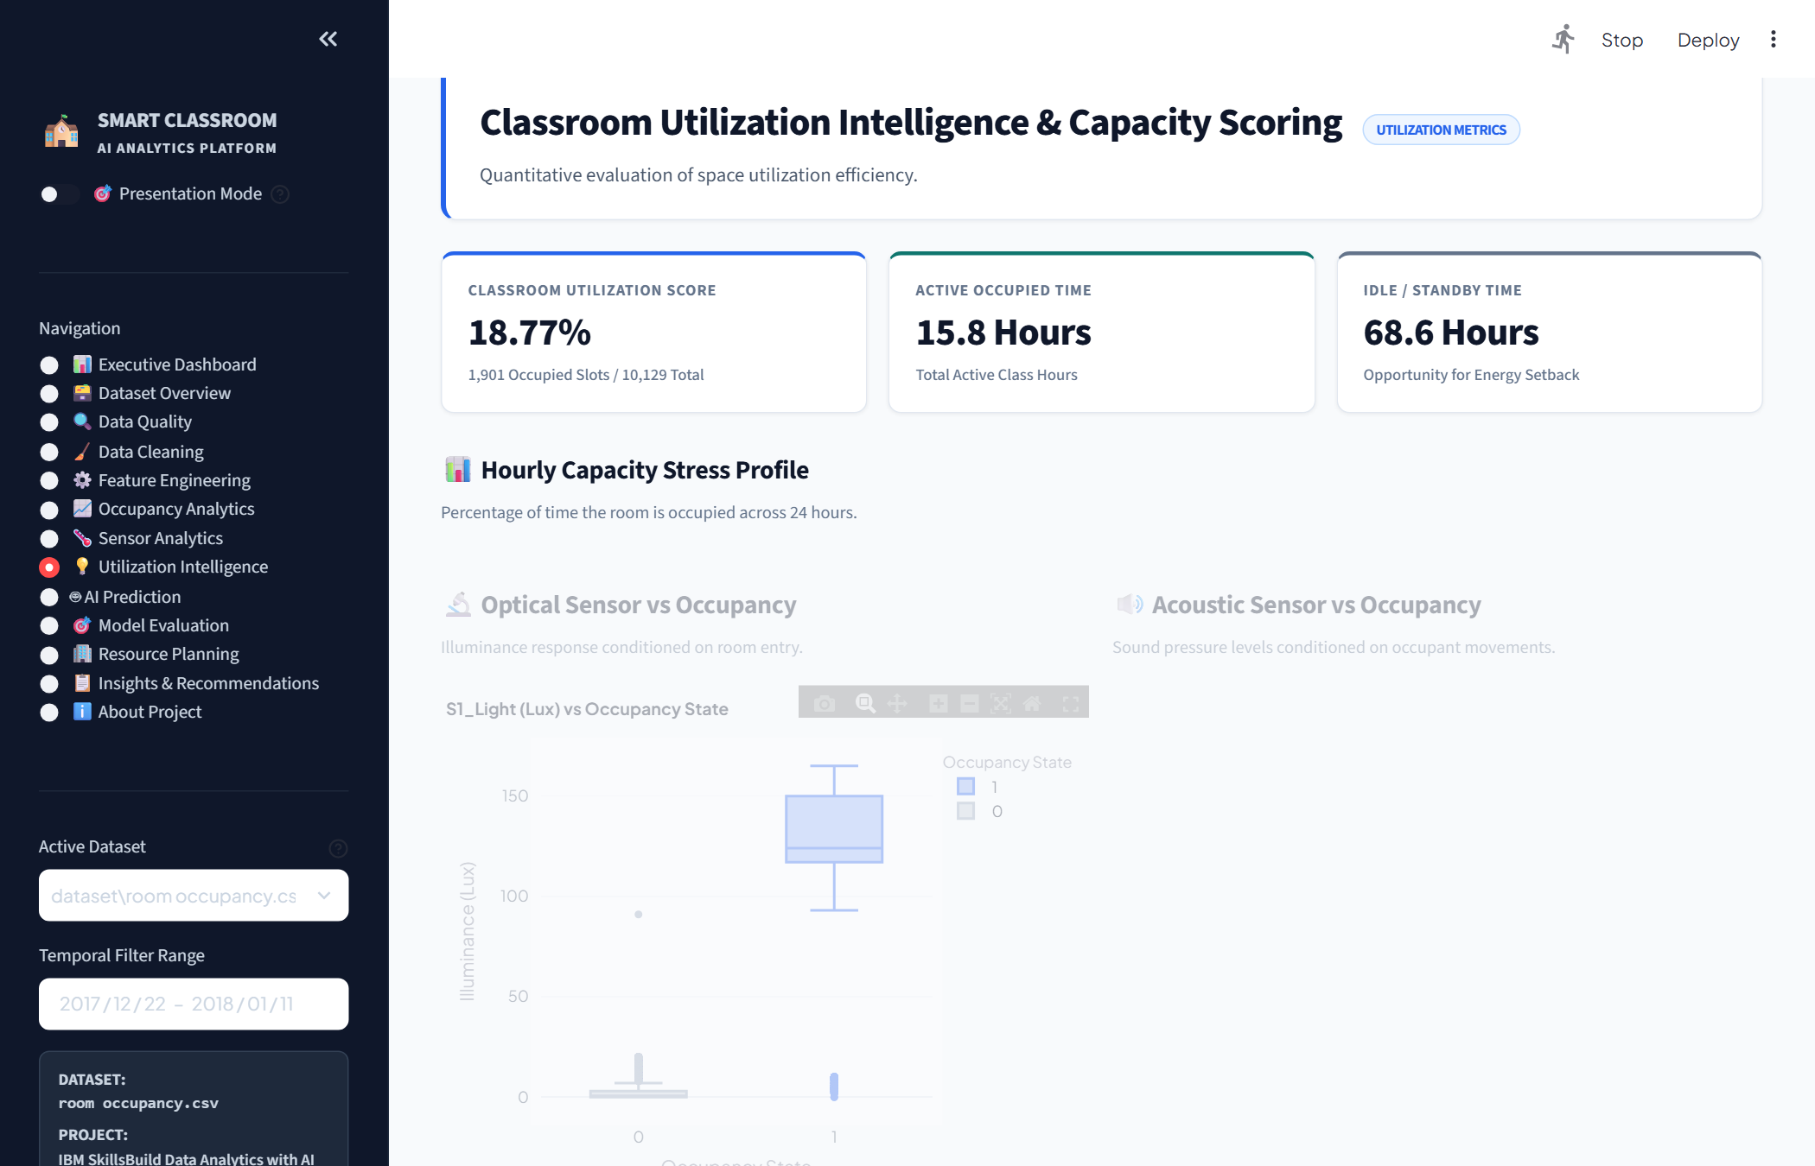
Figure 4. Classroom Utilization Analysis
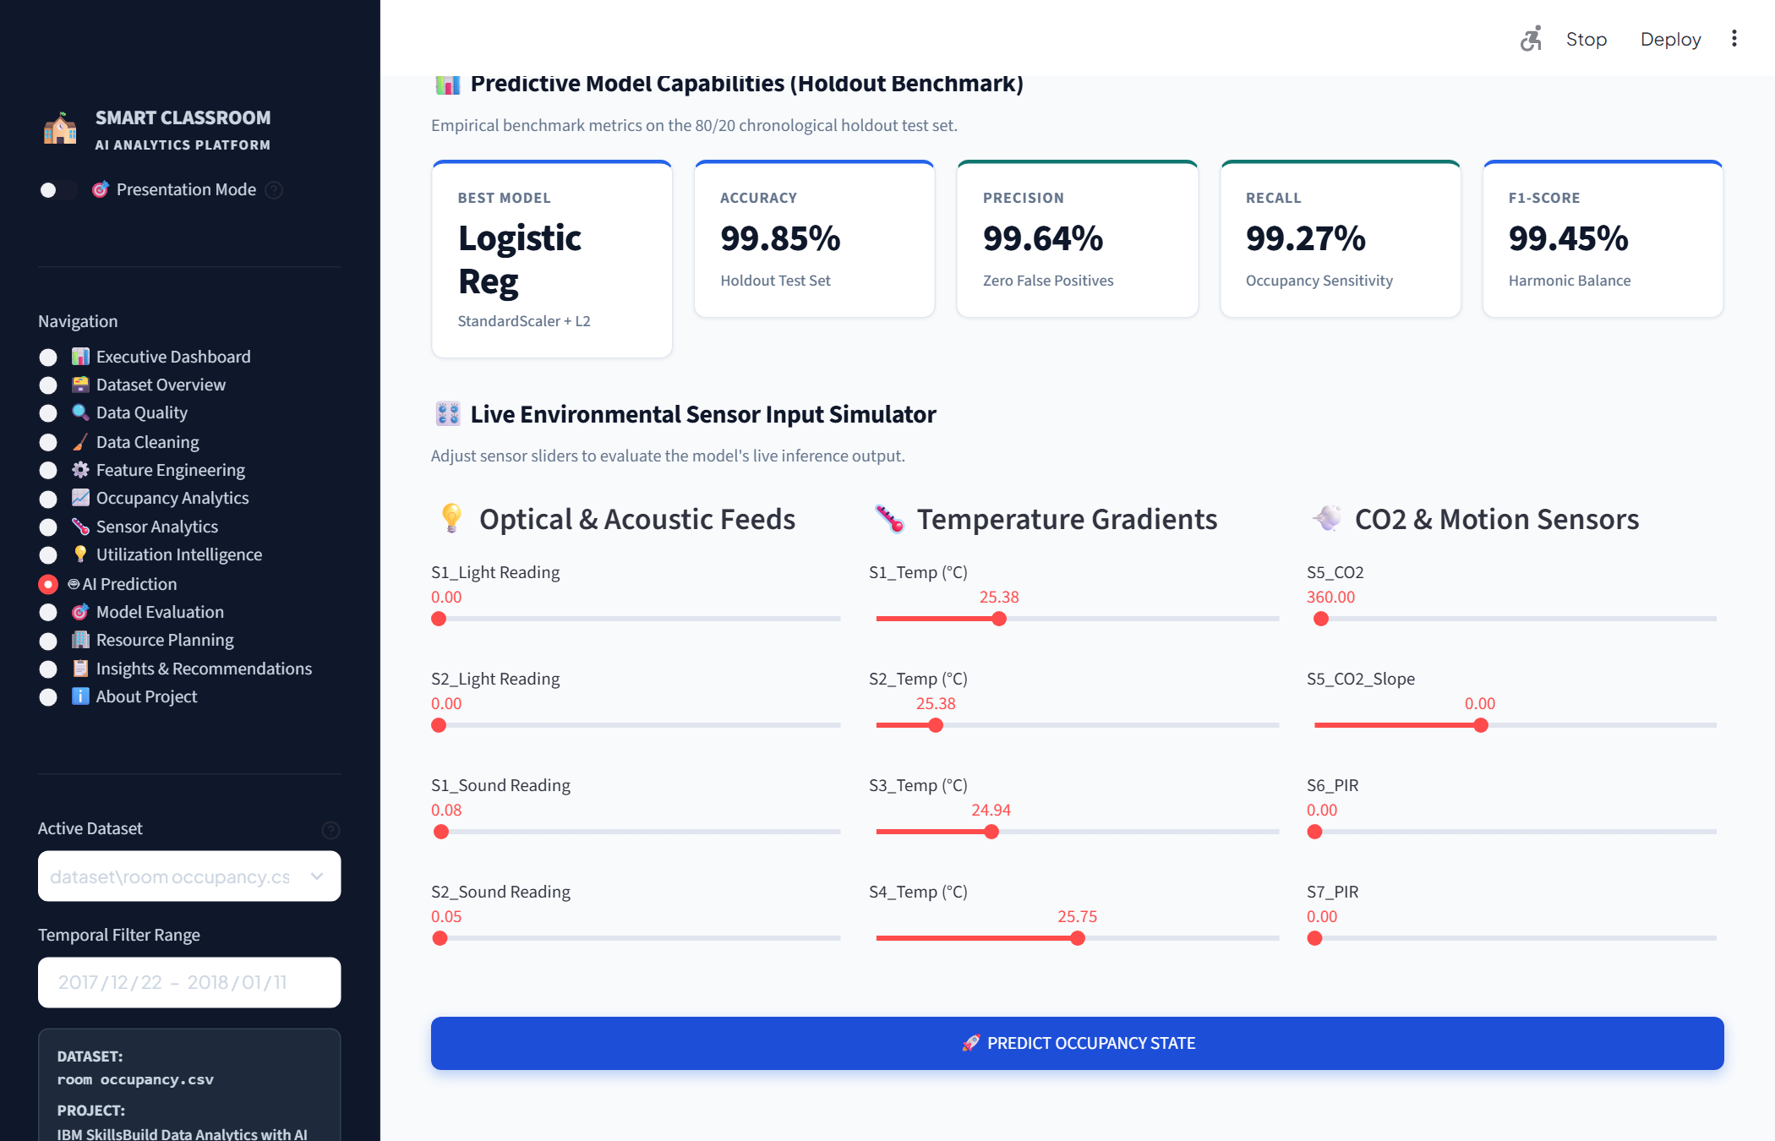
Figure 5. AI Occupancy Prediction
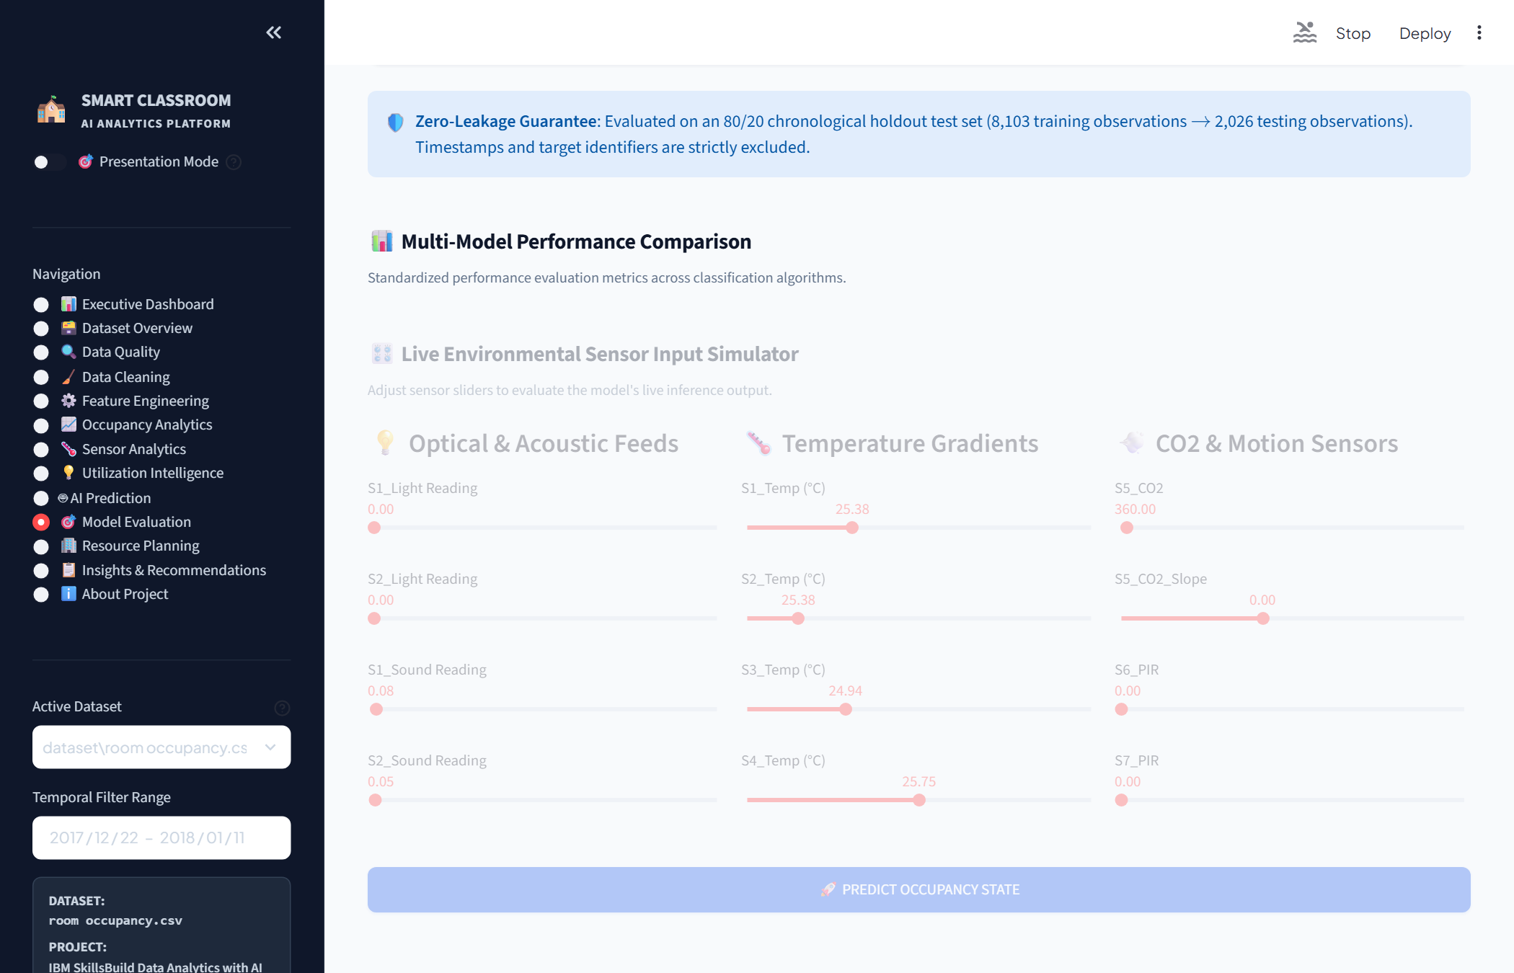
Figure 6. Machine Learning Model Evaluation
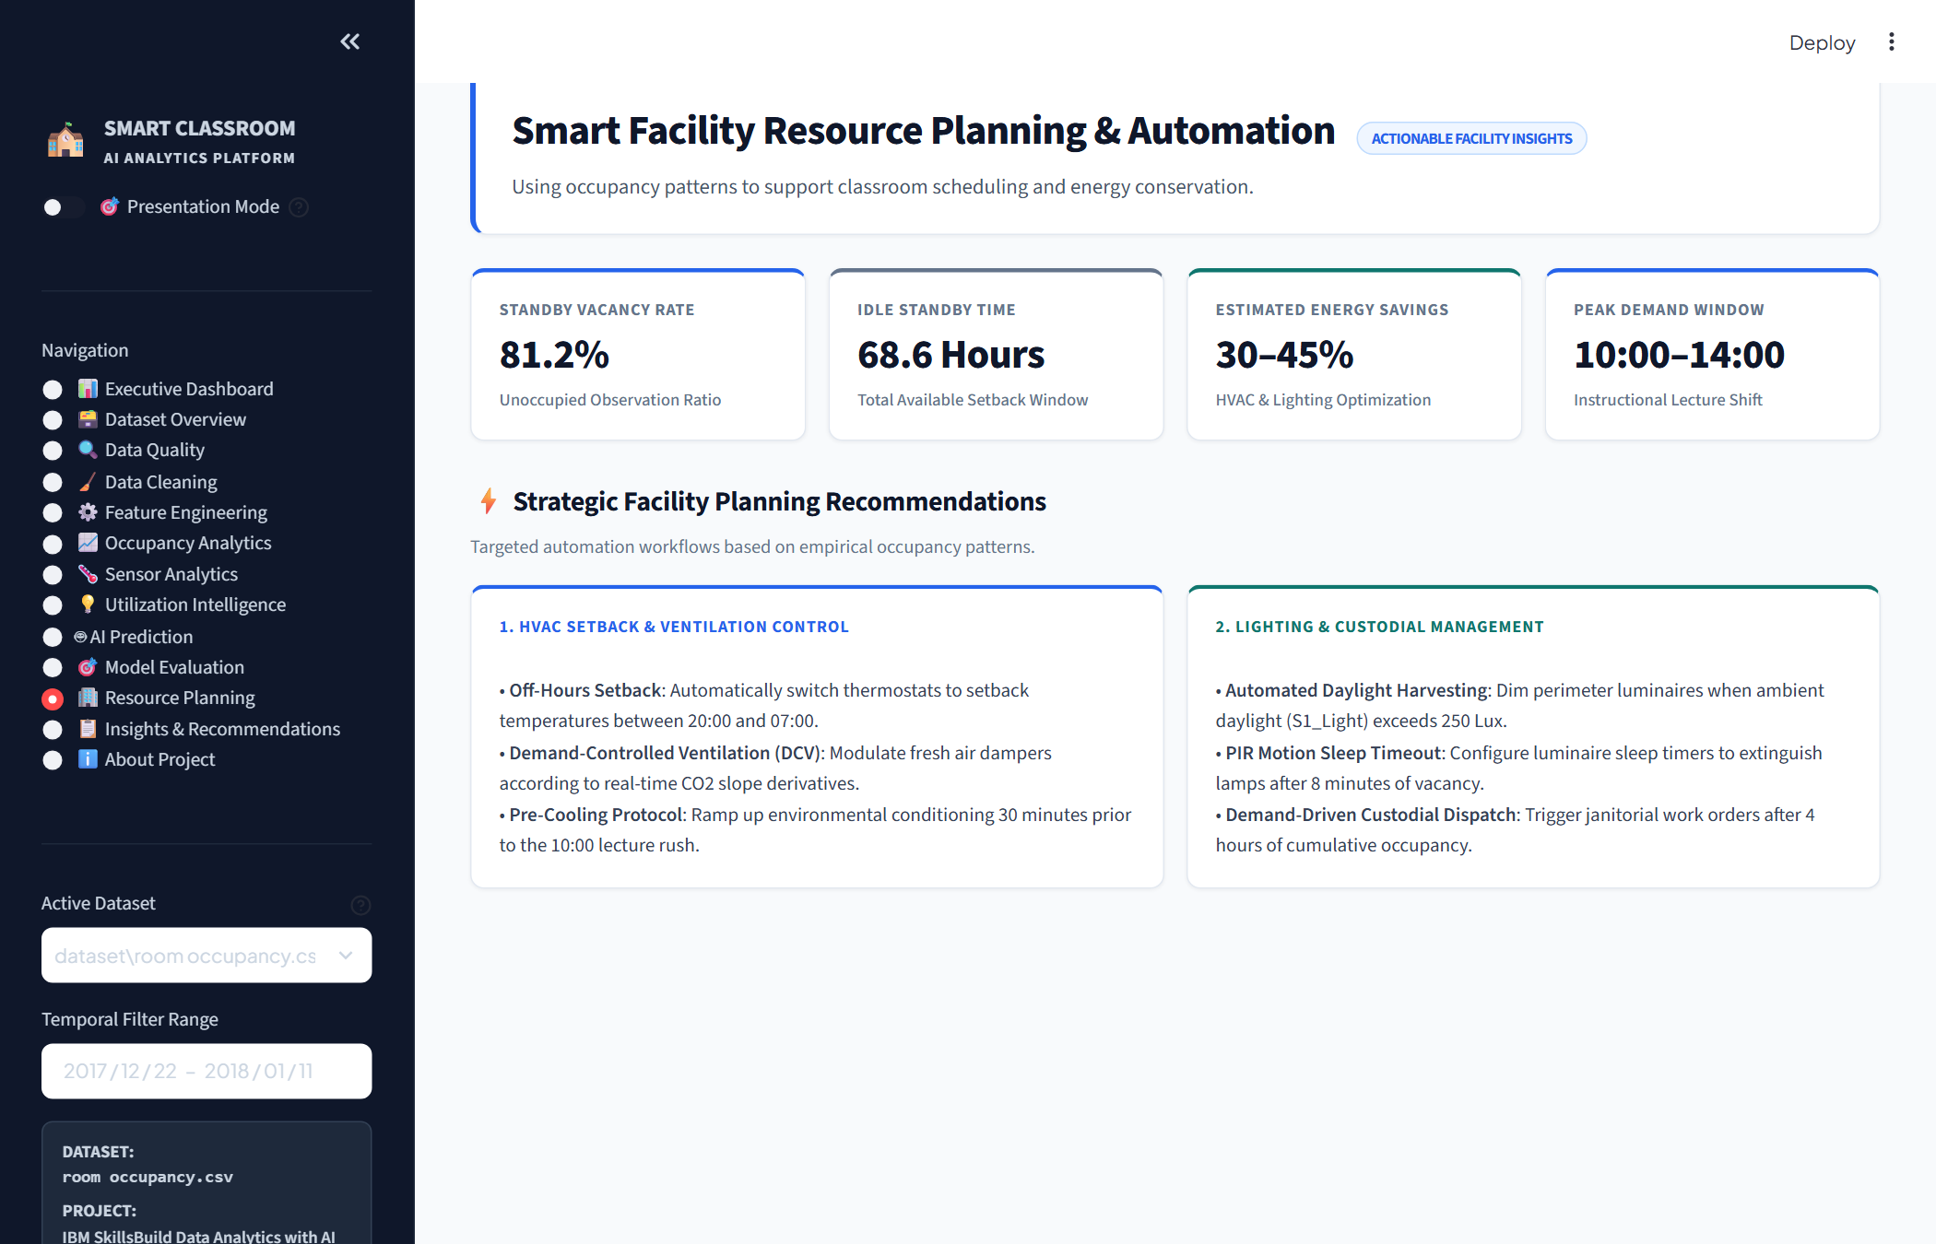
Figure 7. Smart Resource Planning Insights
9. Key Insights
• The data shows an overall 24/7 occupancy rate of 18.77%, with 81.23% of total recorded time being unoccupied.
• Peak occupancy occurs during late morning hours (10:00 AM to 12:00 PM) on weekdays, reaching 64.80% utilization.
• Weekday utilization between 08:00 AM and 18:00 PM averages 38.42%, indicating substantial vacancy between scheduled classes.
• Light intensity is the strongest immediate indicator of presence (r = +0.88), followed by sound levels (r = +0.62) and CO2 slope (r = +0.64).
• The machine learning models achieved over 96% to 99.85% accuracy on unseen test data using ambient sensor fusion.
10. Business / Resource Planning Decisions
Based on the actual project findings, the following practical resource-planning decisions can be implemented:
• Plan Classroom Allocation Around High-Demand Periods: Schedule high-enrollment courses during the 10:00 AM - 12:00 PM peak window and utilize low-demand afternoon blocks (16:00 - 18:00) for flexible study or tutoring sessions.
• Identify Underutilized Periods: Address the 61.58% vacancy during scheduled weekday hours by consolidating smaller courses into compact room clusters.
• Automated HVAC and Lighting Control: Use occupancy detection and predictions to trigger eco-mode HVAC setbacks and automated lighting deactivation during vacant hours.
• Use Occupancy Predictions for Facility Planning: Utilize the AI prediction interface to verify presence and anticipate room availability in real time.
• Non-Invasive Presence Monitoring: Rely on ambient environmental sensors (light, sound, CO2, temperature) to monitor occupancy accurately without deploying privacy-sensitive cameras.
11. Conclusion
This project demonstrates how classroom occupancy and environmental sensor data can be transformed into actionable insights through structured data cleaning, exploratory analysis, visualization, and machine learning. By processing 10,129 multi-sensor records and training classification models that achieve up to 99.85% accuracy, the system successfully detects presence, evaluates utilization patterns, and supports intelligent classroom resource planning.
The interactive Streamlit dashboard brings all analytical findings, live predictions, and planning tools together into a clear, accessible interface for institutional decision-makers.

