# Mini Project 2

# Part 1:

# Code for creation of Itemtable

CREATE TABLE Item (

Item_id int NOT NULL,

Item_name Varchar(20) NOT NULL,

Price varchar(20) NOT NULL,

PRIMARY KEY(Item_id)

UNIQUE(Item_id));

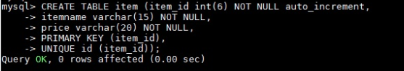

# Schema for Item Table

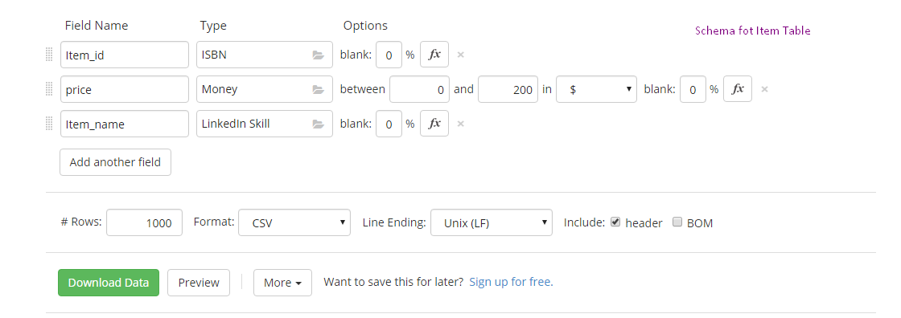

## Preview of data downloaded from mockaroo

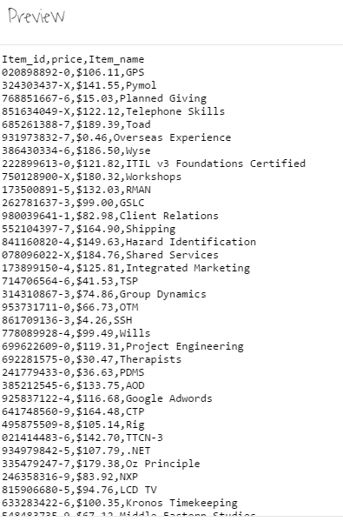

# Code for Shipment Table:

CREATE TABLE shipment (

Shipment_id int NOT NULL auto_increment,

Customer_id int NOT NULL,

Item_id int NOT NULL,

Price varchar(20) NOT NULL,

FOREIGN KEY(item_id) REFERENCES item(item_id)

PRIMARY KEY(shipment_id)

UNIQUE(shipment_id));

# Schema used for shipment table:

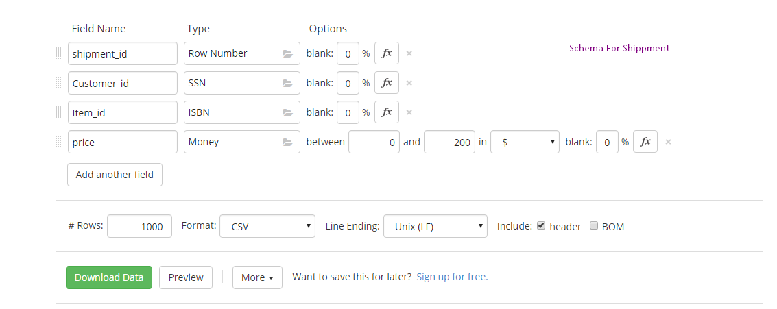

## Preview of data downloaded from mockaroo

