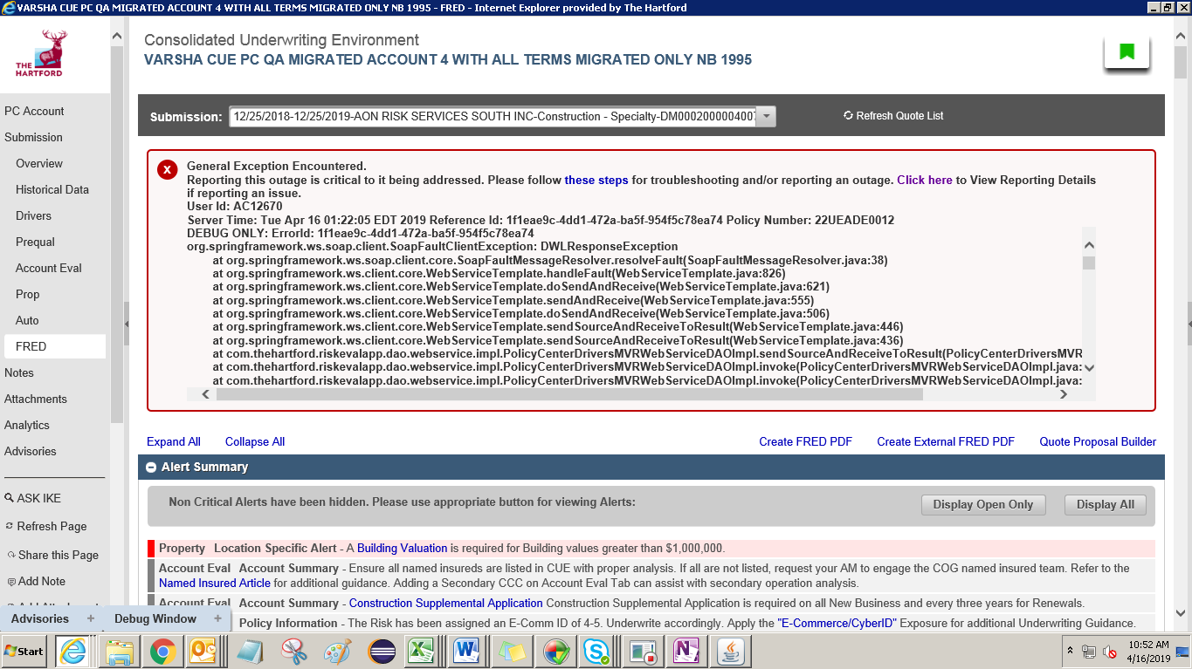

General Exception Encountered.

Reporting this outage is critical to it being addressed. Please follow [these steps](https://qacue.thehartford.com/riskeval/app/Submission/FRED/k9pohflc64796tla2fo4bjr10t/811084861052908/DM0002000004007/) for troubleshooting and/or reporting an outage. [Click here](https://qacue.thehartford.com/riskeval/app/Submission/FRED/k9pohflc64796tla2fo4bjr10t/811084861052908/DM0002000004007/) to View Reporting Details if reporting an issue.   
User Id: AC12670  
Server Time: Tue Apr 16 01:22:05 EDT 2019 Reference Id: 1f1eae9c-4dd1-472a-ba5f-954f5c78ea74 Policy Number: 22UEADE0012

DEBUG ONLY: ErrorId: 1f1eae9c-4dd1-472a-ba5f-954f5c78ea74   
org.springframework.ws.soap.client.SoapFaultClientException: DWLResponseException

at org.springframework.ws.soap.client.core.SoapFaultMessageResolver.resolveFault(SoapFaultMessageResolver.java:38)

at org.springframework.ws.client.core.WebServiceTemplate.handleFault(WebServiceTemplate.java:826)

at org.springframework.ws.client.core.WebServiceTemplate.doSendAndReceive(WebServiceTemplate.java:621)

at org.springframework.ws.client.core.WebServiceTemplate.sendAndReceive(WebServiceTemplate.java:555)

at org.springframework.ws.client.core.WebServiceTemplate.doSendAndReceive(WebServiceTemplate.java:506)

at org.springframework.ws.client.core.WebServiceTemplate.sendSourceAndReceiveToResult(WebServiceTemplate.java:446)

at org.springframework.ws.client.core.WebServiceTemplate.sendSourceAndReceiveToResult(WebServiceTemplate.java:436)

at com.thehartford.riskevalapp.dao.webservice.impl.PolicyCenterDriversMVRWebServiceDAOImpl.sendSourceAndReceiveToResult(PolicyCenterDriversMVRWebServiceDAOImpl.java:74)

at com.thehartford.riskevalapp.dao.webservice.impl.PolicyCenterDriversMVRWebServiceDAOImpl.invoke(PolicyCenterDriversMVRWebServiceDAOImpl.java:59)

at com.thehartford.riskevalapp.dao.webservice.impl.PolicyCenterDriversMVRWebServiceDAOImpl.invoke(PolicyCenterDriversMVRWebServiceDAOImpl.java:28)

at com.thehartford.riskevalapp.services.CachingService.getData(CachingService.java:60)

at com.thehartford.riskevalapp.services.impl.PolicyCenterDriversMVRServiceImpl.getPCDrivers(PolicyCenterDriversMVRServiceImpl.java:74)

at com.thehartford.riskevalapp.services.impl.DriversInfoServiceImpl.refreshDriverDetails(DriversInfoServiceImpl.java:71)

at com.thehartford.riskevalapp.services.impl.DriversInfoServiceImpl.fetchDriverDetails(DriversInfoServiceImpl.java:54)

at com.thehartford.riskevalapp.services.impl.DriversInfoServiceImpl.getDriverDetails(DriversInfoServiceImpl.java:139)

at com.thehartford.riskevalapp.services.mappers.MMASMapper.populateDriversData(MMASMapper.java:3480)

at com.thehartford.riskevalapp.services.mappers.MMASMapper.prepareMMASRequestMap(MMASMapper.java:174)

at com.thehartford.riskevalapp.model.view.LOBEnhancedView.populateMMASMapForNonCompanionPolicy(LOBEnhancedView.java:2021)

at com.thehartford.riskevalapp.model.view.LOBEnhancedView.launchMMASLink(LOBEnhancedView.java:2014)

at com.thehartford.riskevalapp.model.view.MMASView.init(MMASView.java:23)

at sun.reflect.NativeMethodAccessorImpl.invoke0(Native Method)

at sun.reflect.NativeMethodAccessorImpl.invoke(NativeMethodAccessorImpl.java:62)

at sun.reflect.DelegatingMethodAccessorImpl.invoke(DelegatingMethodAccessorImpl.java:43)

at java.lang.reflect.Method.invoke(Method.java:498)

at org.springframework.beans.factory.annotation.InitDestroyAnnotationBeanPostProcessor$LifecycleElement.invoke(InitDestroyAnnotationBeanPostProcessor.java:349)

at org.springframework.beans.factory.annotation.InitDestroyAnnotationBeanPostProcessor$LifecycleMetadata.invokeInitMethods(InitDestroyAnnotationBeanPostProcessor.java:300)

at org.springframework.beans.factory.annotation.InitDestroyAnnotationBeanPostProcessor.postProcessBeforeInitialization(InitDestroyAnnotationBeanPostProcessor.java:133)

at org.springframework.beans.factory.support.AbstractAutowireCapableBeanFactory.applyBeanPostProcessorsBeforeInitialization(AbstractAutowireCapableBeanFactory.java:407)

at org.springframework.beans.factory.support.AbstractAutowireCapableBeanFactory.initializeBean(AbstractAutowireCapableBeanFactory.java:1545)

at org.springframework.beans.factory.support.AbstractAutowireCapableBeanFactory.doCreateBean(AbstractAutowireCapableBeanFactory.java:539)

at org.springframework.beans.factory.support.AbstractAutowireCapableBeanFactory.createBean(AbstractAutowireCapableBeanFactory.java:475)

at org.springframework.beans.factory.support.AbstractBeanFactory$2.getObject(AbstractBeanFactory.java:343)

at org.primefaces.spring.scope.ViewScope.get(ViewScope.java:18)

at org.springframework.beans.factory.support.AbstractBeanFactory.doGetBean(AbstractBeanFactory.java:338)

at org.springframework.beans.factory.support.AbstractBeanFactory.getBean(AbstractBeanFactory.java:195)

at org.springframework.context.support.AbstractApplicationContext.getBean(AbstractApplicationContext.java:973)

at org.springframework.beans.factory.access.el.SpringBeanELResolver.getValue(SpringBeanELResolver.java:55)

at com.sun.faces.el.DemuxCompositeELResolver._getValue(DemuxCompositeELResolver.java:176)

at com.sun.faces.el.DemuxCompositeELResolver.getValue(DemuxCompositeELResolver.java:203)

at com.sun.el.parser.AstIdentifier.getValue(AstIdentifier.java:116)

at com.sun.el.parser.AstValue.getBase(AstValue.java:150)

at com.sun.el.parser.AstValue.getValue(AstValue.java:199)

at com.sun.el.ValueExpressionImpl.getValue(ValueExpressionImpl.java:226)

at com.sun.faces.facelets.el.TagValueExpression.getValue(TagValueExpression.java:109)

at com.sun.faces.facelets.tag.TagAttributeImpl.getObject(TagAttributeImpl.java:356)

at com.sun.faces.facelets.tag.TagAttributeImpl.getBoolean(TagAttributeImpl.java:150)

at com.sun.faces.facelets.tag.jstl.core.IfHandler.apply(IfHandler.java:91)

at javax.faces.view.facelets.CompositeFaceletHandler.apply(CompositeFaceletHandler.java:95)

at javax.faces.view.facelets.DelegatingMetaTagHandler.applyNextHandler(DelegatingMetaTagHandler.java:137)

at com.sun.faces.facelets.tag.jsf.ComponentTagHandlerDelegateImpl.apply(ComponentTagHandlerDelegateImpl.java:190)

at javax.faces.view.facelets.DelegatingMetaTagHandler.apply(DelegatingMetaTagHandler.java:120)

at javax.faces.view.facelets.CompositeFaceletHandler.apply(CompositeFaceletHandler.java:95)

at com.sun.faces.facelets.tag.ui.CompositionHandler.apply(CompositionHandler.java:189)

at com.sun.faces.facelets.compiler.NamespaceHandler.apply(NamespaceHandler.java:93)

at com.sun.faces.facelets.compiler.EncodingHandler.apply(EncodingHandler.java:87)

at com.sun.faces.facelets.impl.DefaultFacelet.include(DefaultFacelet.java:312)

at com.sun.faces.facelets.impl.DefaultFacelet.include(DefaultFacelet.java:371)

at com.sun.faces.facelets.impl.DefaultFacelet.include(DefaultFacelet.java:350)

at com.sun.faces.facelets.impl.DefaultFaceletContext.includeFacelet(DefaultFaceletContext.java:199)

at com.sun.faces.facelets.tag.ui.IncludeHandler.apply(IncludeHandler.java:120)

at javax.faces.view.facelets.DelegatingMetaTagHandler.applyNextHandler(DelegatingMetaTagHandler.java:137)

at com.sun.faces.facelets.tag.jsf.ComponentTagHandlerDelegateImpl.apply(ComponentTagHandlerDelegateImpl.java:190)

at javax.faces.view.facelets.DelegatingMetaTagHandler.apply(DelegatingMetaTagHandler.java:120)

at javax.faces.view.facelets.CompositeFaceletHandler.apply(CompositeFaceletHandler.java:95)

at javax.faces.view.facelets.DelegatingMetaTagHandler.applyNextHandler(DelegatingMetaTagHandler.java:137)

at com.sun.faces.facelets.tag.jsf.ComponentTagHandlerDelegateImpl.apply(ComponentTagHandlerDelegateImpl.java:190)

at javax.faces.view.facelets.DelegatingMetaTagHandler.apply(DelegatingMetaTagHandler.java:120)

at javax.faces.view.facelets.CompositeFaceletHandler.apply(CompositeFaceletHandler.java:95)

at com.sun.faces.facelets.compiler.NamespaceHandler.apply(NamespaceHandler.java:93)

at com.sun.faces.facelets.compiler.EncodingHandler.apply(EncodingHandler.java:87)

at com.sun.faces.facelets.impl.DefaultFacelet.include(DefaultFacelet.java:312)

at com.sun.faces.facelets.impl.DefaultFacelet.include(DefaultFacelet.java:371)

at com.sun.faces.facelets.impl.DefaultFacelet.include(DefaultFacelet.java:350)

at com.sun.faces.facelets.impl.DefaultFaceletContext.includeFacelet(DefaultFaceletContext.java:199)

at com.sun.faces.facelets.tag.ui.CompositionHandler.apply(CompositionHandler.java:169)

at com.sun.faces.facelets.compiler.NamespaceHandler.apply(NamespaceHandler.java:93)

at com.sun.faces.facelets.compiler.EncodingHandler.apply(EncodingHandler.java:87)

at com.sun.faces.facelets.impl.DefaultFacelet.include(DefaultFacelet.java:312)

at com.sun.faces.facelets.impl.DefaultFacelet.include(DefaultFacelet.java:371)

at com.sun.faces.facelets.impl.DefaultFacelet.include(DefaultFacelet.java:350)

at com.sun.faces.facelets.impl.DefaultFaceletContext.includeFacelet(DefaultFaceletContext.java:199)

at com.sun.faces.facelets.tag.ui.CompositionHandler.apply(CompositionHandler.java:169)

at com.sun.faces.facelets.compiler.NamespaceHandler.apply(NamespaceHandler.java:93)

at com.sun.faces.facelets.compiler.EncodingHandler.apply(EncodingHandler.java:87)

at com.sun.faces.facelets.impl.DefaultFacelet.apply(DefaultFacelet.java:161)

at com.sun.faces.application.view.FaceletViewHandlingStrategy.buildView(FaceletViewHandlingStrategy.java:980)

at com.sun.faces.lifecycle.RenderResponsePhase.execute(RenderResponsePhase.java:99)

at com.sun.faces.lifecycle.Phase.doPhase(Phase.java:101)

at com.sun.faces.lifecycle.LifecycleImpl.render(LifecycleImpl.java:219)

at javax.faces.webapp.FacesServlet.service(FacesServlet.java:647)

at weblogic.servlet.internal.StubSecurityHelper$ServletServiceAction.run(StubSecurityHelper.java:286)

at weblogic.servlet.internal.StubSecurityHelper$ServletServiceAction.run(StubSecurityHelper.java:260)

at weblogic.servlet.internal.StubSecurityHelper.invokeServlet(StubSecurityHelper.java:137)

at weblogic.servlet.internal.ServletStubImpl.execute(ServletStubImpl.java:350)

at weblogic.servlet.internal.TailFilter.doFilter(TailFilter.java:25)

at weblogic.servlet.internal.FilterChainImpl.doFilter(FilterChainImpl.java:78)

at org.primefaces.webapp.filter.FileUploadFilter.doFilter(FileUploadFilter.java:100)

at weblogic.servlet.internal.FilterChainImpl.doFilter(FilterChainImpl.java:78)

at org.ocpsoft.rewrite.servlet.RewriteFilter.doFilter(RewriteFilter.java:205)

at weblogic.servlet.internal.FilterChainImpl.doFilter(FilterChainImpl.java:78)

at com.thehartford.riskevalapp.filters.RoleFilter.doFilter(RoleFilter.java:123)

at weblogic.servlet.internal.FilterChainImpl.doFilter(FilterChainImpl.java:78)

at com.thehartford.riskevalapp.filters.NavigationFilter.doFilter(NavigationFilter.java:298)

at weblogic.servlet.internal.FilterChainImpl.doFilter(FilterChainImpl.java:78)

at com.thehartford.riskevalapp.filters.MetaDataFilter.doFilter(MetaDataFilter.java:51)

at weblogic.servlet.internal.FilterChainImpl.doFilter(FilterChainImpl.java:78)

at com.thehartford.riskevalapp.filters.WindowScopeFilter.doFilter(WindowScopeFilter.java:230)

at weblogic.servlet.internal.FilterChainImpl.doFilter(FilterChainImpl.java:78)

at com.thehartford.riskevalapp.filters.CacheControlFilter.doFilter(CacheControlFilter.java:69)

at weblogic.servlet.internal.FilterChainImpl.doFilter(FilterChainImpl.java:78)

at weblogic.servlet.internal.RequestDispatcherImpl.invokeServlet(RequestDispatcherImpl.java:631)

at weblogic.servlet.internal.RequestDispatcherImpl.forward(RequestDispatcherImpl.java:287)

at org.ocpsoft.rewrite.servlet.impl.HttpRewriteResultHandler.handleResult(HttpRewriteResultHandler.java:41)

at org.ocpsoft.rewrite.servlet.RewriteFilter.rewrite(RewriteFilter.java:268)

at org.ocpsoft.rewrite.servlet.RewriteFilter.doFilter(RewriteFilter.java:188)

at weblogic.servlet.internal.FilterChainImpl.doFilter(FilterChainImpl.java:78)

at com.thehartford.riskevalapp.filters.HeaderFilter.doFilter(HeaderFilter.java:190)

at weblogic.servlet.internal.FilterChainImpl.doFilter(FilterChainImpl.java:78)

at org.springframework.web.filter.RequestContextFilter.doFilterInternal(RequestContextFilter.java:99)

at org.springframework.web.filter.OncePerRequestFilter.doFilter(OncePerRequestFilter.java:107)

at weblogic.servlet.internal.FilterChainImpl.doFilter(FilterChainImpl.java:78)

at com.thehartford.riskevalapp.filters.GZIPFilter.doFilter(GZIPFilter.java:52)

at weblogic.servlet.internal.FilterChainImpl.doFilter(FilterChainImpl.java:78)

at com.thehartford.riskevalapp.filters.CacheControlFilter.doFilter(CacheControlFilter.java:69)

at weblogic.servlet.internal.FilterChainImpl.doFilter(FilterChainImpl.java:78)

at weblogic.servlet.internal.RequestEventsFilter.doFilter(RequestEventsFilter.java:32)

at weblogic.servlet.internal.FilterChainImpl.doFilter(FilterChainImpl.java:78)

at weblogic.servlet.internal.WebAppServletContext$ServletInvocationAction.wrapRun(WebAppServletContext.java:3706)

at weblogic.servlet.internal.WebAppServletContext$ServletInvocationAction.run(WebAppServletContext.java:3672)

at weblogic.security.acl.internal.AuthenticatedSubject.doAs(AuthenticatedSubject.java:328)

at weblogic.security.service.SecurityManager.runAsForUserCode(SecurityManager.java:197)

at weblogic.servlet.provider.WlsSecurityProvider.runAsForUserCode(WlsSecurityProvider.java:203)

at weblogic.servlet.provider.WlsSubjectHandle.run(WlsSubjectHandle.java:71)

at weblogic.servlet.internal.WebAppServletContext.doSecuredExecute(WebAppServletContext.java:2443)

at weblogic.servlet.internal.WebAppServletContext.securedExecute(WebAppServletContext.java:2291)

at weblogic.servlet.internal.WebAppServletContext.execute(WebAppServletContext.java:2269)

at weblogic.servlet.internal.ServletRequestImpl.runInternal(ServletRequestImpl.java:1705)

at weblogic.servlet.internal.ServletRequestImpl.run(ServletRequestImpl.java:1665)

at weblogic.servlet.provider.ContainerSupportProviderImpl$WlsRequestExecutor.run(ContainerSupportProviderImpl.java:272)

at weblogic.invocation.ComponentInvocationContextManager._runAs(ComponentInvocationContextManager.java:352)

at weblogic.invocation.ComponentInvocationContextManager.runAs(ComponentInvocationContextManager.java:337)

at weblogic.work.LivePartitionUtility.doRunWorkUnderContext(LivePartitionUtility.java:57)

at weblogic.work.PartitionUtility.runWorkUnderContext(PartitionUtility.java:41)

at weblogic.work.SelfTuningWorkManagerImpl.runWorkUnderContext(SelfTuningWorkManagerImpl.java:652)

at weblogic.work.ExecuteThread.execute(ExecuteThread.java:420)

at weblogic.work.ExecuteThread.run(ExecuteThread.java:360)

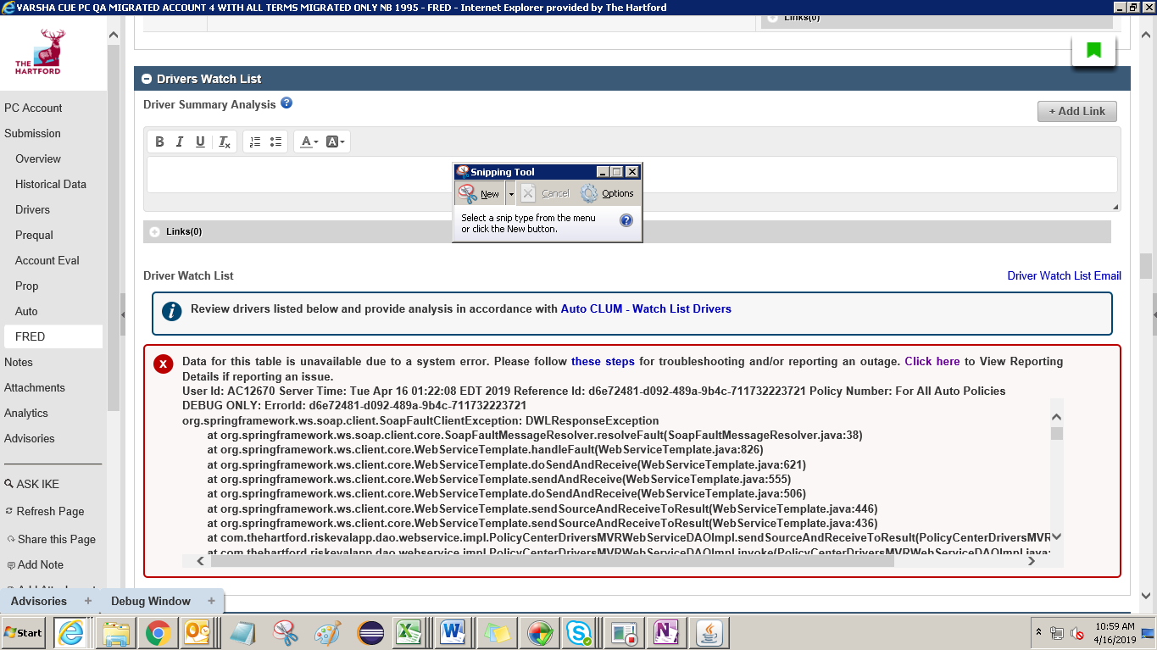

Data for this table is unavailable due to a system error. Please follow [these steps](https://qacue.thehartford.com/riskeval/app/Submission/FRED/k9pohflc64796tla2fo4bjr10t/811084861052908/DM0002000004007/) for troubleshooting and/or reporting an outage. [Click here](https://qacue.thehartford.com/riskeval/app/Submission/FRED/k9pohflc64796tla2fo4bjr10t/811084861052908/DM0002000004007/) to View Reporting Details if reporting an issue.   
User Id: AC12670 Server Time: Tue Apr 16 01:22:08 EDT 2019 Reference Id: d6e72481-d092-489a-9b4c-711732223721 Policy Number: For All Auto Policies

DEBUG ONLY: ErrorId: d6e72481-d092-489a-9b4c-711732223721   
org.springframework.ws.soap.client.SoapFaultClientException: DWLResponseException

at org.springframework.ws.soap.client.core.SoapFaultMessageResolver.resolveFault(SoapFaultMessageResolver.java:38)

at org.springframework.ws.client.core.WebServiceTemplate.handleFault(WebServiceTemplate.java:826)

at org.springframework.ws.client.core.WebServiceTemplate.doSendAndReceive(WebServiceTemplate.java:621)

at org.springframework.ws.client.core.WebServiceTemplate.sendAndReceive(WebServiceTemplate.java:555)

at org.springframework.ws.client.core.WebServiceTemplate.doSendAndReceive(WebServiceTemplate.java:506)

at org.springframework.ws.client.core.WebServiceTemplate.sendSourceAndReceiveToResult(WebServiceTemplate.java:446)

at org.springframework.ws.client.core.WebServiceTemplate.sendSourceAndReceiveToResult(WebServiceTemplate.java:436)

at com.thehartford.riskevalapp.dao.webservice.impl.PolicyCenterDriversMVRWebServiceDAOImpl.sendSourceAndReceiveToResult(PolicyCenterDriversMVRWebServiceDAOImpl.java:74)

at com.thehartford.riskevalapp.dao.webservice.impl.PolicyCenterDriversMVRWebServiceDAOImpl.invoke(PolicyCenterDriversMVRWebServiceDAOImpl.java:59)

at com.thehartford.riskevalapp.dao.webservice.impl.PolicyCenterDriversMVRWebServiceDAOImpl.invoke(PolicyCenterDriversMVRWebServiceDAOImpl.java:28)

at com.thehartford.riskevalapp.services.CachingService.getData(CachingService.java:60)

at com.thehartford.riskevalapp.services.impl.PolicyCenterDriversMVRServiceImpl.getPCDrivers(PolicyCenterDriversMVRServiceImpl.java:74)

at com.thehartford.riskevalapp.services.impl.DriversInfoServiceImpl.refreshDriverDetails(DriversInfoServiceImpl.java:71)

at com.thehartford.riskevalapp.services.impl.DriversInfoServiceImpl.fetchDriverDetails(DriversInfoServiceImpl.java:54)

at com.thehartford.riskevalapp.services.impl.DriversInfoServiceImpl.fetchDriverDetails(DriversInfoServiceImpl.java:130)

at com.thehartford.riskevalapp.services.mappers.AutoDirversSummaryMapper.fetchDriverDetails(AutoDirversSummaryMapper.java:122)

at com.thehartford.riskevalapp.services.mappers.AutoDirversSummaryMapper.getDriversSummary(AutoDirversSummaryMapper.java:1001)

at com.thehartford.riskevalapp.model.view.DocumentationView.getAutoSummaryDetails(DocumentationView.java:1188)

at com.thehartford.riskevalapp.model.view.DocumentationView.init(DocumentationView.java:711)

at sun.reflect.NativeMethodAccessorImpl.invoke0(Native Method)

at sun.reflect.NativeMethodAccessorImpl.invoke(NativeMethodAccessorImpl.java:62)

at sun.reflect.DelegatingMethodAccessorImpl.invoke(DelegatingMethodAccessorImpl.java:43)

at java.lang.reflect.Method.invoke(Method.java:498)

at org.springframework.beans.factory.annotation.InitDestroyAnnotationBeanPostProcessor$LifecycleElement.invoke(InitDestroyAnnotationBeanPostProcessor.java:349)

at org.springframework.beans.factory.annotation.InitDestroyAnnotationBeanPostProcessor$LifecycleMetadata.invokeInitMethods(InitDestroyAnnotationBeanPostProcessor.java:300)

at org.springframework.beans.factory.annotation.InitDestroyAnnotationBeanPostProcessor.postProcessBeforeInitialization(InitDestroyAnnotationBeanPostProcessor.java:133)

at org.springframework.beans.factory.support.AbstractAutowireCapableBeanFactory.applyBeanPostProcessorsBeforeInitialization(AbstractAutowireCapableBeanFactory.java:407)

at org.springframework.beans.factory.support.AbstractAutowireCapableBeanFactory.initializeBean(AbstractAutowireCapableBeanFactory.java:1545)

at org.springframework.beans.factory.support.AbstractAutowireCapableBeanFactory.doCreateBean(AbstractAutowireCapableBeanFactory.java:539)

at org.springframework.beans.factory.support.AbstractAutowireCapableBeanFactory.createBean(AbstractAutowireCapableBeanFactory.java:475)

at org.springframework.beans.factory.support.AbstractBeanFactory$2.getObject(AbstractBeanFactory.java:343)

at org.primefaces.spring.scope.ViewScope.get(ViewScope.java:18)

at org.springframework.beans.factory.support.AbstractBeanFactory.doGetBean(AbstractBeanFactory.java:338)

at org.springframework.beans.factory.support.AbstractBeanFactory.getBean(AbstractBeanFactory.java:195)

at org.springframework.context.support.AbstractApplicationContext.getBean(AbstractApplicationContext.java:973)

at org.springframework.beans.factory.access.el.SpringBeanELResolver.getValue(SpringBeanELResolver.java:55)

at com.sun.faces.el.DemuxCompositeELResolver._getValue(DemuxCompositeELResolver.java:176)

at com.sun.faces.el.DemuxCompositeELResolver.getValue(DemuxCompositeELResolver.java:203)

at com.sun.el.parser.AstIdentifier.getValue(AstIdentifier.java:116)

at com.sun.el.parser.AstValue.getBase(AstValue.java:150)

at com.sun.el.parser.AstValue.getValue(AstValue.java:199)

at com.sun.el.parser.AstNot.getValue(AstNot.java:63)

at com.sun.el.ValueExpressionImpl.getValue(ValueExpressionImpl.java:226)

at com.sun.faces.facelets.el.TagValueExpression.getValue(TagValueExpression.java:109)

at com.sun.faces.facelets.tag.TagAttributeImpl.getObject(TagAttributeImpl.java:356)

at com.sun.faces.facelets.tag.TagAttributeImpl.getBoolean(TagAttributeImpl.java:150)

at com.sun.faces.facelets.tag.jstl.core.IfHandler.apply(IfHandler.java:91)

at javax.faces.view.facelets.CompositeFaceletHandler.apply(CompositeFaceletHandler.java:95)

at com.sun.faces.facelets.tag.ui.DefineHandler.applyDefinition(DefineHandler.java:106)

at com.sun.faces.facelets.tag.ui.CompositionHandler.apply(CompositionHandler.java:201)

at com.sun.faces.facelets.impl.DefaultFaceletContext$TemplateManager.apply(DefaultFaceletContext.java:395)

at com.sun.faces.facelets.impl.DefaultFaceletContext.includeDefinition(DefaultFaceletContext.java:366)

at com.sun.faces.facelets.tag.ui.InsertHandler.apply(InsertHandler.java:111)

at javax.faces.view.facelets.CompositeFaceletHandler.apply(CompositeFaceletHandler.java:95)

at com.sun.faces.facelets.tag.ui.DefineHandler.applyDefinition(DefineHandler.java:106)

at com.sun.faces.facelets.tag.ui.CompositionHandler.apply(CompositionHandler.java:201)

at com.sun.faces.facelets.impl.DefaultFaceletContext$TemplateManager.apply(DefaultFaceletContext.java:395)

at com.sun.faces.facelets.impl.DefaultFaceletContext.includeDefinition(DefaultFaceletContext.java:366)

at com.sun.faces.facelets.tag.ui.InsertHandler.apply(InsertHandler.java:111)

at javax.faces.view.facelets.CompositeFaceletHandler.apply(CompositeFaceletHandler.java:95)

at javax.faces.view.facelets.DelegatingMetaTagHandler.applyNextHandler(DelegatingMetaTagHandler.java:137)

at com.sun.faces.facelets.tag.jsf.ComponentTagHandlerDelegateImpl.apply(ComponentTagHandlerDelegateImpl.java:190)

at javax.faces.view.facelets.DelegatingMetaTagHandler.apply(DelegatingMetaTagHandler.java:120)

at javax.faces.view.facelets.CompositeFaceletHandler.apply(CompositeFaceletHandler.java:95)

at javax.faces.view.facelets.DelegatingMetaTagHandler.applyNextHandler(DelegatingMetaTagHandler.java:137)

at com.sun.faces.facelets.tag.jsf.ComponentTagHandlerDelegateImpl.apply(ComponentTagHandlerDelegateImpl.java:190)

at javax.faces.view.facelets.DelegatingMetaTagHandler.apply(DelegatingMetaTagHandler.java:120)

at javax.faces.view.facelets.CompositeFaceletHandler.apply(CompositeFaceletHandler.java:95)

at com.sun.faces.facelets.compiler.NamespaceHandler.apply(NamespaceHandler.java:93)

at com.sun.faces.facelets.compiler.EncodingHandler.apply(EncodingHandler.java:87)

at com.sun.faces.facelets.impl.DefaultFacelet.include(DefaultFacelet.java:312)

at com.sun.faces.facelets.impl.DefaultFacelet.include(DefaultFacelet.java:371)

at com.sun.faces.facelets.impl.DefaultFacelet.include(DefaultFacelet.java:350)

at com.sun.faces.facelets.impl.DefaultFaceletContext.includeFacelet(DefaultFaceletContext.java:199)

at com.sun.faces.facelets.tag.ui.CompositionHandler.apply(CompositionHandler.java:169)

at com.sun.faces.facelets.compiler.NamespaceHandler.apply(NamespaceHandler.java:93)

at com.sun.faces.facelets.compiler.EncodingHandler.apply(EncodingHandler.java:87)

at com.sun.faces.facelets.impl.DefaultFacelet.include(DefaultFacelet.java:312)

at com.sun.faces.facelets.impl.DefaultFacelet.include(DefaultFacelet.java:371)

at com.sun.faces.facelets.impl.DefaultFacelet.include(DefaultFacelet.java:350)

at com.sun.faces.facelets.impl.DefaultFaceletContext.includeFacelet(DefaultFaceletContext.java:199)

at com.sun.faces.facelets.tag.ui.CompositionHandler.apply(CompositionHandler.java:169)

at com.sun.faces.facelets.compiler.NamespaceHandler.apply(NamespaceHandler.java:93)

at com.sun.faces.facelets.compiler.EncodingHandler.apply(EncodingHandler.java:87)

at com.sun.faces.facelets.impl.DefaultFacelet.apply(DefaultFacelet.java:161)

at com.sun.faces.application.view.FaceletViewHandlingStrategy.buildView(FaceletViewHandlingStrategy.java:980)

at com.sun.faces.lifecycle.RenderResponsePhase.execute(RenderResponsePhase.java:99)

at com.sun.faces.lifecycle.Phase.doPhase(Phase.java:101)

at com.sun.faces.lifecycle.LifecycleImpl.render(LifecycleImpl.java:219)

at javax.faces.webapp.FacesServlet.service(FacesServlet.java:647)

at weblogic.servlet.internal.StubSecurityHelper$ServletServiceAction.run(StubSecurityHelper.java:286)

at weblogic.servlet.internal.StubSecurityHelper$ServletServiceAction.run(StubSecurityHelper.java:260)

at weblogic.servlet.internal.StubSecurityHelper.invokeServlet(StubSecurityHelper.java:137)

at weblogic.servlet.internal.ServletStubImpl.execute(ServletStubImpl.java:350)

at weblogic.servlet.internal.TailFilter.doFilter(TailFilter.java:25)

at weblogic.servlet.internal.FilterChainImpl.doFilter(FilterChainImpl.java:78)

at org.primefaces.webapp.filter.FileUploadFilter.doFilter(FileUploadFilter.java:100)

at weblogic.servlet.internal.FilterChainImpl.doFilter(FilterChainImpl.java:78)

at org.ocpsoft.rewrite.servlet.RewriteFilter.doFilter(RewriteFilter.java:205)

at weblogic.servlet.internal.FilterChainImpl.doFilter(FilterChainImpl.java:78)

at com.thehartford.riskevalapp.filters.RoleFilter.doFilter(RoleFilter.java:123)

at weblogic.servlet.internal.FilterChainImpl.doFilter(FilterChainImpl.java:78)

at com.thehartford.riskevalapp.filters.NavigationFilter.doFilter(NavigationFilter.java:298)

at weblogic.servlet.internal.FilterChainImpl.doFilter(FilterChainImpl.java:78)

at com.thehartford.riskevalapp.filters.MetaDataFilter.doFilter(MetaDataFilter.java:51)

at weblogic.servlet.internal.FilterChainImpl.doFilter(FilterChainImpl.java:78)

at com.thehartford.riskevalapp.filters.WindowScopeFilter.doFilter(WindowScopeFilter.java:230)

at weblogic.servlet.internal.FilterChainImpl.doFilter(FilterChainImpl.java:78)

at com.thehartford.riskevalapp.filters.CacheControlFilter.doFilter(CacheControlFilter.java:69)

at weblogic.servlet.internal.FilterChainImpl.doFilter(FilterChainImpl.java:78)

at weblogic.servlet.internal.RequestDispatcherImpl.invokeServlet(RequestDispatcherImpl.java:631)

at weblogic.servlet.internal.RequestDispatcherImpl.forward(RequestDispatcherImpl.java:287)

at org.ocpsoft.rewrite.servlet.impl.HttpRewriteResultHandler.handleResult(HttpRewriteResultHandler.java:41)

at org.ocpsoft.rewrite.servlet.RewriteFilter.rewrite(RewriteFilter.java:268)

at org.ocpsoft.rewrite.servlet.RewriteFilter.doFilter(RewriteFilter.java:188)

at weblogic.servlet.internal.FilterChainImpl.doFilter(FilterChainImpl.java:78)

at com.thehartford.riskevalapp.filters.HeaderFilter.doFilter(HeaderFilter.java:190)

at weblogic.servlet.internal.FilterChainImpl.doFilter(FilterChainImpl.java:78)

at org.springframework.web.filter.RequestContextFilter.doFilterInternal(RequestContextFilter.java:99)

at org.springframework.web.filter.OncePerRequestFilter.doFilter(OncePerRequestFilter.java:107)

at weblogic.servlet.internal.FilterChainImpl.doFilter(FilterChainImpl.java:78)

at com.thehartford.riskevalapp.filters.GZIPFilter.doFilter(GZIPFilter.java:52)

at weblogic.servlet.internal.FilterChainImpl.doFilter(FilterChainImpl.java:78)

at com.thehartford.riskevalapp.filters.CacheControlFilter.doFilter(CacheControlFilter.java:69)

at weblogic.servlet.internal.FilterChainImpl.doFilter(FilterChainImpl.java:78)

at weblogic.servlet.internal.RequestEventsFilter.doFilter(RequestEventsFilter.java:32)

at weblogic.servlet.internal.FilterChainImpl.doFilter(FilterChainImpl.java:78)

at weblogic.servlet.internal.WebAppServletContext$ServletInvocationAction.wrapRun(WebAppServletContext.java:3706)

at weblogic.servlet.internal.WebAppServletContext$ServletInvocationAction.run(WebAppServletContext.java:3672)

at weblogic.security.acl.internal.AuthenticatedSubject.doAs(AuthenticatedSubject.java:328)

at weblogic.security.service.SecurityManager.runAsForUserCode(SecurityManager.java:197)

at weblogic.servlet.provider.WlsSecurityProvider.runAsForUserCode(WlsSecurityProvider.java:203)

at weblogic.servlet.provider.WlsSubjectHandle.run(WlsSubjectHandle.java:71)

at weblogic.servlet.internal.WebAppServletContext.doSecuredExecute(WebAppServletContext.java:2443)

at weblogic.servlet.internal.WebAppServletContext.securedExecute(WebAppServletContext.java:2291)

at weblogic.servlet.internal.WebAppServletContext.execute(WebAppServletContext.java:2269)

at weblogic.servlet.internal.ServletRequestImpl.runInternal(ServletRequestImpl.java:1705)

at weblogic.servlet.internal.ServletRequestImpl.run(ServletRequestImpl.java:1665)

at weblogic.servlet.provider.ContainerSupportProviderImpl$WlsRequestExecutor.run(ContainerSupportProviderImpl.java:272)

at weblogic.invocation.ComponentInvocationContextManager._runAs(ComponentInvocationContextManager.java:352)

at weblogic.invocation.ComponentInvocationContextManager.runAs(ComponentInvocationContextManager.java:337)

at weblogic.work.LivePartitionUtility.doRunWorkUnderContext(LivePartitionUtility.java:57)

at weblogic.work.PartitionUtility.runWorkUnderContext(PartitionUtility.java:41)

at weblogic.work.SelfTuningWorkManagerImpl.runWorkUnderContext(SelfTuningWorkManagerImpl.java:652)

at weblogic.work.ExecuteThread.execute(ExecuteThread.java:420)

at weblogic.work.ExecuteThread.run(ExecuteThread.java:360)

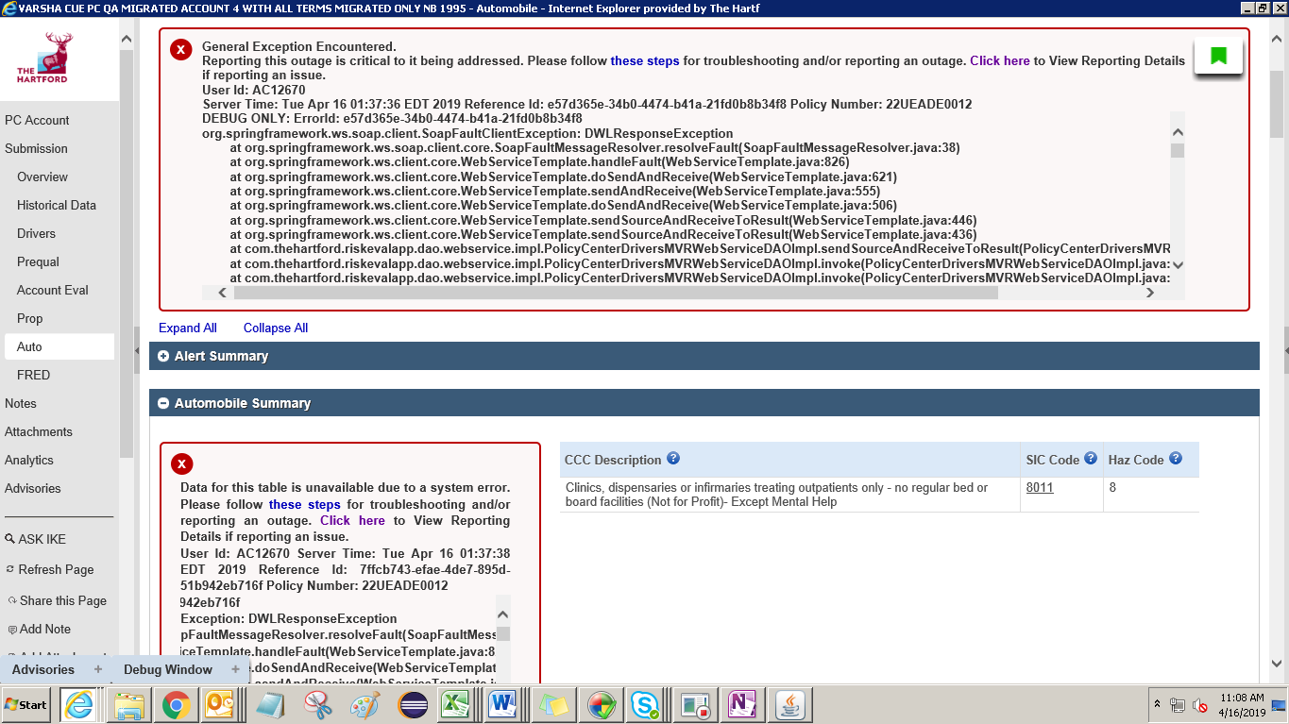

General Exception Encountered.

Reporting this outage is critical to it being addressed. Please follow [these steps](https://qacue.thehartford.com/riskeval/app/Submission/Auto/k9pohflc64796tla2fo4bjr10t/811084861052908/DM0002000004007/) for troubleshooting and/or reporting an outage. [Click here](https://qacue.thehartford.com/riskeval/app/Submission/Auto/k9pohflc64796tla2fo4bjr10t/811084861052908/DM0002000004007/) to View Reporting Details if reporting an issue.   
User Id: AC12670  
Server Time: Tue Apr 16 01:37:36 EDT 2019 Reference Id: e57d365e-34b0-4474-b41a-21fd0b8b34f8 Policy Number: 22UEADE0012

DEBUG ONLY: ErrorId: e57d365e-34b0-4474-b41a-21fd0b8b34f8   
org.springframework.ws.soap.client.SoapFaultClientException: DWLResponseException

at org.springframework.ws.soap.client.core.SoapFaultMessageResolver.resolveFault(SoapFaultMessageResolver.java:38)

at org.springframework.ws.client.core.WebServiceTemplate.handleFault(WebServiceTemplate.java:826)

at org.springframework.ws.client.core.WebServiceTemplate.doSendAndReceive(WebServiceTemplate.java:621)

at org.springframework.ws.client.core.WebServiceTemplate.sendAndReceive(WebServiceTemplate.java:555)

at org.springframework.ws.client.core.WebServiceTemplate.doSendAndReceive(WebServiceTemplate.java:506)

at org.springframework.ws.client.core.WebServiceTemplate.sendSourceAndReceiveToResult(WebServiceTemplate.java:446)

at org.springframework.ws.client.core.WebServiceTemplate.sendSourceAndReceiveToResult(WebServiceTemplate.java:436)

Data for this table is unavailable due to a system error. Please follow [these steps](https://qacue.thehartford.com/riskeval/app/Submission/Auto/k9pohflc64796tla2fo4bjr10t/811084861052908/DM0002000004007/) for troubleshooting and/or reporting an outage. [Click here](https://qacue.thehartford.com/riskeval/app/Submission/Auto/k9pohflc64796tla2fo4bjr10t/811084861052908/DM0002000004007/) to View Reporting Details if reporting an issue.   
User Id: AC12670 Server Time: Tue Apr 16 01:37:38 EDT 2019 Reference Id: 7ffcb743-efae-4de7-895d-51b942eb716f Policy Number: 22UEADE0012

DEBUG ONLY: ErrorId: 7ffcb743-efae-4de7-895d-51b942eb716f   
org.springframework.ws.soap.client.SoapFaultClientException: DWLResponseException

at org.springframework.ws.soap.client.core.SoapFaultMessageResolver.resolveFault(SoapFaultMessageResolver.java:38)

at org.springframework.ws.client.core.WebServiceTemplate.handleFault(WebServiceTemplate.java:826)

at org.springframework.ws.client.core.WebServiceTemplate.doSendAndReceive(WebServiceTemplate.java:621)

at org.springframework.ws.client.core.WebServiceTemplate.sendAndReceive(WebServiceTemplate.java:555)

at org.springframework.ws.client.core.WebServiceTemplate.doSendAndReceive(WebServiceTemplate.java:506)

at org.springframework.ws.client.core.WebServiceTemplate.sendSourceAndReceiveToResult(WebServiceTemplate.java:446)

at org.springframework.ws.client.core.WebServiceTemplate.sendSourceAndReceiveToResult(WebServiceTemplate.java:436)

at com.thehartford.riskevalapp.dao.webservice.impl.PolicyCenterDriversMVRWebServiceDAOImpl.sendSourceAndReceiveToResult

