import javax.swing.*;
import java.awt.*;
import java.awt.event.ActionEvent;
import java.awt.event.ActionListener;
class Trafic extends JPanel implements ActionListener{
JRadioButton r1,r2,r3;
Color red_c,yellow_c,green_c;
Trafic()
{
setBounds(0,0,400,400);

red_c = getBackground();
yellow_c = getBackground();
green_c = getBackground();

r1 = new JRadioButton("Red");
r2 = new JRadioButton("Yellow");
r3 = new JRadioButton("Green");

ButtonGroup gp = new ButtonGroup();
gp.add(r1);
gp.add(r2);
gp.add(r3);

add(r1);
add(r2);
add(r3);

r1.addActionListener(this);
r2.addActionListener(this);
r3.addActionListener(this);
}

public void paintComponent(Graphics g){
super.paintComponent(g);
g.drawOval(200, 100, 50, 50);
g.drawOval(200, 200, 50, 50);
g.drawOval(200, 300, 50, 50);

g.setColor(red_c);
g.fillOval(200, 100, 50, 50);
g.setColor(yellow_c);
g.fillOval(200, 200, 50, 50);
g.setColor(green_c);
g.fillOval(200, 300, 50, 50);
}

public void actionPerformed(ActionEvent ae){
if(r1.isSelected())
{
red_c = Color.red;
yellow_c = getBackground();
green_c = getBackground();
repaint();
}
else if(r2.isSelected())
{
red_c = getBackground();
yellow_c = Color.yellow;
green_c = getBackground();
repaint();
}
else if(r3.isSelected())
{
red_c = getBackground();
yellow_c =getBackground();
green_c = Color.green;
repaint();
}
}

}
class TrafficLight{
static JFrame jf;
public static void main(String args[]){
Trafic t = new Trafic();
jf = new JFrame("Traffic Light");
jf.setSize(500,500);
jf.setLayout(null);
jf.setDefaultCloseOperation(JFrame.EXIT_ON_CLOSE);
jf.add(t);
jf.setVisible(true);
}
}
import javax.swing.*;
import java.awt.*;
import java.awt.event.ActionEvent;
import java.awt.event.ActionListener;
class Calculator implements ActionListener{
JFrame jf;
JTextField jt;
JButton b1,b2,b3,b4,b5,b6,b7,b8,b9,bsub,bmul,bdiv,bc,b0,b17,badd,beq,bdot;
JLabel jl;
float oprand1,oprand2;
int oprt;
Calculator(){
jf = new JFrame("Calculator");
jf.setLayout(null);
jf.setSize(300,500);
jl = new JLabel("Calculator");
jl.setBounds(100,50,100,20);
jf.add(jl);
jt = new JTextField();
jt.setBounds(50,90,200,30);
jf.add(jt);
bc = new JButton("C");
bc.setBounds(50,130,50,50);
bc.addActionListener(this);
jf.add(bc);
bdiv = new JButton("/");
bdiv.setBounds(100,130,50,50);
bdiv.addActionListener(this);
jf.add(bdiv);
bmul = new JButton("X");
bmul.setBounds(150,130,50,50);
bmul.addActionListener(this);
jf.add(bmul);
bsub = new JButton("-");
bsub.setBounds(200,130,50,50);
bsub.addActionListener(this);
jf.add(bsub);
b7 = new JButton("7");
b7.setBounds(50,180,50,50);
b7.addActionListener(this);
jf.add(b7);
b8 = new JButton("8");
b8.setBounds(100,180,50,50);
b8.addActionListener(this);
jf.add(b8);
b9 = new JButton("9");
b9.setBounds(150,180,50,50);
b9.addActionListener(this);
jf.add(b9);
badd = new JButton("+");
badd.setBounds(200,180,50,100);
badd.addActionListener(this);
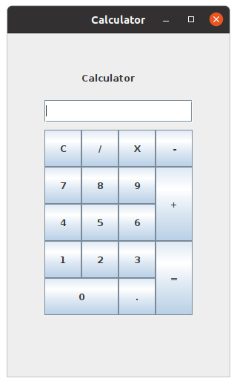
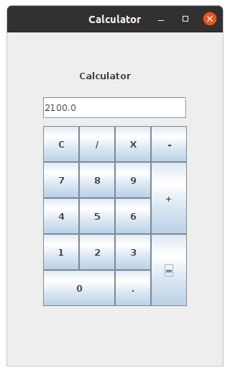
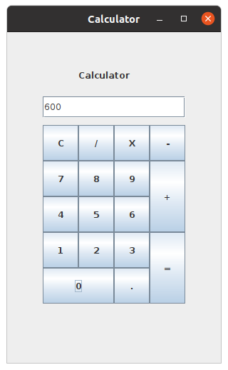
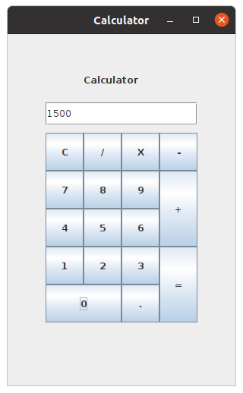
jf.add(badd);
b4 = new JButton("4");
b4.setBounds(50,230,50,50);
b4.addActionListener(this);
jf.add(b4);
b5 = new JButton("5");
b5.setBounds(100,230,50,50);
b5.addActionListener(this);
jf.add(b5);
b6 = new JButton("6");
b6.setBounds(150,230,50,50);
b6.addActionListener(this);
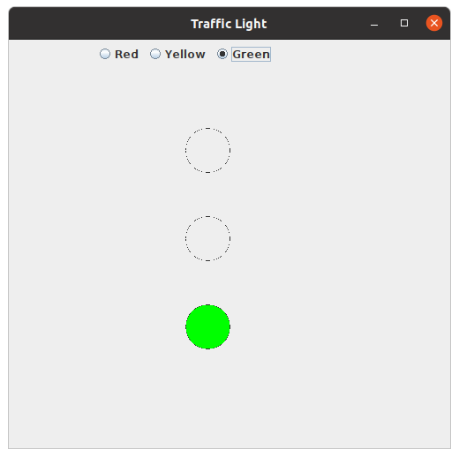
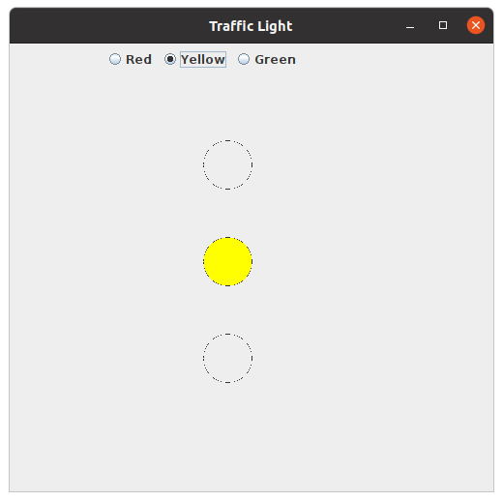
jf.add(b6);
b1 = new JButton("1");
b1.setBounds(50,280,50,50);
b1.addActionListener(this);
jf.add(b1);
b2 = new JButton("2");
b2.setBounds(100,280,50,50);
b2.addActionListener(this);
jf.add(b2);
b3 = new JButton("3");
b3.setBounds(150,280,50,50);
b3.addActionListener(this);
jf.add(b3);
beq = new JButton("=");
beq.setBounds(200,280,50,100);
beq.addActionListener(this);
jf.add(beq);
b0 = new JButton("0");
b0.setBounds(50,330,100,50);
b0.addActionListener(this);
jf.add(b0);
bdot = new JButton(".");
bdot.setBounds(150,330,50,50);
bdot.addActionListener(this);
jf.add(bdot);
jf.setVisible(true);
jf.setDefaultCloseOperation(JFrame.EXIT_ON_CLOSE);}
public void actionPerformed(ActionEvent ae){
String temp;
String source = ae.getActionCommand();
if(source == "C")jt.setText("");
else if(source == "."){
temp = jt.getText();
jt.setText(temp+".");
}
else if(source == "+"){
oprand1 = Float.parseFloat(jt.getText());
System.out.println(oprand1);
oprt = 0;
jt.setText("");
}
else if(source == "-"){
oprand1 = Float.parseFloat(jt.getText());
oprt = 1;
jt.setText("");
}
else if(source == "X"){
oprand1 = Float.parseFloat(jt.getText());
oprt = 2;
jt.setText("");
}
else if(source == "/"){
oprand1 = Float.parseFloat(jt.getText());
oprt = 3;
jt.setText("");
}
else if (source=="="){
oprand2 = Float.parseFloat(jt.getText());
if(oprt==0)jt.setText(Float.toString((oprand1+oprand2)));
else if(oprt==1)jt.setText(Float.toString((oprand1-oprand2)));
else if(oprt==2)jt.setText(Float.toString((oprand1*oprand2)));
else if(oprt==3)jt.setText(Float.toString((oprand1/oprand2)));
}
else if(0<=Integer.parseInt(source)&&9>=Integer.parseInt(source)){
temp=jt.getText();
jt.setText(temp+source);
}
}
}
class calculator
{
public static void main(String args[])
{
Calculator calc = new Calculator();
}
}

