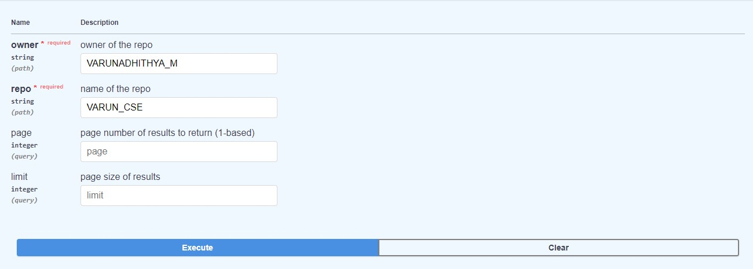

S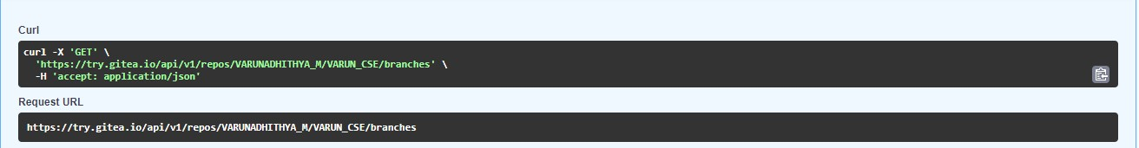

**Response body**

**Download**

**[**

**{**

**"name": "FIRST_BRANCH",**

**"commit": {**

**"id": "2ccef4bcd0093c8ad7eb84e0c839668bd38f3ada",**

**"message": "Initial commit\n",**

**"url": "https://try.gitea.io/VARUNADHITHYA_M/VARUN_CSE/commit/2ccef4bcd0093c8ad7eb84e0c839668bd38f3ada",**

**"author": {**

**"name": "VARUNADHITHYA_M",**

**"email": "varunadhithya_m@noreply.try.gitea.io",**

**"username": "VARUNADHITHYA_M"**

**},**

**"committer": {**

**"name": "VARUNADHITHYA_M",**

**"email": "varunadhithya_m@noreply.try.gitea.io",**

**"username": "VARUNADHITHYA_M"**

**},**

**"verification": {**

**"verified": false,**

**"reason": "gpg.error.not_signed_commit",**

**"signature": "",**

**"signer": null,**

**"payload": ""**

**},**

**"timestamp": "2023-02-21T06:40:12Z",**

**"added": null,**

**"removed": null,**

**"modified": null**

**},**

**"protected": false,**

**"required_approvals": 0,**

**"enable_status_check": false,**

**"status_check_contexts": [],**

**"user_can_push": false,**

**"user_can_merge": false,**

**"effective_branch_protection_name": ""**

**},**

**{**

**"name": "SECOND_BRANCH",**

**"commit": {**

**"id": "2ccef4bcd0093c8ad7eb84e0c839668bd38f3ada",**

**"message": "Initial commit\n",**

**"url": "https://try.gitea.io/VARUNADHITHYA_M/VARUN_CSE/commit/2ccef4bcd0093c8ad7eb84e0c839668bd38f3ada",**

**"author": {**

**"name": "VARUNADHITHYA_M",**

**"email": "varunadhithya_m@noreply.try.gitea.io",**

**"username": "VARUNADHITHYA_M"**

**},**

**"committer": {**

**"name": "VARUNADHITHYA_M",**

**"email": "varunadhithya_m@noreply.try.gitea.io",**

**"username": "VARUNADHITHYA_M"**

**},**

**"verification": {**

**"verified": false,**

**"reason": "gpg.error.not_signed_commit",**

**"signature": "",**

**"signer": null,**

**"payload": ""**

**},**

**"timestamp": "2023-02-21T06:40:12Z",**

**"added": null,**

**"removed": null,**

**"modified": null**

**},**

**"protected": false,**

**"required_approvals": 0,**

**"enable_status_check": false,**

**"status_check_contexts": [],**

**"user_can_push": false,**

**"user_can_merge": false,**

**"effective_branch_protection_name": ""**

**},**

**{**

**"name": "main",**

**"commit": {**

**"id": "2ccef4bcd0093c8ad7eb84e0c839668bd38f3ada",**

**"message": "Initial commit\n",**

**"url": "https://try.gitea.io/VARUNADHITHYA_M/VARUN_CSE/commit/2ccef4bcd0093c8ad7eb84e0c839668bd38f3ada",**

**"author": {**

**"name": "VARUNADHITHYA_M",**

**"email": "varunadhithya_m@noreply.try.gitea.io",**

**"username": "VARUNADHITHYA_M"**

**},**

**"committer": {**

**"name": "VARUNADHITHYA_M",**

**"email": "varunadhithya_m@noreply.try.gitea.io",**

**"username": "VARUNADHITHYA_M"**

**},**

**"verification": {**

**"verified": false,**

**"reason": "gpg.error.not_signed_commit",**

**"signature": "",**

**"signer": null,**

**"payload": ""**

**},**

**"timestamp": "2023-02-21T06:40:12Z",**

**"added": null,**

**"removed": null,**

**"modified": null**

**},**

**"protected": false,**

**"required_approvals": 0,**

**"enable_status_check": false,**

**"status_check_contexts": [],**

**"user_can_push": false,**

**"user_can_merge": false,**

**"effective_branch_protection_name": ""**

**}**

**]**

