DESCRIPTIVE STATISTICS

Graphical Description of Data

A graphical presentation of data will often reveal information about the sample that is not apparent from a table of data measurements.

Goals
1. To be able to display data using various graphing techniques.
2. To be able to interpret a graphical display.

Important Terms and Definitions

Classes are intervals used to group sample measurements.

Class frequency is the number of observations in a particular class. We denote the frequency for a class by f_{i}.

Relative class frequency is the proportion of the total measurements that fall in a particular class. That is, the relative frequency for class i is f_{i}/n.

Type of Graphical Display for Qualitative Data
1. Bar Chart

Types of Graphical Displays for Quantitative Data
1. Relative frequency histogram
2. Stem and leaf display
Some Examples

Example: Below are the Major Course Codes for students in an EX ST 301 class.

109 118 118 118 118 118 118 125 125 125 125 130
130 163 163 220 230 402 402 402 402 402 410 410
410 410 415 420 565 710 710 710 710 710 710 710
710 710 710 710 710 811 865 930 960

109 Agronomy 402 Freshman Engineering
118 Animal Science 410 Ceramic Engineering
CES
125 Aquaculture Fisheries Wildlife Bio 415 Chemical Engineering
130 Community & Rural Development 420 Civil Engineering
CAFLS
163 Horticulture 565 Textile Management
811 Biological Sciences
865 Microbiology 710 Nursing
HEHD
930 Forest Resource Management 960 Parks, Recreation, and Tourism

220 Design (Landscape Arch -BS)
AAH
230 Landscape Architecture

Is this an example of qualitative or quantitative data?
Why?

Example: Below are Math Level II Achievement Test scores for twenty-eight randomly selected students.
390 400 410 440 450 450 450 450 460 460 460
470 470 470 470 480 480 480 480 480 480 500
500 500 500 500 510 520

Is this an example of qualitative or quantitative data?
Why?
Constructing a Bar Chart
1. Arrange the categories along the horizontal axis.
2. Construct rectangles over each category, with their height being the frequency for each category.

Bar Chart for College of the Major

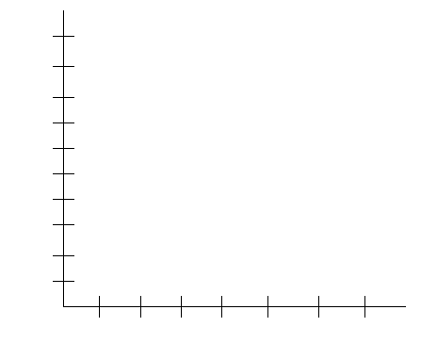

Below is the SAS code for producing a bar chart for college of the major. The bar chart produced from this code can be found on the next page.

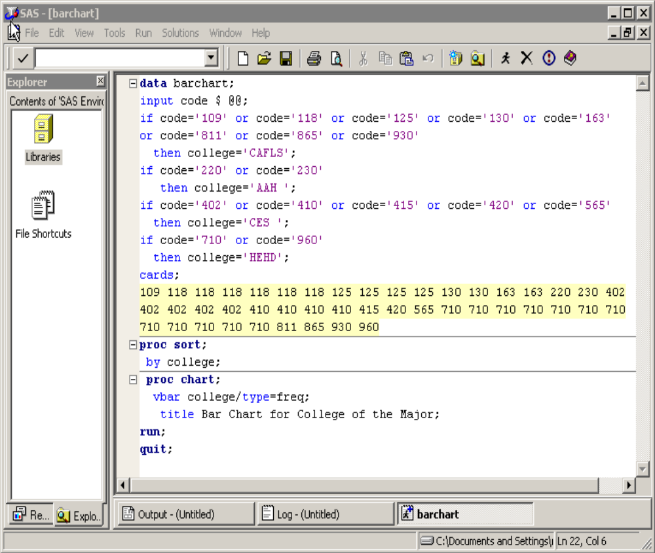

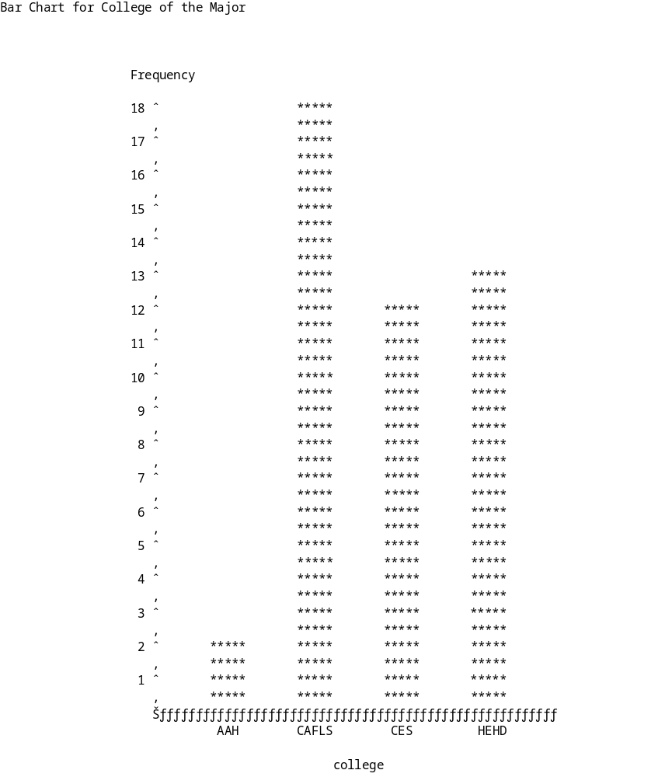

Constructing a Relative Frequency Histogram
1. Determine the number of classes. Usually 5 to 20 classes. The chart below gives an idea of how many classes should be formed.

n | Classes
9 - 16 | 4
17 - 32 | 5
33 - 65 | 6
66 - 132 | 7

2. Determine the class width. To approximate the class width, divide the difference between the largest and smallest measurements by the number of classes. Round this number to a convenient figure. All classes should be the same width.
3. Locate the class boundaries. The lowest class must include the smallest observation, and the highest class must include the largest observation. Boundaries should be chosen so that measurements do not fall on the boundary.
4. Construct rectangles over each class interval, with their height being the relative class frequencies.

Relative Frequency Histogram for Math Level II Scores

Below is the SAS code for producing a histogram using the Math Level II scores. The histogram produced from this code can be found on the next page.

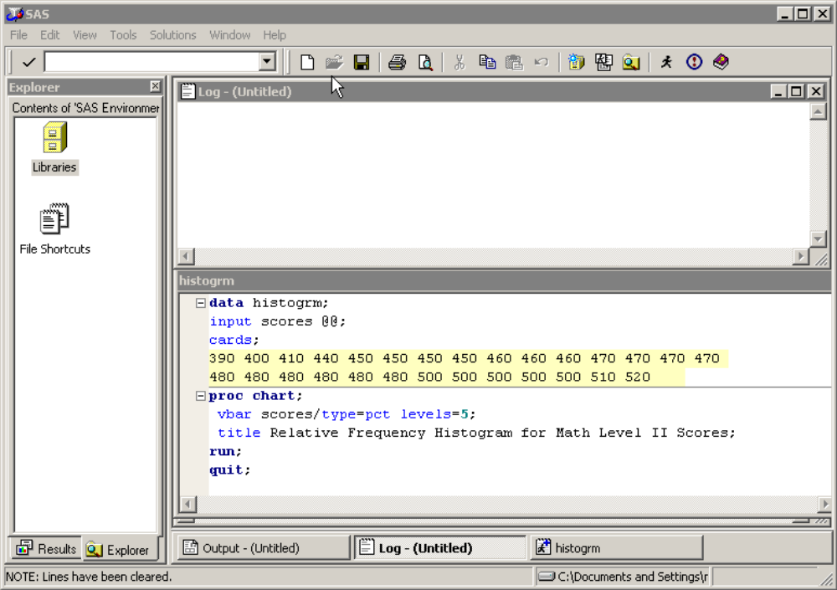

Relative Frequency Histogram for Math Level II Scores

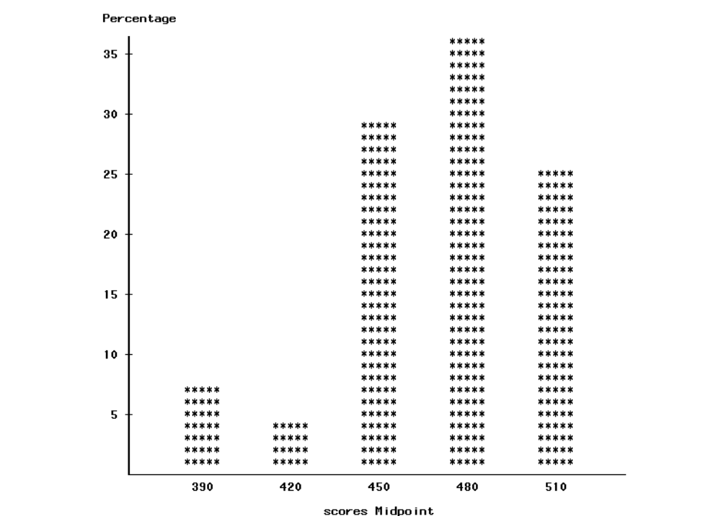
A stem and leaf display is an alternative method for describing a set of data. It looks similar to the relative frequency histogram, but it retains the actual data values.

Constructing a Stem and Leaf Display
1. List the stem values, in order, in a vertical column.
2. Draw a vertical line to the right of the stem values.
3. For each observation, record the leaf portion of the observation in the row corresponding to the
appropriate stem.
4. Reorder the leaves from lowest to highest within each stem row.
5. If the number of leaves appearing in each stem is too large, divide the stems into two groups, the
first corresponding to leaves with 0 through 4, and the second corresponding to leaves beginning
with digits 5 through 9. (This subdivision can be increased to five groups if necessary.)
6. Provide a key to your stem and leaf coding, so the reader can reconstruct the actual measurements.

The following SAS program generated a stem and leaf plot for the Math Level II scores.

