# Название кнопок управления геймпада Xbox One

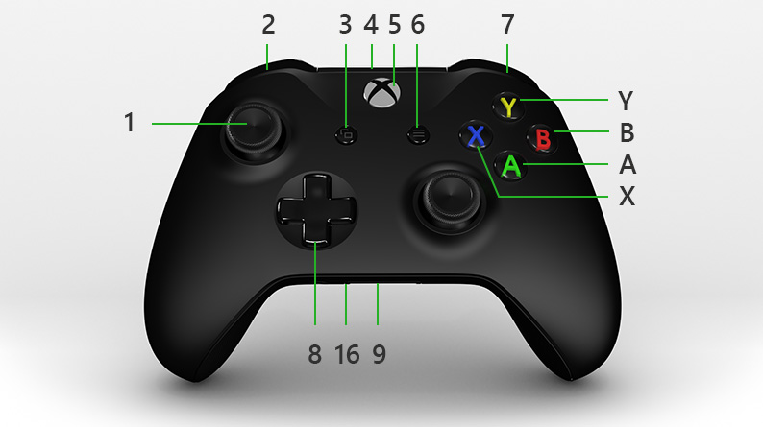

|  |  |  |
| --- | --- | --- |
| 1 Left stick |  | 9 Expansion port |
| 2 Left bumper |  | 10 Right stick |
| 3 View button |  | 16 3.5mm port |
| 4 USB charge port |  | X X button |
| 5 Xbox button |  | Y Y button |
| 6 Menu button |  | A A button |
| 7 Right bumper |  | B B button |
| 8 Directional pad (D-pad) |  |  |

# Система команд геймпада XBOX One

|  |  |  |
| --- | --- | --- |
| HorizontalVectorX | Left stick вправо | 0/1 |
| HorizontalVectorY | Left stick вниз | 0/1 |
| VericalThrust | Right stick вниз | 0/1 |
| PowerTarget | Power Limit Control |  |
| AngularVelocityZ | Right stick вправо | 0/1 |
| ManipulatorState | Left bumper нажат | 0/1 |
| Right bumper нажат | 0/-1 |
| ManipulatorRotate | Left trigger нажат | 0/1 |
| Right trigger нажат | 0/-1 |
| CameraRotate | **A** нажата | 0/-1 |
| **Y** нажата | 0/1 |
| ResetInitialization | Menu нажата | 0/1 |
| LightsState | **X** нажата | 0/1 |
| StabilizationState | Stab Checkbox | 1..15 |
| RollInc | D-pad вверх | 0/1 |
| D-pad вниз | 0/-1 |
| PitchInc | D-pad вправо | 0/1 |
| D-pad влево | 0/-1 |
| ResetPosition | **B** нажата | 0/1 |

