TITLE OF THE PROPOSED WORK
Version-Locked Chained Delta Signatures (VLCDS): Extending Pre-Verify / Post-Verify Firmware Authentication to Secure Delta Updates on Resource-Constrained IoT Devices
[Secure Delta Firmware Update Mechanism for IoT Devices with Version-Locked Signature Verification]
A Cryptography Course Project Proposal
Base Paper Reference
Formanek, L., Kubascik, M., Karpis, O., Kolok, P. “Advanced System for Remote Updates on ESP32-Based Devices Using Over-the-Air Update Technology.” Computers (MDPI), Vol. 14, Issue 12, Article 531, 4 December 2025. DOI: 10.3390/computers14120531
Prior Technique Adapted
US10206114B2 / US10887770B2 (Samsung) — Pre-Verify / Post-Verify Dual Firmware Verification Procedure

Prepared By :-
(B2_Grp_18)
VATSAL SHRIVASTAVA
NISARG SHILPESH NAGAR
JOHNS MARIA JOY

Submitted To :-
KARTHIKA V

1. Summary of the Selected Research Paper
Citation: Formanek, L.; Kubascik, M.; Karpis, O.; Kolok, P. “Advanced System for Remote Updates on ESP32-Based Devices Using Over-the-Air Update Technology.” Computers (MDPI), Vol. 14, Issue 12, Article 531, published 4 December 2025. DOI: 10.3390/computers14120531. This is a peer-reviewed journal article (MDPI Computers), not a conference proceeding, satisfying the requirement for a reputed-publication base paper.
The paper presents a unified Over-the-Air (OTA) update architecture for ESP32-based IoT devices. Its main contributions are:
- A centralized, server-driven release-routing mechanism that manages which firmware version is pushed to which device class.
- Multi-protocol communication support for delivering updates to constrained devices.
- Version-compatibility checks and rollback capability at the device level, so a device can fall back to a previously working image if an update fails.
- Support for delta (differential) updates, which transmit only the difference between the currently installed firmware and the new firmware, reducing bandwidth and time compared to transmitting a full image.
- A discussion of digital signatures (Ed25519) as the mechanism intended to authenticate firmware content, along with reported performance figures on ESP32 hardware (approximately 4.8 ms / 3.5 mJ for an Ed25519 verification, and approximately 25 ms / 2.4 mJ for a SHA-256 hash over 1 MB of data).
Importantly, the authors themselves identify security integration as incomplete. In their Future Work section, they state that the system still requires the incorporation of stronger security features — including mutual authentication, encrypted update channels, digital signature verification, and rollback protection — to be tightly coupled with the delta-update pipeline. This admission from the base paper's own authors is the starting point for the research gap identified in Section 2.

2. Research Gap / Limitations of Existing Work
The gap identified in this project rests on two independent lines of prior work, both examined in detail:

2.1 Limitation in the base paper's own delta-update pipeline
The base paper optimizes bandwidth, energy, and latency for delta updates but leaves cryptographic authentication of those updates as future work. As currently described, version control and rollback are handled as system-level bookkeeping rather than as cryptographically enforced properties tied to the update content itself.

2.2 Limitation in the closest existing cryptographic mechanism (Samsung pre-verify / post-verify patents)
A search for prior art in dual-stage firmware verification surfaced US10206114B2 (filed 2015, granted 2019) and its continuation US10887770B2 (filed 2019, granted 2021), assigned to Samsung. These patents describe a two-stage verification procedure: the device first receives only a hash and signature of the firmware image and performs a lightweight “pre-verify” step; only if this passes does it receive the full image, followed by a second “post-verify” hash check after storage. The stated motivation is to avoid wasting flash-write cycles and memory (e.g., for a rollback copy) transferring an image that would later be rejected.
Close reading of this patent family shows it does not transfer directly to the IoT delta-update context targeted by this project:
- Target hardware: The patent is scoped to phone-class and wearable-class consumer electronics — specifically a worked example of an NFC secure-element chip inside a smartphone communicating with the phone's own application processor over a trusted, fast, on-board bus.
- Unit of verification: Only full firmware images are ever verified (“FW_imageN”); delta or differential patches are not discussed anywhere in the patent.
- Version and rollback state: The patent's pre-verify/post-verify object authenticates image integrity only. Version numbers, downgrade prevention, and replay of old (but validly signed) updates are not part of what gets cryptographically verified — they are absent from the scheme entirely.
- Channel assumptions: The two-stage handshake assumes a reliable, physically trusted local link. It does not address what happens when that handshake itself travels over a lossy, open wireless network, as it must for IoT.
Cross-checking against ESP32's own documented OTA process (Secure Boot plus optional Flash Encryption) confirms that ESP32 does not already implement this pre-verify/post-verify pattern: the standard ESP-IDF flow writes the full image to an inactive partition first and verifies the signature afterward, and its separate anti-rollback mechanism (a Security Version Number held in eFuse) is not bound into the same signature check as the firmware content — the same disconnect found in the patent.

2.3 Consolidated statement of the gap
Gap: Existing mechanisms — both the base paper's delta-update pipeline and the closest cryptographic dual-verification scheme in the patent literature — authenticate the content of a firmware update but do not cryptographically bind that content to the version and update-history context it is valid for. Version and rollback checks, where they exist at all, are performed against fields that sit outside the signed object, and no existing scheme has been shown to extend a pre-verify/post-verify style check to delta patches on resource-constrained, wirelessly connected IoT devices.

3. Problem Statement
Resource-constrained IoT devices (e.g., ESP32-class microcontrollers) increasingly rely on delta (differential) firmware updates delivered over lossy, low-bandwidth wireless links to conserve energy and bandwidth. Current approaches verify the authenticity of update content using a digital signature, but this verification is either performed only after the full firmware image has been reconstructed in flash, or — where a lightweight pre-verify stage exists in prior art — it authenticates image integrity alone, without binding the update to the specific firmware version and update history it is valid for.
This leaves two concrete weaknesses on constrained IoT devices: (i) a patch whose base version does not match the device's actual current firmware, or which represents a replay of an old but validly signed update, may still be downloaded and partially processed before being detected, wasting scarce bandwidth, energy, and flash-write endurance; and (ii) an attacker who can manipulate an unauthenticated version field, without breaking the signature over the patch content itself, may be able to defeat version and rollback checks independently of the cryptographic authenticity check.
Problem: How can a delta firmware update for a resource-constrained IoT device be cryptographically bound — before any patch bytes are transferred or applied — to the specific base firmware version, target version, and update history it is valid for, using a lightweight verification step suitable for constrained hardware and unreliable wireless links?

4. Proposed Contribution
This project proposes the Version-Locked Chained Delta Signature (VLCDS) mechanism, which adapts the pre-verify/post-verify structure established in the Samsung patent family to the IoT delta-update setting, and extends it to close the version-binding gap identified in Section 2. The design is a single, coherent scheme — not a combination of unrelated techniques — because every component modifies the same signed object and the same two-stage verification flow; no component functions independently of the others.
The core idea is to sign one compact manifest that binds six facts together, rather than signing the firmware image alone:
M = Sign_privkey( H(base_fw) ‖ H(delta) ‖ H(target) ‖ version_base ‖ version_target ‖ H(prev_manifest) )
This single signature makes it computationally infeasible to satisfy verification unless all six bound facts are simultaneously true — an attacker cannot pair a validly signed patch with a forged version number or an old, previously accepted manifest, because those values are now inside what the signature authenticates rather than sitting beside it.

4.1 What is adapted from prior work (declared explicitly)
- The two-stage “verify a lightweight object before committing to a full transfer, verify again after” structure — adapted from the Samsung pre-verify/post-verify patent.
- The IoT delta-update context, evaluation baselines, and target hardware (ESP32-class) — taken from the base paper.

4.2 What is original to this project
- Folding version_base, version_target, and a hash-chain link to the previous manifest into the same signed object as the patch content, so version/rollback state is cryptographically bound rather than checked separately.
- Extending “pre-verify” from authenticating a full image's integrity to authenticating a delta patch's applicability — i.e., confirming the patch matches the device's actual current firmware before the device even requests the patch bytes.
- Redesigning the handshake for an untrusted wireless channel and unreliable delivery, rather than the trusted on-board bus assumed in the patent.
- Removing the need for a second signature operation at post-verify time by pre-committing H(target) inside the Stage-1 signature, so post-verify becomes a cheap hash comparison — relevant on energy-constrained hardware.

4.3 Cryptographic grounding
The scheme relies entirely on standard, well-analyzed primitives — a signature scheme such as Ed25519 or ECDSA, and a cryptographic hash function such as SHA-256 — combined via the hash-and-sign paradigm. The contribution lies in the protocol-level design decision of what is bound inside the signed object and when verification occurs relative to data transfer and flash writes, in the same tradition as protocol-level contributions such as TLS's handshake design or JWT's claims structure, which likewise build new structure on top of proven primitives rather than inventing new mathematics.

5. Methodology / Block Diagram
The mechanism operates in three stages between the update server and the IoT device, illustrated below.
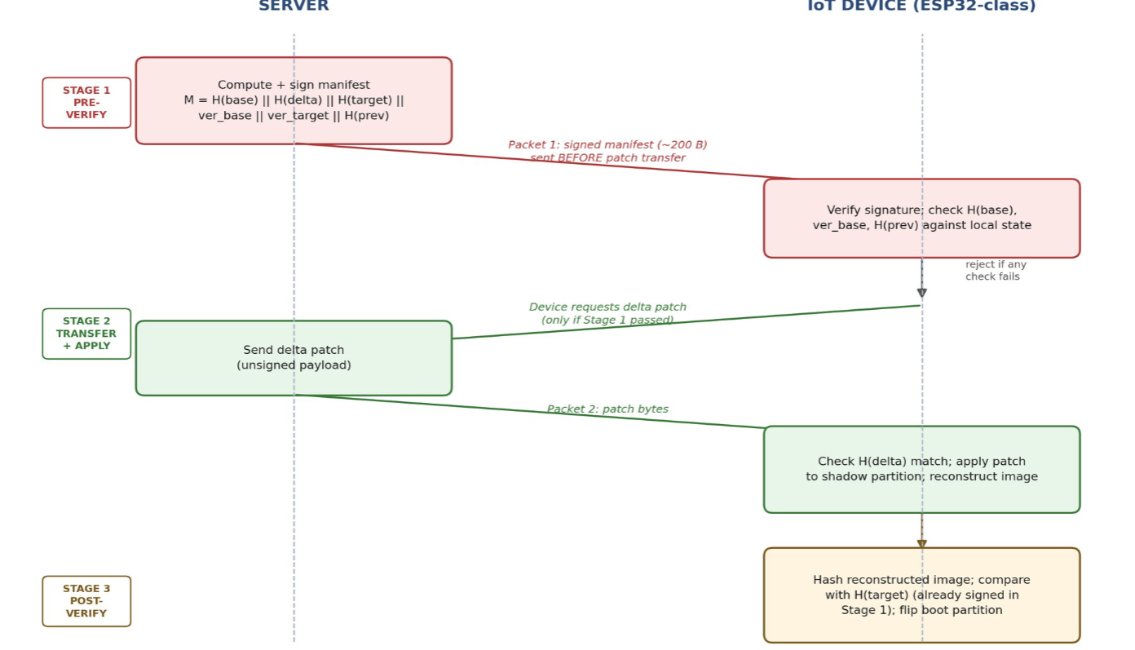

5.1 Stage 1 — Pre-Verify
- The server computes the six-field manifest described in Section 4 and signs it with its private key.
- Only this small manifest (approximately 200 bytes) is sent to the device first — no patch data yet.
- The device verifies the signature with the stored vendor public key, then checks H(base_fw) against the hash of its own currently running firmware, checks version_base against its own installed version, and checks H(prev_manifest) against the last manifest it accepted. All three checks operate on fields inside the one signed object.
- If any check fails, the update is rejected immediately, before any patch bytes, flash writes, or reconstruction cost are incurred.

5.2 Stage 2 — Patch Transfer and Application
- Only if Stage 1 passes does the device request the delta patch itself.
- The patch is transmitted without its own signature; its integrity is instead confirmed by comparing its hash to H(delta), which was already authenticated in Stage 1.
- The device applies the patch to a staging (shadow) partition and reconstructs the candidate firmware image.

5.3 Stage 3 — Post-Verify
- The device hashes the reconstructed image and compares it to H(target), which was already committed inside the Stage-1 signature.
- No second signature verification is required — only a cheap hash comparison — which keeps the scheme's total cryptographic cost close to that of a single-signature baseline.
- Only if the hash matches does the device flip the active boot partition to the newly reconstructed image.

5.4 Packet-level field breakdown
The following table specifies the exact fields carried inside the Stage-1 signed manifest (Packet 1), their meaning, how each is computed, and their approximate size on the wire.

Field | Meaning | Computation | Size
H(base_fw) | Hash of the firmware currently running on the device (the version the patch applies to) | SHA-256(current_firmware_binary) | 32 bytes
H(delta) | Hash of the delta patch that will be sent afterward | SHA-256(patch_binary) | 32 bytes
H(target) | Hash of the firmware image expected after the patch is applied | SHA-256(base_fw patched with delta), computed server-side | 32 bytes
version_base | Version number the device is expected to currently be on | Monotonically increasing integer | 2–4 bytes
version_target | Version number the patch will bring the device to | Monotonically increasing integer, > version_base | 2–4 bytes
H(prev) | Hash of the previous accepted update's manifest — chains this update to update history | SHA-256(previous_manifest_bytes) | 32 bytes
signature | Ed25519 signature over all six fields above | Sign_privkey(concatenated fields) | 64 bytes

At roughly 200 bytes total, Packet 1 is small enough to be exchanged cheaply even over constrained links such as LoRa, Zigbee, or BLE, before any decision is made about whether to request the (much larger) patch payload.

5.5 Comparison with existing work

Aspect | Existing Work (Base Paper / Samsung Patent) | Proposed Solution (VLCDS)
Target platform | Smartphone / NFC secure-element hardware (Samsung patent); general IoT OTA (base paper) | Resource-constrained ESP32-class IoT devices
Update unit verified | Full firmware image only | Delta / differential patch
Verification timing | Pre-verify (hash+signature) before transfer; post-verify after storage | Same two-stage pattern, retained and adapted
Version / rollback state | Not part of the signed object (checked as a separate, unauthenticated field, if at all) | Bound inside the same signed manifest as the patch content
Replay of an old, validly-signed update | Not addressed | Prevented via hash-chain link to previous manifest
Communication channel assumed | Trusted internal bus (phone to companion chip) | Untrusted wireless network (CoAP / MQTT / HTTPS)

5.6 Planned evaluation
- Implement the scheme on ESP32 hardware using an existing delta-diff library (e.g., bsdiff/detools) and Ed25519 for signing.
- Measure and compare against the base paper's reported baselines: verification cost (time, energy), flash writes avoided when a patch is rejected pre-application, and bandwidth saved when a mismatched or replayed patch is rejected before transfer.
- Evaluate resistance to three concrete attacks: (a) a patch whose base-version hash does not match the device's current firmware, (b) replay of an old but validly signed update, and (c) early exploitation of the patch-parsing engine via unauthenticated patch bytes.
- Define the attacker model explicitly as a Dolev–Yao network attacker, consistent with the assumption used in the base paper, for methodological consistency.

