UK Controller Pack 

Version Release Date

2022/0916 september 2022

## Before Installation - IMPORTANT

## **EuroScope Version**

You need to have the [latest full release version of the EuroScope](https://www.euroscope.hu/install/EuroScopeSetup32.msi) controller client installed. **At the time of writing**, we currently recommend installing beta r34, available from [here](https://www.euroscope.hu/install/EuroScopeBeta32a34.zip). Please note, the beta installs on top of the full release. The full release is required to be installed before downloading the beta files. Newer beta release of EuroScope may break settings within the pack and we currently do not support versions other than r34.

## EuroScope Working Directory

Wherever you start EuroScope from, whether it be the start menu or a shortcut, you need to ensure that it is started in the folder Documents\EuroScope. This is achieved by right clicking the shortcut, selecting “properties”. Under the shortcut tab, ensure the “start in” directory matches your “Documents\EuroScope” location. The image below shows an example.

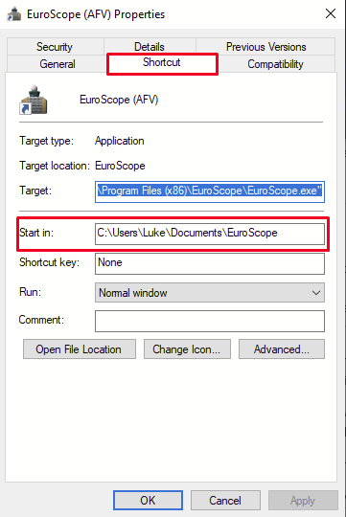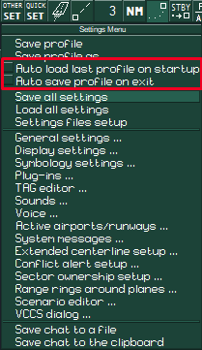

EuroScope Auto-load on start-upPlease ensure this option is **unticked** before loading the controller pack. This option is accessible within EuroScope Under the “Other SET” menu. It is also recommended that you **untick** “Auto save profile on exit” under the same menu. The image above shows the location of these options. Once you have done this, quit EuroScope and when you load it again, it will ask you for a .prf (profile) file.

Microsoft Visual C++ RedistributableThe plugins included in this package require the latest (2022+) C++ Redistributables to function as intended. Please download and install from [here](https://aka.ms/vs/17/release/vc_redist.x86.exe) before opening any of the profiles.

UK Controller Plugin KeyFor first time users, the UK Controller Plugin will ask you to provide a key so that the plugin knows who is connecting. This ensures that access to the plugin’s functions can be traced to the users’ VATSIM CID. To obtain a key, please visit <https://vatsim.uk/ukcp>

## Install

This controller pack comes in a ZIP folder. Due to certain limitations within the EuroScope sector file auto-update module, it is required that you install the pack into Documents\EuroScope

Unzip this ZIP archive directly into your EuroScope working directory.

… Documents\EuroScope\

When you have unzipped this file, double-check it has unzipped into the correct place. You can check by locating a file, for example:

… Documents\EuroScope\UK\Observer\Observer_EGSS.prf

## Loading Up

All profiles (.prf files) found in this pack can be loaded from the subfolders in the main ‘UK’ folder.

## Basic Usage

Most profiles in this pack (with the exception of those only containing one SMR/ATM e.g. ‘Gatwick SMR’), utilise multiple ASRs that you can switch between. These are accessed by pressing the ‘F1’ key, followed by a number key (1-9). The number associated will determine which view is loaded.

For the Area profiles, the numbering scheme is as follows:

1. Radar, no fixes or labels
2. Radar, fixes displayed, no labels
3. Radar, fixes displayed, airspace bases displayed
4. Radar, fixes displayed, fix names displayed
5. 1st SMR map (e.g. Heathrow for South.prf)
6. 2nd SMR map (e.g. Gatwick for South.prf)
7. 3rd SMR map
8. 4th SMR map
9. Variable SMR map*

*Intended to be moved around the remaining ground maps using the “.center” command.

APP profiles follow a similar scheme, though with reduced SMR maps. SMR maps are typically single ASR profiles, therefore cannot be switched.

## Tags

The controller pack contains multiple tag options. The default tag set for Area Control profiles is ‘AC’ and is as closely based on the London Area Control (Swanwick) tags. For this tag set, please notice that the ‘orange’ level is not the cleared level (as often utilised on APP controller packs), but instead the sector exit level. The cleared level will appear below the intention code.

‘AC-2’ tag set follows the same format as AC, though the cleared level is depicted in orange. This is designed to allow those used to this system to get used to the new tag format.

‘NODE’ and ‘NOVA 9000’ tags are designed to be used with APP profiles. However, they provide a compact and simple tag format for area profiles, if preferred.

‘Alternate’ tags are elaborate and more extensive tags. They are not based off any real-world setup.

If you choose to change a tag set, you must do so on all radar profiles (ASRs 1-4). Unfortunately, there is no way of sharing this setting between ASRs.

## Alias File

An alias file is included in this pack, designed to be utilised by Area, Approach and Aerodrome control. It includes many ‘generic’ instructions and includes auto-aliases, turned on by default.

Commands are typically named by the first letter of each word. For example, .cfl = Climb FL, .cnfl = Climb now FL.

Some common/useful aliases are listed below:

* .star "[designator] arrival" (designator taken from the ES information)
* .sid - a clearance based on the ES information
* .sidrw - a SID clearance, specifying the runway designator
* .sidi - a SID clearance, specifying the initial altitude
* .ct - then hit space and type the sector ID (e.g. LC or KKR) followed by tab - a full contact message based on that identified controller
* .rh - see above for usage ("report heading to")
* .rs - see above for usage ("report speed to")
* .rd "route direct"
* .rond or .rnd "resume own navigation direct"
* .sq - Squawk (assigned code)
* .si - Squawk Ident
* .sicnfl - Squawk Ident, climb now FL

For a full reference of commands, please view the alias files located in ‘Data\Alias\’.

## Plugins

The pack now contains the following plugins already set up and ready to go.

* UK Controller Plugin (Andy Ford)
* TopSky (Juha Holopainen)
* vSMR (Pierre Ferran)
* RDF (Claus Hemberg Jørgensen)
* AFV-EuroScope Bridge (Andy Ford)
* VATCAN Slot Manager (VATSIM Canada)