Лабораторная работа №4

## 1. Асинхронный RS‑триггер с прямыми входами

|  |  |  |  |
| --- | --- | --- | --- |
| S | R | Q_prev | Q_next |
| 0 | 0 | 0 | 0 |
| 0 | 0 | 1 | 1 |
| 0 | 1 | 0 | 0 |
| 0 | 1 | 1 | 0 |
| 1 | 0 | 0 | 1 |
| 1 | 0 | 1 | 1 |
| 1 | 1 | 0 | X |
| 1 | 1 | 1 | X |

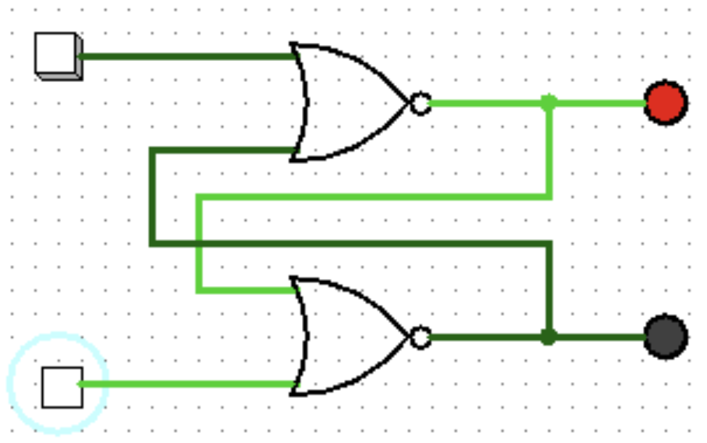

## 2. Асинхронный RS‑триггер с инверсными входами

|  |  |  |  |
| --- | --- | --- | --- |
| S̅ | R̅ | Q_prev | Q_next |
| 0 | 0 | 0 | X |
| 0 | 0 | 1 | X |
| 0 | 1 | 0 | 1 |
| 0 | 1 | 1 | 1 |
| 1 | 0 | 0 | 0 |
| 1 | 0 | 1 | 0 |
| 1 | 1 | 0 | 0 |
| 1 | 1 | 1 | 1 |

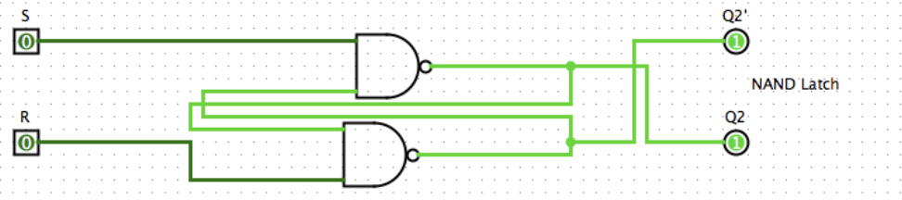

## 3. Синхронный RS‑триггер

|  |  |  |  |  |
| --- | --- | --- | --- | --- |
| C | S | R | Q_prev | Q_next |
| 0 | 0 | 0 | 0 | 0 |
| 0 | 0 | 0 | 1 | 1 |
| 0 | 0 | 1 | 0 | 0 |
| 0 | 0 | 1 | 1 | 1 |
| 0 | 1 | 0 | 0 | 0 |
| 0 | 1 | 0 | 1 | 1 |
| 0 | 1 | 1 | 0 | 0 |
| 0 | 1 | 1 | 1 | 1 |
| 1 | 0 | 0 | 0 | 0 |
| 1 | 0 | 0 | 1 | 1 |
| 1 | 0 | 1 | 0 | 0 |
| 1 | 0 | 1 | 1 | 0 |
| 1 | 1 | 0 | 0 | 1 |
| 1 | 1 | 0 | 1 | 1 |
| 1 | 1 | 1 | 0 | X |
| 1 | 1 | 1 | 1 | X |

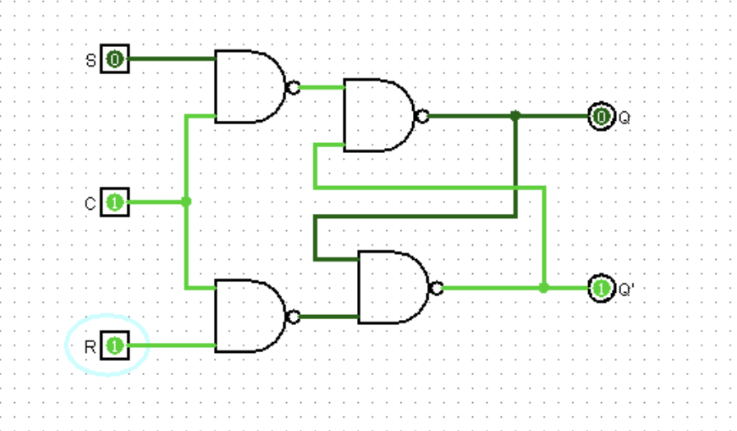

## 4. S‑триггер

|  |  |  |  |
| --- | --- | --- | --- |
| S | R | Q_prev | Q_next |
| 0 | 0 | 0 | 0 |
| 0 | 0 | 1 | 1 |
| 0 | 1 | 0 | 0 |
| 0 | 1 | 1 | 0 |
| 1 | 0 | 0 | 1 |
| 1 | 0 | 1 | 1 |
| 1 | 1 | 0 | 1 |
| 1 | 1 | 1 | 1 |

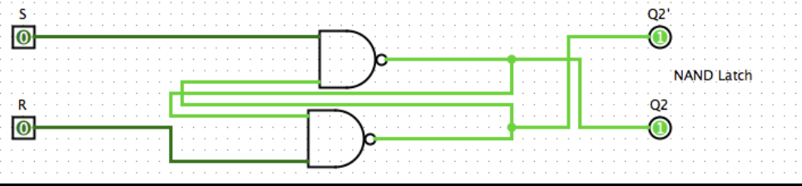

## 5. R‑триггер

|  |  |  |  |
| --- | --- | --- | --- |
| S | R | Q_prev | Q_next |
| 0 | 0 | 0 | 0 |
| 0 | 0 | 1 | 1 |
| 0 | 1 | 0 | 0 |
| 0 | 1 | 1 | 0 |
| 1 | 0 | 0 | 1 |
| 1 | 0 | 1 | 1 |
| 1 | 1 | 0 | 0 |
| 1 | 1 | 1 | 0 |

## 

## 6. E‑триггер

|  |  |  |  |
| --- | --- | --- | --- |
| S | R | Q_prev | Q_next |
| 0 | 0 | 0 | 0 |
| 0 | 0 | 1 | 1 |
| 0 | 1 | 0 | 0 |
| 0 | 1 | 1 | 0 |
| 1 | 0 | 0 | 1 |
| 1 | 0 | 1 | 1 |
| 1 | 1 | 0 | 0 |
| 1 | 1 | 1 | 1 |