**Index**

1. Feasibility Study 1

1.1 Need for Feasibility Study 1

1.1.1 Market Viability 1

1.1.2 Financial Viability 1

1.1.3 Identifying Threats 1

1.1.4 Identifying Opportunities 1

1.2 Types 2

1.2.1. Technical Feasibility: 2

1.2.2. Economic Feasibility 2

1.2.3 Operational Feasibility: 2

1.3 Types of Feasibility Study according to own system 2

1.3.1 TECHNICAL FEASIBLITY: 2

1.3.2 ECONOMIC FEASIBLITY: 2

2.0 Requirement Gathering/Analysis 3

2.1 Requirement Gathering 3

2.2 Data Analysis 3

3.0 Research 4

4.1 Advantages and Disadvantages 5

4.1 Advantages  5

4.2 Disadvantages 5

5.0 SRS 6

5.1. Introduction to SRS 6

5.2. Abstract 6

5.3 List of Modules 7

• Drop-out 7

• Resource 7

• Visualization 7

5.4 Description of Each Module 7

5.4 .1 Drop-out 7

5.4 .2 Resources 7

5.4 .3 Visualization 7

5.5 Hardware software requirements 7

5.6 Time Line chart 8

6.0 System Flow Diagram 9

6.0.1 Dropout 9

Figure (1) - Dropout Diagram 9

6.0.2 Resources 10

Figure (2) - Resources Diagram 10

6.1 UML 11

6.1.1 Activity Diagram 11

Figure (3) - Activity Diagram 11

7.0 Screenshot 12

7.0.1 Screenshot 1 12

Figure (4) –Screenshot 1 12

7.0.2 Screenshot 2 13

Figure (5) –Screenshot 2 13

7.0.3 Screenshot 3 14

Figure (6) –Screenshot 3 14

7.0.4 Screenshot 4 15

Figure (7) –Screenshot 4 15

7.0.5 Screenshot 5 16

Figure (8) –Screenshot 5 16

7.0.6 Screenshot 6 17

Figure (9) –Screenshot 6 17

7.0.6 Screenshot 6 18

Figure (10) –Screenshot 7 18

7.0.6 Screenshot 6 19

Figure (11) –Screenshot 8 19

9.0 Testing 20

10.0 Future Enhancement 21

11.0 References and Bibliography 22

11.0.1 Websites 22

**Data Analysis for E-learning**

# 1. Feasibility Study

Feasibility studies aim to objectively and rationally uncover the strengths and Weaknesses of the existing system or proposed venture. In its simplest term, the two criteria to judge feasibility are cost required and value to be attained. As such, a well-designed feasibility study should provide historical background of the project. Generally, feasibility studies precede technical development and Project implementation.

## Need for Feasibility Study

Starting a new business project is inherently risky because there is no guarantee that a new company, product or service will be profitable. A feasibility study is an analysis that attempts to assess whether a new project has the potential to succeed. Feasibility studies are commonly used in the early stages of planning new ventures to help managers decide whether to go forward with new projects. Feasibility studies technically aren't required to launch new ventures, but they can provide valuable insights that help managers make better decisions and avoid costly mistakes.

### 1.1.1 Market Viability

A feasibility study typically includes a market analysis that looks at the current state and direction of a market and whether a new venture would be viable in the market. For example, if an inventor creates a new type of skateboard, market research he conducts as part of a feasibility study might show little interest exists for the new design. In this case, the inventor might save himself time and money by scrapping the project.

### 1.1.2 Financial Viability

Even if consumers are interested in a new product or service, a business can't succeed unless it can produce and deliver the product to customers at a price that is profitable. A feasibility study can assess the start-up and operational costs of a venture and make revenue projections to estimate whether a project is likely to be profitable. If a product is too expensive to produce to be profitable, managers can look into ways to cut costs to make it financially feasible.

### 1.1.3 Identifying Threats

Many external factors can harm the profitability of a business. Conducting a feasibility study can help managers identify threats such as market competition, unfavourable laws and new technologies that might affect a project's chances of success. Identifying threats early on gives managers the opportunity to take action to mitigate the impact they might have on a business as a new venture proceeds.

### 1.1.4 Identifying Opportunities

Small businesses often focus on selling products and services to small segments, or niches, within larger markets that have specific needs and preferences. A feasibility study can help business managers identify niches in markets. For instance, a feasibility study might reveal that certain demographic groups within a market are willing to pay extra for product features that are not currently available, giving a new company the chance to profit by fulfilling the need.

## 1.2 Types

### 1.2.1. Technical Feasibility:

Generally, feasibility studies precede technical development and project implementation. The assessment is based on a system requirement in terms of Input, Processes, Output, Fields, Programs and Procedure. This can be quantified in terms of volumes of data, trends, frequency of updating, etc., in order to estimate whether the new system will perform adequately or not. Technological feasibility is carried out to determine the capability, in terms of software, hardware, personnel and expertise, to handle the completion of the project. When writing a feasibility report the following should be taken to consideration:

* A brief description of the data
* The part of the data being examined
* The human and economic factor
* The possible solutions to the problems

In technical Feasibility we can show which type of Technology we are using to build our system like OS- windows and application is python, anaconda, panda, numpy, matplotlib and SQL server.

### 1.2.2. Economic Feasibility

Economic analysis is the most frequently used method for evaluating the effectiveness of a new system. More commonly known as cost/benefit analysis, the procedure is to determine the benefits and savings that are expected from a candidate system and compare them with costs. E-playground is cost effective because we can access our system on any operating system through using browser. The only cost of our system is server cost.

### 1.2.3 Operational Feasibility:

Operational feasibility is a measure of how well a proposed system solves the problems, and takes advantage of the opportunities identified during scope definition and how it satisfies the requirements identified in the requirements analysis phase of system development the operational feasibility of the system can be checked as it solves the problems and reduces the complications occurring in the paper-pencil test. We have also reduced the paper work here if we find any error then we provide a facility of complain box where we can send their error through admin and other user then can easily solve their error.

## 1.3 Types of Feasibility Study according to own system

Data analysis for E-learning is used for company to develop app or website and some time its post analysis.

### 1.3.1 TECHNICAL FEASIBLITY:

It is very easy to manage historical data in database and analysis what data is beneficial for the company to develop app or website.

### 1.3.2 ECONOMIC FEASIBLITY:

As no papers required so it less costly. It would be beneficial because only onetime

Development efforts required. All people are aware of technologies so no special skills

required to run the system.

# 2.0 Requirement Gathering/Analysis

## 2.1 Requirement Gathering

If the feasibility report is positive towards undertaking the project, next phase starts with gathering requirements from the user. Analysts and engineers communicate with the client and end-users to know their ideas on what the software should provide and which features they want the software to include

## 2.2 Data Analysis

After collecting a data next process is to analysis data with the use of algorithm and statistical method. Data analysis is a process of inspecting, cleansing, transforming and modelling data with the goal of discovering useful information, informing conclusion and supporting decision-making. Data analysis has multiple facets and approaches, encompassing diverse techniques under a variety of names, and is used in different business, science, and social science domains. In today's business world, data analysis plays a role in making decisions more scientific and helping businesses operate more effectively

# 3.0 Research

Research may be very broadly defined as systematic gathering of data and information and its analysis for advancement of knowledge in any subject. Research attempts to find answer intellectual and practical questions through application of systematic methods. Types of research can be classified in many different ways. Some major ways of classifying research include the following.

* Descriptive Research
* Applied Research
* Quantitative Research
* Conceptual Research

Descriptive research concentrates on finding facts to ascertain the nature of something as it exists. In contrast analytical research is concerned with determining validity of hypothesis based on analysis of facts collected. Applied research is carried out to find answers to practical problems to be solved and as an aid in decision making in different areas including product design, process design and policy making. Fundamental research is carried out as more to satisfy intellectual curiosity, than with the intention of using the research findings for any immediate practical application. Quantitative research studies such aspects of the research subject which are not quantifiable, and hence not subject to measurement and quantitative analysis. In contrast quantitative research makes substantial use of measurements and quantitative analysis techniques. Conceptual research is involving investigation of thoughts and ideas and developing new ideas or interpreting the old ones based on logical reasoning. In contrast empirical research is based on firm verifiable data collected by either observation of facts under natural condition or obtained through experimentation.

**It’s Benefit**

* Better understand evolving community needs
* Inform program development and refinement
* We can find which type of new things need.
* Measure the outcomes of programs and account for use of resources
* Create new understanding about what works and what does not
* Strengthen the case for program funding

# Advantages and Disadvantages

## 4.1 Advantages

* It detects and corrects the errors from data sets with the help of data cleansing. This helps in improving quality of data and consecutively benefits both customers and institutions such as banks, insurance and finance companies.
* It removes duplicate information from data sets and hence saves large amount of memory space. This decreases cost to the company.
* It helps in displaying relevant advertisements on the online shopping websites based on historic data and purchase behaviour of the users. Machine learning algorithms are applied for the same. This helps in increasing revenue and productivity of the companies.
* It reduces banking risks by identifying probable fraudulent customers based on historic data analysis. This helps institutes in deciding whether to issue loan or credit cards to the applicants or not.
* It is used by security agencies for surveillance and monitoring purpose based on information collected by huge number of sensors. This helps in preventing any wrongdoings and/or calamities

## 4.2 Disadvantages

* This may breach privacy of the customers as their information such as purchases, online transactions; subscriptions are visible to their parent companies. The companies may exchange these useful customer databases for their mutual benefits.
* The cost of data analytics tools vary based on applications and features supported. Moreover some of the data analytics tools are complex to use and require training. This increases cost to the company willing to adopt data analytics tools or software.
* The information obtained using data analytics can also be misused against group of people of certain country or community or caste.
* It is very difficult to select the right data analytics tools. This is due to the fact that it requires knowledge of the tools and their accuracy in analysing the relevant data as per applications. This increases time and cost to the company.

# 5.0 SRS

## 5.1. Introduction to SRS

A software requirements specification (SRS) is a description of a software system to be developed. It lays out functional and non-functional requirements, and may include a set of use cases that describe user interactions that the software must provide

## 5.2. Abstract

E-learning data consists of large volume of educational data and available with complex and hybrid data architecture. Capturing of student performances, student evaluation and student's interaction information are one of the challenges faced by the e-learning software users at the time of analysis. Integrating student data along with educational data for analysis needs complex system design framework. New innovations in e-learning also facilitates augmented learning, adaptive learning, web based learning, activity based learning, and project based learning. Education technology interventions using learning management system, content management system, advanced distributed learning; sharable content object reference models and application program interfaces enhanced and extended the e-learning frameworks to a greater horizon

## 

## 5.3 List of Modules

## Drop-out

## Resource

## Visualization

## 5.4 Description of Each Module

## 5.4 .1 Drop-out

Under this we are collecting data why student are drop-out from school and finding reason behind it to solve this problem. For data analysis the method is used is mathematical approach is average dropout ratio and percentage wise dropout list.

## 5.4 .2 Resources

As we know that every student required basic resources in their school life. If we doesn’t provide or they didn’t get then how they will study. For example, in village there is no school then children have to travel lots of distance to go for schooling in that time the student which are motivated will go to school and other left it. So, according to me student should be given the resources which are they required and we are finding it to solve the problem.

## 5.4 .3 Visualization

After the data analysis our task is to generate visual images to make better understanding of our work. Suppose, we have to show how many students are leaving school due to transportation and then the result will come according to the graph.

## 5.5 Hardware software requirements

* **System configuration*:***

1. Server configuration
2. Core i5(7th Gen processor operating at 3.50 GHz)
3. 8gb ram
4. 1TB Free space hard disk

* **Software Requirements**

1. Anaconda
2. Python

## 5.6 Time Line chart

|  |  |  |  |  |  |  |  |
| --- | --- | --- | --- | --- | --- | --- | --- |
| Development Phase | 104 Days | | | | | | Duration  (Days) |
| 0 to 17  Day | 18 to 36 Days | 37 to 55 Days | 56 to 75 Days | 76 to 95 Days | 96 to 104 Days |
| Research Title |  |  |  |  |  |  | 7 |
| Feasibility |  |  |  |  |  |  | 9 |
| System Requirement Specification |  |  |  |  |  |  | 5 |
| Diagrams |  |  |  |  |  |  | 7 |
| Data Dictionary |  |  |  |  |  |  | 14 |
| Form Design |  |  |  |  |  |  | 21 |
| Form Design with code |  |  |  |  |  |  | 14 |
| Form Design with Validation |  |  |  |  |  |  | 14 |
| System Testing |  |  |  |  |  |  | 7 |
| Document Submission |  |  |  |  |  |  | 6 |
| Total Times |  | | | | | | 104 |

# 6.0 System Flow Diagram

## 6.0.1 Dropout

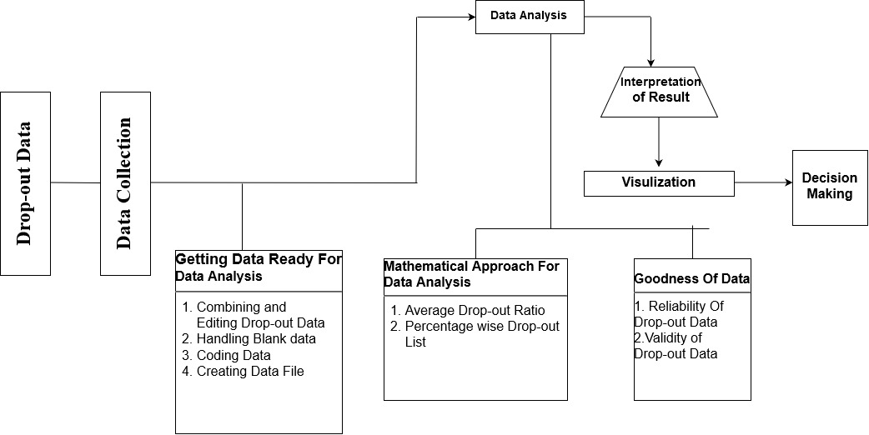

## Figure (1) - Dropout Diagram

## 6.0.2 Resources

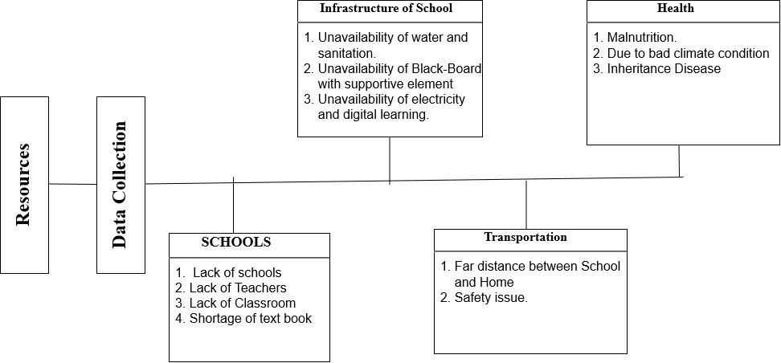

## Figure (2) - Resources Diagram

## 6.1 UML

## 6.1.1 Activity Diagram



## Figure (3) - Activity Diagram

## 7.0 Screenshot

## 7.0.1 Screenshot 1

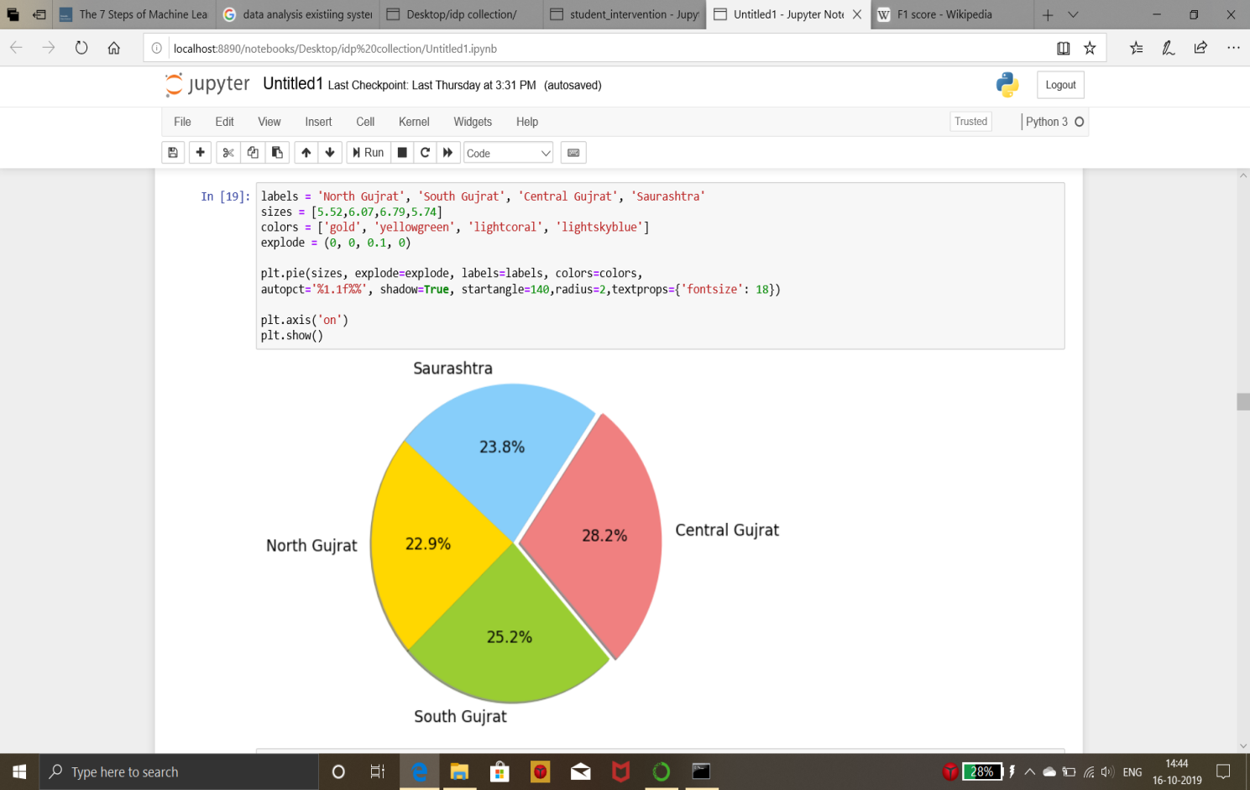

## Figure (4) –Screenshot 1

## 7.0.2 Screenshot 2

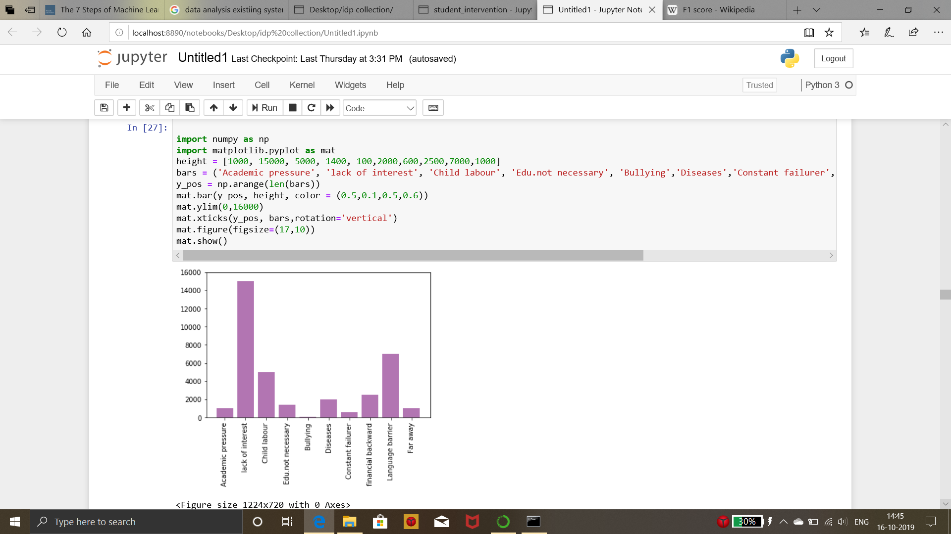

## Figure (5) –Screenshot 2

## 7.0.3 Screenshot 3

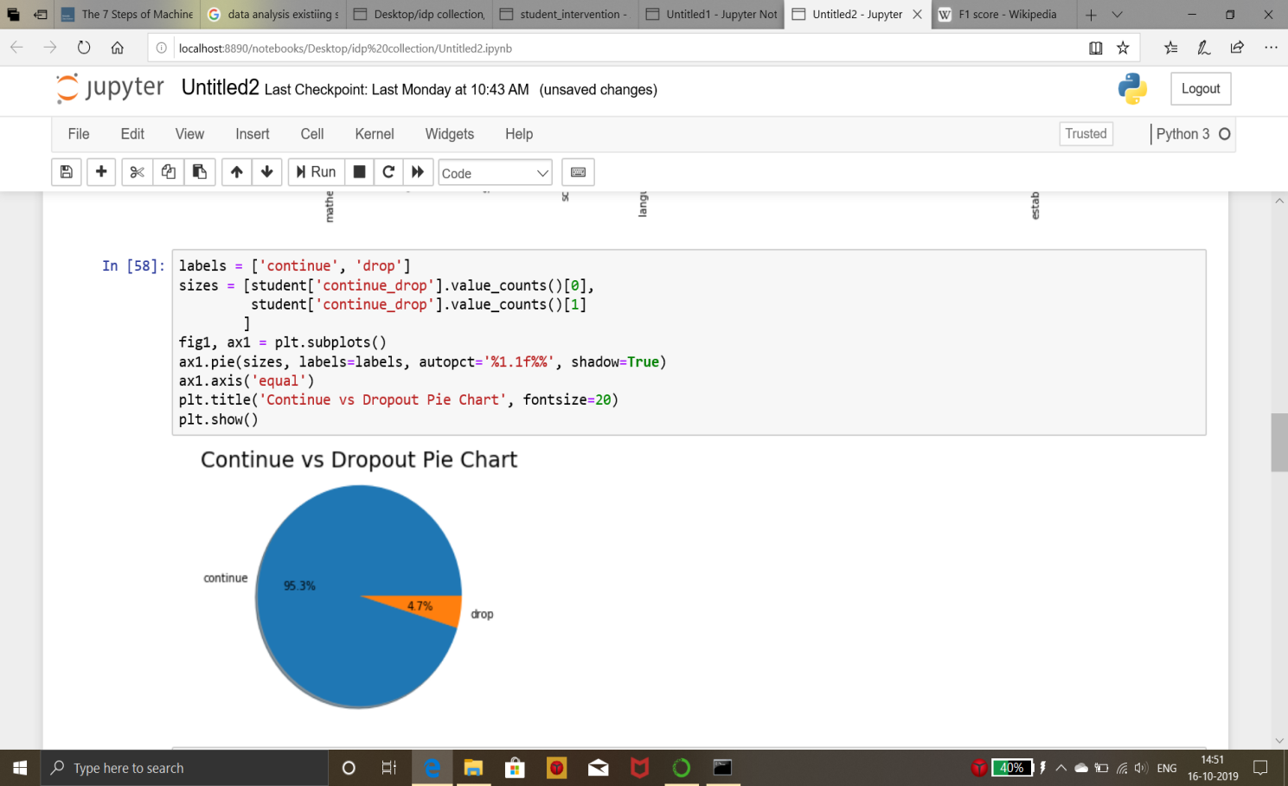

## Figure (6) –Screenshot 3

## 7.0.4 Screenshot 4

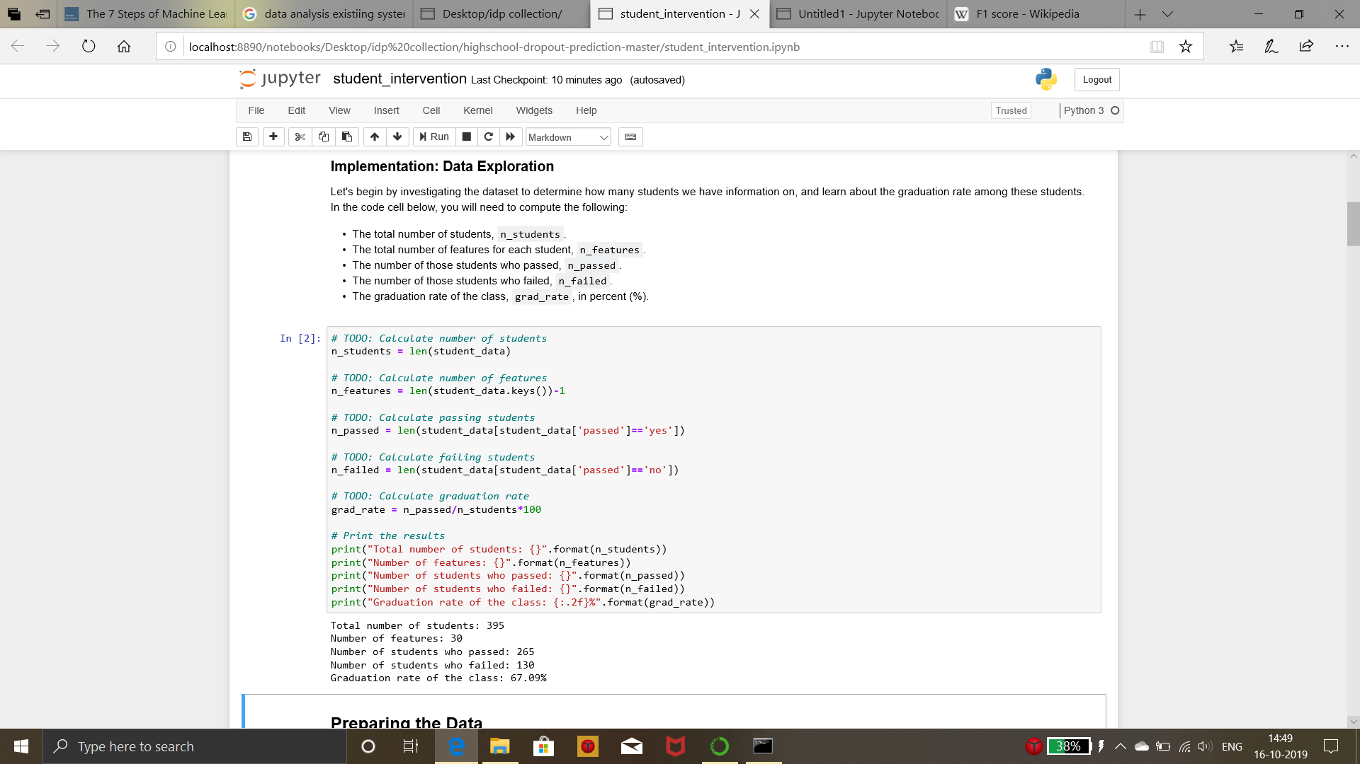

## Figure (7) –Screenshot 4

## 7.0.5 Screenshot 5

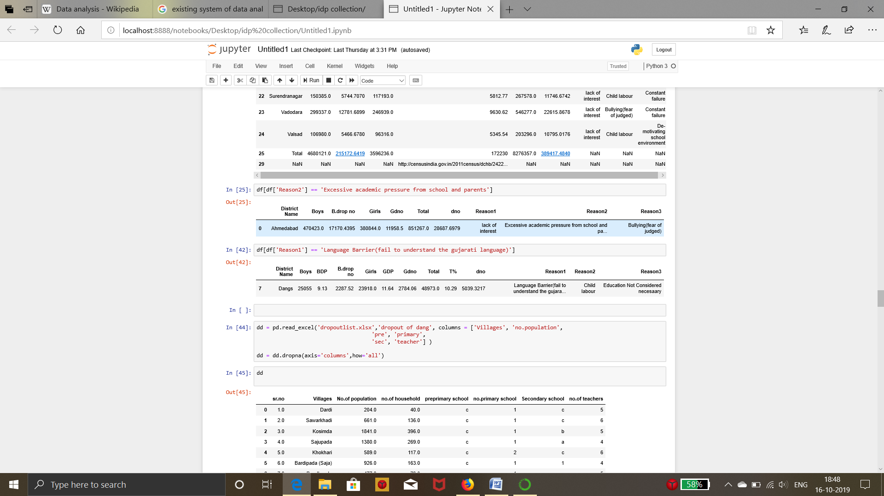

## Figure (8) –Screenshot 5

## 7.0.6 Screenshot 6

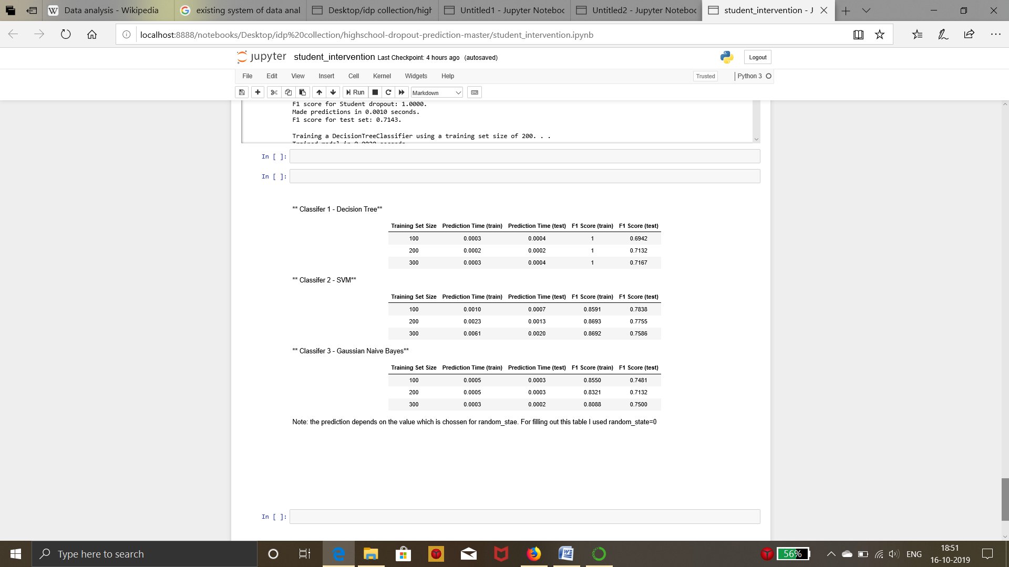

## Figure (9) –Screenshot 6

## 7.0.6 Screenshot 6

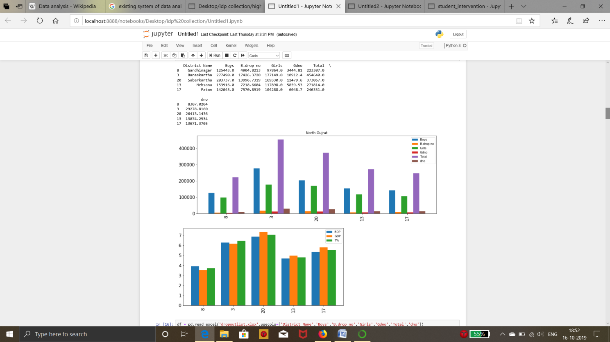

## Figure (10) –Screenshot 7

## 7.0.6 Screenshot 6

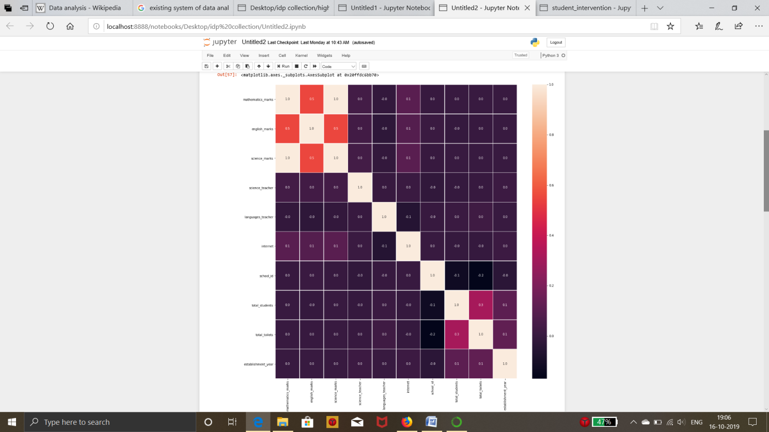

## Figure (11) –Screenshot 8

## 8.0 Testing

**Testing** means to check the behaviour of a complete and fully integrated System based on the software requirements specification (SRS) document. The main focus of this testing is to evaluate Business / Functional / End-user requirements.

This is black box type of testing where external working of the software is evaluated with the help of requirement documents & it is totally based on Users point of view. For this type of testing do not required knowledge of internal design or structure or code.

##### ****Why system testing is important:****

a) In Software Development Life Cycle the System Testing is perform as the first level of testing where the System is tested as a whole.

b) In this step of testing check if system meets functional requirement or not.

c) System Testing enables you to test, validate and verify both the Application Architecture and Business requirements.

d) The application/System is tested in an environment that particularly resembles the effective production environment where the application/software will be lastly deployed.

* **Types of testing**

1. **Unit testing** – Testing is done in the development process while developer completes the unit development.  The object of this testing is to verify correctness of the module.
2. **Integration testing** – System Integration Testing is started after the individual software modules are integrated as a group. A typical software project consists of multiple modules & these are developed by different developers.
3. **System testing** – This is the first time end to end testing of application on the complete and fully integrated software product before it is launch to the market.
4. **Acceptance testing** – User acceptance is a type of testing performed by the Client to certify the system with respect to the requirements that was agreed upon.  This is beta testing of the product & evaluated by the actual end users. The main purpose of this testing is to validate the end to end business flow.

## 9.0 Future Enhancement

* We collect more data in future according to new surveys and make our data analysis report more efficient.
* We will use modern technologies such as AI and Deep Learning.
* Real Time Data Collection will be done.

## 10.0 References and Bibliography

## 10.0.1 Websites

<http://censusindia.gov.in/2011census/dchb/DCHB_A/24/2422_PART_A_DCHB_THE%20DANGS.pdf>

<https://www.in.undp.org/content/dam/india/docs/human-development/District%20HDRs/4.The%20Dangs_DHDR_July%202015.pdf>

## 