Dashboard Design
Date | 06 September, 2026
SID | SWUID2026285697
Project Name | India's Agricultural Crop Production Analysis
Maximum Marks | 5 Marks

Activity 1: Interactive and visually appealing dashboard
One Tableau dashboard was developed to consolidate the agricultural production analysis. It combines KPI indicators, time trends, geographic distribution, state comparisons, cultivated-area comparison, production ranking, production-unit distribution and seasonal production share.
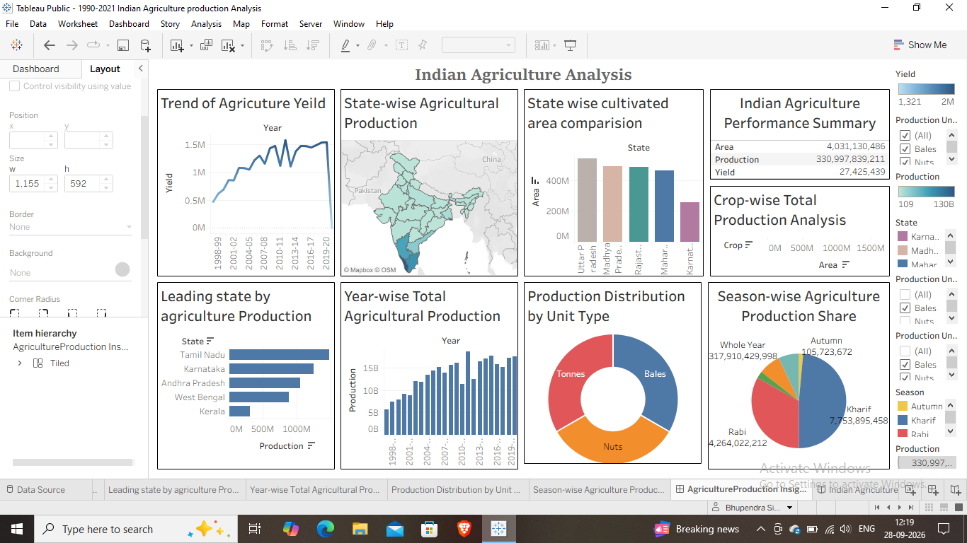
Major outcomes represented by the dashboard
- Overall agricultural production and yield are presented through KPI indicators.
- Yield trends from 1997 to 2021 are presented through a line chart.
- State-wise agricultural production is presented geographically using an India map.
- State-wise total production is compared using a horizontal bar chart.
- State-wise cultivated area is compared using a grouped bar chart.
- Leading states by agricultural production are represented using a bar chart.
- Year-wise total agricultural production from 1997 to 2021 is represented using a bar chart.
- Production distribution by production unit type is represented using a donut chart.
- Season-wise agricultural production share is represented using a pie chart.
Dataset fields: State, District, Crop, Year, Season, Area, Area Unit, Production, Production Unit and Yield. Tableau Calculation fields used: 0.

Activity 2: Publish Dashboard on Tableau Public
Tableau Public Dashboard Link: https://public.tableau.com/views/1990-2021IndianAgricultureproductionAnalysisDashboard/AgricultureProductionInsight?:language=en-US&:sid=&:redirect=auth&:display_count=n&:origin=viz_share_link

