Story
Date | 06 September, 2026
SID | SWUID2026285697
Project Name | India's Agricultural Crop Production Analysis
Maximum Marks | 5 Marks

One Tableau story was developed to communicate the agricultural production analysis through a logical sequence of visual insights.
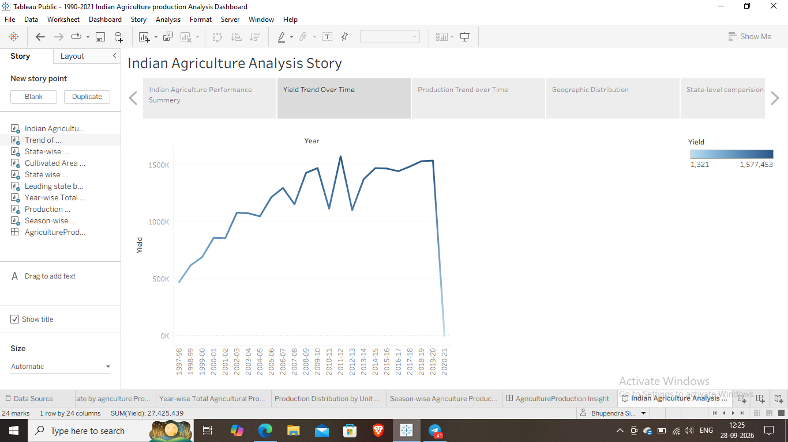
Observations
- The story presents overall agricultural production and yield through KPI indicators.
- The yield trend from 1997 to 2021 provides a time-based view of agricultural yield.
- The India map provides a geographic view of production distribution across states.
- State-level visualizations support comparison of total production and cultivated area.
- The leading-state visualization supports comparison of agricultural production among states.
- The year-wise production visualization shows variation in total production across 1997–2021.
- The production-unit visualization shows production distribution according to unit type.
- The season-wise visualization shows the share of agricultural production across seasons.
Exact numerical findings and highest/lowest categories should be taken directly from the final Tableau view rather than inferred in this document.
Activity 2: Publish Story on Tableau Public
Tableau Public Story Link: https://public.tableau.com/views/1990-2021IndianAgricultureproductionAnalysisStory/IndianAgricultureAnalysisStory?:language=en-US&:sid=&:redirect=auth&:display_count=n&:origin=viz_share_link

